

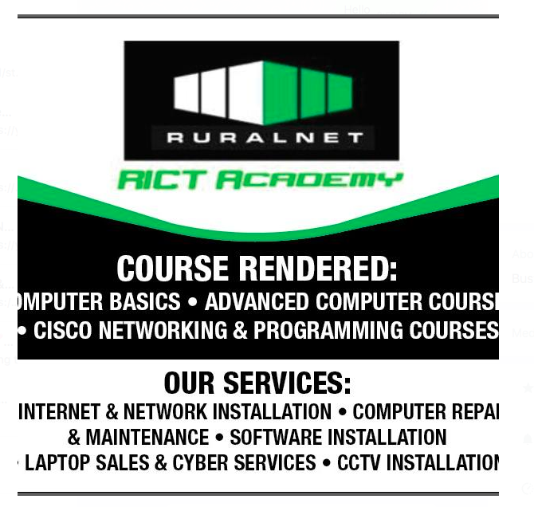
RURALNET ICT ACADEMY
0723845040/0700886058
Ruralnet2016@gmail.com
www.ruralnetict.co.ke
Second floor of
Oguya plaza, Ugunja town
Along Kisumu/Busia Road
Opposite Easy Coach booking office
P. O. BOX 4 – 40606,

UGUNJA

AUTHORISED COURSE OUTLINE

Week 1: Introduction to Computers
- Definition of a computer
- Types of computers
- Basic computer hardware & peripherals
- Software (system vs application)
- Computer startup and shutdown procedures
- File and folder management
- Introduction to touch typing
- Speed and accuracy exercises
- Document preparation practice (letters, memos, CVs, reports)
- Office procedures (filing, printing, emailing, scanning)

Week 2: Operating System
- Operating systems basics (Windows/Linux/Macintosh)
- Desktop, taskbar, and start menu navigation
- File management (copy, paste, delete, rename)
- Creating and managing folders
- Using accessories (calculator, notepad, paint, snipping tool)
- Installing and uninstalling software
- System settings (control panel, personalization, security basics)

Week 3: Microsoft Word
- Creating, saving, and formatting documents
- Page setup and printing
- Tables, columns, and lists
- Inserting images, shapes, charts, and word art
- Styles, templates, and themes

- Mail merge (letters, labels, envelopes)
- Proofing tools (spell check, grammar, thesaurus)

Week 4: Microsoft Excel
- Creating and saving workbooks
- Data entry and formatting cells
- Formulas and functions (SUM, AVERAGE, IF, VLOOKUP, etc.)
- Graphical analysis
- Sorting and filtering data
- Pivot tables basics
- Printing worksheets

Week 5: Microsoft Access (Database Management)
- Introduction to databases
- Creating tables and relationships, Data entry and validation
- Forms and buttons
- Queries (select, update, delete)
- Reports and Printing reports
- Project (Encrypted Data entry system Development)

Week 6: Desktop Publishing (DTP) – MS Publisher / Canva
- Introduction to DTP and Formatting text/objects
- Creating calendars, flyers/brochures, and business cards
- Exporting and printing designs

Week 7: Microsoft PowerPoint
- Introduction to presentations
- Creating and saving slideshows
- Slide layouts and designs
- Applying transitions and animations
- Inserting images, charts, and videos
- Running a presentation (slideshow mode)
- Printing slides and handouts

Week 8: Networking, Internet & Email
- Introduction to networking, internet and web browsers
- Using search engines effectively
- Downloading and uploading files
- Creating and managing an email account
- Sending, receiving, and organizing emails
- Email etiquette and attachments

- Cloud services (Google Drive, OneDrive, Dropbox basics)

