

Source: https://www.wikihow.com/Use-a-Computer-Mouse

How to Use a Computer Mouse
Two Methods: Using a PC Computer Mouse | Using a MAC Computer Mouse | Community Q&A

Using a computer mouse is one of the first steps to properly operating a computer. The mouse allows you to move the cursor and click programs. These steps will show you how to use a PC and MAC computer mouse, whether it is plugged into the computer, wireless, or connects via bluetooth.
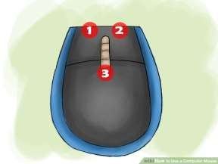
- Familiarize yourself with the mouse. The front of the mouse points away from you and has two buttons on the left and right which you can click. These allow you to open programs and menus. In the middle of these two buttons is a small wheel, which allows you to scroll up and down pages.
  - You can use your index finger to click the left button and the middle finger to click the right one.
  - On the bottom of the mouse is a censor that allows the mouse to know where to move.
  - A wireless mouse may have a compartment to insert a battery, and it may have an on and off button
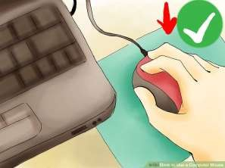
- Place the mouse on a clean, smooth surface, preferably a mouse pad. This allows the mouse to move without interference. You may have issues with the mouse if it is not on a mousepad, such as it not scrolling smoothly.

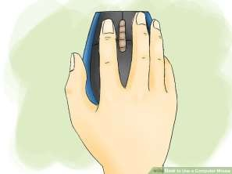
- Grip the mouse lightly in your dominant hand. You don’t want to hang on to the mouse too tightly or click with a lot of force. Keep your fingers relaxed, and keep the mouse at elbow level. If your fingers become tired, take breaks from the computer.

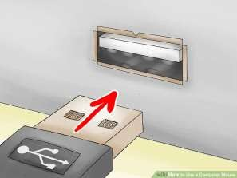
- Plug in the mouse with its USB connector. Your mouse will have a cable extending from it, or it will come with a small USB connector if it is wireless. USB ports are located in different areas for every computer, but in general, laptops will have USB ports on the left or right side of the keyboard; most desktops will have a USB on the front or back of the modem or either side of the monitor.
  - Look for a small square port about the size of your USB connector.
  - Insert the USB connector. Flip the USB connector upside down if it does not fit the first time, but never force the USB connector in.

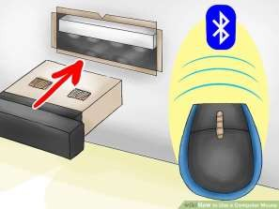
- Connect the mouse via Bluetooth if necessary.[3] Plug the Bluetooth transceiver into a USB port, then press and hold the connect button on the USB transceiver for five seconds. Next, the connection wizard will pop up, so follow the instructions in the wizard to connect your device.

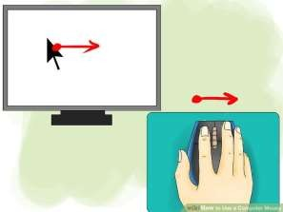
- Make sure the mouse is working. Your computer should be on, and you should see a cursor on the screen you can control by moving your mouse. If the mouse isn’t working, try plugging it in to a different USB port or plugging it in again.[4] Also, make sure a wireless mouse is on and has batteries.

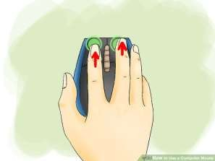
- Practice clicking with the mouse. The left button is the primary button for right- handed users, and the right button is the primary button for left-handed users. Click the primary button once to click on something and twice in a row to “double click” on a program or menu. When clicking the non-primary button, this is called “right-clicking.”
  - Single-clicking often selects an item or opens a menu.
  - Double-clicking often opens items or folders.
  - Right-clicking usually displays a list of things you can do with a selected item.

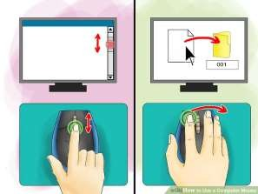
- Practice scrolling and dragging items with the mouse. Move the wheel with your pointer finger to scroll up and down pages. To drag an object, place the cursor on it, then press and hold down the primary button, and move the mouse to a new location. Release the primary button once you are done.

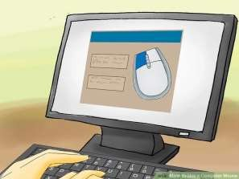

- Customize the mouse as needed. You can change how quickly your mouse pointer moves on the screen, change the mouse’s primary buttons if you’re left handed, and even change the pointer’s appearance. Go to the settings on your PC to do this.

"Article provided by wikiHow, a wiki building the world's largest, highest quality how-to manual. Please edit this article and find author credits at wikiHow.com on How to Use a Computer Mouse. Content on wikiHow can be shared under a Creative Commons License."

Article from WikiHow: http://www.wikihow.com

Modified from: “How to Use a Computer Mouse”: https://www.wikihow.com/Use-a-Computer-Mouse

