Pointing devices of computer
An input device used to control a pointer on the screen is called a pointing device. A pointer is a small symbol that appears on the screen in a graphical user interface. Different shapes of a pointer are available.

Types of Pointing Devices
Different types of pointing devices are as following:
Mouse Trackball
Touchpad/ Trackpad Pointing Stick Graphics Tablet Touchscreen
Light Pen Joystick Stylus

Mouse
A mouse is a small, lightweight input device. The mouse is moved on a flat surface to control the movement of the cursor on a screen. A mouse usually has two or three buttons. These buttons are used to do various tasks.
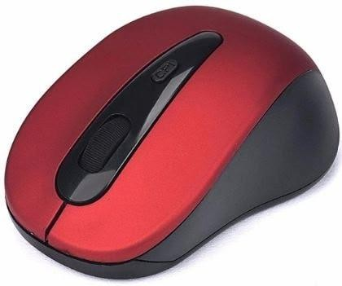

Trackball
A trackball can also be used as an alternative to a mouse. This device also has buttons similar to those on a mouse.
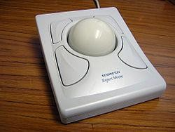
It holds a large moving ball on the top. The body of the trackball is not moved. The ball is rolled with fingers. The position of the cursor on the screen is controlled by rotating the ball.The main benefit of the trackball over a mouse is that it takes less space to move. The trackball is often included in laptop computers. The standard desktop computer also uses a trackball operated as a separate input device.

Touchpad/ Trackpad
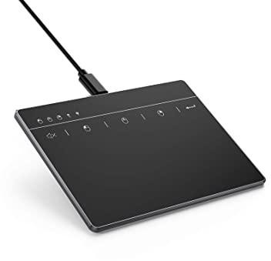
A touchpad is a small, plain surface over which the user moves his finger. The user controls the movement of the cursor on the screen by moving his fingers on the touchpad. It is also known as a trackpad.
Pointing Stick
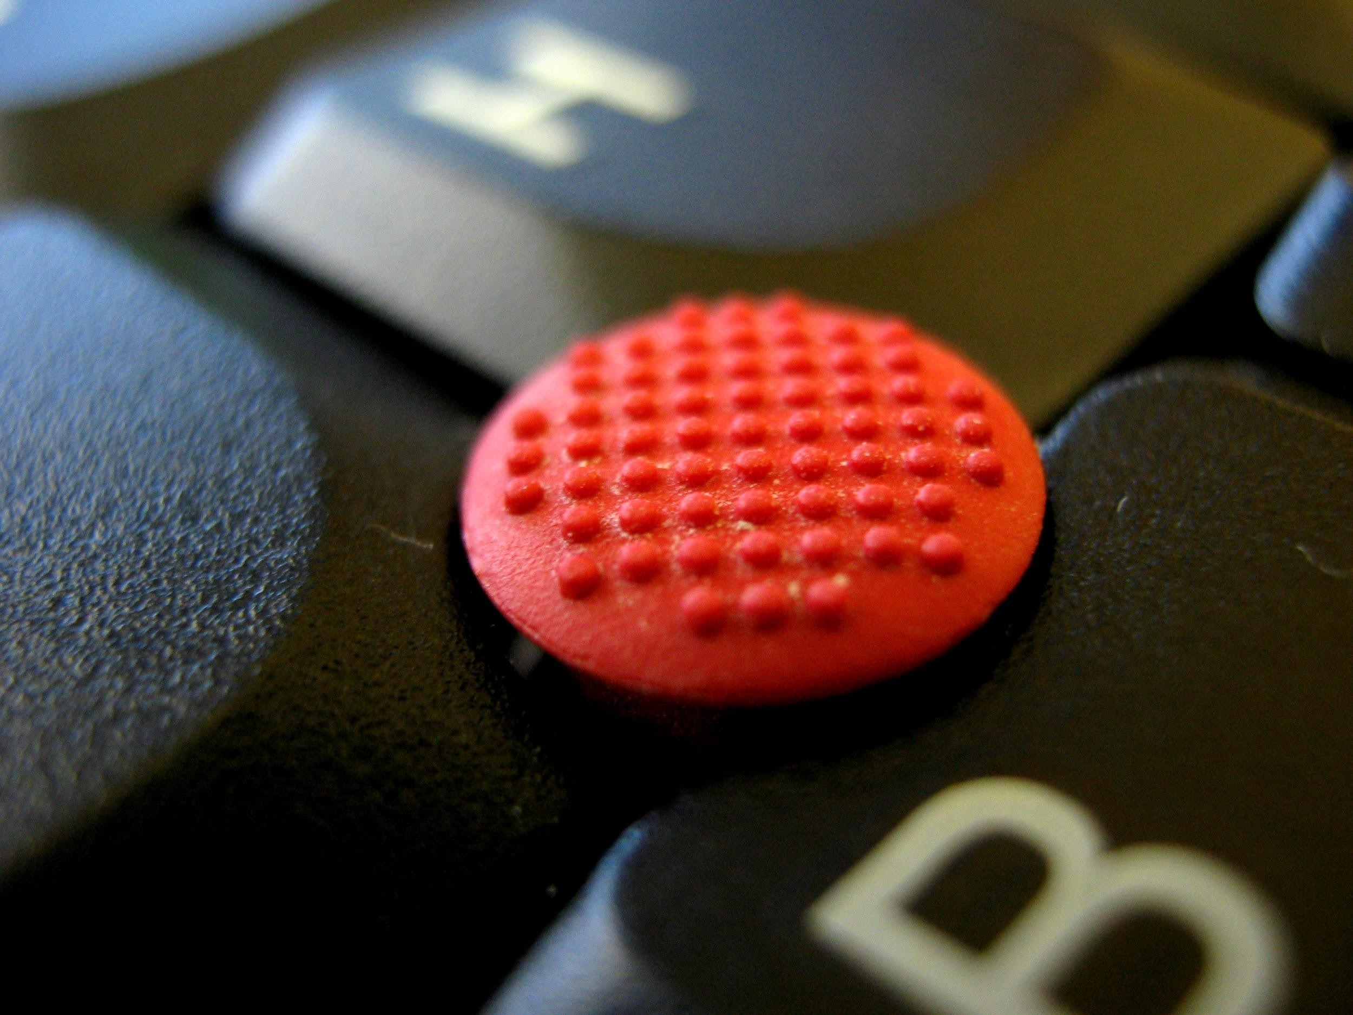
A pointing stick is a pressure-sensitive device. It is similar to a pencil eraser and exits between keys on the keyboard. When the user pushes the pointing stick, the pointer on the screen also moves. It demands no extra space or cleaning like a mouse. A pointing stick is normally used with notebook computers.

Graphics Tablet
A graphics tablet consists of a flat pad on which the user draws with a special pen called a stylus. The image is created on the screen as the user draws on the pad. A designer can produce very accurate drawings using a graphics tablet. It is also called a digitizer.

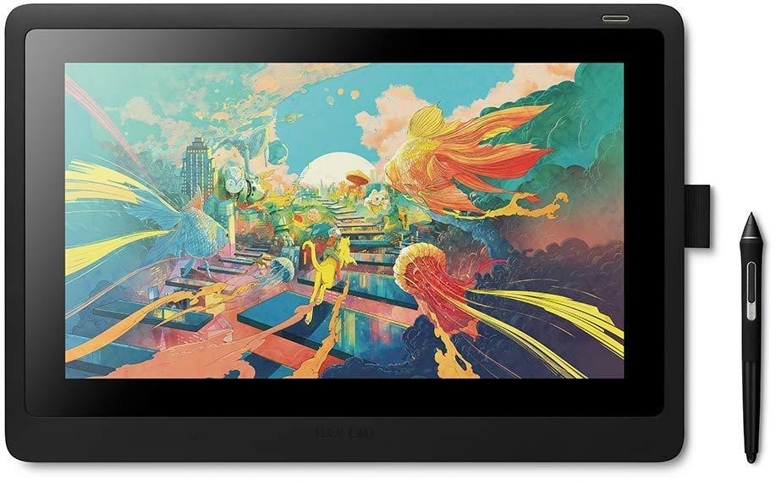

Touchscreen
The touchscreen is a video display screen that receives input from the touch of a finger. The screen is covered with a plastic layer. There are undetectable beams of infrared light at the back of the screen. In order to enter data, the user touches icons or menus on the screen. Most touchscreen computers use sensors to detect the touch of a finger.
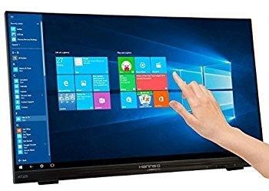

Light Pen
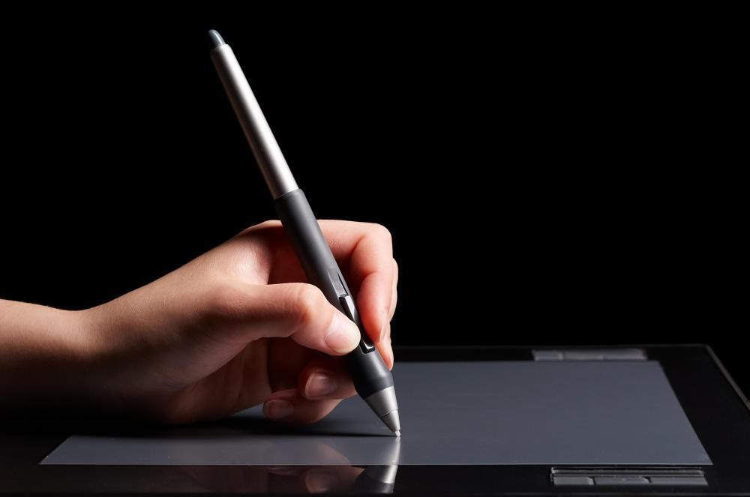
A light pen is a hand-held pen-like device. It is a light-sensitive stylus. The light pen is connected by a wire to the computer. It has a device at the tip that emits light. The pen sends information to the computer when a user touches the pen on certain areas of a specially designed screen. A light pen I usually used by engineers, graphics designers, and illustrators.

Joystick
A joystick consists of a base and a stick. The stick can be moved in several directions to shift an object anywhere on the computer screen. A joystick can perform a similar function to a mouse or trackball. It is often considered less comfortable and efficient. The most common use of a joystick is for playing computer games.
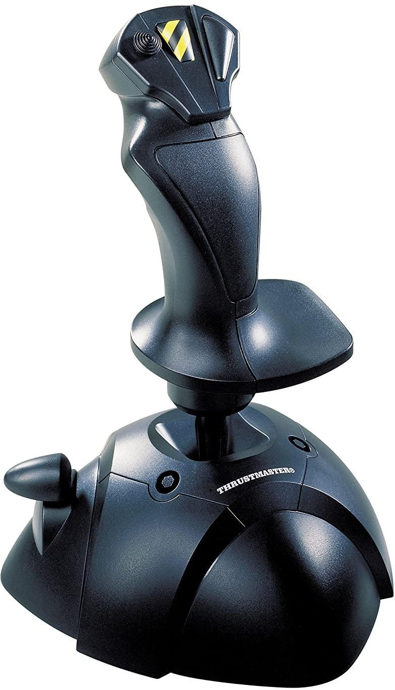
Stylus
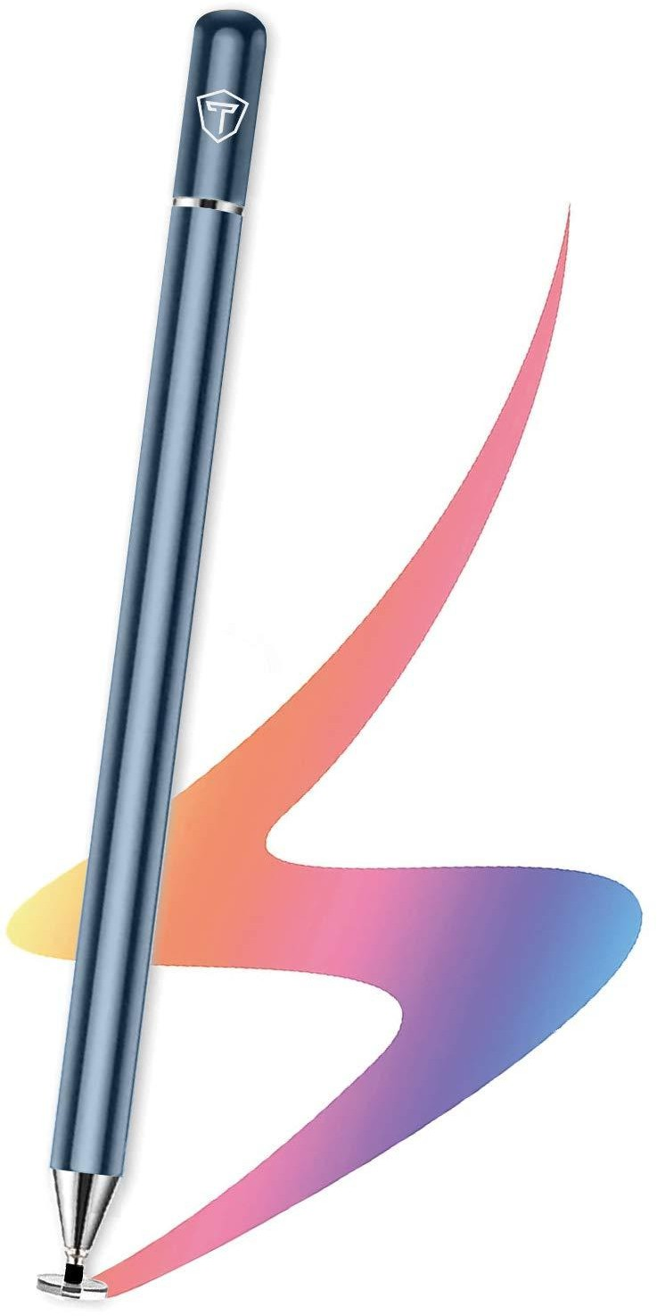
The stylus is similar to a ballpoint pen. It uses pressure to write text and draw lines. It was also called a pen. A stylus is used in graphical applications. Architects, artists, and designers use it to create drawings and sketches.

