

Microsoft Word
STUDENTS DETAILS


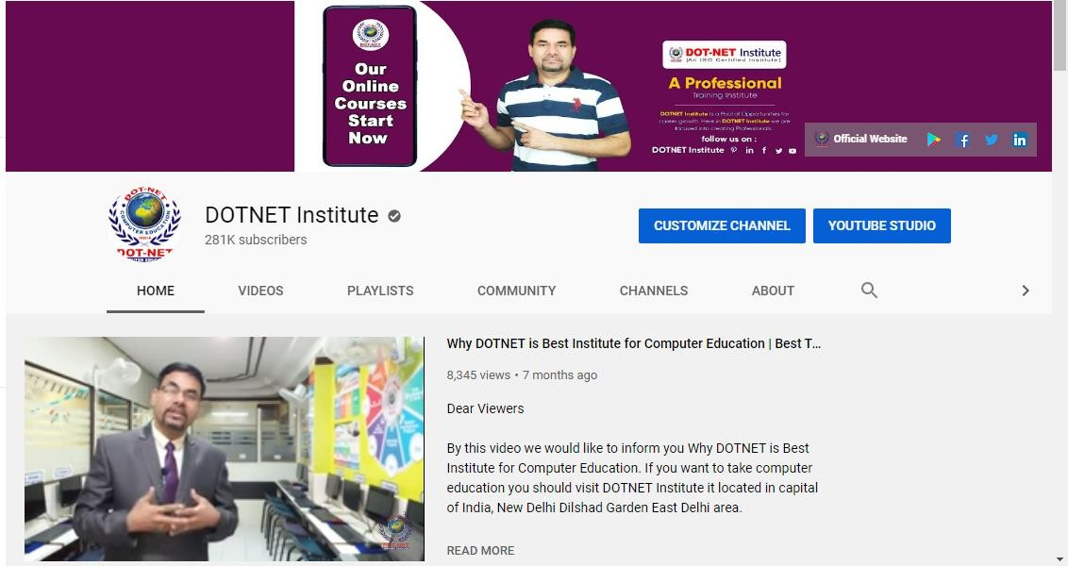

Name of Students DOT-NET Roll No.
Date Of Joining Name of Course
Batch Timing
:
:
:
:
:
………………………………………………………………
………………………………………………………………
………………………………………………………………
………………………………………………………………
………………………………………………………………

You can connect with us online with our YouTube Channel DOT-NET Institute

Subscribe it to get new video notification
Click on Subscribe button after that click bell icon to get new video notification.
Visit:www.youtube.com/c/dotnetinstitute

Microsoft Word

Microsoft Word 2010-13




COURSE CONTENTS
INRTODUCTIONS OF MS WORD Page
 What is Ms Word? 2
 About Extensions 2
 Ms Word is Part of. 2
 How to Start 2
HOME TOOLBARS
 Clipboard 3
 Fonts (Practical Assignment) 4
 Paragraph (Practical Assignment) 5
 Styles(Practical Assignment) 6
 Editing (Practical Assignment) 6
INSERT TOOLBARS
 Pages & Tables (Practical Assignment) 7
 Illustrations (Practical Assignment) 8/9
 Links (Practical Assignment) 10/11
 Header & Footer (Practical Assignment) 12
 Text & Symbols (Practical Assignment) 13
FORMAT TOOLBARS
 Text Box Styles (Practical Assignment) 14
 Shadows & 3-D Effects (Practical Assignment) 15
 Arrange & Size Management (Practical Assignment) 15
PAGE LAYOUT TOOLBARS
 Page Setup (Practical Assignment) 16
 Page Background (Practical Assignment) 17
 Paragraph & Arrange (Practical Assignment) 17
MAILINGS TOOLBARS
 Create Letter (Practical Assignment) 18
 Start Mail Merge 18
 Write & Insert Fields 19
 Preview Results & Finish 19
SHORTCUT KEYS 20






Microsoft Word

Introduction of Ms. Word

What is Ms. Word?
Microsoft Office Word 2007-10 helps you produce professional-looking documents by providing a comprehensive set of tools for creating and formatting your document in a new interface. Rich review, commenting, and comparison capabilities help you quickly gather and manage feedback from colleagues. Advanced data integration ensures that documents stay connected to important sources of business information.

About Extensions
The meaning of extensions that identification and trade mark of application there are many type of applications in computer so if you have so many files in one folder and all the files are different types of application in that case you can identify the application by their extensions.
Identification Symbols :
Ms. Word Extensions : .DOCX

Ms. Word is Part of
The Ms. Word is the part of Microsoft Office family Software there are following part of Microsoft Office family:
  - Microsoft Word
  - Microsoft Excel
  - Microsoft Access
  - Microsoft PowerPoint

How to start Ms. Word
We can use these steps to start Ms. Word:-
Click on Start Bar
All Programs
Microsoft Office
Microsoft Office Word 2007-10

Now you have screen of Microsoft Word and you can start your work in this.

Microsoft Word

Home Toolbars
The Home Toolbar is the first toolbar of Ms. Word this toolbar always display on the top of the Ms. Word Screen like as:

Clipboard

Font
Paragraph

Styles
Editing


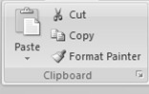


Clipboard
In this clipboard very simple options are available like as:
Cut (Ctrl+X) : Cut selected matter.
Copy (Ctrl+C) : Copy selected matter.
Paste (Ctrl+V) : Paste Cut / Copy Matter.
Format Painter (Ctrl+Shift+C): Copy formatting from one place and apply it to
another place

Cut

Paste Copy

Format Painter

Microsoft Word

Font

In the font clipboard there are so many options for font formatting like as:

Font (Ctrl+Shift+F) : Change the font face. Font Size (Ctrl+Shift+P) : Change the font size. Grow Font (Ctrl+>) : Increase the font size. Shrink Font (Ctrl+<) : Decrease the font size.
Clear Formatting : Clear all the formatting from the selection.
Bold (Ctrl+B) : Make the selected text bold.
Italic (Ctrl+I) : Italicize the selected text.
Underline (Ctrl+U) : Underline the selected text.
Strikethrough : Draw a line through the middle of the selected text.
Subscript (Ctrl+=) : Create small letters below the text baseline.
Superscript (Ctrl+Shift++) : Create small letters above the line of text.
Change Case : Change all the selected text to upper, lowercases. Text Highlight Color : Make text look like it was marked with a marker pen. Font Color : Change the text color.

Font
Font Size
Grow Font
Shrink Font

Clear Formatting

Font Color
Bold

Italic

Underline

Strikethrough

Superscript
Text Highlight Change Case


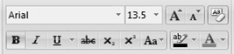

Subscript

 Use all the options with Practical Assignment



Microsoft Word

Practice Exercise:- 1 (For Fonts & Formatting)

BIO-DATA
Name : Anil Gupta
Father’s Name : Mr. Ram Mohan Gupta
Date of Birth : 5th June 1992
Nationality : Indian
Sax : Male
Language Known : Hindi & English
Address : D-34, Street No. 3 Old Sheema Puri Delhi – 110095
Contact No. : 9876543210
E-mail ID : anilgupta67@gmail.com
Educational Qualification : 10th Pass from CBSE in 2010. 12th Pass from CBSE in 2012.
Doing B.A. Ist Year From Delhi Univ.
Professional Qualification : One Year Diploma Course in Computer
from DOT-NET Institute.
Experience : Fresher
Hobbies : Playing Cricket & Watching Vedios.

Date:
Place:
(Anil Gupta)

Microsoft Word

- Paragraph

In the paragraph clipboard all the function for paragraph formatting with bullets and listings like as:

Bullets : Start a bulleted list. (Click arrow to choose different style) Numbering : Start a numbered list. (Click arrow to choose different style) Multilevel List : Start a multilevel list. (Click arrow to choose different style) Decrease Indent : Decrease the indent level of paragraph.
Increase Indent : Increase the indent level of paragraph.
Sort : Alphabetize the selected text and numerical data. Show/Hide (Ctrl+*) : Show paragraph marks and other hidden formatting symbols Align Text Left (Ctrl+L) : Align text to the left.
Centre (Ctrl+E) : Centre Text.
Align Text Right (Ctrl+R) : Align text to the right.
Justify (Ctrl+J) : Align text to both the left and right margins.
Line Spacing : Change the spacing between lines of text.
Shading : Color the background behind the selected text of paragraph.
Borders : Border the selected matter.

Bullets

Numbering

Multilevel List
Increase Indent

Decrease Indent

Sort

Centre
Show/Hide

Align Text Left

Line Spacing
Borders

Align Text Right
Justify
Shading


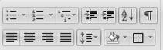

 Use all the options with Practical Assignment

Microsoft Word

Practice Exercise:- 2 (For Fonts & Paragraph)

Resume



AMIT PANDEY
PRESENT ADDRESS:
KC 11, Ganesh Nagar Shakarpur, (New Delhi) PIN 110092
Mob.+91-8860661508
- Mail. amitkumarpandey04@gmail.com
OBJECTIVE:
  - I present myself with a strong desire to achieve the organization goal with a bounding self confidence in mind very kind of objection, as a challenge with excellent analytical problem solving communication & interpersonal skills. I look forward a progressive & challenging carrier.
  - Intend to build a career with leading corporate of hi-tech environment with committed and dedicated people who will help me to explore myself and realize my potential. Willing to work in a challenging and creative environment to develop my technical skills.
EDUCATIONAL QUALIFICATION:
    - MATRICULATION
H.S.C. from U.P. Board, Allahabad in 2006 with 2nd division.

    - INTERMEDIATE
10+2 (Science) from U.P. Board, Allahabad in 2008 with 1st division.
    - GRADUATION
B. A. Under Mahatma Gandhi Kashi Vidyapeeth, Varanasi. In year 2013 with second division.
    - DOEACC “O” LEVEL
From Excel Micro System, Sambalpur(Odisha)



Microsoft Word

EXPERIENCES AND ACHIVEMENT:
Working in a NICE Computer Center, Rengali as a teaching faculty, from November 2012 to till now.
COMPUTER SKILLS:
      - M.S. Office (Word, Excel, Power Point).
      - Operating System (Window XP, Window Vista, Window 7, Dos).
      - Computer Language (C,C++,Java,.Net C#).
      - DBMS (Visual FoxPro).

PERSONAL DETAILS:
Father’s Name : A.K Pandey Gender : Male
Date of birth : 23-april-1991 Marital status : Unmarried Nationality : Indian
Religion : Hindu Language known : Hindi, English
Permanent Address : VPO Bansdih, Dist. Ballia
State. Utter Pradesh Pin. 277202
DECLARATION:
I do hereby declare that the information provided above is genuine and true to the best of my knowledge, if given an opportunity to work in your organization. I will put my best efforts.
Date:
Place:
(AMIT KUMAR PANDEY)


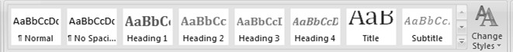
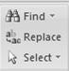

Microsoft Word

Styles & Editing

Styles: The styles options are use for changing formatting style like as:

We can change our formatting style with these options like Normal, No Spacing, Heading 1, Heading 2 etc.

Change Styles: Change the sets of styles, colors and fonts used in this document.

Editing: The editing options there are many options to edit our text matter like as Find, Replace and selecting matters with menu bars.

Find (Ctrl+F) : Find text in the document.
Replace (Ctrl+H) : Replace text in the document.
Select : Select text or Objects in the document.

 Use all the options with Practical Assignment

Microsoft Word
Practice Exercise:- 3 (For Fonts & Paragraph)

DEEPAK KUMAR BISHT
C-124/3 Street no-9,West Vinod Nagar Delhi-110092
E-Mail-deepak_bisht66@yahoo.com Mob.no-9582437447


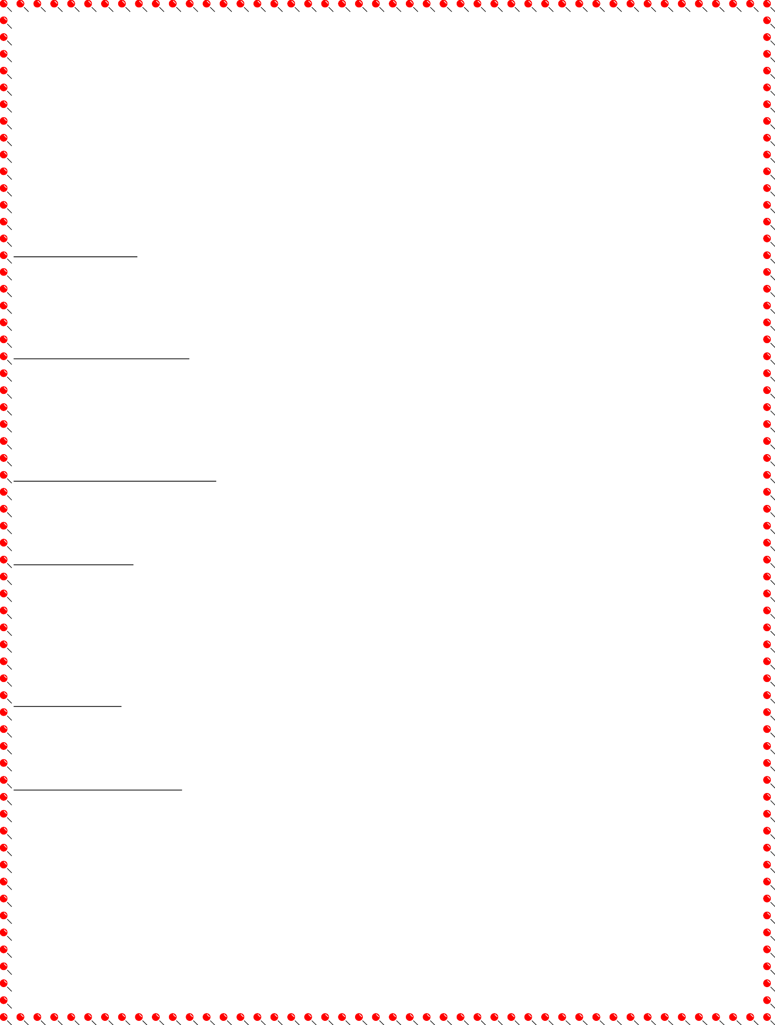
CAREER OBJECTIVE:

- To obtain a challenge and responsible position in a professionally managed organization where in, I can contribute to the successful growth of the organization utilizing my current skills and hard work.

ACADEMIC QUALIFICATION:

- Graduation from IGNOU (Bachelor of Tourism Studies).
- Pursuing Master of Tourism Management from IGNOU.
- 10+2 form CBSE.

PROFESSIONAL QUALIFICATION:

- Certificate Course Ticketing Reservation from DITTM in Chanakya Puri Delhi

COMPUTER SKILLS:

- D.T.P : Adobe Photoshop5.5& 6,Adobe PageMaker6.5&CorelDraw
- Operating Systems : Window 98 and 2000
- MS-Office : MS-Word, MS-Excel and MS-Power Point
- Internet

JOB EXPERIENCE:

  - Fresher

PERSONAL INFORMATION:

Father’s Name : Mr.Aan Singh Bisht
Date of Birth : 20th Aug, 1988
Language Known : English &Hindi
Marital Status : Single
Nationality : Indian

Place:
Date:
(Deepak Kumar Bisht)

Microsoft Word

Insert Toolbars
The Insert Toolbar is the second toolbar of MS Word this toolbar always display on after home toolbar top of the Ms Word Screen like as:

Pages

Tables
Links

Illustrations Header & Footer

Symbols
Text


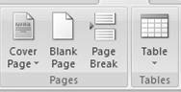
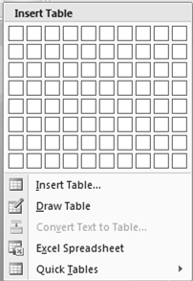
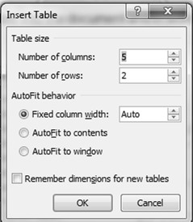

Pages & Tables
Pages: The options are use for page setting making a cover page, Blank page and page breaks like as:

Cover Page : Insert a fully formatted cover page. You fill in the title, author, date and other information.
Blank Page : Insert a new blank at the cursor position.
Page Break (Ctrl+Enter) : Insert the next page as the current position.

Tables: Insert or draw a table into the document and in word, you can also convert exciting text into a table.

 Use all the options with Practical Assignment



Microsoft Word
Practice Exercise:- 4 (For Fonts & Paragraph)
Suraj Malik .
A-83, Nehru Gali, Shiv Mandir Marg, Mandawali, New Delhi-110092 Contact No. 9999279748.
Email id :surajmalik2008@gmail.com, webdesigner.suraj@gmail.com

Curriculum-Vitae
Objective:

To obtain a position in a reputed organization that utilizes my skills and strategic thinking for career advancement and professional growth in the field of the Website Design and SEO.
Career Summary:

- Creative web designer with 1 years of work experience in designing the website as per current market trend.
- Experience in designing static pages.
- Team player with good listening skills and innovative ideas to make attractive designs.
Skills Set:
- Designing Software: Adobe Photoshop 7, CS5, CS6
- Web Designing: Adobe Dream Weaver, HTML, XHTML, CSS, FTP
- Animation Software: Adobe Flash
- Operating System: XP, Windows 2003, Windows 7
Employers:
- Working with Calipus Software Pvt. Ltd. as Web Designer Since Jan-2013 - Till Date
- Worked with Icreon Communication Pvt Ltd. as SEO Executive from July-08 – Jan-2011
Academic Qualifications:

Year | Institute | Examination | Percentage
2010 | JIWAJI UNIVERSITY. GWALIOR | B.A. | 65%
2007 | N.I.O.S. DELHI | 10+2 | 55%
2005 | N.I.O.S. DELHI | 10th | 48%



Microsoft Word

Projects:

Have worked on following projects during my tenure:-

  - www.calipus.com
  - www.greenlandjourney.com
  - www.projectionscreenhub.in
  - www.weddings9.com
  - www.bluehousephoto.com

Interests and Activities:
  - Create new themes and design of Websites with Designing Tools.

Personal Details

Hobbies : Making New Designs & Surfing Internet
Language Know : English & Hindi
Date of Birth : 13th Nov 1980
Nationality. : Indian
Marital Status : Married

Date:
Place:
Suraj Malik


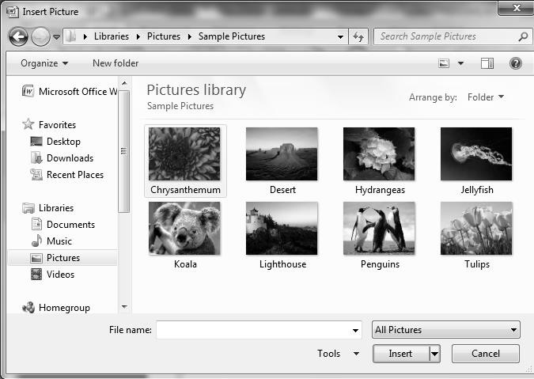
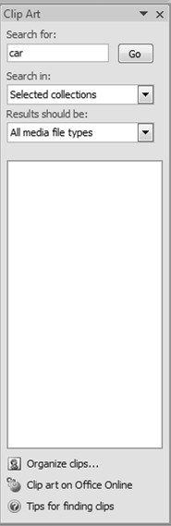
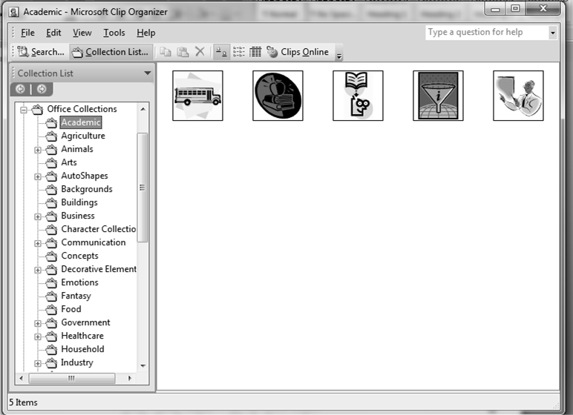

Microsoft Word

Illustrations

The option of Illustration are very much useful options in word in this we can import external picture, clip art, shapes, smart art and insert charts in word documents.

Picture: Insert Picture from file like as:

Clip Art: Insert clip art into the document, including drawing, movies, sounds, or stock photography to illustrate a specific concept like as:

 Use all the options with Practical Assignment


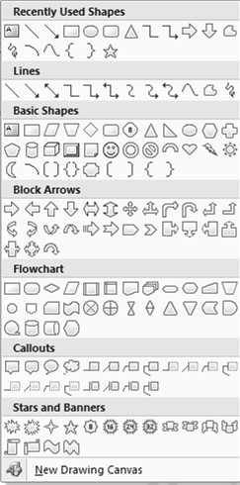
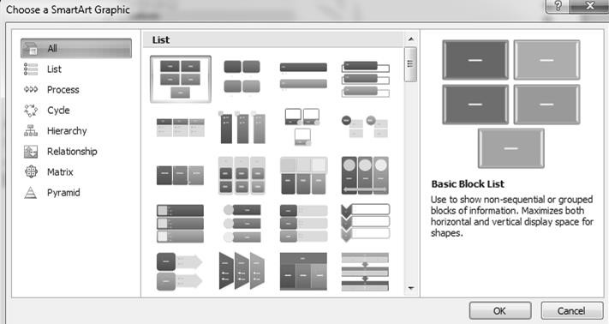

Microsoft Word

Shapes: Insert ready-made shapes, such as rectangles and circles, arrows, lines, flowchart, symbols and callouts like as:

Smart Art: Insert a smart art graphics to visually communicate information. Smart Art graphics range from graphical list and process diagram to more complex graphics such as venn diagrams and organization charts like as:

 Use all the options with Practical Assignment



Microsoft Word
Practice Exercise:- 5 (For Tables) Table 1
Sl.  No | Name | Address | City | Phone | Mobile | E-mail
1. | Anil Kumar | D-34,Dilshad Colony | Delhi | 22477388 | 9810458720 | anil@gmai.com
2. | Rahul | S-34, Raj  Nagar | Kolkatta | 54218796 | 1254789631 | rahul@yahoo.com
3. | Mohan | G-45, Indira  Colony | Mumbai | 25413698 | 8542178962 | Mohan@hotmail.com
4. | Rohan | H-345, Naini Park | Chennai | 25416378 | 9854785965 | Rohan@rediff.com
5. | Sunita | K-345, Indra  Colony | Lucknow | 25416378 | 5487485965 | sunita@gmail.com
6. | Babita | F-34, Rani  Bagh | Rampur | 78542136 | 9685471236 | babita@gmail.com
7. | Anita | H.no.345,  Ram Nagar | Jaipur | 25418936 | 9852632514 | anita@yahoo.com

Table 2

Sl. no | Details of Products | Quantity | Rate | Tax Details |  |  | Total Amount
 |  |  |  | VAT | Service Tax | CST | Tax Amount | Amount | Paissa
1 | CD | 10 | 15/- | 4%
2 | DVD | 12 | 25/- | 4%
3 | Pen Drive | 15 | 250/- | 4%
4 | HDD | 5 | 2550/- | 4%
5 | DDR  Ram | 12 | 1520/- | 4%
6 | Keyboard | 5 | 275/- | 4%
7. | Mouse | 25 | 175/- | 4%

Microsoft Word

Practice Exercise:- 6 (For Word Arts)

SOFT WAR

HARDWARE
GRAPHIC DESIGNIN G

COURSE

COMPUTER PROGRAMMING


























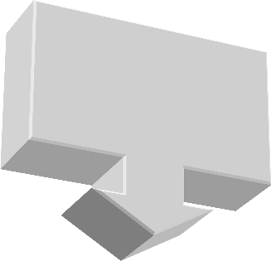


E-ACCOUNTING
WEB DESIGNIN G

ENGLISH SPEAKING


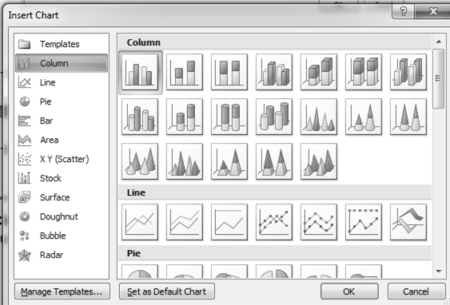
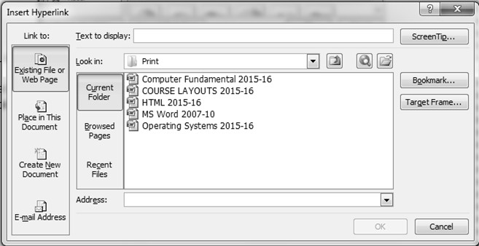

Microsoft Word
Chart: Insert a chart to illustrate and compare data by Bar, Pie, Line area and surface are some of the available types like as:

Links

The link options are very much useful for like the external files with hyperlink, Bookmarks and Cross-references.

Hyperlink (Ctrl+K): Create a link to a web page, a picture, an e-mail address or a program like as:

 Use all the options with Practical Assignment


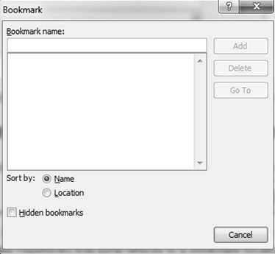
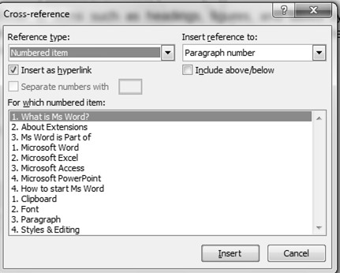

Microsoft Word

Bookmark: Create a bookmark to assign a name to a specific point in a document. You can make hyperlinks that jump directly to a bookmark location.

Cross-reference: Refer to items such as headings, figures, and tables by inserting a cross references. Cross references are automatically updated if the content is moved to another location like as:

 Use all the options with Practical Assignment


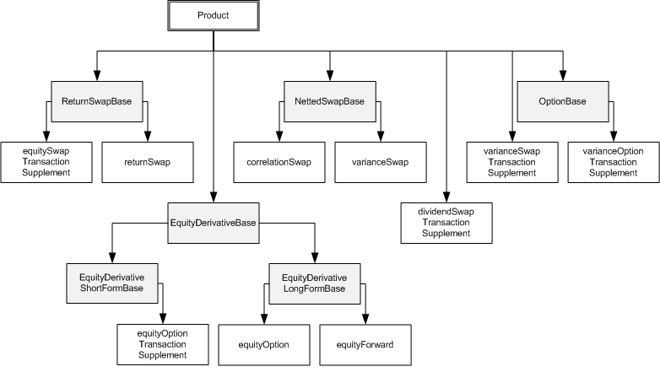

Microsoft Word
Ms. Publisher
Ms. Power Point
Practice Exercise:- 7 (For Text Box)
Ms. Access
Ms. Outlook

Ms. Word

Microsoft Office
Family

Ms. Excel


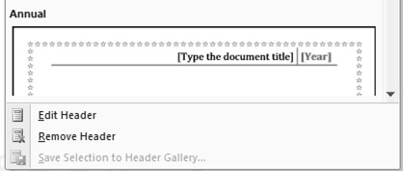
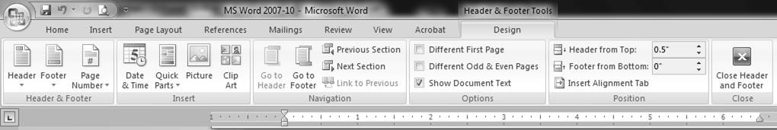
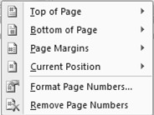


Microsoft Word

Header & Footer

The header and footer options are useful in page formatting like inset page number and author names and other titles. Edit the header & footer of the document. The content in the header appear at the top of each printed page like as:

Page Number: Insert the page numbers into the document like as:

 Use all the options with Practical Assignment


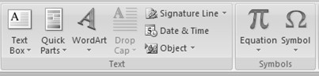

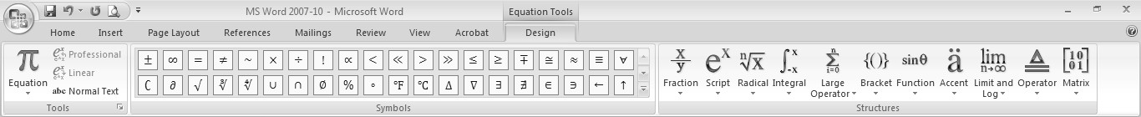
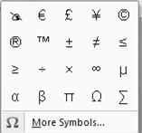

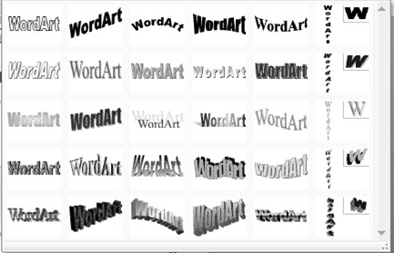

Microsoft Word

4. Text & Symbols

The text clipboards have useful options to work in ms word such as Text box, Word Art and Drop Cap etc.

Text Box : Insert preformatted text box.
Quick Part : Insert reusable pieces of content.
Word Art : Insert decorative text in your document.
Drop Cap : Create a large capital letter at the beginning of a paragraph.
Equation : Insert common mathematical equation or build up your own equations using a library of math symbols.
Symbol : Insert symbol that are not in your keyboard, such as copyright symbols , trademark symbols, paragraph marks, and Unicode characters.

 Use all the options with Practical Assignment


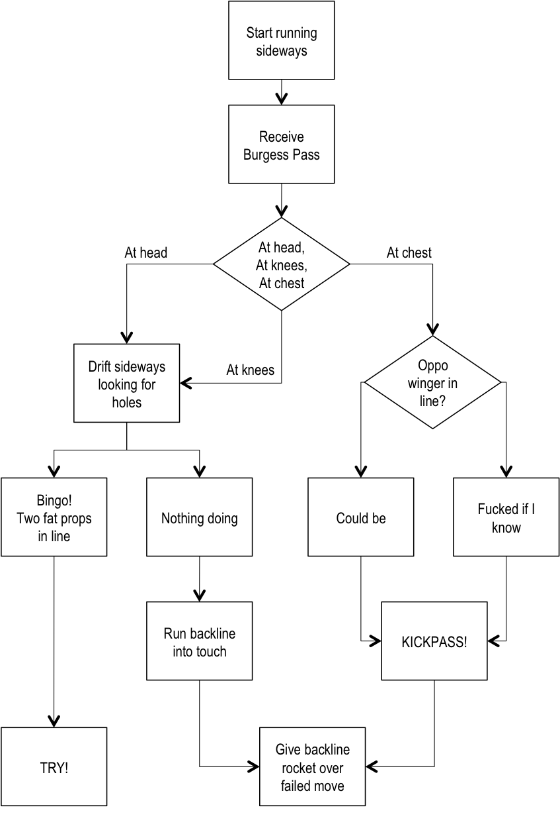

Microsoft Word
Practice Exercise:- 8 (For Text Box)

Microsoft Word

Format Toolbars
The Format Toolbar is the diagram editing toolbars in Ms Word this toolbar always display when we edit any diagram on the top of the Ms Word Screen in last of the toolbar after end of diagram editing this bar aromatically hide like as:

Shadow Effects
Text Text Box Style & 3-D Effects
Arrange & Size


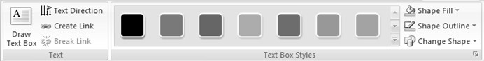
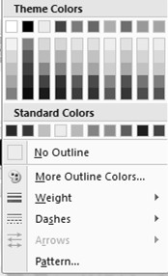
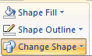
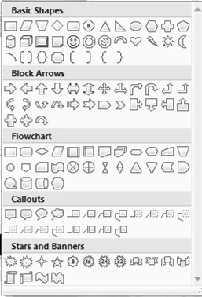
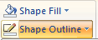
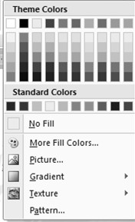

Text Box & Styles

The format toolbars are very much useful bar in ms word there are many type of effects in this toolbar like as:

Draw Text Box : Insert a text box into the documents.
Text Direction : Change the text direction within the selected cells.
Shape Fill : Fill the selected shape with a solid color, gradient, picture.
Shape Outline : Specify the color, width and line style for the outline of selected shape.
Change Shape : Changing the shape of the drawing.

 Use all the options with Practical Assignment



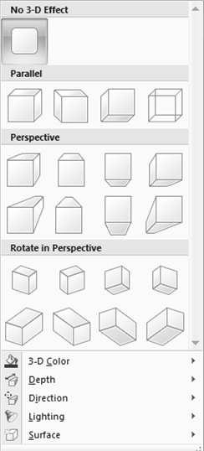
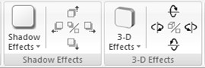
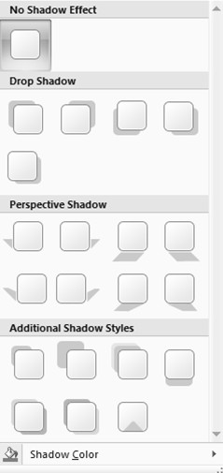
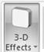
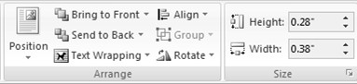

Microsoft Word

Shadow Effect & 3-D

These options are much valuable in format toolbar we can make or diagram with shadow effect and 3-D effect also like as:

Shadow Effects : Add a shadow to the shape.
3-D Effects : Add a 3-D effect to shape.

Arrange & Size Management

The arrange & Size management options are much useful in this toolbar we can arrange our diagram by these options like as:

 Use all the options with Practical Assignment


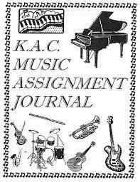

Microsoft Word
Practice Exercise:- 9 (For Clipart & Insert Pictures)

Microsoft Word

Page Layout Toolbars
The Page Layout Toolbar is the third toolbar of MS Word this toolbar are meanly for page alignment, always display on the top of the MS Word Screen like as:

Themes

Page Setup

Page Setup

Page Background Paragraph
Arrange


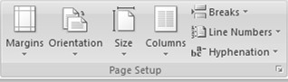
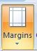
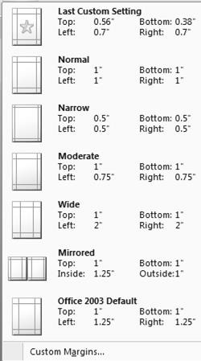
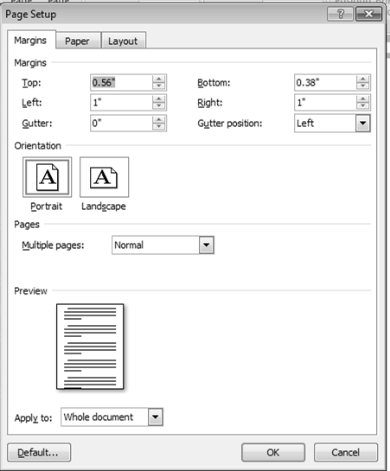

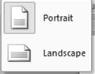

The page setup clipboards are useful for page alignment like margins, orientation, size and columns with breaks and many more.
Margins : Select the margin sizes for the entire document or the current section.
Orientation : Switch the pages between portrait and landscape layouts.
Size : Choose a paper size for a current section.
Columns : Split text two or more columns.

 Use all the options with Practical Assignment


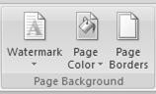

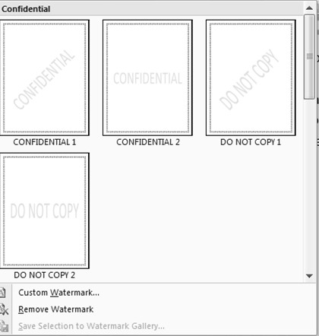
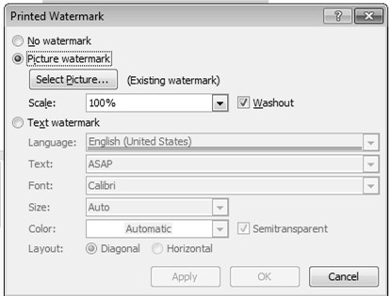
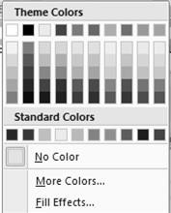

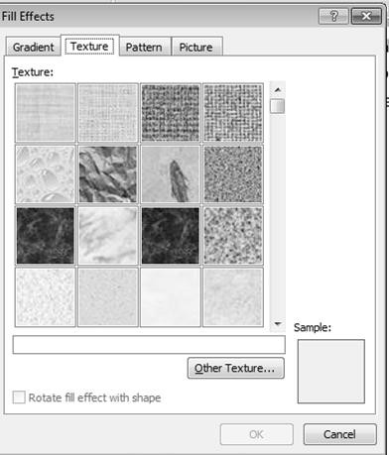
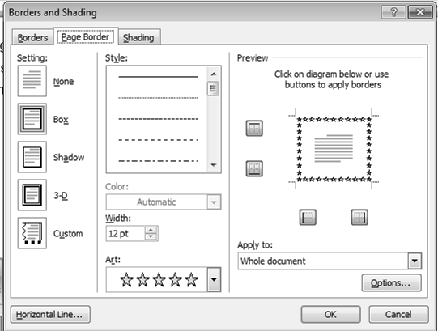

Microsoft Word

Page Backgrounds

This is very useful clipboard in this toolbar we can change page background, watermark, page color and page borders also.

Watermark : Insert ghosted text behind the content on the page.
Page Color : Choose a color for the background on the page.
Page Boarder : Add or change the boarder around the page.

 Use all the options with Practical Assignment

Microsoft Word

Dear Sir/Madam

Practice Exercise:- 10 (For Page Layouts)

Employee Training and Development is essential to the ongoing success of every organization. Although technology and the internet have enabled global collaboration and competition, people are the organization’s competitive
advantage. Employee training and development enables employees to develop skills and competencies necessary to enhance bottom-line results for their organization.

We work with your leadership team to identify training needs, and to design,
develop, implement, and for marketing, sales, and technical teams in Fortune
500 companies both domestically and
internationally. Our experience and insight can
shorten your development cycle and free you to focus
on other areas.

Employee Training and Development is a key ingredient in performance improvement. However, the first step in designing an employee training and development program is to identify the training needs. The training needs are based on what is needed to achieve the organization’s strategic objectives. Key steps for performance improvement include
- Assess and define performance improvement issues and gaps

- Gain management commitment for performance improvement

- Develop a business plan to manage performance improvement

- Establish best practices for work processes and performance standards
- Provide employee training and development to develop required skills

- Establish new practices that support improved performance

- Measure and monitor results and provide coaching where needed

What are your organization’s critical skills? Essential skills for many organizations include effective time management,
effective communication, collaboration, project
management, customer service, teamwork, and
specialized technology skills to use SAP, Siebel, PeopleSoft, and other
Thanking You Your Truly










Amit Mohan
www.dotnetinstitute.co.in 31
Call us: 011-40040815


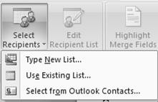
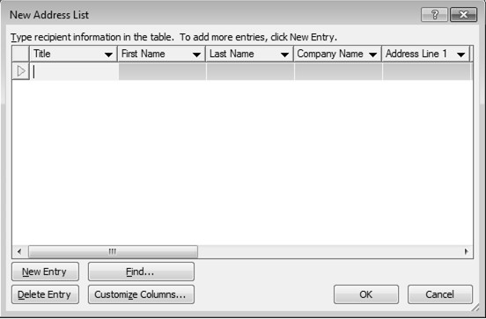
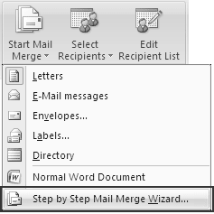

Microsoft Word

Mailings Toolbars
You use mail merge when you want to create a set of documents, such as a form letter that is sent too many customers or a sheet of address labels. Each letter or label has the same kind of information, yet the content is unique. For example, in letters to your customers, each letter can be personalized to address each customer by name. The unique information in each letter or label comes from entries in a data source.

Create Start Mail Merge Write & Insert Fields Preview Results

Create Letter

For Mail merge we should type letter and complete the formatting of letter then go to mail merge. (See the assignment of mail merge letter).

Start Mail Merge

Start a mail merge to create a form letter which you intend to print and e-mail multiple times sending each copy to a different recipient like as:

 Use all the options with Practical Assignment



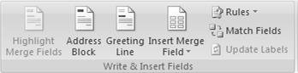
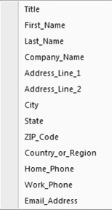
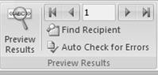
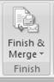

Microsoft Word

Write & Insert Fields

You can add any column heading from your data file to the main document as a field. This gives you flexibility when you design form letters, labels, e-mail messages, and other merged documents. For example:

Preview Results & Finish

You can preview your merged documents and make changes before you actually complete the merge.
To preview, do any of the following in the Preview Results group of the Mailings tab:

Click Preview Results.

Complete the merge
You can print the merged documents or modify them individually. You can print or change all or just a subset of the documents.

- On the Mailings tab, in the Finish group, click Finish & Merge, and then click Print Documents.

- Choose whether to print the whole set of documents, only the copy that's currently visible, or a subset of the set, which you specify by record number.

Microsoft Word

To

Practice Exercise:- 11 (For Mail Merging Letter)

Mr. Amit Kumar
M/s. Apex International Ltd. New Delhi

Sub: “Out sourcing Business offer”

Dated: 24th Sep 2015



Dear Sir/Madam

Employee Training and Development is essential to the ongoing success of every organization. Although technology and the internet have enabled global collaboration and competition, people are the organization’s competitive advantage. Employee training and development enables employees to develop skills and competencies necessary to enhance bottom-line results for their organization.
We work with your leadership team to identify training needs, and to design, develop, implement, and evaluate employee training and development programs to meet your company’s strategic objectives. We have experience in developing end-to-end employee training and development programs for marketing, sales, and technical teams in Fortune 500 companies both domestically and internationally. Our experience and insight can shorten your development cycle and free you to focus on other areas.
Employee Training and Development is a key ingredient in performance improvement. However, the first step in designing an employee training and development program is to identify the training needs. The training needs are based on what is needed to achieve the organization’s strategic objectives. Key steps for performance improvement include
  - Assess and define performance improvement issues and gaps

  - Gain management commitment for performance improvement

  - Develop a business plan to manage performance improvement

  - Establish best practices for work processes and performance standards

  - Provide employee training and development to develop required skills

  - Establish new practices that support improved performance

  - Measure and monitor results and provide coaching where needed

What are your organization’s critical skills? Essential skills for many organizations include effective time management, effective communication, collaboration, project management, customer service, teamwork, and specialized technology skills to use SAP, Siebel, PeopleSoft, and other enterprise applications. Lost productivity due to training gaps is expensive. A targeted training and development program focused on strategic skills can significantly enhance profits quickly.
Thanking You Your Truly

Rahul Sharma



Microsoft Word

List of Shortcut Keys for Microsoft Word

Action | Keybord shortcut
Application window-maximize | Alt-F10
Application window-previous | Alt-Shift-F6
Application window-restore | Alt-F5
Bold | Ctrl-B
Break-column | Ctrl-Shift-Enter
Break-page | Ctrl-Enter
Case-All Caps | Ctrl-Shift-A
Close | Ctrl-F4
Close | Ctrl-W
Copy | Ctrl + C
Copy formatting | Ctrl-Shift-C
Cut | Ctrl-X
Decrease font size | CTRL+SHIFT+<
Dialog box next tabbed section | Ctrl-Tab
Exit application | Alt-F4
Fields-display code | Shift-F9
Find | Find Ctrl + F
Font | Ctrl-D
Font | Ctrl-Shift-F
Font grow/shrink 1 pt | Ctrl- ] or [
Create a new blank document | Ctrl + N
Go Back | Ctrl-Alt-Z
Go Back | Shift-F5
GoTo | Ctrl-G
GoTo Next/Previous Paragraph | Ctrl-Up/Down
GoTo Next/Previous Word | Ctrl-Left/Right
Header/Footer-link to previous | Alt-Shift-R
Heading Level 1 | Ctrl-Alt-1
Help | F1
Hyperlink | Ctrl-K
CTRL+SHIFT+> | Increase font size
Indent-decrease | Ctrl-Shift-M
Indent-increase | Ctrl-M
Italics | Ctrl-I
Justify-Center | Ctrl-E
Justify-Full | Ctrl-J



Microsoft Word

 | Justify-Left | Ctrl-L
 | Justify-Right | Ctrl-R
 | Line-spacing | Ctrl-1
 | Line-spacing 1.5 | Ctrl-5
 | Line-spacing 2 | Ctrl-2
 | List Bullet Style | Ctrl-Shift-L
 | Maximize window | Ctrl-F10
 | Menu Bar | F10
 | Next window | Ctrl-F6
 | Normal Style Ctrl-Shift-N | Ctrl-Shift-N
 | Open a document | Ctrl-O
 | Open | Ctrl + O Opens a saved document
 | Outlining-Show Heading 1 | Alt-Shift-1
 | Page number field | Alt-Shift-P
 | Pane-Close | Alt-Shift-C
 | Paste | Ctrl-V
 | Print | Ctrl-P
 | Print Preview | Ctrl-Alt-I
 | Replace | Ctrl-H
 | Save As | F12
 | Save | Ctrl-S
 | Select All | Ctrl-A
 | Shortcut Menu | Shift-F10
 | Small Caps | Ctrl-Shift-K
 | Subscript | Ctrl =
 | Symbol Font | Ctrl-Shift-Q
 | Table-remove border lines | Ctrl-Alt-U
 | Table-to column | bottom Alt-PgDn
 | Table-to column top | Alt-PgUp
 | Table-to row beginning | Alt-Home
 | Table-to row end | Alt-End
 | Time Field | Alt-Shift-T
 | To bottom/top of screen | Ctrl-Alt-PgDn/PgUp
 | Underline | CTRL+U
 | Underline-double | Ctrl-Shift-D
 | Underline-word | Ctrl-Shift-W
 | Undo | Ctrl-Z
 | View-Normal | Ctrl-Alt-N
 | View-Outline | Ctrl-Alt-O
 | View-Page | Ctrl-Alt-P



Microsoft Word

DOT-NET GUIDE LINE FOR STUDENTS

DOT-NET always tries to give better education for our student, not only in the field of computer but we also develop our students how to fight competition in the professional life. We also provide them jobs after complete the course.

TEACHING METHODOLOGY: - DOT-NET provides 7 Hrs. Class within 6 days in a week like as:

- 5 Day Practical (1 Hrs. a day)
- 1 Day Theory (2 Hrs.)
  - 30 Min. Subjective of Computers
  - 30 Min. Quarry Sessions
  - 30 Min. Personality Development
  - 30 Min. Presentations

STUDY MATERIAL: - DOT-NET provides study material as NOTES with every module as per DOT-NET Course Layouts. The every student has to buy this with start of new modules. This notes books will necessary to buy every student.

MONTHLY TEST: - DOT-NET management are very serious about our student’s performance so we take monthly test like as:

- Practical Test : 40 Marks
- Theory Test : 40 Marks
- Oral Test : 20 Marks
- After complete of course we will provide Mark sheet with your Certificate.
- Students will have to attend at least 5 monthly tests compulsory if the course is for 6th months or 11 monthly tests compulsory if the course is 1 year.

ANNUAL AWARDS FUNCTION: - DOT-NET provides our students “Best Students of the Year Award” in Annual Function of the Centre.

Annual Awards Prize

- Best Student of The Year Award
- Rs. 500/- Cash
- Certificate and DOT-NET Momentous

DOT-NET will place the photographs Annual winners in DOT-NET website (www.dotnetinstitute.co.in)

PLACEMENT: - DOT-NET provides the 100% job placement to our students but students have ability to fight the interview, if students are not able to face interview then we will make a batch for such students and give them 10 days job interview training, then place them to companies.

ANNUAL TOUR: - DOT-NET arranges annual tour outside of Delhi every year for our students.

FEE DEPOSIT: - DOT-NET collects the fee on time so every student has to pay monthly fee on your due date. After three days of due date the Late Charge Rs.50.00 per day till next 7 days after 7 days we will stop his/her class.




Microsoft Word

