PyOTE Models

There is a saying that is useful to keep in mind when discussing the fitting of theoretical models to observation data: All models are wrong, but some are useful.
In occultation timing extraction (OTE), one matches a parameterized model light curve to an observation by varying the parameters of the model and using some metric to indicate whether a given parameter change improved the fit or made it worse. The minimum set of parameters of a useful model for OTE are event duration (chord length), event start time, baseline intensity, and magDrop (the light decrease during the event). For more complex models, there may be additional parameters such as star disk diameter, limb angle, miss distance, wavelength, etc.
The most commonly used model for OTE is often referred to as a square-wave model. It is based on geometrical optics where diffraction effects are deliberately ignored. Of course, diffraction effects are always present, so this model is therefore always ‘wrong’ in the sense that it does not incorporate known and applicable physics, but it is frequently ‘good enough’, is easy to calculate and fit, and so is the most often used OTE model. The conditions for ‘good enough’ are when diffraction effects are small, and the star disk is also small - a frequently encountered set of conditions.
But sometimes diffraction effects are prominent and obvious, or the star disk may be large, perhaps even larger than the occulting asteroid. In these cases, the square-wave model may no longer be ‘good enough' and a different model light curve will need to be used.
Definitions:
- The start of a chord is defined as where the center of the star disk intersects the asteroid.
- A ‘miss’ is defined as the situation where the star disk center does not intersect the asteroid (so there is no chord as defined above) yet the star disk is partially occulted by the asteroid or, in the case of diffraction, light is diffracted around the asteroid that can be detected outside the normal geometric shadow of the asteroid.
- Rho = asteroid_radius / fresnel_length (i.e., the radius of the asteroid expressed in Fresnel units)
The Other models tab of PyOTE adds three additional model light curves that can be utilized for OTE when the square-wave model might be inadequate:
- Edge-on-disk model: to be used for the case where there is an appreciable star disk that is of a size where the edge of the asteroid being ‘sampled’ by the star disk can be treated as a straight edge. The name comes from the edge of the asteroid occulting the disk of the star. Geometrical optics are used in creating this model. A ‘miss’ can be modelled.
- Disk-on-disk model: to be used for the case where the star disk and the asteroid disk are comparable enough that it is no longer reasonable to consider the asteroid as presenting straight edges to the star disk during the occultation but instead should be treated as having the outline of a disk. The name comes from the idea of an asteroid disk occulting a star disk. Geometrical optics are used in creating this model. A ‘miss’ can be modelled.
- Diffraction model: to be used where diffraction effects are prominent or dominant. Physical optics are used to model the diffraction effects with the asteroid treated as a circular disk. Fourier transform methods are used for calculating the diffraction pattern when the asteroid rho (rho = asteroid_radius / fresnel_length) is less than 16, in which case the central spot will be computed. For asteroid rho values greater than 16, the standard analytical expression for diffraction around a straight edge is used and there will be no central spot in the model light curve. For large rho values (> 16), the central spot is very small in size and would require an observation to be exactly on the centerline for the central spot to affect the observed light curve. A ‘miss’ can be modelled.
Example light curves
Example .csv observation files are available for training/experimentation purposes in <you>\Desktop\model-examples. They were written there when this version of PyOTE was first run. When PyOTE starts up, this directory will be created if it is not already present and filled with any .csv files from the PyOTE distribution that are not already in the folder.
Note: there are three light curves in each .csv example files: the example with noise; a noise-free version of the example; and a no-star (i.e., background) curve that is often convenient in establishing a zero level in the plot window.
A good procedure to follow to gain familiarization with the new models is:
- Click on the Read light curve button and navigate to <you>\Documents\model-examples and double click on one of csv files.
- Enter a name of your choosing for the ‘event’. This will be used when saving the event data that you are about to enter to a special file that will be placed in the folder that contains the .csv file. Press the tab key to finish the entry. This action changes the keyboard entry focus to the Asteroid diameter Km edit box, ready for your entry.
- Scroll the log file panel (lower right) to find the comments that were placed in the header of the csv file. There you will find the parameters that were used to create the example light curve. Enter the asteroid diameter data and press tab.
- Repeat the above procedure until all of the edit boxes between the three black bars have a value in them. At this point, other widgets will become active. Click the Model to use: radio button for the model used in generating the example file.
- In the plot panel, select a point near the center and then click the Demo model lightcurve button.
- When satisfied that the data entry is correct, be sure to save the event data for later use.
- Familiarize yourself with what the various edit boxes and buttons do/control by right-clicking on the boxes or associated labels.
Diffraction model
This example is being presented first because it shows in a dramatic fashion an observation light curve that requires a full diffraction computation to explain. In this particular case, the observer was unlucky to have recorded the occultation from a point outside the geometric shadow of the asteroid. But the observer was close enough to the outer edge of the asteroid shadow that an unusual light curve was recorded anyway. From the example file: diffraction_miss_shotnoise_1.0_readnoise_20.0.csv ---
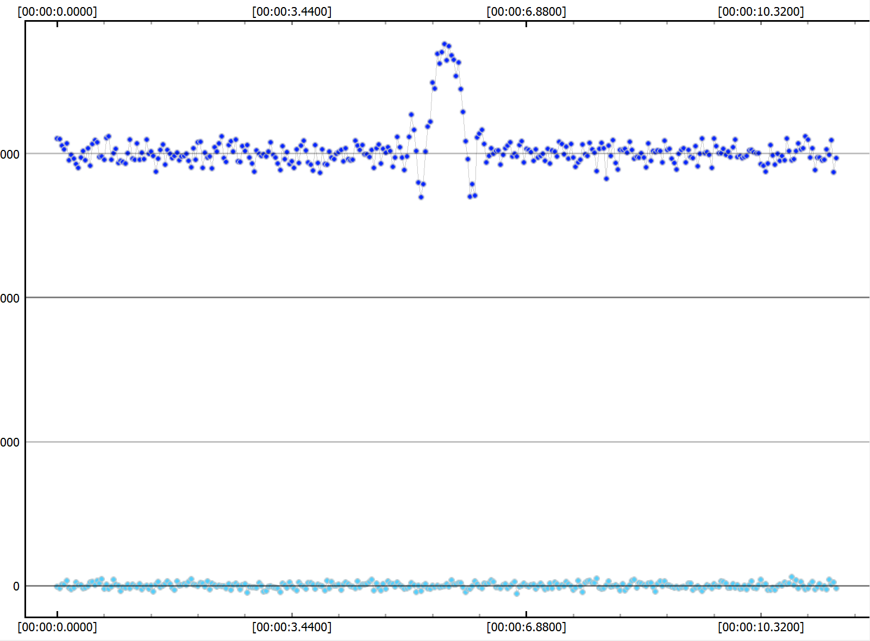
PyOTE can produce a graphic for low rho diffraction events that shows what the light pattern projected on the ground looks like (a single wavelength of light is used in the computation – the effect of the finite bandpass of the sensor is not included here, but that effect is included in the generated model light curve). That graphic for this event is shown on the next page.
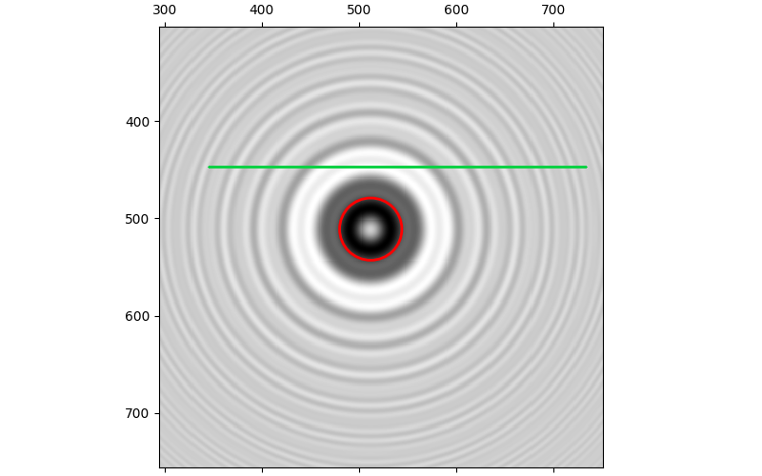
The green line shows the part of the light pattern that passed over the observer. The ‘central spot’ is also very apparent in this display. This is a ‘miss’ but still provides evidence of an event because there is an easily detectable disturbance of the light curve. The ‘miss’ distance can be valuable in conjunction with a chord measured by a luckier observer in estimating limits on the size and position of the asteroid. The ‘whiteness’ of the pixels in the graphic corresponds to brightness and shows why the observer recorded an increase in light during the event.
Below is the model light curve generated by PyOTE for this event. This model can be fitted to the observation data to extract the miss distance.
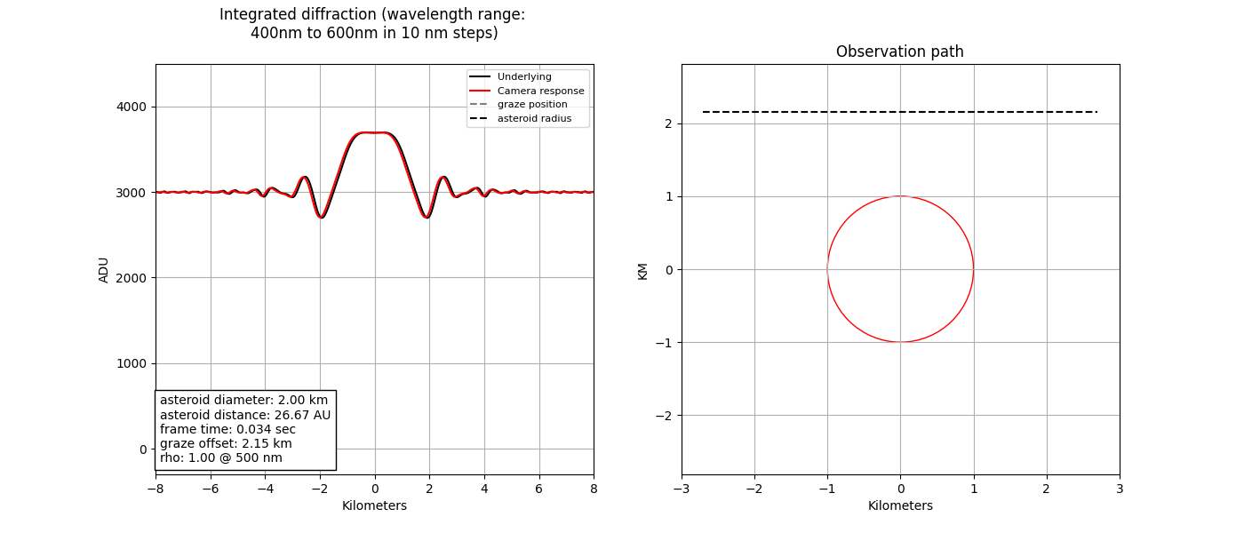
The luckier observer of this event might have been on the centerline of the occultation path and would have had to use the model light curve shown below to extract the chord position and duration from his recording:
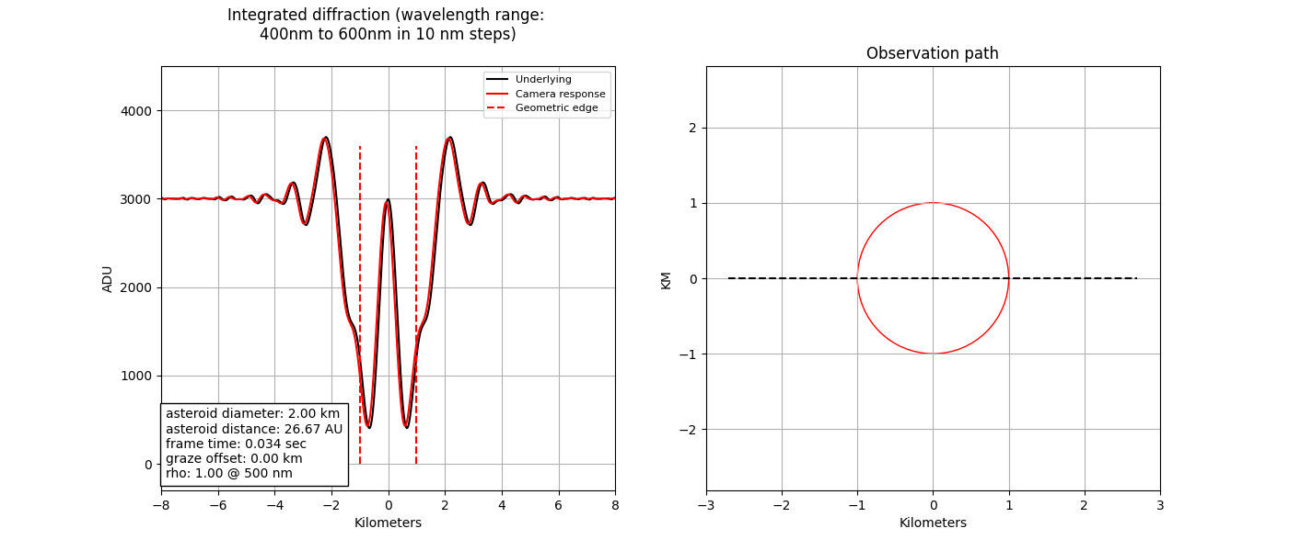
A square wave model could not be used to extract a ‘miss’ distance – it has no such parameter. If, for convenience, a square wave model was applied to the centerline observation, the result would be an over-estimation of the chord duration (asteroid size) by about 50% and a shift of the start of the event (D edge) to earlier in time.
The example file for this event is diffraction_with_central_spot_shotnoise_1.0_readnoise_20.0.csv
Note: this model cannot be used for lunar occultations where modelling of diffraction effects is needed. For this application, Pyote 4.9.2 can be used (just put in the moon diameter where the asteroid diameter is asked for); Limovie is another good alternative.

.

Disk on disk model
One of the more interesting edge cases that PyOTE’s disk on disk model can handle is an annular occultation, which can happen when the star disk is larger than the asteroid disk. Of course, this would be rare, but occultations involving giants like Betelgeuse may present such a possibility. The example file disk_on_disk_annular_shotnoise_1.0_readnoise_20.0.csv demonstrates this case. The observation light curve (the one with noise) looks like this:
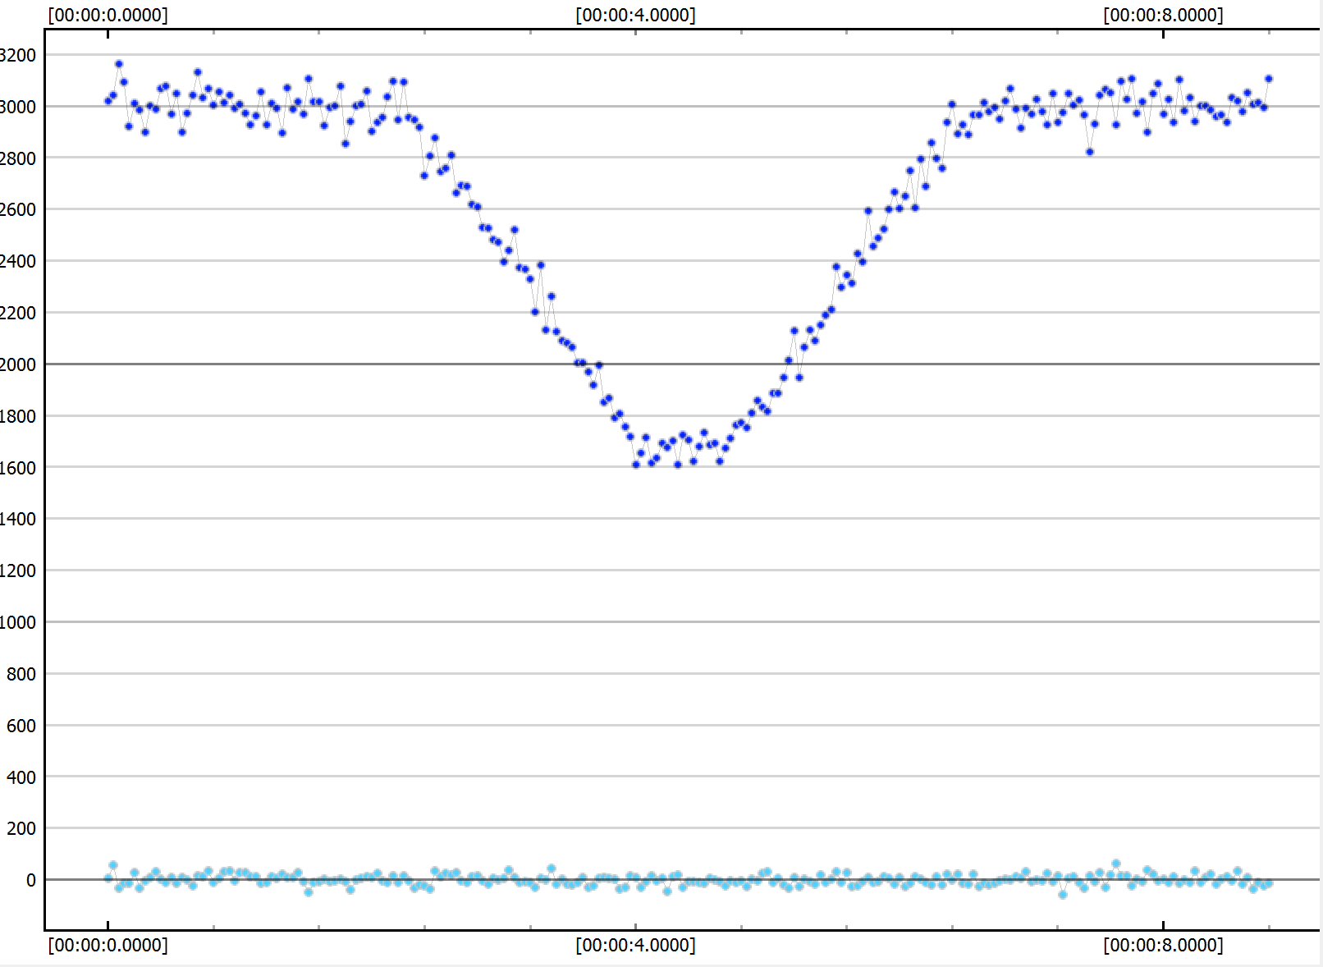
The model to fit this is observation is shown on the next page.

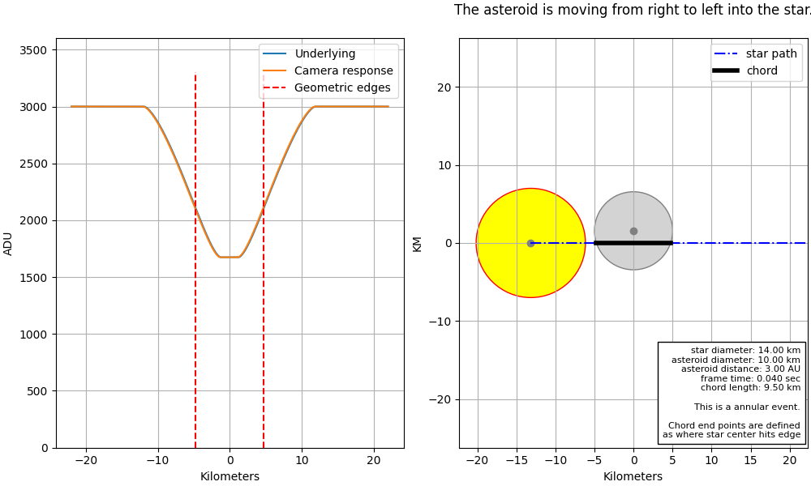

Edge on disk model
When the star disk is significant (1 to 20 km projected at the asteroid position), but the asteroid disk is much larger than that of the star, one may choose to model the intersection of the star with the asteroid edge as though the asteroid edge were a featureless straight line. For this model, the parameter called ‘limb angle’ is introduced to describe the slope of the asteroid edge at the intersection points. The convention used in PyOTE is that a limb angle is the angle between the star path and a tangent line drawn through the point of intersection on the asteroid. With this convention, a ‘direct hit’ would be specified by setting the limb angle to 90 degrees.
The light curves that occur during D and R transitions are often referred to as penumbral curves, so the example csv file that demonstrates this is (with a D limb angle of 55 degrees and an R limb angle of 35 degrees) is:
edge_on_disk_standard_penumbral_D55_R35_shotnoise_2.0_readnoise_20.0.csv
The model to fit this observation is:
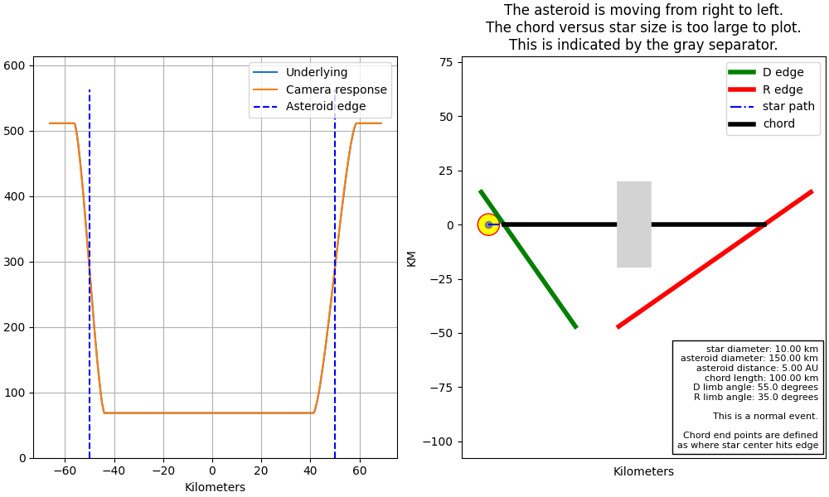

Where to find event parameters for your observation
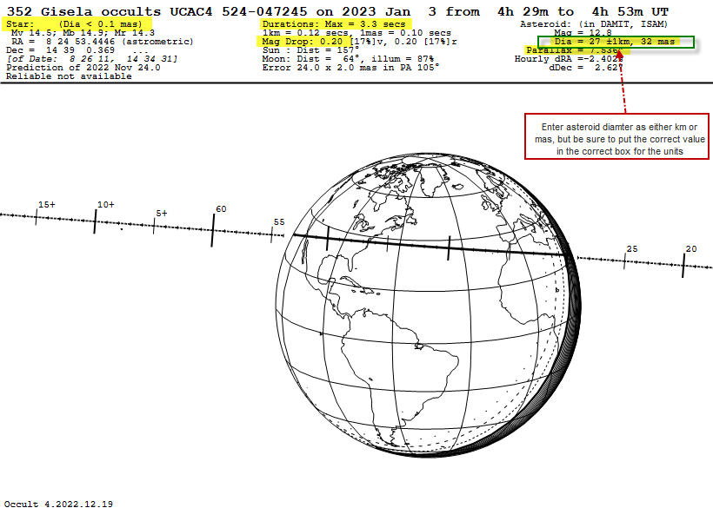
All of the information needed to fill in the core event parameters utilized by these new models can be found on the Occult 4 path map for the event or the OccultWatcher cloud website. Here is an example from Occult 4 (many thanks to Tony George for adding this documentation)…

