[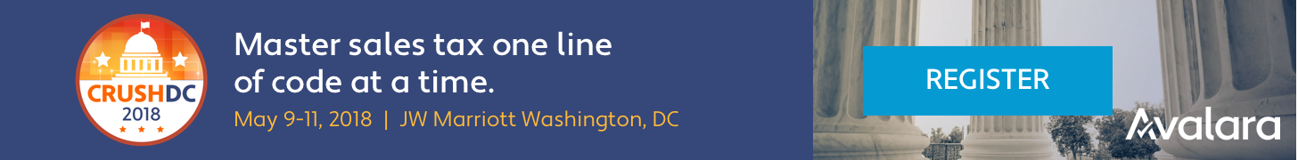](http://www.avalaracrush.com/?CampaignID=7010b000001Dq5K)

**Business Case: Attend Avalara CRUSH Conference - Sales Tax Developer Track, Washington, DC May 9-11, 2018.**

The business case for [your name] attending the Avalara CRUSH Conference as a developer at [your organization] is provided below.

The total expenses are estimated as [expense total], so a budget allocation of [expense total + $XXX] is requested. In addition to these direct expenses [your name] will be absent from the office for [days absent] days. Regular duties will be covered by [your delegate] while they are unavailable, although they will remain in contact via email and will be on-call in the event of any critical incidents requiring their attention.

**Overview**

Avalara is the vendor that we’re [using/considering] to automate tax calculation. Benefits expected from attending the Sales Tax Developer track at this conference are:

* Accelerated development of our transactional tax project
* Improved subject matter knowledge on sales tax [your industry]
* A robust developer-focused track covering everything from the basics of calculating tax using AvaTax to building connectors for enterprise-level organizations
* Tech demos and learning labs
* Knowledge sharing from our expert team of Avatax developers and engineers
* Networking opportunities with Avalara’s team of expert engineers

The primary benefit is direct, in-person access to Avalara’s developer relations team and tax experts. This will speed-up delivery of tax automation in [your ecommerce platform / ERP]. Our finance team may also benefit from sending a representative to this conference.

Attendance is limited and filling quickly. There is a discount code available to a limited number of developer attendees, which is still available. Please consider this business case for attending Avalara CRUSH as soon as is practical.

**Expenses**

Travel: [$xxx]

This will cover taxi, train and flight expenses as required for travel to and from the conference. It will also cover any daily travel needs while in Washington, DC.

Accommodation: [$xxx]

This will cover the accommodation fees for staying [x] night(s) in Washington, DC.

Food & Misc expenses: [$xxx]

This will cover the miscellaneous expenses related to food and incidentals for [x] days of travel and attendance at IODC16 combined.

Total expenses: [$x,xxx]

**Key Sessions**

The specific agenda for developers at Avalara CRUSH is available here: <https://developer.avalara.com/blog/2017/12/06/CRUSH-DC-2018/>

Additional general information on the conference, and the registration form for others that might want to attend are available here: <http://www.avalaracrush.com/?CampaignID=7010b000001Dq5K>