Donor Tracking Plugin for Koha
© 2015 Robert Ewart
(bob-ewart at bobsown dot com)
Copyright © 2015 Robert Ewart

This application is a plugin for Koha and follows the same conditions as Koha.

Koha is free software; you can redistribute it and/or modify it under the terms of the GNU General Public License as published by the Free Software Foundation; either version 2 of the License, or (at your option) any later version.

Koha is distributed in the hope that it will be useful, but WITHOUT ANY WARRANTY; without even the implied warranty of MERCHANTABILITY or FITNESS FOR A PARTICULAR PURPOSE. See the GNU General Public License for more details.

You should have received a copy of the GNU General Public License along with Koha; if not, write to the Free Software Foundation, Inc., 51 Franklin Street, Fifth Floor, Boston, MA 02110-1301 USA.

Introduction
Many libraries are supported by local governments. Others, such as ours, are supported by donations and grants. We needed a way to track those donations and the donors in order to make our fund raising more effective. Knowing what a donor has given to (Building Fund, Museum Fund, Archives...) and how much was given in the past is a big help in asking for future donations.
The development team needs a way to track donor interests and donation history. This plugin gives them a way to do that in order to plan targeted giving requests. Because we wanted this to be able to show the names and addresses of all income, we had to add business and fund patron categories to Koha. Businesses pay to sponsor events and donate items for them. Funds, such as an employee gift matching program, also need to be tracked. We can show what income came from a patron and what came from a fund for that patron.
This plugin saves income exported from almost any accounting program and keeps notes on each donor. The development team can review a donor's history before meeting with them and make a more effective request. Notes on the meeting can be recorded to help in future meetings.
There is a flexible report generation feature which is used for 'data mining'; e.g. who gave between $500 and $1000 to the building fund last year.
We use special patron categories for businesses and funds. Funds such as an employee gift matching program are a special case. You can look at a fund's giving which shows for whom it was given. The patron's records will show direct donations and donations given by a fund.
We use patron attributes to: link families together, show who gets mail, show whose name can be published and other select codes. The select codes are used to show volunteers, members of the board, in-kind donors and so on. You can run a report for example showing how much members of the board gave to the building fund.

General processing flow

Transfering income
Enter income as usual in your accounting program. Create new customer accounts as needed, but leave the account number blank. Make any changes to the customer's address or phone number. The best practice is to export all the income starting with the beginning of the year. Import the income transfer file into the donor plugin. It will delete all the data with dates matching the date range of the transfer file.
Customer addresses are checked and updated as needed. The program will search by name and address for donations with a blank account number. If a good match is found, it will be assigned to that patron. Otherwise, it will create a new patron and fill in the address etc. The upload routine will display all the new patrons, matched patrons and changed addresses. Update the customer account number for all the new patrons or matched patrons.
Create a new patron for incorrectly matched donations and update that customer account number. The next transfer run will correct the donation history.
The data flow is from the accounting program to the donor plugin. There is no way, at the moment, to transfer data from Koha to the accounting package. That's why it is important to keep the accounting customer addresses up to date and let the donor plugin update Koha.
If you need to make changes to old income transactions, make sure that the starting date for the transfer file is prior to then.
The data should be transferred at least once a month as the month is closed. It can be run more often whenever the development team needs it. The transfer file can get very large toward the end of the year. In that case, consider moving up the start date. At the end of the year once the audit has been signed off, you may need to re-transfer all that year's income.

Retrieving patron information
You can retrieve a patron's donations by entering their name or Koha card number. When you enter the name, you may get multiple hits. They will be displayed and give you the chance to select the one you want.
A pull down list of all the current reports will let you run that report. Depending on your permissions, you may be able to create new ones. You will be able to link directly to the donor plugin patron information page from a report.

Accounting program
The main requirements for an accounting program are:
- Each donor must have a separate account with name, address, city, state, zipcode and account number fields. The account number may be left blank until that patron is created in Koha. If the account number is required, you will have to create the patron in Koha before transfering any income.
- The accounting program must be able to export income data. The preferred export format is an Excel (.xlsx or .xls) spreadsheet. Open document format spreadsheets (.ods) will also work.
When donations are made by a fund such as an employee matching gift program, You should create a sub-account giving the name as 'customer name:fund name' with the same account number as the customer. The fund should be added as a patron in Koha with a special category code. The category code defaults to 'FUND', which may be changed on the System->Miscellaneous constants page. That category code should be restricted to such funds. Income from a fund which is not assigned to a particular patron should be entered with the fund's card number. It may be entered as sub-account with the name as 'Unknown Donor:fund name'. Patron's donations will indicate what was given by a fund.
You should have an "Unknown Donor" customer and patron for anonymous income.
We have successfully used Peachtree and QuickBooks.

Useful patron attributes
We make use of a number of patron attributes:
- MAIL – It has the value of True|False and is optional. It will be displayed on reports as 'OK', 'Not OK' or 'N/S'. When multiple members of the same family are patrons, this may be used to suppress general mailings to all but one of them.
- PUBLISH--It has the value of True|False and is optional. Like MAIL, it will be displayed on reports as 'OK', 'Not OK' or 'N/S'. Some donors don't want their names displayed on lists recognizing major donors.
- FAMILY--It contains one Koha card number of another member of the family. A patron may have multiple Family tags. It is not checked to be a valid Koha card number, but this plugin will complain if it isn't.
- SELECT--It contains codes which may be useful in searching for reports. It may occur multiple times as needed. The descriptions of its authorized values, SCODE, will appear in a report generation selection pull-down. Examples are:
  - VOL--Volunteer
  - BOD--Board of Directors
  - xBOD--ex Board of Directors
  - Prospect--Possible donor
  - IKD--In-Kind-Donor
The actual names of these attributes (MAIL, PUBLISH, FAMILY, SELECT, SCODE) can be changed. The authorized values for SCODE are set in Koha.
The names of any of these attributes may be left blank and won't appear in report creation or results.

Usage
The main page looks like this:

Some sections of this page may not be present depending on the user's donor plugin permissions.

Uploading accounting transfer spreadsheets
The top section is used to upload income data. Usually only the office manager or bookkeeper would see it. Click on the Browse button to select the transfer file that you wish to upload. Then click on the Upload link and wait. Eventually you will get a window that looks something like this:

The first thing the upload does is to delete all existing donation records which occur within the date range of this upload. In this case, no records were deleted.
A section of unknown fund names will show at the top of the page. When the income comes from a fund, the name is shown as 'patron name:fund name' with the two names separated by a colon (:). When it can't find the fund name it will display that name. You can then map it to an existing fund or let it create a new patron as a fund with that name. In this case the card number 23529001223641 for the 'PDQ Employee Matching Fund' should be entered in the yellow box and Update funds clicked.
The next section contains patron records which have been added, updated or found. Joann Duffy's address changed. Sam Ballard is in Koha but his card number is blank in the accounting package. Ernest Hemmingway is not in Koha and has been added, the accounting package needs to be updated with his data.
The final section shows the account totals for all the imported income. If you are always transferring the income from the start of the year, these totals should match the year to date income.

Patron information
The middle section in the main page is used to select a patron. When you know the patron's card number you can enter it and go directly to that patron's data.
It also appears in on other pages.
More often you will want to search by name. You can enter the 'surname', 'firstname surname' or 'surname, firstname'. The surname need not be fully spelled out. Thus searching for 'smit' could find 'Smit', 'Smith' or 'Smithers'. When multiple words are specified, it is fairly smart about figuring out how to split it up and leave off the suffixes. When a firstname is included, it will try to match that as well including nicknames. So searching for 'tim smith' could find 'Tim Smith' and 'Timothy Smith'. When there is no match for 'tim smith', you will get a list of all the Smith's.
Organizations should have their name in the surname field. Put a percent (%) in front of the phrase. It will search the surname, address and address2 fields for a match somewhere in those fields. Searching for '%foundation' would retrieve 'The Ajax Foundation, Inc', 'Foundation for Koha', 'Foundation Garments' or 'Sam Jones, 123 Main St, Jones Foundation, ...'.

The above image shows what might be shown for a patron. The top left quarter shows general information about the patron. When there is an alternate address, it will be shown as well as a link to swap the addresses. This is useful when the patron is here for part of the year. (We call them snowbirds in south Florida.) Other family members are also listed here with links to their data pages. If you have permission in Koha to update the patron's record, a link to that page will be present. It will open in another tab, so you can switch back and forth between the main Koha pages and this plugin.
Below that is a list of all the year totals. The years are links to a detailed list of all the income from that year.
Comments and a picture of the patron, if present, are on the right. It is a good idea to summarize meetings with a patron and indicate what that person's interests are. Comments are listed with the most recent first.

Reports
The reports pulldown near the bottom of the main page will let you select an already created report and run it. If you have permission to do so, you may also edit the report, delete it or create a new one. The report edit page is grouped into various sections which allow you to select how the data is selected and how it is displayed.

First comes the name of the report and a description of it. The name will be used in the report list on the main page.
Next comes a list of check boxes to specify what patron data needs to be displayed. The name can be displayed in one column or two, e.g. 'John Doe' or 'John' 'Doe'. The Address1 field concatenates the street number, address and street type fields. I know that the street type field is no longer shown as an input field, but it's there.
The next section creates selections based on expiry date, zip code or whether or not the patron has an email address. The expiry date range can be used to select patrons whose membership has just expired or will soon. The zip code range can be used to target specific neighborhoods. The email check boxes are used to generate lists of people who have or don't have an email address. Leave them unchecked if you don't care about email.
Dates can be entered in many forms and will be converted to the standard ISO format of yyyy-mm-dd. If you enter:
'jan 1' it would be converted to 2015-01-01 in 2015.
'now' or 'today' will give the current date.
'first of march' will give 2015-03-01.
'last day of feb' will give 2015-02-28
'last week', 'last month', 'yesterday', 'next month' … all work.

Giving a date range of 'last month' through 'next month' will have the dates converted and saved as 2015-07-04 through 2015-09-04 if done on the 4th of August in 2015. If you run this report later, those dates won't change. You should edit the report and change the dates as needed.
The donations section lets you select on a date range and amount range. Both are open ended. If you specify a starting date, it will retrieve all donations on or after that date. Similarly, specifing a Thru amount it will retrieve all donations up to and including that amount. The description box will include donations with that phrase in the memo field of the donation.
The following sections can be used to limit selections by ledger accounts, patron categories or select codes. Multiple selections can be made by holding down the shift or Ctrl key. You could select for board members (Select code BOD) who gave to one of the endowment funds.
Then you can select whether you want the donations totaled, detailed or not shown.
The final section sets up the sort. All the sorts, except for Total, sort into ascending order. A sort by totals will put the biggest donations at the top.

System variables and user permissions
The system update link on the home page take you to:

The top of the page shows the users granted permission to use use this plugin.
The 'donate' permission allows the user to upload income transfer spreadsheets. Normally only the office manager or bookkeeper would have this permission.
The 'group' permission allows the user to create or modify reports (thus grouping patrons into useful lists.)
The 'system' permission allows the user to reach this page and change system parameters or add, change or delete user from the donation plugin.
The 'contact' permission will eventually allow the user to see and update patron comments.

Transfer Columns
This page is used to tell where the data is in the transfer spreadsheet.
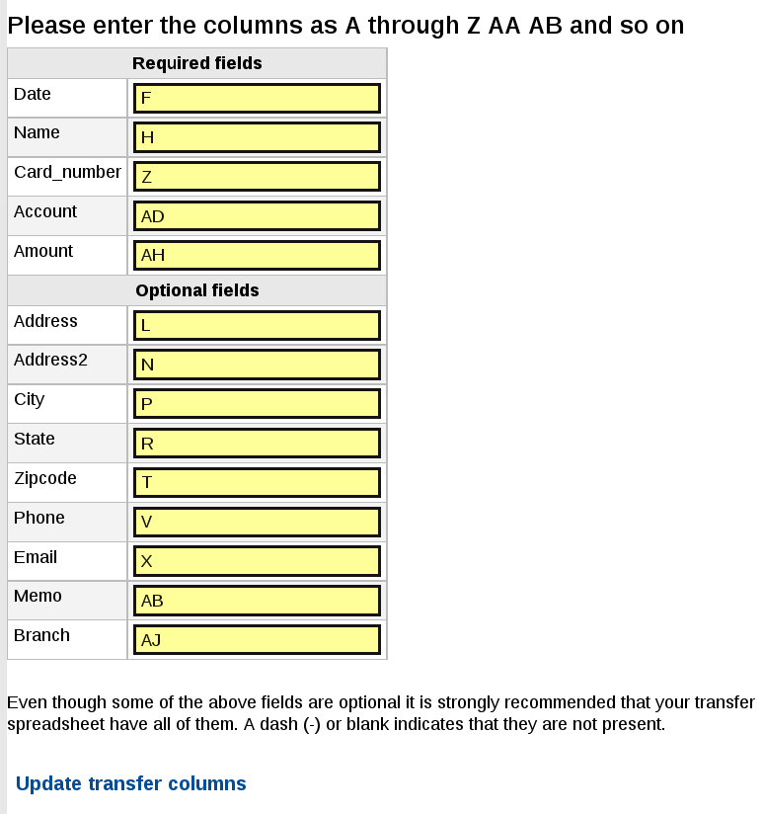
The columns are referenced by letters. Some programs refer to columns by number; some starting with 0 others with 1. To cut down on the confusion, use the letters above the columns.
The date, name, card number, account (accounting income account) and amount are required. You should include the address fields as well; the donor plugin will complain if you don't. This will keep the accounting program and Koha in synch.
Name field can be in normal or inverted (surname, first name) order. Use a comma in inverted order. Names like 'Jerry van der Wald' can be difficult to parse into first name – surname;

Miscellaneous constants
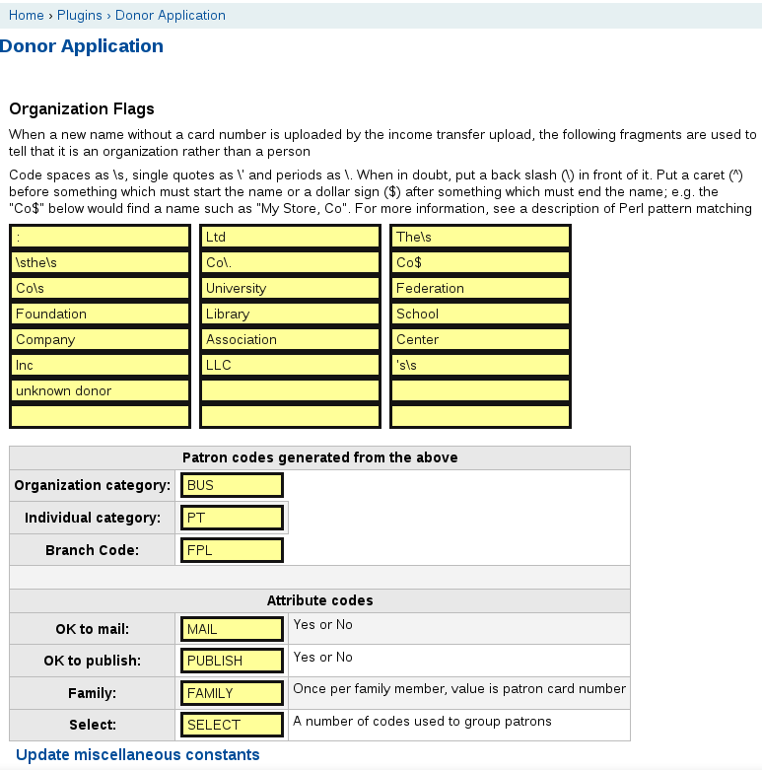
The flags at the top are used to determine whether a name is of a person or an organization. Organzation names are put into the surname field and the first name is left blank. Names like Jerry's Bakery or Jabba the Hut are considered organizations. This only comes into play when the accounting program does not have a card number.
If you really wanted to have Jabba as the first name and the Hut as the surname, you could enter it as the Hut, Jabba or, better, just change it in Koha and make sure that the Koha card number is in the accounting data. Note that surnames do not necessarily start with a capital letter.
Created individual and organizational patrons are assigned the default patron codes and are assigned to the branch code listed above. The codes assigned by the donor plugin can always be changed in Koha.
The last section shows the names of the patron attributes that we use. Capitalization does matter; mail is not the same as MAIL. The MAIL and PUBLISH should have the YES_NO authorized value.
The select attribute must have an authorized value. It is called SCODE in the sample, but it is picked up automatically from the select attribute. These values can be used to limit the patrons selected for a report.

Installation

Preliminary accounting package tasks
- Create a spreadsheet with your accounting ledger numbers and descriptions. Your accounting package may be able to just dump that as a spreadsheet. We used Quickbooks which put the Account consisting of “number – title” in column C, the type (Income) in column E, a description in column G and Accnt.# in column I.
Column C is the only one important. We then created three additional columns.
  - Column K is a 1 for accounts which are tax deductible for the patron and 0 if not. In the US income for book/gift shop sales is not deductible where contributions for a building fund is.
  - Column L is used to set an amount which would cause the expiry date to automatically be extended to the end of the month next year, unless it is already beyond that. For example setting the value to 35 on the 'Membership Dues' account will extend the expiry date whenever anyone pays $35 or more. Setting it to 0 bypasses that for that account.
  - Column M is used 'map' one account to another. Originally we were using one accounting package and switched to another with different non-overlapping account numbers. All the old account numbers are in our database. We wanted to map 4010 – Dues from the old system to 47230 – Membership Dues in the new one. That way when we want totals from 47230 it will include income from 4010.
If you have hierarchical accounts such as:
* 42000 Endowments
* 42010 Endowments-Operating
* 42020 Endowments-Books
* 42030 Endowments-Staffing
You may want to map 42010, 42020 and 42030 to 42000. Then calling for a total on 42000 would include income from the other three.
  - These last three columns are not required since they can be changed any time through the plugin's system menu.
- Export a detailed income spreadsheet from your accounting package,
  - It must include the date, account, patron name, patron card number (if assigned) and amount for each transaction.
  - It should include the address fields, phone, email, branch code and possibly a memo field
  - Note the columns in which each field is located.

Install
- Install Koha and create a site.
- Edit koha-conf.xml which is in /etc/koha/sites/your_library or /etc/koha depending on whether you have installed Koha from a Debian or Debian derivative package or compiled from a tarball. Search for <enable_plugins>0</enable_plugins> and change the 0 to 1.
- Go to Koha administration → Global system preferences → Enhanced contents → Plugins:
Set UseKohaPlugins to Enable.
- Execute:
sudo apt-get install gcc libspreadsheet-read-perl libexcel-writer-xlsx-perl liblingua-en-nameparse-perl libstring-approx-perl libstring-similarity-perl libdata-dumper-concise-perl
- sudo cpan (if this is the first time you've used cpan, you may be asked to configure it. Just answer 'yes'
  - install Spreadsheet::ReadSXC (if you plan to use open document format spreadsheets (.ods)
  - install DateTime::Format::Excel
  - install Lingua::EN::Nickname
  - install Text::Metaphone
  - install Lingua::EN::MatchNames

- Go to Tools → Tool plugins. Select the donorapp.kpz file and upload it.
- Run the plugin.
  - It will automatically create our tables in your Koha database and populate some of them.
  - The user who installed the plugin is automatically given all donor application privileges.
  - The transfer spreadsheet columns are set to what QuickBooks uses in our system. Check them.
- Go to System update → Set accounts. Check the columns listed match what you created in step 1 of the preliminary accounting package tasks. Upload your account descriptions.
- Go to System update → Transfer columns. Check that the columns listed match what you created in step 2 of the preliminary accounting package tasks.
- Go to System update → Miscellaneous constants and check the default settings.
  - You may need to change the spelling or add to the Organization flags used to differentiate between people and organizations.
  - Set the default patron categories for new people or organizations and default branch code.
  - Set the names of the attribute codes.
- The user who installed the donor plugin will automatically be granted all permissions for the donor plugin. Now is a good time to add other users.
- Upload all the income you can put into a spreadsheet. We have data back to 2002.
- Have fun! Look at some patrons. Generate some reports.

Testing
You may want to create a test site to try out the donor tracking plugin.
- Create a site such as “donortest”.
- Execute :
cd Koha-plugin-DonorApp-master/Testing or wherever it's located
mysql -p donortest
source donortest.sql
- There are four users with passwords:
Name | Opac ID | Password | Permissions
Koha Admin | admin | koha | donate,contact,group,system
Development Director | test | koha | donate,contact,group,system
Dev Team | DevTeam | koha | contact,group
Ronnie Ballard | ronnie | koha | --none--

- If you log in with test or admin, the donor plugin will show all features, Logging in with DevTeam will not show “Upload income transfer file” or 'System update”. Logging in with ronnie will show an error message and not permit any use of the plugin.

- There are two reports defined.
  - Current members will show everyone with an expiry date of 2015-06-30 through 2021-01-01.
    - Note that the Ballard family show the other members of the family in the far right columns.
    - Click on the card number of one of them and see his/her giving record and all the details
    - There is a link to the main Koha patron page for that person.
  - Current donors will put you on the Edit Report page with an error message saying no records found. That's because the 2015 income has not been uploaded.
- Click on the Donor Application link and then click on the Browse button to upload the 2015 income. Go to the Testing directory and select sample-accounting-transfer.xlsx. Then click on the Upload link.
- You will get a page with the results of the upload.
  - At the top is a fund name of PDQ Employee which should have been PDQ Employee Matching Fund.
    - You can leave the card number (the yellow box) blank and click on update funds to create a new fund patron.
    - You should copy the card number of the PDQ Employee Matching Fund into the yellow box and either name will be matched to that fund in the future.
  - Below that there are a lot of expiry dates updated
  - Joann Duffy's address has been changed.
  - Near the bottom of that list
    - Sam Ballard was found but his card number is not in the accounting package.
    - Jake Barnes was not in Koha and has been added as a new patron.
    - Both of those card numbers should be updated in the accounting package.
  - The account totals for this upload are listed at the very bottom of the page
- There are four patron attribute type that we have added
  - FAMILY – contains the card number of other family members, may occur multiple times.
  - MAIL – OK to Mail may occur once. It will appear in reports as OK, NOT OK, or N/S.
  - PUBLISH – OK to Publish may occur once. Same output as MAIL
  - SELECT – Codes used to identify various patrons. Authorized values in SCODE.
    - BOD – Board member
    - IKD – In-kind donor
    - DON – Major Donor
    - xBOD – Previous board member
    - PROS – Prospect
    - PR – Public Relations
    - VOL – Volunteer
- You can define a report which looks at volunteer donations using those select codes.
- Try making some reports
- Add some comments to a patron
- Have fun

