Setting up github and cloning your first repo

# Prerequisites

Create an account with your work email or one that you will remember and have access to. You will get access to the Company’s org later with this account. This is for Testing purposes to be ahead of the game. Once you set up your account Send Tan your user name

**\*\*NOTE\*\*** Screenshots going forth shows a different name but steps are the same.

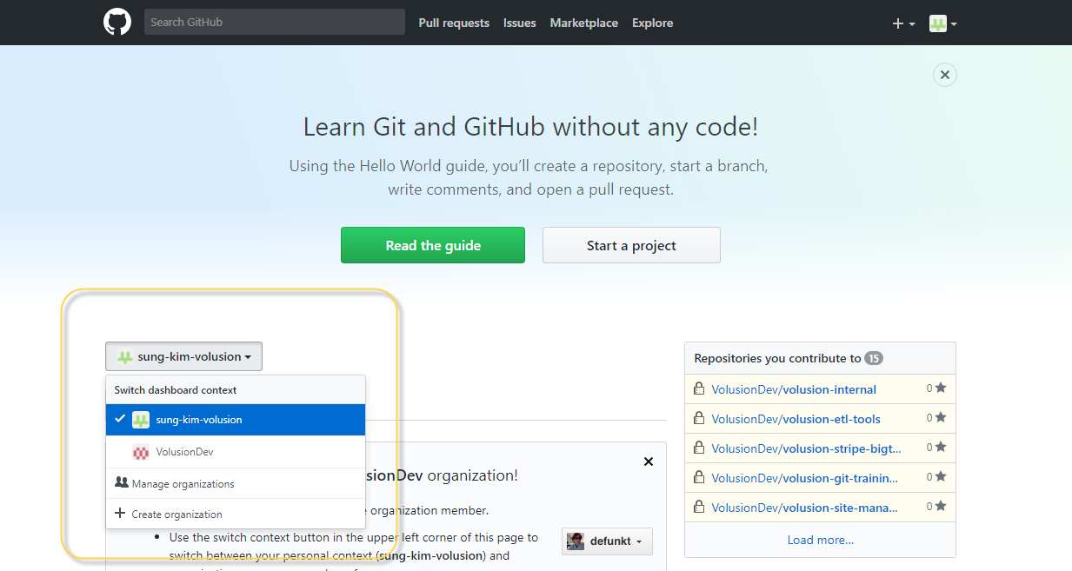

# Initial Setup

Once you get access to Tan’s **PUBLIC** environment, you must grant your computer remote access the github environment. This allows you to use GitHub without constantly needing to type your password.

Go to the settings page:

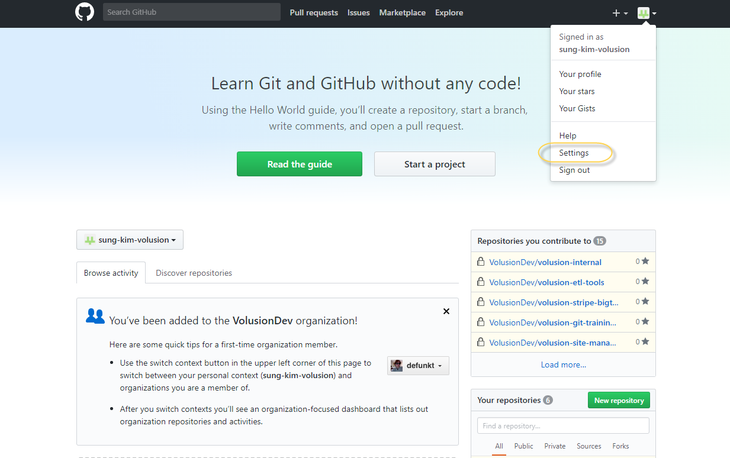

Go to the “SSH and GPG keys” tab and click “New SSH key” button

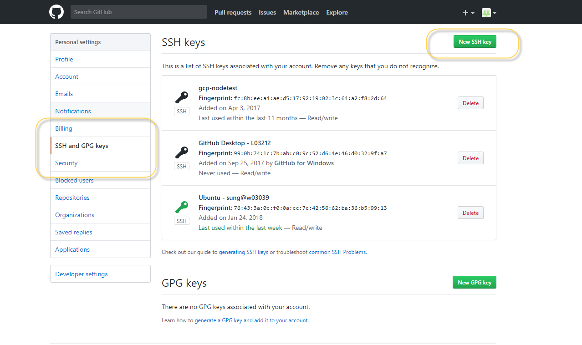

Follow the steps on link and add ssh key: (shows instructions for Mac/Windows/Linux)

<https://help.github.com/articles/generating-a-new-ssh-key-and-adding-it-to-the-ssh-agent/>

<https://help.github.com/articles/adding-a-new-ssh-key-to-your-github-account/>

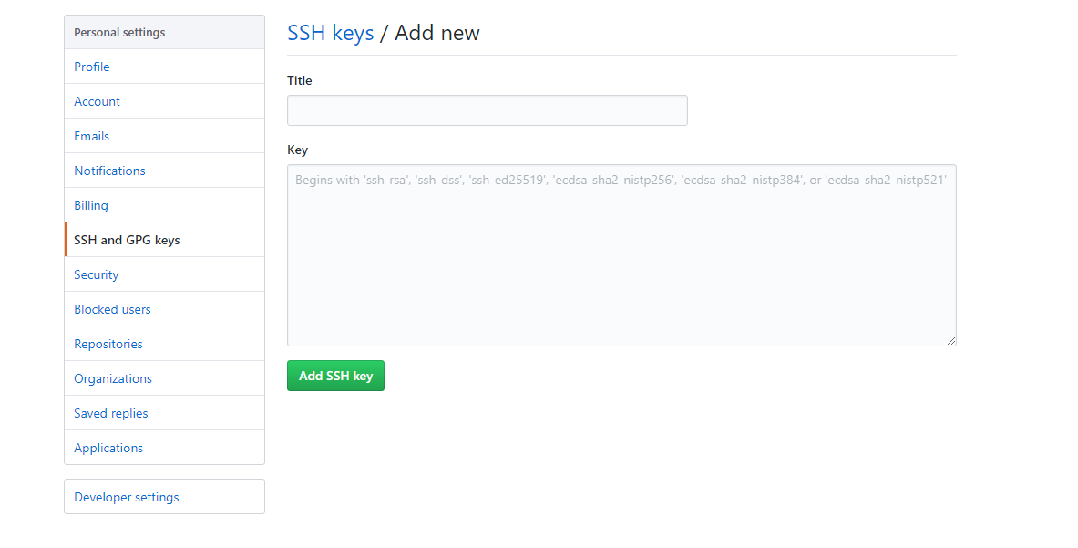

## Enable Two Factor Authentication

Then go to “Security” tab and configure your “two factor auth”:

You can follow the steps in this link: <https://github.com/blog/1614-two-factor-authentication>

(shows instructions for Mac/Windows/Linux).

Note: Two factor can be done with your phone or with your DUO app on your phone.

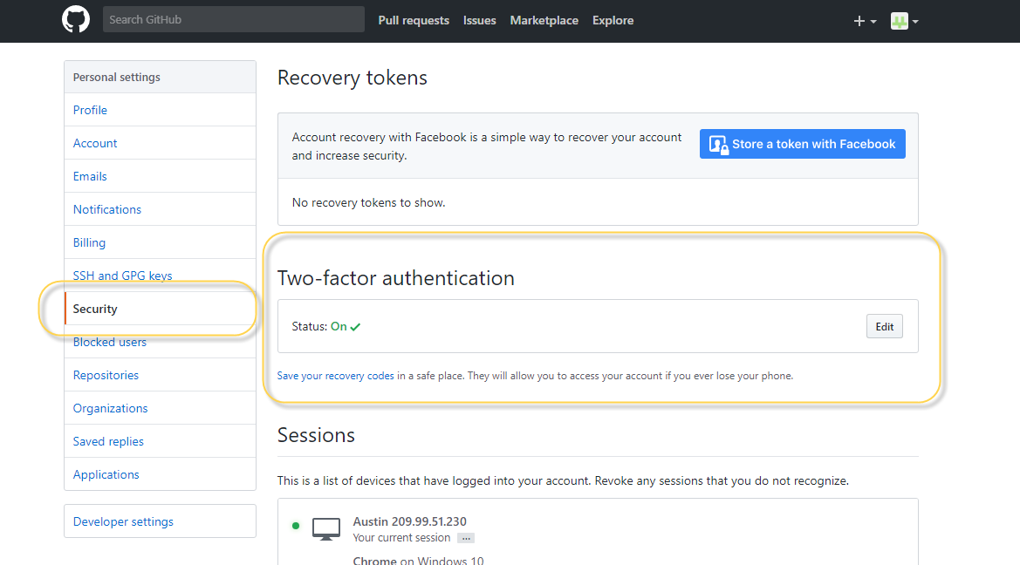

Now your local computer should have access to git repository when connecting with git client.

# Cloning your first repo

* First install Git client: <https://git-scm.com/downloads> (link has mc/windows/linux clients)
* From the installed files use “Git Bash” which is the cmd based git
* First navigate to the folder where you would like to create your git repository. You can initially do “cd desktop” then navigate from there to the folder of your choice

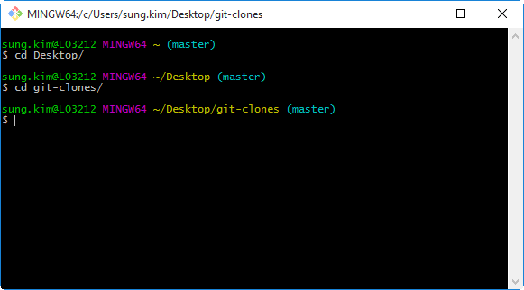

* Assuming that you have finished the steps on adding your “SSH key” in “Initial Setup” section, you should now be able to clone the repository. Go back to the github site, find the repository you would like to clone and get the link to clone to repo.

## (OPTIONAL) Fork Repository before cloning

Forking a repo means creating a remote copy of the repository.

Please follow this step if you are not yet familiar with git and cloning a repo used by multiple users or if you are cloning the “vNOC-Prep” for training purposes

Forking is very simple, just click on the “fork” button on the top corner of the screen once you get to your repository page:

Find the repository: https://github.com/tan-duong-volusion/vNOC-Prep

If you do not have access to the repository (you see a 404 page) please contact one of the git instructors so you can have your access to the repo granted.

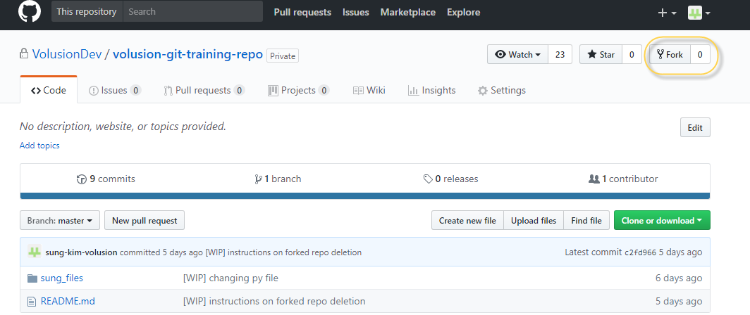

Choose your personal github account for your forked repo location:

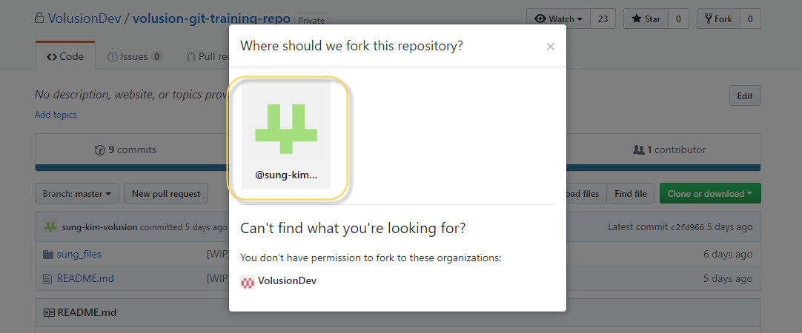

Now from your personal organization you can find the copied (forked) repo. For the next step “Clone Repo” use the link from this page to clone your repository.

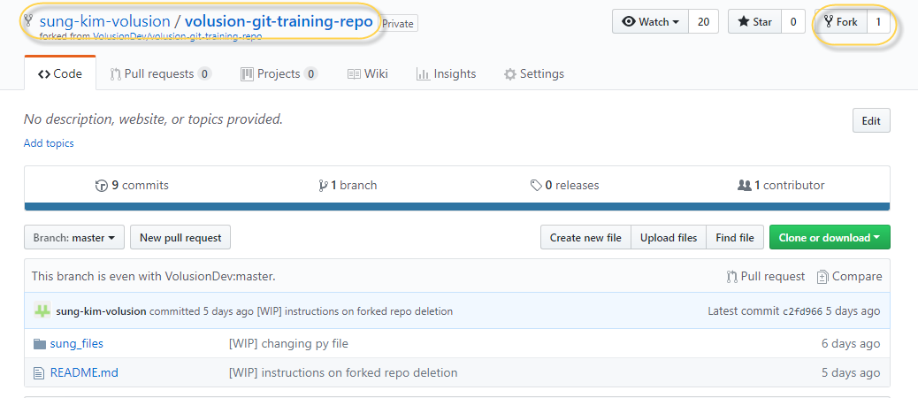

## Clone Repo

Find the repository: https://github.com/tan-duong-volusion/vNOC-Prep (it will be https://github.com/**GIT-UserName**/vNOC-Prep if you forked)

If you do not have access to the repository (you see a 404 page) please contact one of the git instructors so you can have your access to the repo granted.

The green button you see below will show you the link, make sure you get the “Clone with SSH” link. Not the “HTTPS” link.

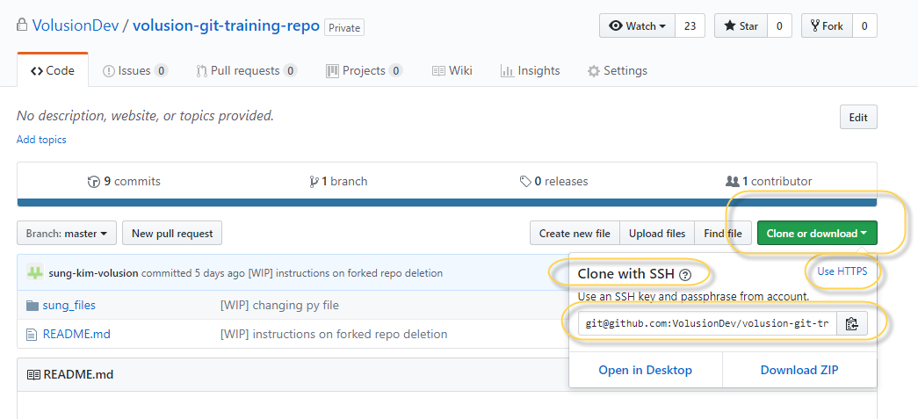

Once you have the link, you can go back to the cmd can make a local copy:

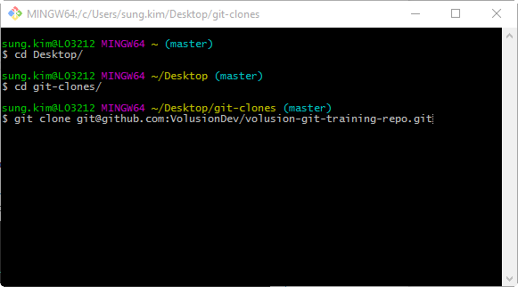

This will create a local copy of the remote repository in your current folder path:

