Yawa Hallo

11/10/2022

Module 5 **Assignment: MySQL Functions**

**Functions and explanation of when it might be used**:

**TIMEDIFF()** : this function is used to return the difference between two time/datetime expressions. Both times should be in the same format, and the calculation is *time1-time2*.

<https://www.w3schools.com/sql/func_mysql_datediff.asp>

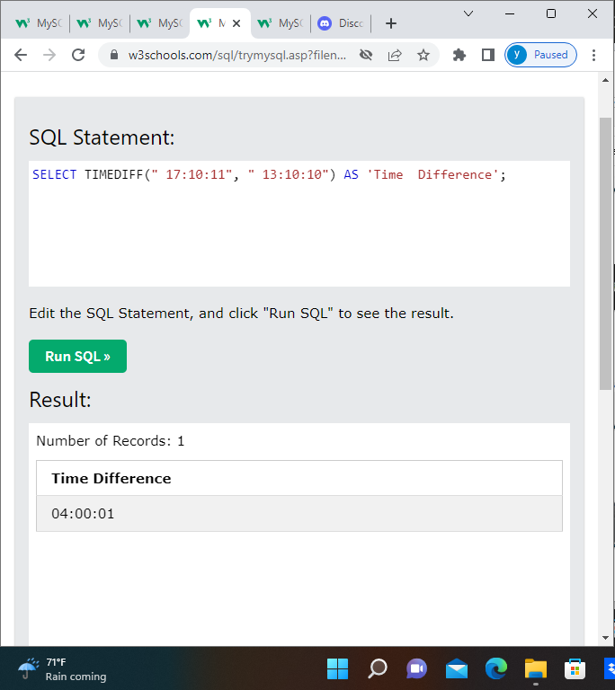

**REPLACE()** : this function replaces all occurrences of a substring within a string with a new substring. The original string, the string that will be replaced, and the new string are provided in the parenthesis. <https://www.w3schools.com/sql/func_mysql_replace.asp>

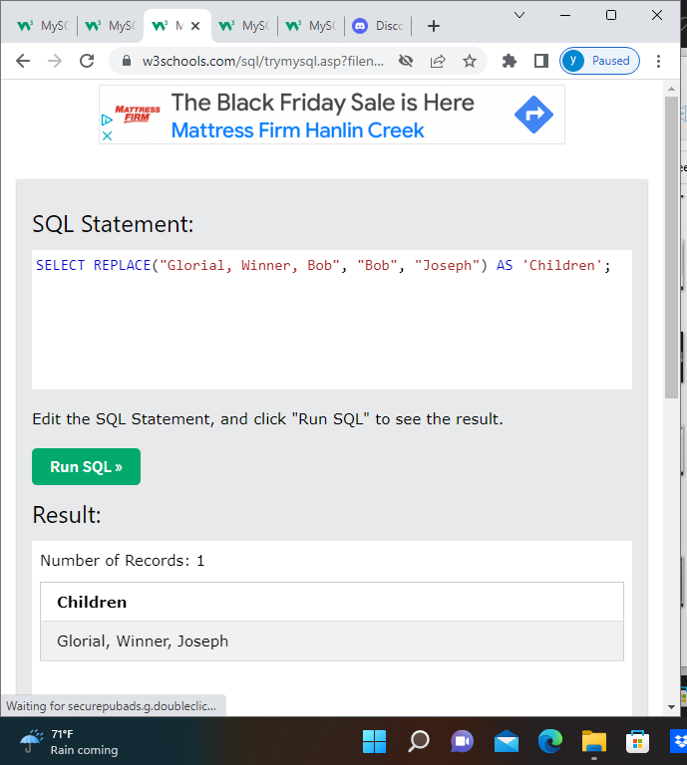

**REPEAT** (): this function repeats a string as many times as specified. In the parenthesis, you write a string to be repeated and the number of times.

<https://www.w3schools.com/sql/func_mysql_repeat.asp>

