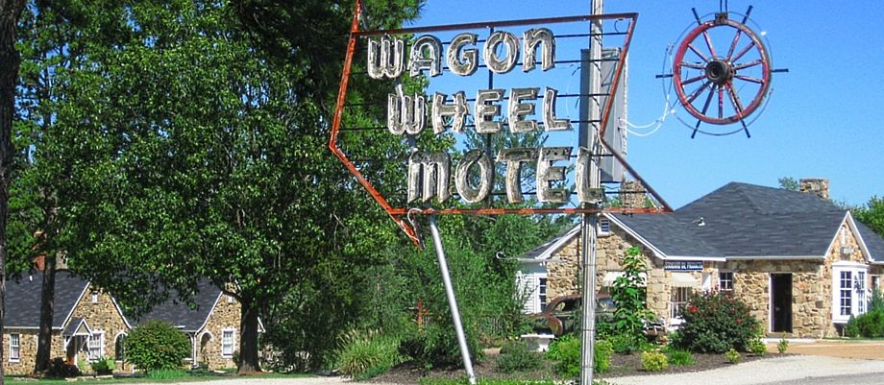

Route 66 Trip Lodging
Sunday | 10/23/22 | Wagon Wheel | Cuba, MO | 114.92
Monday | 10/24/22 | Microtel | Miami, OK | 144.55
Tuesday | 10/25/22 | Comfort Inn | OK city, OK | 107.12
Wednesday | 10/26/22 | Comfort Inn | Amarillo, TX | 113.63
Thursday | 10/27/22 | Days Inn | Santa Fe, NM | 80.71
Friday | 10/28/22 | Roadway Inn | Gallup, NM | 62.24
Saturday | 10/29/22 | Howard Johnsons | Williams, AZ | 77.93
Sunday | 10/30/22 | Days Inn | Needles, ca | 82.49
Monday | 10/31/22 | Hampton Inn | San Bernardino, CA | 175.22
Tues & Wed | 11/01 & 11/02 | Studio 6 Stuites | San Pedro,CA | 214.58
Tuesday | 11/08/22 | Redfoof Inn | Kingman, AZ | 115.34
Wednesday | 11/09/22 | Howard Johnsons | Albuguero, NM | 97.23
Thursday | 11/10/22 | Econo Lodge | Clovis, NM | 79.13
Friday | 11/11/22 | Days Inn | Heneryetta, OK | 81.83
Sat & Sun | 11/12 & 11/13 | Days Inn Graceland | Memphis, TN | 285.96
 |  |  |  | 1832.88
 |  | Route 66 Trip Gas
 |  | 39.63
 |  | 23.35
 |  | 35.96
 |  | 40.71
 |  | 32.52
 |  | 46.40
 |  | 50.00
 |  | 31.06
 |  | 35.46
 |  | 67.75
 |  | 59.80
 |  | 0.07
 |  | 35.16
 |  | 42.61
 |  | 28.45
 |  | 43.78
 |  | 31.12
 |  | 41.86
 |  | 45.60
 |  | 731.29

