Day 20 Friday Nov 11 455 miles
Clovis, NM to Henryetta, OK
Mazzio's Pizza in Henryetta
Days Inn In Henryetta

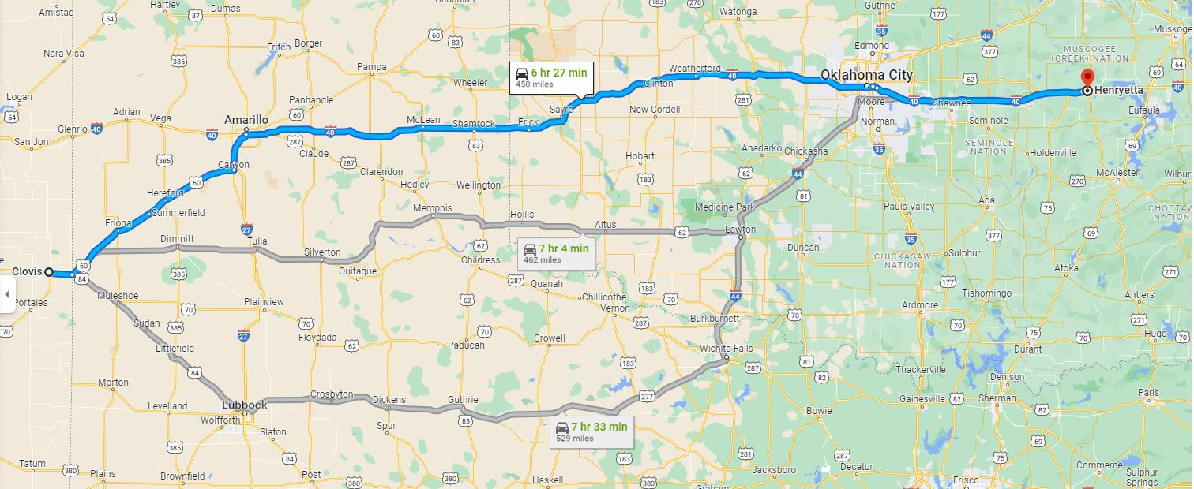

Just Driving, Eating And Sleeping
We drove straight through to Henryetta, Oklahoma. We checked into a nice Days Inn (another one of the cheaper places to stay that was wonderful), and had a wonderful dinner at Mazzio’s Pizza.
Mazzio’s reminds me of our Pizza Huts in the Chicagoland area, some time ago. They have good pizza, and a nice salad bar. From their Website it shows a lot of locations in the middle of the US. I only found one location at the very southern tip of Illinois. Highland, Illinois.
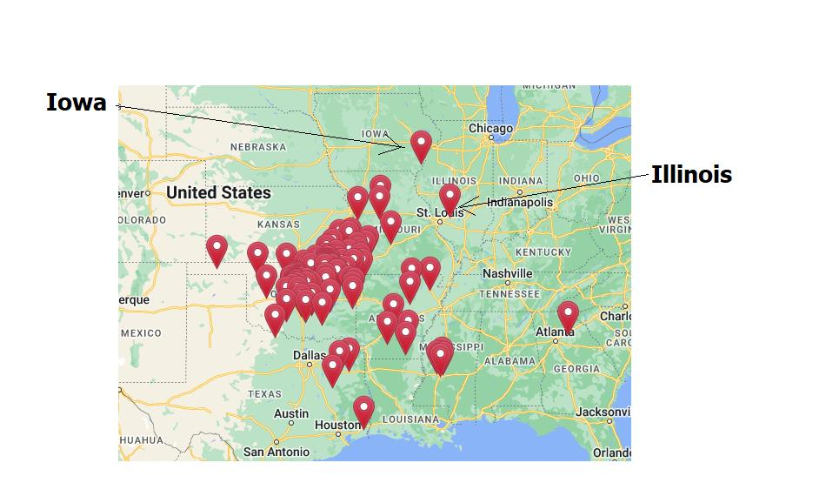
Continue On Down The Road
Home To Index Page

