Day 18 Wednesday Nov 9
Kingman, AZ to Albuquerque, NM 475 miles
Howard Johnsons
Route 66 Diner Old Dinner with old Dress.

Another Straight Through Day
We drove staight through from Kingman, AZ. To Albuquerque, NM. We found a Howard Johnson's for the night and went out looking for some dinner. We pulled into a place and didn't realize we'd been there before. Once inside we knew where we were. You can read more about it from Day6. After dinner, we were off to bed.
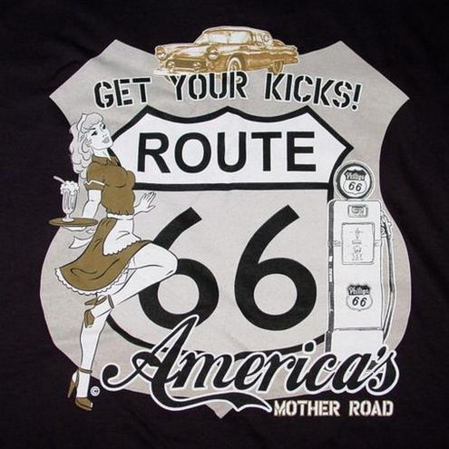
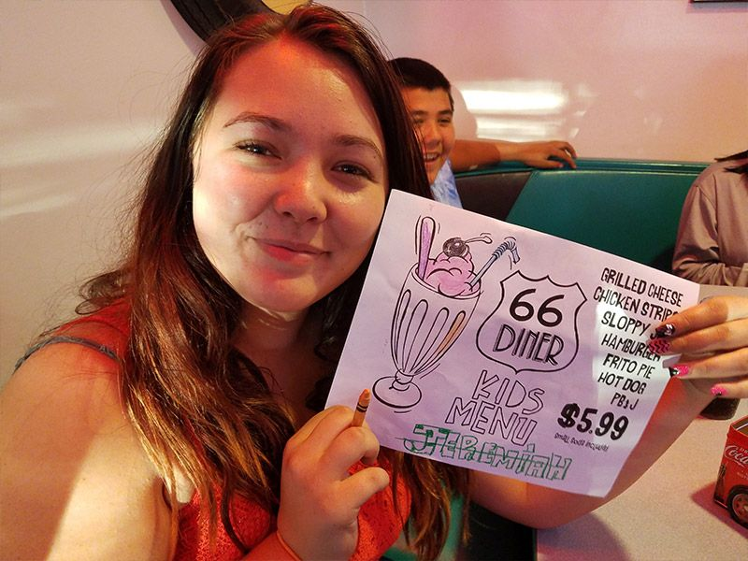
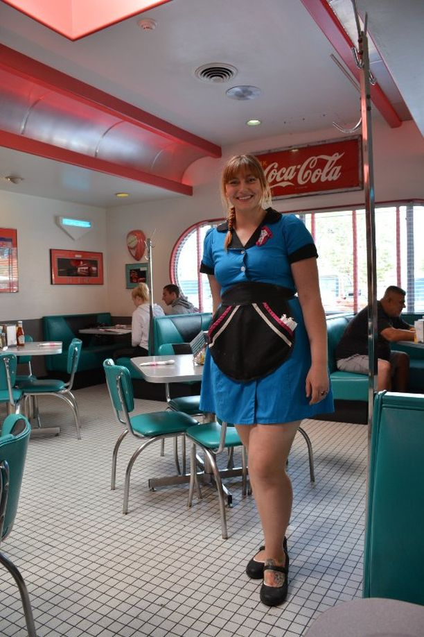
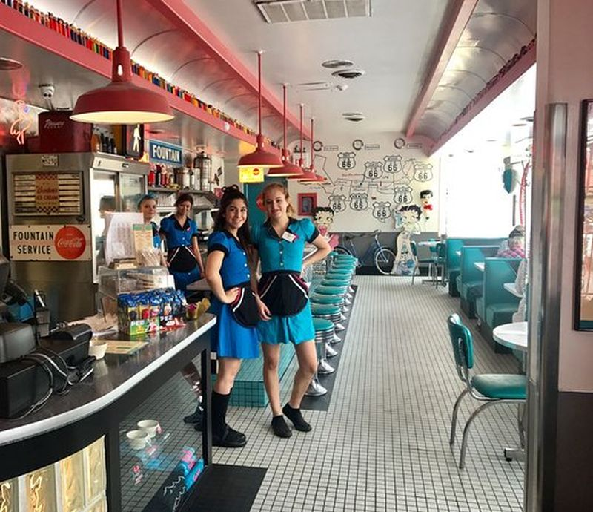
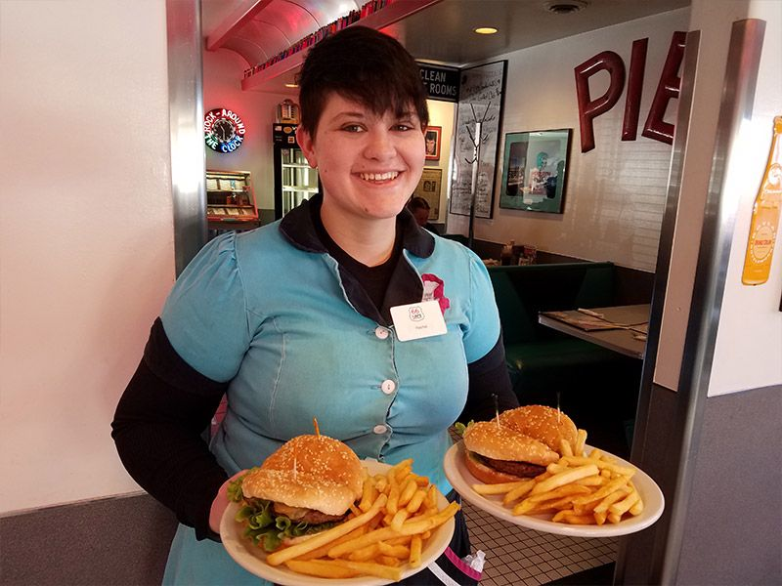
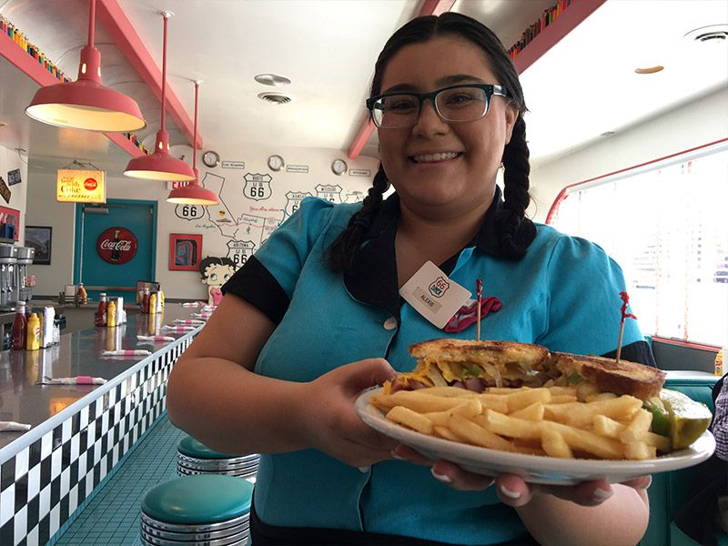
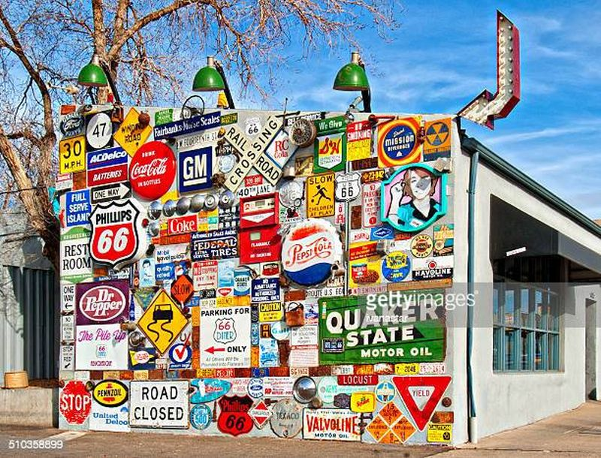
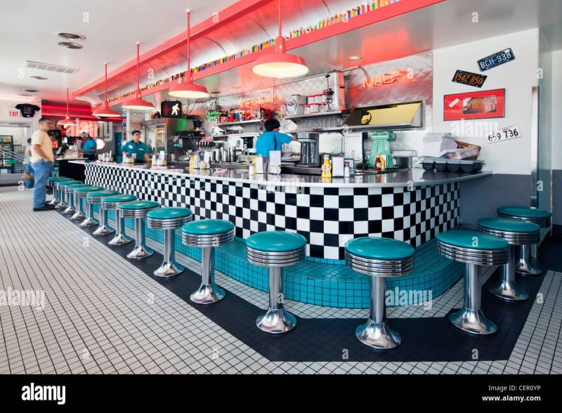
Continue On Down The Road
Home To Index Page

