In Illinois:

Dixie Truckers Home: Oldest truck stop
in Country. Now a modern travel plaza.
398 Main Street
McLean

Paul Bunyan Hot Dog Statue
Atlanta

Palms Grill Cafel: 1940's Style
Have beef noodle soup
110 Sw Arch Street
Atlanta

World’s Largest Covered Wagon
1750 5th Street
Lincoln

Shirley Temple Silhouette
209 Governor Oglesby Street
Elkhart

Route 66 Motorheads Bar and Grill
600 Toronto Road, Springfield, Il.

Litchfield Museum & Route 66 Welcome Center
Address: 334 North Old Route 66. Litchfield IL 62056

Skyview Drive In
Drive In Movies
1500 Old Route 66
Litchfield

Weezy's Route 66 Bar And Grill
108 South Old Route 66
Hamel

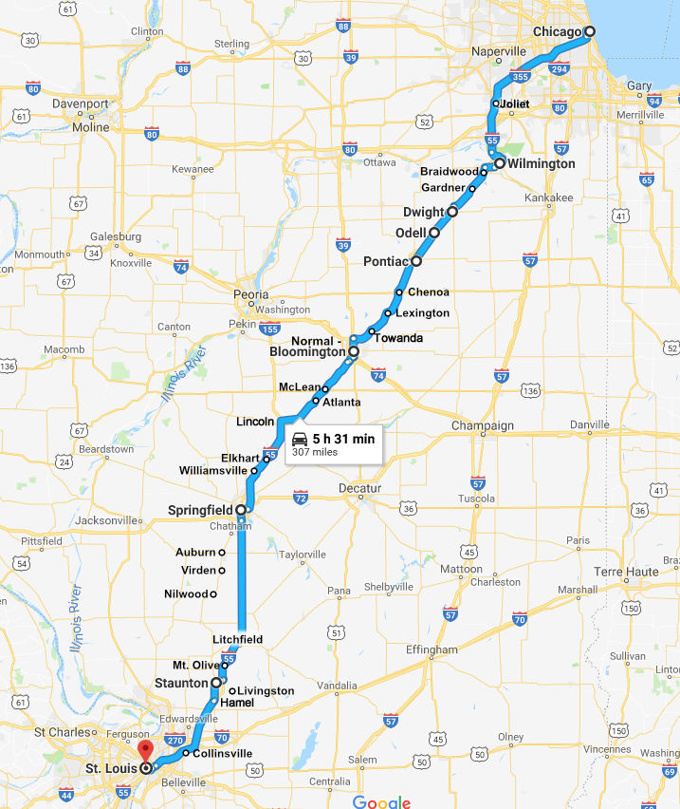
In Missouri:

Missouri Hicks Bar-B-Que
913 East Washington Street
Cuba

Wagon Wheel Motel
901 East Washington Street
Cuba
FIRST DAY STOP AND SLEEP

Bob's Gasoline Alley: Cool Vintage Signs
822 Beamer Lane
Fanning—NO GO CLOSED!

Large Rocking Chair
Fanning

Hoppers Pub: 66 Beers On Tap(Open 11:30 Sat.Sun. 4-9 Mon-Fri
318 Route 66
Waynesville

Dowd's Catfish and BBQ
1760 W. Elm Street
Lebanon

Munger Moss Motel: A Vintage Motel
1336 East Route66
Lebanon

Park Central Library: Wild Bill Hickock Shootout
128 Park Central Square
Springfield, Mo

Whole Hog Cafe: BBQ
2731 N. Glenstone Ave
Springfield, Mo

Best Western Route66 Rail Haven:Vintage 50's Motel
203 South Glenstone
Springfield, Mo

Civil War Museum: Battle of Carthage
205 South Grant
Carthage

66 Drive In Theatre
17321 Old 66 Blvd.
Carthage

Granny Shaffer's Family Restaurant: Family Food
2728 N. Rangeline
Joplin

Wilder's Steakhouse: Great Steak and Sea Food
1216 S. Mainstreet
Joplin

Joplin History and Mineral Museum: Bonnie And Clyde Stuff (10-4 Tues.-Sat.)
504 S. Schifferdecker Ave
Joplin

Note: From Pontiac, Il. to Joplin Missouri
it is 7 hours via Route66

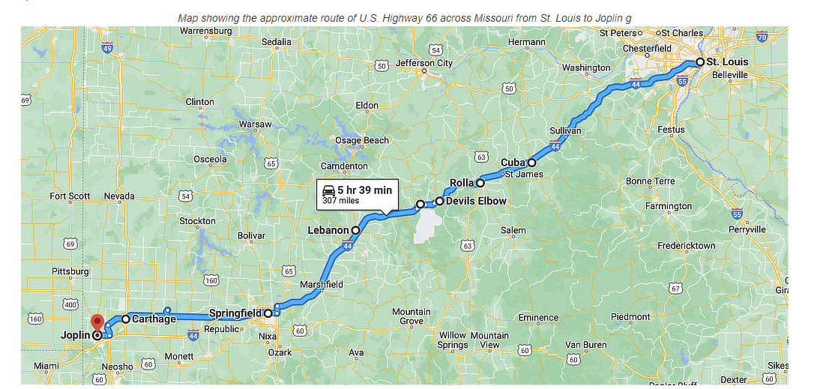
In Kansas:

Baxter Springs Heritage Center And Museum: Civil War Stuff
740 E. Ave
Baxter Springs

Note: From Joplin, Mo to Baxter Springs,Ks is just 30 min.
From Baxter Springs to Kansas City, Ks is 2.5 hours.

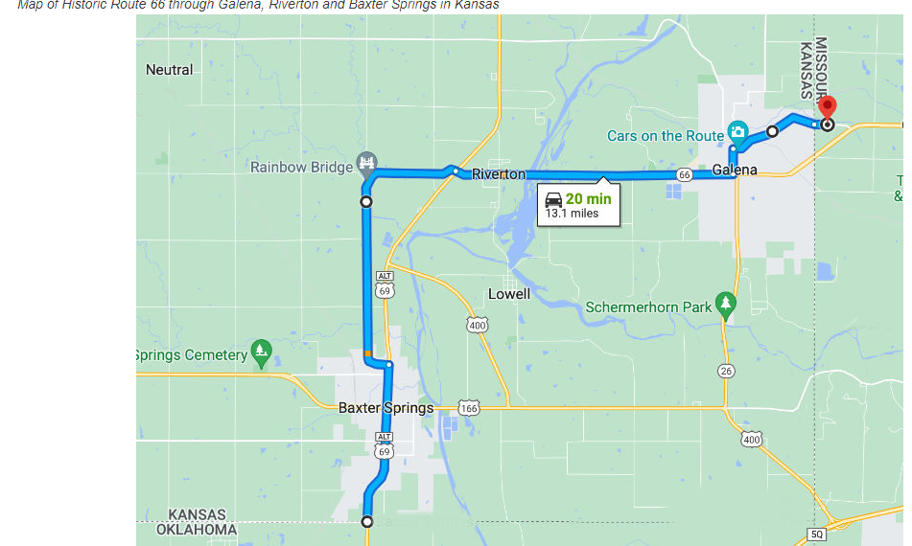
In Oklahoma:

Hogue House- 1st Sears Prefab House In Oklahoma
1001 Olive Street
Vinita

Totem Pole Park
21300 E. SR-28a
Chelsea

Blue Whale- A Big Blue Whale Construction
2680 N. SR-66
Catoose

Seabe Station Vintage Motorcycle Museum
336992 SR-66
Warwick

First Americans Museum- American Indians
659 American Indian Blvd.
Oklahoma City
SECOND DAY STOP AND SLEEP

Lucilles Service Station- Old Gas Station
.5 Miles West of SR-58 North of 66
Hydro

Cherokee Trading Post – Indian Stuff
23107 North Frontage Road
Just Outside Of Weatherford (town)

Mohawk Lodge Indian Store-Open 9-5:30
22702 RT. 66 (north side)
Clinton

Route 66 Museum-Open 9-5 Tues.-Sat.
2229 W. Gary Blvd.
Clinton

National Route 66 Museum-Open 9-5 Tues.-Sat.
320 West Third Street
Elk City

Parker Drilling Rig-Big Old Rig Used To Drill Holes For Atom Bomb Tests Underground
Behind Casa Grand Hotel
103 East Third Street
Elk City

One Room Cinder Block Jail
One Block North On Main Street
Texola

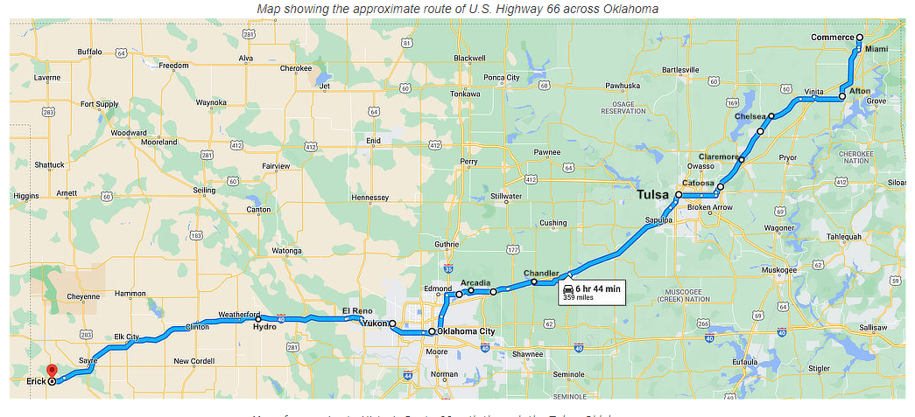
In Texas:

VW Slug Bug Ranch- Vdubs In The Ground
.5 Mile North Of 66 On SR-207
Conway

Palo Duro Canyon State Park- 2nd Largest Canyon (Grand Canyon Number 1)
11450 State Highway Park Road
Between Conway And Amarillo
3RD DAY STOP AND SLEEP IN AMARILLO.

Big Texas Steak Ranch- Has the big 72oz. Eat for free.
7701 E. I-40
Amarillo

Cadillac Ranch-Cadillacs in Ground
I40 Frontage Road Near Exit 60
Outside Amarillo

Dots Mini Museum and Collectables- Three Buildings of Collectables(Open Dawn to Dusk)
105 N. 12 Street
Vega

Roosters-Old Restaurant In Gas Station
(8-8 Mon- Sat)
1300 Vega Blvd.
Vega

TOWN OF ADRIAN IS HALFWAY POINT OF ALL ROUTE 66

Mid Point Cafe-Good Food
(8-5 Tues-Sun)
305 W. Route 66
Adrian

Glenrio is Desolate Border Town (New Mexico/Texas)

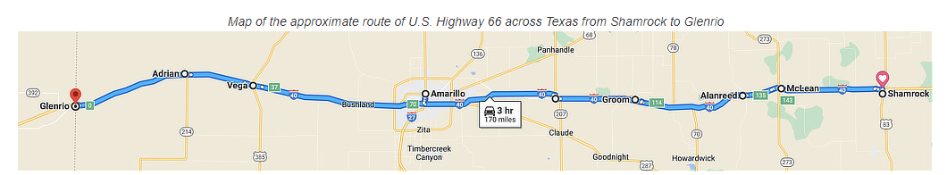
In New Mexico:

New Mexico Route 66 Museum
9-5Mon, Fri, Sat. 9-1 Tues-Sat
1500 W. Route66
Tucumcari

College Dinosaur Museum- Good Museum
10-4 Tues. - Sat.
222 E. Laughlin Street
Tucumcari

Tee Pee Curios- Route 66 and Junk
924 E. Route 66
Tucumcari

Kix On 66- Breakfast All Day; Diner
1102 E. Route66
Tucumcari

Watson’s BBQ- BBQ
7:30-5 Mon-Fri
7:30-4 Sat.
502 S. Lake Street
Tucumcari

Blue Swallow Motel- Motel with 50’s Furniture
($85-$140)
815 E. Route 66
Tucumcari

Historic Route 66 Motel
($50-$165)
1620 E. Route 66
Tucumcari, New Mexico

Motel Safari-Retro 60’s
($70-$115)
722 E. Route 66
Tucumcari

Fort Sumner Historic Site-Forced Apache Indians To Work/20% Starved To Death
3647 Billy The Kid Road
Wed.-Sun. 8:30-4:30
Outside Town Of Cuervo

Billy The Kid Museum- Grave and Museum
8:30-5 Mon.-Sat.
1435 E. Sumner Drive
Fort Sumner
Note: Graveston in Fort Sumner Park Cemetary
Near Billy The Kid Drive and Old Fort Park Road.

Comet 2 Drive In- Great Homemade Mexican Food
1257 E. Route 66
9-5 Tues.-Sun.
Santa Rosa

Pecos National Historic Park-Ancient Pueblo and Civil War Battlefield
8-6
1 Peach Drive
SR.63 and Ranger Lane
Pecos, New Mexico

The Plaza-Shop and Eat
San Francisco Street and Old Sante Fe Trail
Sante Fe

- Palace of Governors- Oldest Public Building In US(1600’s)
105 W. Palace Ave.
Santa Fe

- New Mexico History Museum- History
10-5 Tues. - Sun.
113 Lincoln Ave.
Sante Fe

- New Mexico Museum Of Art
10-5 Tues. - Sun.
107 W. Palace Ave.
- These 3 are Close To Each Other

Museum Of International Folk Art- World’s Largest Collection Of Cultjure Art
10-5 Sun.-Tues.
706 Camino Lejo
Sante Fe

Museum Of Indian Arts and Culture
10-5 Tues.-Sun.
710 Camino Lejo
Sante Fe

El Farol- Interesting Mexican Restaurant
3-9 Wed.-Sun.
808 Canyou Road
Sante Fe

Silva Saloon- Old Bar From 1930’s
11-7 Mon.-Sat/12-6:30 Sun.
955 S. Camino Del Pueblo
Bernalillo

Tinkertown- Miniature Stuff
9-6 ($3.75)
121 Sandria Crest Road
Outside San Antonio

Kilmo Theatre- Old theatre/Old and New Movies
9-4 Tues.-Sat.
423 Central Ave.
Albuquerque

Old Town- History of Albuquerque, Shops, Etc.
Address of San Felipe De Neri church
2005 N. Plaza St. Nw.
Albuquerque

Powdrell’s Barbeque House- Barbeque
11-7 Tues.-Sat.
11301 Central Ave. Ne
Albuquerque

66 Diner- Another Diner
11-8 Sun-Thurs.
1405 Central Ave. Ne.
Albuquerque

Standard Diner- Diner made from 1938 Texaco Station
11-9 Mon.-Sat./9-9 Sun.
320 Central Ave. Se.
Albuquerque

Route 66 Casino Hotel- Hotel and Gambling
(Rooms $99-$129)
14500 Central Ave. Sw.
Abuquerque

Acoma Pueblo- Oldest inhabited Settlement in North American
$25 Admission
9-5
Outside Laguna/South of Route 66

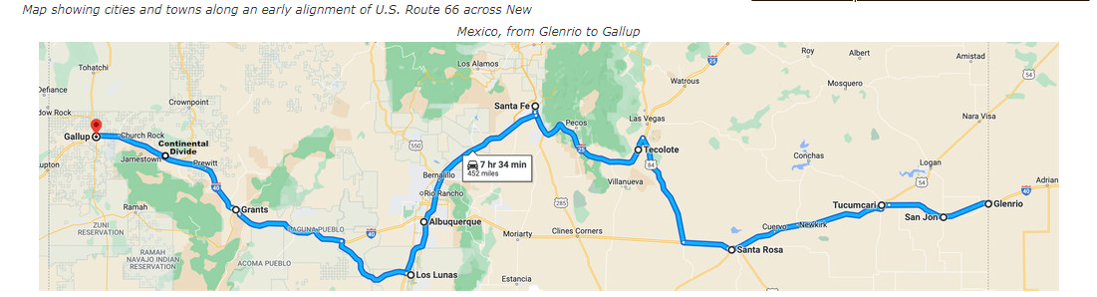
In Arizona:

Painted Desert and Petrified Forest National Park- Bunch of Stuff In Park
Route 66 Studebaker
$25 Admission
Exit 311 of I40 In Navajo, Arizona

Navajo County Historic Court House- Old jail of a real Wild, West Town
8-5
100 E. Arizona St.
Holbrook, Arizona

Geronimo Trading Post- Route 66 stuff, Etc.
8-5
5372 Geronimo Road
Josheph City, Arizona

Jack Rabbit Trading Post- From Movie “Cars”
8-5
3306 Route 66
Joseph City, Arizona

Meteor Crater- Best preserved meteor impact on planet and museum
$22
I40 Exit 233 Meteor Crater Road
Winslow, Arizona

Mother Road Brewing Co.- Brews, Beers,Ales
2-9 Mon.-Thur.,2-10 Fri.,12-10Sat.,12-9 Sun.
7 S. Mikes Pike
Flagstaff, Arizona

Grand Canyou National Park
Off 66- Use Garmin and book to
get to. $35

Flinstones Bedrock City and Raptor Ranch- Flintstones and wildlife
$5
101 S. U.S.180
Williams, Arizona

Cruisers Route666- 50’s and beer. Call you “Sweetie” and “Hon”
233 W. Route66
Williams, Arizona

Desoto’s Salon- Closed but car on roof with Elvis
314 W. Lewis
Ash Fork, Arizona

Lulu Belles BBQ- BBQ with twice baked potatoes
33 W. Lewis Ave.
Ash Fork, Arizona

Historic Route 66 Motel – Has Route 66 Bedspreads
22750 W. Route66 ($75)
Seligman, Arizona

Powerhouse Visitor Center – Has Route66 Museum and Free Access to Mohave Museum
$4 120 W. Andy Devine Ave.
Kingman, Arizona

Mohave Museum – Dedicated to Andy Divine
400 W. Beale St.
Kingman, Arizona

Floyd and Company Real Pit BBQ- BBQ
11-2/4-7 Tues.-Thurs. 11-8 Fri. And Sat.
Kingman, Arizona
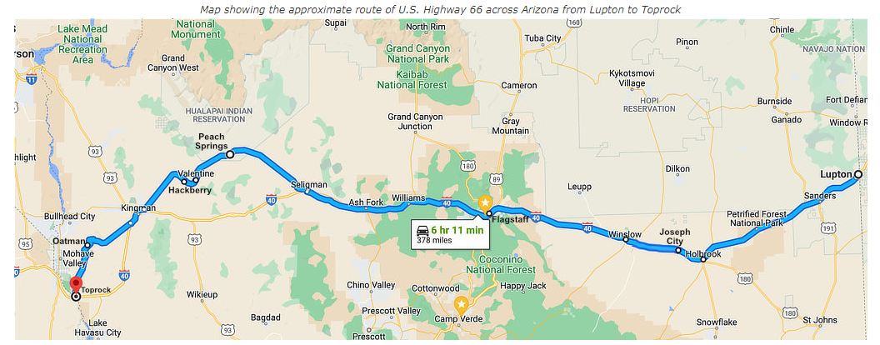
In California: 315 miles – 2 Days?

Peggy Sues Diner:- 50’s Diner with Elvis and Betty Boop
6-10 Daily
35654 W. Yermo Rd.
Yermo, Ca.

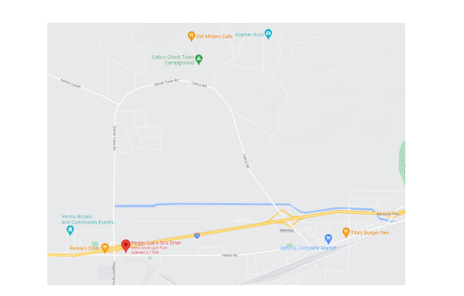

Calico Ghost Town – Old Silver Mining Town
9-5 $15
36600 Ghost Town Road
Yermo, Ca.
Note: Town is reached by loop road running between Exits 191 and 194
off I- 15

Casa Del Desierto Harvey House- Houses Route 66 Mother Road Museum.
10-4
681 N. 1st Ave.
Barstow, Ca.

Elmer Long’s Bottle Tree Ranch- Lots of Bottles(Open dawn to dusk)
24266 National Trails Hwy
Oro Grande, Ca.

Californis Route66 Museum
Open 10-4 Mon and Thurs.-Sat. 11-3 Sun. ($3)
16825 S.D Street
Victorville, Ca.

Original McDonald’s and Site Museum
9-5 Mon. - Fri. 10-5 Sat. And Sun.
1398 N. E. Street West of I215
San Bernardino, Ca.

The Donut Man- Great Donuts
915 E. Route66 Open 24 Hours
Glendora, Ca.

Bradbury Building – In Films (Blade Runner)
304 S. Broadway
Los Angeles, Ca

