Day11 Wednesday Nov 2 11 miles
Stayed in San Pedro Rest day
Found Pier 93 and Parking, Checked out Docks
Saw USS IOWA ship
Nikos Pizzeria for Dinner great Pizza

Rest Day
No driving today! We got up a little later than usual, since we had no where to be till tomorrow.
We went across the street and checked out the USS Iowa. It’s cool. Lotta history.
The Norwegian Jewel was docked at Pier93 and we found it with no problem. We also found where we would park. Everything was virtually across the street from the Motel6. We also checked out the restaurants by the pier, keeping them in mind for dinner.
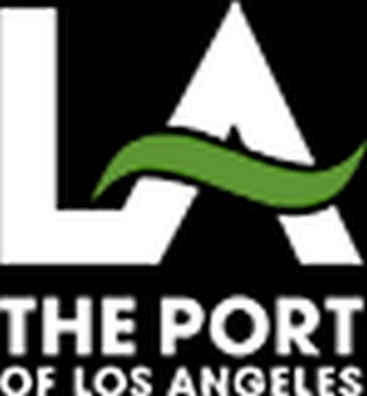
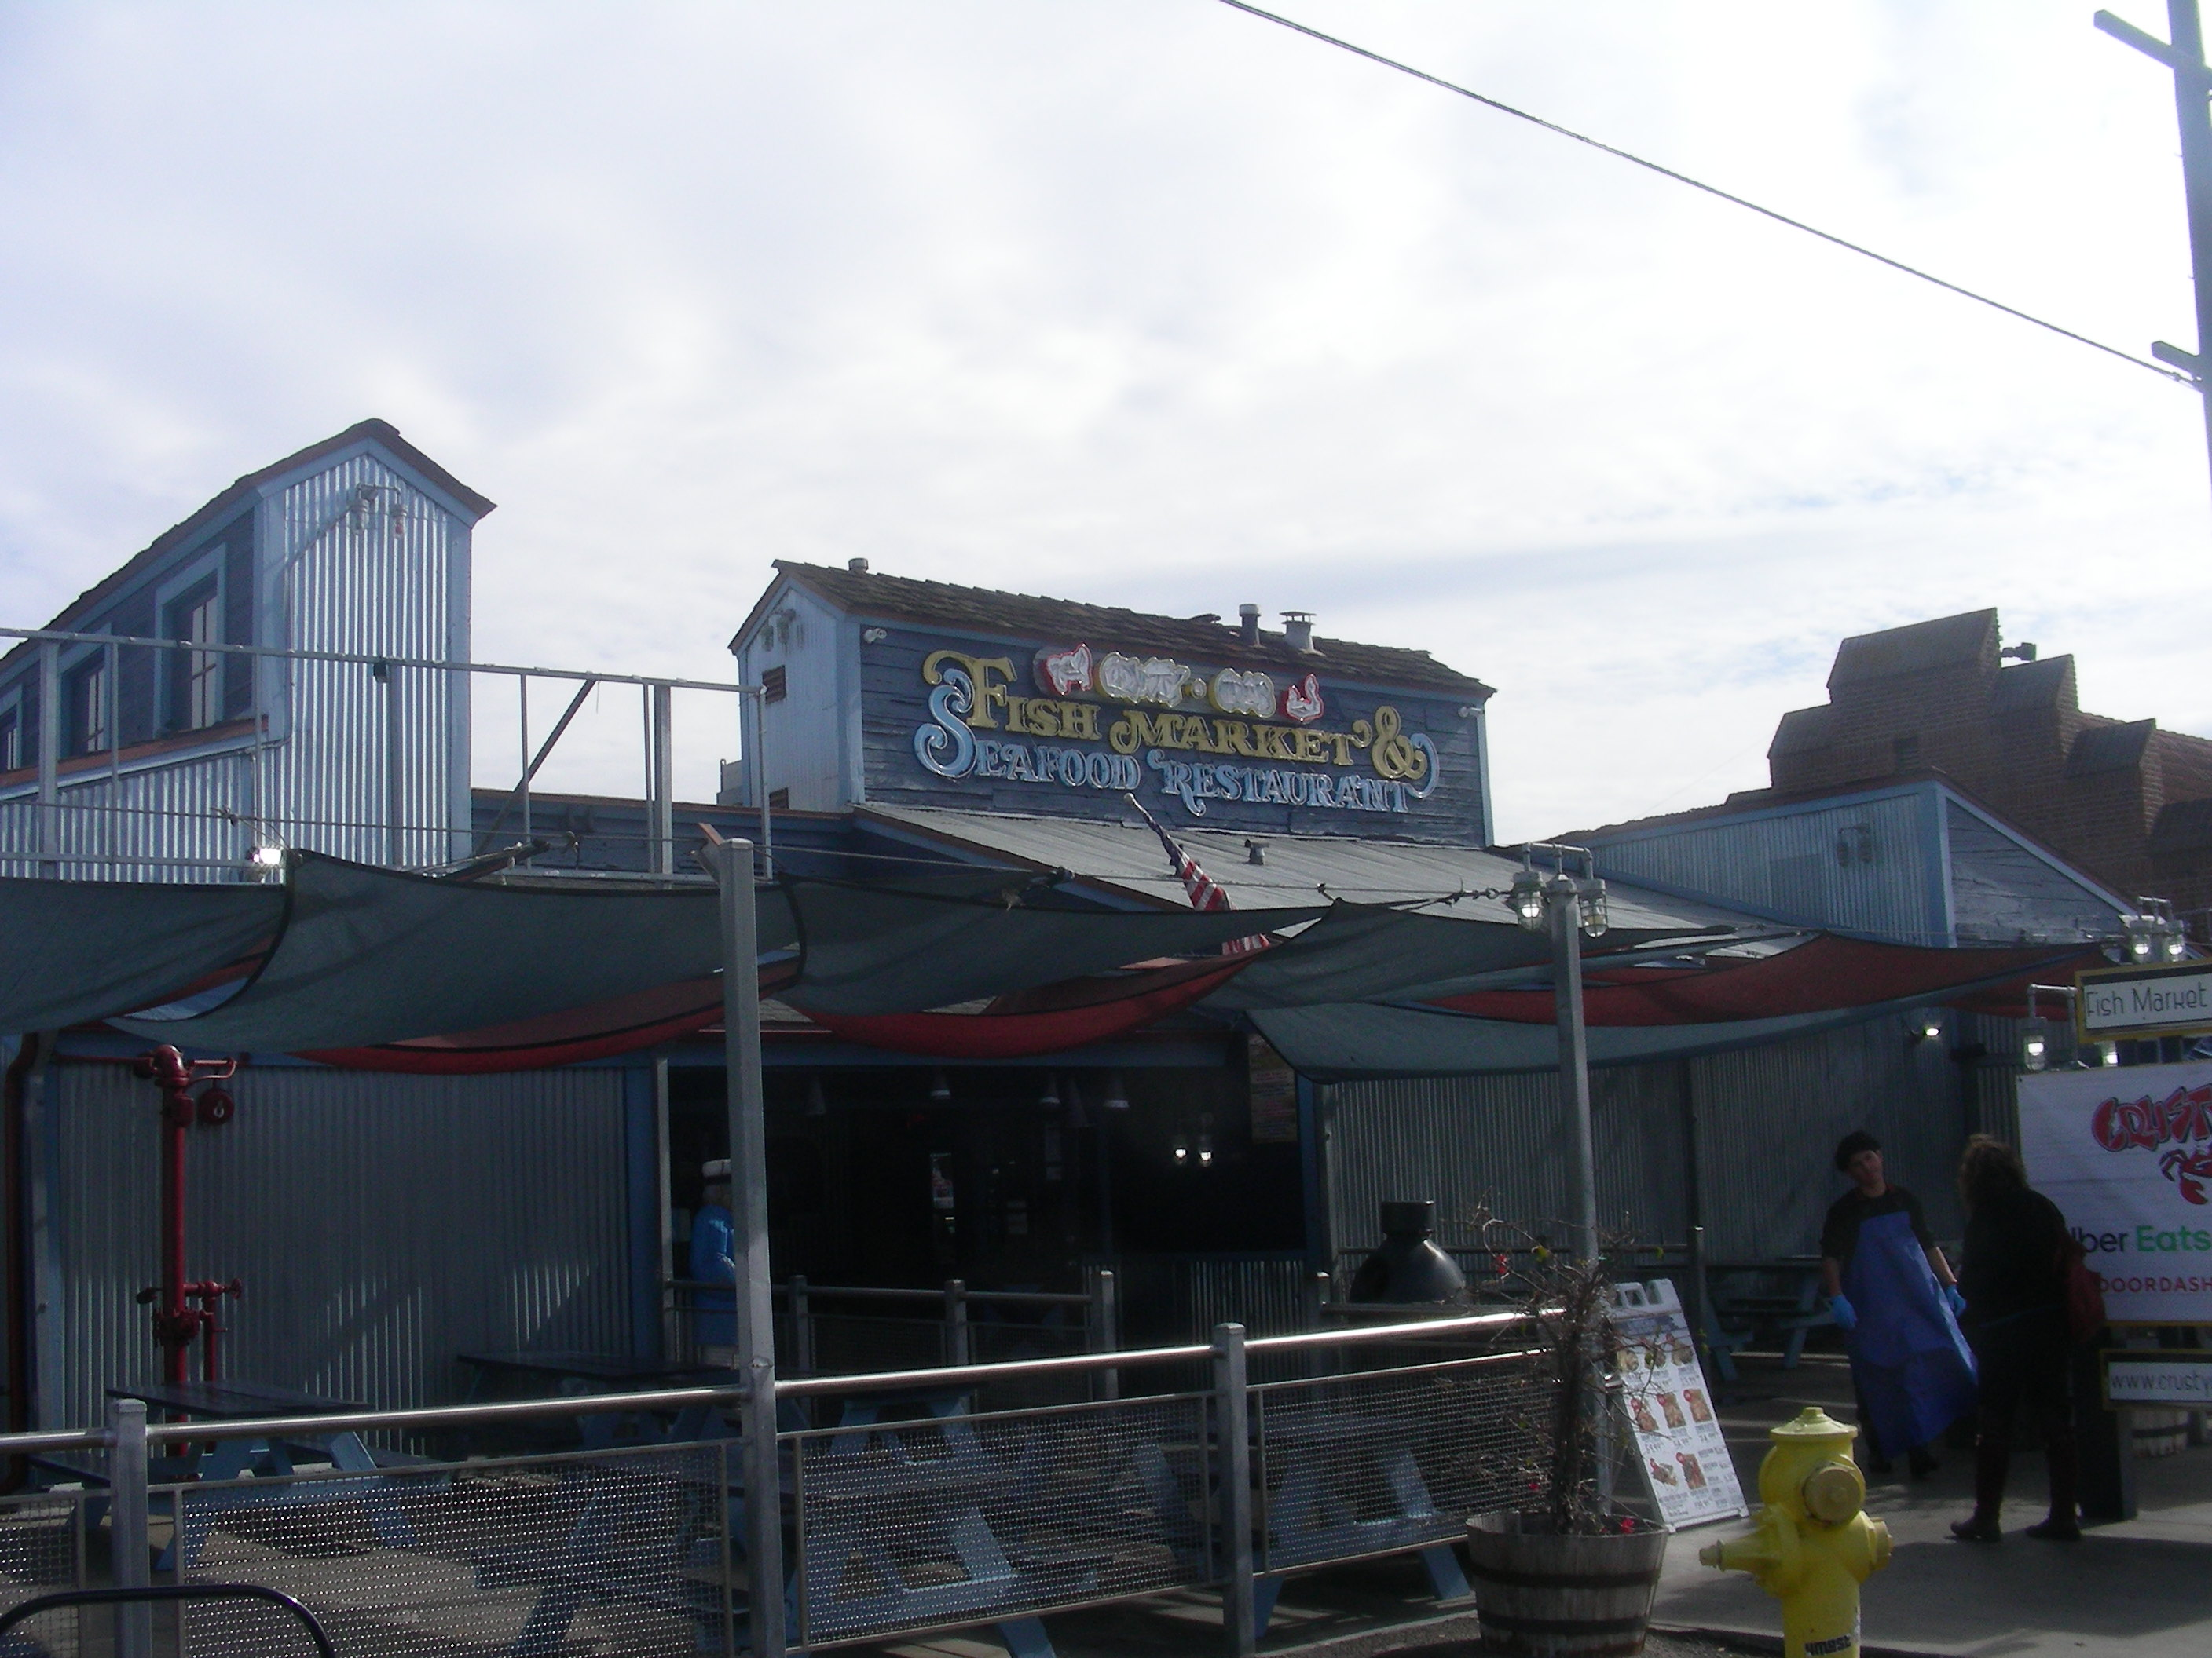
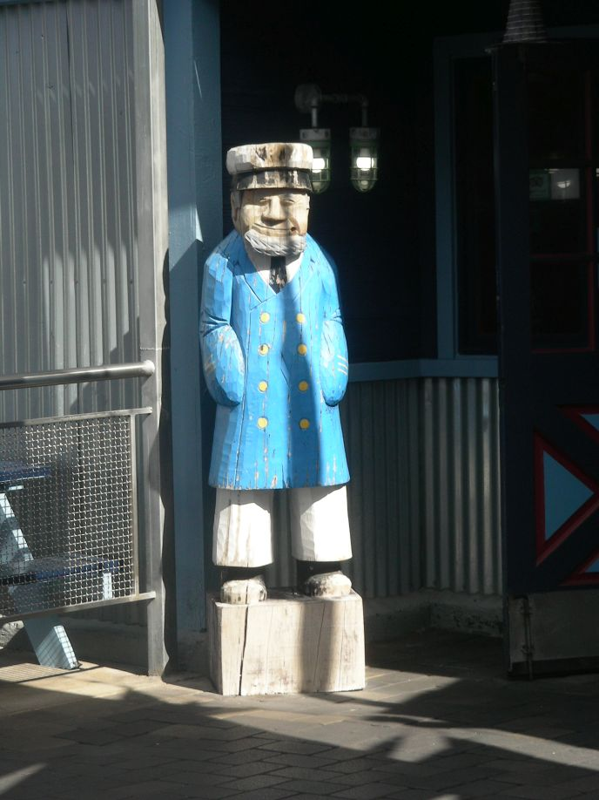
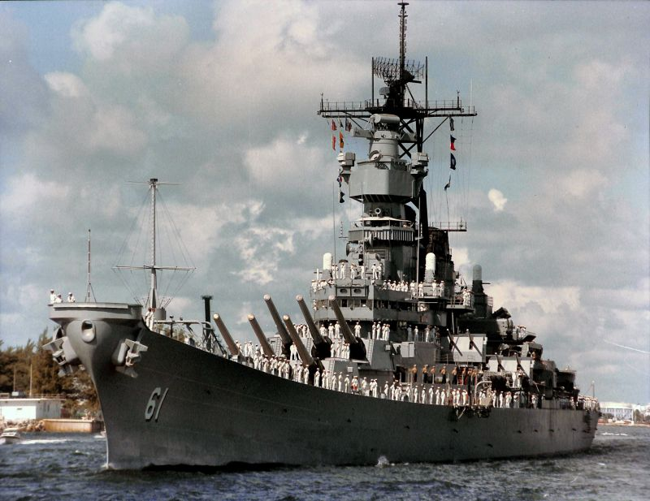
Pizza For Dinner
We decided on pizza for dinner and headed over to Niko’s Pizzeria. Niko’s was close to our Motel6, just a little east of the port. Pizza and beer was excellent. The service was excellent, and a nice employee gave me a couple of coasters to give to my friend Leonard. He collects them.
Back to the room for bedtime. Tomorrow we board the Norwegian Jewel!
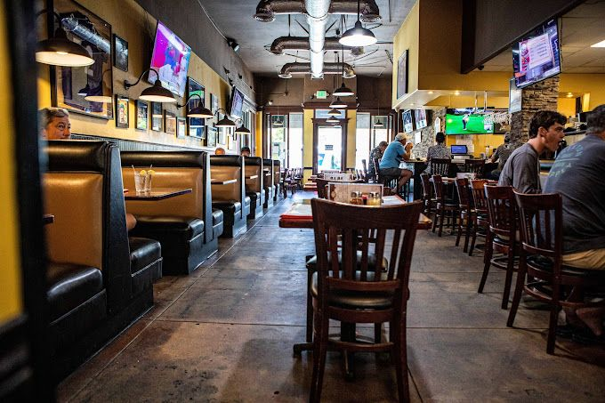
Continue On Down The Road
Home To The Index Page

