Dixie Truck Stop

Just south of Pontiac, Il, is an old truck stop(McClean, Il.) along I55. Food is great and the place has a wonderful Route66 Vibe. Check it out.

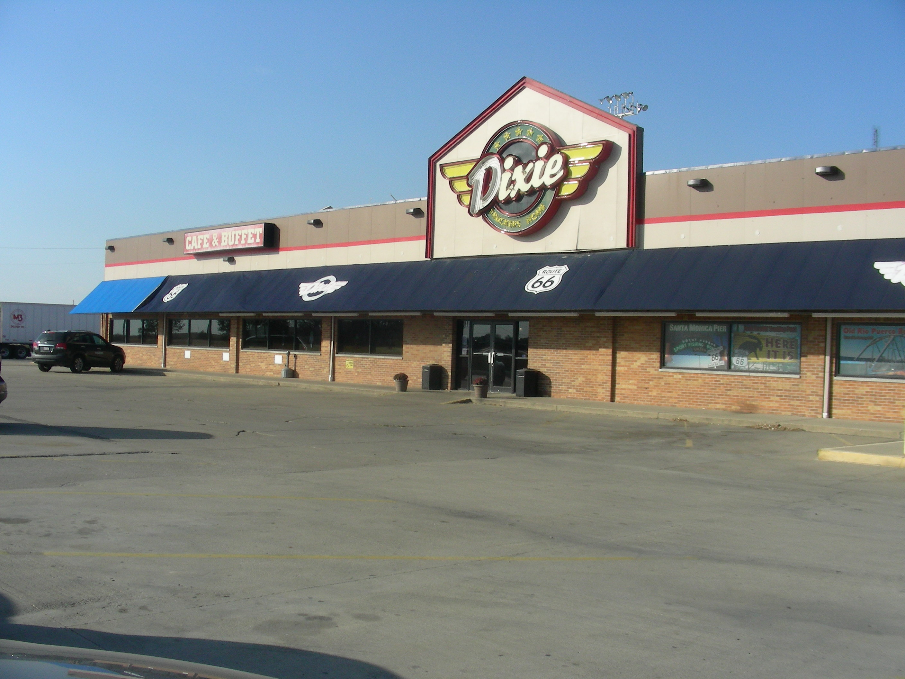
Continue Days 1-23 In Order With Pics

View All 23 Days Itinerary

View Route66 Gas Prices

View Route66 Lodging Prices

Home To Index Page

