Day 17 Tuesday Nov 8
San Pedro, CA to Kingman, AZ 362 miles
Denny's in Hesperia Breakfast
Floyd & Co BBQ in Downtown
Red Roof Inn

On The Road To Memphis
From the parking lot at the Port Of L.A., we headed for Interstate 40. We had a good breakfast at Denny’s in Hesperia, Ca., just off of Interstate15.
From there we just drove straight through to Kingman, AZ on Interstate40. We had dinner at Floyd’s BBQ, located in downtown Kingman. Excellent BBQ. Highly recommended. We settled in for the night at the Red Roof Inn.
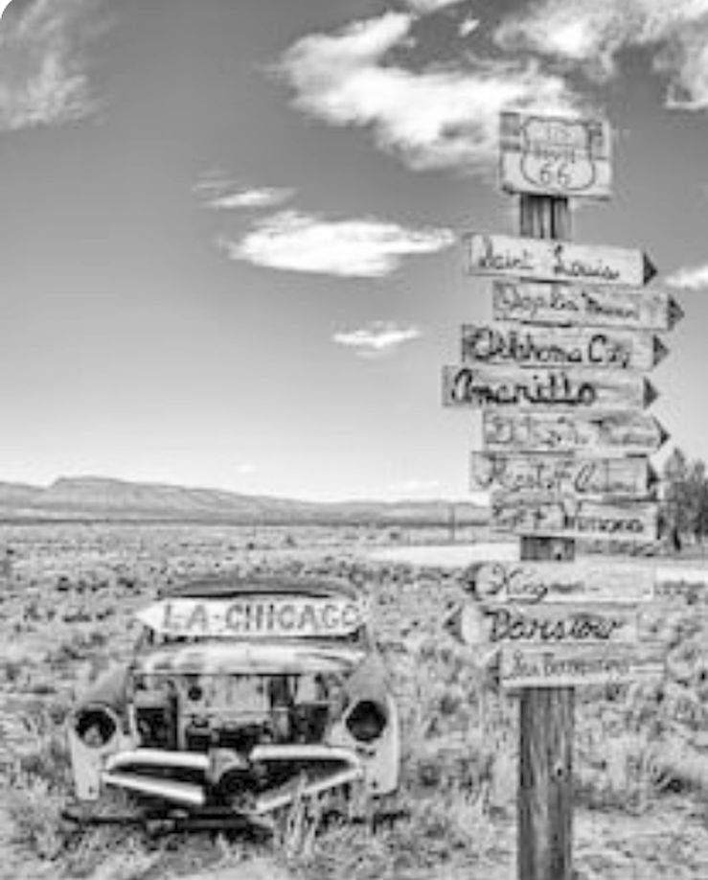

Continue On Down The Road
Home To Index Page

