5.

1. 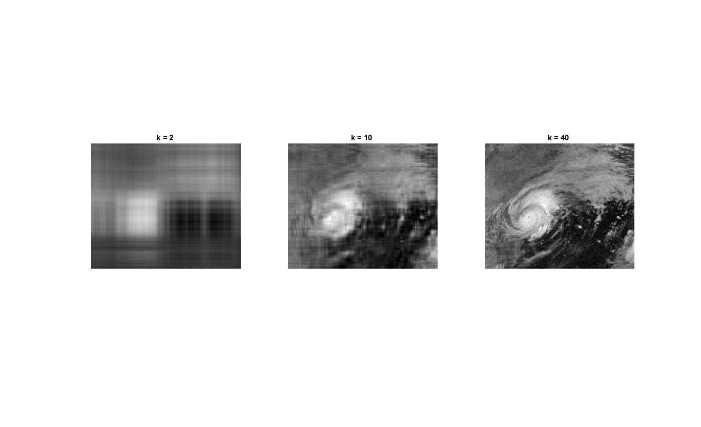

$$For k∈\left\{2, 10, 40\right\}, \frac{{\left\|X-\overline{X}\right\|}_{F}}{{\left\|X\right\|}_{F}}=[0.2815, 0.1587, 0.0837]$$

* Matlab Code

1 X = double(rgb2gray(imread('harvey-saturday-goes7am.jpg')));

2 [U,S,V] = svd(X);

3 k = [2 10 40];

4 X_approximate = zeros(size(X,1), size(X,2), size(k,2));

5 error = [];

6 for i = 1 : size(k,2)

7 X_approximate(:, :, i) = U(:, 1:k(i))*S(1:k(i), 1:k(i))*transpose(V(:, 1:k(i)));

8 error = [error norm(X - X_approximate(:,:,i),'fro')/norm(X,'fro')];

9 subplot(1, size(k,2), i);

10 imshow(uint8(X_approximate(:, :, i)));

11 txt = sprintf('k = %d ', k(i));

12 title(txt);

13 end

14 disp(error);

1. The numbers (n) we need to describe the approximation

For k = 2, n = 1296*2 + 2 + 2*1548

For k = 10, n = 1296*10 + 10 + 10*1548

For k = 40, n = 1296*40 + 40 + 40*1548