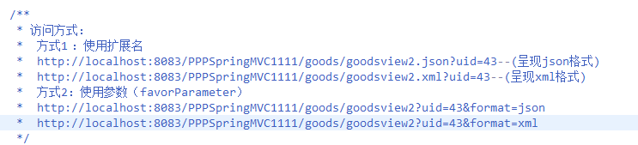

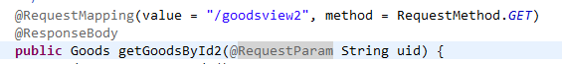

Sf标签

Spring jdbc

