
Subject Leader User Guide
Adding, editing and analysing curriculum mappings in Caerleon Skills Tracker
What this guide is for
Use this guide when you need to add curriculum entries, attach Literacy, Numeracy, DCF or cross-cutting theme evidence, edit existing mappings, and review subject-level curriculum coverage.

Quick Workflow
1. Add  Record the curriculum activity first. | 2. Evidence  Attach skills and CCT evidence where useful. | 3. Edit  Find and update mappings by subject. | 4. Analyse  Use reports to spot strengths and gaps.

1. The Subject Leader Workflow
A curriculum mapping is a record of a piece of curriculum work. Skills references and cross-cutting theme elements are evidence links attached to that activity. Start with the activity, then add evidence where it genuinely applies.
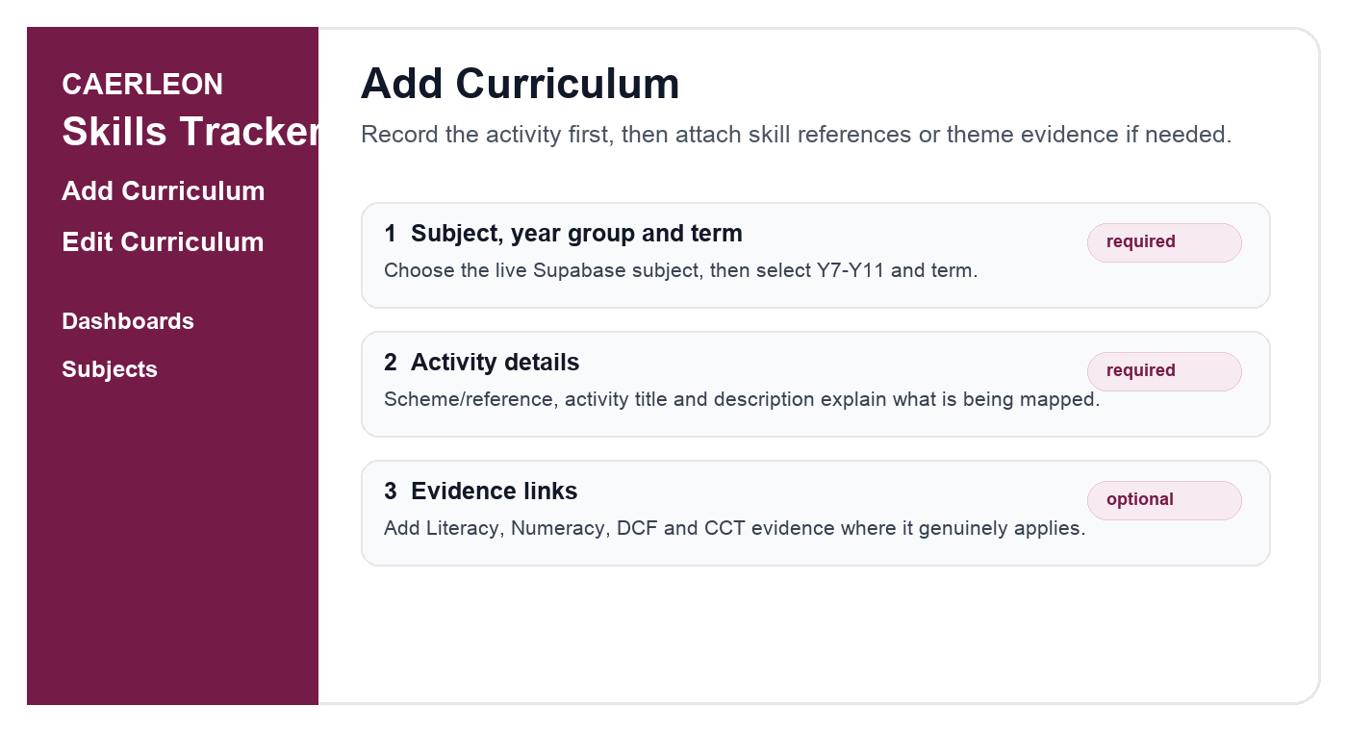
Screen guide: Add Curriculum starts with the activity, then evidence links.

What must be completed?
Area | What to enter | Required?
Subject / year / term | Choose the subject from the live subject list, then select year group and term. | Yes
Activity details | Enter scheme/reference, activity title and a brief description. | Yes
Skills references | Literacy, Numeracy and DCF links can be added if the activity evidences them. | Optional
CCT elements | Cross-cutting theme elements can be ticked if relevant. | Optional
Important
You can save a curriculum entry with no skill or CCT evidence links if the top curriculum details are complete. Evidence can be added later when a subject leader reviews the mapping.

2. Add a Curriculum Mapping
- Open Add Curriculum from the left navigation.
- Choose the subject, year group and term.
- Enter the scheme/reference, activity title and activity description.
- Add skills references only where there is genuine Literacy, Numeracy or DCF evidence.
- Add cross-cutting theme elements only where the activity genuinely evidences them.
- Choose Save mapping, or Save and add new if you are entering several schemes.

Good activity descriptions
A useful description says what pupils do and what the curriculum intention is. It does not need to be long, but it should make the evidence understandable later.
Example
Pupils investigate global connections using maps, short sources and data. They discuss how trade, migration and communication affect local and international places, then create a short evidence summary.

3. Add Skills Framework References
Skills framework references are for Literacy, Numeracy and the Digital Competence Framework. The system uses the live framework tables and official progression descriptors.
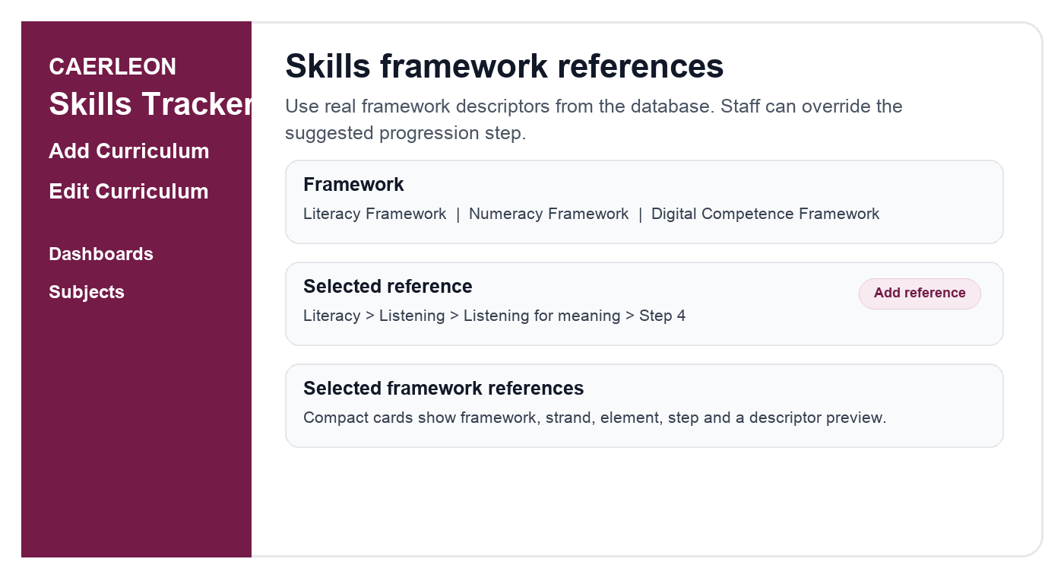
Screen guide: add a framework reference, then it appears in the selected references list.

How to choose a skills reference
- Choose Literacy Framework, Numeracy Framework or Digital Competence Framework.
- Choose the strand and element. Short labels are used where official strand names are very long.
- Choose the progression step. For Year 10 and Year 11, Step 5 is selected by default where available, but staff can override it.
- Read the official descriptor to check it matches the activity.
- Add an optional note explaining why the activity meets the reference.
- Click Add framework reference.

Subject leader checks for skills
- Is the reference authentic, or is it being stretched?
- Does the progression step match the expectation for the year group?
- Are Numeracy and DCF opportunities visible beyond the obvious departments?
- Are there repeated references that could be consolidated or clarified?

4. Add Cross-Cutting Theme Evidence
Cross-cutting themes are not progression frameworks. They are mapped through specific theme elements grouped under the five parent themes. Tick one or more elements if the activity genuinely evidences them.
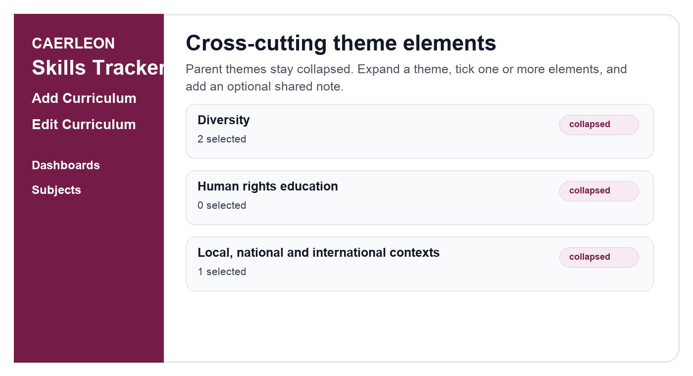
Screen guide: CCT parent themes are collapsed by default; selected counts remain visible.

Using CCT elements well
- Expand only the parent themes that are relevant to the activity.
- Tick the specific element or elements evidenced by the activity.
- Use the optional note to explain the link if it will help future reviewers.
- Do not tick a parent theme just because the topic sounds related; choose the specific element that is evidenced.

5. Edit Existing Curriculum Mappings
Use Edit Curriculum to browse existing mappings by subject, year group and scheme/reference. This is the main place for subject leaders to tidy, improve and update existing evidence.
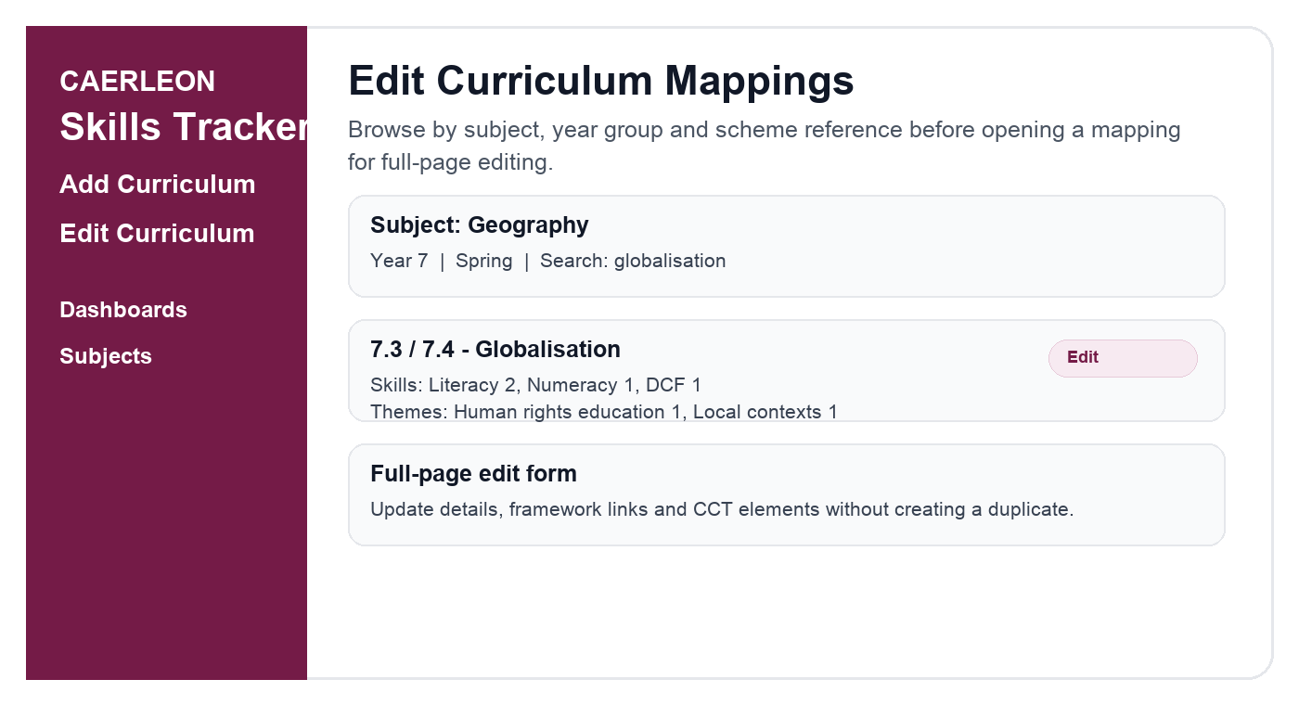
Screen guide: browse first, then open a selected mapping in the full-page edit form.

Editing safely
- Open Edit Curriculum.
- Choose your subject and filter by year group, term or keyword.
- Find the scheme/reference in chronological order.
- Choose Edit to open the full-page edit form.
- Update curriculum details, skills references or CCT elements.
- Save changes. The existing mapping is updated; a duplicate mapping should not be created.

Common editing tasks
Task | What to do
Change the activity description | Edit the curriculum details section and save changes.
Add DCF evidence | Add a framework reference and choose Digital Competence Framework.
Remove a weak skills link | Remove the selected framework reference card before saving.
Add CCT evidence | Expand the relevant parent theme and tick the specific CCT element.
Correct the subject or term | Update the top curriculum details and save changes.

6. Analyse Curriculum Data as a Subject Leader
Subject leaders should use the reporting pages to move from data entry to curriculum improvement. The useful question is not simply how many links exist, but whether the curriculum journey is coherent and whether evidence is meaningful.
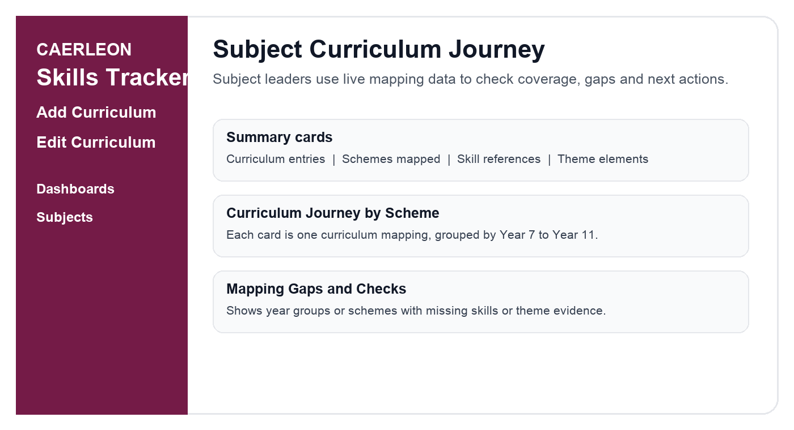
Screen guide: subject analysis focuses on curriculum journey, evidence and gaps.

Where to look
Page | Use it for | Subject leader action
Subject Curriculum Journey | Review schemes, skills and CCT evidence for one subject. | Check gaps, then edit weak mappings.
Subject Health Report | Summarise subject coverage and improvement actions. | Use in department review meetings.
Skills Explorer | Browse mapped activities and framework evidence. | Check whether entries appear in the right framework views.
Progression Overview | See Step 3, Step 4 and Step 5 coverage. | Look for underrepresented progression steps.
SLT Improvement Dashboard | Whole-school picture for senior leaders. | Use for cross-department priorities.

Interpreting the Subject Curriculum Journey
- Each card should represent one real curriculum mapping, not one card per skills link.
- Skills should be grouped as Literacy, Numeracy and DCF counts rather than repeated labels.
- CCT evidence should show parent theme and element, for example Diversity > Challenge stereotypes.
- Use View details to inspect exact strand, element, step and notes.
- Use Edit mapping when a scheme has missing or weak evidence.

7. A Half-Termly Review Routine
A short, regular review is more useful than a large clean-up once a year. This routine keeps curriculum mapping accurate without overwhelming departments.
Done | Review area | Prompt
[ ] | Curriculum entries | Are the current schemes present for each year group and term?
[ ] | Skills evidence | Do Literacy, Numeracy and DCF links reflect authentic learning?
[ ] | Progression steps | Do Year 10 and Year 11 mappings include appropriate Step 5 opportunities where relevant?
[ ] | CCT evidence | Are theme elements mapped specifically, not just broadly?
[ ] | Gaps and checks | Which mappings need editing before the next department review?

8. Troubleshooting
If this happens | Try this
A subject is missing from a dropdown | Ask an admin to check the Subjects list in Admin. Dropdowns should use live Supabase subjects.
No progression descriptors appear | Check that a framework, strand and element are selected. If still blank, ask an admin to check framework seed data.
A CCT theme looks empty | Expand the parent theme. If no element appears, ask an admin to confirm CCT elements are active for the school.
A mapping appears duplicated | Check whether duplicate parent curriculum mappings exist for the same subject, year, term and scheme/reference.
You are redirected to login | Your session may have expired. Sign in again, then return to the page you were using.

Subject Leader Checklist
- New mappings have a clear activity title and description.
- Evidence links are authentic and not over-mapped.
- CCT selections use specific elements, not broad theme assumptions.
- Year 10 and Year 11 progression steps have been checked for Step 5 where appropriate.
- Subject reports have been reviewed for gaps before department or SLT discussion.

