
CAERLEON SKILLS TRACKER
Teacher and Subject Leader User Guide
Purpose
A practical guide to adding, editing and reviewing curriculum mapping across Literacy, Numeracy, DCF and Cross-Cutting Themes.

Version: __________ Date: __________

Maximising Potential / Sicrhewch Ragoriaeth

QUICK START OVERVIEW

Quick Start Overview
The Skills Tracker helps staff record where curriculum activities develop Literacy, Numeracy, Digital Competence and Cross-Cutting Theme evidence. The system works best when each entry describes a real piece of curriculum work, then attaches the relevant evidence.
5-minute workflow
Log in -> choose your subject -> select year group and term -> add or edit the curriculum activity -> add meaningful skills or theme evidence -> save -> review subject health.

- Log in with your staff account.
- Use Add Curriculum to create a new mapping, or Edit Curriculum to update an existing one.
- Choose the subject, year group and term.
- Describe the activity clearly enough that another teacher understands what pupils do.
- Add Literacy, Numeracy, DCF and/or Cross-Cutting Theme evidence where it is genuinely taught, practised or assessed.
- Save, then use Subject Health Report or Subject Detail to review coverage.

Current navigation map
Menu area | What is there | When to use it
Primary actions | Add Curriculum; Edit Curriculum | Create new curriculum mappings or find and update existing ones.
Dashboards | Whole School; Literacy; Numeracy; DCF; Themes | Review overall evidence patterns and framework coverage.
Subjects | Subject View; Subject Detail | Review curriculum mapping by subject and open subject-level detail.
Explore | Skills Explorer; Progression Overview; Year Group Journey; Framework Browser | Browse mapped activity, progression steps, year group journeys and framework reference data.
Review | Subject Health Report; SLT Improvement Dashboard; Recent Updates; Review Summary | Use for subject review, leadership oversight and recent mapping checks.
Setup / Admin | Admin and user-management tools, depending on role | Manage setup only if your role allows it.

LOGGING IN AND ACCESS

Logging In and Access
Use the login page supplied by the school. The app is protected, so curriculum pages should only be visible when you are signed in.
Role | Typical access | What this means
Teacher | Assigned subject access | Add or edit mappings for subjects assigned to you.
Subject lead | Department review access | Review subject health and update curriculum evidence for your subject area.
School admin | School setup and broader access | Manage subjects, frameworks, users and curriculum data where authorised.
Platform admin | Platform-level access | Support setup and testing across roles.

If access looks wrong
If you cannot see your subject, cannot edit an entry, or see a page you do not expect, contact the system administrator. Access is role-based and may need your staff profile or subject assignment checking.

UNDERSTANDING THE HOME/DASHBOARD

Understanding the Home/Dashboard
The dashboard and subject pages are designed to show what has been mapped, where evidence exists and where gaps may need attention. Counts and cards should be treated as curriculum review prompts, not judgements on individual teachers.
Area of screen | What it shows | What teachers should do with it
Subject cards | Subjects and mapped opportunities. | Open your subject to check entries and coverage.
Year groups | Where curriculum entries sit from Year 7 to Year 11. | Check that mappings match your department sequence.
Framework evidence | Literacy, Numeracy and DCF references attached to entries. | Look for genuine taught opportunities and progression.
Theme evidence | Cross-Cutting Theme elements attached to entries. | Check wider curriculum themes are visible where appropriate.
Review links | Subject Health Report and whole-school dashboards. | Use for department discussion and improvement planning.

ADDING CURRICULUM

Adding Curriculum
Use Add Curriculum when you want to record a new piece of curriculum work. Start with the curriculum activity, then add the evidence links.
- Open Add Curriculum from the primary action button in the sidebar.
- Choose the subject from the live subject list.
- Select the year group and term.
- Add the scheme or unit reference, for example CT7.2 or 8.3.
- Add a clear activity title.
- Write a brief description of the activity or project.
- Add skills/framework references and Cross-Cutting Theme elements if relevant.
- Press Save mapping. The form clears after a successful save.

What a good curriculum entry looks like
Weak entry | Better entry | Why it is better
Fractions | Using equivalent fractions, simplifying fractions and applying fractions to real-life problem solving. | It explains what pupils actually learn and apply.
Presentation | Creating and evaluating a digital presentation for a specific audience using image, text and charts. | It gives enough detail to support DCF and Literacy mapping.
Sources | Investigating Windrush source material, identifying viewpoint and discussing human rights themes. | It makes skills and Cross-Cutting Themes visible.

MAPPING CURRICULUM TO SKILLS

Mapping Curriculum to Skills
Mappings should be meaningful. Add a reference when the skill or theme is genuinely taught, practised or assessed in the activity. Avoid mapping everything to everything.

Literacy, Numeracy and DCF
- Choose the framework: Literacy Framework, Numeracy Framework or Digital Competence Framework.
- Choose the strand. Some long Numeracy strands use shorter button labels, but the official strand name remains stored in the system.
- Choose the element.
- Choose the progression descriptor. The default step may be selected automatically, but staff can override it.
- Add an optional note explaining where the skill appears.
- Click Add framework reference. You can add more than one reference for the same activity.

Cross-Cutting Themes
Cross-Cutting Themes are separate from Literacy, Numeracy and DCF. They are recorded as theme elements, not progression steps.
- Open the Cross-Cutting Themes section.
- Expand the relevant parent theme, such as Diversity or Human rights education.
- Tick one or more specific theme elements.
- Add a short optional note if it helps explain the evidence.
- You can select several theme elements across different parent themes for one activity.

Useful evidence notes
Area | Example note
Literacy | Learners write an extended explanation comparing two viewpoints.
Numeracy | Learners interpret data from a graph and justify conclusions.
DCF | Learners create and evaluate a digital presentation for a specific audience.
Cross-Cutting Themes | The activity explores stereotypes and encourages pupils to challenge assumptions respectfully.

EDITING CURRICULUM

Editing Curriculum
Use Edit Curriculum to find existing mappings and update them. This avoids creating duplicate entries for the same piece of work.
- Open Edit Curriculum from the sidebar.
- Choose your subject.
- Use year group, term and search filters to find the mapping.
- Click Edit on the mapping card.
- Update subject, year group, term, scheme reference, title or description as needed.
- Add or remove skills/framework references.
- Add or remove Cross-Cutting Theme elements.
- Click Save changes. Use Back to subject browser to return to the same subject context.
Careful editing
Only edit entries you are responsible for. If unsure, check with your subject lead. Editing should improve accuracy, not overwrite another teacher’s curriculum planning unexpectedly.

DELETING OR ARCHIVING CURRICULUM

Deleting or Archiving Curriculum
Admin users may see a Delete mapping button when editing a mapping. Deleting a mapping removes the parent curriculum entry and its linked skills and Cross-Cutting Theme evidence. Teachers who do not see this option should contact a subject lead or system administrator.
Situation | Better action
Spelling mistake or minor wording problem | Edit the entry and save changes.
Curriculum content has changed | Update the existing entry so the journey remains accurate.
Duplicate entry was created by mistake | Ask an admin to delete the duplicate mapping.
Outdated curriculum no longer taught | Check with the subject lead before deleting or archiving.

VIEWING SUBJECT HEALTH

Viewing Subject Health
Subject Health is a curriculum review tool. It is not a judgement on individual teachers. It helps departments spot where curriculum evidence is strong, thin, repeated or missing.
Indicator | What it may suggest | Possible action
Low DCF coverage | Digital skills may be under-recorded or not explicitly taught. | Review where digital competence is genuinely developed.
Many unmapped entries | Activities exist but evidence links have not been added. | Add appropriate skills or theme references.
Repeated same element | Coverage may be narrow. | Check breadth of skills coverage across the year.
Strong coverage but weak notes | Evidence exists but may not be clear to reviewers. | Improve concise notes explaining the link.
No theme elements in a year group | Wider curriculum themes may not be visible. | Review authentic Cross-Cutting Theme opportunities.

BROWSING OTHER SUBJECTS

Browsing Other Subjects
Browsing other subjects supports curriculum awareness and collaboration. It is not for editing another subject’s curriculum unless you are authorised.
- Use Subject View or Subject Detail to review another subject’s mapped curriculum journey.
- Use Skills Explorer to browse mapped activities by framework, strand, element, subject or year group.
- Use Progression Overview to see mapped opportunities by progression step.
- Use Year Group Journey to understand how evidence is distributed across years.
- Use Framework Browser to inspect the live framework, strand, element and descriptor data.
Professional use
Browsing other subjects is for curriculum awareness, collaboration and whole-school skills planning. If you spot an issue, discuss it with the relevant subject lead rather than editing directly unless authorised.

GOOD MAPPING PRINCIPLES

Good Mapping Principles
Do | Avoid
Map specific taught opportunities. | Mapping whole units vaguely.
Use concise evidence notes. | Adding every framework element just in case.
Check progression across year groups. | Treating mapping as a compliance tick-box.
Discuss gaps as a department. | Duplicating entries instead of editing existing ones.
Think about the learner experience. | Mapping skills that pupils do not actually practise.

Quality over coverage
A smaller number of accurate, well-evidenced mappings is more useful than a large number of vague links. The question is: where do pupils genuinely develop this skill or theme?

SUBJECT LEADER USE

Subject Leader Use
Subject leaders can use the tracker to support department review, curriculum conversations and improvement planning.
- Review curriculum by year group and term.
- Check whether key schemes of learning have been mapped.
- Look for Literacy, Numeracy and DCF evidence across the subject journey.
- Check whether Cross-Cutting Theme elements are visible where appropriate.
- Use Subject Health Report to identify gaps and strengths.
- Use reports as prompts for professional conversation, not as a compliance checklist.

Useful subject leader questions
- Where are pupils explicitly developing Literacy?
- Where is Numeracy genuinely embedded?
- Where is DCF meaningful rather than tokenistic?
- Are Cross-Cutting Themes visible across the curriculum?
- Is there progression from Year 7 to Year 9 and into Year 10 or Year 11 where relevant?
- Are we repeating the same skills while missing other important elements?
TROUBLESHOOTING

Troubleshooting
Problem | Possible cause | What to do
I cannot log in. | Your account/session may have expired or your account may not be set up. | Go to the login page and sign in again. If it continues, contact the system administrator.
I cannot see my subject. | Your staff profile may not have the subject assigned. | Ask an administrator to check your subject permissions.
I cannot edit an entry. | Your role may be read-only or the entry belongs to another subject. | Check with your subject lead or administrator.
My mapping has not saved. | Required top fields may be incomplete, or the session may have expired. | Check subject, year group, term and title, then try again. If redirected, sign in and retry.
I cannot find a year group. | A filter may be active or the entry may be saved under another year. | Clear filters in Edit Curriculum and search by title or scheme reference.
I accidentally added the wrong mapping. | A duplicate or incorrect entry may have been saved. | Edit it if possible, or ask an admin to delete the duplicate.
Subject health does not look right. | Mappings may be missing, duplicated or not linked to skills/theme elements. | Use Edit Curriculum to inspect entries and check evidence links.

FINAL CHECK

Before Saving a Mapping
- Is the subject correct?
- Is the year group and term correct?
- Does the scheme/reference match the department plan?
- Does the title describe the activity clearly?
- Are skill references meaningful and not excessive?
- Have Cross-Cutting Theme elements been selected only where there is genuine evidence?
- Would another teacher understand the mapping from the description and notes?

Visual Walkthrough for Teachers and Subject Leaders
This section is written as a practical walkthrough. It shows the normal route a teacher or subject leader uses: add a curriculum activity, attach genuine evidence, edit it later, and then review the subject curriculum journey.
Principle
Start with the curriculum activity. Add skills and cross-cutting theme evidence only where pupils genuinely develop or practise it. Leaving evidence blank is better than forcing a weak link.

1. Add a new curriculum entry
Use Add Curriculum when you are recording a planned activity, unit or piece of work. The first two sections are the core curriculum record: subject, year group, term, scheme reference, title and description.
- Open Add Curriculum from the sidebar.
- Choose the subject, year group and term.
- Enter the scheme/reference used by your department, for example 7.1 7.2 or CT7.2.
- Enter the activity title and a short description of what pupils do.
- Add skills and theme evidence if it is genuinely represented, then press Save mapping.
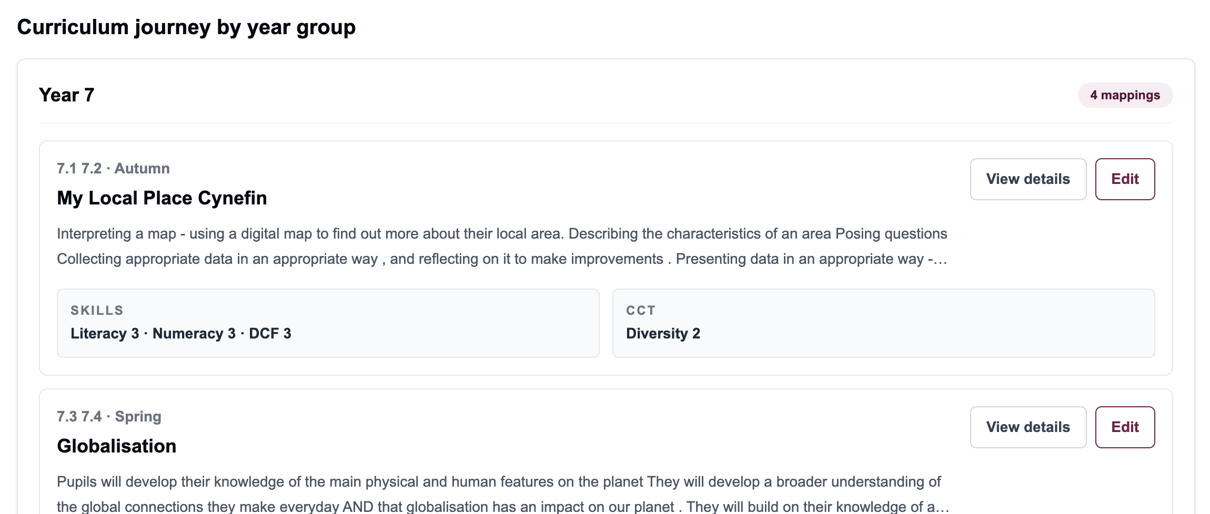
Screenshot: Add Curriculum starts with the curriculum activity before evidence is added.

Worked example: Geography Year 7
This is the sort of entry a subject leader could model for the department. The evidence should describe what is actually happening in the lesson or unit, not just list labels.
Field | Example entry
Subject | Geography
Year group and term | Year 7 · Autumn
Scheme/reference | 7.1 7.2
Activity title | My Local Place Cynefin
Activity description | Pupils use digital maps to investigate their local area, pose questions, collect appropriate data and present findings.
Possible skills evidence | Literacy, Numeracy and DCF only where pupils genuinely practise those skills.
Possible CCT evidence | Diversity or local, national and international contexts where the activity genuinely supports that theme.

2. Add Literacy, Numeracy or DCF evidence
The framework section lets you add more than one skill reference to the same curriculum activity. Each reference is saved separately, but it remains attached to the same activity.
- Choose Literacy, Numeracy or DCF.
- Choose the strand and element that best fit the activity.
- Choose the progression step descriptor. Step 4 or Step 5 may be selected automatically depending on the year group, but you can change it.
- Add a short note explaining the link if it will help another teacher understand the evidence.
- Click Add framework reference. Repeat if the activity genuinely develops another skill.
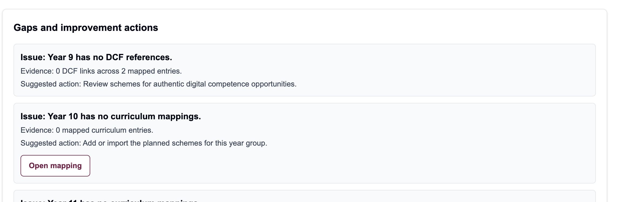
Screenshot: add a framework reference, choose the step, then add it to the activity.
Good evidence note
Instead of “Literacy covered”, write something like: Pupils listen to a source extract, identify implied meaning and use this to inform discussion.

3. Add cross-cutting theme evidence
Cross-cutting themes are not progression frameworks. They are theme elements. You can select more than one theme element for the same activity.
- Open the relevant parent theme, for example Diversity or Human rights education.
- Tick one or more specific theme elements.
- Use the notes box to explain how the activity links to the selected theme elements.
- Do not select a theme unless it is genuinely represented in the activity.
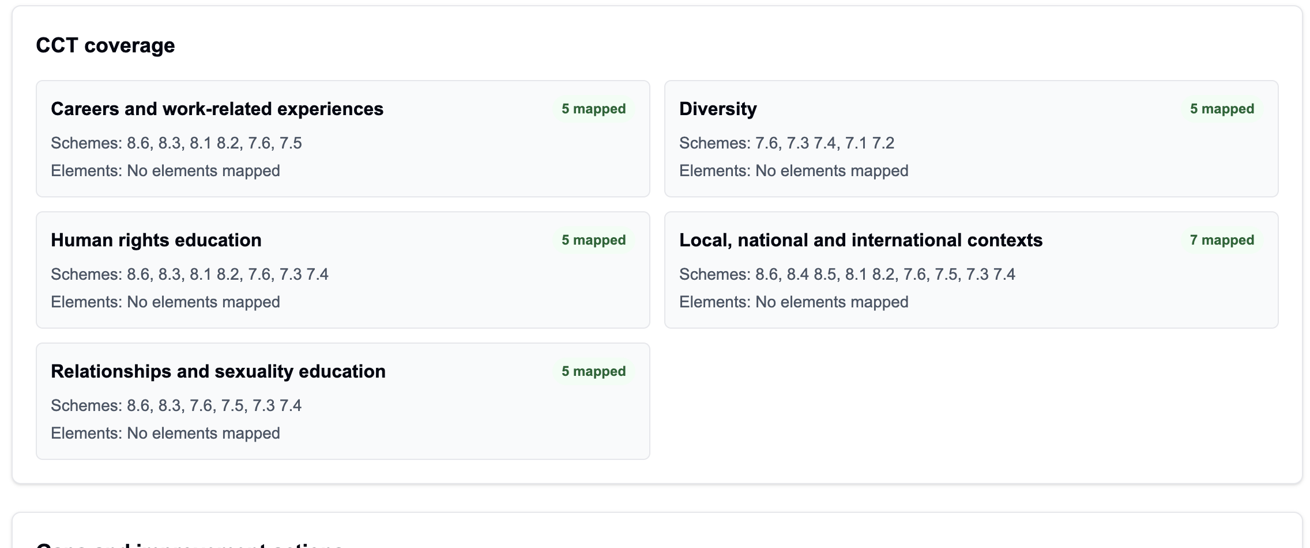
Screenshot: CCT themes are grouped; expand a theme and select the specific elements that apply.

4. Edit an existing curriculum mapping
Use Edit Curriculum when the activity already exists. This prevents duplicates and lets you update the same curriculum record.
- Open Edit Curriculum.
- Choose the subject, then use year group, term and search filters to find the activity.
- Click Edit on the activity card.
- Change the curriculum details or add/remove skill and theme evidence.
- Press Save changes. Use Back to subject browser to return to the same subject list.
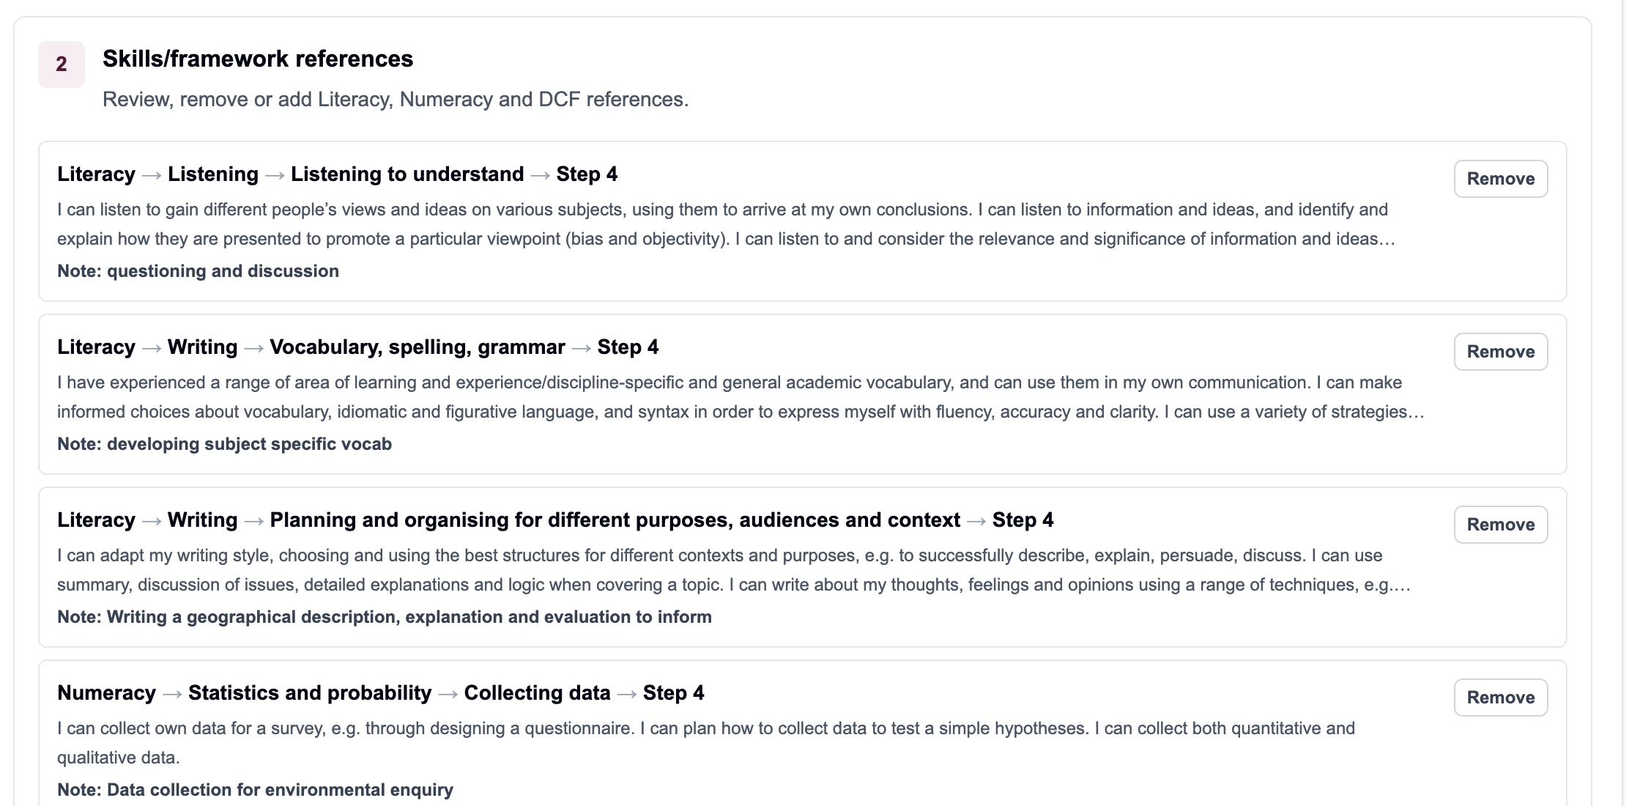
Screenshot: Edit Curriculum shows mappings grouped by year group, with Edit and Delete options where permitted.
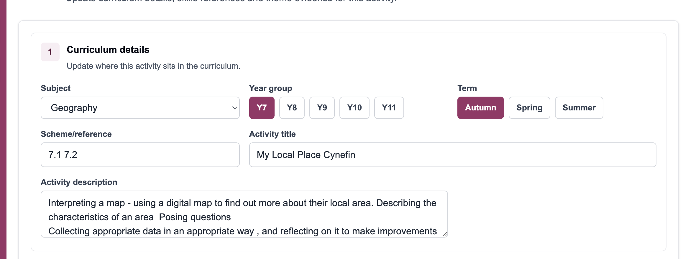
Screenshot: when editing, update the curriculum details first.
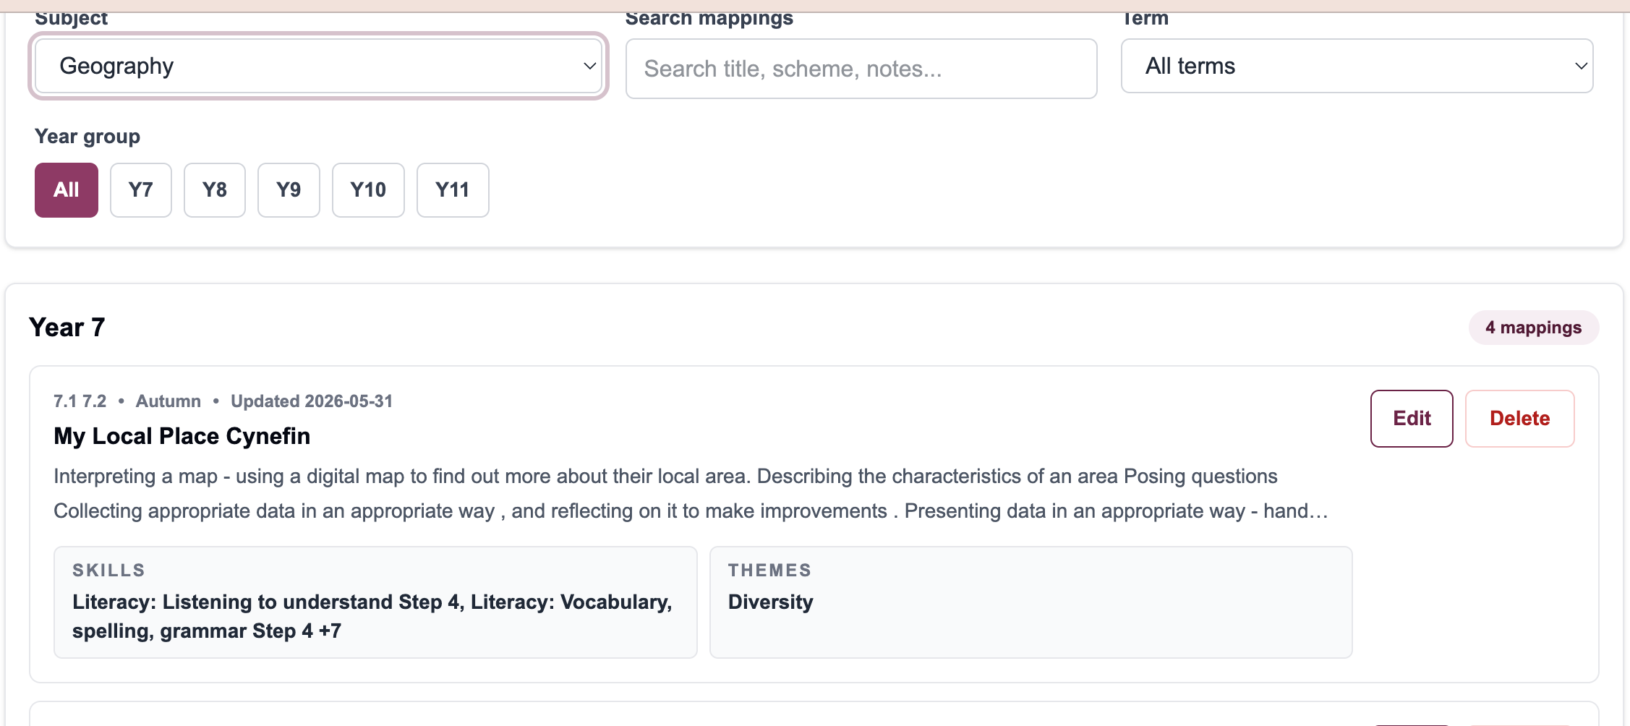
Screenshot: existing skill references can be reviewed or removed before saving changes.
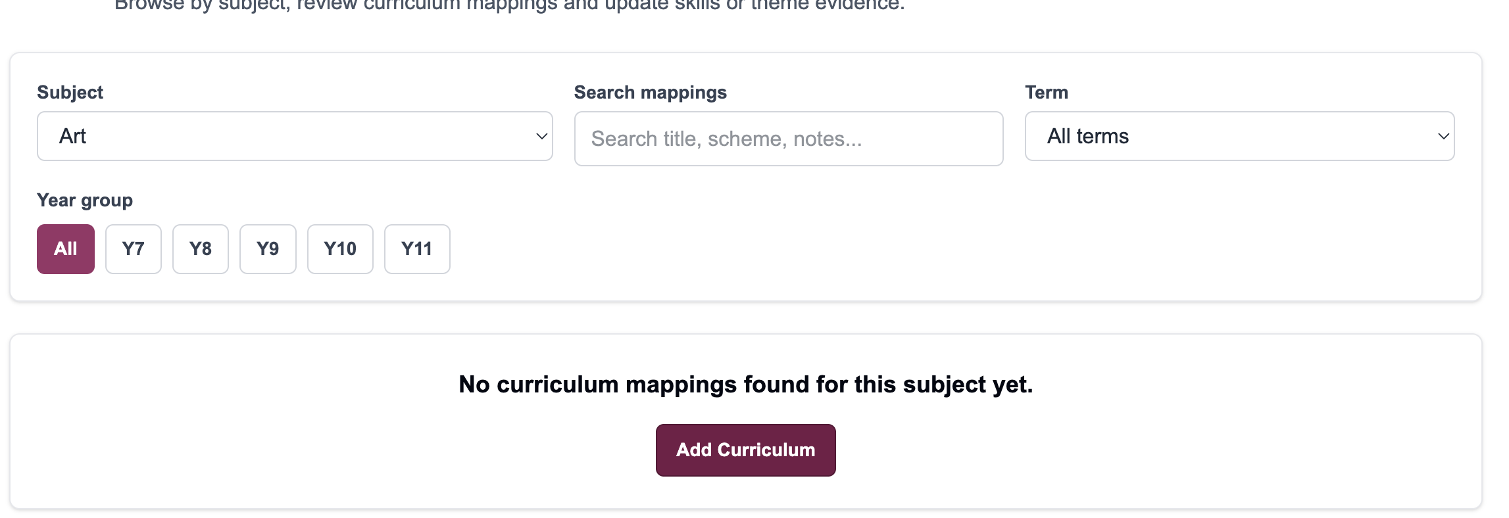
Screenshot: add or update theme notes, then save changes.

5. Explore and review a subject curriculum
Subject leaders use the review screens to check whether the department’s curriculum map is balanced, complete and useful. The key question is not “have we filled every box?” but “does the evidence reflect what pupils actually experience?”
Subject leader task | Where to go | What to look for
Check the sequence of mapped work | Edit Curriculum or Subject Detail | Are schemes listed in the right year group and term? Are there missing units?
Inspect a subject’s evidence | Subject Health Report | Which year groups have Literacy, Numeracy, DCF and CCT evidence?
Find gaps | Gaps and improvement actions | Look for missing DCF, no CCT evidence or year groups with no entries.
Review exact evidence | View details or Edit | Check the actual elements, descriptors and teacher notes.
Improve over time | Edit Curriculum | Update the existing record rather than creating a duplicate.

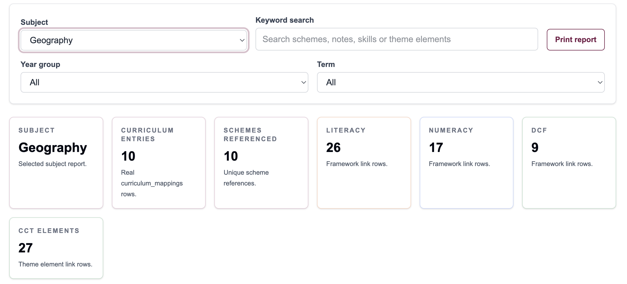
Screenshot: Subject Health Report gives a live summary for the selected subject.
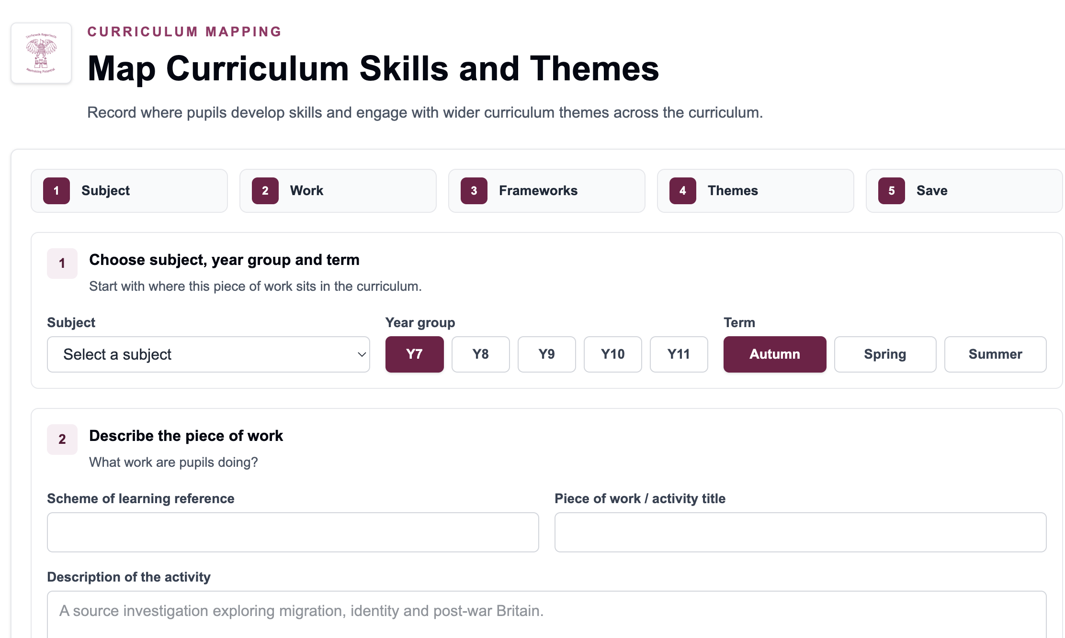
Screenshot: the curriculum journey shows each mapped activity once, grouped by year group.
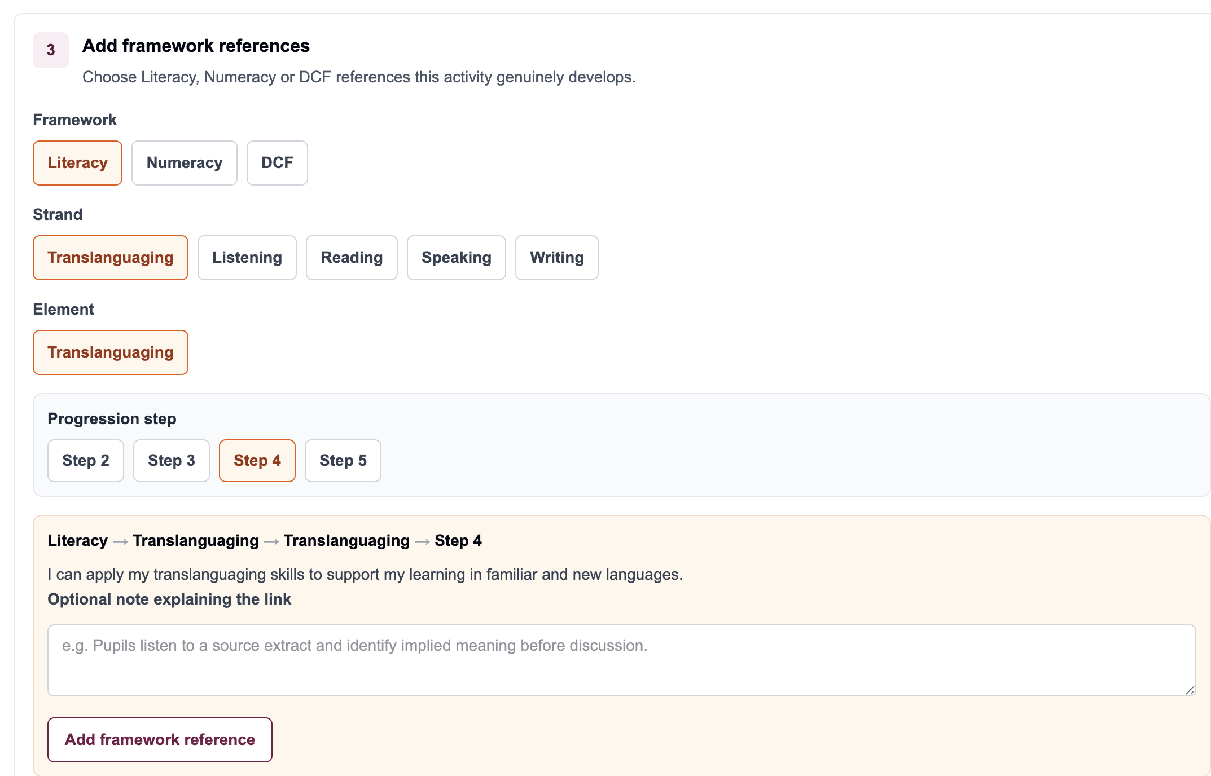
Screenshot: Gaps and improvement actions highlight where a subject leader may need to review mapping.

A simple subject leader review cycle
- Start in Subject Health Report and choose your subject.
- Check the summary cards: entries, schemes, Literacy, Numeracy, DCF and CCT.
- Read the curriculum journey by year group to make sure every key scheme is represented.
- Use View details to check evidence quality, then Edit where changes are needed.
- Use gaps and improvement actions to agree two or three practical departmental next steps.
- Return later and check whether the gaps have reduced.
Subject leader judgement
A strong map is not the one with the most references. It is the one where the references are accurate, useful and easy for the department to review.

What to avoid
- Do not create a new mapping if the activity already exists. Edit the existing mapping instead.
- Do not add Literacy, Numeracy, DCF or CCT evidence just to make the numbers go up.
- Do not use vague notes such as “covered in lesson”. Say what pupils actually do.
- Do not delete mappings unless you are sure the curriculum entry should be removed.

