

Caerleon Skills Tracker: Teacher User Guide
  - Adding, editing and reviewing curriculum mapping
Audience: Teachers and subject leads who need to record curriculum work, keep mappings accurate and review subject coverage.

Use this guide for: Add Curriculum Entry, Edit Curriculum Entry and Subject Health Report workflows.

Important: Always save before leaving a page. If you are unsure whether a mapping already exists, check Edit Curriculum before creating a new entry.

Before you start
The tracker is used to show where curriculum work develops Literacy, Numeracy, DCF and wider theme evidence. The aim is not to record everything pupils do. The aim is to keep useful, accurate evidence that a teacher or subject lead can review later.
- Use Add Curriculum when the scheme or activity is not already in the tracker.
- Use Edit Curriculum when a mapping already exists and needs improving.
- Use Subject Health to check coverage and decide what needs attention next.
- Keep descriptions short, specific and written in plain school language.
- Only map skills and themes that are genuinely taught, practised or evidenced.
Staff reminder: If you are not sure whether an item already exists, check Edit Curriculum first. This avoids duplicate mappings and keeps the Subject Health report trustworthy.

Workflow 1: Add Curriculum Entry

What this workflow is for
Use Add Curriculum to record a piece of curriculum work and link it to the skills and themes it develops. A good entry should make sense to another teacher reading it later.
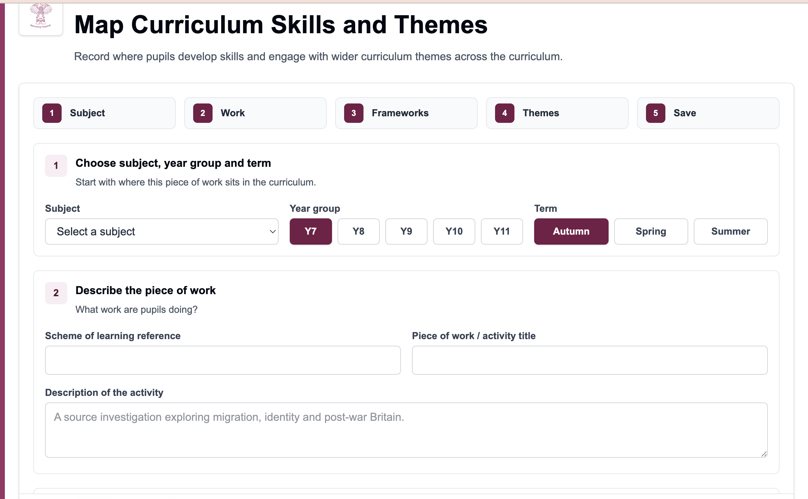
Add Curriculum page showing the main workflow steps.

Step 1: Choose where the work sits
- Open Add Curriculum from the left-hand menu.
- In Subject, choose the subject that owns the curriculum work.
- Select the correct year group.
- Select the term in which the work is mainly taught.
- Check the selections before moving on. These filters affect how the work appears in reports.
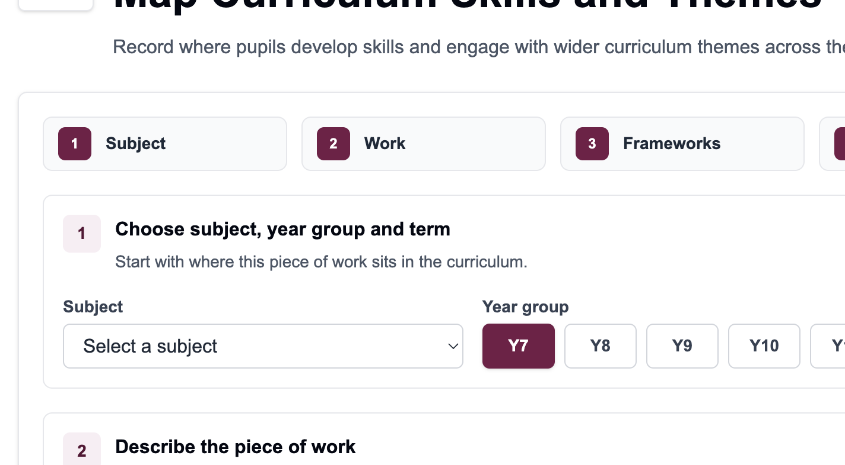
Subject, year group and term area in Add Curriculum.

Step 2: Describe the curriculum work
- Enter the scheme or reference. Use the department code or scheme reference staff will recognise, for example 7.1 or CT7.3.
- Enter a clear activity title. Keep it short enough to scan in reports.
- Write a concise description of what pupils do or learn. One or two specific sentences is usually enough.
- Avoid vague descriptions such as general classwork. Make the entry useful for review.
Good description: State the learning activity and the evidence it produces. For example: pupils compare source material and write a justified response, rather than simply writing task.

Step 3: Add framework references
Framework references explain which skills are developed by the curriculum work. Add references only when the skill is genuinely part of the learning.
- Choose the framework: Literacy, Numeracy or DCF.
- Choose the strand that best matches the work.
- Choose the element within that strand.
- Check the progression step and descriptor. Step 4 is often the sensible default, but it still needs checking.
- Click Add framework reference.
- Repeat the process for any other genuine framework links.
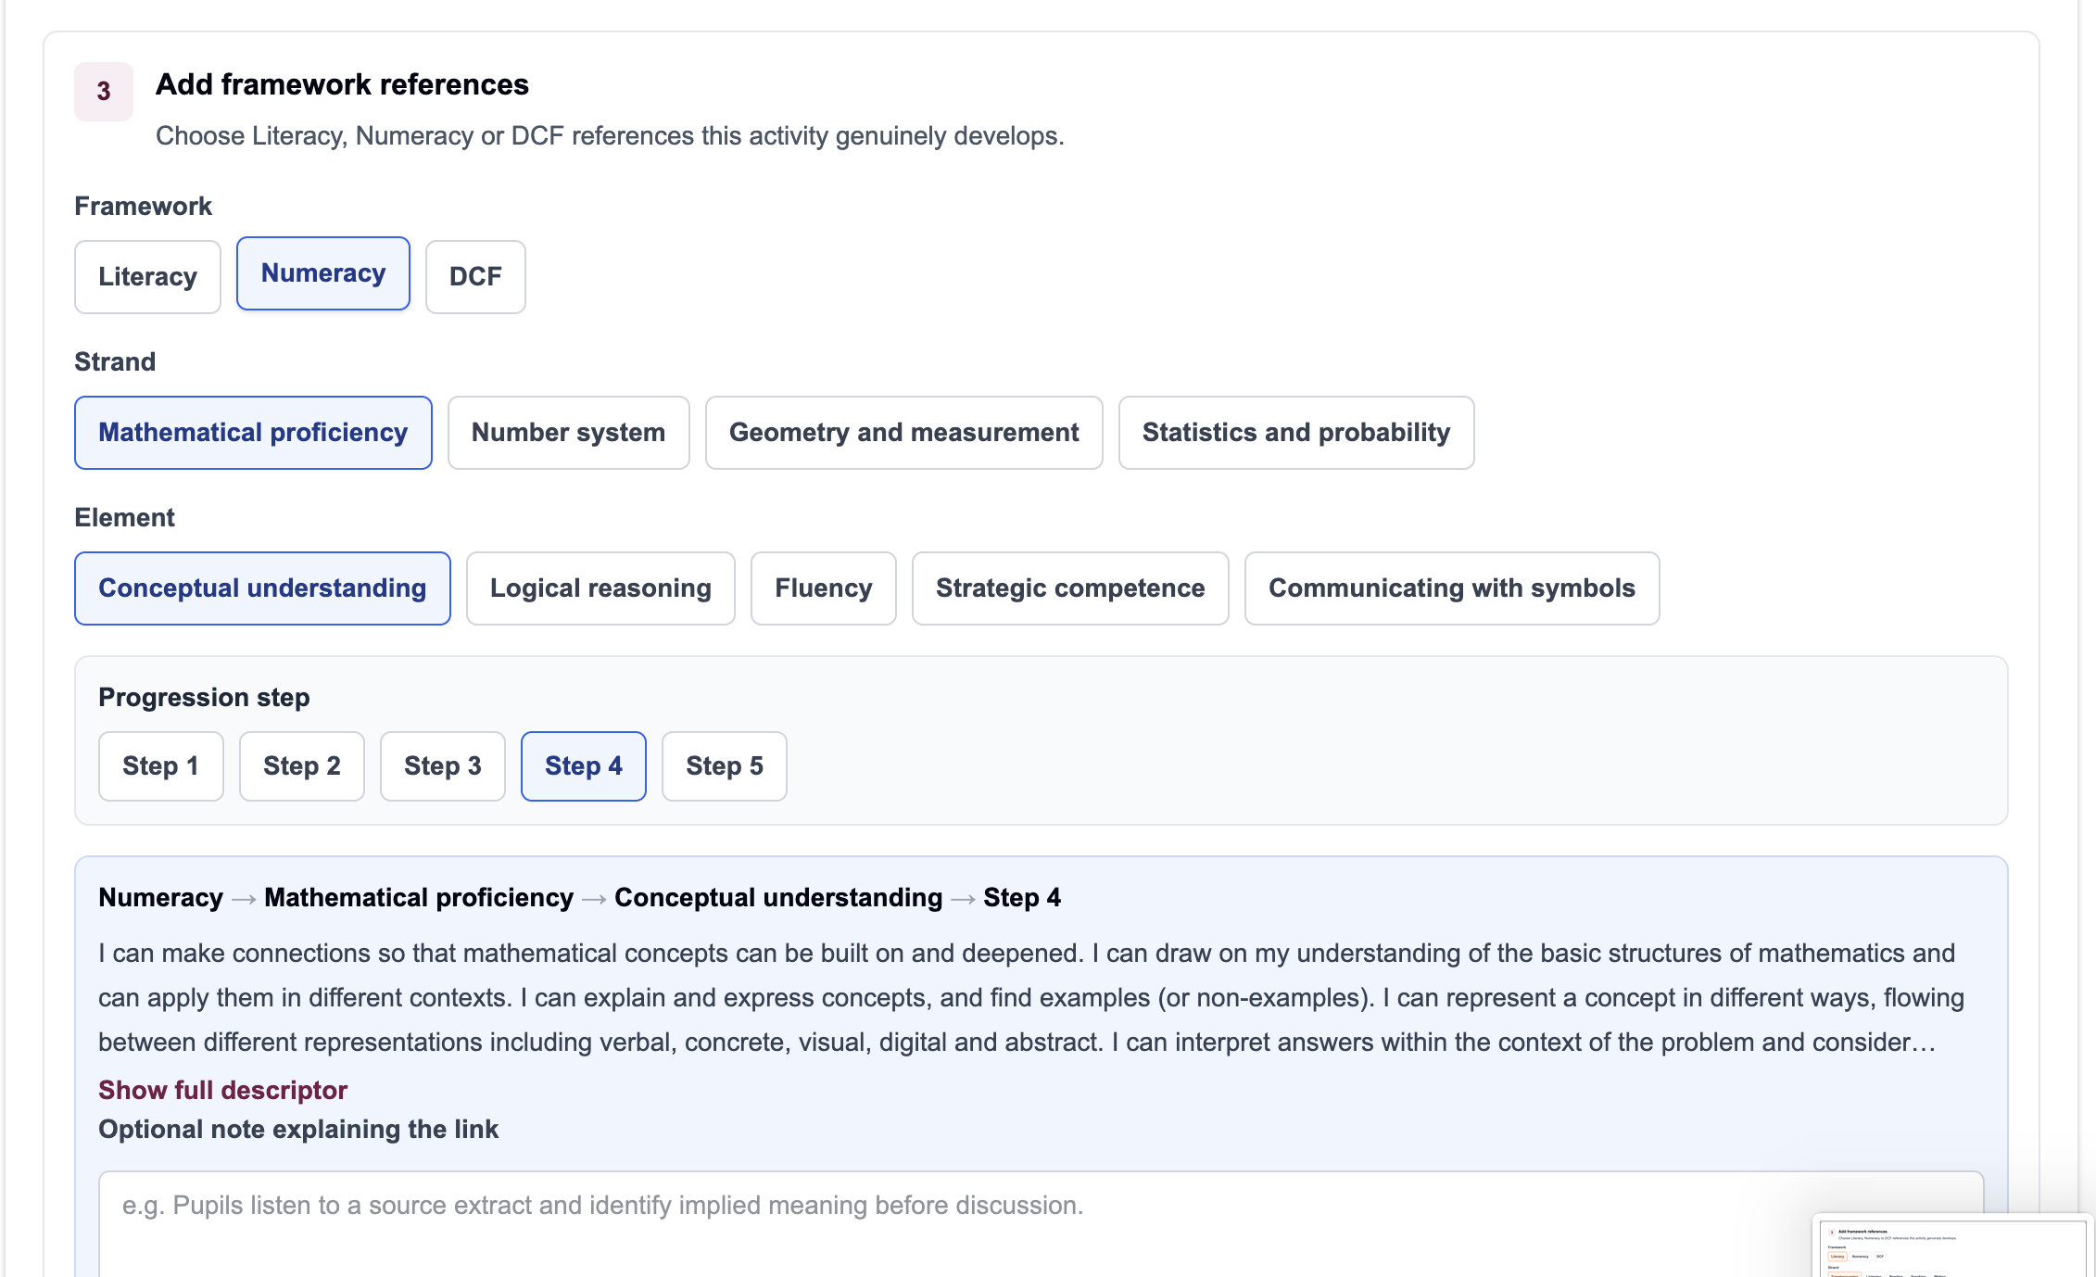
Example framework reference selector for Numeracy.
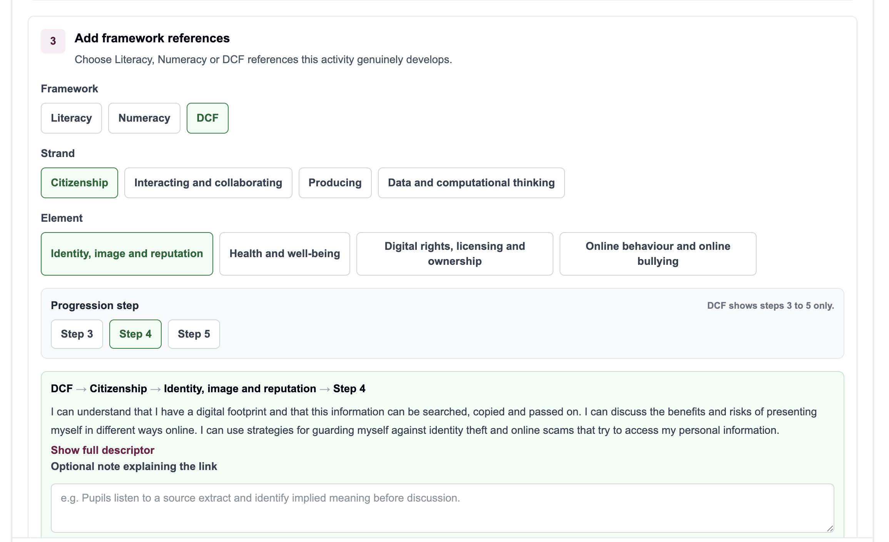
Example framework reference selector for DCF.
Do not over-map: It is better to have fewer accurate references than a long list that does not reflect the actual teaching.

Step 4: Add cross-cutting theme evidence if relevant
Cross-cutting theme elements are optional on skills entries. Add them when the activity clearly contributes to a theme and the evidence would be useful for curriculum review.
- Open the Themes step.
- Expand the relevant theme.
- Tick only the elements that are genuinely covered.
- Add a short note if it helps explain the judgement.
- Leave themes unticked when they are not relevant.
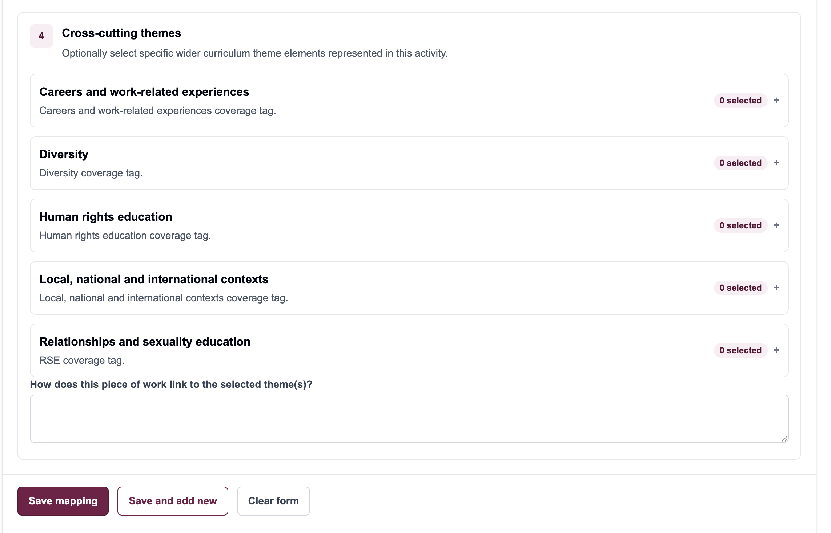
Cross-cutting theme selector.

Step 5: Save the mapping
- Review the subject, year group, term, scheme reference and activity title.
- Check that framework references and theme elements are accurate.
- Click Save mapping.
- Wait for the save to complete before leaving the page.
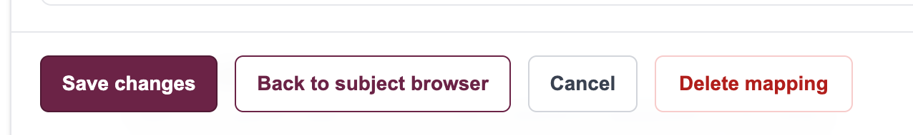
Save and navigation buttons.
After saving: If you later notice a mistake, use Edit Curriculum rather than creating a second entry for the same work.

Workflow 2: Edit Curriculum Entry

What this workflow is for
Use Edit Curriculum to correct or improve existing mappings. This keeps the tracker tidy and helps subject reports stay accurate.
- Correct curriculum details or scheme references.
- Add missing Literacy, Numeracy or DCF references.
- Remove references that do not really apply.
- Add or amend theme evidence and notes.
- Save the improved mapping.

Step 1: Browse by subject
- Open Edit Curriculum from the left-hand menu.
- Select the subject you need to review.
- Use year group, term or search filters if the list is long.
- Find the scheme or activity card you want to change.
- Click Edit on the mapping.
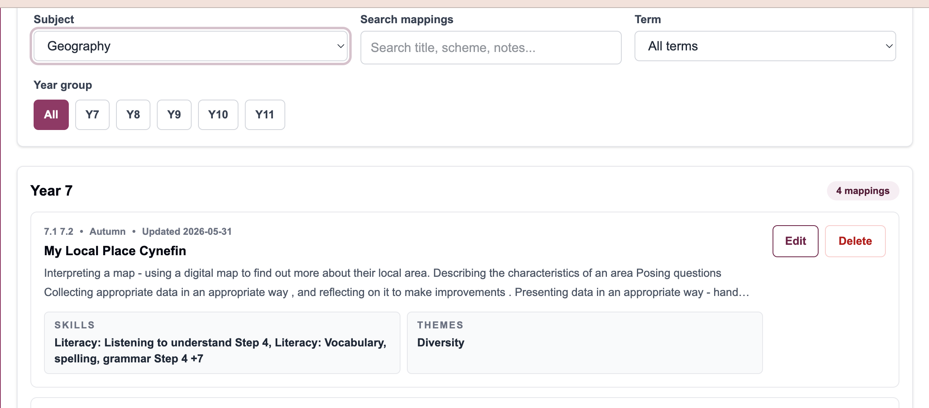
Edit Curriculum browser with subject filter and scheme cards.

Step 2: Update the mapping
- Check the curriculum details first: subject, year group, term, scheme/reference, title and description.
- Update any incorrect or unclear text.
- Review the existing skills and framework references.
- Remove references that no longer apply.
- Add missing references using the same framework selector process as Add Curriculum.
- Review theme elements and notes if they are present.
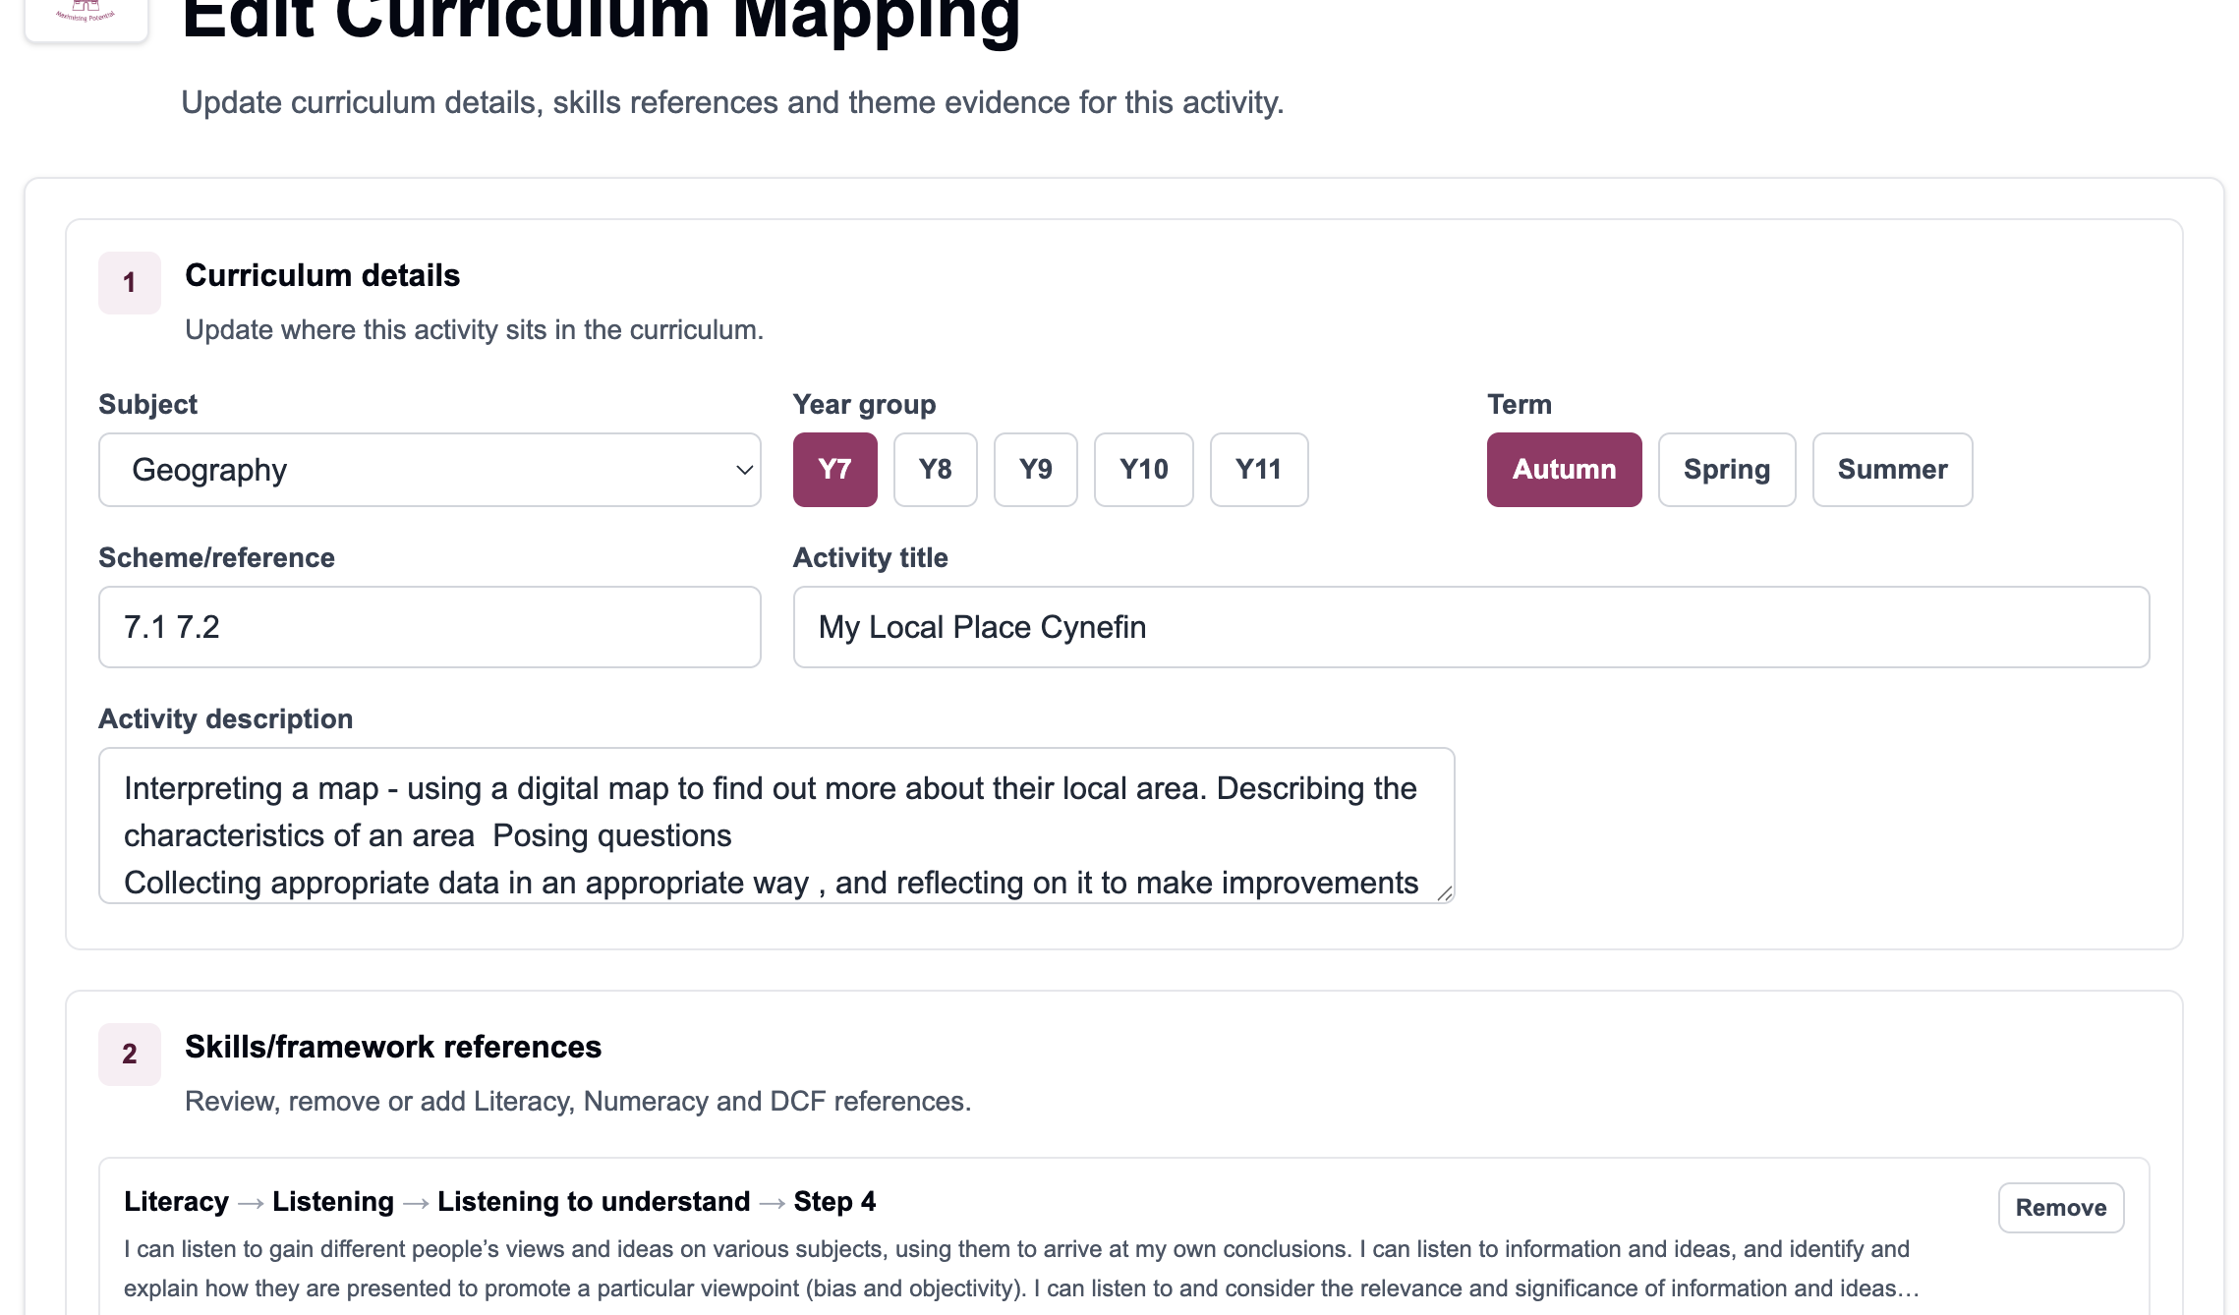
Editing curriculum details and linked references.
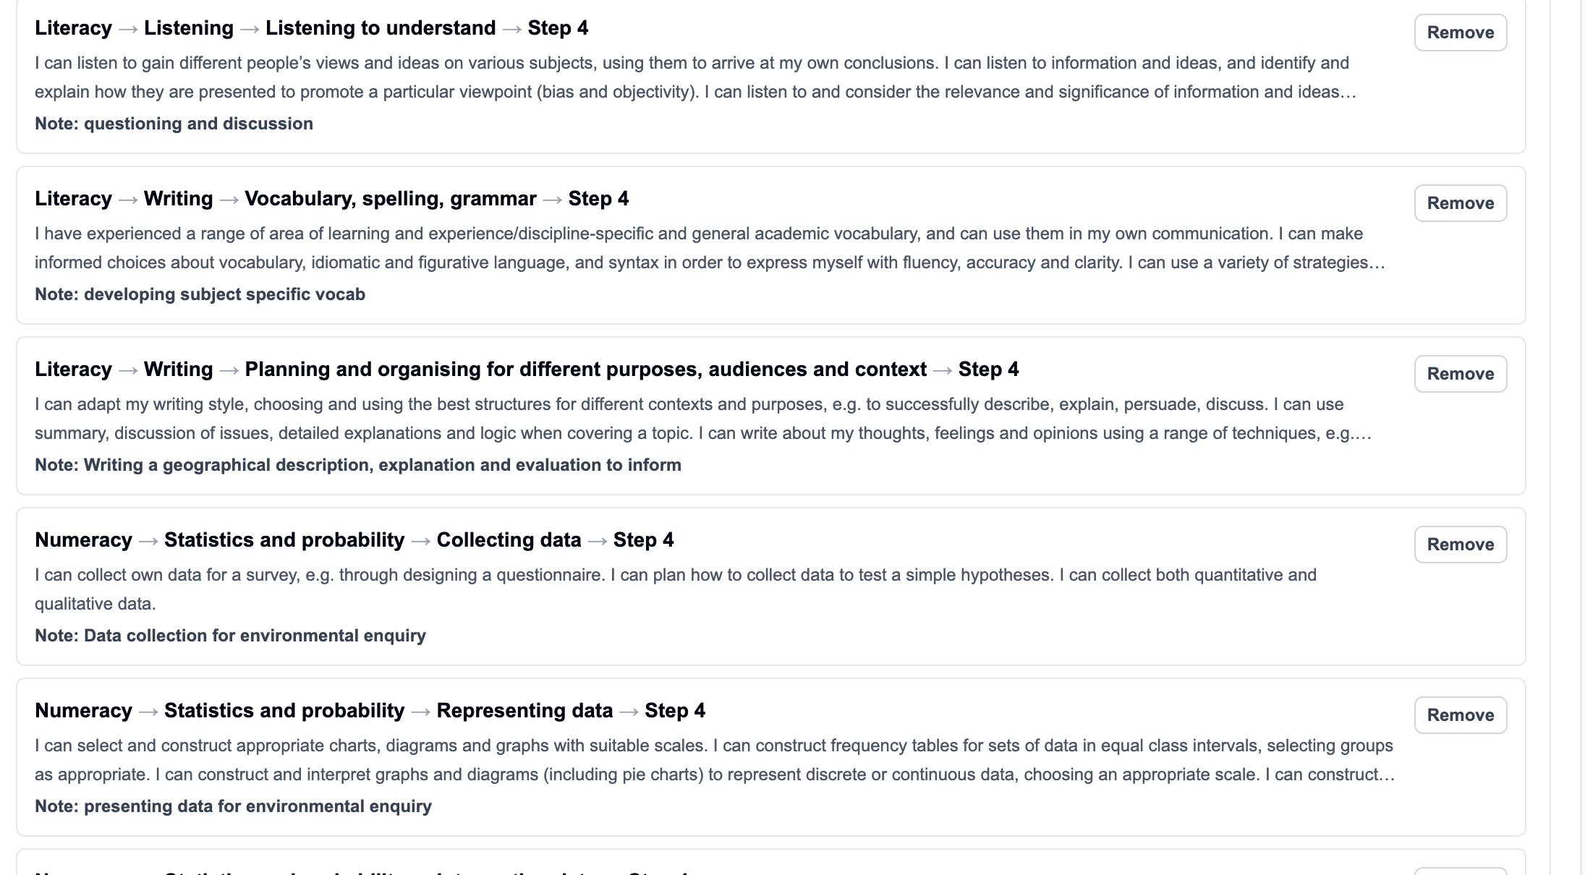
Existing framework references inside an edit form.

Step 3: Save changes
- Read through the edited entry once before saving.
- Click Save changes when the mapping is accurate.
- Use Back to subject browser if you need to return to the list.
- Use Delete mapping only when the entry should not exist at all.

Save, back, cancel and delete controls.
Good editing practice: If the same scheme appears more than once, decide whether the entries represent genuinely different work. If not, keep the clearest mapping and remove or merge the duplicate through the normal school process.

Workflow 3: View Subject Health

What this report is for
Subject Health helps subject leads understand coverage across the curriculum. It shows what has been mapped, where skills evidence is strong and where there may be gaps to improve.
- See mapped schemes and curriculum entries.
- Check Literacy, Numeracy and DCF coverage.
- Review cross-cutting theme evidence.
- Find gaps by year group or term.
- Open mappings that need improvement.

Step 1: Open the report
- Open the Subjects menu.
- Choose Subject Health Report.
- Select the subject you want to review.
- Use year group and term filters if you want a narrower view.
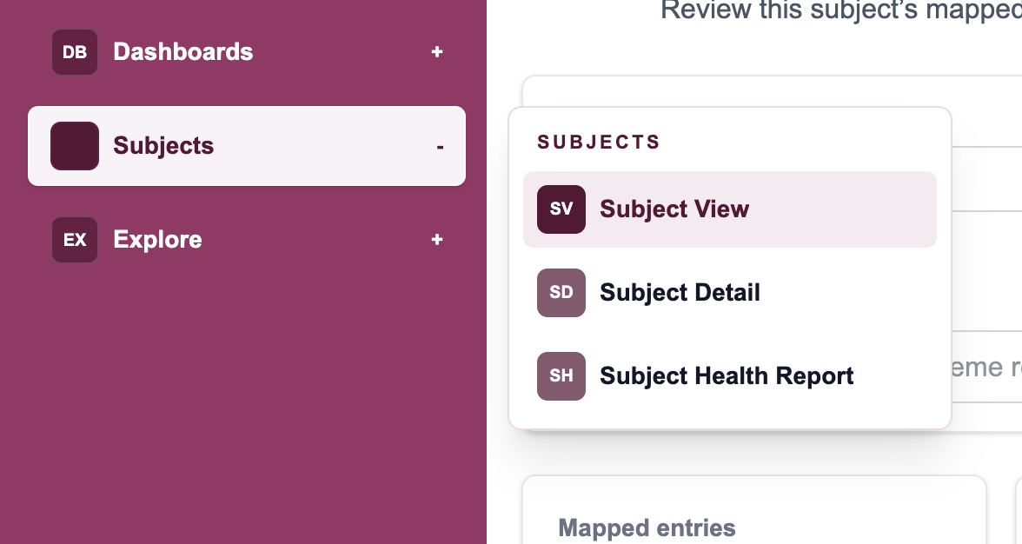
Subjects menu with Subject Health Report.
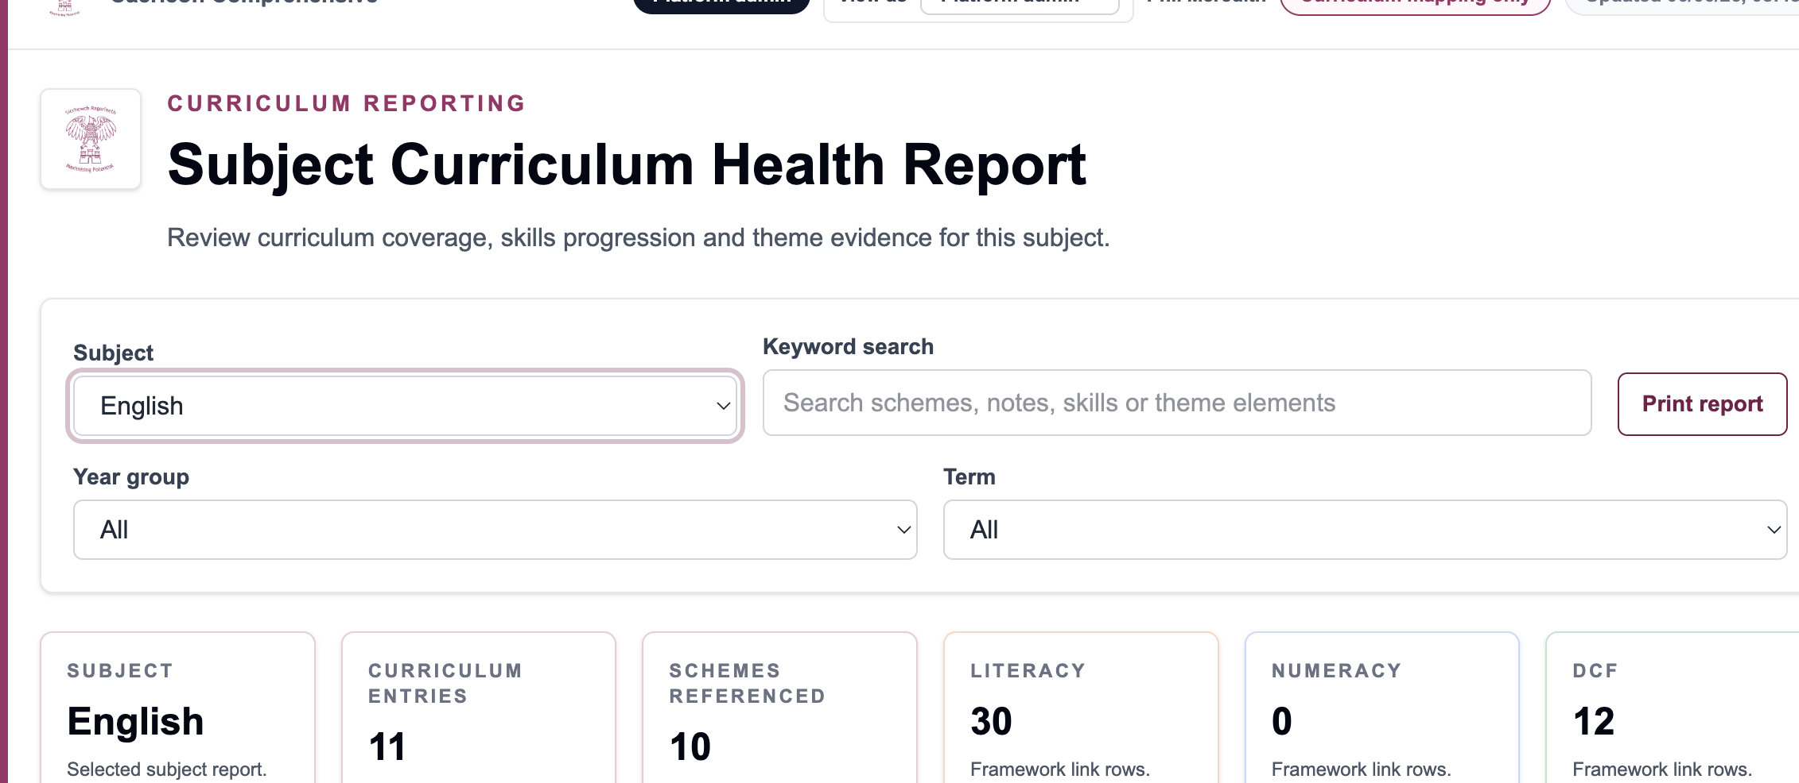
Subject Curriculum Health Report overview.

Step 2: Read the summary cards
The summary cards give a quick health check before you go into detail. Use them to ask whether the subject has enough mapped evidence and whether the balance across frameworks looks sensible.
- Check Curriculum entries to see how much curriculum work is mapped.
- Check Schemes referenced to see how many schemes are represented.
- Compare Literacy, Numeracy and DCF counts. A zero may be expected in some subjects, but it should be checked deliberately.
- Look for patterns across year groups and terms rather than treating one number in isolation.
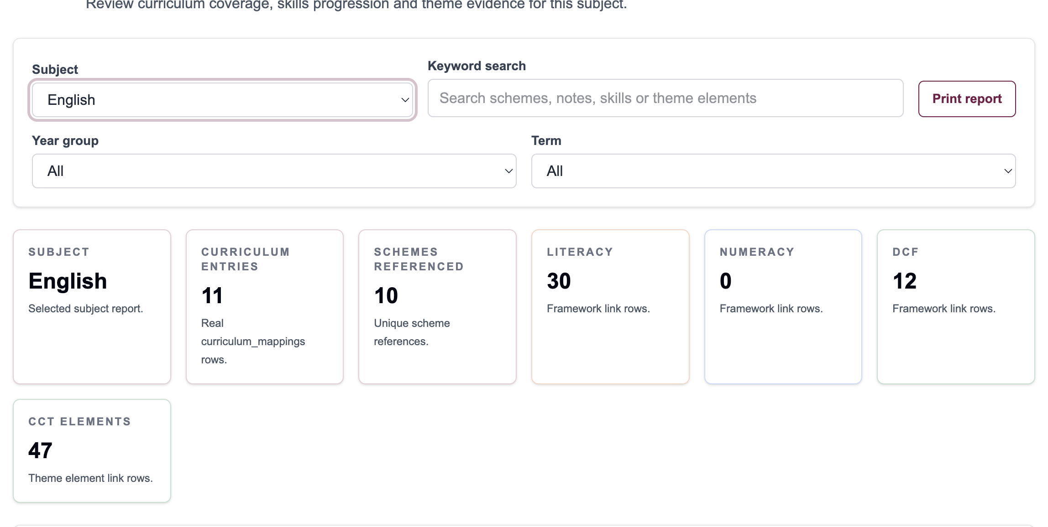
Subject Health summary cards.

Step 3: Spot gaps and decide actions
The report is most useful when it leads to a small number of practical actions. Look for gaps that are real, meaningful and worth improving.
- Look for year groups with no curriculum mappings.
- Check schemes with no DCF evidence where digital skills should be present.
- Check schemes with no cross-cutting theme evidence where a theme is genuinely relevant.
- Watch for over-reliance on one framework while others are missing.
- Consider whether any scheme should include Step 5 challenge.
- Open the relevant mapping and improve it rather than making a note that is never followed up.
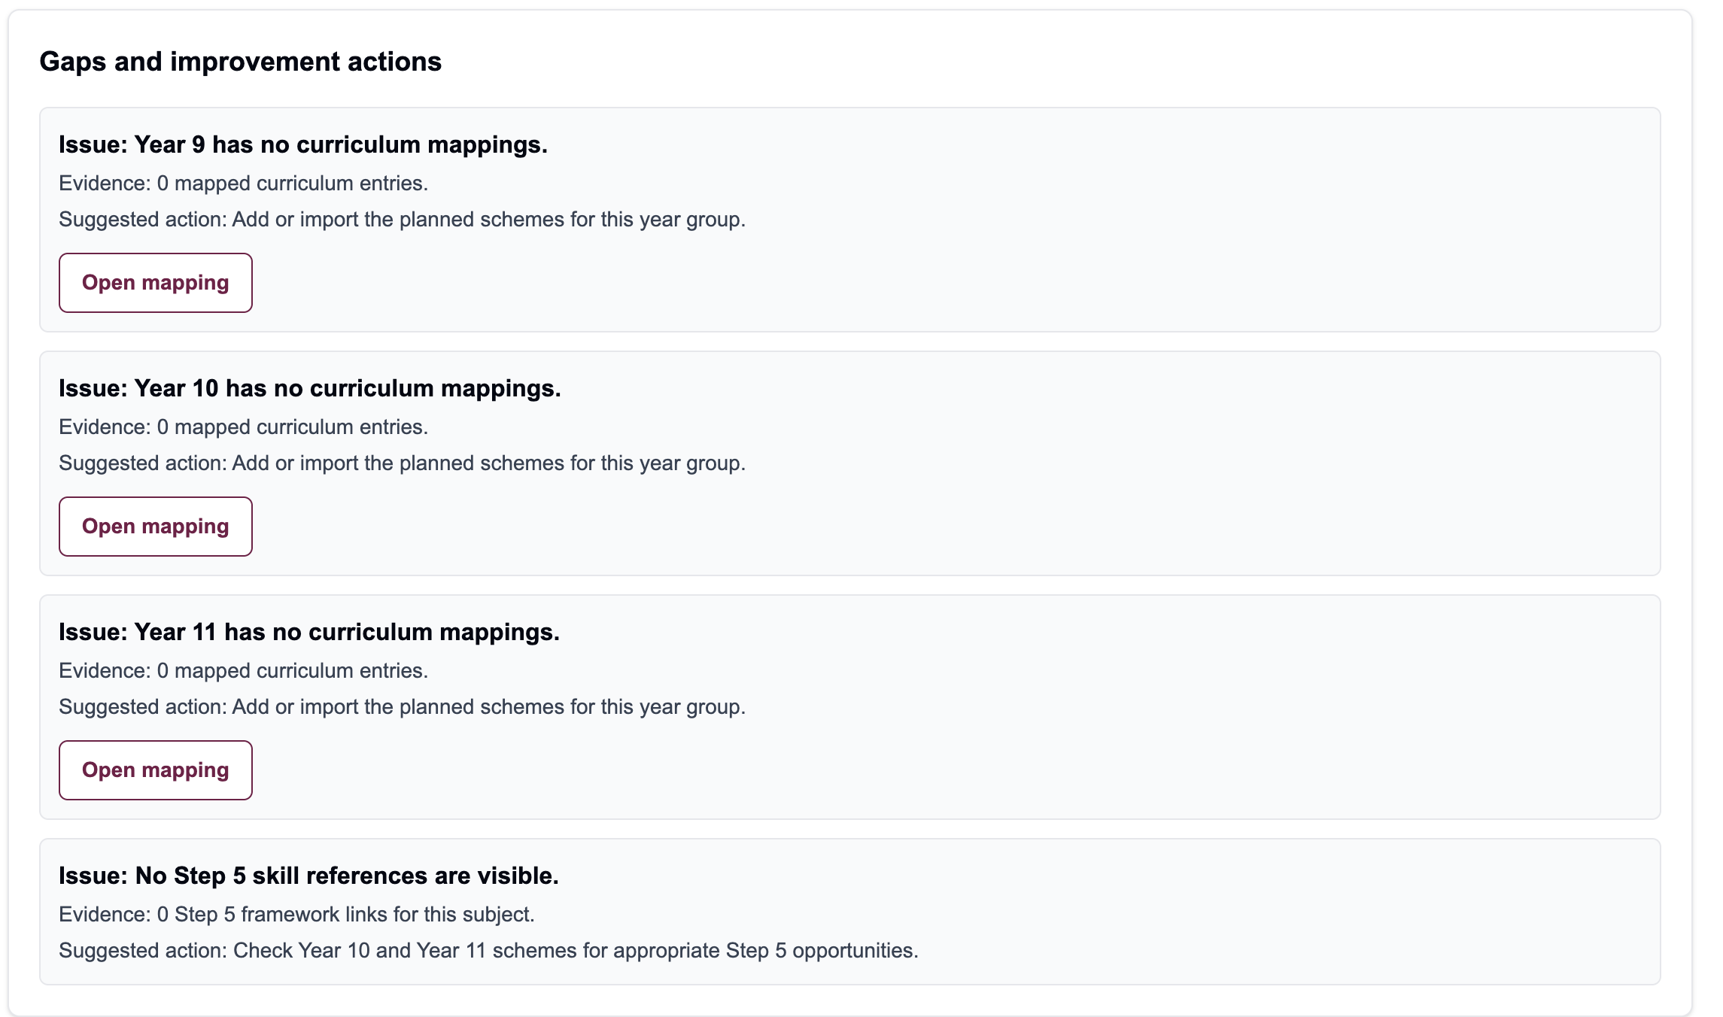
Gaps and improvement actions area in Subject Health.
Best use for subject leads: Agree one or two high-value improvements, update the relevant mappings, then revisit the report to check the impact.

Quick reference checklist
Use this table as a final check before you leave the page or report you are working on.
Add Curriculum | Edit Curriculum | Subject Health
Choose subject, year group and term | Browse by subject | Select the subject
Add scheme and activity details | Find the scheme or activity | Review mapped schemes
Add framework references | Open the item and edit | Check Literacy, Numeracy and DCF coverage
Add theme elements if relevant | Check references and notes | Look for gaps and weak areas
Save mapping | Save changes | Open items that need improvement

