VIETNAM-KOREA UNIVERSITY OF INFORMATION AND COMMUNICATION TECHNOLOGY
VIETNAM-KOREA UNIVERSITY
Faculty of Computer Science


COURSE PROJECT REPORT
Simulation and proposed mitigation for message queue attacks using
Redis string injection

Students: HO SY BAO NHAN
LE THI KIM OANH
TRUONG THI THUONG
Course: Information System Security and Safety
Instructor: Dr. Dang Quang Hien

Da Nang, May 2026
VIETNAM-KOREA UNIVERSITY OF INFORMATION AND COMMUNICATION TECHNOLOGY
VIETNAM-KOREA UNIVERSITY
Faculty of Computer Science


COURSE PROJECT REPORT
Simulation and proposed mitigation for message queue attacks using
Redis string injection

Students: HO SY BAO NHAN
LE THI KIM OANH
TRUONG THI THUONG
Course: Information System Security and Safety
Instructor: Dr. Dang Quang Hien

Da Nang, May 2026

INSTRUCTOR COMMENTS
………………………………………………………………………………………………………………………………………………………………………………………………………………………………………………………………………………………………………………………………………………………………………………………………………………………………………………………………………………………………………………………………………………………………………………………………………………………………………………………………………………………………………………………………………………………………………………………………………………………………………………………………………………………………………………………………………………………………………………………………………………………………………………………………………………………………………………………………………………………………………………………………………………………………………………………………………………………………………………………………………………………………………………………………………………

Instructor

ACKNOWLEDGEMENTS
To complete this course project, we received valuable support from our lecturers. We would like to express our sincere gratitude to all lecturers who created favorable conditions for our study, research, and project development.
We respectfully thank the lecturers of the Vietnam-Korea University of Information and Communication Technology, The University of Danang, for their guidance and support. Their teaching and encouragement helped us complete this course project.
We especially thank Dr. Dang Quang Hien, who directly supervised this project and provided detailed guidance during the implementation period.
Because our time and experience are limited, this report may still contain shortcomings. We welcome comments from lecturers so that we can improve our knowledge and better apply it in future practice.

Students,
Ho Sy Bao Nhan
Le Thi Kim Oanh
Truong Thi Thuong

TABLE OF CONTENTS
Contents
CHAPTER 1 PROJECT OVERVIEW 2 2
1.1 Topic introduction 2
1.1.1 The role of message queues in modern systems 2
1.1.2 Security issues with Redis 2
1.2 Project objectives 2
1.3 Research scope 2
1.4 Lab system architecture 2
1.5 Technologies used 3
CHAPTER 2 THEORETICAL BACKGROUND 4 4
2.1 What is a Message Queue? 4
2.2 Redis 5
2.3 Redis Injection Vulnerability 6
2.4 SSRF (Server-Side Request Forgery) 6
2.5 Pickle Deserialization Attack 6
2.6 HMAC and Data Authentication 7
2.7 Network Policy (K8s) 7
2.7.1 Operating mechanism 8
2.7.2 Security significance 8
2.7.3 Relation to the attack scenario 9
CHAPTER 3 EXPERIMENT AND DEMO 10 10
3.1 System setup 10
3.1.1 Deployment architecture 10
3.1.2 Running the system 11
3.1.3 Operational check 11
3.1.4 Automatic job scheduler 11
3.2 Attack simulation (Red Team) 11
3.2.1 Attack model 11
3.2.2 Exploiting SSRF 12
3.2.3 Injecting Redis commands 12
3.2.4 Executing RCE 12
3.2.5 Attack result 12
3.3 Defense solutions (Blue Team) 12
3.3.1 HMAC authentication 12
3.3.2 Removing pickle 13
3.3.3 Input validation 13
3.3.4 Secure worker 13
3.3.5 Defense testing 13
3.3.6 Result 13
3.4 Demo Runbook on Minikube 13
3.4.1 Phase 1 - Setup and Deployment 13
3.4.2 Phase 2 - Red-Team Attack Demonstration 14
3.4.3 Phase 3 - Blue-Team Verification 15
3.4.4 Cleanup 15
3.5 Docker Compose Alternative 16

LIST OF FIGURES
Figure 2-1 Basic Message Queue Model (Producer - Consumer) 4
Figure 2-2 Message Distribution to Consumers 5
Figure 2-3 Redis Queue with List and Stream 5
Figure 2-4 Serialization and Deserialization Mechanism 6
Figure 2-5 Kubernetes Architecture with NetworkPolicy 7
Figure 2-6 Kubernetes NetworkPolicy Structure 8
Figure 3-1 Docker Compose Deployment Architecture 10
Figure 3-2 Redis Message Queue with Multiple Consumers 10
Figure 3-3 Pickle Deserialization Attack Model 12
Figure 3-4 Minikube deployment status and web service access 14
Figure 3-5 Vulnerable web service health check in Minikube 14
Figure 3-6 Red-team attack marker in the vulnerable worker 14
Figure 3-7 Blue-team verification checklist output 15
Figure 3-8 Kubernetes NetworkPolicy objects applied in Minikube 15

INTRODUCTION

Rationale
In modern software systems, message queues play an important role in asynchronous processing, improving performance and scalability. Among popular tools, Redis is often used as a lightweight queue because it is fast and easy to deploy. However, Redis is not designed specifically as a message broker and does not automatically provide sin message authentication or fine-grained access control. This creates risks such as injection and forged data in queues. The team selected this topic to simulate realistic attack scenarios and propose suitable defensive solutions.

Implementation plan
The project is implemented in three phases. First, the team studies message queues, Redis, and related security vulnerabilities, then designs a lab architecture including a web application, Redis, workers, and testing tools. Second, the team builds the system with Docker and verifies the normal data flow. Finally, the team simulates attacks, observes the vulnerable worker behavior, and applies defenses such as HMAC validation, input checking, safe data formats, secure workers, and network isolation.

Report structure
After the Introduction, the report is organized into three chapters:
Chapter 1. Project overview.
This chapter presents the research context, topic rationale, objectives, Redis message queue model, security risks caused by uncontrolled input, and the overall architecture of the lab system.
Chapter 2. Theoretical background.
This chapter explains message queues, Redis queue mechanisms, Redis injection, SSRF, deserialization risks, HMAC-based authentication, and Kubernetes NetworkPolicy.
Chapter 3. Experiment and demo.
This chapter describes system setup, component deployment, operational testing, red-team attack simulation, blue-team mitigation, and the detailed demo runbook used for presentation.
The report ends with the conclusion, references, and related appendices.

CHAPTER 1 PROJECT OVERVIEW

Topic introduction

The role of message queues in modern systems
Message queues act as an intermediary that allows system components to communicate indirectly by sending and receiving messages. Instead of processing every request synchronously, a system can place tasks into a queue for later processing, reducing load on primary services and improving scalability.

Security issues with Redis
Although Redis is widely used, it is not a dedicated message broker and does not automatically validate the trustworthiness of queue data. If applications trust every queue entry, malicious data can be injected and later processed by workers.

Project objectives
The objective is to build a complete simulation environment for studying security issues when Redis is used as a message queue. The system includes a web application, Redis, and workers so that normal and malicious message flows can be observed.
The project focuses on identifying vulnerabilities that arise when Redis queues are used without input validation or message authentication. The team simulates malicious data injection and unsafe deserialization in the consumer.
The project also evaluates impact by observing system behavior after exploitation, clarifying how design mistakes such as trusting queue data can lead to serious consequences.
Based on the simulation results, the project proposes defenses including data authentication, input validation, safer parsing formats, secure worker logic, and network isolation.

Research scope
The project focuses on Redis as a message queue in a simple application system and analyzes security risks in queue data processing. The scope includes queue operations, attack simulation, and defensive validation.
The project does not deeply examine dedicated message brokers, clustering, replication, high availability, operating-system hardening, firewall configuration, or transport encryption. The main focus is application-level queue security.

Lab system architecture
The lab follows a simple model that simulates a real message queue flow. It includes a web application as producer, Redis as the intermediate queue, and workers that consume and process queue data. Attack and verification scripts are also included.
The flow begins when a user submits information through the web interface. The data is packaged into a job and pushed to Redis. A worker continuously monitors the queue, retrieves jobs, and performs the corresponding action. In the attack scenario, an attacker injects malicious jobs into Redis.

Technologies used
The project uses Redis as the message queue, Flask for the web application, Python for workers and scripts, Docker/Docker Compose for container deployment, MailHog for email observation, and Minikube/Kubernetes for the extended demo environment.
These technologies make the lab flexible, reproducible, and suitable for demonstrating both normal queue processing and security testing.

CHAPTER 2 THEORETICAL BACKGROUND

What is a Message Queue?
A message queue is an intermediary mechanism that allows system components to communicate asynchronously through messages. Instead of direct synchronous interaction, data is placed into a queue and processed later by consumers.
In this model, the sender is called a producer, the receiver is called a consumer or worker, and the queue or broker stores messages between them.
A common queue behavior is FIFO (First In, First Out), meaning messages are processed in the order they are added. Advanced systems may adjust ordering depending on processing requirements.
Message queues help decouple components, improve scalability, handle workload spikes, and make background processing more reliable.
Common queue technologies include Redis, RabbitMQ, and Apache Kafka. Each has different characteristics but shares the goal of reliable and efficient message transfer.
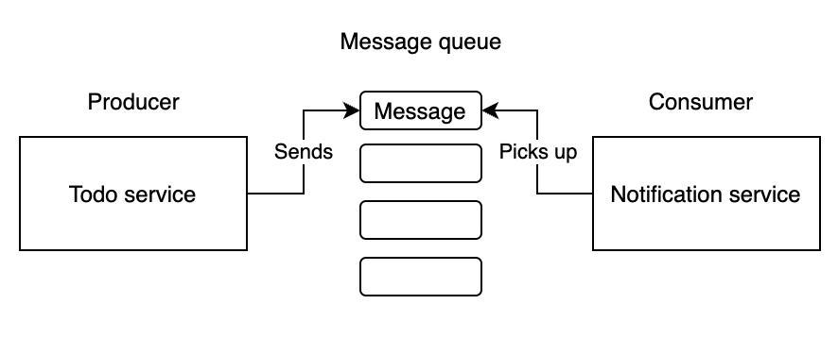
Figure 2-1 Basic Message Queue Model (Producer - Consumer)
Illustrates the basic message queue mechanism in which a producer sends messages to a queue and a consumer retrieves them for processing.
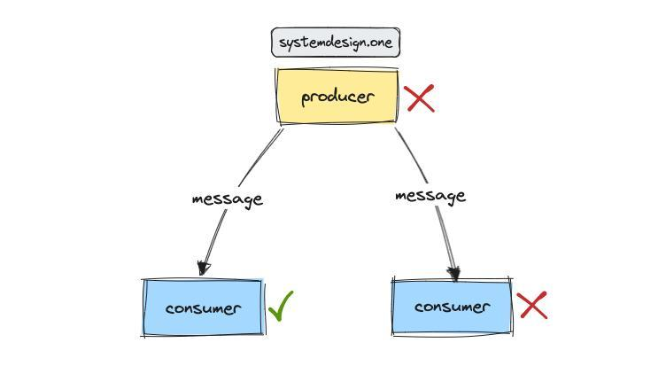
Figure 2-2 Message Distribution to Consumers
Shows how messages are distributed from producer to consumers, where each message is processed by one consumer.

Redis
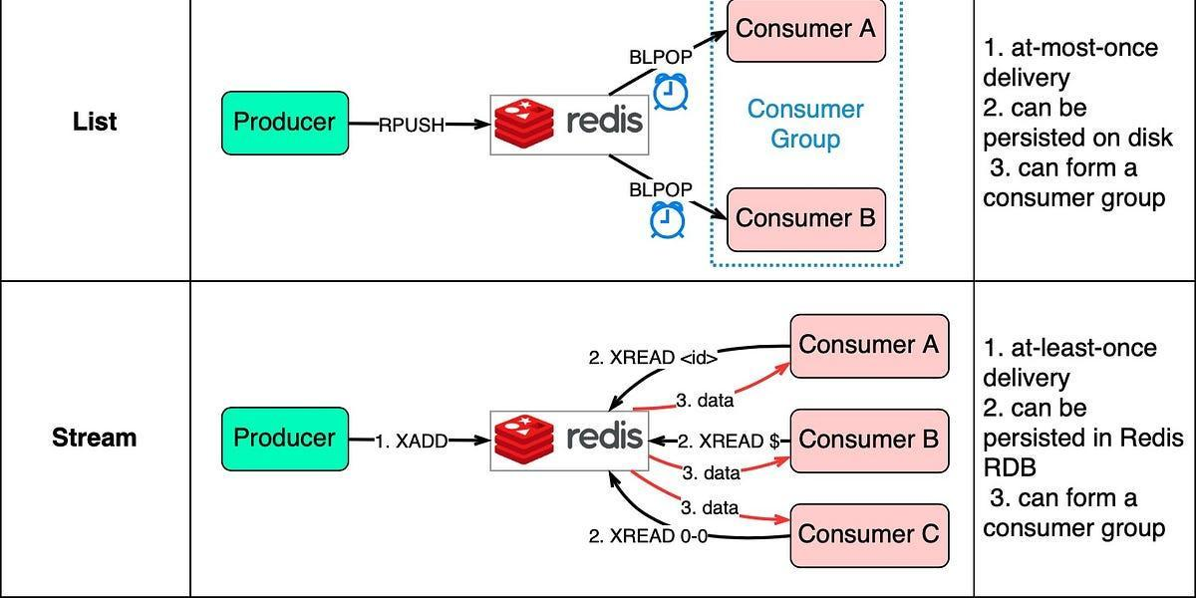
Figure 2-3 Redis Queue with List and Stream
Redis is an in-memory key-value data store known for high performance and support for data structures such as strings, lists, sets, and hashes. Because of these features, Redis is often used not only as a cache but also as a lightweight queue.
In a queue model, Redis commonly uses lists. Producers push data with LPUSH, while consumers retrieve data with BRPOP. This blocking behavior lets workers wait efficiently for new jobs.
Redis queues are easy to deploy and fast for small or medium systems. However, Redis is not a full message broker and lacks built-in message content authentication and advanced delivery guarantees unless the application adds them.

Redis Injection Vulnerability
Redis injection occurs when untrusted data is inserted into Redis without proper validation or authentication. This is dangerous in a message queue because workers often trust and process queue entries.
A common scenario is abusing SSRF to send Redis commands from inside the network. An attacker can use commands such as LPUSH to insert malicious data into a queue.
If the worker uses unsafe processing such as Python pickle deserialization, the attacker can craft a payload that leads to remote code execution when consumed.
The main causes include lack of message authentication, excessive trust in queues, and unsafe parsing. Defenses include HMAC integrity checks, input validation, safe serialization formats, and network controls.

SSRF (Server-Side Request Forgery)
SSRF is a vulnerability that allows an attacker to force a server to send requests to resources that are normally inaccessible from outside. The attacker borrows the server network position to reach internal services.
In this project, SSRF is the bridge to Redis. A vulnerable endpoint accepts arbitrary URLs, and an attacker can use a protocol such as gopher to send crafted traffic to Redis.
The impact is serious because internal services such as Redis may be reachable only from the application network. SSRF can therefore become a path for queue poisoning.

Pickle Deserialization Attack
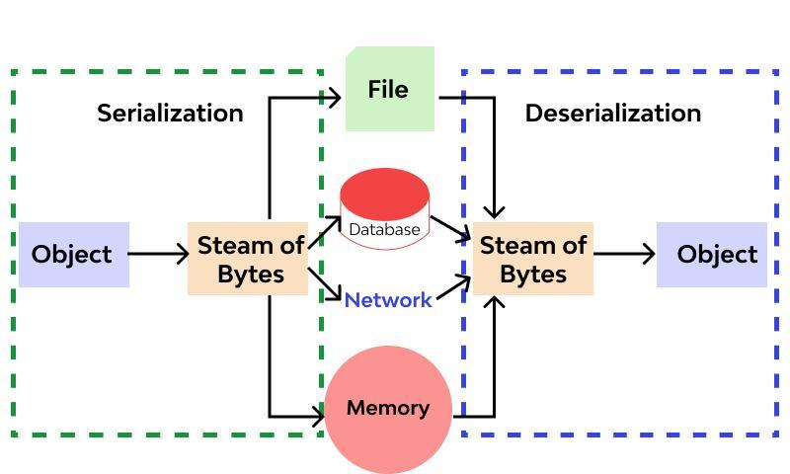
Figure 2-4 Serialization and Deserialization Mechanism
Illustrates object-to-byte conversion and the reverse process, which can become vulnerable when deserializing untrusted data.
Pickle is a Python mechanism for serializing and deserializing objects. It must not be used with untrusted data because deserialization can execute embedded behavior.
In the attack scenario, the worker reads data from Redis and calls pickle.loads(). If the data is controlled by an attacker, a crafted payload can execute commands on the host.
The exploitation mechanism often uses special Python methods such as __reduce__ to define behavior during deserialization. When pickle.loads() runs, the malicious behavior is triggered.
This vulnerability is severe because it occurs in data processing logic. To prevent it, untrusted data should use safer formats such as JSON and should be authenticated before processing.

HMAC and Data Authentication
HMAC (Hash-based Message Authentication Code) provides data integrity and authenticity by combining a secret key with a hash function such as SHA-256.
In this system, HMAC signs jobs before they are placed into Redis. When a worker retrieves a job, it recomputes the HMAC and compares it with the attached signature. If the values do not match, the job is rejected.
HMAC adds an important protection layer because Redis does not validate message content by itself. The worker no longer blindly trusts the queue and instead verifies message authenticity.

Network Policy (K8s)
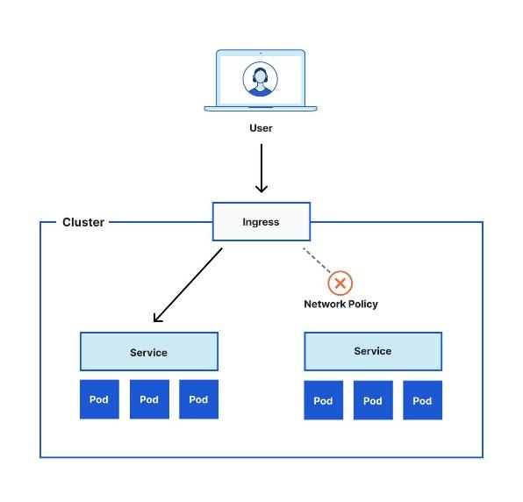
Figure 2-5 Kubernetes Architecture with NetworkPolicy
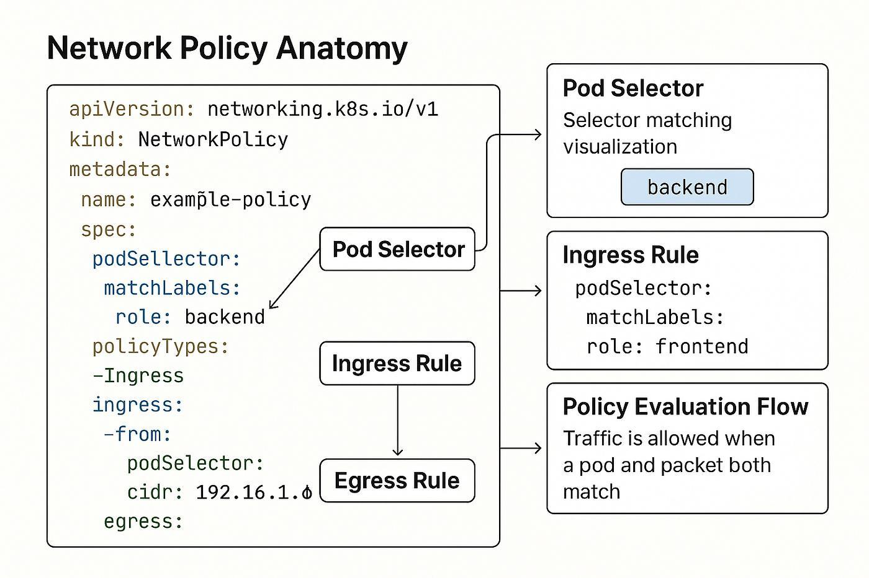
Figure 2-6 Kubernetes NetworkPolicy Structure
In Kubernetes, NetworkPolicy controls traffic between pods in a cluster. By default, pods may communicate freely, which creates risk if one component is compromised.
NetworkPolicy defines ingress and egress rules based on namespaces, labels, and ports. This limits communication to required flows and blocks unnecessary access.
In this project, Redis is sensitive because it is the central message queue. Without network control, internal requests or compromised pods may send commands directly to Redis.
NetworkPolicy is applied to restrict access to Redis. Only authorized pods should connect to Redis, while unnecessary paths such as web-to-Redis in the vulnerable attack path can be controlled in the secured design.

Operating mechanism
NetworkPolicy works through two main rule types:
- Ingress: controls connections entering a pod
- Egress: controls connections leaving a pod
Example in this system:
- Redis allows ingress only from authorized workers
- Workers are allowed to egress to Redis
- The web component is not allowed to access Redis directly in the secured policy model

Security significance
Applying NetworkPolicy provides several benefits:
  - Limits communication scope between components
  - Prevents unauthorized access to Redis
  - Reduces SSRF exploitation opportunities
  - Strengthens defense in depth

Relation to the attack scenario
Without NetworkPolicy, the attacker can perform the attack chain:
Attacker → Web (SSRF) → Redis → Inject payload → Worker
After NetworkPolicy is applied:
  - Attacker → Web (SSRF): Redis (blocked)
  - Worker → Redis : (allowed)
Therefore, a critical step in the attack chain is blocked and the attacker cannot continue exploitation through the same path.

CHAPTER 3: EXPERIMENT AND DEMO

System setup

Deployment architecture
The system is built with key components: a web application as producer, Redis as the intermediate queue, workers for job processing, and MailHog for email observation. It also includes scripts for attack simulation and security verification.
The system is deployed with Docker containers. The containers communicate through an internal Docker network, which helps simulate a realistic service environment.
The normal flow is: a user submits an email through the web interface, the data is packaged into a job and pushed to Redis, then the worker retrieves the job and sends a simulated email to MailHog.
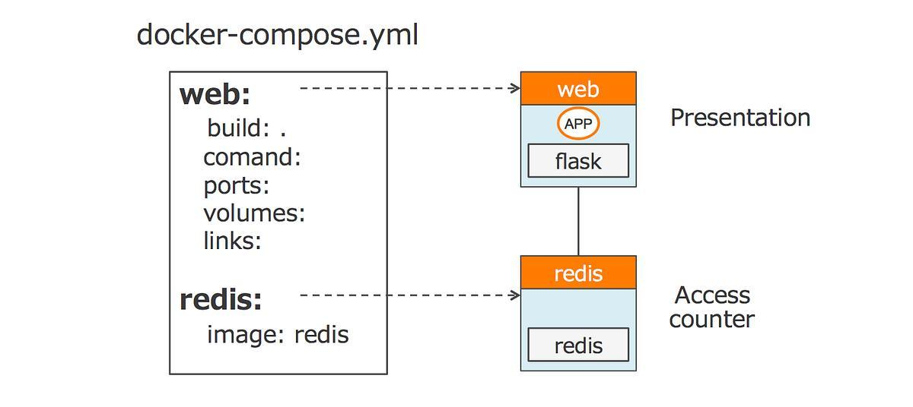
Figure 3-1 Docker Compose Deployment Architecture
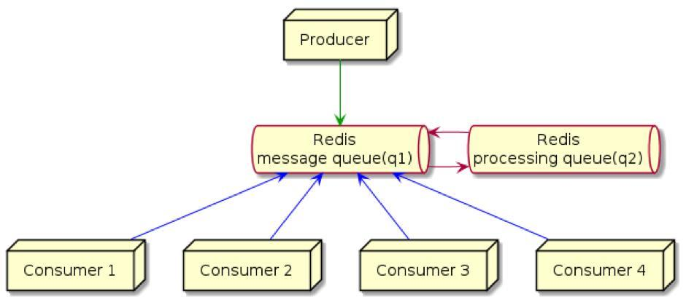
Figure 3-2 Redis Message Queue with Multiple Consumers

Running the system
The system is started with: docker compose up -d --build
After successful startup, access:
- Web: http://localhost:5000http://localhost:5000
- MailHog: http://localhost:8025http://localhost:8025

Operational check
When a user enters an email in the form, the system will:
Push a job into Redis
- Worker retrieves the job using BRPOP
- Send the email to MailHog
Redis queue inspection can be performed with: redis-cli LRANGE mail_jobs 0 5
This command allows observation of jobs currently in the queue and helps verify data flow between components.

Automatic job scheduler
Besides manual job creation from the web interface, the system includes a scheduler that automatically creates periodic jobs. The scheduler generates report data and pushes it to Redis at fixed intervals.
This mechanism simulates real systems where background tasks run automatically and also creates continuous queue data for testing and observation.

Attack simulation (Red Team)

Attack model
The attack scenario is built as a chained exploitation path. The attacker does not need direct Redis access; instead, the attacker abuses SSRF in the web service to send commands to internal Redis, injects a malicious payload into the queue, and affects the worker when it processes data.
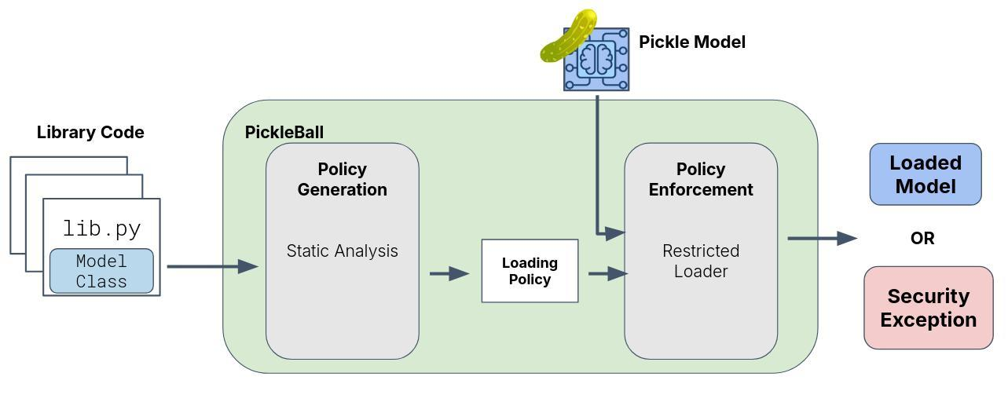
Figure 3-3 Pickle Deserialization Attack Model

Exploiting SSRF
The vulnerable system has an endpoint that can access arbitrary URLs. The attacker abuses it to send a request to Redis through the gopher protocol, allowing interaction with Redis even though Redis is not publicly exposed.

Injecting Redis commands
After SSRF succeeds, the attacker can send Redis commands such as LPUSH to insert malicious data into the queue. The payload is formatted according to the Redis protocol so Redis accepts and stores it.

Executing RCE
In the vulnerable system, the worker uses unsafe pickle deserialization. When it retrieves data from Redis and deserializes it, the malicious payload is triggered and executes commands.
This is the key point of the attack, allowing remote code execution.

Attack result
The result shows that the system is exploited successfully. The worker executes the malicious payload and creates observable changes such as a marker file, proving that uncontrolled queue data can lead to severe consequences.

Defense solutions (Blue Team)

HMAC authentication
To ensure data integrity and authenticity in the queue, the system applies HMAC to sign jobs before pushing them to Redis. Each job contains a payload and a signature generated with a secret key.
When the worker retrieves a job, it recomputes the signature from the payload and compares it with the attached signature. If they do not match, the job is rejected.

Removing pickle
The initial worker used pickle deserialization, which caused the remote code execution vulnerability. The secure design removes pickle completely and uses JSON for data exchange.
JSON is a simple data format that does not execute code, making it safer for untrusted input. This change removes the deserialization exploitation path.

Input validation
The system adds input validation to ensure only valid data is processed. Fields such as email are checked, and the job structure is validated before processing.
Input validation reduces processing errors and limits abnormal or malicious payloads.

Secure worker
The worker is redesigned with the principle of not trusting queue data. Before processing, it validates HMAC signatures, data format, and required fields.
If data fails these checks, the job is rejected. As a result, the worker is no longer the weak point that executes malicious queue payloads.

Defense testing
The system is tested by sending both valid and malicious data to the queue. Verification scripts simulate attacker behavior and check worker responses.
Testing shows that the secure worker distinguishes valid data from forged data. Malicious payloads are rejected while legitimate jobs are processed normally.

Result
After applying defenses, the previous injection and remote code execution paths are no longer feasible. The system still preserves normal queue processing and email functionality.
This result shows that combining multiple protection layers, from data authentication to safe processing logic and network isolation, is necessary for secure Redis-based message queue systems.

3.4 Demo Runbook on Minikube

3.4.1 Phase 1 - Setup and Deployment
Install local dependencies for the red-team and blue-team scripts:
python -m pip install -r requirements-dev.txt
Start the local Kubernetes cluster:
minikube start --cpus=4 --memory=4096
kubectl version
Build the local images directly into Minikube:
minikube image build -t redis-injection/web-vulnerable:latest -f web/Dockerfile.vulnerable web
minikube image build -t redis-injection/web-safe:latest -f web/Dockerfile web
minikube image build -t redis-injection/worker-vulnerable:latest -f worker/Dockerfile.vulnerable worker
minikube image build -t redis-injection/worker-secure:latest -f worker/Dockerfile.secure worker
Deploy the namespace, services, workers, Redis, and network policies:
kubectl apply -f k8s/minikube-lab.yaml
kubectl apply -f k8s/network-policies.yaml
kubectl -n redis-injection-lab get pods
Open a local tunnel to the vulnerable web service:
kubectl -n redis-injection-lab port-forward svc/web-vulnerable 5000:5000
Expected result: all pods are in the Running state and the vulnerable web endpoint is reachable at http://127.0.0.1:5000.
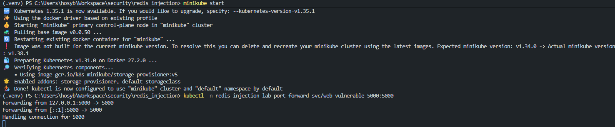
Figure 3-4 Minikube deployment status and web service access

3.4.2 Phase 2 - Red-Team Attack Demonstration
Check whether the vulnerable web service is responding:
python -c "import requests; print(requests.get('http://127.0.0.1:5000', timeout=5).status_code)"
Figure 3-5 Vulnerable web service health check in Minikube
Remove any previous attack marker to avoid false positives:
kubectl -n redis-injection-lab exec deploy/worker-vulnerable -- sh -c "rm -f /tmp/redteam_owned.txt"
Trigger the SSRF to Redis poisoning chain and verify the Kubernetes evidence:
python scripts/red_team_attack.py --web-base-url http://127.0.0.1:5000 --redis-host redis --queue mail_jobs_vuln --verify-k8s --namespace redis-injection-lab
Confirm the marker file inside the vulnerable worker:
kubectl -n redis-injection-lab exec deploy/worker-vulnerable -- cat /tmp/redteam_owned.txt
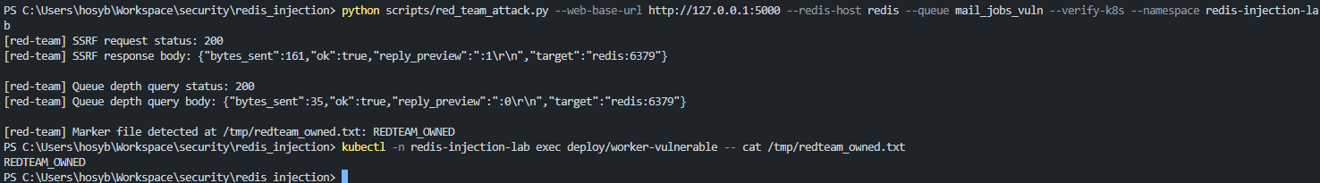
Figure 3-6 Red-team attack marker in the vulnerable worker
Collect worker logs as supporting evidence:
kubectl -n redis-injection-lab logs deploy/worker-vulnerable --tail=120

3.4.3 Phase 3 - Blue-Team Verification
Run the defensive checklist against the secure queue and secure worker:
python scripts/blue_team_verify.py --mode k8s --web-base-url http://127.0.0.1:5000 --namespace redis-injection-lab --wait-seconds 8
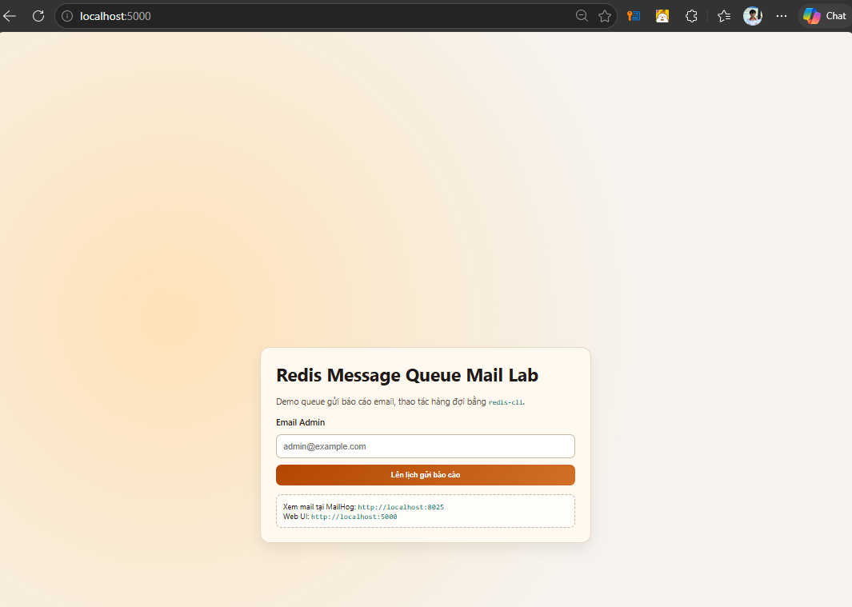
Figure 3-7 Blue-team verification checklist output
Expected checklist: malicious payload rejected, valid signed payload accepted, malicious marker not created in the secure worker, and NetworkPolicy objects found.
Inspect secure-worker logs:
kubectl -n redis-injection-lab logs deploy/worker-secure --tail=200
Check the applied NetworkPolicy objects:
kubectl -n redis-injection-lab get networkpolicy
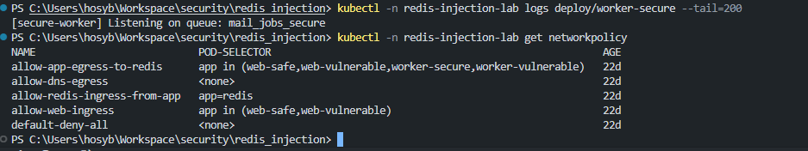
Figure 3-8 Kubernetes NetworkPolicy objects applied in Minikube

3.4.4 Cleanup
Remove the Kubernetes resources and stop Minikube:
kubectl delete -f k8s/network-policies.yaml
kubectl delete -f k8s/minikube-lab.yaml
minikube stop

3.5 Docker Compose Alternative
When Minikube is not available, the same red-team and blue-team flow can be demonstrated with Docker Compose:
docker compose -f docker-compose.vulnerable.yml up -d --build
python scripts/red_team_attack.py --web-base-url http://localhost:5001 --redis-host redis --queue mail_jobs_vuln
docker compose -f docker-compose.vulnerable.yml exec -T worker-vulnerable cat /tmp/redteam_owned.txt
python scripts/blue_team_verify.py --mode compose --web-base-url http://localhost:5001 --redis-host redis --secure-queue mail_jobs_secure --compose-file docker-compose.vulnerable.yml --compose-service worker-secure

CONCLUSION AND FUTURE WORK

Achieved results
The team successfully built a Redis-based message queue simulation that reproduces data processing in practical systems. The system includes web application, Redis, workers, and testing tools.
The project successfully simulated representative attacks, including SSRF access to internal Redis, malicious queue injection, and unsafe worker processing that leads to remote code execution.
The team proposed and implemented defenses such as HMAC-based data authentication, removal of unsafe deserialization, input validation, and secure worker design. Testing shows that these defenses block malicious payloads while preserving valid processing.
Overall, the project achieved its objectives by clarifying security risks when Redis is used as a message queue and providing practical approaches for system hardening.

Future work
Future development can integrate stronger security mechanisms such as user authentication, encrypted transport, Redis ACLs, and more detailed access control.
The system can also be deployed in a more realistic Kubernetes environment to evaluate infrastructure security policies, especially NetworkPolicy for controlling communication between components.
The project may compare Redis with dedicated message brokers such as RabbitMQ or Apache Kafka to evaluate differences in performance, reliability, and security.
Finally, more automated testing tools and diverse attack scenarios can be developed to build a broader security testing framework for message queue systems.

TASK ASSIGNMENT
Member name | % | Assigned work
Ho Sy Bao Nhan | 33.3 | Attack simulation and Minikube demo runbook
Le Thi Kim Oanh | 33.3 | Defense analysis and secure worker verification
Truong Thi Thuong | 33.3 | System setup, Docker/Kubernetes deployment, and report formatting

REFERENCES
Amazon Web Services. (n.d.). What is a message queue? Retrieved May 10, 2026, from https://aws.amazon.com/message-queue/
CWE. (n.d.). CWE-502: Deserialization of untrusted data. MITRE. Retrieved May 10, 2026, from https://cwe.mitre.org/data/definitions/502.html
Fielding, R., Nottingham, M., & Reschke, J. (2022). HTTP semantics (RFC 9110). Internet Engineering Task Force. https://doi.org/10.17487/RFC9110
Krawczyk, H., Bellare, M., & Canetti, R. (1997). HMAC: Keyed-hashing for message authentication (RFC 2104). Internet Engineering Task Force. https://doi.org/10.17487/RFC2104
Kubernetes. (n.d.). Network policies. Retrieved May 10, 2026, from https://kubernetes.io/docs/concepts/services-networking/network-policies/
Open Web Application Security Project. (2021). Server-side request forgery. OWASP. Retrieved May 10, 2026, from https://owasp.org/www-community/attacks/Server_Side_Request_Forgery
Open Web Application Security Project. (2021). A08:2021 - Software and data integrity failures. OWASP Top 10. Retrieved May 10, 2026, from https://owasp.org/Top10/A08_2021-Software_and_Data_Integrity_Failures/
Python Software Foundation. (n.d.). pickle - Python object serialization. Python documentation. Retrieved May 10, 2026, from https://docs.python.org/3/library/pickle.html
Redis Ltd. (n.d.). Lists. Redis documentation. Retrieved May 10, 2026, from https://redis.io/docs/latest/develop/data-types/lists/
Redis Ltd. (n.d.). Redis security. Redis documentation. Retrieved May 10, 2026, from https://redis.io/docs/latest/operate/oss_and_stack/management/security/
Celery Project. (n.d.). Security. Celery documentation. Retrieved May 10, 2026, from https://docs.celeryq.dev/en/stable/userguide/security.html
Klein, A. (2005). Divide and conquer: HTTP response splitting, Web cache poisoning attacks, and related topics. Web Application Security Consortium. https://owasp.org/www-community/attacks/HTTP_Response_Splitting

