ANCHOR UNIVERSITY LAGOS
DEPARTMENT OF COMPUTING
POSTGRADUATE DIPLOMA IN COMPUTING
TALENTHUB
A Creator–Brand Collaboration Marketplace
for the African Digital Creator Economy
SOFTWARE DEVELOPMENT LIFE CYCLE DOCUMENTATION
Project Planning · Requirements Analysis · System Design
A group project submitted in partial fulfilment of the requirements for
CMP 722 — SOFTWARE ENGINEERING
GROUP 2
Robertson (PG/CMP/25/006) — Project Manager 1
David — Project Manager 2 / Technical Lead
Mercy — QA Tester
Olufems — Developer
SEPTEMBER 2026

TABLE OF CONTENTS
CHAPTER ONE — Project Planning 3
1.1 Introduction 3
1.2 Background and Problem Statement 3
1.3 Aim and Objectives 4
1.4 Scope 4
1.5 Review of Existing Systems 5
1.6 Feasibility Study 6
1.7 Team Roles and Responsibilities 7
1.8 Choice of SDLC Model 7
1.9 Increment Roadmap 8
1.10 Risk Register 9
CHAPTER TWO — Requirements Analysis 11
2.1 Requirements Elicitation Approach 11
2.2 Stakeholder Analysis 11
2.3 System Context 11
2.4 Functional Requirements 12
2.5 Non-Functional Requirements 14
2.6 Use Case Model 14
2.7 Use Case Specifications 15
2.8 User Stories by Increment 18
2.9 Data Flow 19
2.10 Requirements Traceability Matrix 20
CHAPTER THREE — System Design 21
3.1 Design Objectives 21
3.2 Architectural Design 21
3.3 Technology Stack 22
3.4 Database Design 22
3.5 Process Design 25
3.6 Milestone State Model 27
3.7 Interface Design 28
3.8 Security Design 28
3.9 Deployment View 29
3.10 Design Traceability 29

CHAPTER ONE — Project Planning

1.1 Introduction
TalentHub is a web-based marketplace that connects African digital creators with the brands and businesses that wish to hire them. The project was undertaken by Group 2 as the group assignment for CMP 722 (Software Engineering), Department of Computing, Anchor University Lagos.
The group’s first proposal was a personal portfolio website. That concept was abandoned during Week 1 planning for a reason worth recording, because it shaped everything that followed: a personal portfolio has exactly one subject. It carries one name, one biography and one body of work. Four people cannot author it fairly — whoever the site is about owns the deliverable and the remaining three build someone else’s artefact. The group therefore looked for a product with a neutral subject, multiple distinct classes of user, and a transaction at its centre, so that the work of requirements engineering and design would be genuine rather than decorative. TalentHub is that product.

1.2 Background and Problem Statement
Africa’s creator economy is expanding rapidly. Independent estimates place it between US$3 billion and US$5.1 billion in 2026, with forecasts ranging from US$17.8 billion by 2030 to US$29.8 billion by 2032 (Communiqué & TM Global, 2026; Contemeleon, 2026). Nigeria alone has over 6.3 million TikTok creators with more than 1,000 followers, and YouTube paid Nigerian creators over US$10 million in 2024.
The creators inside that economy are nevertheless not capturing its value. The Africa Creator Economy Report 2026 found that 60% of African creators earn less than US$100 per month, that 57% have fewer than 10,000 followers, and that 40% regard creation as a hobby rather than a business. The constraint is not talent or demand; it is the absence of functioning market infrastructure. Five specific failures recur:
(a) Discovery. No trusted, searchable registry of African creative professionals exists. Brands hire through personal networks or agencies, which means the pool a brand can reach is a function of who it already knows.
(b) Two-sided distrust. Between 15% and 30% of influencer followings are estimated to be artificial, costing brands around US$1.3 billion annually. In the other direction, creators report briefs abandoned mid-campaign and invoices never settled. As the co-founder of a Nigerian entrant put it, “sometimes creators would collect payment and then disappear. Briefs got ignored, and agencies charged too much without real results.”
(c) Payment fragmentation. Cross-border settlement within Africa is expensive and slow. A Kenyan brand engaging a Nigerian creator has no straightforward, low-fee, protected route to pay.
(d) Intermediary cost and exclusion. Agencies charge substantial fees, while international platforms set follower thresholds that exclude the micro and mid-tier creators who form the majority of the market.
(e) Unverifiable outcomes. Campaign performance is largely self-reported. Difficulty in proving return has now overtaken budget as brands’ leading concern, and 73% of influencer campaigns are reported to fail against objective.
Problem statement. African digital creators and the organisations that would hire them have no shared, trustworthy marketplace in which identity and capability are verified, agreements are recorded, payment is protected until work is accepted, and settlement reaches the creator through instruments they actually hold. The consequence is a market in which most participants earn very little and most buyers cannot find or safely transact with them.

1.3 Aim and Objectives
Aim. To design and implement a web-based, mobile-first marketplace that enables verified African digital creators to be discovered, contracted and paid by brands through an escrow-protected workflow.
Objectives.
- To analyse existing creator and freelance platforms serving African markets and identify the functional gap TalentHub addresses.
- To elicit and specify the functional and non-functional requirements of the platform for all identified stakeholder classes.
- To design the system architecture, data model and user interfaces.
- To implement the platform incrementally across six weekly increments, each producing a demonstrable working slice.
- To verify the delivered increments against the specified requirements through functional, usability and performance testing.

1.4 Scope
Within scope.
- Creator registration, profile management, portfolio upload and skills declaration
- Identity verification (KYC) and social-account linking for audience metrics
- Brand registration and organisation profiles
- Campaign and commission brief creation, publication and closure
- Creator search and filtering by skill, location, rate, audience size and rating
- Application, shortlisting, award and contracting workflow
- Milestone-based escrow: funds committed on award, released on acceptance
- Deliverable submission, review, revision request and acceptance
- Payouts to bank account and mobile money across supported African markets
- Two-way ratings and reviews after contract closure
- In-platform messaging between contracted parties
- Administrative moderation, dispute handling and platform reporting
Outside scope.
- Native mobile applications for iOS and Android (the web client is mobile-first and responsive; native apps are deferred)
- Automated content production or AI content generation
- Direct posting to creators’ social accounts on their behalf
- Physical merchandise fulfilment or logistics
- Tax filing and statutory reporting on behalf of users
- Direct integration with advertising platforms for paid media buying

1.5 Review of Existing Systems
Nine platforms were reviewed across three groups: African influencer-marketing platforms, creator monetisation tools, and global freelance marketplaces. Figure 1.1 plots them against the two axes that matter: what a brand can actually buy, and how well the platform serves African market infrastructure.
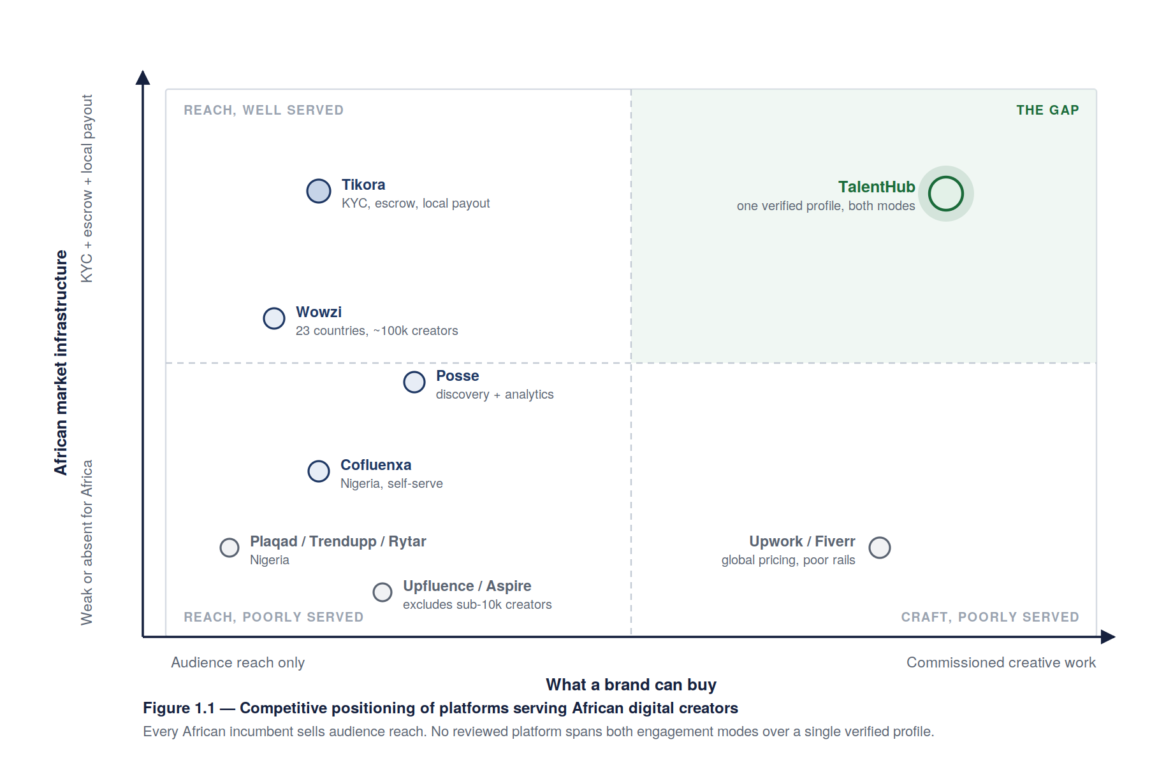
Platform | Category | Reach | Verification | Escrow | Local payout | Commissioned creative work
Wowzi | African influencer marketing | 23 countries, ~100,000 creators | Creator vetting | Not published | Mobile-app fulfilment | No — reach campaigns only
Posse | African influencer marketing | Pan-African, not published | Social data profiles | Not published | Not published | No
Tikora | African influencer marketing | 11+ countries, ~12,000 creators | KYC verified | Yes | Bank, mobile money, crypto | No — campaign types are reach-based
Cofluenxa | Nigerian influencer marketing | Nigeria, launched Oct 2025 | Algorithmic matching on engagement | Not published | Not published | No
Plaqad / Trendupp / Rytar | Nigerian influencer marketing | Nigeria | Varies | Not published | Local | No
Selar / Mainstack | Creator monetisation | Pan-African | Seller onboarding | N/A — direct sale | Local | No — sells creators’ own products
Upwork / Fiverr | Global freelance | Global | Limited identity checks | Yes | Poor African coverage, high fees | Yes
Upfluence / Aspire | Global influencer marketing | Global | Audience analytics | Partial | No African rails | No
Findings. The African platforms are, without exception, influencer marketing platforms: what a brand buys is access to the creator’s own audience. Tikora is the most mature — it already provides KYC verification, escrow and local payout, which are therefore not by themselves a differentiator and the group does not claim them as one.
The gap is on the other axis. None of the African platforms serve the digital creator as a commissioned craft professional — the motion designer, video editor, photographer, illustrator, podcast producer or copywriter whose deliverable is a piece of creative work handed to the client, not a post to their own followers. A Lagos brand needing a motion designer has only the global freelance marketplaces, which impose global price competition, weak identity verification, and payout rails that serve African creators badly. Conversely, the global freelance marketplaces have no concept of verified audience, so a creator whose value is genuinely their reach cannot represent it there.
Positioning. TalentHub is therefore specified as a dual-mode marketplace. A single verified creator profile carries both a portfolio of craft work and authenticated audience metrics, and a brand may engage that creator either for a reach campaign or for a commissioned deliverable, under one contracting, escrow and payout mechanism. No reviewed platform spans both modes, and the unified profile is what makes spanning them coherent rather than merely adjacent.

1.6 Feasibility Study
Technical feasibility. The platform is a conventional three-tier web application with well-understood components: a responsive client, a REST API, a relational datastore, object storage for portfolio media, and third-party integrations for payments, KYC and social metrics. Every integration required is available as a documented commercial API in the target markets — Paystack and Flutterwave for collections and payouts, Smile Identity or Dojah for KYC, and the official Instagram Graph, TikTok and YouTube Data APIs for audience metrics. The team holds prior React and Node.js experience. The one substantive technical risk is correctness of the escrow ledger, which is addressed in design by double-entry bookkeeping and idempotent transitions rather than by ad-hoc balance updates. Assessed: feasible.
Economic feasibility. Development cost within the course is the team’s own time — four members at 7–10 hours per week over six weeks, approximately 200–240 person-hours. Recurring infrastructure cost for a demonstration deployment is low: managed hosting, a managed PostgreSQL instance and object storage fall within free or entry tiers, and the payment and KYC providers charge per transaction rather than by subscription. The commercial model is a commission on completed contracts, benchmarked against the 15% charged by the closest comparator. Assessed: feasible within course constraints.
Operational feasibility. The workflow TalentHub encodes — brief, apply, award, deliver, approve, pay — is the workflow both sides already follow informally over WhatsApp, email and bank transfer. The platform formalises an existing practice rather than asking users to adopt an unfamiliar one, which materially lowers the adoption barrier. The principal operational demand is dispute resolution, which requires human adjudication and is specified as an administrative function. Assessed: feasible.
Legal and regulatory feasibility. Holding client funds in escrow is a regulated activity. The design avoids taking custody of funds directly: settlement is orchestrated through licensed payment service providers, with TalentHub recording entitlement rather than holding balances. Nigeria’s Data Protection Act 2023 governs the personal and KYC data processed, requiring lawful basis, purpose limitation, and data-subject rights; the design therefore specifies consent capture, retention limits and export/erasure endpoints. Contracts formed between brand and creator are between those parties, with TalentHub as platform rather than employer. Assessed: feasible, with the compliance obligations above carried into the requirements as NFRs.
Schedule feasibility. Six weeks is short for the full scope of §1.4. The incremental model in §1.8 exists precisely to manage this: Increments 1–4 deliver the core transactional path and constitute the minimum viable deliverable, while ratings, messaging and analytics in Increments 5–6 are explicitly de-scopable if velocity falls short. Assessed: feasible for the core path; peripheral scope at risk and consciously ordered last.

1.7 Team Roles and Responsibilities
Member | Role | Responsibilities | Principal deliverables
Robertson | Project Manager 1 | Overall coordination, timeline, stakeholder communication, requirements sign-off, repository administration, final presentation | Project charter, requirements specification, weekly status reports, retrospective
David | Project Manager 2 / Technical Lead | Architecture decisions, code review and standards, environment and build pipeline, deployment, performance | Architecture and design documents, code style guide, deployment playbook
Mercy | QA Tester | Test planning, functional and non-functional verification, cross-browser and responsive testing, accessibility, defect reporting and sign-off | Test plan, test cases, defect reports, QA sign-off
Olufems | Developer | Feature implementation, data layer, third-party integrations, technical documentation of code | Application source, database migrations, integration modules
Code review is mandatory: no branch merges without review by the Technical Lead, and no increment closes without QA sign-off.

1.8 Choice of SDLC Model
The incremental / iterative model was selected. Each increment passes through its own requirements, design, build and test activities and terminates in a working, demonstrable slice of the platform; requirements are re-examined at each increment boundary rather than frozen after analysis. Figure 1.2 shows the model as applied here.
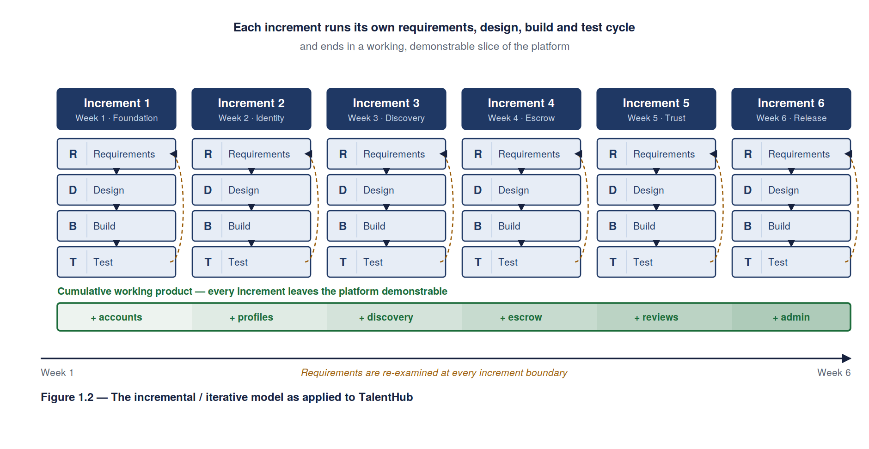
Justification.
- Requirements will change. The group is not the customer. Understanding of how brands and creators actually transact improved materially between Week 1 and Week 3, and a model that forbids revision would have forced the team to build against a specification it knew to be wrong.
- Risk is front-loadable. The riskiest element is the escrow and payout path. Incremental delivery allows it to be built and tested in Increment 3, with three increments of slack remaining, instead of arriving during integration.
- Assessment requires demonstrable progress. A working slice every week gives the module supervisor something to assess continuously and gives the team an early signal when velocity is wrong.
- De-scoping is graceful. Because increments are ordered by importance, running short of time removes peripheral features rather than leaving the core half-built.
Models rejected. Waterfall was rejected because it assumes stable, fully-known requirements — untrue here — and defers all integration risk to the end of a six-week schedule. Full Scrum was rejected as disproportionate: with four part-time members and a six-week horizon, the ceremony overhead would consume a significant share of available effort, and the module requires formal phase documentation that Scrum does not naturally produce. The chosen model retains iteration while still yielding the planning, requirements and design artefacts the assessment expects.

1.9 Increment Roadmap
Figure 1.3 gives the six-week schedule, the dependency between increments, and the two activities that run continuously across all of them.
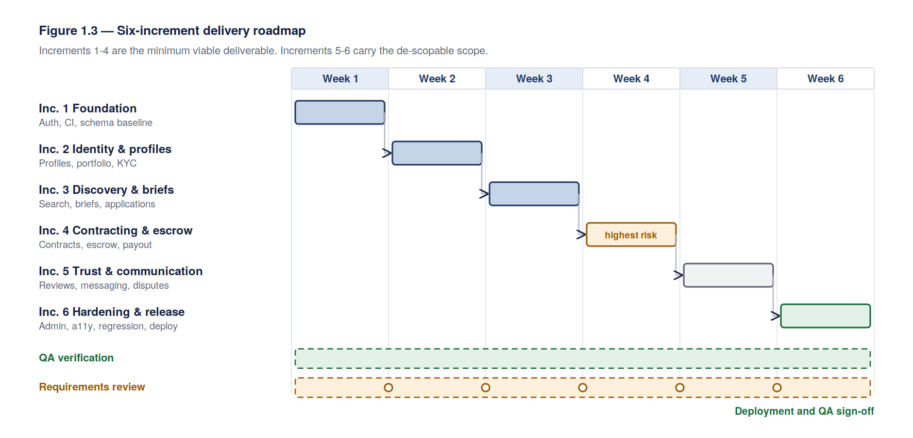
# | Week | Increment theme | Scope delivered | Exit criterion
1 | 1 | Foundation | Repository, environment, CI, schema baseline, authentication, role selection | A user can register, verify email, log in and be routed by role
2 | 2 | Identity & profiles | Creator profile, portfolio upload, skills taxonomy, KYC submission, brand organisation profile | A creator can publish a complete profile; a brand can publish an organisation
3 | 3 | Discovery & briefs | Creator search and filtering, campaign/commission brief creation and publication, applications | A brand can publish a brief and receive applications; a creator can be found by filter
4 | 4 | Contracting & escrow | Award, contract generation, milestone definition, escrow funding, deliverable submission, review and acceptance, payout release | A brand can fund, receive, accept and pay for a deliverable end to end
5 | 5 | Trust & communication | Two-way ratings and reviews, in-platform messaging, notifications, dispute raising | A completed contract yields reviews on both sides; parties can message in-platform
6 | 6 | Hardening & release | Admin moderation console, reporting, accessibility and performance remediation, regression testing, deployment | Regression suite passes; platform deployed; QA sign-off issued
Increments 1–4 constitute the minimum viable deliverable. Increments 5 and 6 carry the de-scopable scope identified in §1.6.

1.10 Risk Register
Exposure is scored as Probability × Impact on a 1–5 scale.
ID | Risk | P | I | Exp | Response
R1 | Payment provider sandbox approval delayed, blocking escrow development | 4 | 5 | 20 | Abstract payments behind a provider interface; build and test against a mock provider so Increment 4 is not gated on external approval
R2 | Six-week schedule insufficient for full scope | 4 | 4 | 16 | Increments ordered by importance; Increments 5–6 pre-identified as de-scopable; weekly velocity review at increment boundary
R3 | Escrow ledger defects causing incorrect balances | 3 | 5 | 15 | Double-entry ledger, idempotent state transitions, reconciliation test suite written before the feature
R4 | Social platform API rate limits or access restrictions block audience verification | 3 | 4 | 12 | Cache metrics with scheduled refresh; degrade to creator-declared figures marked unverified rather than failing the profile
R5 | Member unavailability through illness or examination clash | 3 | 4 | 12 | Documented handover per role; no single-owner critical path; pair on the escrow module
R6 | KYC provider cost or coverage gaps in target markets | 3 | 3 | 9 | Provider abstracted behind an interface; manual administrative verification as fallback path
R7 | Scope creep from stakeholder feedback during increments | 3 | 3 | 9 | Change requests logged as backlog items against a future increment, never admitted mid-increment
R8 | Data protection non-compliance in handling KYC data | 2 | 5 | 10 | Consent capture, encryption at rest, retention limits and erasure endpoint specified as NFRs in Chapter Two
R9 | Integration failures surfacing late | 2 | 4 | 8 | Continuous integration from Increment 1; integration tests per increment rather than a terminal integration phase
R1, R2 and R3 are the three highest exposures and are reviewed at every weekly standup.

References
Communiqué & TM Global (2026) Africa Creator Economy Report 2026. Reported by Techpoint Africa. Available at: https://techpoint.africa/news/africa-creator-economy-report-2026/
Contemeleon (2026) The State of the Creator Economy in Africa: Data, Trends, and the Road to $30 Billion. Available at: https://www.contemeleon.com/blog/state-of-creator-economy-in-africa
TechCabal (2025) Nigerian Tech Startup, Cofluenxa, Launches to Streamline Influencer Marketing in Africa. Available at: https://techcabal.com/2025/10/02/exclusive-nigerian-tech-startup-cofluenxa-launches-to-streamline-influencer-marketing-in-africa/
Tikora (2026) Africa’s Influencer Marketing Platform. Available at: https://www.tikora.app/
Wowzi (2026) Connecting Brands with Africa’s Top Creators. Available at: https://www.wowzi.co/
Posse (2026) Influencer Marketing Platform for Brands & Creators. Available at: https://www.posse.africa/

CHAPTER TWO — Requirements Analysis

2.1 Requirements Elicitation Approach
Four techniques were used, chosen for what was achievable within the course timetable.
Technique | Applied to | Output
Document analysis | Africa Creator Economy Report 2026, Contemeleon market study, trade press coverage of African platforms | Quantified problem statement; earnings, verification and payment failure data
Competitive system analysis | Nine platforms (§1.5) | Baseline feature set; identification of the commissioned-work gap
Informal interviews | Three practising creators (a photographer, a video editor and a micro-influencer) and two small-business owners who had commissioned creative work | Pain points in payment timing, brief clarity and scope disputes
Analogy analysis | Escrow and milestone mechanics of general freelance marketplaces | Contracting and deliverable-review workflow patterns
The interviews changed the specification in two concrete ways. First, creators raised scope disputes — work accepted then endlessly revised — more often than outright non-payment, which produced the bounded revision limit in FR-30. Second, both buyers described judging creators on past work, not follower counts, which is what led to the portfolio being a first-class entity rather than an optional profile field.

2.2 Stakeholder Analysis
Stakeholder | Interest in the system | Influence | Key requirement
Creator (primary user) | Be found, be hired, be paid reliably | High | Verified profile; payment protected before work begins
Brand / Business (primary user) | Find suitable creators; get usable work for money spent | High | Trustworthy discovery; funds not released until work is accepted
Platform Administrator | Keep the marketplace safe and solvent | High | Moderation, verification override, dispute adjudication
Payment Service Provider | Regulatory compliance of flows it settles | High (external) | Correct, auditable, idempotent transaction instructions
KYC Provider | Accurate identity submissions | Medium (external) | Conformant document and biometric submission
Social Platform APIs | Terms-of-service compliance | Medium (external) | Authorised, rate-limited metric retrieval
Module Supervisor | Evidence of sound engineering process | High (assessment) | Complete, traceable SDLC documentation
Agencies (secondary) | Manage several brands’ campaigns | Low | Out of scope for this release; noted for future work

2.3 System Context
TalentHub sits between two classes of human user and four external services. Figure 2.1 shows the system boundary and every crossing of it.
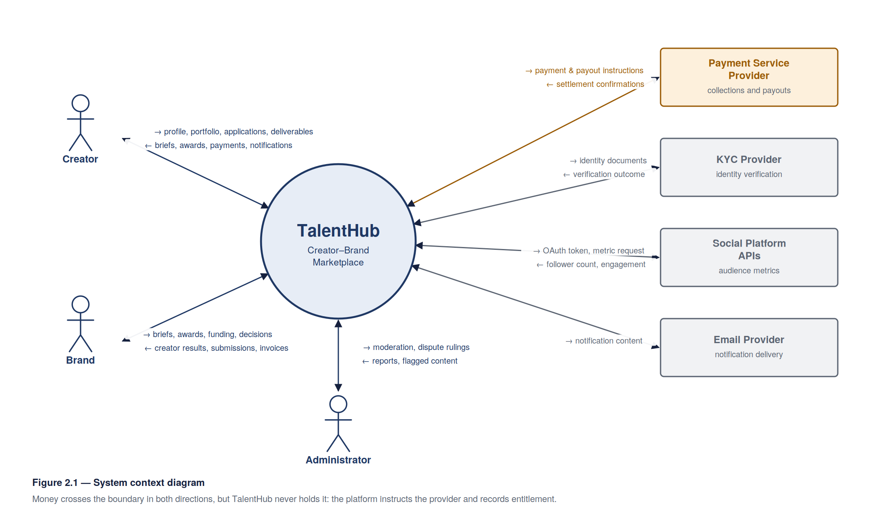
The boundary matters for a specific reason recorded in §1.6: money crosses it in both directions, but TalentHub never holds it. The platform instructs the payment service provider and records entitlement; custody stays with the licensed provider.

2.4 Functional Requirements
Priority follows MoSCoW: M must have, S should have, C could have. The Inc. column gives the increment that delivers the requirement.

2.4.1 Account and identity
ID | Requirement | Pri | Inc.
FR-01 | The system shall allow a visitor to register as either a Creator or a Brand, capturing email, password and role. | M | 1
FR-02 | The system shall verify a registered email address by time-limited token before granting access to transactional features. | M | 1
FR-03 | The system shall authenticate returning users by email and password, and shall lock an account after five consecutive failed attempts. | M | 1
FR-04 | The system shall allow a user to reset a forgotten password via a single-use, time-limited link. | M | 1
FR-05 | The system shall route an authenticated user to the dashboard corresponding to their role. | M | 1
FR-06 | The system shall allow a Creator to submit identity documents for KYC verification and shall display verification status as unverified, pending, verified or rejected. | M | 2
FR-07 | The system shall allow an Administrator to override a KYC outcome, recording the acting administrator and a reason. | S | 6

2.4.2 Creator profile and portfolio
ID | Requirement | Pri | Inc.
FR-08 | The system shall allow a Creator to maintain a profile comprising display name, biography, country, city, languages and primary discipline. | M | 2
FR-09 | The system shall allow a Creator to declare skills from a controlled taxonomy, each with a self-assessed proficiency level. | M | 2
FR-10 | The system shall allow a Creator to upload portfolio items (image, video or document, with title, description and role played) to a maximum of 20 items. | M | 2
FR-11 | The system shall allow a Creator to link social accounts by OAuth and shall retrieve follower count and engagement rate from the platform’s official API. | M | 2
FR-12 | The system shall mark audience metrics as verified when retrieved by API and self-declared when entered manually, and shall refresh verified metrics at least every 7 days. | M | 2
FR-13 | The system shall allow a Creator to publish a day rate and a project-based rate per discipline, in a selected currency. | M | 2
FR-14 | The system shall allow a Creator to set availability as available, limited or unavailable. | S | 2

2.4.3 Brand profile
ID | Requirement | Pri | Inc.
FR-15 | The system shall allow a Brand to maintain an organisation profile comprising legal name, trading name, country, sector, website and logo. | M | 2
FR-16 | The system shall allow a Brand to invite additional users into its organisation with either administrator or member permission. | C | 6

2.4.4 Discovery
ID | Requirement | Pri | Inc.
FR-17 | The system shall allow a Brand to search Creators by free text across name, biography and portfolio titles. | M | 3
FR-18 | The system shall allow results to be filtered by discipline, skill, country, city, engagement mode, rate range, audience size band, verification status and average rating. | M | 3
FR-19 | The system shall allow results to be sorted by relevance, rating, rate or audience size, and shall paginate at 20 per page. | M | 3
FR-20 | The system shall allow a Brand to save a Creator to a named shortlist. | S | 3

2.4.5 Briefs and applications
ID | Requirement | Pri | Inc.
FR-21 | The system shall allow a Brand to create a brief specifying engagement mode (reach campaign or commissioned work), title, description, required skills, deliverables, budget, currency and closing date. | M | 3
FR-22 | The system shall allow a Brand to save a brief as a draft, publish it, or close it to further applications. | M | 3
FR-23 | The system shall allow a Creator to apply to a published brief with a covering note and a proposed fee, and shall prevent more than one application per Creator per brief. | M | 3
FR-24 | The system shall allow a Brand to mark an application as shortlisted, rejected or awarded. | M | 3
FR-25 | The system shall allow a Brand to invite a specific Creator directly to a brief without a prior application. | S | 3

2.4.6 Contracting, escrow and delivery
ID | Requirement | Pri | Inc.
FR-26 | On award, the system shall generate a contract recording the parties, scope, agreed fee, platform commission, deliverables, milestones and acceptance criteria, requiring acceptance by both parties. | M | 4
FR-27 | The system shall allow a contract to be divided into one or more milestones, each with a description, amount and due date, the sum of which equals the agreed fee. | M | 4
FR-28 | The system shall require the Brand to fund a milestone into escrow before the Creator may begin it, and shall not permit submission against an unfunded milestone. | M | 4
FR-29 | The system shall allow a Creator to submit deliverables against a funded milestone as file uploads or external links, with a submission note. | M | 4
FR-30 | The system shall allow a Brand to accept a submission, or request revision with stated reasons, to a maximum of two revision requests per milestone. | M | 4
FR-31 | The system shall automatically accept a submission not acted upon within 7 days of submission, and shall notify both parties before doing so. | M | 4
FR-32 | On acceptance, the system shall release the milestone amount less platform commission to the Creator’s payout balance, and shall record the movement as a double-entry ledger transaction. | M | 4
FR-33 | The system shall allow a Creator to withdraw an available payout balance to a registered bank account or mobile money wallet. | M | 4
FR-34 | The system shall allow either party to cancel a contract before any milestone is funded, without penalty. | S | 4
FR-35 | The system shall allow either party to raise a dispute on a funded milestone, which shall freeze the milestone pending administrative adjudication. | M | 5
FR-36 | The system shall allow an Administrator to resolve a dispute by releasing to the Creator, refunding to the Brand, or splitting the milestone amount, recording a reason. | M | 5

2.4.7 Trust, communication and administration
ID | Requirement | Pri | Inc.
FR-37 | The system shall allow each party to rate the other from 1 to 5 with a written review after contract completion, and shall publish reviews only once both are submitted or 14 days have elapsed. | M | 5
FR-38 | The system shall compute and display each user’s mean rating and completed-contract count. | M | 5
FR-39 | The system shall allow messaging between parties to an active contract or an open application, retaining message history against the contract. | M | 5
FR-40 | The system shall notify users of application, award, funding, submission, acceptance, payout and dispute events by in-app notification and email. | M | 5
FR-41 | The system shall allow a user to report a profile, brief or message for policy violation. | S | 6
FR-42 | The system shall allow an Administrator to suspend a user, withdraw a brief, and view an audit trail of administrative actions. | M | 6
FR-43 | The system shall present an Administrator dashboard reporting registrations, published briefs, contract value, escrow held, disputes open and commission earned over a selected period. | S | 6

2.5 Non-Functional Requirements
ID | Category | Requirement
NFR-01 | Performance | Search results shall return within 2 seconds at the 95th percentile for a catalogue of 50,000 creator profiles.
NFR-02 | Performance | Any page shall achieve first contentful paint within 3 seconds on a 3G connection at 400 kbps.
NFR-03 | Performance | The system shall sustain 500 concurrent authenticated sessions without degradation beyond NFR-01.
NFR-04 | Usability | The interface shall be operable on a viewport of 360 px width without horizontal scrolling.
NFR-05 | Usability | A first-time Creator shall be able to publish a complete profile within 10 minutes without assistance.
NFR-06 | Accessibility | The interface shall conform to WCAG 2.1 Level AA, including keyboard operability and a minimum 4.5:1 text contrast ratio.
NFR-07 | Availability | The platform shall target 99.5% monthly availability, excluding announced maintenance.
NFR-08 | Reliability | No financial transaction shall be lost or double-applied; all monetary state transitions shall be idempotent under retry.
NFR-09 | Security | Passwords shall be stored using bcrypt at cost factor 12 or greater; plaintext passwords shall never be logged or persisted.
NFR-10 | Security | All traffic shall be served over TLS 1.2 or above; KYC documents and payout instruments shall be encrypted at rest.
NFR-11 | Security | Authorisation shall be enforced server-side on every request; no endpoint shall rely on client-side role checks.
NFR-12 | Security | Authentication endpoints shall be rate-limited to 10 attempts per IP address per minute.
NFR-13 | Privacy | Personal and KYC data shall be processed on a recorded lawful basis under the Nigeria Data Protection Act 2023; KYC documents shall be retained no longer than 5 years after account closure.
NFR-14 | Privacy | A user shall be able to export their personal data and request erasure, subject to statutory retention of financial records.
NFR-15 | Auditability | Every monetary movement and administrative action shall be recorded immutably with actor, timestamp and reason.
NFR-16 | Maintainability | Code shall pass linting and achieve at least 70% unit-test line coverage on service and ledger modules before merge.
NFR-17 | Portability | The client shall function on current versions of Chrome, Firefox, Safari and Edge, and on Android 9+ and iOS 14+ browsers.
NFR-18 | Scalability | The application tier shall be stateless so that capacity can be added by horizontal replication.
NFR-19 | Localisation | Monetary values shall be stored in minor units with an explicit ISO 4217 currency code; no cross-currency arithmetic shall occur without a recorded rate.
NFR-20 | Interoperability | Each external provider (payments, KYC, social metrics) shall be accessed through an internal interface permitting substitution without changes to business logic.

2.6 Use Case Model
Four actors interact with the system: Creator, Brand, Administrator and the external Payment Service Provider. Figure 2.2 shows the use case model.
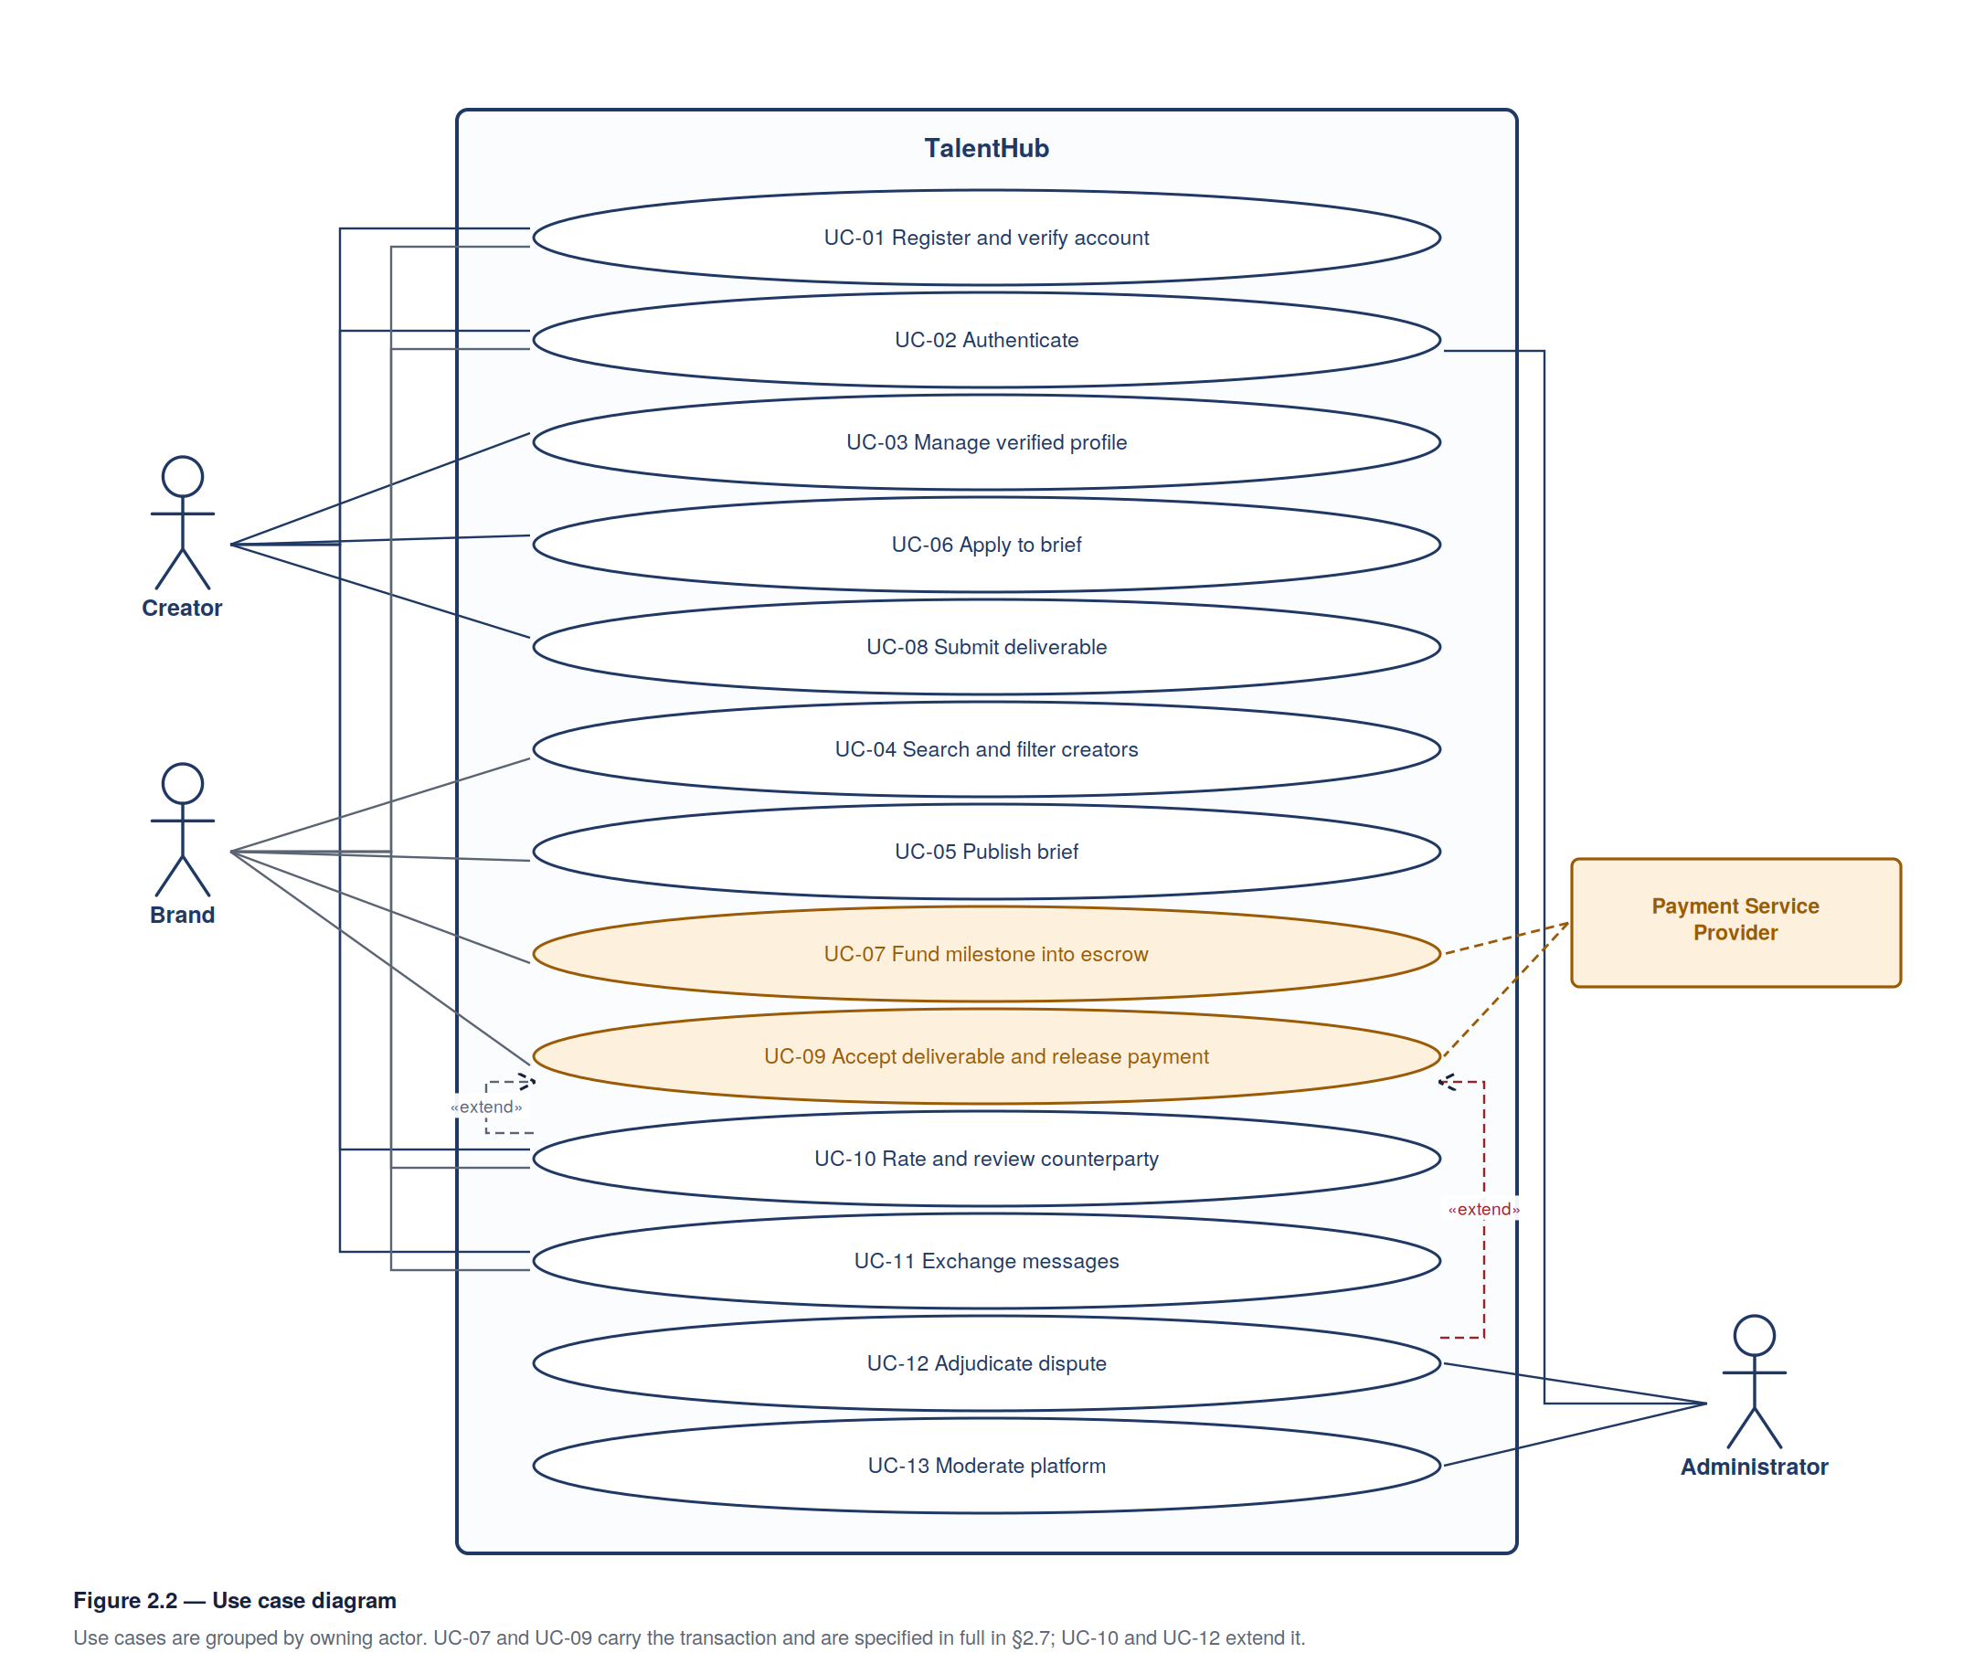

2.7 Use Case Specifications
Three use cases are specified in full: the two that carry the highest risk (escrow funding and payout release) and the one that defines the product’s core value (creator discovery).

UC-07 — Fund Milestone into Escrow
Field | Detail
ID / Name | UC-07 — Fund Milestone into Escrow
Actor | Brand (primary), Payment Service Provider (secondary)
Requirements | FR-28, FR-32, NFR-08, NFR-15, NFR-19
Pre-conditions | A contract exists and has been accepted by both parties; the target milestone is in state pending; the Brand is authenticated and authorised on the contract
Post-conditions | The milestone is in state funded; a double-entry ledger transaction records the movement; the Creator is notified and may begin work
Trigger | The Brand selects Fund milestone on a contract
Main flow
- The Brand selects a milestone in state pending.
- The system displays the milestone amount, the platform commission and the total payable.
- The Brand confirms and selects a payment method.
- The system creates a payment intent with an idempotency key derived from the milestone identifier and initiates the transaction with the Payment Service Provider.
- The Provider authorises the payment and returns a confirmation reference.
- The system posts a ledger transaction debiting the Brand’s funding account and crediting the escrow account for the milestone amount.
- The system sets the milestone to funded, records the provider reference, and notifies the Creator.
Alternative flows
- A1 — Payment declined (step 5). The Provider returns a decline. The system leaves the milestone pending, posts no ledger entry, records the failure against the attempt, and invites the Brand to retry or choose another method. Returns to step 3.
- A2 — Provider timeout (step 5). No response is received within the configured window. The system marks the attempt indeterminate and does not change milestone state. A reconciliation job re-queries the Provider using the original idempotency key and completes or abandons the attempt on the authoritative answer. No second charge can occur, satisfying NFR-08.
- A3 — Duplicate submission (step 4). The same idempotency key is presented again. The system returns the outcome of the original attempt without initiating a second transaction.
Exception
- E1 — Milestone no longer fundable. The milestone has been cancelled or funded since the page was rendered. The system rejects the request with an explanatory message and re-renders current contract state.

UC-09 — Accept Deliverable and Release Payment
Field | Detail
ID / Name | UC-09 — Accept Deliverable and Release Payment
Actor | Brand (primary), Creator and Payment Service Provider (secondary)
Requirements | FR-29, FR-30, FR-31, FR-32, FR-33, NFR-08, NFR-15
Pre-conditions | The milestone is in state submitted; the Brand is authorised on the contract
Post-conditions | The milestone is accepted; the net amount is credited to the Creator’s payout balance; commission is recognised; both parties are notified and invited to review
Trigger | The Brand selects Accept on a submission, or the 7-day auto-acceptance timer elapses
Main flow
- The Brand opens the submission and reviews the attached deliverables.
- The Brand selects Accept.
- The system computes the platform commission and the net amount due to the Creator.
- The system posts a ledger transaction debiting escrow and crediting the Creator’s payout balance and the platform commission account.
- The system sets the milestone to accepted.
- Where the accepted milestone is the contract’s last, the system sets the contract to completed and opens the review window (FR-37).
- The system notifies the Creator that funds are available for withdrawal.
Alternative flows
- A1 — Revision requested (step 2). The Brand selects Request revision and supplies reasons. If fewer than two revisions have been requested on this milestone, the system returns it to in progress, records the request, and notifies the Creator. On the third attempt the option is unavailable and the Brand must accept or raise a dispute (FR-35).
- A2 — Auto-acceptance (trigger). Seven days elapse without action. The system notifies both parties 24 hours in advance, then executes steps 3–7 with the acting party recorded as system.
- A3 — Dispute raised (step 2). The Brand raises a dispute instead of accepting. The milestone moves to disputed, escrow is frozen, and UC-12 (Adjudicate Dispute) takes over.
Exception
- E1 — Ledger posting fails (step 4). The transaction is rolled back atomically and the milestone remains submitted. No partial credit is possible. The failure is logged for administrative attention.

UC-04 — Search and Filter Creators
Field | Detail
ID / Name | UC-04 — Search and Filter Creators
Actor | Brand
Requirements | FR-17, FR-18, FR-19, FR-20, NFR-01, NFR-04
Pre-conditions | The Brand is authenticated
Post-conditions | A paginated, ordered result set of published Creator profiles is displayed; applied filters are reflected in the URL so the search is shareable
Trigger | The Brand submits a search term or applies a filter
Main flow
- The Brand enters a search term and/or applies filters (discipline, skill, country, engagement mode, rate range, audience band, verification status, minimum rating).
- The system validates filter values and rejects incoherent ranges.
- The system queries published, non-suspended Creator profiles matching all applied criteria.
- The system orders results by the selected criterion, defaulting to relevance, and returns the first 20.
- The system displays each result as a card showing name, discipline, location, verification badge, audience figure with its verification state, rate and mean rating.
- The Brand may page through results, refine filters, open a profile, or save a Creator to a shortlist.
Alternative flows
- A1 — No matches (step 4). The system reports that no creators match, states which filters are active, and offers to relax the most restrictive.
- A2 — Filter combination too narrow. The system suggests the nearest broader criterion — typically widening the rate range or audience band.
Exception
- E1 — Search backend unavailable. The system degrades to a direct database query on discipline, country and skill only, and states that ranked relevance is temporarily unavailable.

2.8 User Stories by Increment
Increment 1 — Foundation
- As a visitor, I want to register as a creator or a brand so that the platform presents the right tools for me.
- As a user, I want to verify my email address so that my account is trusted.
- As a returning user, I want to log in and land on my own dashboard so that I can resume work.
- As a user, I want to reset my password so that a forgotten password does not lock me out.
Increment 2 — Identity and profiles
- As a creator, I want to publish a profile with my biography, location and discipline so that brands understand what I do.
- As a creator, I want to upload past work so that brands can judge me on output rather than follower count.
- As a creator, I want to link my social accounts so that my audience figures are verified rather than merely claimed.
- As a creator, I want to complete identity verification so that brands can see I am a real, accountable person.
- As a brand, I want to publish an organisation profile so that creators can see who is hiring them.
Increment 3 — Discovery and briefs
- As a brand, I want to filter creators by skill, location and rate so that I can build a shortlist quickly.
- As a brand, I want to publish a brief so that suitable creators come to me.
- As a creator, I want to apply to a brief with a note and a fee so that I can win work I am suited to.
- As a brand, I want to shortlist and reject applications so that I can manage a large response.
Increment 4 — Contracting and escrow
- As a brand, I want a contract generated on award so that scope and fee are recorded before work starts.
- As a creator, I want the brand’s money held in escrow before I begin so that I am not working on trust alone.
- As a creator, I want to submit my deliverables in the platform so that delivery is evidenced.
- As a brand, I want to request a bounded number of revisions so that I get usable work without the scope becoming open-ended.
- As a creator, I want payment released on acceptance and withdrawable to my bank or mobile money so that I am actually paid.
Increment 5 — Trust and communication
- As either party, I want to rate and review the other after completion so that reputation accumulates.
- As either party, I want to message in-platform so that the conversation stays attached to the contract.
- As either party, I want to raise a dispute so that a stalemate has a route out.
- As an administrator, I want to adjudicate disputes so that frozen funds can be resolved fairly.
Increment 6 — Hardening and release
- As an administrator, I want to suspend abusive accounts and withdraw offending briefs so that the marketplace stays safe.
- As an administrator, I want a reporting dashboard so that I can see the platform’s health.
- As any user, I want the platform to work on my phone over a slow connection so that I can use it where I actually am.

2.9 Data Flow
Figure 2.3 decomposes the platform into its five major processes and the data stores they read and write.
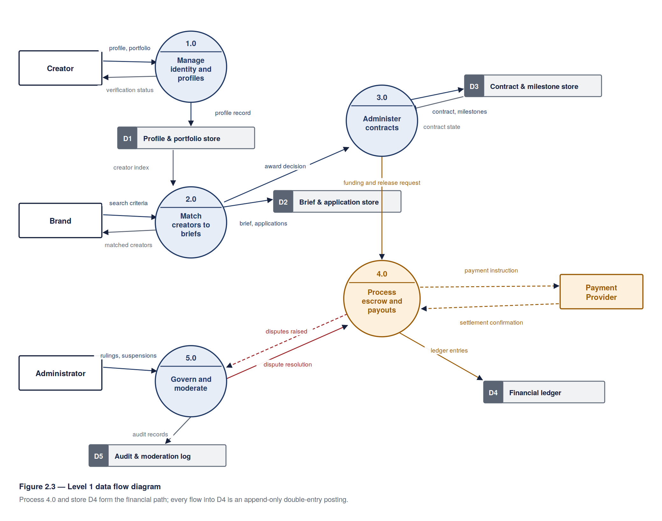

2.10 Requirements Traceability Matrix
Objective (§1.3) | Requirements | Use cases | Increment | Verification
2 — Specify requirements for all stakeholder classes | FR-01 to FR-43, NFR-01 to NFR-20 | UC-01 to UC-13 | 1–6 | Supervisor review of this chapter
Secure, role-based access | FR-01 to FR-05, NFR-09 to NFR-12 | UC-01, UC-02 | 1 | Functional and penetration testing
Verified creator identity and capability | FR-06 to FR-14 | UC-03 | 2 | Functional testing; KYC sandbox verification
Trustworthy discovery | FR-17 to FR-20, NFR-01 | UC-04 | 3 | Functional testing; load test at 50,000 profiles
Brief-to-application workflow | FR-21 to FR-25 | UC-05, UC-06 | 3 | Functional testing
Escrow-protected contracting | FR-26 to FR-34, NFR-08, NFR-15, NFR-19 | UC-07, UC-08, UC-09 | 4 | Ledger reconciliation suite; idempotency tests
Dispute resolution | FR-35, FR-36 | UC-12 | 5 | Functional testing of all three resolution outcomes
Accumulated reputation | FR-37, FR-38 | UC-10 | 5 | Functional testing
Communication and notification | FR-39, FR-40 | UC-11 | 5 | Functional testing; email delivery verification
Platform governance | FR-07, FR-41 to FR-43, NFR-15 | UC-13 | 6 | Functional testing; audit trail inspection
5 — Verify against specification | All NFRs | — | 6 | Mercy’s test plan; QA sign-off
Mobile-first, low-bandwidth access | NFR-02, NFR-04, NFR-06, NFR-17 | All | 6 | Lighthouse audit; throttled-network testing; WCAG audit
Every functional requirement traces to at least one use case and exactly one increment; every objective in §1.3 traces to a verification activity.

CHAPTER THREE — System Design

3.1 Design Objectives
The design is governed by five objectives derived from Chapter Two.
- Financial correctness before all else. Money must never be lost, duplicated or stranded (NFR-08). Every design decision in the transaction path is subordinate to this.
- Substitutable externals. Payment, KYC and social-metric providers differ by market and change commercially. Each is reached through an internal interface so that business logic is unaffected by substitution (NFR-20).
- Mobile-first on constrained networks. The median user is on a mid-range Android device over a slow connection (NFR-02, NFR-04, NFR-17).
- Server-authoritative access control. Role and ownership checks are enforced on every request; the client is never trusted (NFR-11).
- Auditability by construction. Financial and administrative history is append-only rather than reconstructed from mutable rows (NFR-15).

3.2 Architectural Design
A layered (three-tier) architecture with a modular service layer was selected. Figure 3.1 shows the arrangement.
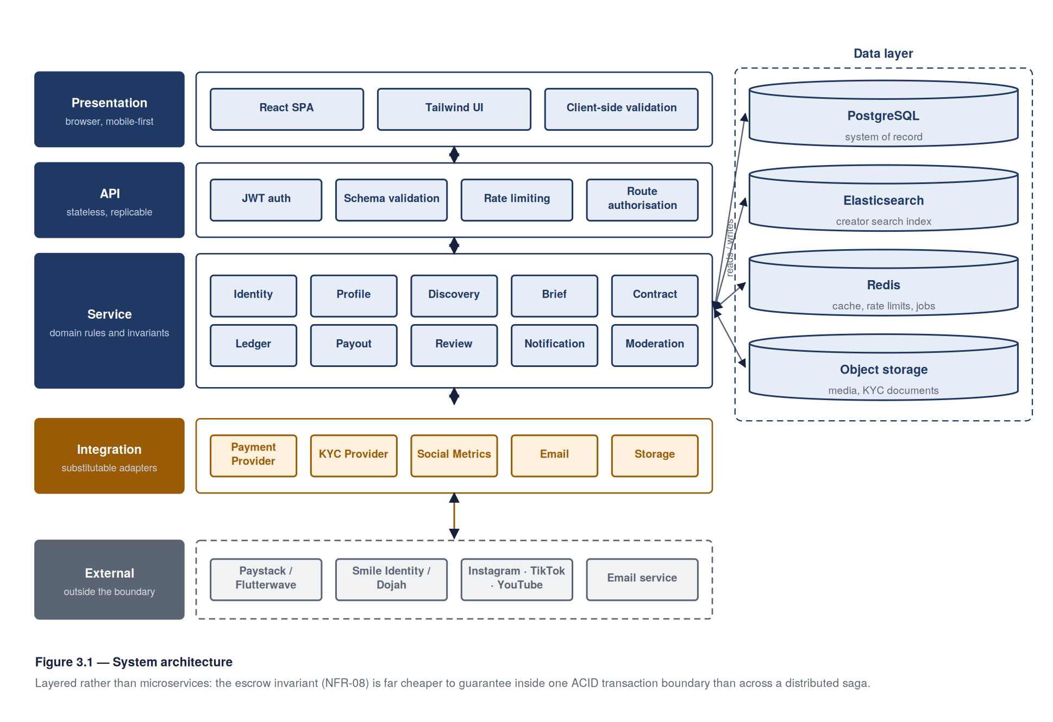
Layer | Responsibility | Components
Presentation | Rendering, client-side validation, state, routing | React SPA; Tailwind CSS; responsive layout; served as static assets from a CDN
API | Request authentication, authorisation, input validation, rate limiting, response shaping | Node.js / Express REST API; JWT access and refresh tokens; per-route authorisation middleware
Service (domain) | Business rules, invariants, orchestration of external providers | Identity, Profile, Discovery, Brief, Contract, Ledger, Payout, Review, Notification, Moderation modules
Integration | Provider adapters behind internal interfaces | PaymentProvider, KycProvider, SocialMetricsProvider, EmailProvider, StorageProvider
Data | Persistence, search indexing, media, queued work | PostgreSQL (system of record); Elasticsearch (creator search index); S3-compatible object storage (portfolio media, KYC documents); Redis (cache, rate limits, job queue)
Why layered rather than microservices. Microservices were considered and rejected. A six-week schedule with four part-time developers cannot absorb the operational cost of distributed deployment, and — more importantly — the escrow invariant in NFR-08 is far easier to guarantee inside a single ACID transaction boundary than across a distributed saga. The service layer is nevertheless kept modular, with no cross-module database access, so that a module can be extracted later if scale demands it.
Key architectural decisions.
- Stateless API. Sessions are carried in signed tokens, not server memory, so capacity is added by replication (NFR-18).
- Search index separate from the system of record. Multi-criteria filtering over 50,000 profiles within 2 seconds (NFR-01) is served by Elasticsearch, populated asynchronously from PostgreSQL. The index is a derived, rebuildable artefact; its loss degrades search (UC-04/E1) but never loses data.
- Asynchronous work off the request path. Metric refresh, email dispatch, payment reconciliation and index updates run as queued jobs so that no user request waits on a third party.
- Ledger as append-only double entry. See §3.5.

3.3 Technology Stack
Concern | Selection | Rationale
Client | React 18, Tailwind CSS, Zustand | Team experience carried over from the archived project; small bundle achievable for NFR-02
API | Node.js 20, Express, Zod validation | One language across the stack; the team’s strongest competence
Database | PostgreSQL 15 | Transactional integrity is mandatory for the ledger; NUMERIC for money; mature constraint support
Search | Elasticsearch 8 | Multi-facet filtering and relevance ranking at the required latency
Cache / queue | Redis 7 with BullMQ | Rate limiting, session cache and background jobs in one dependency
Object storage | S3-compatible with pre-signed URLs | Media uploads bypass the API tier; private bucket for KYC documents
Payments | Paystack (primary), Flutterwave (secondary) | Collections and payouts across the target markets; both behind PaymentProvider
KYC | Smile Identity or Dojah | African document and biometric coverage; behind KycProvider
Social metrics | Instagram Graph, TikTok and YouTube Data APIs | Official, terms-compliant retrieval
Testing | Jest, Supertest, Playwright, k6 | Unit, API, end-to-end and load coverage for NFR-01 and NFR-03
CI/CD | GitHub Actions | Lint, test and coverage gate on every pull request (NFR-16)

3.4 Database Design
Figure 3.2 gives the entity–relationship model. Sixteen entities form the system of record.
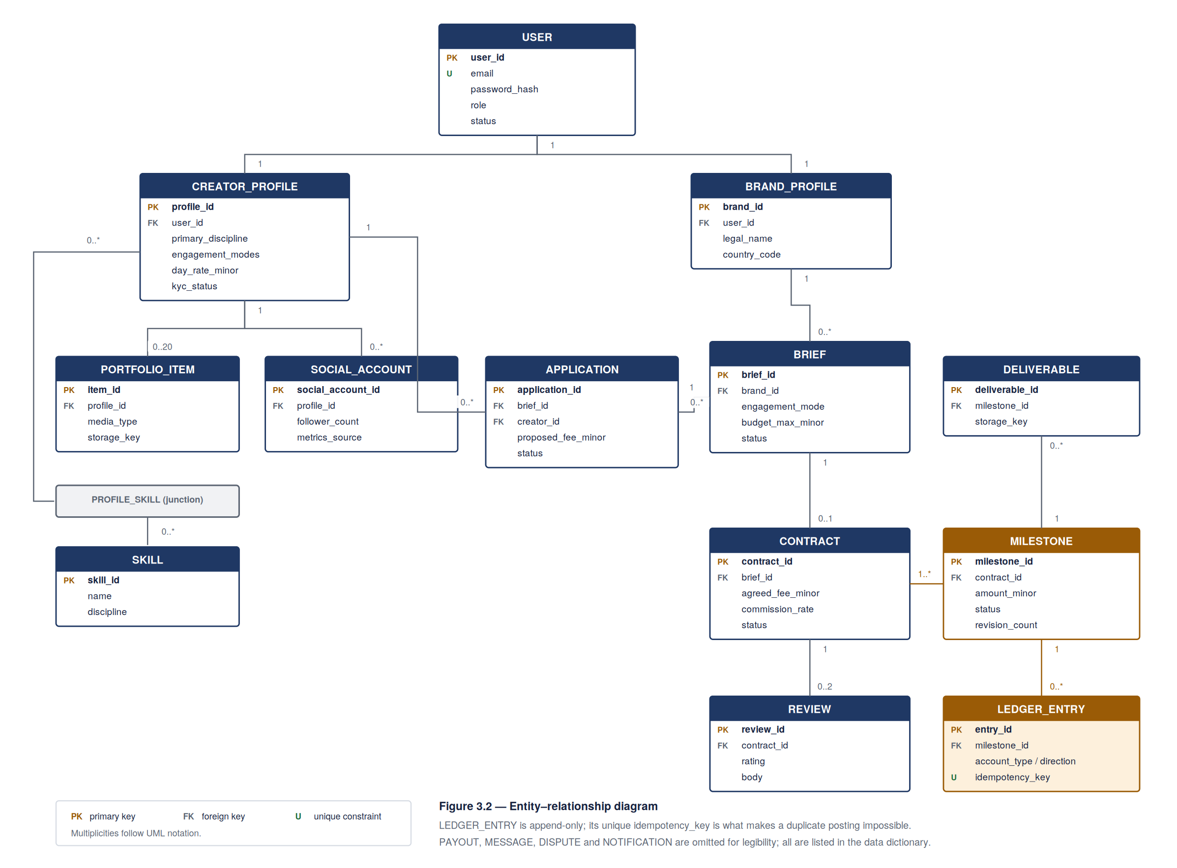

3.4.1 Data dictionary (principal entities)
USER — one row per authenticated principal.
Attribute | Type | Constraints | Notes
user_id | UUID | PK
email | VARCHAR(255) | UNIQUE, NOT NULL | Lowercased on write
password_hash | VARCHAR(255) | NOT NULL | bcrypt, cost ≥ 12 (NFR-09)
role | ENUM | NOT NULL | creator, brand, admin
email_verified_at | TIMESTAMPTZ | NULL | NULL until FR-02 satisfied
status | ENUM | NOT NULL | active, suspended, closed
failed_login_count | SMALLINT | NOT NULL DEFAULT 0 | Supports FR-03 lockout
created_at, updated_at | TIMESTAMPTZ | NOT NULL
CREATOR_PROFILE — 1:1 with a user of role creator.
Attribute | Type | Constraints | Notes
profile_id | UUID | PK
user_id | UUID | FK → USER, UNIQUE
display_name | VARCHAR(120) | NOT NULL
biography | TEXT
country_code | CHAR(2) | NOT NULL | ISO 3166-1 alpha-2
city | VARCHAR(120)
primary_discipline | VARCHAR(80) | NOT NULL | From controlled taxonomy
engagement_modes | ENUM[] | NOT NULL | reach, commission, or both
day_rate_minor | BIGINT |  | Minor units (NFR-19)
project_rate_minor | BIGINT
currency_code | CHAR(3) | NOT NULL | ISO 4217
availability | ENUM | NOT NULL | available, limited, unavailable
kyc_status | ENUM | NOT NULL | unverified, pending, verified, rejected
mean_rating | NUMERIC(3,2) |  | Derived from REVIEW
completed_contracts | INTEGER | NOT NULL DEFAULT 0 | Derived
published_at | TIMESTAMPTZ | NULL | NULL = not discoverable
PORTFOLIO_ITEM — many per creator profile, capped at 20 (FR-10).
Attribute | Type | Constraints
item_id | UUID | PK
profile_id | UUID | FK → CREATOR_PROFILE
title | VARCHAR(160) | NOT NULL
description | TEXT
media_type | ENUM | image, video, document, link
storage_key | VARCHAR(512) | Object-storage key
role_played | VARCHAR(160)
display_order | SMALLINT | NOT NULL
SOCIAL_ACCOUNT — linked audience source (FR-11, FR-12).
Attribute | Type | Constraints | Notes
social_account_id | UUID | PK
profile_id | UUID | FK → CREATOR_PROFILE
platform | ENUM | NOT NULL | instagram, tiktok, youtube, x
handle | VARCHAR(120) | NOT NULL
follower_count | BIGINT
engagement_rate | NUMERIC(5,2) |  | Percentage
metrics_source | ENUM | NOT NULL | api_verified, self_declared
last_refreshed_at | TIMESTAMPTZ |  | Drives the 7-day refresh (FR-12)
 |  | UNIQUE (profile_id, platform)
BRIEF — a published opportunity (FR-21, FR-22).
Attribute | Type | Constraints | Notes
brief_id | UUID | PK
brand_id | UUID | FK → BRAND_PROFILE
engagement_mode | ENUM | NOT NULL | reach, commission
title | VARCHAR(200) | NOT NULL
description | TEXT | NOT NULL
budget_min_minor, budget_max_minor | BIGINT
currency_code | CHAR(3) | NOT NULL
closes_at | TIMESTAMPTZ | NOT NULL
status | ENUM | NOT NULL | draft, published, closed, withdrawn
CONTRACT — the agreement formed on award (FR-26).
Attribute | Type | Constraints | Notes
contract_id | UUID | PK
brief_id | UUID | FK → BRIEF
creator_id, brand_id | UUID | FK
agreed_fee_minor | BIGINT | NOT NULL
commission_rate | NUMERIC(5,4) | NOT NULL | Frozen at award
currency_code | CHAR(3) | NOT NULL
status | ENUM | NOT NULL | pending_acceptance, active, completed, cancelled, disputed
creator_accepted_at, brand_accepted_at | TIMESTAMPTZ |  | Both required for active
MILESTONE — the unit of funding and delivery (FR-27 to FR-32).
Attribute | Type | Constraints | Notes
milestone_id | UUID | PK
contract_id | UUID | FK → CONTRACT
sequence_no | SMALLINT | NOT NULL | UNIQUE with contract_id
description | TEXT | NOT NULL
amount_minor | BIGINT | NOT NULL, > 0 | Sum per contract = agreed_fee_minor
due_date | DATE
status | ENUM | NOT NULL | See §3.6
revision_count | SMALLINT | NOT NULL DEFAULT 0 | Capped at 2 (FR-30)
funded_at, submitted_at, accepted_at | TIMESTAMPTZ
LEDGER_ENTRY — append-only double entry. No row is ever updated or deleted.
Attribute | Type | Constraints | Notes
entry_id | BIGSERIAL | PK
transaction_id | UUID | NOT NULL | Groups the entries of one transaction
account_type | ENUM | NOT NULL | brand_funding, escrow, creator_payable, platform_commission, provider_settlement
account_owner_id | UUID | NULL | NULL for platform accounts
direction | ENUM | NOT NULL | debit, credit
amount_minor | BIGINT | NOT NULL, > 0
currency_code | CHAR(3) | NOT NULL
milestone_id | UUID | FK, NULL
idempotency_key | VARCHAR(160) | UNIQUE | Enforces NFR-08 at the database level
created_at | TIMESTAMPTZ | NOT NULL
Invariant. For every transaction_id, the sum of debits equals the sum of credits in each currency. A reconciliation job asserts this continuously; a violation raises an administrative alert.
Remaining entities: BRAND_PROFILE, SKILL, PROFILE_SKILL, APPLICATION, DELIVERABLE, REVIEW, MESSAGE, DISPUTE, PAYOUT, NOTIFICATION, AUDIT_LOG.

3.4.2 Indexing
Index | Purpose
USER(email) unique | Login lookup
CREATOR_PROFILE(country_code, primary_discipline, published_at) | Search fallback path (UC-04/E1)
BRIEF(status, closes_at) | Open-brief listing
APPLICATION(brief_id, creator_id) unique | Enforces one application per creator (FR-23)
MILESTONE(contract_id, sequence_no) unique | Ordering
LEDGER_ENTRY(idempotency_key) unique | Duplicate-transaction prevention
LEDGER_ENTRY(account_type, account_owner_id, created_at) | Balance derivation
Monetary values are stored as BIGINT minor units with an explicit currency code. Floating-point types are used nowhere in the financial path.

3.5 Process Design

3.5.1 Escrow funding, delivery and release
Figure 3.3 traces the full transaction path — funding, submission, acceptance and payout — across the client, API, service layer, ledger and payment provider. This is the sequence realising UC-07 and UC-09, and it is where NFR-08 is won or lost.
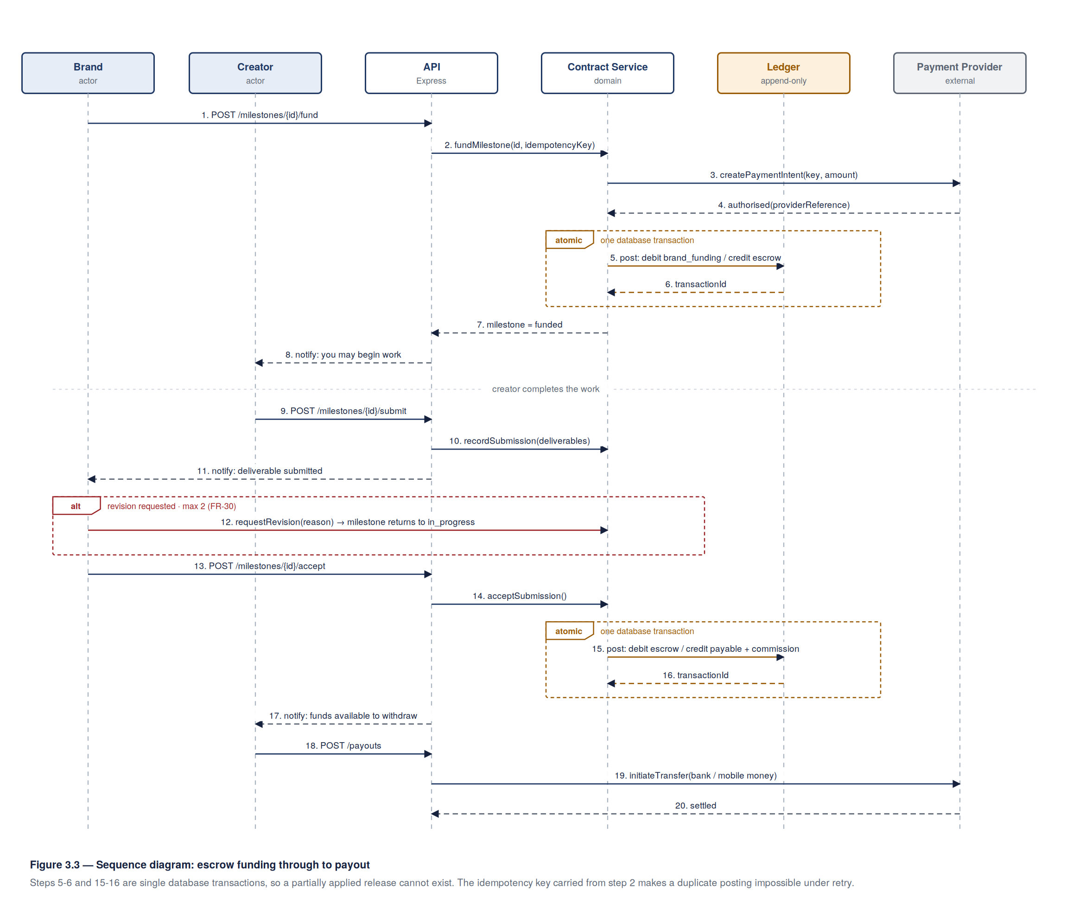
Three mechanisms deliver the correctness objective:
- Idempotency keys. Each monetary operation derives a deterministic key from its subject (for example fund:<milestone_id>). The unique constraint on LEDGER_ENTRY.idempotency_key makes a duplicate posting impossible even under concurrent retry — correctness rests on a database constraint, not on application discipline.
- Atomic state and ledger transitions. A milestone’s status change and its ledger entries are written in one database transaction. A partially applied release cannot exist (UC-09/E1).
- Reconciliation over rollback. Where a provider’s outcome is unknown (UC-07/A2), state is left unchanged and a scheduled job re-queries the provider with the original key until an authoritative answer is obtained. The system never guesses at a payment’s outcome.

3.5.2 Creator verification
Figure 3.4 shows identity verification and audience-metric retrieval, both asynchronous because both depend on third parties whose latency the platform does not control.
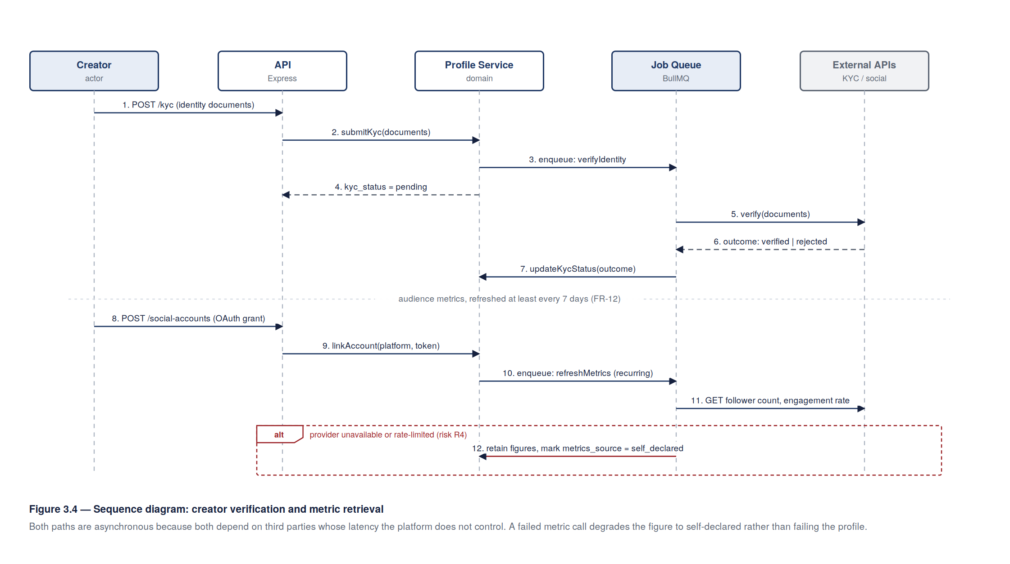
Where a social API is unavailable or rate-limited, the profile publishes with metrics marked self_declared rather than failing (FR-12, risk R4). The distinction is surfaced in the interface, so a brand always knows which figures have been independently confirmed.

3.6 Milestone State Model
The milestone is the system’s most heavily guarded state machine. Figure 3.5 gives its permitted transitions; any transition not shown is rejected by the service layer.
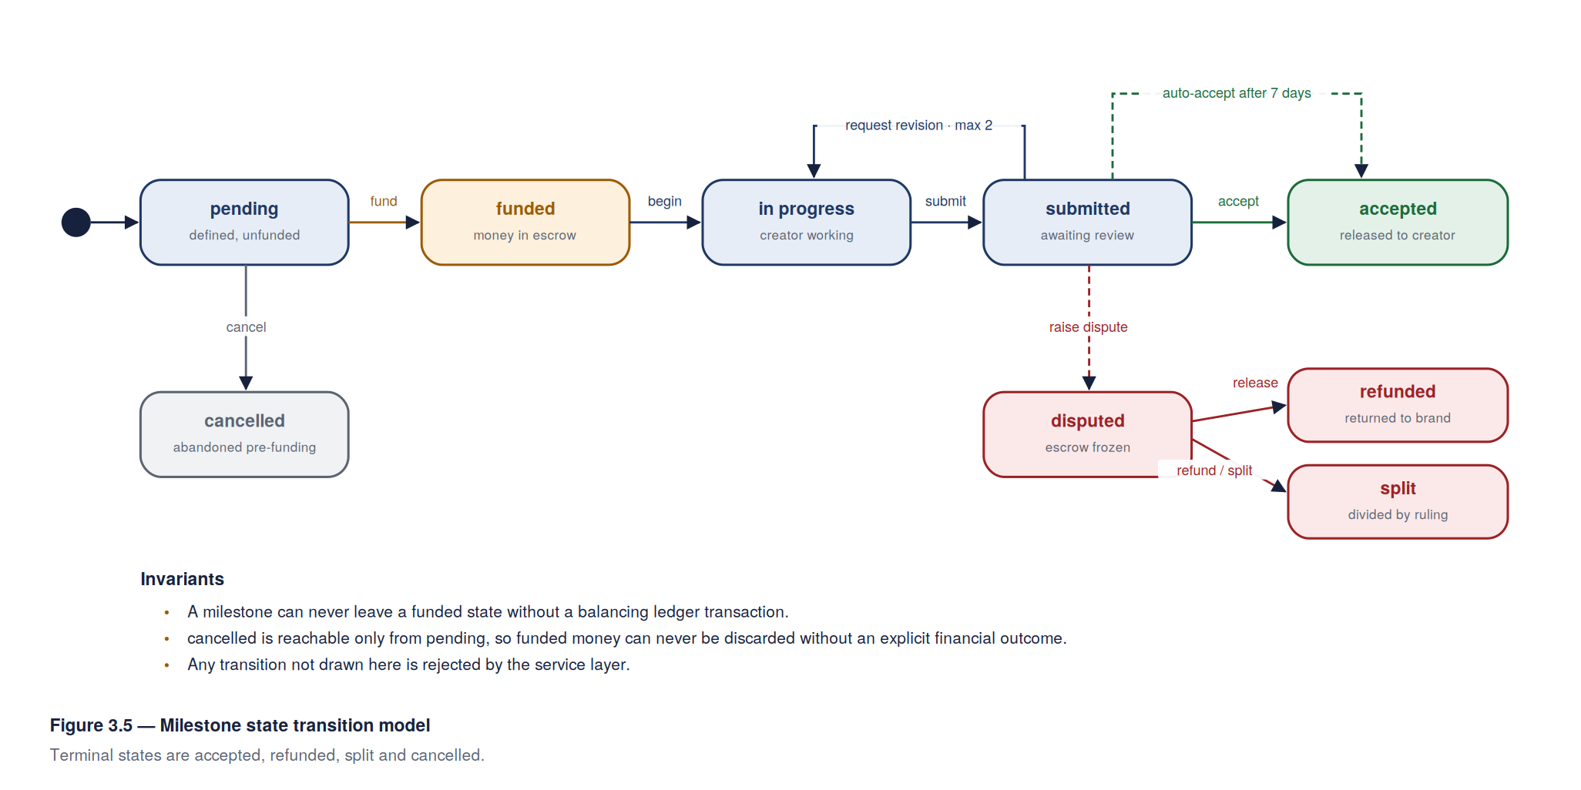
State | Meaning | Permitted next states
pending | Defined, not yet funded | funded, cancelled
funded | Money in escrow; creator may begin | in_progress
in_progress | Creator working | submitted
submitted | Deliverable awaiting brand review | accepted, in_progress (revision, < 2), disputed
accepted | Approved; funds moved to creator payable | terminal
disputed | Frozen pending adjudication | accepted, refunded, split
refunded | Returned to brand by adjudication | terminal
split | Divided by adjudication | terminal
cancelled | Abandoned before funding | terminal
Two rules are invariant: a milestone can never leave a funded state without a balancing ledger transaction, and cancelled is reachable only from pending, so funded money can never be discarded without an explicit financial outcome.

3.7 Interface Design
The interface is designed mobile-first at a 360 px baseline and progressively enhanced (NFR-04). Figure 3.6 shows wireframes for the four screens that carry the core workflow.
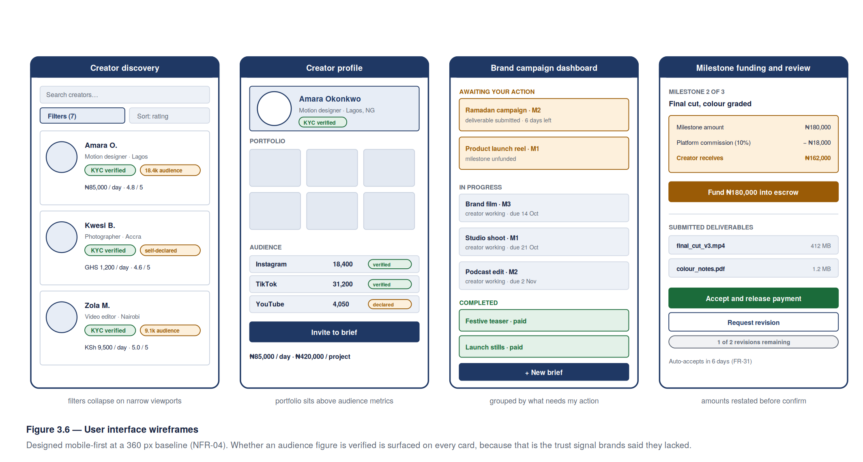
Screen | Design intent
Creator discovery | Filters collapse behind a single control on narrow viewports; each result card leads with discipline, location and whether the audience figure is verified, because that is the trust signal brands said they lacked
Creator profile | Portfolio work appears above audience metrics, reflecting the interview finding that buyers judge on output first
Brand campaign dashboard | Contracts grouped by milestone state, so awaiting my action is answerable at a glance
Milestone funding and review | Commission and net amount shown before confirmation, never after; revision allowance displayed as a remaining count
Interface conventions: a single accent colour for primary actions, one action per screen; destructive and financial actions always confirmed with the amount restated; every form field labelled and error-associated for screen readers (NFR-06); skeleton states rather than spinners, so perceived latency stays low on slow connections.

3.8 Security Design
Concern | Control
Authentication | bcrypt cost ≥ 12; short-lived JWT access tokens with rotating refresh tokens; account lockout after five failures (FR-03, NFR-09)
Authorisation | Per-route middleware asserting both role and resource ownership; every contract, brief and milestone query scoped to the requesting principal (NFR-11)
Transport | TLS 1.2+ enforced; HSTS; secure, HttpOnly, SameSite cookies for refresh tokens
Data at rest | Database encryption at rest; KYC documents in a private bucket reachable only by short-lived pre-signed URL; payout instruments encrypted at column level (NFR-10)
Input handling | Schema validation on every endpoint; parameterised queries only; uploads restricted by MIME type, magic-number check and size
Abuse | Rate limiting per IP and per principal on authentication, search and application endpoints (NFR-12)
Financial integrity | Unique idempotency keys; append-only ledger; continuous reconciliation; no client-supplied amounts trusted — all amounts recomputed server-side from stored contract terms
Privacy | Consent recorded at collection; purpose limitation; 5-year KYC retention cap; export and erasure endpoints subject to statutory financial retention (NFR-13, NFR-14)
Audit | Append-only AUDIT_LOG capturing actor, action, subject, timestamp and reason for every administrative and financial event (NFR-15)
Secrets | Provider credentials in environment configuration, never in source; rotated on member departure
Threat model summary. The four threats judged material are: account takeover of a creator profile to redirect payouts (mitigated by re-authentication and notification on payout-instrument change); a brand disputing in bad faith after receiving usable work (mitigated by evidenced in-platform delivery and adjudication); fabricated audience metrics (mitigated by API-sourced verification and explicit labelling of self-declared figures); and replayed payment instructions (mitigated by idempotency keys and provider-side references).

3.9 Deployment View
Figure 3.7 shows the deployment topology.
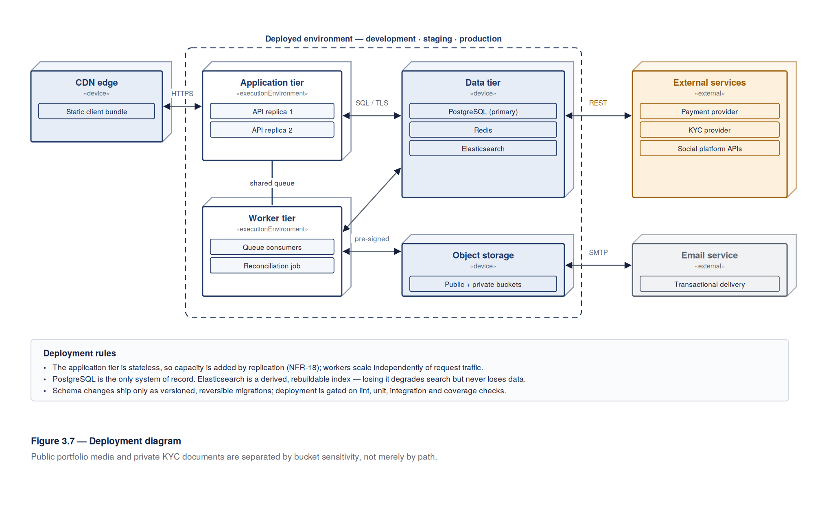
Node | Contents | Notes
CDN edge | Static client bundle | Cached close to users, serving NFR-02
Application tier | Two or more stateless API replicas behind a load balancer | Horizontally scalable (NFR-18)
Worker tier | Queue consumers — metric refresh, email, reconciliation, index updates | Scaled independently of request traffic
Data tier | Managed PostgreSQL with automated backup and point-in-time recovery; Redis; Elasticsearch | PostgreSQL is the only system of record
Object storage | Public bucket for portfolio media; private bucket for KYC documents | Separated by sensitivity
External | Payment provider, KYC provider, social APIs, email provider | All reached through adapters (NFR-20)
Environments are development, staging and production, with schema changes applied only by versioned, reversible migrations. Deployment is by GitHub Actions on a merge to main, gated on lint, unit, integration and coverage checks (NFR-16).

3.10 Design Traceability
Requirement | Design element
NFR-01 (search latency) | Elasticsearch index, §3.2; composite fallback index, §3.4.2
NFR-02, NFR-04 (mobile, bandwidth) | CDN-served bundle, §3.9; mobile-first wireframes, §3.7
NFR-08 (financial reliability) | Idempotency keys and append-only double-entry ledger, §3.4.1 and §3.5.1
NFR-11 (server-side authorisation) | Per-route ownership middleware, §3.8
NFR-15 (auditability) | LEDGER_ENTRY and AUDIT_LOG, both append-only, §3.4.1 and §3.8
NFR-18 (scalability) | Stateless API tier, §3.2 and §3.9
NFR-19 (currency handling) | BIGINT minor units with ISO 4217 code, §3.4.2
NFR-20 (provider substitution) | Integration adapter layer, §3.2 and §3.3
FR-28 to FR-32 (escrow) | Milestone state machine, §3.6; funding sequence, §3.5.1
FR-12 (metric verification) | SOCIAL_ACCOUNT.metrics_source and refresh job, §3.4.1 and §3.5.2
FR-30 (bounded revisions) | MILESTONE.revision_count, §3.4.1; guarded transition, §3.6

