PNNNR: Data Preparation R Scripts

Protocol
Contents
Background 1
1) Download R and R Studio on your computer 1
2) Prepare the SOUND FILES 2
3) DOWNLOAD/UPDATE elpR_Shiny FOLDER 3
4) Open the elpR app 4
5) THE APP 5
6) BASIC Info 6
7) Sound Check 6
8) EXCLUDE BAD SOUNDS 9
9) RUN THE GUNSHOT AND RUMBLE DETECTORS 11
10) RESTRUCTURE: PREPARE DETECTOR OUTPUT FOR REVIEW IN RAVEN 11
Rumble Selection Table Restructure 12
Gunshot Detector 15
General Restructure 16
11) ANNOTATE DETECTOR OUTPUT IN RAVEN 16
12) SUMMARIZE AND PLOT DATA (only for elephant rumbles right now) 17
Improvement Suggestions 21

Background
- For continuous sound files only
- Currently only .wav files will work (working on .flac)
- This application works with Raven Pro Sound Selection Tables only
- Required columns: Selection, View, Begin Time (s), End Time (s), High Freq (Hz), Low Freq (H), Begin Path, File Offset (s)

Download R and R Studio on your computer
- R: https://cran.r-project.org/mirrors.html
- R Studio: https://posit.co/download/rstudio-desktop/
- I recommend turning off some features on R that have caused some problems with loading the package:
- Tool > Global Options uncheck
- Always save history
- Restore .RData into workspace at startup
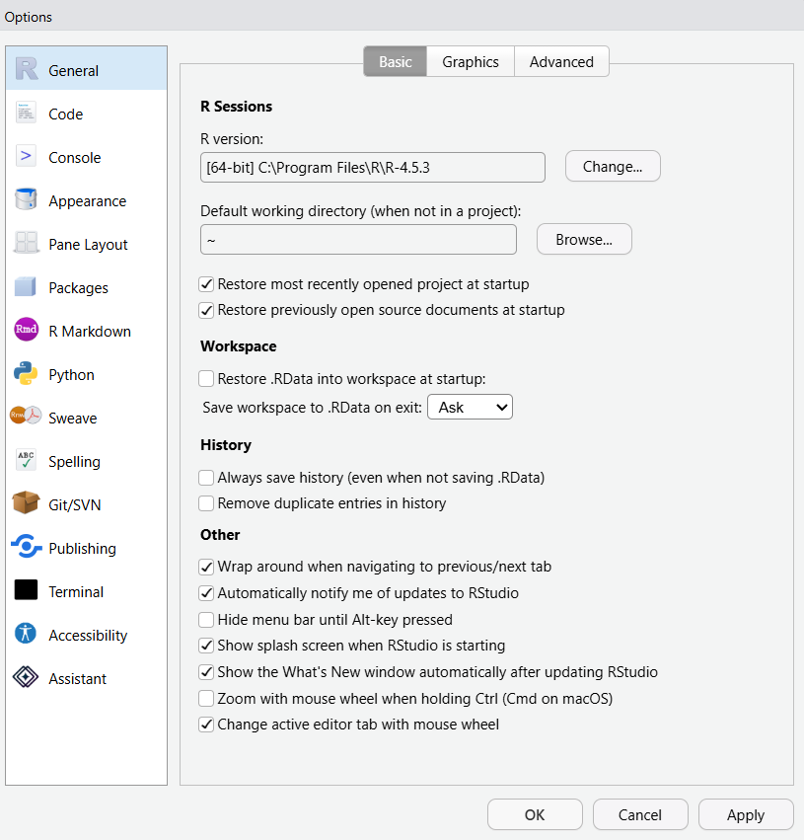

Prepare the SOUND FILES
  - Download the sound files from SD cards to computer or external hard drive
  - Prepare sounds for the analysis and to run in the R scripts
    - Use the following folder structure
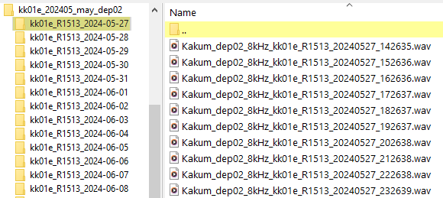
    - Use the following naming convention for your sound files:
Project_Deployment##_ SampleRatekHz_ SiteID_Box##_YYYYMMDD_HHMMSS.wav
e.g.: Kakum_dep03_8kHz_kk01e_R1426_20230530_095123.wav
    - The only other files that should be in the sound folders would be SwiftOne configuration (config.txt) and debug .txt files. Those should stay where they are in the folder.
  - Resample sounds if needed to run detectors. Use Raven Compass.

DOWNLOAD/UPDATE elpR_Shiny FOLDER
- Check if there is a more updated version of the R package on GitHub.
The GitHub repository is here: https://github.com/bobbi-git/elpR_Shiny
Note: Since this repository is currently set to Private you will need a GitHub account to access it.
- The downloaded or synced elpR_Shiny folder should contain an elpR2 folder and a files_for_elpR folder.
  - The files_for_elpR folder should automatically contain the following folders:

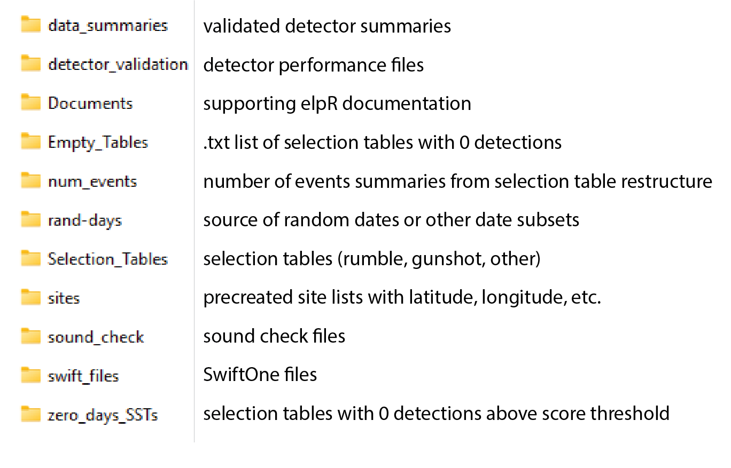
- In the “sites” folder, create a .txt file with a list of the sites if it does not already exist for your project. Add latitude and longitude (look at existing files for example)
  - Name the file with the simple project name followed by “sites”
(e.g., PNNN_sites.txt)
    - Follow the format of the files that are already in that folder (see PNNN_Sites.txt).

Open the elpR app
  - Navigate to unzipped elpR_Shiny folder on your computer
  - Open elpR2 folder and open the ‘elpR2.Rproj’ file
    - This will open in R studio and you should see the elpR folder in the files tab of the lower right panel (see figure below)
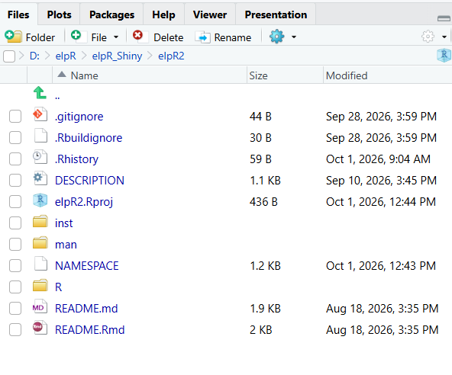
  - For first time using elpR_Shiny on this computer:
    - In R Studio, open the README.Rmd file and follow the instructions in the file
  - If you have already installed dev tools and have used elpR_Shiny on this computer, then install the elpR package by clicking “Build” in the upper right panel, then “Install”. The window should say “DONE (elpR)". You will need to do this each time you load the elpR app.
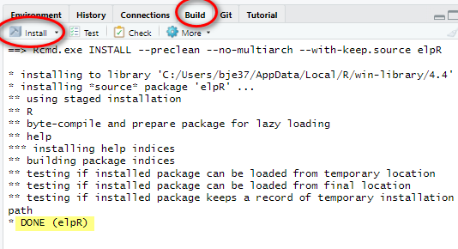
  - In the Console, type “elpRApp()” and hit Enter – this will launch the App

THE APP
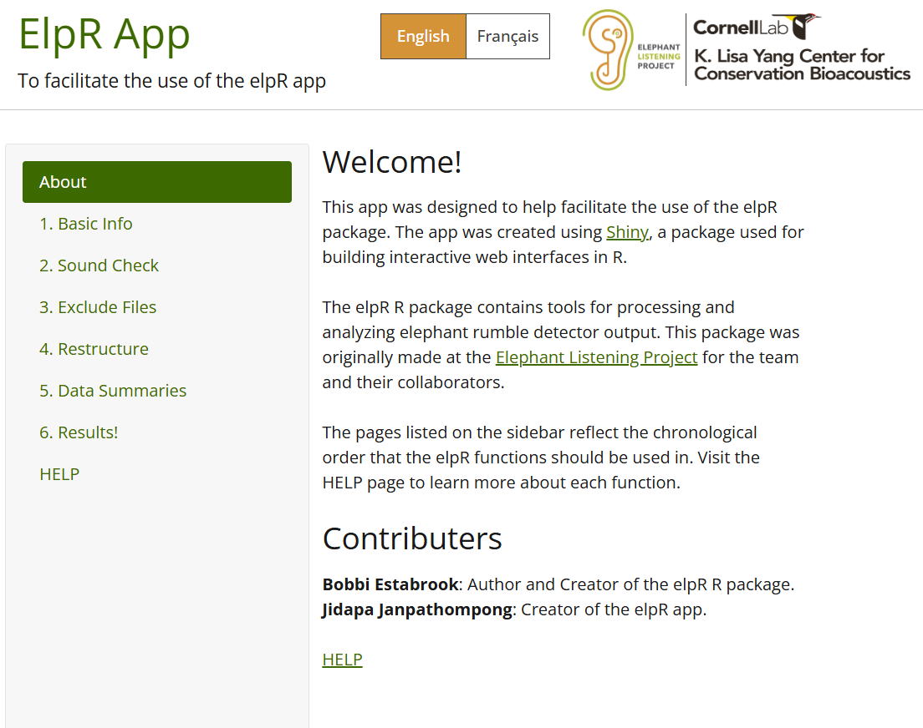
Once you launch the app, take a moment to look at the different options along the left panel, particularly the HELP menu.

BASIC Info
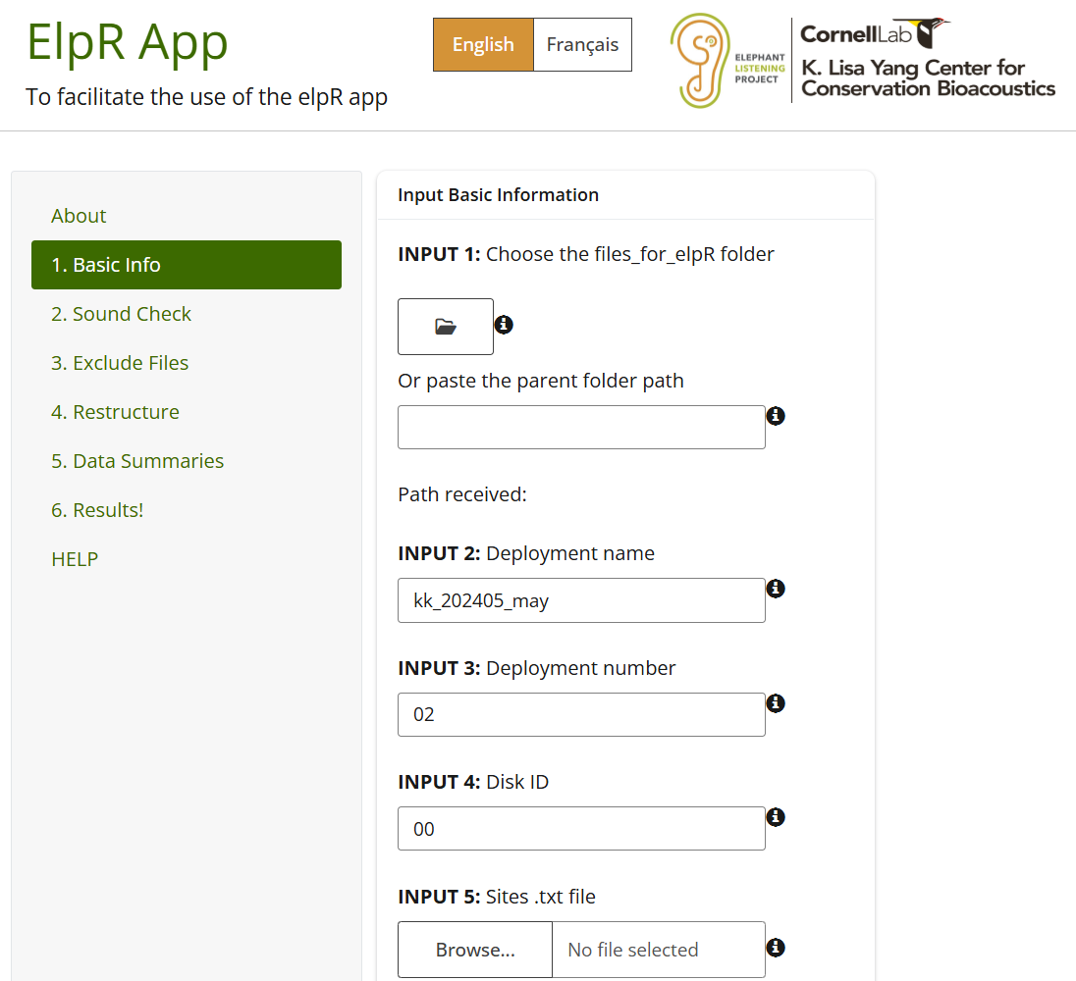
You must fill out this section in order to run Sound Check, Sound Exclude, Restructure, and Results from Data Summaries.
  - Update the required fields:
    - Input 1: Select where the files_for_elpR folder is. You have two options, choose one - either paste the folder path in the blank cell (e.g., D:\elpR\elpR_Shiny\files_for_elpR) or manually choose the folder by navigating to the folder through the folder icon.
    - Input 2: Deployment Name: type the deployment name of the project. It should follow our normal naming structure (e.g., nn_202302_feb)
    - Input 3: the deployment number (e.g., 16). Should be numeric.
    - Input 4: the disk number that contains the sound files (e.g., 01) or 00 if no disk
    - Input 5: the.txt file that contains a list of the site names for the specific project (e.g.,"PNNN_Sites.txt"). If no file exists for your project, create a new one following the format of existing files.
- Sound Check
The Sound Check function will broadly check the parameters of the sound files (sample rate, duration, date, file size, etc.). The function will read in all the sounds and will highlight sound files that are empty (no data), gaps in the recording, recording overlap in time, time stamp issues, wrong sample rate, wrong duration of the file, etc.. Warning: This script can take a long time (+30 minutes) to run on lots of files. It can also depend on the read speed of the drive the script is reading sounds from.
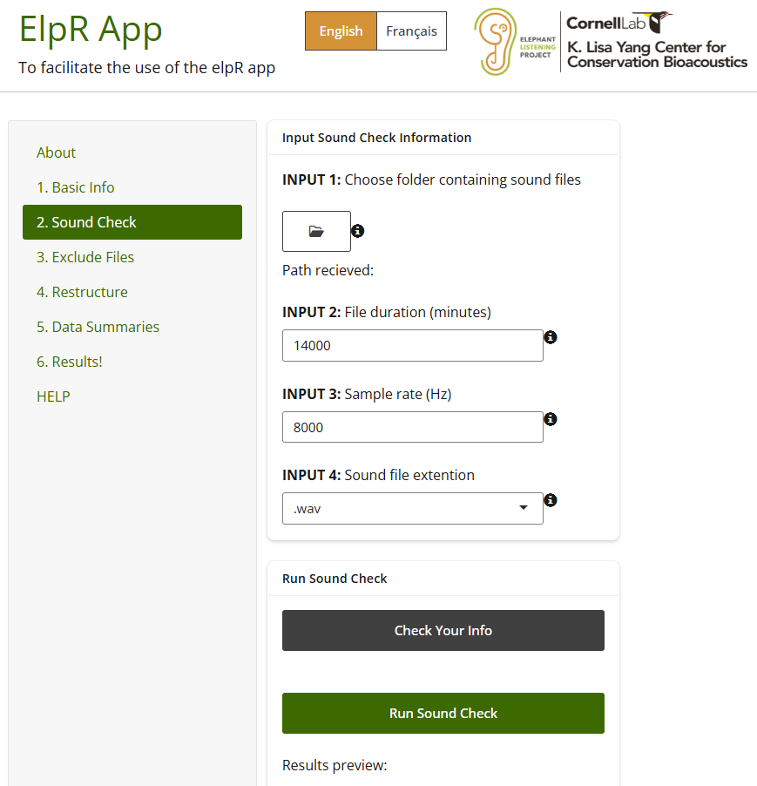
  - Required inputs:
    - Input 1: Navigate to the folder containing the sound files. This can have multiple subfolders. But make sure there are only sounds that you wish the app to read, and no other sounds are present.
    - Input 2: Provide the duration (in minutes) of each sound file. This will allow the script to check which sounds do not meet the expected file duration and those files will be flagged for review.
    - Input 3: Choose the sample rate (Hz) of the sound files. This will enable to script to check that each sound file matches the expected sample rate and will flag sound files that do not.
    - Input 4: Choose the sound file type. This will enable the script to search for those files types in your input 1 folder. It will ignore all other file types (e.g., .txt).
    - Click “Check Your Info” to preview your input information and confirm that it all looks correct. This will include some of the Basic Info you added.
  - When the script is complete, an Excel table will be created in elpR_Shiny\files_for_elpR\sound_check folder, and the name of the file will include the deployment name, number, and disk number that was defined above (e.g., “Sound_Check_Reports_nn_202302_feb_dep16_d02.xlsx”).
    - The workbook contains the following spreadsheets:
      - Sounds:
        - A list of each sound file, with:
          - Site name: Site name parsed from sound file name
          - File Path: computer location of sound file
          - Current File Name: should follow naming convention described in Part 2 (e.g., Kakum_dep03_8kHz_kk01e_R1426_20230530_095123.wav)
          - Site Name Length Check: marks if number of characters in site portion of the sound name match expected length (5, including extension)
          - Current File Start DateTime: Date and time based on current sound file name
          - Calculated End DateTime: calculated from duration of sound file (for continuous data)
          - Begin Date: The date the sound file begins on (based on YYYYMMDD in file name)
          - File Duration (s): Duration of the sound file in seconds
          - Duration Minutes: Duration of the sound file in minutes
          - Duration Hours: Duration of the sound file in hours
          - File Duration Check: Checks if file duration matches that specified by the user in script (fileDurationMin)
          - Duration (DHMS): Duration of the file in days, hours, minutes and seconds
          - Total Hours in Date per Site: The number of recording hours in the date of the sound file
          - File Length Check: Marks sound files with length 0 (0 seconds) as "No Data"
          - File Size (GB): Size of the sound file in gigabytes
          - SampleRate: Sample rate of the sound file in Hz
          - Sample_Rate_Check: Checks if sample rate matches expected based on used input from script (sample_rate)
          - Year Check: If year is 2000 (indicating a Swift clock reset), it is marked as the Wrong Year
          - Expected File Start Difference minutes: Difference in minutes between the start time of the file to the expected start time of the file based on the duration of the previous file.
          - Sound Gap Check: marks if the sound file represents a gap (when there > 3 minutes between consecutive sound files for a single site) in recording time or overlaps in time with the timestamp of another sound file for the same site. We do not trust the timestamps on sound with overlap or large gaps.
          - Exclude (y/e): Sounds marked as “y” include those with no data or are <1 minute in duration, and sound time overlap. These sounds will be excluded by the Sound Exclude function in later steps. Sounds marked as “e” indicate that the date for this sound file does not contain a total of 23 hours of sounds, and this file will be excluded from the rumble analysis. This will happen with the Hori-Harm Selection Table Restructure script in later steps.
            - Sounds <1 minute in duration (gunshots & elephants) will be marked with a ‘y’
            - Note: The detectors will not run on sounds files of 0 s duration and 0 bytes are in the folders, so will be marked with a ‘y’ in the Exclude (y/e) column by the sound.check script
            - All sounds after sound overlap should be deleted because we can’t trust the timestamp after that point. You will need to evaluate these situations and manually add a “y” to those sounds as needed because the script will not automatically make those events to be removed.
            - Sounds with less than 23 hours for a day will be marked with an ‘e’. Since the elephant analysis should only be conducted on full days [23+ hrs] to capture all hours of the survey equally, these sound will be excluded from the rumble analysis in later steps.
          - Notes: Summarized notes on sound problems per file
          - Deployment: From the user-defined deployment_num value in the script
      - File Name Length: Number of files with normal name length (25 characters) and non-normal name length per site
      - File Duration: Number of files with expected duration and other durations per site
      - Wrong Year: Number of files with the wrong year (e.g., 2000) per site
      - Sound Gap-Overlap: Number of files with overlap or gap in timestamp relative to next files per site
      - Duration 0s: Number of files with 0s or no data per site
      - Sound File Count: Number of sound files per site
      - Sample_Rate: Number of sound files per sample rate per site
      - Sound Stats: Summaries of sounds per site
    - Review the spreadsheet and check for sound problems marked in the “Sounds” tab and in the summary tabs. The summary tabs will contain information on the number of sound files with or without specific sound problems. Sound problems include:
        - On the “Sounds” tab, look for bad sounds (use the summaries tabs to help guide you to the sites with problems) and mark bad sounds with a “y” in the “Exclude (y/e)” column
        - Add notes to the bad sounds and investigate why they are considered bad
- EXCLUDE BAD SOUNDS
This function automatically removes sound files that were marked with “y” in the Exclude (y/e) column of the Sound Check Report. It will move bad sounds out of the sound folder and into a user-defined folder.
Only run this step after all the sound file problems in the ‘Sound_Check_Reports’ excel sheet have been checked and all the files that are to be excluded have been marked with ‘y’ and sounds that are to be excluded from the elephant analysis marked with ‘e’ in the “Exclude (y/e)” column.
Do not rename the ‘Sound_Check_Reports’ sheet or move it out of this folder yet. The script will find it in the \sound_check folder automatically, and looks for the specific file name that was produced when Sound Check was run.
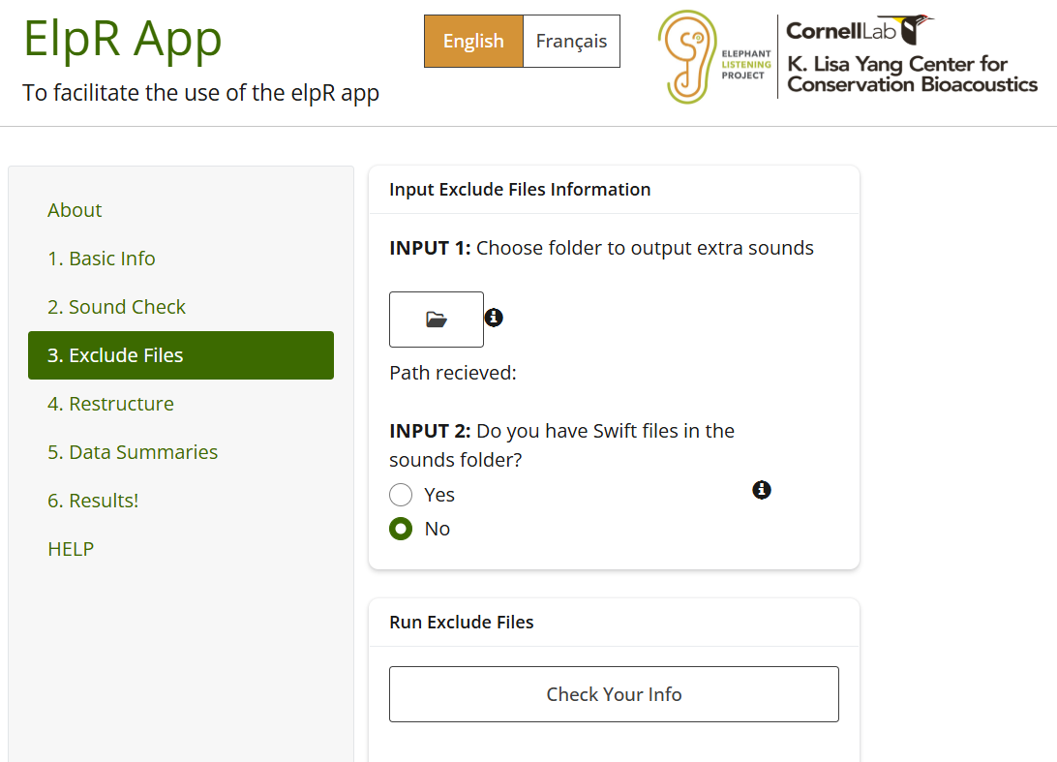
    - Make sure you fill in all the Basic Info first
    - Fill in the Sound Check inputs next, but do not run the Sound Check script if you have already run it on this deployment. This script needs the inputs from that function.
    - Input 1: computer path to where the ‘bad’ sounds should be moved to
    - Input 2: If your sound files have Swift Config of Swift Debug .txt files in the sound folders that need to be moved out, set to “Yes”. Setting to “yes” will rename the .txt files with the site ID and move them out of the sound folder into the \swift_files folder. If you choose “yes” to merging the swift files, Swift config files will be merged into one file. This will not delete the original swift files, but will create a merged copy of them as a .txt file in the \swift_files folder. If you do not have SwiftOne files in these sound folders, choose “No” and the script will not rename or move any .txt files. We use this feature to automatically rename the files because the files do not have unique, distinguishing names (they are all the same name) and can overwrite each other if copied to the same location. Secondly, this feature will remove the .txt files from the sound folders because our detectors will not work if another file type is in the folder with the sound files.
    - Check Your Info before you run the function. If it looks correct, then run the function.
    - This script will:
        - Add the site name to SwiftOne .txt files and move them out of the site folder to the ‘~/swift_files folder if you specified that there were SwiftOne files.
        - move the sound files that are marked with a ‘y’ in the sound check report to the sound exclude folder that the user specified. It will not delete any sounds.
        - Summarize the total excluded sound files per site and adds a tab to the ‘Sound_Check_Reports’ excel sheet with the summary (this is why you should not rename or move this excel workbook in the R project folder). Tracking this information is helpful to quantify how many sounds files are bad and helps with troubleshooting sound problems with the recording devices.

- RUN THE GUNSHOT AND RUMBLE DETECTORS
  - Do this after the bad sound files (those marked with a ‘y’ in the sound check spreadsheet) have been moved to the extra files folder
  - Remember that the hori-harm and gunshot detectors require 8 kHz sound files, so you should have resampled the sounds before running Sound Check.

RESTRUCTURE: PREPARE DETECTOR OUTPUT FOR REVIEW IN RAVEN
The Selection Table Restructure scripts will clean up rumble and gunshot detector output and prepare them as sound selection tables for analysis in Raven Pro. The scripts will produce specific columns for gunshots and specific columns for rumbles, which is why they are handled separately. There is also a general restructure option, which simply merges multiple selection tables together to create one table. Read each section carefully.
In order to restructure gunshot and rumble selection tables, you must have already created the sound_check_report file and it should be in the \sound_check\ folder with the file name unchanged. If you must change the file name, only do so after running the steps below. For gunshot and rumble selection tables, this script will only work on sites for the corresponding sound check file, so make sure you run this for each sound check report file (for example if you had multiple disks for one deployment, each with a different set of sites on it, then you would have separate sound check files that correspond to those disks and sites).

Rumble Selection Table Restructure
WARNING: Make sure the \Selection_Tables\rumble\raw folder is empty (except for the .gitignore file) before running the script. If there are any files from other deployments in the folder, make sure you have a copy of them elsewhere and delete them from the raw folder before running this function.
The Selection Tables are required to be in subfolders. Typically, these would be site-specific folders, but if all detections are created by the stand-alone detector, they will all be in one folder. Call this folder “HH_detecions_brut”. Copy the hori-harm detector output to the \Selection_Tables\rumble\raw folder (or to the HH_detections_brut folder if they are not in site-specific folders). IMPORTANT: The script expects the detector files to be in a folder that is inside the raw folder.
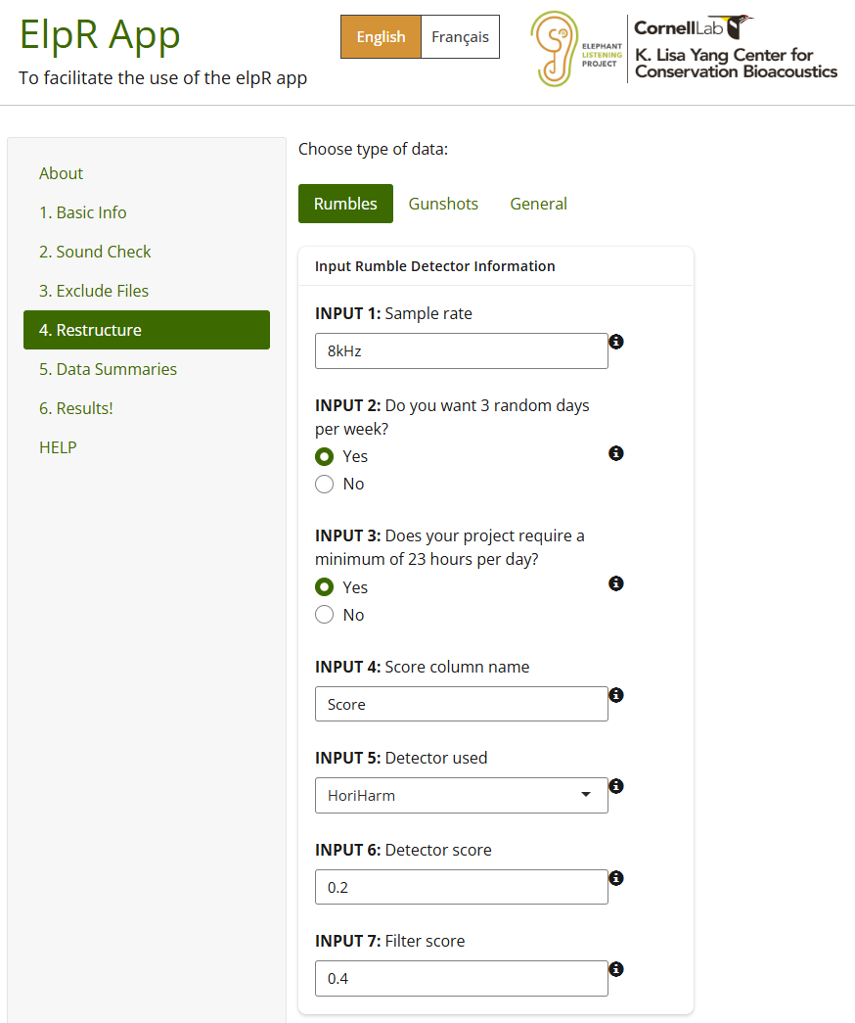
            - Fill out the Basic Info tab first
    - Input 1: Specify the sample rate that was used for the sound files the detector was run on. This is a character string, not numeric, so you can use “8kHz” or “4000Hz”. This will be added to the file name so there is a record of the sample rate. Use the sample rate of the sound files that the detector was run on, not the original file sample rate if it differed. If sound files were decimated from 32 kHz to 8 kHz and the detector was run on the 8 kHz sound files, then use “8kHz” in this line.
    - Input 2: Choose if you want the files to be filtered by the pre-defined 3 random days per week. If you choose “yes” then the script will reference the "elpR_Shiny\files_for_elpR\rand-days\Rand_dates.csv" file to filter the selection table by those random dates. These random dates were already created, so you do not need to select them. They last util 2030, at which time we will need to expand the dates. Do not change this file! If you choose “no”, the selection table will not be filtered by random dates.
    - Input 3: If you
        - Detector: name of the detector used for rumble detectio n (alphanumeric)
          - Hori-Harm = “HHv6”
          - FruitPunch detector = “FPv1”
          - Stanford detector = “SDv1”
        - Detector_ScoreThreshold: The score that was applied to the detector when it ran on the sound files (numeric)
        - Filter_ScoreThreshold: The score that you would like to further filter the detector results by prior to analysis (numeric)
      - The script can take a bit to complete running, but should not take longer than 10 minutes. It depends on the number of detections it is processing.
      - After the script completes, check for error messages in the R console. If you encounter an error message, contact Bobbi (bje37@cornell.edu)
      - If there are no error messages, check for the following files in the folders below:
        - Empty tables .txt file: \PNNNR\Files\Empty_Tables\rumble
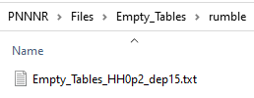
          - This is a list of selection tables that had no detections with a score > 0.2
        - Detector Selection tables:
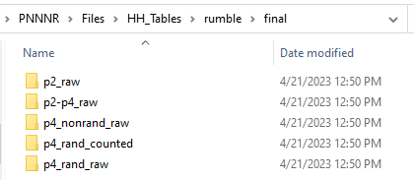
          - Raw detector output with score >0.2: PNNNR\Files\HH_Tables\rumble\final\p2_raw
          - Detector output with score 0.2-0.4: PNNNR\Files\HH_Tables\rumble\final\p2-p4_raw
          - Detector output with score >0.4 for random and non-random dates: PNNNR\Files\HH_Tables\rumble\final\p4_nonrand_raw
          - Detector output for score >0.4 for random dates: PNNNR\Files\HH_Tables\rumble\final\p4_rand_raw
          - Detector output for score >0.4 for random dates to be reviewed by analysts: PNNNR\Files\HH_Tables\rumble\final\p4_rand_counted
        - Plots with the number of detections per site and day: PNNNR\Files\num_events\rumble
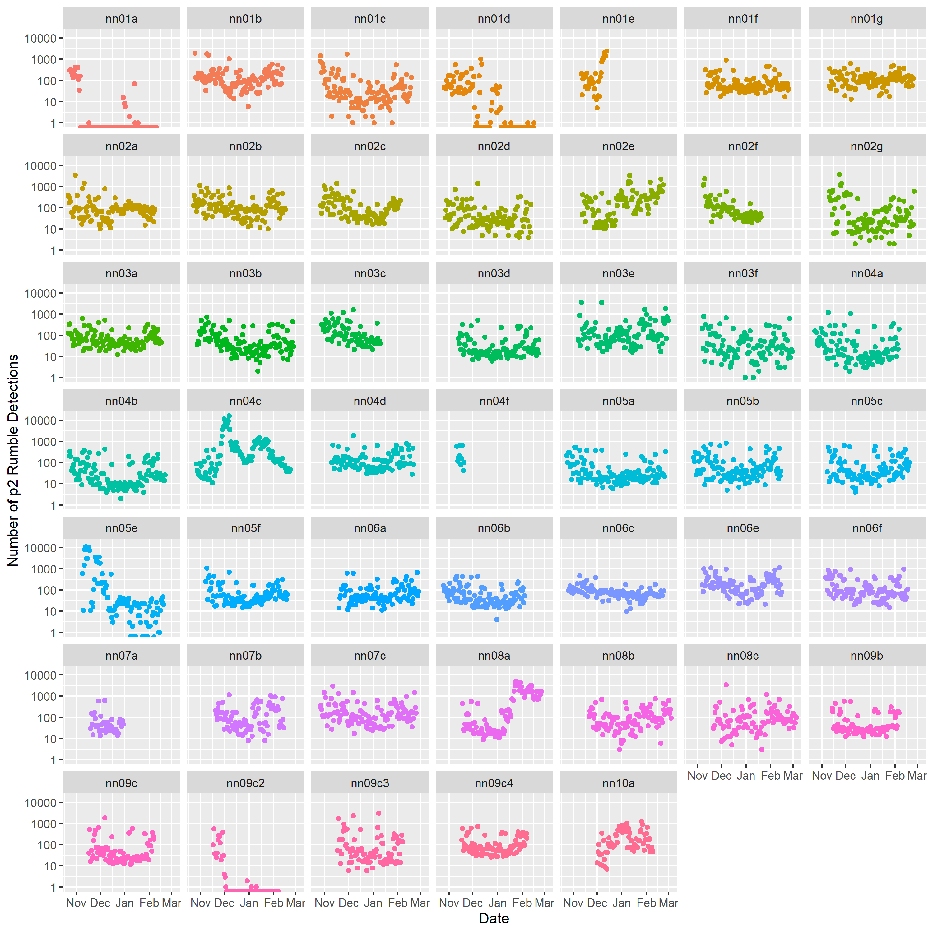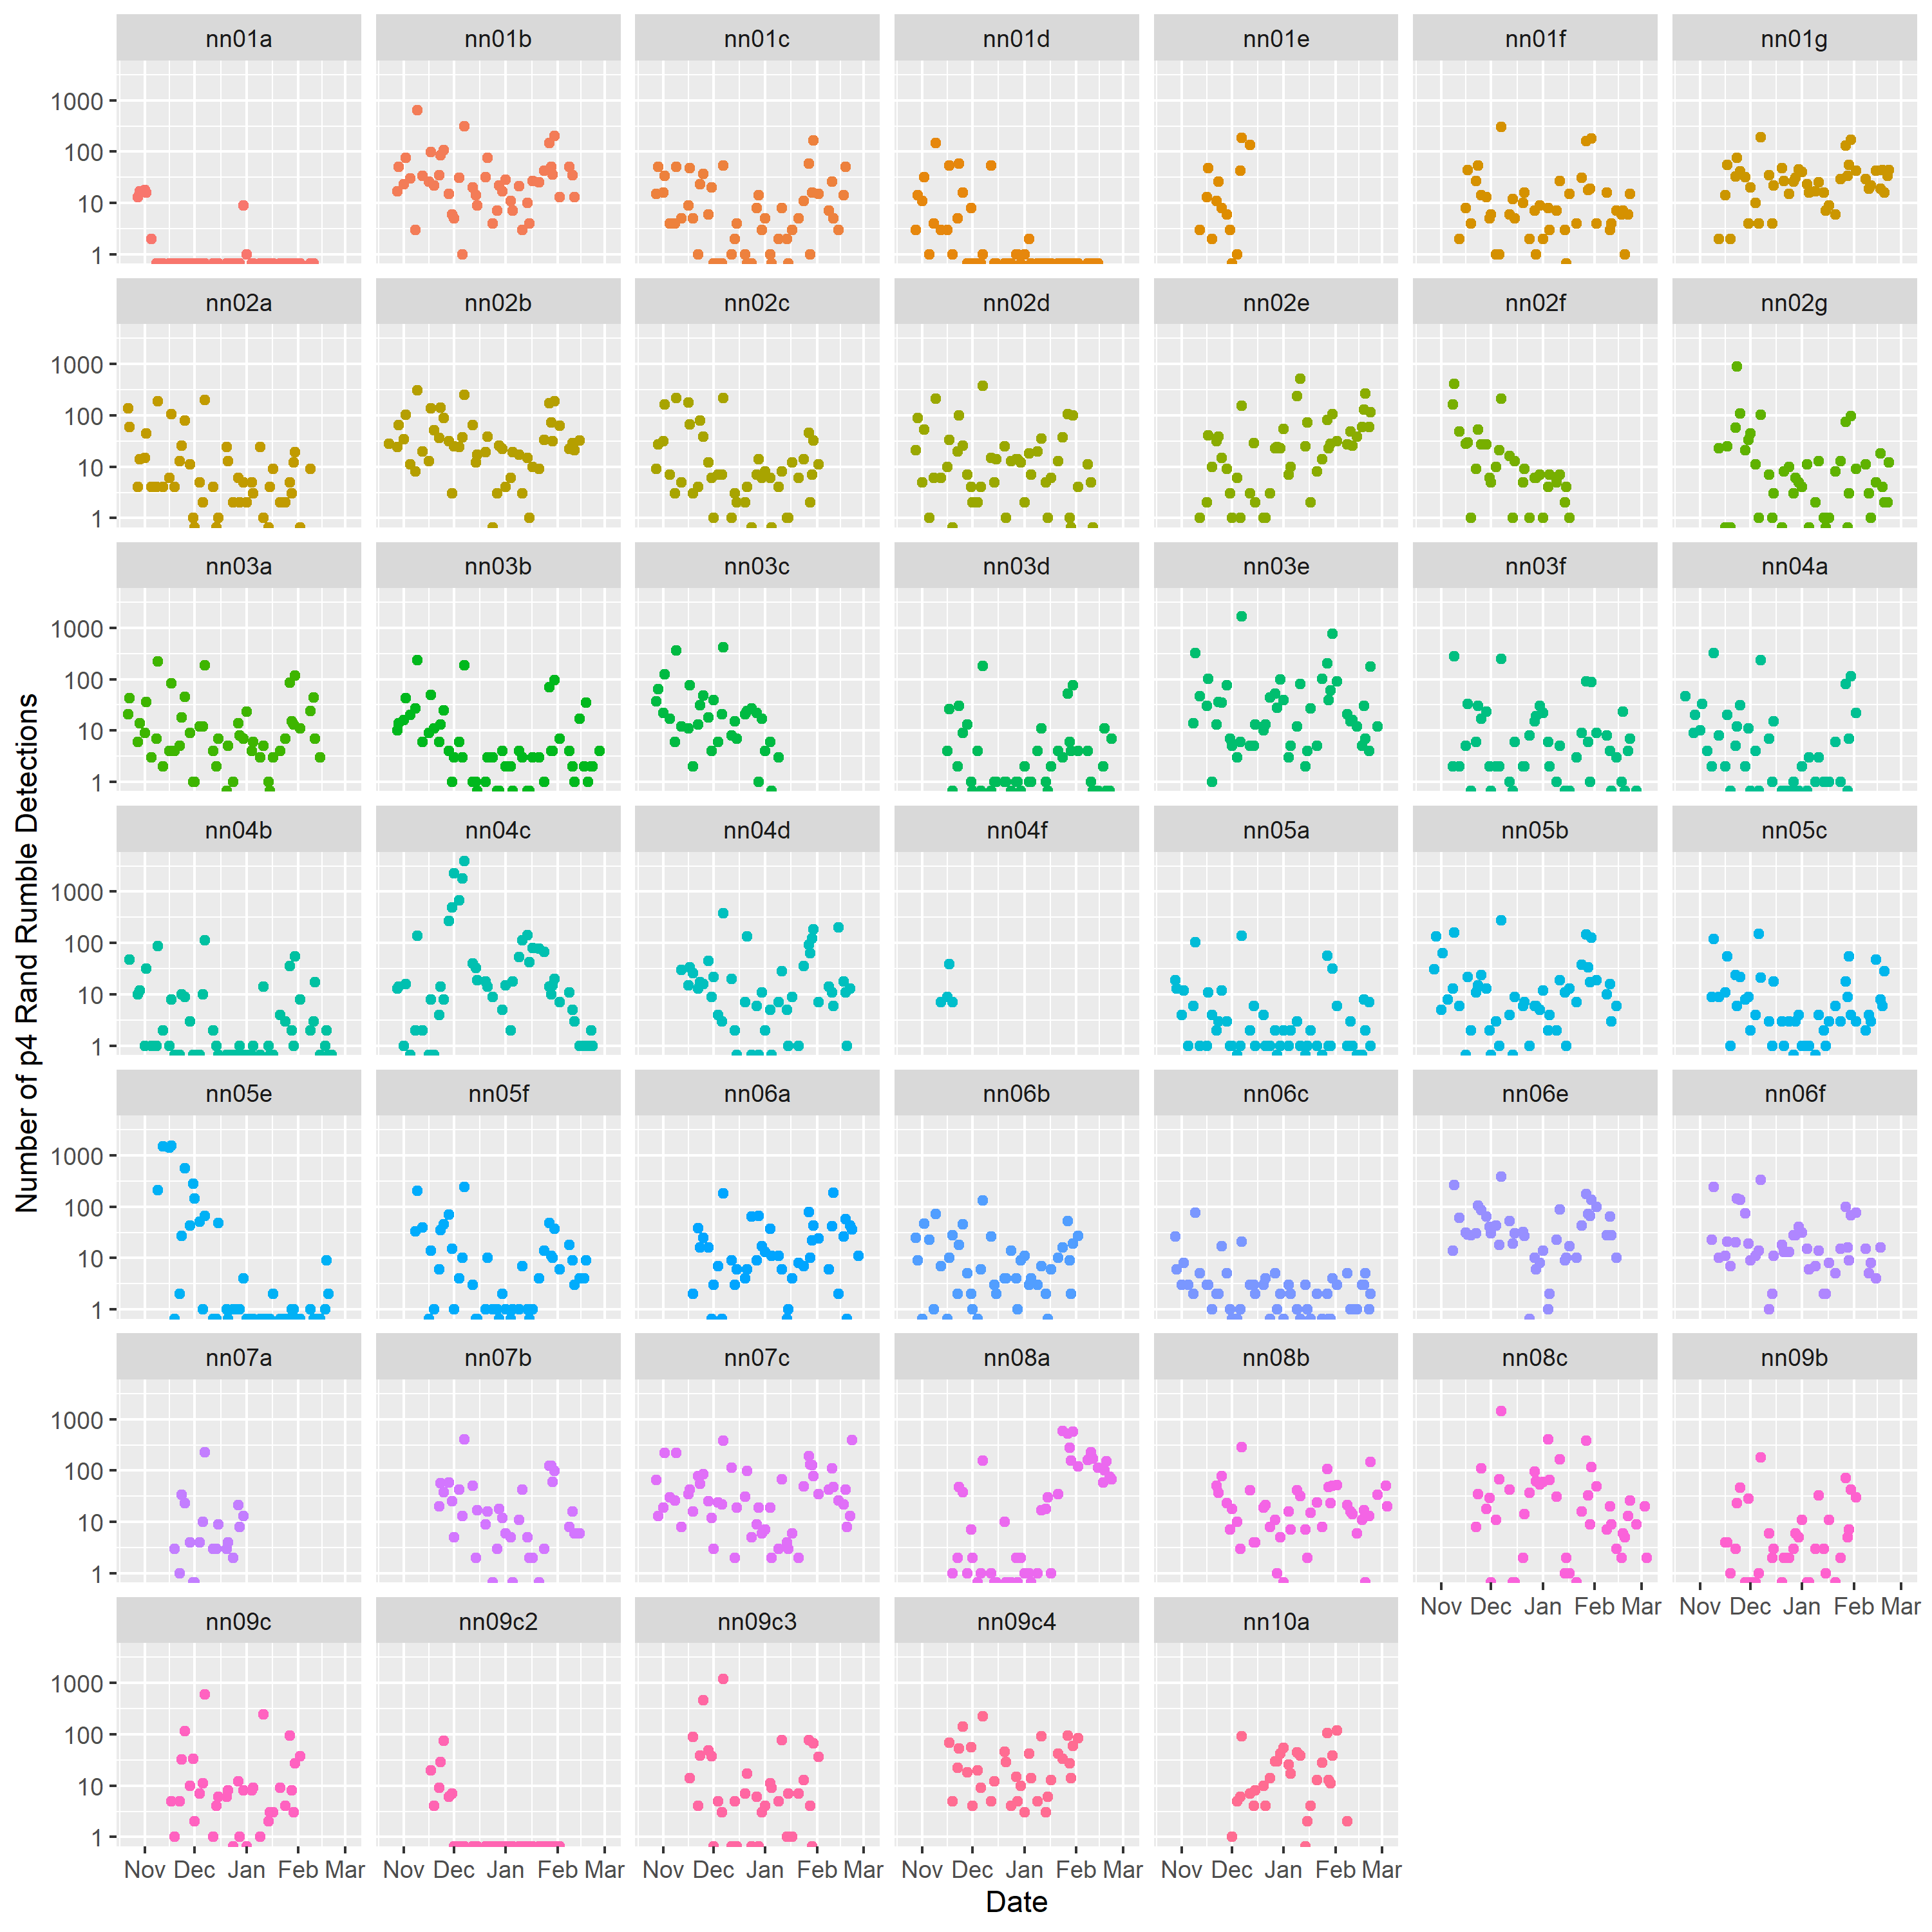
        - Sound Check file: PNNNR\Files\sound_check
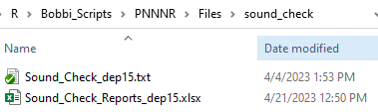
          - The sound check spreadsheet will have an updated tab called “Rumble Detector Summaries” in green
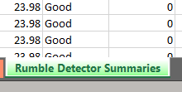
        - Zero Days: Selection table with sound files that did not have detections at score >0.4: PNNNR\Files\zero_days_SSTs\rumble
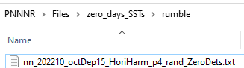

Gunshot Detector
WARNING: Make sure the \Selection_Tables\gunshot\raw folder is empty (except for the .gitignore file) before running the script. If there are any files from other deployments in the folder, make sure you have a copy of them elsewhere and delete them from the raw folder before running this function.
This function currently only works on the gunshot template detector output, but other gunshot detector output files will be incorporated in the future.
      - Copy the raw detector selection tables to elpR_Shiny\files_for_elpR\Selection_Tables\gunshot\raw
        - The selection tables do not need to be in a subfolder within the raw folder.
      - Make sure the corresponding sound check file exists in elpR_Shiny\files_for_elpR\sound_check
      - Open the elpR App
      - Fill out the Basic Info section of the App
      - Click on Restructure > Gunshots in the App

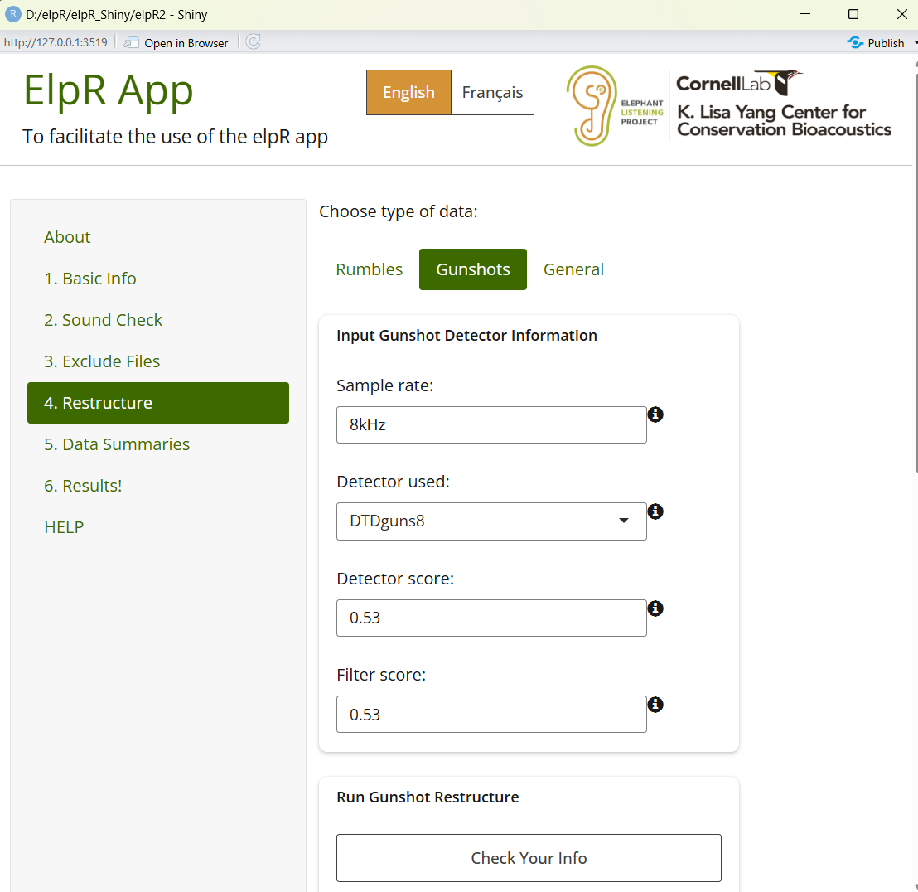

      - Gunshot detector output tables by site

General Restructure

ANNOTATE DETECTOR OUTPUT IN RAVEN

SUMMARIZE AND PLOT DATA (only for elephant rumbles right now)
In this part, you will summarize the data from the annotated selection tables, the sound check files, and the zero-days selection tables into hourly, daily, weekly, and monthly time periods. The summaries will yield a .txt file table and plots as .png and .eps files.
- Make sure the elpR package is loaded
- Open the elpR_DataSummaries.R file in the Scripts folder
  - Choose your output location where you want to save the summary data
  - Choose the folder that contains the .xlsx version of all sound check files you want to include in the summaries
  - Choose the folder that contains the selection tables
    - Selection tables must have the following columns:
      - Site
      - Begin File
      - File Offset (s)
      - Rumble Count
      - Deployment Number
      - Sound Problems
      - Notes
  - Choose the folder containing all the zero-days files that were generated when the rumble selection table restructure script was run
    - These files should have been copied to your project’s selection tables folder, but are originally saved in the Files> zero_days_SSTs folder in the elpR package
  - Choose the sites file that contains the latitude and longitude of the sites that are to be included in the summaries. This file can also include (optional):
    - “Vegetation Class”
    - “Strata”
  - Provide project-specific details
    - Project name (character string)
    - Deployment number (can be a string of characters like “01-09”)
    - Detector name (character string)
    - Duration of sound files
  - Specify data handling options with “y” (yes) or “n” (no)
    - Sound_check_include = are there sound check files for this summary?
    - rand_dates_needed = do you need to filter date by including only the 3 random dates per week (this is used for the PNNN elephant analysis)
    - zeroDays_table_exist = do zero-days selection tables exist for this project or should they be included in the summaries?
    - ele_bad_sound_remove = should “bad” sound days be removed?
      - These are files marked with “y” in Exclude (y/n) column of the sound check file
    - use_only_sites_provided = do you want to filter the results to only include sites listed in the Sites.txt file?
- Next, open the elpR_Data_Summaries_Function.R file from the R folder in the elpR package
  - Run the function to activate it
- Back in the script file, run the data_summaries() command to generate data summaries
- The output will be saved to the folder you specified and will include:
  - Hourly summaries
    - Total rumbles per hour per site per day
      - Table (.txt): “_Rumbles_ZeroDays_ExcludeBadSounds_Rand_hourly.txt”
        - Includes
          - File name
          - Date
          - Deployment number
          - Latitude
          - Longitude
          - Month
          - Year
          - Week date (first date of each week)
          - If the hour is considered day (06:00 – 18:00) or night (18:00 – 06:00)
      - Plot (.png and .eps)
        - “_ele_hrly_plot”: line plot of Total rumbles per hour per site
        - “_ele_hrly_nightday_plot”: boxplot of total rumbles during the night and day time hours (all sites combined)
        - “_ele_hr_site_plot”: barplot of Mean (±SE) rumbles per hour per site
        - “_ele_hr_plot”: barplot of Mean (±SE) rumbles per hours (sites combined)
  - Daily Summaries
    - Table (.txt): “_Rumbles_perDay.txt”
      - Includes:
        - Date
        - Site
        - WeekDate (first date in week)
        - Latitude
        - Longitude
        - Optional other site columns (“Vegetation Class”, “Strata”) if included in sites.txt file
        - Total_rumbles: Total Rumbles for the date and site
        - N_hours: Total hours sampled for the date and site
        - Night_total: total nighttime rumbles for date and site
        - Prop_night: proportion of nighttime rumbles to all rumbles for date and site
        - Prop_day: proportion of daytime rumbles to all rumbles for date and site
        - Month
        - Year
        - Week
      - Plots (.eps and .png)
        - “_ele_daily_site_plot”: Total rumbles per date by site
        - “_ele_daily_strata_plot”: Total rumbles per date by strata
          - Only enabled if Strata is present in sites.txt file
        - “_ele_daily_vegetation_plot”: Total rumbles per vegetation class
          - Only enabled if “Vegetation Class” is present in the sites.txt file
  - Weekly Summaries
    - Calculated from the daily summaries
    - Table:
      - “_Rumbles_Site_Weekly_Summaries.txt"
        - Includes
          - Site
          - WeekDate
          - Latitude
          - Longitude
          - MeanDailyRumbles: mean number of rumbles per day for the week
          - sdDailyRumbles: standard deviation of the number of rumble per day for the week
          - n: number of sampled days included in weekly calculations
          - seDailyRumbles: standard error of the number of rumbles per day in the week
          - maxDailyRumbles: the maximum number of rumbles per day for the week
          - minDailyRumbles: the minimum number of rumbles per day for the week
          - sumRumbles: total number of rumbles for the week
          - sumRumblesNight: total number of rumbles during nighttime hours for the week
          - meanRumblesNight: average number of rumbles during nighttime hours for the week
          - sdRumblesNight:
          - seRumblesNight
          - PropNightRumbles: proportion of rumbles during nighttime hours to all rumbles during the week
          - SumRumblesPerDaysSampled: Total rumbles during daylight hours for the week
          - SumNightRumblesPerDaysSampled: number of nighttime rumbles divided by number of days per week
        - “Rumbles_Strata_Weekly_Summaries”
          - Total and mean weekly rumbles per strata
        - “Mean_Daily_Rumbles_VegClass_Weekly_Summaries”
    - Plots (.png and .esp)
      - “_RumbleWeeklySite_plot”: line plot of mean (±SE) number of daily rumbles per site per week with linear fit
      - "_RumbleWeeklyStrata_plot”: line plot of mean (±SE) daily rumbles per week per strata plus linear fit (is strata is present in the sites.txt file)
      - “_RumbleWeeklyStrata_withNight_plot”: ”: line plot of mean (±SE) daily rumbles per week per strata plus linear fit (is strata is present in the sites.txt file) on primary y axis and mean nighttime rumbles on secondary y axis.
      - “_RumbleWeeklyVeg_plot”: Mean (±SE) Daily Elephant Rumbles per Week by Vegetation Class
  - Monthly Summaries
    - Tables
    - Plots
    - Linear regression models
  - Site Map summaries (in progress)
    - Plot
      - Total rumbles per site
      - Total Rumbles per site per year
      - Total Rumbles per site per month (disabled)

Needs for the R GUI
- Shiny app with buttons
  - User controls input and output paths
  - selects detector from list or adds custom
  - inputs the detector score threshold values
  - user types in expected duration of file and sample rate
  - user check box if rand dates needed
  - user check box if swift files need to be renamed and moved from sound folder
- Auto update packages when deprecated or incompatible with R version
  - Check compatibility
- Prompt user when something is missing or doesn’t meet the format requirements
  - Give specific reasons why the input doesn’t meet expectations so the use can fix it
- Plots and visuals in a GUI window
  - Allow interactive plot in window so user can hover over data points and get information

Improvement Suggestions
- Read_tsv instead of read.table (more stable, faster, and memory efficient).

