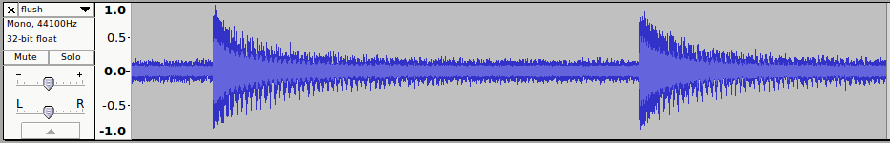
y[n] = x[n] if x[n] > threshold; else 0
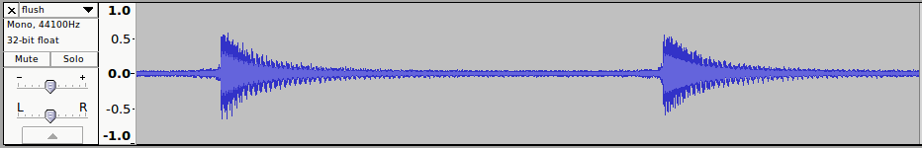
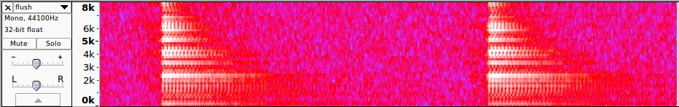
y[n] = α * (y[n-1] + x[n] – x[n-1])
