Acoustic detection of elephant presence

Karthik Bobbili, Student ID #1508583

Elephants use low frequency infrasound rumbles[1] as one of the means of communication and hence automated acoustic detection can be used to detect their presence in alleviating Human – Elephant Conflict in effected areas. Through this project we intent to present a probable approach in dealing with the problem. The approach involves building a better algorithm and comparing the noisy situation recordings with a larger set of wildlife recordings.

Platform and Equipment: PC with Matlab or other Equivalent Signal Processing Software. Digital Signal Processing Development Board with analog Inputs.

The presence of the elephants is a hard nut to crack see the amount of noise present in the real-world forest scenario. It is essential also to understand and analyze the needs and necessities of the requirement of the real-world applications.

There are two most important loactions which have immediate applications,

1.Sathyamangalam(Sathy): It is one of the most famous forests in the southern part of the country encapsulated in the greenery of the elegant western ghats. It is also home to the infamous Veerappan. The main cause of the Man-Elephant Conflict arises when an male elephants in a group or as an individual are trying to actually attack or try to damage the crop of most of the tropical farms like banana. The main reason for the conflict being the man trying to confront and try to scare away the elephants. In this case where the elephants are trying to show the dominance or an elder or a senior elephant is trying to teach the younger elephants the art of attacking. In this scenario the main approach towards the problem the farmers are sleep deprived from the continuous monitoring the crops day and night. The solution lies in where we have an alarm system which detects the elephant’s presence and gives the farmers goodnight sleep.

2. Valaparai: It is one of the most beautiful places within the nilgiris of the western ghats. It is one of the most famous wildlife destinations thickly enclosed in of the most beautiful rain forests and hence home to rarest of the species which are not present anywhere else in the world. This is a special situation where the conflict is completely different from what exists in *Sathy*. This is a very famous spot for tea plantations and Elephant Matriarch groups use the same spots to feed on to the young ones and the human elephant conflict arises where people randomly encounter elephants in the dark and are killed in the process or severely hurt in the process. The solution in this case is a device that can detect the presence of the elephants in the vicinity as elephants communicate and listen sounds form a long distance[2] this gives us a considerable advantage in helping us detect elephants from a good distance which may help in preventing wild encounters.

Time Line

|  |  |
| --- | --- |
| Week | Topic |
| 1 | Introduction |
| 2 | Research |
| 3 | Data gathering |
| 4 | Data gathering |
| 5 | Data gathering |
| 6 | Algorithm |
| 7 | Algorithm |
| 8 | Algorithm |
| 9 | Algorithm |
| 10 | Mid/Poster |
| 11 | Testing |
| 12 | Testing |
| 13 | Demo |
| 14 | Final Documentation |
| 15 | Presentation |

A typical elephant rumble consists of dominant rumbles with maximum spectral density very close to or in the infra sonic range, shown in Fig.1 is a typical elephant rumble.

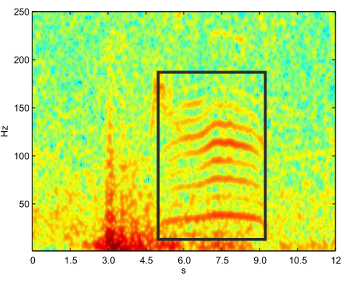Fig. 1 Typical Rumble

The fundamental frequency of the rumble is a distinctive signature which helps us to understand the structure of the rumble and the findings helps us get more information about the rumble and extract more information about the same.

Age group estimation can be performed by observing the acoustic patterns of the rumbles and statistically analyzing the same and there by classifying the age group as infants, calves and mature adults[3].

The fundamental frequency of the rumble varies with the age and it drops down in the spectrogram and as we see in the Fig. 2 and table 1 it comes closer to the infrasonic range as the age of the elephant decreases.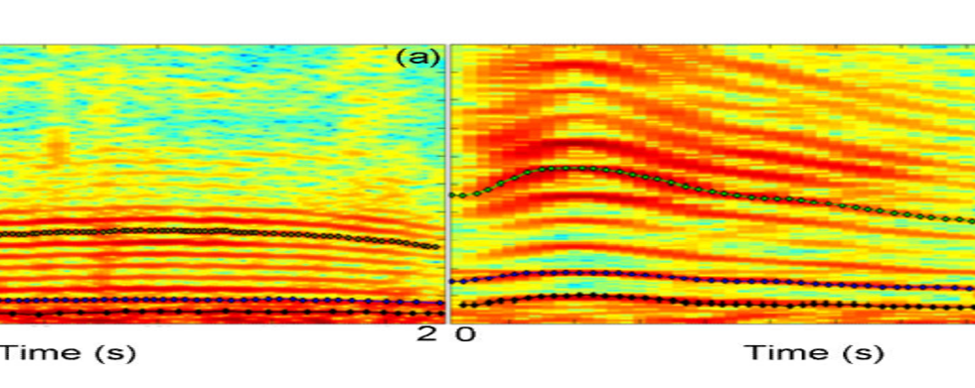

Fig.2 Showing the spectrogram Comparision

Table 1

|  |  |  |
| --- | --- | --- |
| **Classification** | **Age** | **Fundamental Frequency** |
| Infant | <1 | 59.8±7.7 |
| Calf | 1-4 | 54.2±7.3 |
| Juvenile | 5-12 | 48.1±8.7 |
| SubAdults /  Adults | 13< | 38.0±5.8 |

Additionally, the sexual dimorphism can be extracted from the spectrograms and this categorization can be used by the success rate of it is not very promising when compared to the one used to estimate the age group. In this case we actually compare the variation in the frequency and try to compare the variation for the approximation[4].

References:

1. Payne, K.B., W.R. Langbauer, and E.M. Thomas, *Infrasonic calls of the Asian elephant (Elephas maximus).* Behavioral Ecology and Sociobiology, 1986. **18**(4): p. 297-301.

2. WILLIAM R. LANGBAUER, J., KATHARINE B. PAYNE, RUSSELL A. CHARIF, LISA RAPAPORT, FERREL OSBORN, *AFRICAN ELEPHANTS RESPOND TO DISTANT PLAYBACKS OF LOW-FREQUENCY CONSPECIFIC CALLS.* Journal of Experimental Biology 1991(157): p. 35-46.

3. Angela S. Stoeger, M.Z., and Anton Baotic, *Age group estimation in free-ranging African elephants based on acoustic cues of low-frequency rumbles.* Nature, 2015. **434**(7032).

4. Baotic, A. and A.S. Stoeger, *Sexual dimorphism in African elephant social rumbles.* PLoS One, 2017. **12**(5): p. e0177411.