# Account setup

You can either choose your own AWS account or use one of the AWS provided accounts for today’s workshop.

If you choose your own account make sure that you have admin permissions within this account and the account is development account which is not used for production services.

If you chose to use the AWS provided account keep in mind that this account will be disabled the day after the workshop, so make sure you save any artifacts which you want to keep at the end of the day.

# Using an AWS provided account

Below is a list of hashes which will give you access to an AWS account, please note down one of the hashes on your local machine and ~~strike out~~ the value which you have noted down. Then follow instructions below

|  |  |
| --- | --- |
| 0b7605b88a8c | 27f901f8a3eb |
| efef699284c9 | 0f017bd7381e |
| 962fa78afd5b | 35adae152f5b |
| dd656c080063 | f34ee675334f |
| 27205ad3d809 | 0ebfb3dbd891 |
| 614550130a5b | 09dbcce0937f |
| c6d7db93d9ae | a6d205c856c4 |
| 66f37a0b5c26 | 1d6edd2e30b4 |
| b3440c2d77f5 | 1bba34a1379d |
| d825035aadf1 |  |

|  |
| --- |
|  |

Login at <https://dashboard.eventengine.run/login> and type in the hash value you have noted down.

Then click on the ‘AWS console’ button:

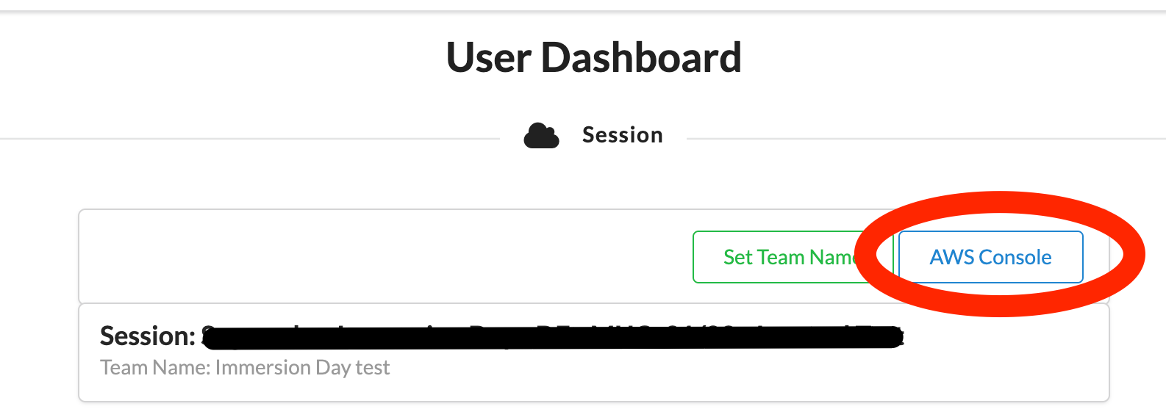

This will open up a dialog to login to AWS console and also provides CLI credentials.