11.5.1 POSTPONEMENT OF JOBS / ROUTINES
POSTPONEMENT OF JOBS / ROUTINES | Rev. 1 - 22 Dec 2017
Where tasks are outstanding, which cannot be completed as planned, procedures are in place for rescheduling maintenance.
All the rescheduling is by exception and vessel must provide reasons to do so.
Approval authority and completion time frame will be dependent upon job priority:
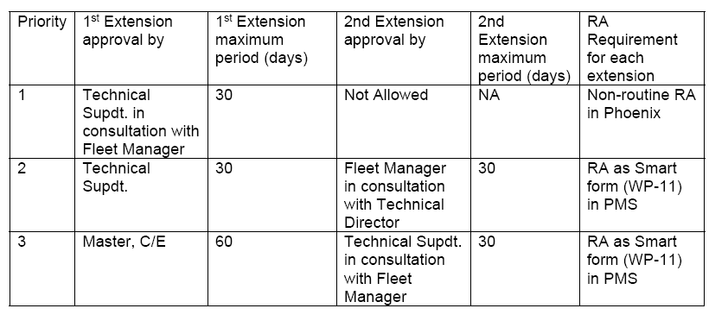
- Performance satisfactory
- If vessel is selecting this option for postponing the job than the actual performance of the machinery to be recorded.

- E.g. if the job is related to Air compressor then time taken to fill up from say 15 bar to 25/30bar to recorded and compared with initial test results.
- If the job is related to pumps then pump performance e.g. (for centrifugal pump) with discharge valve closed to be recorded and compared with maker pump performance graph.
- IF the job is related to main engine then maker’s / egics evaluation of the performance to be attached.
- IF the job is related to lub oil renewal etc. then quarterly test report and onboard test results to be attached
- If the job is related to cooler / heater then the temp of inlet and outlet for cooling medium and medium being cooled to be mentioned.

- Awaiting spares
Under this category, vessel must mention the reqn no, date reqn raised an office advise on expected date of spares availability. Mail from office may be attached.

- Awaiting suitable opportunity
Under this category, vessel present schedule with date and port call to be mentioned and basis the tentative itinerary, expected location and date to be mentioned for carrying out the job.

- Postponed to next Dry dock
DD specs to be made and DD specs no to be mentioned in the details.

- Other reason
The other reason should be justified with all supporting evidences to be attached.

