**Table of Contents:**

1 INTRODUCTION...............................................................................1

* 1. Purpose ...........................................................................................1
  2. Scope of the Project........................................................................1
  3. Definitions, Acronyms and abbreviations......................................2
  4. References......................................................................................3
  5. Overview ........................................................................................3

2 OVERALL DESCRIPTION ...............................................................3

2.1 Product Perspective ........................................................................4

2.2 Product Functions...........................................................................4

2.3 User Characteristics........................................................................4

2.4 Constraints......................................................................................5

2.5 Assumption and Dependencies......................................................5

3 SPECIFIC REQUIREMENTS..........................................................6

3.1 External Interface Requirements..................................................6

3.1.1 User Interfaces........................................................................6

3.1.2 Software Interfaces.................................................................6

3.1.3 Hardware Interfaces................................................................6

3.1.4 Communication Interfaces......................................................6

3.2 Functional Requirements .............................................................7

3.2.1 Registration.............................................................................7

3.2.2 Logging In...............................................................................7

3.2.3 Reservation .............................................................................7

3.2.4 Receptionist Access................................................................8

3.2.5 Manager Access......................................................................8

3.2.6 Payment Management System................................................8

3.3 Performance Requirements..........................................................9

3.4 Security Requirements .................................................................9

3.5 Safety Requirements ....................................................................9

3.6 Capacity Requirements ................................................................9

3.7 Availability Requirements ...........................................................10

3.8 Software System Attributes..........................................................10

3.9 Requirement Traceability Matrix.................................................10

APPENDIXES………………………………………………………....11

Data Flow Diagram………………………………………………….11

Entity Relationship Diagram………………………………………...12

1. **Introduction**

**1.1Purpose:**

The purpose of the holiday booking website is to provide an online platform that enables users to search for, book, and manage their holiday reservations conveniently. The website aims to simplify the process of finding and booking holiday packages, including flights, accommodations, and activities, by offering a user-friendly and intuitive interface. It will facilitate a seamless experience for users to plan and organize their vacations.

**1.2Scope of the project:**

The holiday booking website will encompass the following features and functionalities:User

Registration and Authentication:Users will have the ability to create new accounts and log in using their registered email and password. This feature will ensure secure access and personalized experiences for users.

Search and Filtering:Users will be able to search for holiday packages based on criteria such as destination, dates, and budget. The website will provide filters to refine search results based on preferences such as accommodation type, amenities, and activities.

Booking and Reservation Management:Users will have the capability to select desired holiday packages and proceed with the booking process. The website will collect necessary information, including personal details and payment information, to facilitate reservations. Confirmation of bookings will be provided to users through email or their website accounts. Users will also be able to view and manage their reservations, including options to modify or cancel bookings.

Payment Processing:The website will integrate a secure payment gateway to enable users to make online payments for their holiday bookings. Various payment methods, such as credit cards, debit cards, or online payment platforms, will be supported. The payment process will be secure and compliant with industry standards.

**1.3.Definitions, Acronyms and abbreviations :**

**Definitions:**

Holiday Booking Website: An online platform that allows users to search, book, and manage holiday reservations, including flights, accommodations, and activities.

**Acronyms and Abbreviations:**

* SRS: Software Requirements Specification
* UI: User Interface
* UX: User Experience
* API: Application Programming Interface
* SSL: Secure Socket Layer
* XSS: Cross-Site Scripting
* SQL: Structured Query Language

**Additional Acronyms and Abbreviations (specific to the domain of travel and bookings):**

* OTA: Online Travel Agency
* GDS: Global Distribution System
* CRS: Central Reservation System
* IATA: International Air Transport Association
* ICAO: International Civil Aviation Organization
* OTA: Open Travel Alliance
* B&B: Bed and Breakfast
* AI: All-Inclusive
* FBO: Fixed-Base Operator
* MICE: Meetings, Incentives, Conferences, and Exhibitions
* PMS: Property Management System

Please note that the above list is not exhaustive, and additional acronyms and abbreviations specific to your project or industry may be included as needed.

**1.4 References :**

**<https://dribbble.com/tags/holiday_booking.>**

**<https://www.trawex.com/holiday-reservation-system>**

**1.5 Overview:**

The holiday booking website project aims to develop a user-friendly online platform that allows users to search, book, and manage holiday reservations. The website will provide a seamless experience for users to explore various holiday packages, including flights, accommodations, and activities. Users will be able to register and authenticate themselves, search for packages based on preferences, and apply filters to refine their search results. The website will facilitate the booking process, including the collection of necessary information and integration with a secure payment gateway. Users will receive booking confirmations and have the ability to view and manage their reservations. Additionally, the website will feature user reviews and ratings for packages, helping users make informed decisions. The project will adhere to industry standards for security, performance, and usability.

**2 OVERALL DESCRIPTION**

**2.1 Product Perspective**

The holiday booking website is a standalone product that operates independently and does not rely on any other systems or external software. It provides a comprehensive platform for users to search, book, and manage holiday reservations. While it may integrate with external payment gateways and APIs for certain functionalities, the core functionality and operation of the website are self-contained.

**2.2 Product Functions**

The holiday booking website will have the following key functions:

* User registration and authentication
* Search and filtering of holiday packages
* Booking and reservation management
* Payment processing
* User reviews and ratings

**2.3 User Characteristics**

The target users of the holiday booking website include individuals who are looking to book holiday packages. The users may vary in terms of their computer literacy and familiarity with online booking systems. The website should provide a user-friendly interface that caters to users with different levels of technical proficiency.

**2.4 Constraints**

The development of the holiday booking website will have certain constraints, which may include:

* Time constraints for the project completion.
* Budget constraints for development and maintenance.
* Compliance with legal and regulatory requirements related to data protection and online payments.
* Compatibility with different web browsers and devices.
* Scalability to handle a potentially large number of users and concurrent bookings.

**2.5 Assumption and Dependencies :**

The development of the holiday booking website makes the following assumptions and dependencies:

* Assumption: Users will have access to a stable internet connection to use the website.
* Assumption: Users will provide accurate and up-to-date information during the booking process.
* Dependency: Integration with external payment gateways for secure payment processing.
* Dependency: Availability of APIs or data sources for retrieving information such as flight schedules, accommodation details, and activity options.
* Please note that the above information is based on general assumptions and dependencies and may vary depending on the specific requirements and context of your holiday booking website project.

**3 SPECIFIC REQUIREMENTS**

**3.1 External Interface Requirements**

**3.1.1 User Interfaces**

* The user interface of the holiday booking website shall be intuitive, user-friendly, and visually appealing.
* The website shall have a responsive design, ensuring compatibility with various devices and screen sizes.
* The user interface shall provide clear navigation menus, search bars, and filters to enhance the user experience.
* The website shall display relevant information, including package details, pricing, availability, and images, in a well-organized manner.

**3.1.2 Software Interfaces**

* The holiday booking website shall integrate with external payment gateways to facilitate secure online transactions.
* The website may integrate with APIs or data sources to retrieve real-time information such as flight schedules, accommodation availability, and activity options.
* The website may provide social media integration for users to share their bookings or reviews on their social media accounts.

**3.1.3 Hardware Interfaces**

* The holiday booking website will be accessed through standard web browsers on desktop computers, laptops, tablets, and smartphones.
* The website shall be compatible with commonly used operating systems, including Windows, macOS, iOS, and Android.

**3.1.4 Communication Interfaces**

* The website shall provide communication interfaces such as contact forms or chat support for users to communicate with customer support or make inquiries about their bookings.

**3.2 Functional Requirements**

**3.2.1 Registration**

* Users shall be able to register for an account by providing necessary information, including name, email address, and password.
* The registration process shall include validation of user inputs, ensuring the accuracy and completeness of the provided information.
* The website shall generate a unique user ID or username for each registered user.

**3.2.2 Logging In**

* Registered users shall be able to log in to their accounts using their email address and password.
* The website shall authenticate user credentials securely and provide appropriate error messages for invalid login attempts.

**3.2.3 Reservation**

* Users shall be able to search for holiday packages based on criteria such as destination, dates, and budget.
* The website shall provide filters to refine search results based on preferences such as accommodation type, amenities, and activities.
* Users shall be able to select a package and proceed with the booking process by providing necessary details, including personal information, payment information, and any additional requirements.

**3.2.4 Receptionist Access**

* A receptionist or customer support representative shall have access to a backend interface to manage reservations, including viewing, modifying, or canceling bookings.
* The receptionist interface shall provide search and filtering options to efficiently retrieve and manage reservations.

**3.2.5 Manager Access**

* A manager or administrator shall have access to a backend interface with additional functionalities for managing the holiday booking website.
* The manager interface shall provide features such as user management, package management, and generating reports or analytics related to bookings and sales.

**3.2.6 Payment Management System**

* The website shall integrate with a secure payment gateway to process online payments for holiday bookings.
* The payment management system shall support various payment methods, such as credit cards, debit cards, or online payment platforms.
* The payment process shall comply with industry standards for secure transactions and protect sensitive financial information.

**3.3 Performance Requirements**

* The website shall be capable of handling multiple concurrent user sessions without significant performance degradation.
* The website shall have fast response times for search queries, booking processes, and reservation management actions.
* The website's server infrastructure shall be scalable to accommodate increased user traffic during peak periods without causing system slowdowns or disruptions.
* The website shall be regularly monitored for performance metrics such as page load time, server response time, and transaction processing time to ensure

**3.4 Security Requirements**

* The website shall implement secure authentication mechanisms, including password hashing and encryption, to protect user login credentials.
* User personal information and payment details shall be stored securely and comply with data protection regulations.
* The website shall implement measures to prevent common security vulnerabilities such as cross-site scripting (XSS) and SQL injection attacks.
* Access to sensitive data and administrative functions shall be restricted to authorized personnel only.
* The website shall have a secure communication protocol (e.g., SSL) to encrypt data transmitted between the user's browser and the server.

**3.5 Safety Requirements**

* The website shall not compromise the safety and security of users' personal information and financial data.
* The website shall not provide inaccurate or misleading information about holiday packages, flights, accommodations, or activities that could jeopardize users' safety during their travels.
* The website shall comply with safety regulations and guidelines applicable to the travel industry.

**3.6 Capacity Requirements**

* The website shall be able to handle a large number of concurrent users and process multiple bookings simultaneously without system slowdowns or crashes.
* The server infrastructure shall have sufficient storage capacity to store user data, booking information, and other relevant data.

**3.7 Availability Requirements**

* The website shall have a high level of availability to ensure users can access and use the platform without significant downtime.
* The website shall have a robust backup and disaster recovery plan to minimize the impact of any system failures or data loss.

**3.8 Software System Attributes**

* Usability: The website shall have an intuitive user interface and provide clear instructions and feedback to guide users through the booking process.
* Reliability: The website shall be reliable and maintain data integrity, ensuring that user bookings and information are accurately stored and retrieved.
* Maintainability: The website shall be designed and developed with clean and modular code, making it easier to maintain and update in the future.
* Scalability: The website shall be designed to handle increasing user demand and accommodate future growth.

**3.9 Requirement Traceability Matrix**

A Requirement Traceability Matrix (RTM) can be created to trace the requirements outlined in the specification document to specific design elements, implementation, and testing. It helps ensure that all requirements are adequately addressed throughout the development process and assists in tracking their status.

The RTM typically includes columns for requirements, design components, implementation units, and testing status, allowing stakeholders to track the progress of requirements fulfillment from design to testing phases.

**APPENDIXES:**

**Data Flow Diagram**

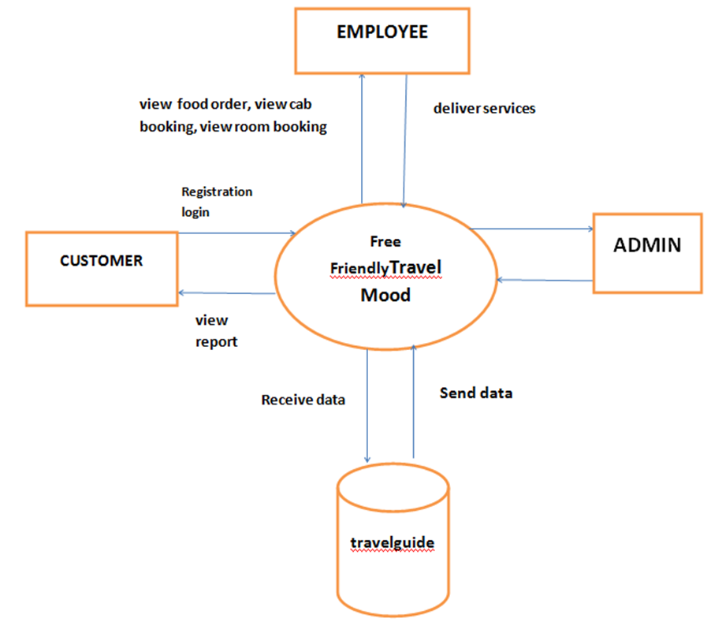A Data Flow Diagram (DFD) is a graphical representation of the flow of data within a system. It shows how data is input, processed, and outputted in a system, including the interactions between different components or entities. Here's an example of a high-level Data Flow Diagram for a holiday booking website:

**Entity Relationship Diagram:**

* The user interacts with the holiday booking website by searching for holiday packages, selecting a package, providing personal and payment information, and managing reservations.
* 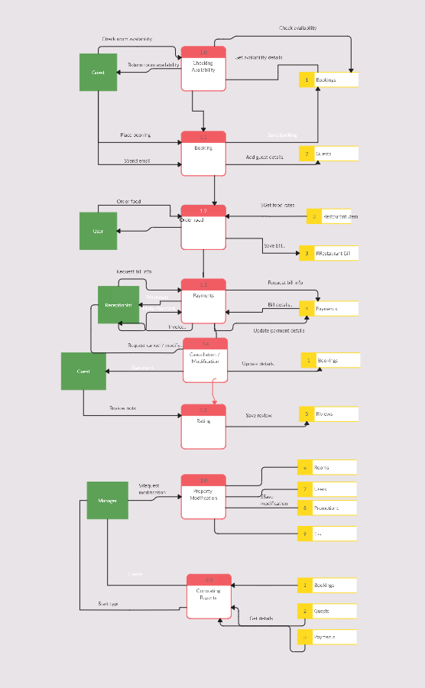The website processes user inputs, retrieves relevant data (e.g., package details, availability), and performs actions such as payment processing and reservation management.
* Data flows from the user to the website and vice versa, representing the input and output of data in the system.

**CONCULSION:**

The development of a holiday booking website involves various requirements and considerations to provide users with a seamless and user-friendly experience for searching, booking, and managing holiday reservations. The project encompasses features such as user registration, authentication, search and filtering of holiday packages, reservation management, payment processing, and user reviews.

Overall, a holiday booking website project requires careful planning, development, and testing to create a robust and user-friendly platform that meets the needs of users in the travel and booking domain.