

**U. S. Department of Agricult**

**ure**

**National Finance Center**

**System Performance Issues**

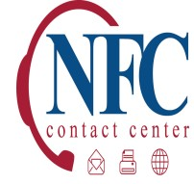

**Date:**

**August 4**

**, 2015**

**Subject**

**:**

**NF**

**C Connectivity Issues**

**Update**

**-**

**#1**

**0**

**76200**

**-**

**Resolved**

**Database/Customer(s) Affected:**

**All**

Dear Customer

:

This communication is a follow

-

up to a notice issued on Monday, August 3, 2015, stat

ing

the National Finance Center (NFC) was experiencing connectivity issues that had

impacted the NFC’s hosted systems and applications.

The issues have been resolved.

Currently, no action is required on the part of the

customers.

**Federal employees with**

**questions concerning this notification should contact their**

**Servicing Personnel Office**

.

Authorized agency representatives with questions

concerning this notification should contact NFC’s Contact Center at either

1

-

855

-

632

-

4468

; via email to

NFCcontactcenter@nfc.usda.gov

or via the Remedy

Requestor Console.

KJS/ P8