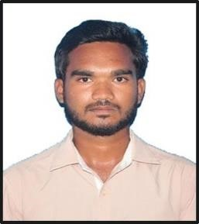
P. CHAITHANYA
Gudur, Andhra Pradesh
Email: arjunchaithanya7@gmail.com | Phone: 6304213766 |LinkedIn: www.linkedin.com/in/
chaithanya-poluru-2867a832a | Hacker Rank : https://www.hackerrank.com/profile/poluruchaithanya |GitHub: https://github.com/bobby307
PROFESSIONAL SUMMARY
Aspiring Python Developer with expertise in backend development, automation, and data analysis. Skilled in Python, Flask, Django, and database management. Passionate about building scalable applications and leveraging data processing techniques to drive efficiency. Seeking an opportunity to contribute my skills in a dynamic development environment.

EDUCATION
N.B.K.R. Institute of Science and Technology
B. Tech in Artificial Intelligence & Data Science | CGPA: 7.44 | 2021 - 2025
Narayana Junior College
Intermediate | Score: 856/1000 | 2019 - 2021
St. Marys English Medium High School
SSC | GPA: 9.0 | 2018 - 2019

TECHNICAL SKILLS
- Programming: Python (Flask, Django),Machine Learning Algorithms
- Databases: MySQL, MongoDB
- Web Development: HTML, CSS, JavaScript
- Data Processing & Automation: Pandas, NumPy, Matplotlib, Seaborn
- Operating Systems: Windows, Linux
- Tools & Applications: MS Office, VSCode

PROJECTS
- Advanced Solar Radiation Prediction - Developed a solar radiation prediction model using BI-LSTM and XG-Boost.
- Flask API for Student Management - Built a REST API using Flask with MongoDB for CRUD operations.
- Hooked Up Repository (Book Exchange Website) - Created an online platform for users to buy, sell, and exchange books.

INTERNSHIPS & EXPERIENCE
Oasis Info Byte | Data Science Internship (Nov 2024 - Dec 2024) - Worked on data analysis, visualization, and automation.
Deloitte Australia | Data Analytics Job Simulation (Feb 2025) - Created a Tableau dashboard and classified forensic data. Accenture North America | Data Analytics & Visualization Job Simulation (Feb 2025) - Modelled datasets and presented insights.

CERTIFICATIONS
- Python for Data Science – Udemy, Full Stack Web Development - EDX Platform
- Data Analytics Job Simulation (Deloitte & Accenture), Data Science Internship - Oasis InfoByte
NPTEL Training: Privacy & Security I n Social Media

