CS 276 Week 10 Assignment – Reading From and Loading to a flat file (I/O in PL/SQL)

**PART 1 – Importing with SQLLDR**

Instructions:

1. Create a student table as follows:

STUDENT_ID number

STUDENT_LAST_NAME varchar2(25)

STUDENT_FIRST _NAME varchar2(25)

1. Download the Week10_LoaderFile.csv file **in a place you will remember.** You will need to type this location in the file you create for number 3.
2. In the same directory/folder as the .csv file, create a file with Notepad called **SQLLDR_FILE.txt** – this will be your control file for loading a flat file to a database. This file will contain the following text:

load data

infile 'C:/directorywhereyouputthefile/Week10_LoaderFile.csv'

into table student

fields terminated by ","

( student_id, student_last_name, student_first_name )

There are a BUNCH of other parameters and commands for SQLLDR – you may peruse them at your leisure by typing **sqlldr help** at the command prompt.

1. Open your command prompt and change directories to where you placed the csv and txt files. I put mine in my Downloads folder.

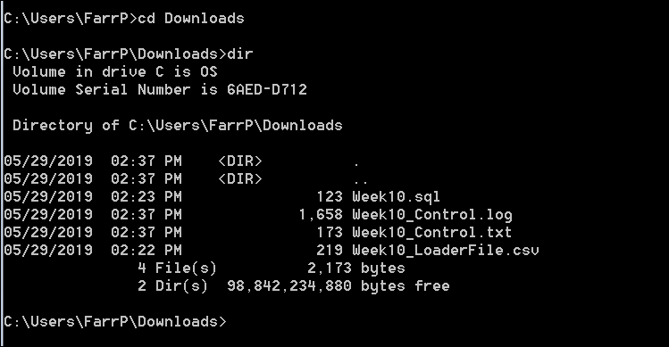

1. Execute the following command at the command prompt:

**sqlldr student/whateveryourpasswordis control=SQLLDR_FILE.txt**

1. There should be 9 records loaded to the student table. Feel free to peruse the log file as well.

**PART 2 – Importing with SQL Developer**

Another way of loading up data to the Oracle Database is directly through SQL Developer.

1. Start up SQL Developer and login as student
2. Execute the following command – this will drop the rows from the student table from Part 1.

**Truncate table student;**

1. Open up the “Tables” entry on the left hand side of the screen, and double click on the “STUDENT” table.



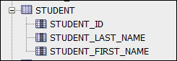

1. In the right hand panel, you should see the following:

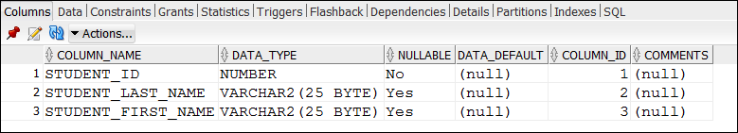

1. Click on “Actions” (right above COLUMN_NAME), and click on “Import Data”

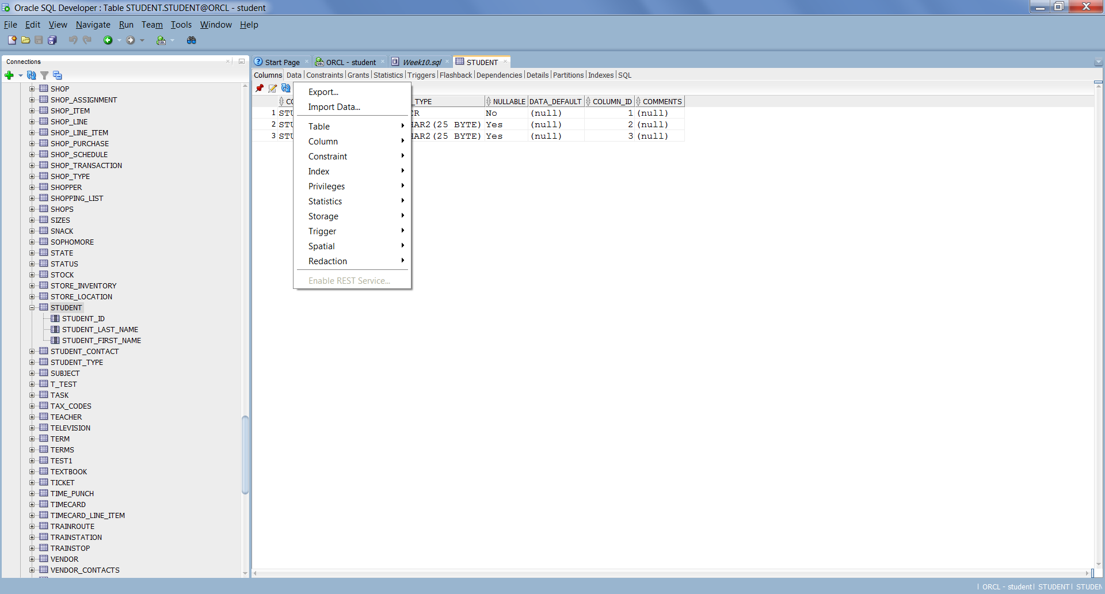

1. Fill in the “Import Data File” location, and select the “Week10_LoaderFile.csv” file.
2. Uncheck the “Header” check box, and click “Next”
3. Click “Next” on this screen.

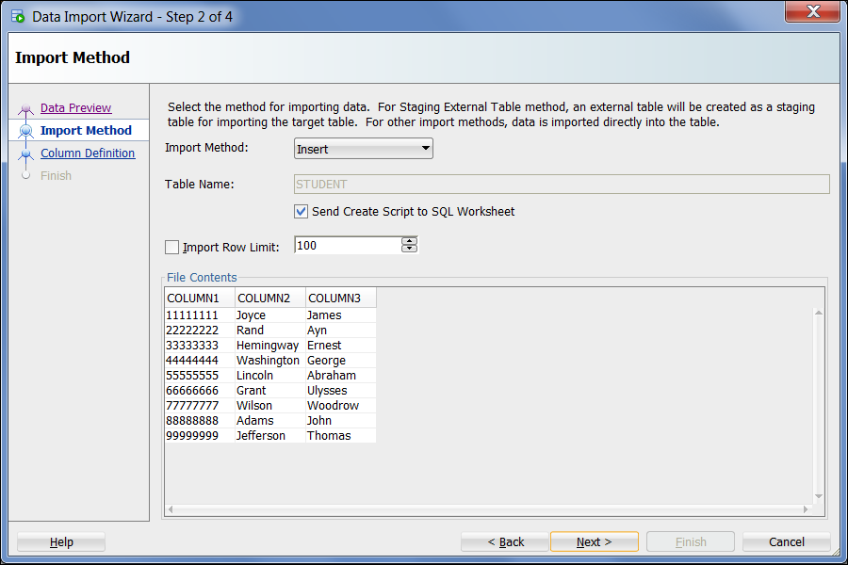

1. Click “Next” on this screen. Note the data showing at the bottom of the screen.

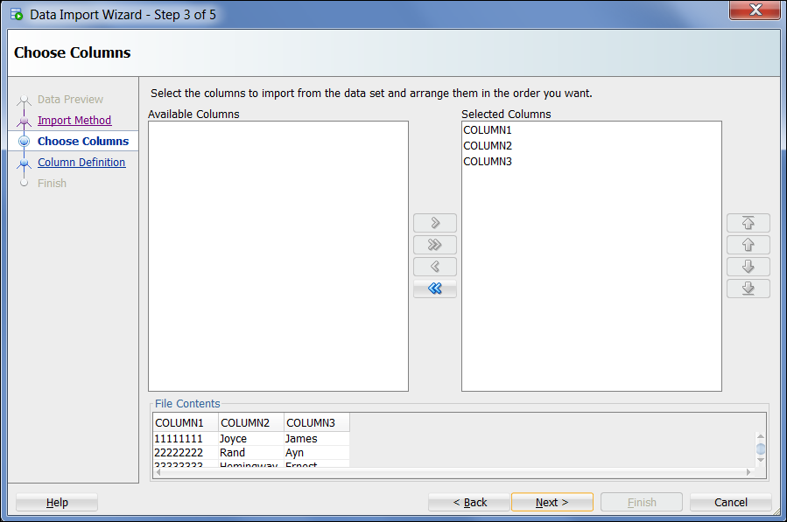

1. For this screen, with the “Source Data Columns” listed as Column1, Column2, Column3, Click on each of those names (Column1, 2, 3) individually and it will map to the columns listed on the right hand side, then click “Next”

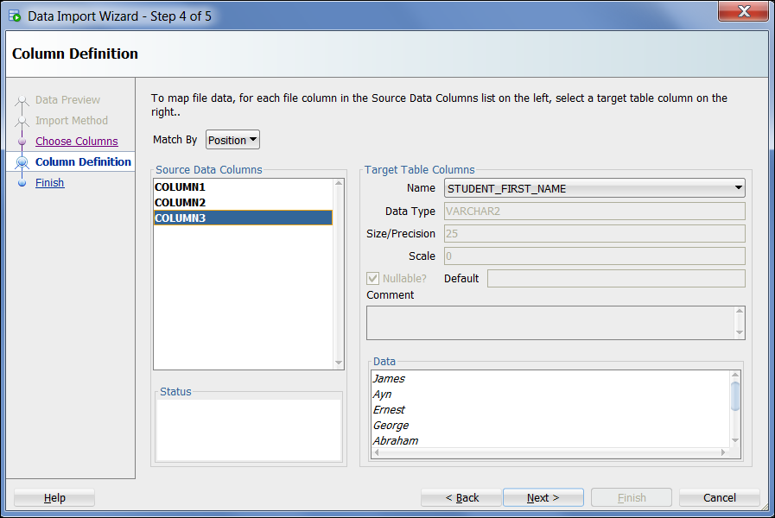

1. Click “Finish” on this screen.

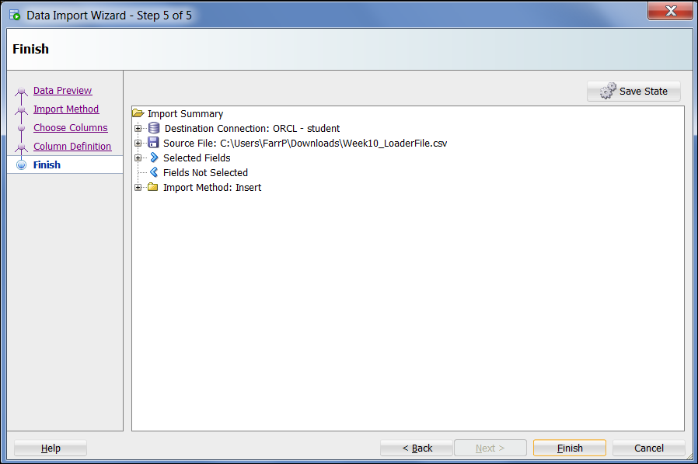

1. Ta da!

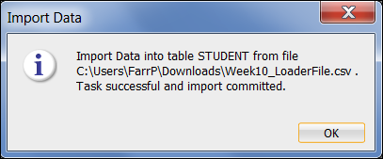

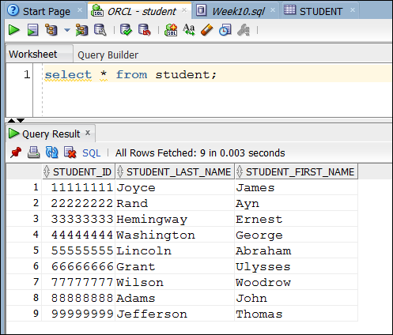

**PART 3 – Exporting through PL/SQL**

Most folks use the first method to get data into their database, simply because it can be a batch process, and won’t lock up your terminal inserting 80,000 records at a time.

NOW, let’s say you receive a phone call from the Federal Government asking you to download a list of students registered in CS 120 for all of the last academic year. How do you download this data to a flat file? You CAN use SQL Developer again, but if you need to do this repeatedly, you will want to set up an automated batch process.

For this part, you will write a procedure that will create a file, open it, write the names of students to it, and close the file using an ancient utility called UTL_FILE which has been around for decades, and is still the most often used function in getting large amounts of data out of a database.

1. You need to define a place for your file, so as **system** in SQL Developer,execute the following commands:

**create directory my_directory as 'C:\Users\Farrp\Downloads'; -- or whatever your Downloads directory is**

**grant read, write on directory my_directory to student;**

This will create a directory object in your database as a cupboard where your output files can reside at the operating system level.

1. Create procedure export_data, and don’t pass in any parameters, because you will be manipulating data in the database.

**Download Week10_PLSQL.sql file and run it from SQL Developer.**