UNIT-II
DATA PREPROCESSING
An Overview, Data Cleaning, Data Integration, Data Reduction, Data Transformation and Data Discretization.
2.1 AN OVERVIEW
2.1.1 Data Quality: Why Preprocess the Data
  - Data preprocessing is essential in data mining because real-world data is often messy—full of errors, missing values, duplicates, and inconsistencies. Without preprocessing, any data analysis or model built on such data will produce unreliable results.
Data Quality Dimensions
1.Accuracy
  - Refers to the correctness of data values.
Example: Errors or unusual values in transactions like incorrect prices.
2.Completeness
  - Refers to data missing attribute values, attributes of interest, or even whole records.
Example: Missing values for whether an item was on sale.
3.Consistency
  - Refers to data that does not contradict itself across records or systems.
Example: Discrepancies in department codes for categorizing items.
4.Timeliness
  - Indicates whether the data is up-to-date and available when needed.
Example: Sales records submitted late, causing delayed bonus distribution.
5.Believability
  - Reflects how much the data is trusted by users.
Example: Past data errors caused users to distrust the current data even if it’s correct now.
6.Interpretability
  - Reflects how easily the data can be understood.
Example: Use of accounting codes not understood by the sales team.
2.1.2 Major Tasks in Data Preprocessing
1. Data Cleaning
  - Deals with dirty data: missing values, noise, outliers, and inconsistencies.
  - Tasks include:
[A] Filling in missing values
[B] Smoothing noisy data
[C] Identifying or removing outliers
[D] Resolving inconsistencies
Importance: Unclean data leads to unreliable mining results and user distrust.
2. Data Integration
  - Combines data from multiple sources (databases, data cubes, files).
  - Issues handled:
[A] Naming inconsistencies (e.g., customer id vs. cust id)
[B] Value inconsistencies (e.g., "Bill", "William", "B.")
[C] Redundancy detection and removal
  - Integration helps build a unified dataset for analysis.
3. Data Reduction
  - Produces a smaller volume of data that still yields similar results.
  - Two main strategies:
(i)Dimensionality Reduction:
Data compression techniques (e.g., PCA, wavelets)
Attribute subset selection
Attribute construction
(ii)Numerosity Reduction:
Parametric models (e.g., regression)
Nonparametric methods (e.g., sampling, clustering, histograms)
  - Improve efficiency of mining on large datasets.
4. Data Transformation
  - Converts data into suitable forms for mining algorithms.
  - Includes:
(i)Normalization (e.g., scaling to [0.0, 1.0])
Ensures attributes like age and salary are comparable
(ii)Discretization:
Converts numeric data to ranges (e.g., age → youth, adult, senior)
  - Concept Hierarchy Generation: Maps data to higher-level concepts

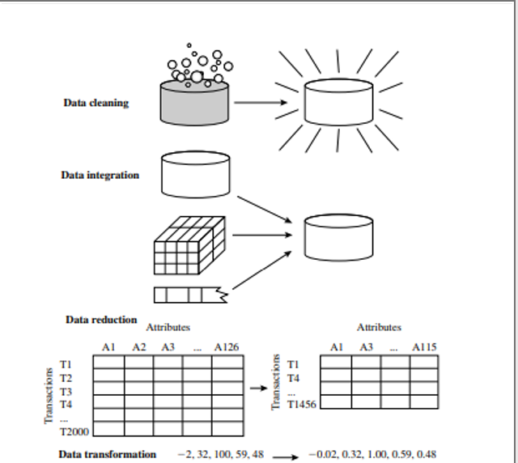
Figure: Forms of data preprocessing
2.2 DATA CLEANING
- Data cleaning (or data cleansing) routines attempt to fill in missing values, smooth out noise while identifyingIncomplete (missing values),
- Noisy (contains errors or outliers),
- Inconsistent (contradictory or conflicting data values).
- outliers, and correct inconsistencies in the data.
2.2.1 Missing Values: Handling Techniques
When analyzing data such as sales or customer data (e.g., customer income), several tuples may have missing attribute values.The following methods are used to handle such cases:
1. Ignore the Tuple
  - Used when the class label is missing.
  - Not effective if many values are missing in the tuple.
  - Wastes useful data from other attributes.
2.Fill in Missing Values Manually
  - Time-consuming and impractical for large datasets.
3.Use a Global Constant
  - Replace all missing values with a constant (e.g., “Unknown” or −∞).
  - Can mislead the mining algorithm into recognizing “Unknown” as a valid concept.
4.Use Mean or Median of the Attribute
  - For symmetric distributions → Use mean
  - For skewed distributions → Use median
  - Example: Replace missing income with average income of $56,000.
5.Use Class-Specific Mean or Median
  - Replace missing value with the mean/median for the same class label.
  - Median preferred for skewed distributions.
6.Use the Most Probable Value
  - Estimate using methods like:
Regression
Bayesian inference
Decision tree induction
  - Considers other attribute values to make a better estimate.
2.2.2 NOISY DATA
  - Noise is defined as random error or variance in a measured variable.
  - For example, in a numeric attribute like price, noise can distort patterns.
  - Outliers (extreme values) often indicate noise.
  - Tools such as boxplots, scatter plots, and visualization help identify noise.
Data Smoothing Techniques (to handle noise)
1. Binning
  - Binning smooths sorted data values by grouping them into bins (buckets).
  - Local smoothing method – consults neighboring values.
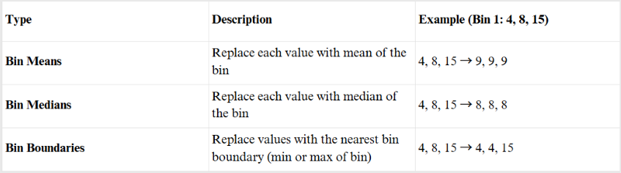

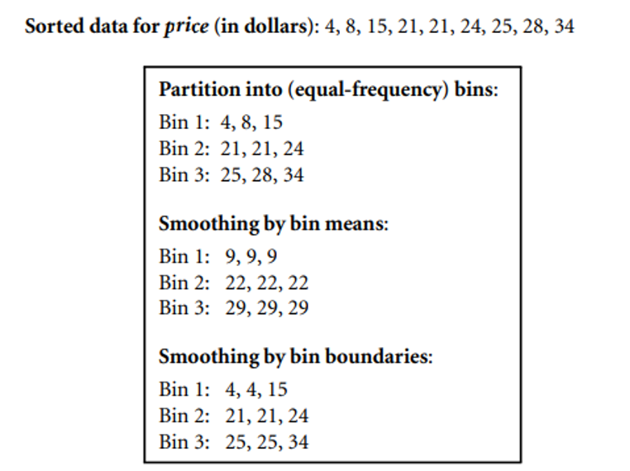
Figure : Binning methods for data smoothing.
2. Regression
  - Fits data values to a function.
  - Linear Regression: Fits a straight line between two variables.
  - Multiple Linear Regression: Fits data to a multidimensional surface with multiple variables.
3. Outlier Analysis
  - Detects extreme values that deviate from the rest.
  - Example: Clustering-based outlier detection—outliers are data points that don’t belong to any cluster.
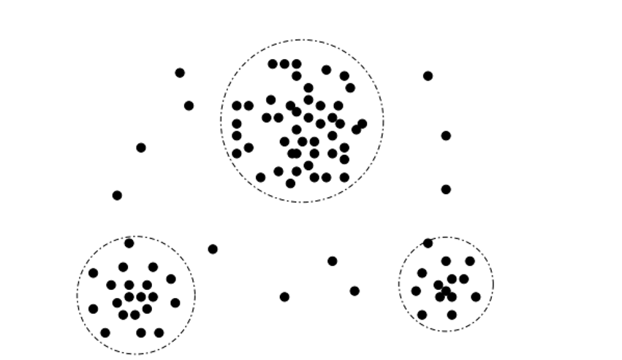
Figure : A 2-D customer data plot with respect to customer locations in a city, showing three data clusters. Outliers may be detected as values that fall outside of the cluster sets.
2.3 DATA INTEGRATION
2.3.1 Entity Identification Problem
  - Data mining requires data integration—the merging of data from multiple data stores.
  - Careful integration can help reduce redundancies and inconsistencies in the data set.
  - This can help improve the accuracy and speed of the subsequent data mining process.
Entity Identification Problem
  - There are a number of issues during data integration.
  - Schema integration can be tricky.
  - How can equivalent real-world entities from multiple data sources be matched up? This is referred to as the entity identification problem.
  - For example, how can the data analyst be sure that customer id in one database and cust number in another refer to the same attribute?
  - Examples of metadata for each attribute include the name, meaning, data type, and range of values for the attribute.
2.3.2 Data Value Conflict Detection and Resolution
  - Data integration also involves the detection and resolution of data value conflicts.
  - For the same real-world entity, attribute values from different sources may differ due to:
Differences in representation
Differences in scaling
Differences in encoding
Examples:
  - A weight attribute may be stored in:
Metric units in one system
British imperial units in another
2. A hotel chain’s room price may differ due to:
Different currencies
Different services (e.g., free breakfast)
Different taxes
3. Schools exchanging information face issues because:
Each school may have its own curriculum
Each school may have a different grading scheme
Example:
  - One university may use a quarter system, offer three database courses, and assign grades from A+ to F
  - Another may use a semester system, offer two database courses, and assign grades from 1 to 10
4. Attributes may differ in abstraction level:
Example:
"Total sales" in one database → refers to one branch
"Total sales" in another → refers to all stores in a region
2.4 DATA REDUCTION
What is Data Reduction?
Data reduction means shrinking the size of your data while keeping the important information. This makes data easier and faster to work with.
2.4.1 Overview of Data Reduction Strategies
1. Dimensionality Reduction
  - Think of this like removing extra columns from your dataset that don’t help much.
  - For example, if you're analyzing student performance, the "favorite color" column might not matter.
Common methods:
  - PCA (Principal Component Analysis) – combines related columns into fewer ones.
  - Wavelets – compress signals/data.
  - Attribute Subset Selection – just pick the useful columns.
2. Numerosity Reduction
  - This is about simplifying the amount of data by replacing it with something smaller but still meaningful.
There are Two types:
[A] Parametric: Use formulas to summarize data (like using a regression line).
[B] Non-parametric: Use clever tricks to reduce data:
  - Histograms – group similar values together.
  - Clustering – group similar items and treat the group as one.
  - Sampling – take only a small portion of data.
  - Data Cube Aggregation – summarize data for fast querying.
3. Data Compression
This is like zipping a file – make the data smaller to save space.
  - Lossless: Shrinks the data but you can get back the original exactly.
  - Lossy: You lose a bit of detail, but it still looks/works okay (like JPEG images).
- Overview of Techniques
Data reduction techniques produce a reduced representation of the data set that is much smaller in volume, but it is similar to original data.
  - That is, mining on the reduced data set should be more efficient.
  - Data reduction Techniques:
Attribute Subset Selection
Histograms
Sampling
2.4.2 Attribute Subset Selection
  - Data sets for analysis may contain hundreds of attributes, many of which may be irrelevant to the mining task.
  - For example, the task is to classify customers based on whether they will purchase a CD at AllElectronics, attributes such as the customer’s telephone number is likely to be irrelevant.
  - Attribute subset selection reduces the data set size by removing irrelevant or redundant attributes.
  - The goal of attribute subset selection is to find a minimum set of attributes.
  - Mining on a reduced set of attributes helps to make the patterns easier to understand.
  - “How can we find a ‘good’ subset of the original attributes?” For n attributes, there are 2n possible subsets.
  - Heuristic methods are used for attribute subset selection, these methods are typically greedy.
1.Stepwise forward selection:
  - The procedure starts with an empty set of attributes as the reduced set.
  - The best of the original attributes is determined and added to the reduced set.
  - At each subsequent iteration or step, the best of the remaining original attributes is added to the set.
2. Stepwise backward elimination:
  - The procedure starts with the full set of attributes.
  - At each step, it removes the worst attribute remaining in the set.
3.Combination of forward selection and backward elimination:
  - The stepwise forward selection and backward elimination methods can be combined, at each step, the procedure selects the best attribute and removes the worst from the remaining attributes.
4.Decision tree induction:
  - Decision tree algorithms were used for classification.
  - Decision tree induction constructs a flowchart like structure where each internal node denotes a test on an attribute, each branch corresponds to an outcome of the test, and each external (leaf) node denotes a class prediction.
2.4.3 Histograms
  - Histograms use binning to approximate data distributions .
  - A histogram for an attribute, A, partitions the data distribution of A into disjoint subsets, referred to as buckets or bins.
  - If each bucket represents only a single attribute–value/frequency pair, the buckets are called singleton buckets.
  - Often, buckets instead represent continuous ranges for the given attribute.
- Ex: The following data are a list of AllElectronics prices for items . The numbers have been sorted: 1, 1, 5, 5, 5, 5, 5, 8, 8, 10, 10, 10, 10, 12, 14, 14, 14, 15, 15, 15, 15, 15, 15, 18, 18, 18, 18, 18, 18, 18, 18, 20, 20, 20, 20, 20, 20, 20, 21, 21, 21, 21, 25, 25, 25, 25, 25, 28, 28, 30, 30, 30
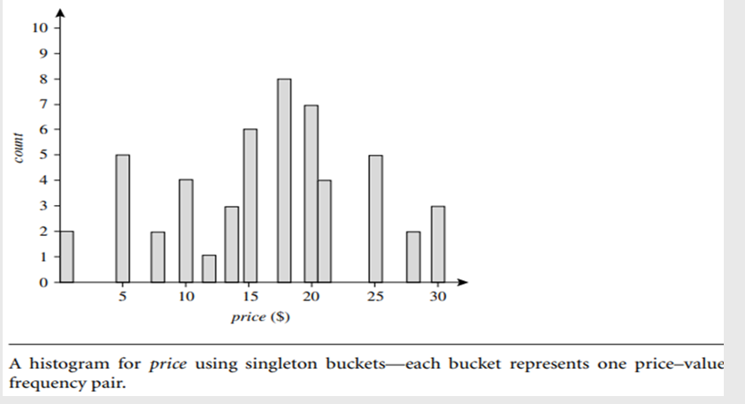
- each bucket represents a different $10 range for price.
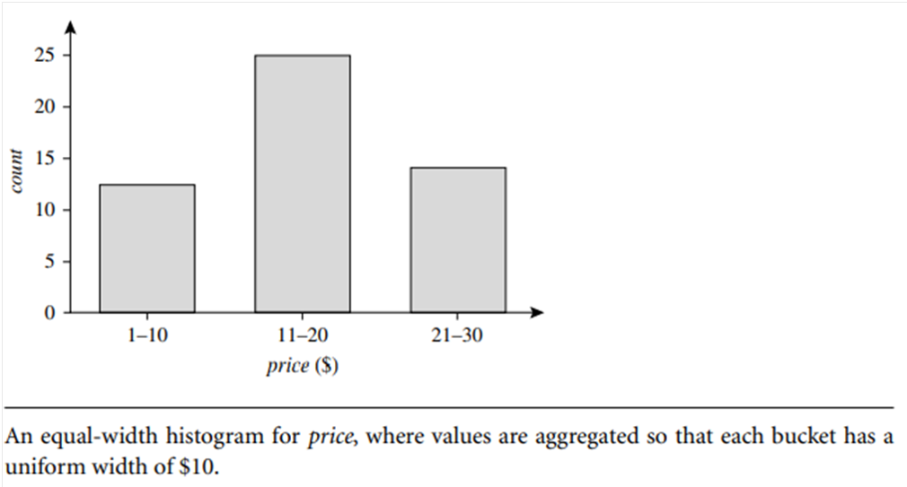
- Equal-width: In an equal-width histogram, the width of each bucket range is uniform .
- Equal-frequency (or equal-depth): In an equal-frequency histogram, the buckets are created so that, roughly, the frequency of each bucket is constant.
2.4.4 Clustering
What is Clustering (in Data Reduction)?
- Clustering is like grouping similar items together so we can treat the whole group as one unit instead of dealing with each item separately.
- Imagine you’re organizing your wardrobe: you group all your shirts together, pants together, etc. — that's clustering.
How Clustering Works:
  - Each data record (called a data tuple) is seen as an object.
  - We group similar objects together into clusters.
  - “Similar” means close to each other, based on some distance (like how near two houses are on a map).
Two Common Ways to Measure Cluster Quality:
1.Cluster Diameter
  - The maximum distance between any two points inside a cluster.
  - Smaller diameter = tighter, better cluster.
2.Centroid Distance
  - The average distance of each object in the cluster from the cluster’s center point (centroid).
  - Smaller average = better cluster.
Why Use Clustering in Data Reduction?
  - Once similar items are grouped:
  - You can represent a whole group using its center (centroid).
  - This reduces the amount of data you need to work with.
  - Best used when the data has clear groups.
  - Not very helpful if the data is smeared or mixed.
2.4.5 Sampling
  - Sampling can be used as a data reduction technique because it allows a large data set to be represented by a much smaller random data sample.
  - Suppose that a large data set, D, contains N tuples.
  - Simple random sample without replacement (SRSWOR) of size s:
  - This is created by drawing s of the N tuples from D (s < N), where the probability of drawing any tuple in D is 1/N.
Simple random sample with replacement (SRSWR) of size s:
  - This is similar to SRSWOR, except that each time a tuple is drawn from D, it is placed back in D, so that it may be drawn again.
  - Cluster sample: If the tuples in D are grouped into M disjoint “clusters,”then an SRS of s clusters can be obtained,
  - Stratified sample: If D is divided into disjoint parts called strata, a stratified sample of D is generated by obtaining an SRS.
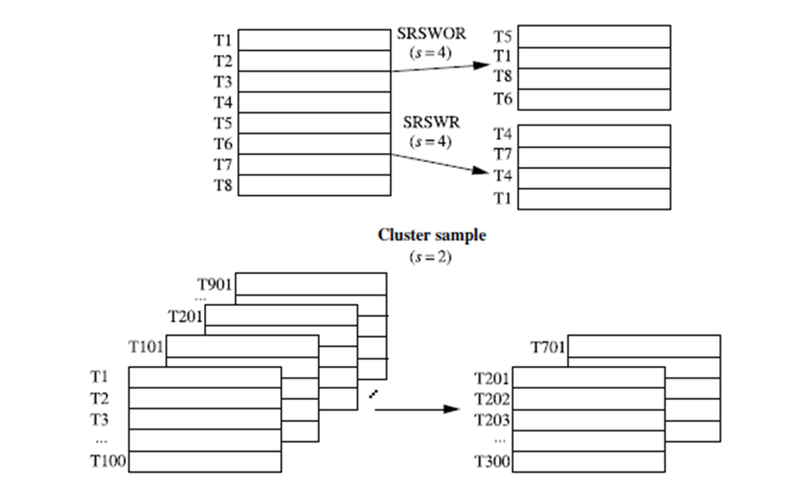

Figure : Sampling
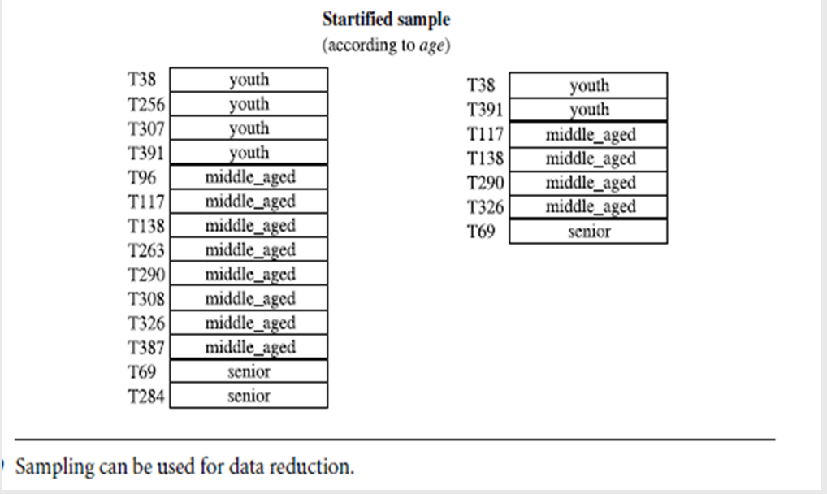
2.4.6 Data Cube Aggregation
  - Data cube aggregation is like summarizing large amounts of data into smaller, more meaningful summaries that are easier and faster to analyze.
  - Example (AllElectronics Sales):
Imagine you have sales data for each quarter (Q1–Q4) from 2008 to 2010:
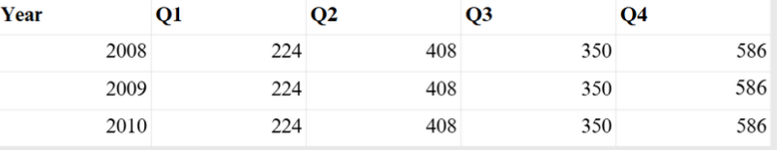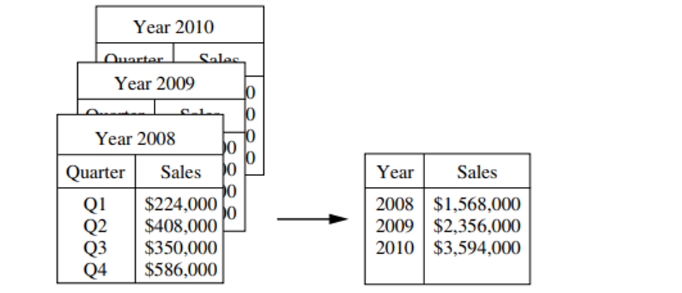Figure: Sales data for a given branch of AllElectronics for the years 2008 through 2010. On the left, the sales are shown per quarter. On the right, the data are aggregated to provide the annual sales.
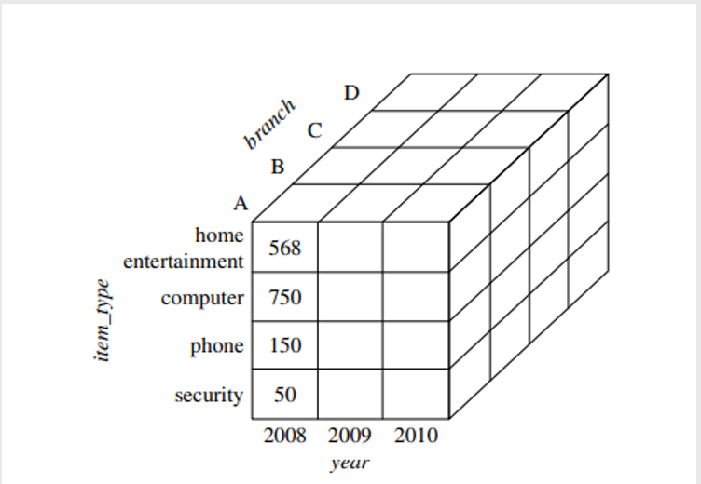
Figure: A data cube for sales at AllElectronics.
  - But you only care about total yearly sales, not quarterly sales.
  - So we aggregate the quarters into annual totals:

  - Result: Less data to store, but still all the info you need.
What is a Data Cube?
  - A data cube is a multi-dimensional structure used to store summarized (aggregated) data.
  - Think of it as a Rubik's cube where:
  - Each axis (dimension) represents an attribute (like year, item type, or branch)
  - Each cell contains the summarized value like total sales
  - Each cell in the cube gives sales for:
A specific item type
In a specific branch
In a specific year
Types of Cuboids:
  - Base Cuboid: Most detailed level (e.g., sales by branch, item, year).
  - Apex Cuboid: Most summarized level (e.g., total sales for all branches, all items, all years).
  - Data cube aggregation means turning detailed data into summaries across multiple angles (like time, location, product). This reduces data size, speeds up analysis, and helps spot patterns easily.
2.5 DATA TRANSFORMATION AND DATA DISCRETIZATION
2.5.1 Data Transformation Strategies Overview
In data transformation, the data are transformed or consolidated into forms appropriate for mining. Strategies for data transformation include the following:
1. Smoothing, which works to remove noise from the data. Techniques include binning, regression, and clustering.
2. Attribute construction (or feature construction), where new attributes are constructed and added from the given set of attributes to help the mining process.
3. Aggregation, where summary or aggregation operations are applied to the data. For example, the daily sales data may be aggregated so as to compute monthly and annual total amounts. This step is typically used in constructing a data cube for data analysis at multiple abstraction levels.
4. Normalization, where the attribute data are scaled so as to fall within a smaller range, such as −1.0 to 1.0, or 0.0 to 1.0.
5. Discretization, means converting continuous numeric values (like age or price) into categories or ranges.
6. Concept hierarchy generation for nominal data, means grouping nominal (categorical) data into levels, from specific to general.
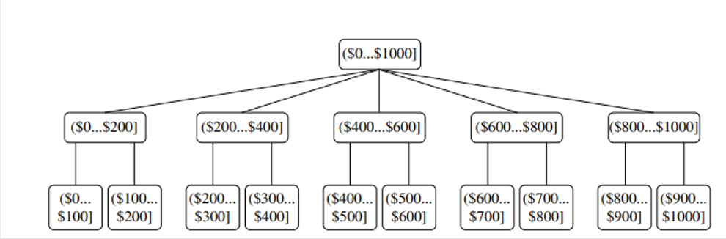
Figure: A concept hierarchy for the attribute price, where an interval ($X ...$Y] denotes the range from $X (exclusive) to $Y (inclusive).
2.5.2 Data Transformation by Normalization
  - In this preprocessing step, the data are transformed or consolidated so that the resulting mining process may be more efficient.
  - The measurement unit used can affect the data analysis.
  - For example, changing measurement units from meters to inches for height, or from kilograms to pounds for weight,may lead to very different results.
  - To avoid problems, the data should be normalized or standardized.
  - This involves transforming the data to fall within a smaller or common range such as [-1, 1] or [0.0, 1.0].
  - There are many methods for data normalization.
  - min-max normalization, z-score normalization, and normalization by decimal scaling.
  - For example, let A be a numeric attribute with n observed values, v1, v2, : : : , vn.
  - Min-max normalization performs a linear transformation on the original data.
  - Suppose that minA and maxA are the minimum and maximum values of an attribute, A.
  - Min-max normalization maps a value, vi , of A to v1i in the range [new minA,new maxA] by computing
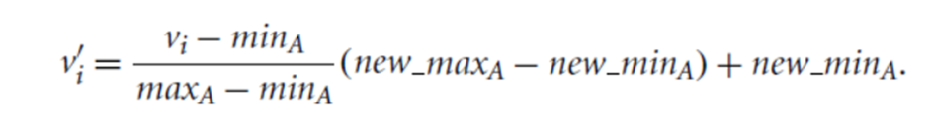

  - Min-max normalization Example: Suppose that the minimum and maximum values for the attribute income are $12,000 and $98,000, respectively.
  - We would like to map income to the range [0.0, 1.0].
  - By min-max normalization, a value of $73,600 for income is transformed to
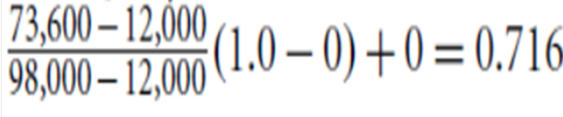
  - In z-score normalization (or zero-mean normalization), the values for an attribute,A, are normalized based on the mean (i.e., average) and standard deviation of A.
  - A value,vi ,of A is normalized to v1i by computing

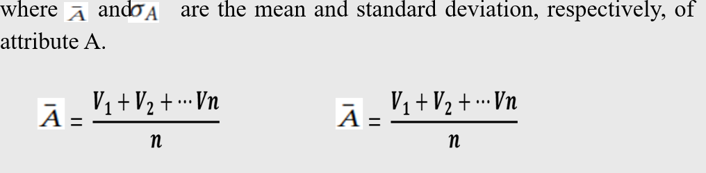
  - z-score normalization example: Suppose that the mean and standard deviation of the values for the attribute income are $54,000 and $16,000, respectively.
  - With z-score normalization,a value of $73,600 for income is transformed to

  - Normalization by decimal scaling normalizes by moving the decimal point of values of attribute A.
  - The number of decimal points moved depends on the maximum absolute value of A. A value, vi , of A is normalized to v1i by computing

where j is the smallest integer such that

  - Decimal scaling Example: Suppose that the recorded values of A range from -986 to 917.
  - The maximum absolute value of A is 986.
  - To normalize by decimal scaling, we therefore divide each value by 1000 (i.e., j = 3) so that -986 normalizes to -0.986 and 917 normalizes to 0.917.
2.5.3 Discretization by Binning
  - Binning is a top-down splitting technique based on a specified number of bins.
  - binning methods use discretization methods for data reduction.
  - For example, attribute values can be discretized by applying equal-width or equal-frequency binning.
  - each bin value can be replaced with mean or median, as in smoothing by bin means or smoothing by bin medians.
2.5.4 Concept Hierarchy Generation for Nominal Data
  - Nominal data (like city, job, or product type) has categories without any natural order.
  - Concept hierarchy generation helps organize such data from specific to general levels — making it easier to analyze and mine knowledge at different levels.
  - Makes large, detailed data more manageable.
  - Helps find patterns at different abstraction levels (e.g., sales by street → city → country).
  - Enables multilevel analysis for data mining.
4 Main Methods to Generate Concept Hierarchies:
1. Manual Ordering at Schema Level
  - The user or expert manually defines the order of attributes in the hierarchy.
  - Example: Street < City < State < Country.
  - This approach is straightforward when the structure is already known
2. Manual Grouping of Values
  - Users define part of the hierarchy by grouping certain values.
  - Useful for creating intermediate categories like "Prairies Canada" from provinces.
  - It saves effort when full hierarchy definition is too large.
3. Automatic Ordering by Distinct Values
  - The system uses the number of unique values to auto-build the hierarchy.
  - Fewer distinct values
→ higher level (e.g., Country), more values → lower (e.g., Street).
  - Helpful when user skips ordering, but may need manual adjustments.
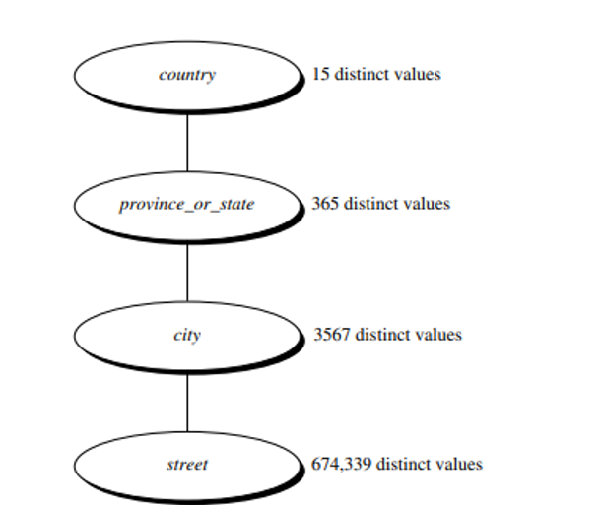
Figure : Automatic generation of a schema concept hierarchy based on the number of distinct attribute values.
4. Semantic Linking from Partial Attributes
  - If the user provides only a few attributes (e.g., City), the system pulls in related ones (e.g., Street, Country).
  - This works by using predefined semantic links in the database schema.
  - It simplifies user input and completes the hierarchy automatically.

MULTIPLE CHOICE QUESTIONS (MCQS)
Q1. Why is data preprocessing essential in data mining?
a) To store data efficiently
b) To make data suitable for analysis
c) To increase data size
d) To encrypt data
Answer: b) To make data suitable for analysis
Q2. Which of the following is NOT a reason for data preprocessing?
a) Noise removal
b) Data normalization
c) Data loss
d) Handling missing values
Answer: c) Data loss
Q3. Which is not a major data preprocessing task?
a) Data cleaning
b) Data warehousing
c) Data integration
d) Data transformation
Answer: b) Data warehousing
Q4. Which task deals with removing inconsistencies in data?
a) Data cleaning
b) Data reduction
c) Data integration
d) Data discretization
Answer: a) Data cleaning
Q5. Which is a common technique for handling missing values?
a) Deleting entire dataset
b) Replacing with the most frequent value
c) Ignoring all data
d) Increasing dataset size
Answer: b) Replacing with the most frequent value
Q6. Missing values can be filled using:
a) Regression models
b) Random number generators only
c) Encryption techniques
d) Data compression
Answer: a) Regression models
Q7. What is noise in a dataset?
a) Duplicate records
b) Irrelevant data
c) Random error or variance
d) Encrypted values
Answer: c) Random error or variance
Q8. Which method is commonly used to remove noise?
a) Smoothing
b) Clustering
c) Binning
d) Sampling
Answer: a) Smoothing
Q9. Entity identification refers to:
a) Identifying missing values
b) Identifying data noise
c) Identifying real-world entities from data records
d) Identifying numerical values
Answer: c) Identifying real-world entities from data records
Q10. Which issue does entity identification help resolve?
a) Class imbalance
b) Redundant attributes
c) Duplicate entries across tables
d) Low data volume
Answer: c) Duplicate entries across tables
Q11. Data value conflict occurs when:
a) Two values match
b) Missing values are detected
c) The same attribute has different values in different sources
d) All data is normalized
Answer: c) The same attribute has different values in different sources
Q12. A method to resolve data value conflicts is:
a) Data encryption
b) Data cleaning
c) Conflict resolution rules
d) Entity resolution
Answer: c) Conflict resolution rules
Q13. Data reduction is used to:
a) Increase data redundancy
b) Minimize data size while preserving integrity
c) Remove all attributes
d) Encrypt data
Answer: b) Minimize data size while preserving integrity
Q14. Which is not a data reduction technique?
a) Sampling
b) Attribute selection
c) Smoothing
d) Data aggregation
Answer: c) Smoothing
Q15. Attribute subset selection removes:
a) Important attributes
b) Duplicate values
c) Irrelevant or redundant attributes
d) Missing values
Answer: c) Irrelevant or redundant attributes
Q16. Which method helps in attribute selection?
a) Decision trees
b) Data cleaning
c) Data warehousing
d) Encryption
Answer: a) Decision trees
Q17. Histograms are used in data reduction for:
a) Data cleaning
b) Data compression
c) Data distribution representation
d) Data integration
Answer: c) Data distribution representation
Q18. Which type of histogram divides values into intervals?
a) Equal-width
b) Unequal-width
c) Binary tree
d) Flat tree
Answer: a) Equal-width
Q19. Clustering groups data based on:
a) Frequency
b) Labels
c) Similarity
d) Randomness
Answer: c) Similarity
Q20. Which algorithm is commonly used for clustering?
a) K-means
b) Naive Bayes
c) Apriori
d) Logistic Regression
Answer: a) K-means
Q21. Sampling is used to:
a) Create duplicates
b) Select representative data subsets
c) Normalize data
d) Encrypt data
Answer: b) Select representative data subsets
Q22. Which is a common sampling technique?
a) Smoothing
b) Stratified sampling
c) Discretization
d) Clustering
Answer: b) Stratified sampling
Q23. Data cube aggregation involves:
a) Reducing resolution by grouping data
b) Enhancing data precision
c) Generating noise
d) Removing missing values
Answer: a) Reducing resolution by grouping data
Q24. Which OLAP operation supports aggregation?
a) Roll-up
b) Drill-through
c) Sorting
d) Filtering
Answer: a) Roll-up
Q25. Data transformation refers to:
a) Data loss
b) Modifying data format and structure
c) Data generation
d) Data deletion
Answer: b) Modifying data format and structure
Q26. Which is a data transformation technique?
a) Binning
b) Normalization
c) Entity resolution
d) Conflict detection
Answer: b) Normalization
Q27. Normalization is used to:
a) Expand data range
b) Reduce data range to a standard scale
c) Encrypt data
d) Join tables
Answer: b) Reduce data range to a standard scale
Q28. Which normalization method scales data to [0,1]?
a) Min-max
b) Z-score
c) Decimal scaling
d) Interpolation
Answer: a) Min-max
Q29. Binning is a technique used in:
a) Data encryption
b) Data discretization
c) Data sampling
d) Data integration
Answer: b) Data discretization
Q30. In binning, data is grouped into:
a) Noise
b) Bins
c) Trees
d) Tables
Answer: b) Bins

Q31. Concept hierarchy is used for:
a) Grouping nominal data into higher-level categories
b) Normalizing numeric values
c) Creating relational schemas
d) Encrypting text
Answer: a) Grouping nominal data into higher-level categories
Q32. Example of concept hierarchy in location data:
a) City → State → Country
b) Byte → Kilobyte → Megabyte
c) Blue → Green → Red
d) Tall → Medium → Short
Answer: a) City → State → Country

