UNIT–V
CLUSTER ANALYSIS
Cluster Analysis: Overview, Basics and Importance of Cluster Analysis, Clustering techniques, Different Types of Clusters; K-means: The Basic K-means Algorithm, K-means Additional Issues, Bi-secting K Means, Agglomerative Hierarchical Clustering: Basic Agglomerative Hierarchical Clustering Algorithm DBSCAN: Traditional Density Center-Based Approach, DBSCAN Algorithm, Strengths and Weaknesses.
5.1 OVERVIEW
5.1.1 Basics and Importance of Cluster Analysis
What Is Cluster Analysis?
  - Cluster analysis or simply clustering is the process of partitioning a set of data objects (or observations) into subsets.
  - •Each subset is a cluster, such that objects in a cluster are similar to one another, yet dissimilar to objects in other clusters.
Applications of Clustering
  - Marketing: Help marketers discover distinct groups in their customer bases, and then use this knowledge to develop targeted marketing programs
  - Land use: Identification of areas of similar land use in an earth observation database
  - Insurance: Identifying groups of motor insurance policy holders with a high average claim cost
  - City-planning: Identifying groups of houses according to their house type, value, and geographical location
Requirements for Cluster Analysis
  - The following are typical requirements of clustering in data mining.
  - Scalability: Many clustering algorithms work well on small data sets containing fewer than several hundred data objects.
  - Ability to deal with different types of attributes: Many algorithms are designed to
  - cluster numeric data. However, applications may require clustering
  - other data types, such as binary, nominal (categorical), and ordinal data
Discovery of clusters with arbitrary shape: Many clustering algorithms determine clusters based on Euclidean or Manhattan distance measures.
Requirements for domain knowledge to determine input parameters:
  - Many clustering algorithms require users to provide domain knowledge in the form of input parameters such as the number of clusters.
  - The following are orthogonal aspects with which clustering methods can be compared:
  - The partitioning criteria: In some methods, all the objects are partitioned so that no hierarchy exists among the clusters.
  - That is, all the clusters are at the same level
  - Alternatively, other methods partition data objects hierarchically, where clusters can be formed at different semantic levels.
  - Separation of clusters: When clustering customers into groups so that each group is taken care of by one manager, each customer may belong to only one group.
  - Similarity measure: Some methods determine the similarity between two objects by the distance between them.
  - Clustering space: Many clustering methods search for clusters within the entire given data space.
  - These methods are useful for low-dimensionality data sets.
5.1.2 Clustering techniques
There exist a large number of clustering algorithms
Clustering methods can be classified into following categories
  - Partitioning methods
  - Hierarchy methods
  - Density-based methods
  - Grid-based methods
Partitioning methods:
  - Given a database of n objects and k, number of clusters, to form a partitioning algorithm organizes the objects into k partitions(k<=n), where each partition represents a cluster.
  - It satisfy the following requirements:
1.each group must contain at least one object, and
2.each object must belong to exactly one group.
  - It uses iterative technique that attempts to improve the partitioning by moving objects from one group to another.
  - Popular methods are
(1) k-means algorithm, where each cluster is represented by the mean value of the objects in the cluster, and
(2)k-medoids algorithm, where each cluster is represented by one of the objects located near the centre of the cluster.
  - The divisive approach, also called the top-down approach, starts with all the objects in the same cluster.
  - In each successive iteration, a cluster is split into smaller clusters, until eventually each object is in one cluster.
Density-based methods:
  - The clustering methods based on density. Continue growing a given cluster as density (no of objects) in the “neighborhood” exceeds some threshold.
Ex: OPTICS. Density-based methods can be used to filter out noise and discover clusters of arbitrary shape.
Grid-based methods:
  - Grid-based methods quantize the object space into a finite number of cells that form a grid structure.
  - All the clustering operations are performed on the grid structure.
  - The main advantage of this approach is its fast processing time, which is dependent only on the number of cells in each dimension.
Ex : STING(Statistical Information Grid Approach)
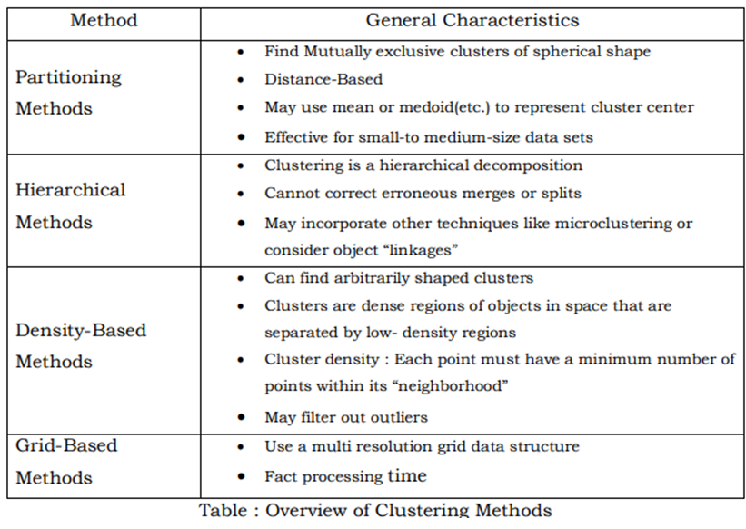
5.1.3 Different Types of Clusters
1. Well-Separated Clusters
  - Definition: Each point in a cluster is closer (or more similar) to every other point in the same cluster than to any point outside.
  - Shape: Can be of any form (not necessarily round).
  - When it works best: When data has natural, clearly separated groups.
Example: Students divided into "male" and "female" groups with no overlap.
2. Prototype-Based Clusters (Center-Based Clusters)
  - Definition: Each cluster has a prototype (either a centroid or medoid), and each object belongs to the cluster whose prototype is closest.
  - Prototype:
Centroid → average of points (e.g., in K-means).
Medoid → the most representative actual point (e.g., in K-medoids).
  - Shape: Usually globular or spherical.
Example: Grouping houses by average price (centroid is the "typical" price).
3. Graph-Based Clusters
  - Definition: Data is represented as a graph (nodes = objects, edges = similarity/connection).
  - A cluster is a connected component or clique in the graph.
Example Types:
  - Contiguity-based: Two points belong to the same cluster if they are within a threshold distance.
  - Clique-based: All members are directly connected.
  - Issue: Noise or "bridges" can incorrectly merge clusters.
4. Density-Based Clusters
- Definition: A cluster is a dense region of points separated by areas of low density (noise).
- Strength: Can detect arbitrary-shaped clusters and handle noise/outliers.
- Algorithm: DBSCAN, OPTICS.
Example: Cities where population density separates one city from another.
5. Shared-Property / Conceptual Clusters
  - Definition: A cluster is formed when objects share a common property or concept, not just spatial closeness.
Example:
  - A triangular area vs. rectangular area.
  - Two intertwined circles.
  - Note: Requires specific "conceptual" definitions, close to pattern recognition.
  - Use Case: When clusters are based on attributes (e.g., "all customers who buy milk AND bread").
5.2 K-MEANS
k-Means: A Centroid-Based Technique
  - The k-means algorithm takes the input parameter, k, and partitions a set of n objects into k clusters so that the resulting intra cluster similarity is high but the inter cluster similarity is low.
  - Suppose a data set, D, contains n objects in Euclidean space. Partitioning methods distribute the objects in D into k clusters, C1,…,Ck, that is, Ci ՈCj =ø .
  - A centroid-based partitioning technique uses the centroid(center) of a cluster, Ci , to represent that cluster.
  - The centroid can be defined in various ways such as by the mean or medoid of the objects.
  - The difference between an object p ϵCi and ci, the representative of the cluster, is measured by dist(p, ci), where dist(x,y) is the Euclidean distance between two points x and y.
  - The quality of cluster Ci can be measured by the sum of squared error between all objects in Ci and the centroid ci, defined as
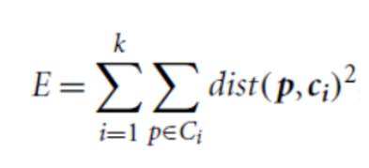
  - where E is the sum of the squared error for all objects in the data set; p is the point in space representing a given object; and ci is the centroid of cluster Ci.
The k-means partitioning algorithm
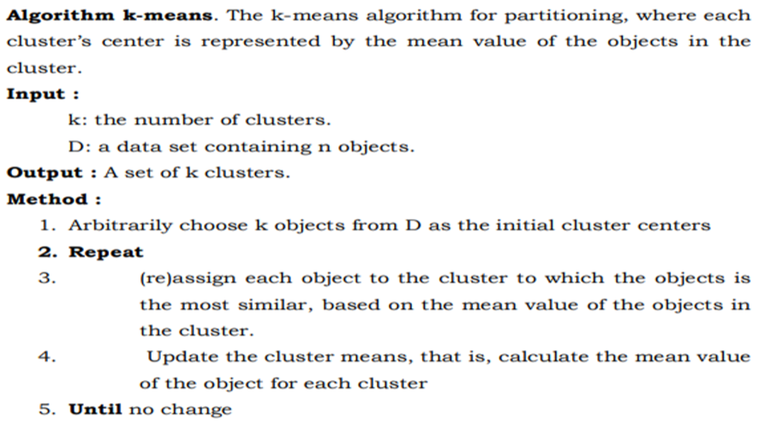
Clustering of a set of objects using the k-means method
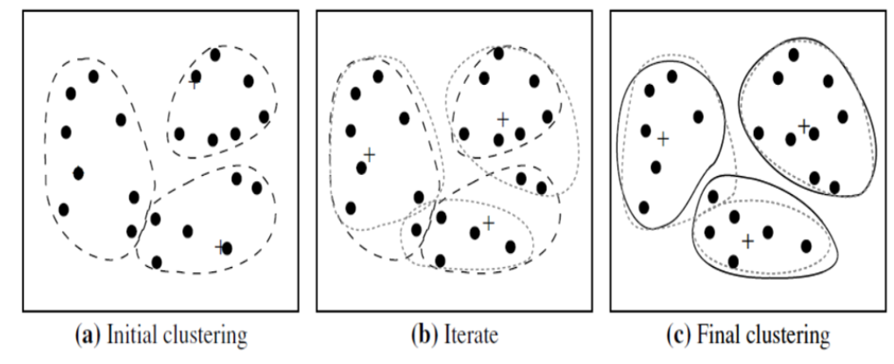
- Consider a set of objects located in 2-D space,
- Let k = 3, that is, three clusters.
- arbitrarily choose three objects as three initial cluster centers, where centers are marked by a +.
- Each object is assigned to a cluster based on the cluster center to which it is the nearest.
- The process of iteratively reassigning objects to clusters, until,
- no reassignment of the objects in any cluster occurs and so the process terminates.
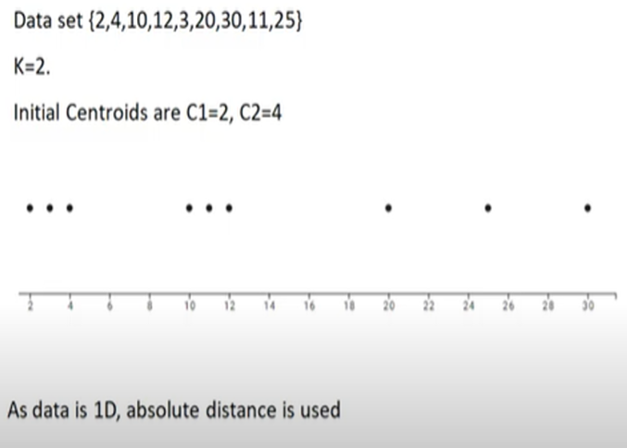
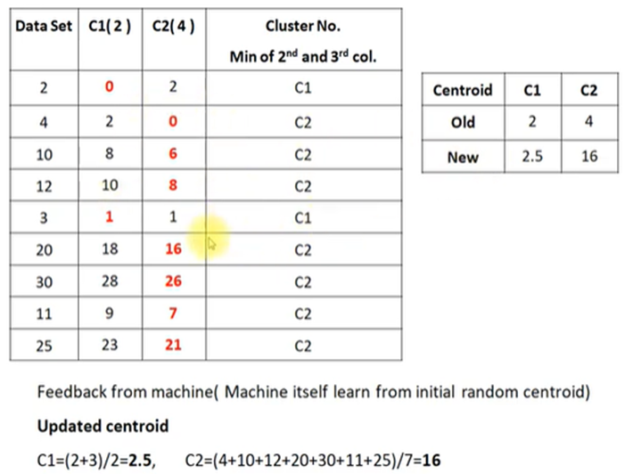
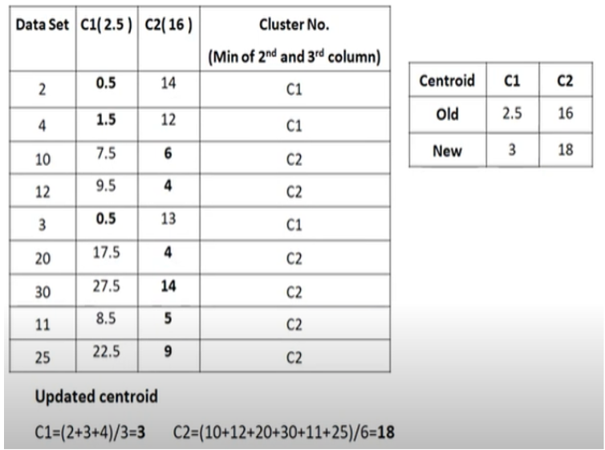

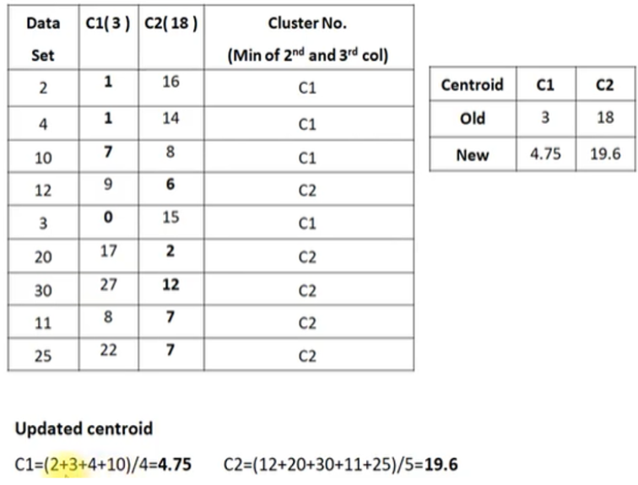
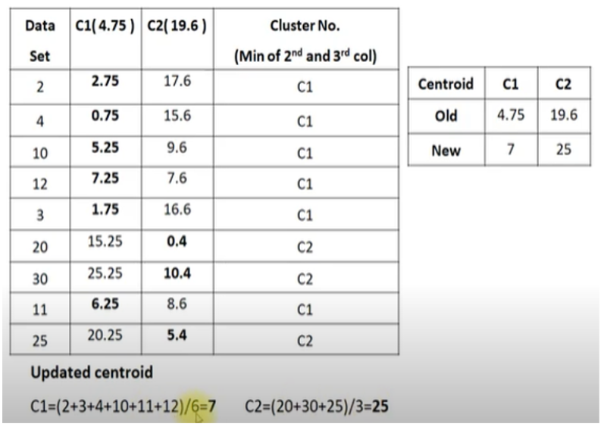

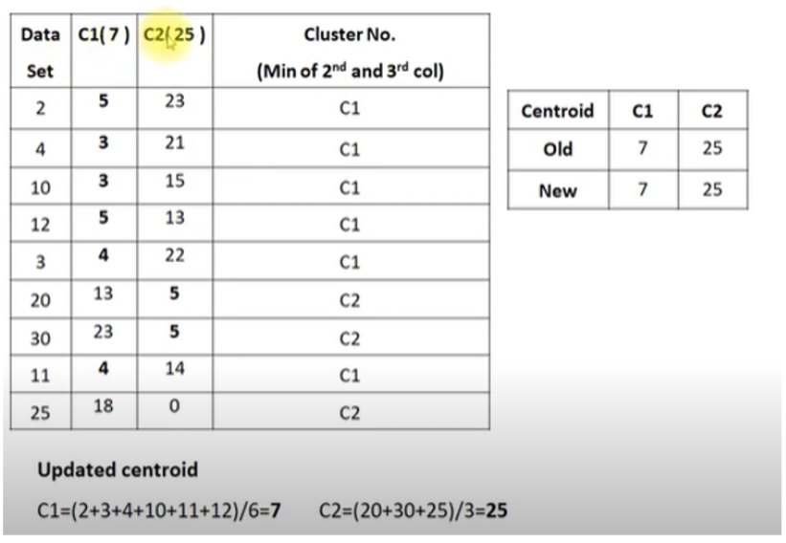
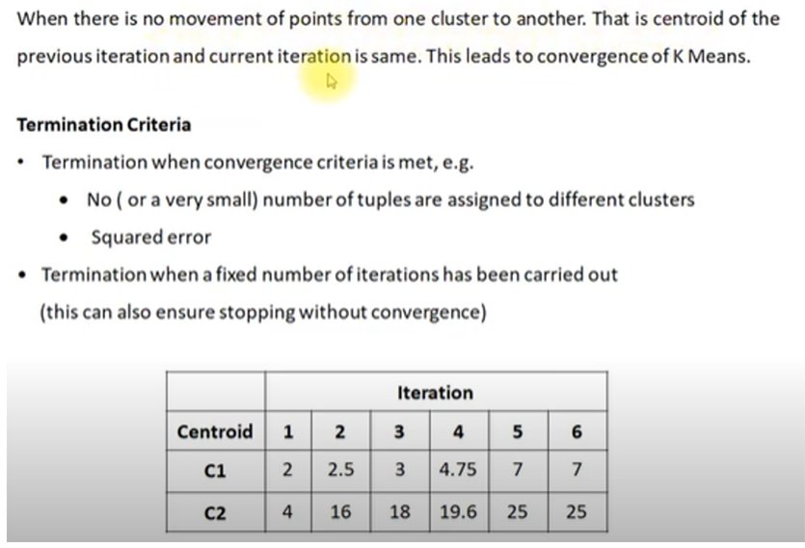
Problem-01:
  - Cluster the following eight points (with (x, y) representing locations) into three clusters:
  - A1(2, 10), A2(2, 5), A3(8, 4), A4(5, 8), A5(7, 5), A6(6, 4), A7(1, 2), A8(4, 9)
  - Initial cluster centers are: A1(2, 10), A4(5, 8) and A7(1, 2).
  - The distance function between two points a = (x1, y1) and b = (x2, y2) is defined as-
Ρ(a, b) = |x2 – x1| + |y2 – y1|
  - Use K-Means Algorithm to find the three cluster centers after the second iteration.
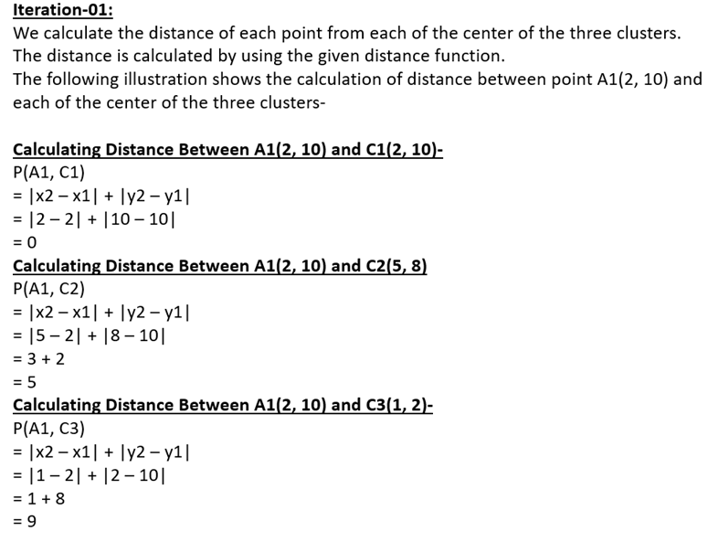
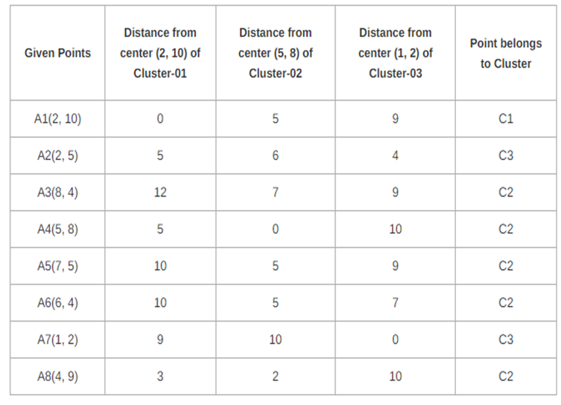
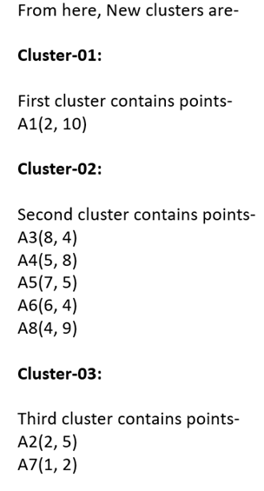
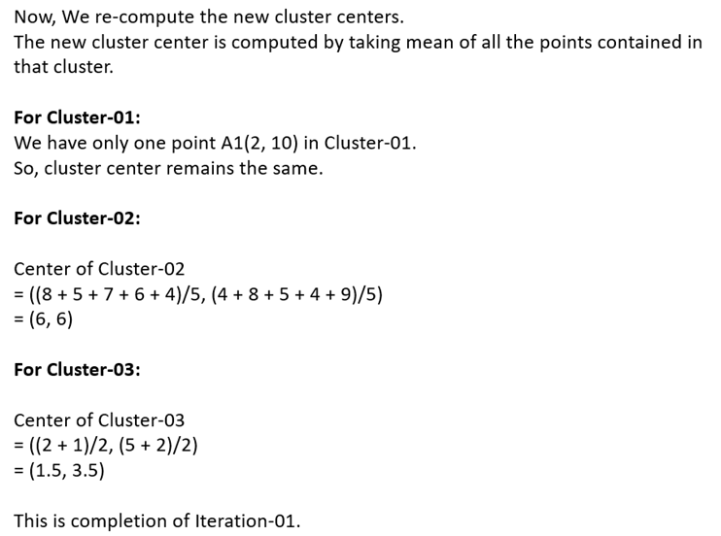
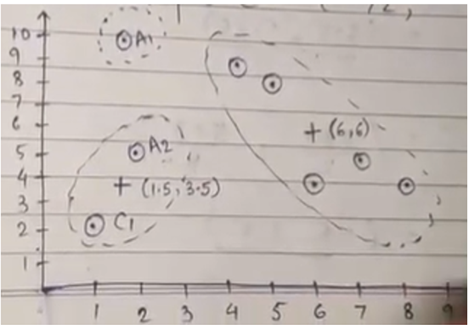

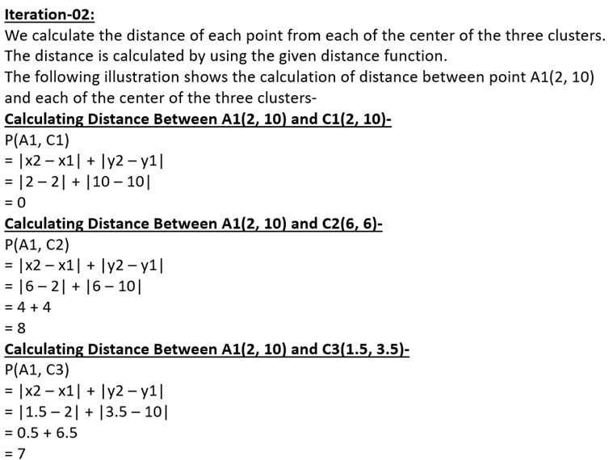

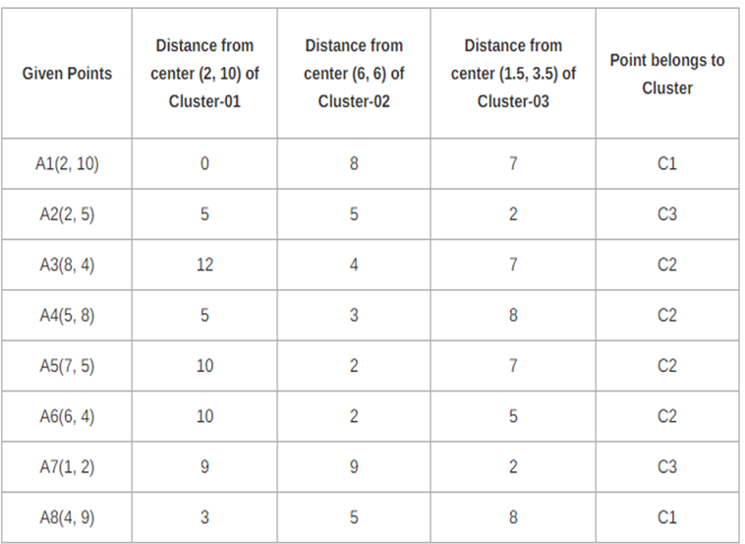
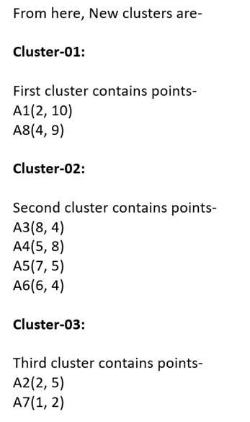
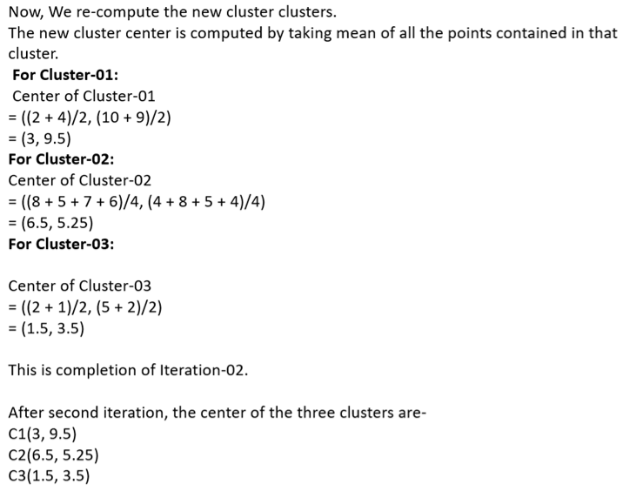
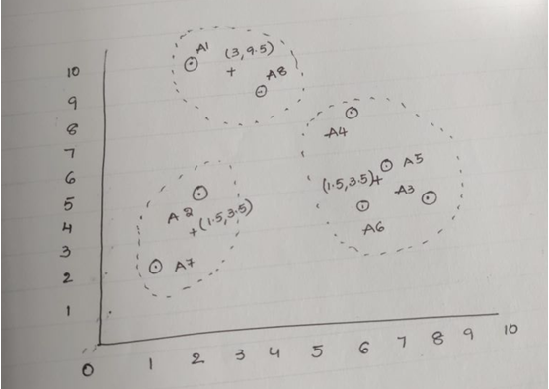
Similarity and Dissimilarity Between Objects
1) Euclidean distance
  - The most popular distance measure is Euclidean distance, which is defined as
  - where i=(xi1, xi2,.. , xin) and j =(x j1, x j2, : : : , x jn) are two n-dimensional data objects.
2) Manhattan distance OR City Block OR Taxicab
  - Another metric is Manhattan distance, defined as
Both the Euclidean distance and Manhattan distance satisfy the following mathematic
requirements of a distance function
1. d(i, j) ≥ 0 : Distance is a nonnegative number.
2. d(i, i) = 0 : The distance of an object to itself is 0.
3. d(i, j) = d( j, i) : Distance is a symmetric function.
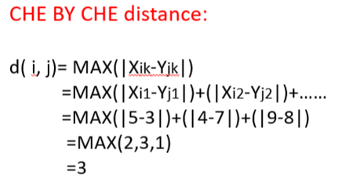
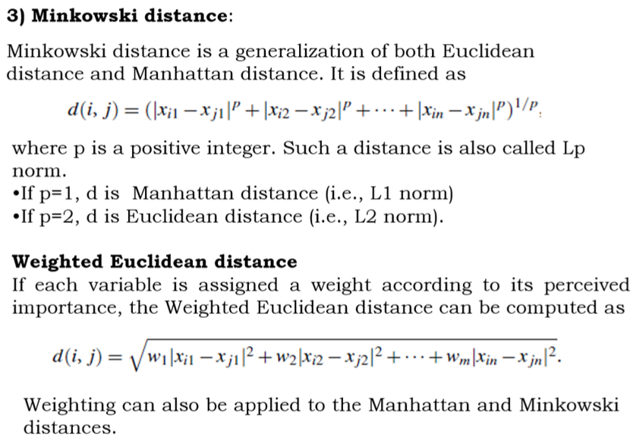
1.Given two objects represented by the tuples (23,3,42) and (20, 1, 36); Compute the Euclidean distance between the two objects
ANSWER: 7
2. Given two objects represented by the tuples (22, 1, 42, 10) and (20, 0, 36, 8); Compute the Manhattan distance between the two objects.
ANSWER: 11
3. Consider a set of five 2-dimensional points p1=(0,0), p2=(0,1), p3=(5,8),
p4=(5,7),and p5=(0,0.5). Use Euclidean distance as the distance function to find clusters
ANSWER: (p1,p2,p5)(p3,p4)
4. Consider the following table that has 5 objects (say 5 people) and for each of them we know two features (height and weight). Applying k-means clustering, We want to group them into k=2 clusters. First of all, we have to initialize the value of the centroids for our clusters. For instance, let’s choose Person 2 and Person 3 as the two centroids c1 and c2, so that c1=(120,32) and c2=(113,33).
Now, compute the Euclidian distance between each of the two centroids and the first person.
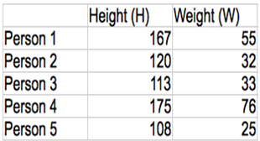
ANSWER: 52.3, 58.3
  - There are several variants of K-means to overcome its weaknesses
  - K-Medoids: resistance to noise and/or outliers
  - K-Modes: extension to categorical data clustering analysis
  - CLARA: extension to deal with large data sets
  - Mixture models (EM algorithm): handling uncertainty of clusters
5.2.2 K-means: Additional Issues
  - Outliers
- Outliers distort cluster centroids and increase SSE.
- Options: remove before clustering, detect after clustering, or keep if meaningful.
- Reducing SSE with Postprocessing
Splitting phase → divide clusters with high SSE or large spread.
Merging phase → merge clusters with close centroids or smallest SSE increase.
  - Helps escape local minima of SSE.
3.Updating Centroids Incrementally
  - Update centroids immediately after each point assignment (instead of batch update).
  - Prevents empty clusters, faster convergence, supports other objectives.
  - Order dependent, slightly more expensive.
5.2.3 Bisecting K Means
  - Normal K-means: Directly creates K clusters at once.
  - Bisecting K-means: Creates K clusters step by step by splitting one cluster into two at a time.
  - Think of it like cutting a big cake into smaller slices one by one .
Step-by-Step Process:
1.Start with one big cluster
  - Put all data points together.
2.Choose a cluster to split
Usually, we pick:
  - the largest cluster (most points), or
  - the one with highest SSE (most spread out),
  - or based on a mix of both.
3.Split the chosen cluster into 2 clusters using K-means
  - But since K-means can give different results based on initialization,
→ we run it several times (trial runs).
  - Select the split that has the lowest SSE (best quality).
4.Replace the original cluster with these 2 new clusters.
5.Repeat steps 2–4 until we have exactly K clusters.

Advantages of Bisecting K-means:
- Less sensitive to initialization (because at each step we only need to find 2 clusters, which is easier than finding many at once).
- More accurate clusters (due to trial splits and choosing the best one).
- Hierarchical flavor (since we keep splitting clusters, it forms a tree-like structure).
Example (Suppose we want K = 4):
Step 1: Start with all data points in one cluster.
Step 2: Split into 2 clusters → Now we have 2 clusters.
Step 3: Pick the cluster with more spread (high SSE) and split it → Now we have 3 clusters.
Step 4: Pick another large/spread cluster and split it → Now we have 4 clusters
Final result = 4 clusters.
  - Instead of finding all clusters at once (like K-means), Bisecting K-means keeps splitting clusters until we get the required number.
5.3 AGGLOMERATIVE HIERARCHICAL CLUSTERING
Hierarchical Methods
  - A hierarchical clustering method works by grouping data objects into a hierarchy or “tree” of clusters.
  - Representing data objects in the form of a hierarchy is useful for data summarization.
  - For example, as the manager of human resources at AllElectronics you may organize your employees into major groups such as managers, and staff.
Hierarchical methods can be categorized into two types
1. Agglomerative Clustering method
2. Divisive Clustering method
Agglomerative versus Divisive Hierarchical Clustering:
  - A hierarchical clustering method can be either agglomerative or divisive, depending on whether the hierarchical decomposition is formed in a bottom-up (merging) or top-down (splitting) fashion.
Agglomerative hierarchical clustering method:
  - It uses a bottom-up strategy.
  - It typically starts by letting each object form its own cluster
  - It iteratively merges clusters into larger clusters, until all the objects are in a single cluster .
  - For the merging step, it finds the two clusters that are closest to each other (according to some similarity measure), and combines the two to form one cluster.
Divisive hierarchical clustering method :

  - It employs a top-down strategy.
  - It starts by placing all objects in one cluster, which is the hierarchy’s root.
  - It then divides the root cluster into several smaller sub clusters, and recursively partitions those clusters into smaller ones.
  - The partitioning process continues until each cluster at the lowest level ie containing only one object
  - In either agglomerative or divisive hierarchical clustering, a user can specify the desired number of clusters as a termination condition.
Example Agglomerative versus divisive hierarchical clustering.
  - AGNES (AGglomerative NESting), an agglomerative hierarchical clustering method,
  - DIANA (DIvisive ANAlysis), a divisive hierarchical clustering method, on a data set of five objects, (a, b, c, d, e).
  - Agglomerative and divisive hierarchical clustering on data objects (a,b, c,d, e)
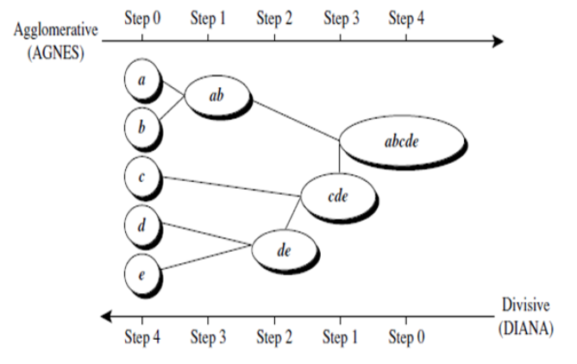
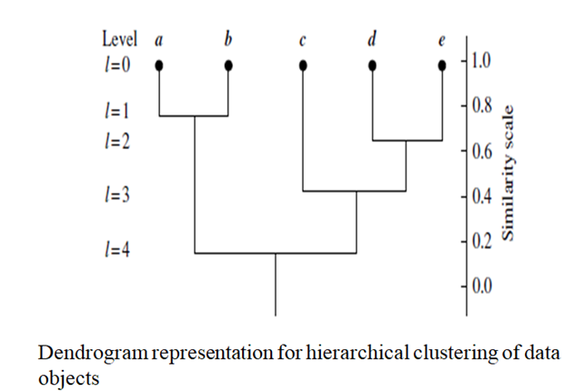
5.3.1 Basic Idea of Agglomerative Hierarchical Clustering
  - Start: Each data point is its own cluster.
  - Step: Repeatedly merge the two closest clusters.
  - End: Continue until only one cluster remains (a hierarchy/tree is formed).
- This process creates a dendrogram (tree diagram), showing how clusters were merged.
Algorithm (Steps)
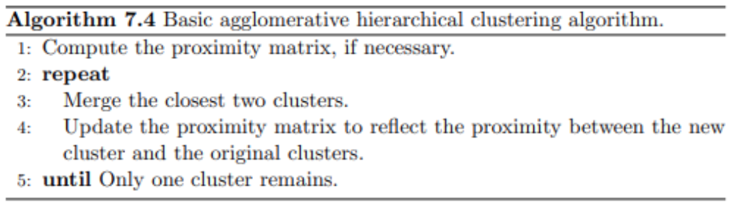
How to Measure “Proximity” Between Clusters
This is the key difference between methods:
1.Single Link (MIN) → distance between the closest two points of different clusters.
  - Can create “chained” clusters.
  - Graph analogy: shortest edge between two groups.
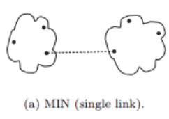
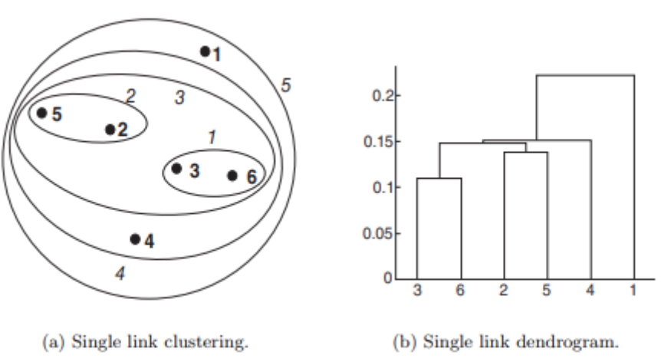
Figure : Single link clustering
2.Complete Link (MAX) → distance between the farthest two points of different clusters.
  - Creates more compact clusters.
  - Graph analogy: longest edge between two groups
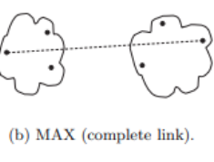
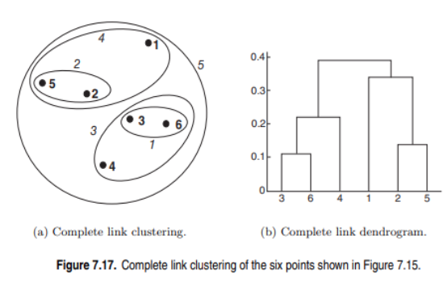
3.Group Average → average of all pairwise distances between points in different clusters.
  - Balanced between Single & Complete link.
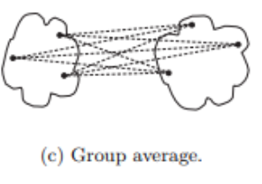
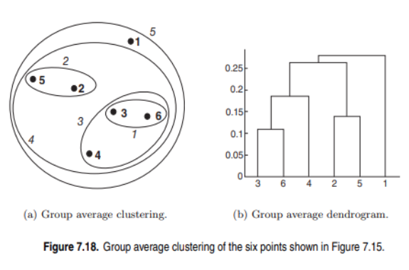
4.Centroid Method → distance between cluster centroids.
5.Ward’s Method → increase in SSE (sum of squared errors) if two clusters are merged.
  - Tries to minimize total variance.
  - Similar in spirit to K-means.
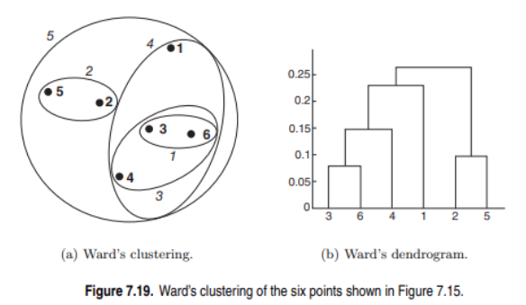

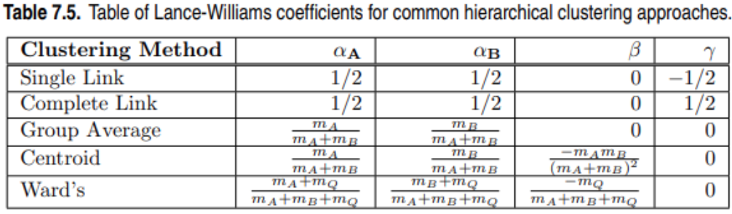
Time & Space Complexity
  - Space: Need to store proximity matrix → O(m²).
  - Time:
    - Naive: O(m³).
    - With efficient data structures: O(m² log m).
  - Limitation: Not good for very large datasets.
  - Agglomerative hierarchical clustering = bottom-up merging.
  - Different methods (Single, Complete, Average, Centroid, Ward’s) define cluster “distance” differently.
  - Result =dendrogram (hierarchical tree).
5.4 DBSCAN
Density-Based Clustering (DBSCAN
  - DBSCAN (Density-Based Spatial Clustering of Applications with Noise) finds core objects, that is, objects that have dense neighborhoods.
  - It connects core objects and their neighborhoods to form dense regions as clusters.
  - A user-specified parameter Є > 0 is used to specify the radius of a neighborhood we consider for every object.
  - The -neighborhood of an object o is the space within a radius centered at o.
  - The density of a neighborhood can be measured by the number of objects in the neighborhood.
  - DBSCAN uses another user-specified parameter, MinPts, which specifies the density threshold of dense regions.
  - An object is a core object if the -neighborhood of the object contains at least MinPts objects.
Example Density-reachability and density-connectivity.
  - Consider Figure for a given represented by the radius of the circles, and, say, let MinPts is 3.
  - Of the labeled points, m,p,o, r are core objects because each is in an Є–neighborhood containing at least three points.
  - Object q is directly density-reachable from m. Object m is directly density-reachable from p and vice versa.
  - Similarly, r and s are density-reachable from o and o is density-reachable from r.
  - Thus, o, r, and s are all density-connected
Density-reachability and density-connectivity
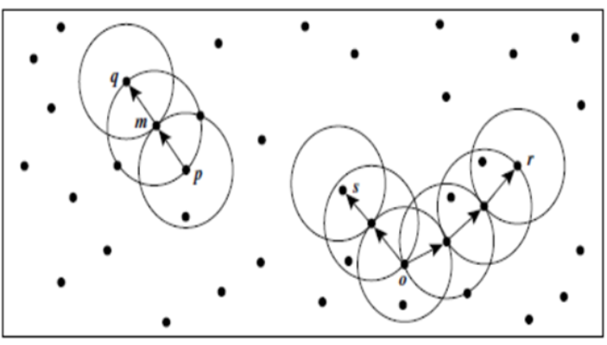

5.4.1 Traditional Density Center-Based Approach
  - DBSCAN is built on the center-based definition of density.
  - To measure the density around a point:
    - Draw a circle of radius Eps (ε) around the point.
    - Count how many points fall inside this circle (including the point itself).
  - That count = Density of the point.
Example
  - Suppose Point A has 7 points (including itself) within its Eps radius → Density(A) = 7.
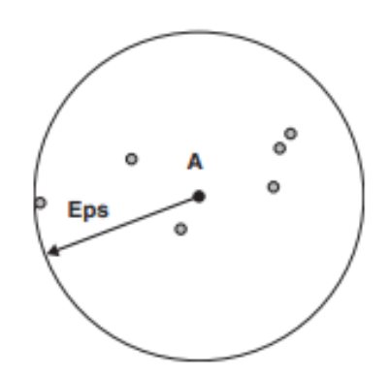
Figure : Center-based density.
Classification of Points According to Center-Based Density
DBSCAN divides points into 3 categories:
1. Core Point
  - If a point has at least MinPts neighbors within its Eps radius.
Example: Point A in the diagram.
  - These are at the center of dense regions.
2. Border Point
  - Has fewer than MinPts neighbors,
  - But lies within the neighborhood of a core point.
Example: Point B.
3. Noise Point (Outlier)
  - Not a core point, not in the neighborhood of any core point.
Example: Point C.
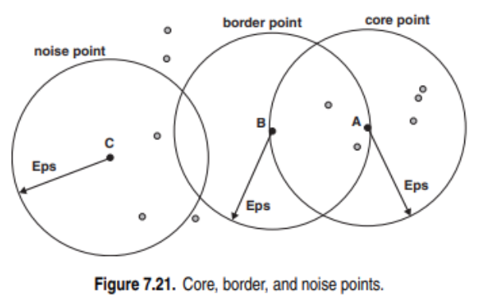
5.4.2 DBSCAN Algorithm
  - DBSCAN = Density-Based Spatial Clustering of Applications with Noise.
  - It groups together points that are closely packed (high density) and marks points in sparse regions as noise.
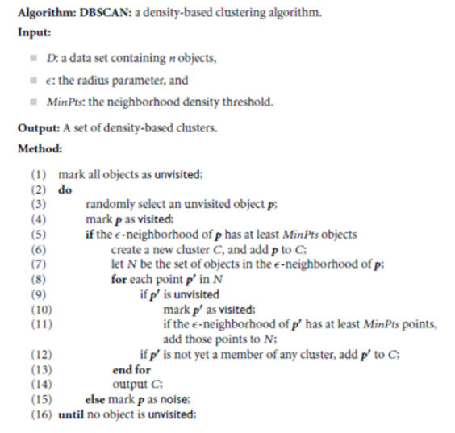
Working Steps (Algorithm 7.5)
1.Label all points as:
Core ,Border ,Noise(based on Eps and MinPts)
2.Eliminate noise points.
3.Connect core points:
  - If two core points are within Eps distance → put them in the same cluster.
4.Form clusters:
  - Each connected group of core points = one cluster.
5.Assign border points to a nearby core point’s cluster.
Selection of DBSCAN Parameters (Eps & MinPts)
  - DBSCAN depends heavily on two parameters:
    - Eps (ε): Radius of neighborhood.
    - MinPts: Minimum number of points needed inside Eps to form a cluster.
  - Choosing them properly is very important, otherwise DBSCAN may merge clusters or misclassify noise.
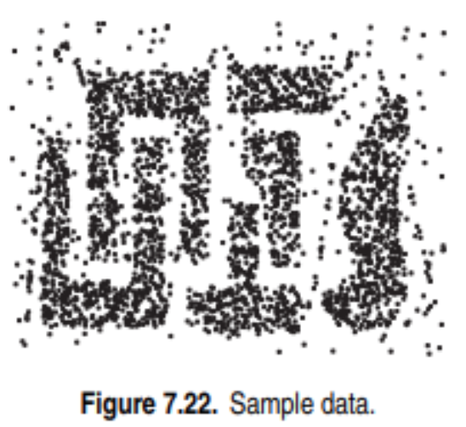
Example (from book)
  - Data set = 3000 points.
  - MinPts = 4.
  - Plot the 4th nearest neighbor distances.
  - At the knee of the curve (Figure 7.23), the distance sharply increases.
  - That value ≈ Eps = 10.
So, parameters chosen:
  - Eps = 10
  - MinPts = 4
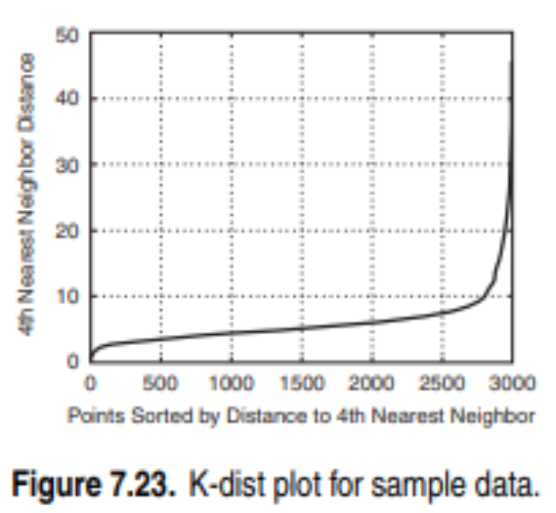
How to Choose MinPts
  - Small MinPts (like 2 or 3) → even random noise points can form clusters (bad).
  - Large MinPts → small clusters may be lost (they will be marked as noise).
  - A good rule of thumb:
    - MinPts = dimensionality + 1 (for low dimensions).
    - Commonly 4 is used in 2D data.
Problem with Varying Density
  - DBSCAN works well if clusters have similar density.
  - If cluster densities vary a lot, it struggles:
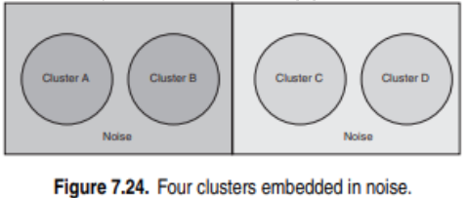
Example :
Clusters A & B are dense.
Clusters C & D are less dense.
  - If Eps is set small enough to detect C and D → A & B may merge.
  - If Eps is set large enough to separate A & B → C and D may vanish into noise.
Summary
  - Use k-distance plot to choose Eps.
  - MinPts = small number (like 4 in 2D), but not too small.
  - DBSCAN struggles when clusters have very different densities.
Example: With Eps=10, MinPts=4, DBSCAN can detect meaningful clusters in large datasets.
Example in Action
  - Dataset = 3000 points.
  - Using Eps = 10, MinPts = 4 → DBSCAN found 4 clusters + noise.
  - Output (Figure 7.25):
  - Core points in the middle.
  - Border points around them.
  - Noise points outside.
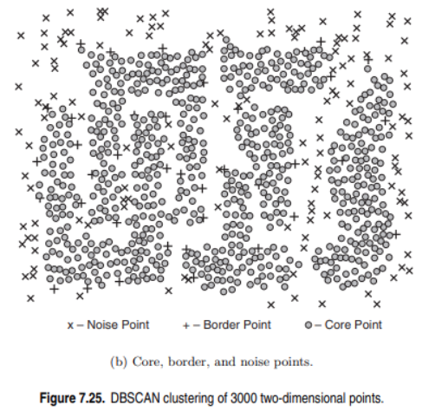

MCQ’S
- Cluster analysis is primarily used for:
a) Classification
b) Grouping similar objects
c) Regression
d) Prediction
Answer: b) Grouping similar objects
- Which of the following is not a goal of cluster analysis?
a) Market segmentation
b) Data summarization
c) Predicting future values
d) Outlier detection
Answer: c) Predicting future values
- Which of the following is a partitional clustering method?
a) DBSCAN
b) K-means
c) Agglomerative clustering
d) Divisive clustering
Answer: b) K-means
- Hierarchical clustering produces:
a) Flat partitions only
b) Nested clusters in a tree structure
c) Only spherical clusters
d) Clusters based on regression lines
Answer: b) Nested clusters in a tree structure
- Density-based clusters are useful for:
a) Detecting clusters of arbitrary shapes
b) Only circular clusters
c) High-dimensional data always
d) Regression tasks
Answer: a) Detecting clusters of arbitrary shapes
- Which cluster type is most suitable for overlapping groups?
a) Well-separated clusters
b) Fuzzy clusters
c) Center-based clusters
d) Contiguous clusters
Answer: b) Fuzzy clusters
- In K-means, the distance is usually calculated using:
a) Cosine similarity
b) Euclidean distance
c) Hamming distance
d) Manhattan distance only
Answer: b) Euclidean distance
- The K in K-means refers to:
a) Number of attributes
b) Number of clusters
c) Number of iterations
d) Number of data points
Answer: b) Number of clusters
- K-means is sensitive to:
a) Initial cluster centers
b) Dimensionality reduction
c) PCA
d) Standard deviation
Answer: a) Initial cluster centers
- Which problem occurs if clusters vary in size or density?
a) Empty clusters
b) Misclassification by K-means
c) Faster convergence
d) Perfect separation
Answer: b) Misclassification by K-means
- Bisecting K-means is a variant of K-means that:
a) Merges smaller clusters
b) Splits clusters recursively
c) Uses density estimation
d) Uses fuzzy membership
Answer: b) Splits clusters recursively
- Which advantage does Bisecting K-means have over traditional K-means?
a) Always finds global optimum
b) Handles overlapping clusters
c) Produces better hierarchical structure
d) Requires no distance metric
Answer: c) Produces better hierarchical structure
- Agglomerative clustering starts with:
a) One big cluster containing all data
b) Each data point as a separate cluster
c) Random cluster centers
d) Predefined number of clusters
Answer: b) Each data point as a separate cluster
- The result of hierarchical clustering is typically visualized using:
a) Confusion matrix
b) Dendrogram
c) Scatter plot only
d) Regression line
Answer: b) Dendrogram
- Density-based approaches define a cluster as:
a) Group of points closest to a centroid
b) Region of high point density separated by low density
c) Only circular boundaries
d) Regression function output
Answer: b) Region of high point density separated by low density
- In density-based clustering, which is important?
a) Number of classes
b) Density threshold
c) Initial centroids
d) Gradient descent
Answer: b) Density threshold
- DBSCAN requires two parameters:
a) K and max_iter
b) Eps and MinPts
c) Mean and variance
d) Precision and recall
Answer: b) Eps and MinPts
- DBSCAN classifies points into:
a) Centroids and non-centroids
b) Core points, border points, noise
c) Parents and children
d) Train and test
Answer: b) Core points, border points, noise
- A major strength of DBSCAN is:
a) Does not require specifying number of clusters
b) Works best only on circular clusters
c) Requires centroids initialization
d) Faster than K-means always
Answer: a) Does not require specifying number of clusters
- A weakness of DBSCAN is:
a) Cannot detect noise
b) Sensitive to parameter selection (Eps, MinPts)
c) Cannot handle arbitrary shapes
d) Works only for 1D data
Answer: b) Sensitive to parameter selection

