UNIT–1
DATA WAREHOUSING AND ONLINE ANALYTICAL PROCESSING
Basic concepts, Data Warehouse Modeling: Data Cube and OLAP, Data Warehouse Design and Usage, Data Warehouse Implementation, Cloud Data Warehouse, Data Mining and Patten Mining, Technologies, Applications, Major issues, Data Objects & Attribute Types, Basic Statistical Descriptions of Data, Data Visualization, Measuring Data Similarity and Dissimilarity.
1.1 BASIC CONCEPTS: Data Warehousing and Online Analytical Processing (OLAP)
1.1.1 What Is a Data Warehouse?
  - Data warehousing provides architectures and tools for business executives to systematically organize, understand, and use their data to make strategic decisions.
  - Data repository maintained separately from an organization’s operational databases.
Definition
“A data warehouse is a subject-oriented, integrated, time-variant, and nonvolatile collection of data in support of management’s decision making process” .
Subject-oriented:
- A data warehouse is organized around major subjects such as customer, supplier, product, and sales.
- Rather than concentrating on the day-to-day operations and transaction processing of an organization.
- a data warehouse focuses on the modeling and analysis of data for decision makers.

Integrated:
A data warehouse is usually constructed by integrating multiple heterogeneous sources, such as relational databases, flat files, and online transaction records.
Time-varient:
Data are stored to provide information from an historic perspective (e.g., the past 5–10 years).
Nonvolatile:
- A data warehouse is a physically separate store of data transformed from the application data found in the operational environment.
- Due to this separation, a data warehouse does not require transaction processing, and recovery.
- It usually requires only two operations in data accessing: initial loading of data and access of data.
1.1.2 Differences between Operational Databases Systems and Data Warehouses
1.OLTP (on-line transaction processing)
  - DBMS is to perform online transaction and query processing.
  - Day-to-day operations:
  - purchasing,banking,manufacturing,registration,acounting, etc.
2. OLAP (on-line analytical processing)
  - organize and present data in various formats to fulfill diverse needs of different users.
  - Data analysis and decision making
Users and system orientation:
  - An OLTP system is customer-oriented and is used for transaction and query processing by clerks, clients, and IT professionals.
  - An OLAP system is market-oriented and is used for data analysis by knowledge workers, including managers, executives, and analysts.
Data contents:
  - An OLTP system manages current data which is too detailed to be easily used for query processing.
  - An OLAP system manages large amounts of historic data, provides facilities for summarization and aggregation, and stores and manages information at different levels of granularity.
Database design:
  - An OLTP system usually adopts an entity-relationship (ER) data model and an application-oriented database design.
  - An OLAP system typically adopts either a star or a snowflake model.
Users and system orientation:
  - An OLTP system is customer-oriented and is used for transaction and query processing by clerks, clients, and IT professionals.
  - An OLAP system is market-oriented and is used for data analysis by knowledge workers, including managers, executives, and analysts.
Data contents:
- An OLTP system manages current data which is too detailed to be easily used for query processing.
- An OLAP system manages large amounts of historic data, provides facilities for summarization and aggregation, and stores and manages information at different levels of granularity.
Database design:
- An OLTP system usually adopts an entity-relationship (ER) data model and an application-oriented database design.
- An OLAP system typically adopts either a star or a snowflake model.

View:
  - An OLTP system focuses mainly on the current data within an enterprise or department, without referring to historic data or data in different organizations.
Access patterns:
  - An OLTP system consist mainly of short , atomic transactions. Such a system requires concurrency control and recovery mechanisms.
- OLTP Vs OLAP

1.1.3 Data Warehousing: A Multi-tiered Architecture
  - Data warehouses often adopt a three-tier architecture, as presented in Figure
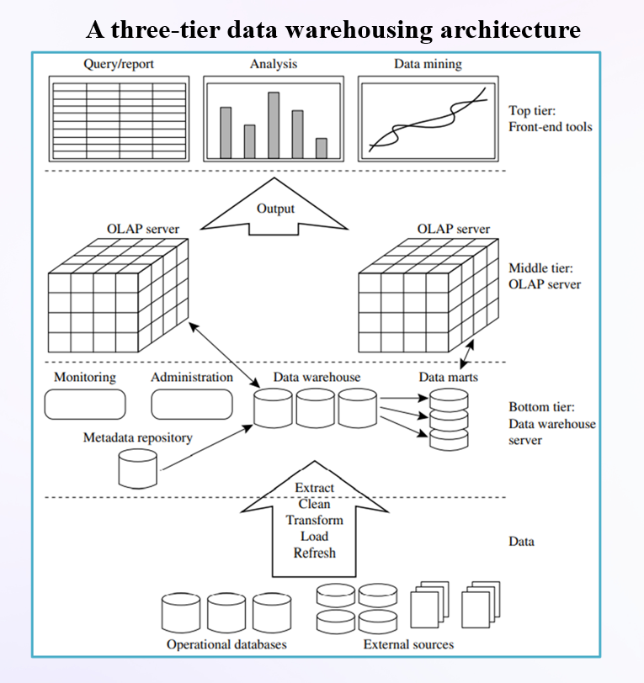

1. bottom tier
  - This is a warehouse database server which is like a relational database system.
  - Back-end tools are used to feed data into the bottom tier from operational databases
  - The data are extracted using application program interfaces known as gateways.
  - A gateway is supported by the DBMS and allows client programs to generate SQL code to be executed at a server.
  - Examples of gateways: (given by Microsoft)
–ODBC (Open Database Connection)
  - This tier also contains a metadata repository
2. The middle tier is an OLAP server that is typically implemented using either
  - a relational OLAP(ROLAP) model (i.e., an extended relational DBMS that maps operations on multidimensional data to standard relational operations);
Or
  - a multidimensional OLAP (MOLAP) model (i.e., a special-purpose server that directly implements multidimensional data).
3. The top tier is a front-end client layer, which contains query and reporting tools,analysis tools, and/or data mining tools.
1.1.4 Data Warehouse Models: Enterprise Warehouse, Data Mart, and Virtual Warehouse
Enterprise Data Warehouse (EDW):
  - A centralized warehouse that collects and integrates data from across the entire organization. It supports cross-functional analysis and stores both detailed and summarized data.
Data Mart:
  - A subset of a data warehouse focused on a specific business area or department (e.g., sales, marketing). It contains summarized data relevant to its users.

Virtual Warehouse:
  - A set of views created over operational databases that provide a virtual data warehouse without physically storing the data. Only some views may be materialized for performance.
1.2 DATA WAREHOUSE MODELLING: DATA CUBE AND OLAP
1.2.1 DATA WAREHOUSE MODELLING: DATA CUBE AND OLAP
What is a data cube?
  - A data cube allows data to be modeled and viewed in multiple dimensions.
  - It is defined by dimensions and facts.
  - In general terms, dimensions are the entities with respect to which an organization wants to keep records.
  - Each dimension may have a table associated with it, called a dimension table.
  - A multidimensional data model is typically organized around a central theme, such as sales.
  - This theme is represented by a fact table. Facts are numeric measures.
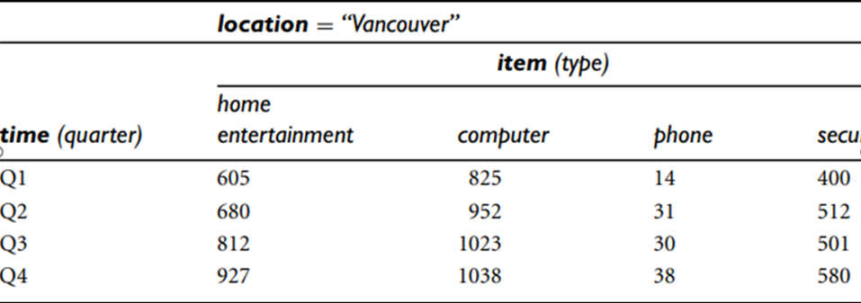
It is 2-D view of sales data for AllElectronics where dimensions(time and item); measure(dollars_sold(in thousands))
Now, suppose that we would like to view the sales data with a third dimension

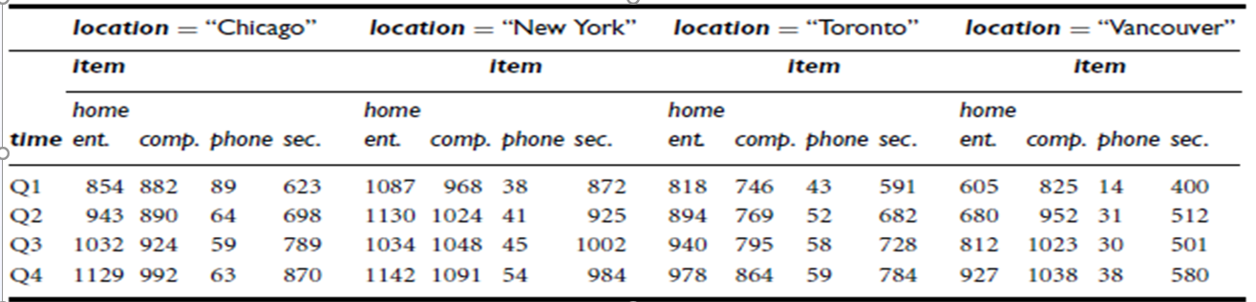
3-D Data cube: 3-D View of Sales Data for AllElectronics According to time, item, and location
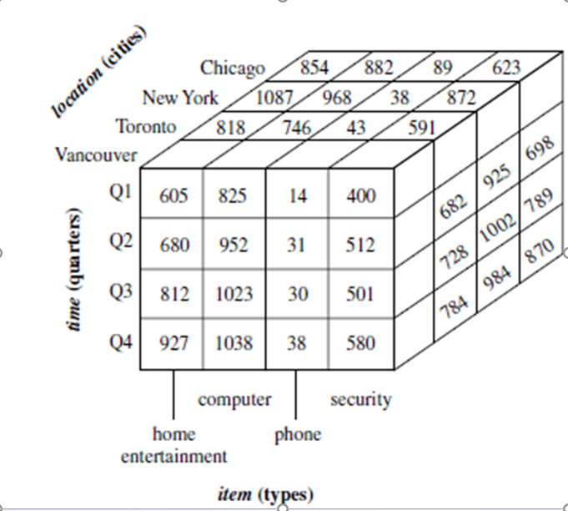
Suppose that we would now like to view our sales data with an additional fourth dimension, such as supplier.
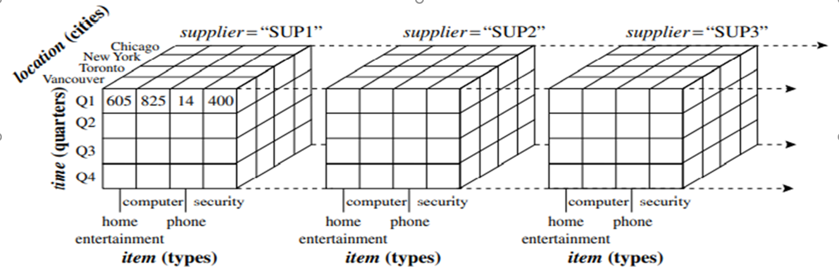

  - Given a set of dimensions, we can generate a cuboid for each of the possible subsets of the given dimensions.
  - The result would form a lattice of cuboids, each showing the data at a different level of summarization.
  - The cuboid that holds the lowest level of summarization is called the "base cuboid“.
  - The 0-D cuboid, which holds the highest level of summarization, is called the "apex cuboid".
- Lattice of cuboids with 4D data cube

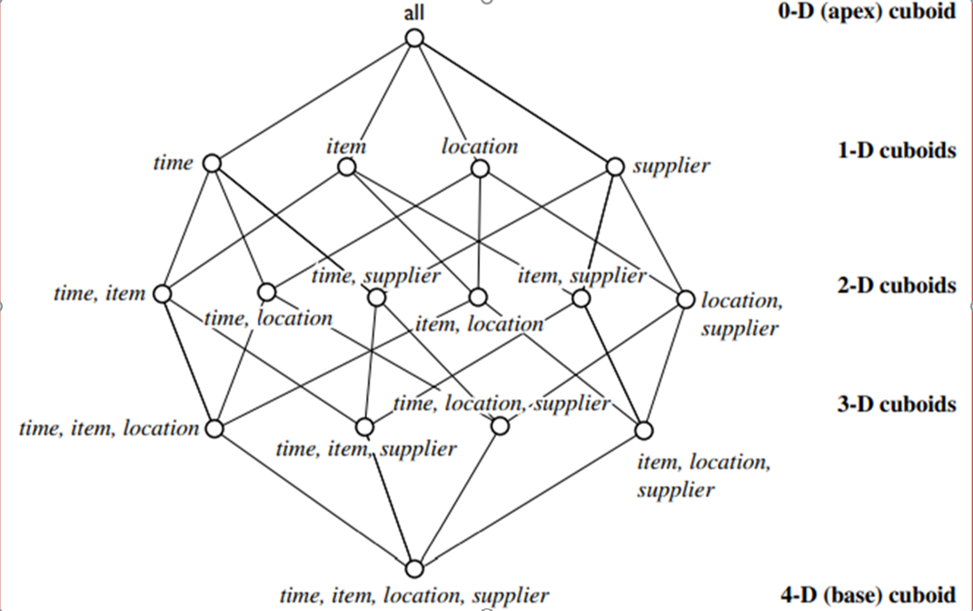
1.2.2 Star, SnowFlakes, Fact Constellation Schemas for Multidimensional
Such a model can exist in the form of
1) star schema
2) snowflake schema
3) fact constellation schema.

1.Star schema: the data warehouse contains
- A large central table (fact table) containing the bulk of the data(key and measures)
- And a set of smaller dimension tables, one for each dimension.
- And each dimension table is joined to the fact table using primary key
- It is called a Star Schema because the entity relationship diagram of schema resembles a star, with points radiating from central table.
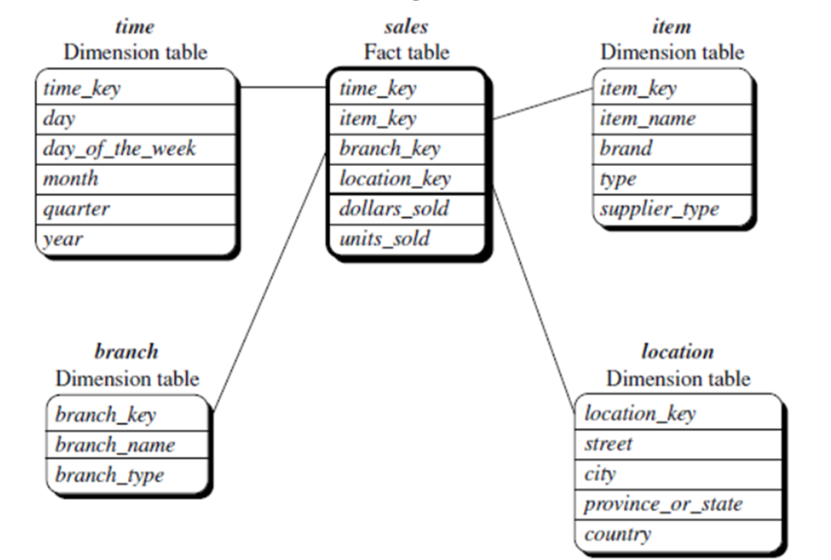
figure : Star schema of sales data warehouse.
- A star schema for AllElectronics sales :Sales are considered along four dimensions: time, item, branch, and location.
- The schema contains a central fact table for sales that contains keys to each of the four dimensions, along with two measures: dollars sold and units sold.
Snowflake schema:
  - The snowflake schema is a variant of the star schema model, where some dimension tables are normalized, thereby further splitting the data into additional tables.
  - The resulting schema graph forms a shape similar to a snowflake..
  - The Snow flaking is only effecting the dimensional tables.

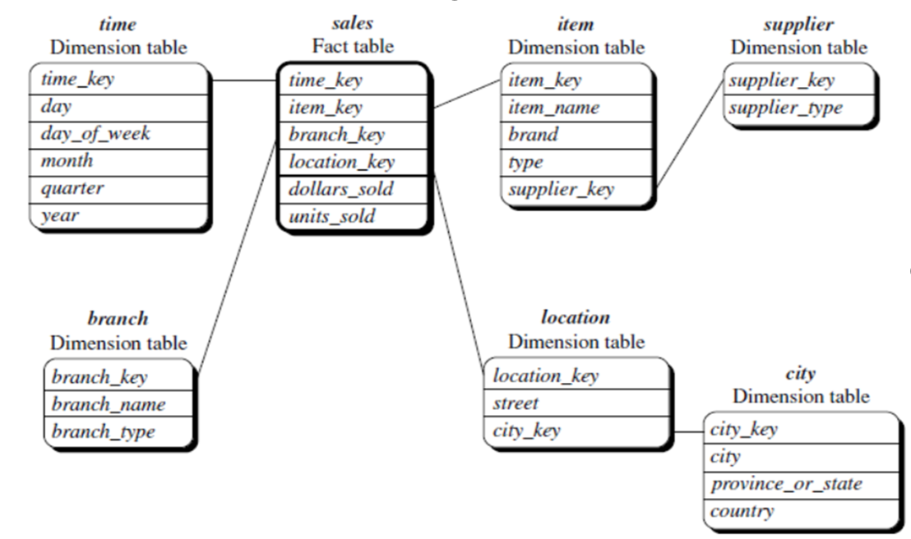
Figure: Snowflake schema of a sales data warehouse.
Fact constellation:
- Sophisticated applications may require multiple fact tables to share dimension tables.
- This kind of schema can be viewed as a collection of stars, and hence is called a galaxy schema or a fact constellation.
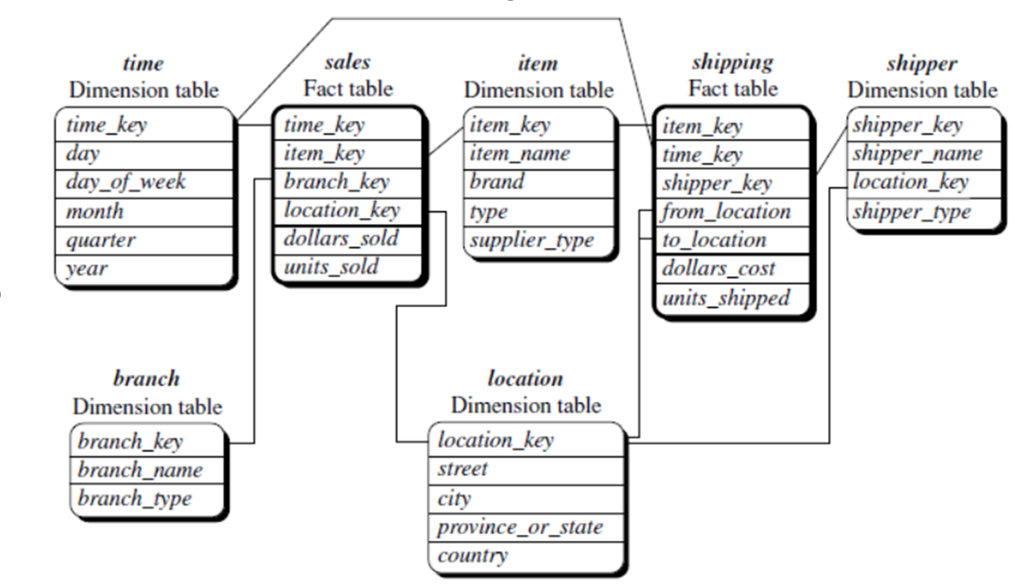
Figure : Fact constellation schema of a sales and shipping data warehouse.
1.2.3 Dimensions: The role of Concept Hierarchies
  - concept hierarchy defines a sequence of mappings from a set of low-level concepts to higher-level, more general concepts.
  - For ex, concept hierarchy for the dimension location, mapping a set of low level concepts (i.e., cities) to higher level, more general concepts (i.e., countries).
  - Concept hierarchies allow data to be handled at varying levels of abstraction.
  - Consider a concept hierarchy for the dimension location.
  - City values for location include Vancouver, Montreal, New York, and Chicago.
  - Each city, however, can be mapped to the state.
  - For example, Vancouver can be mapped to British Columbia, and Chicago to Illinois.
  - The states can in turn be mapped to the country to which they belong, such as Canada or the USA.
- A concept hierarchy for location
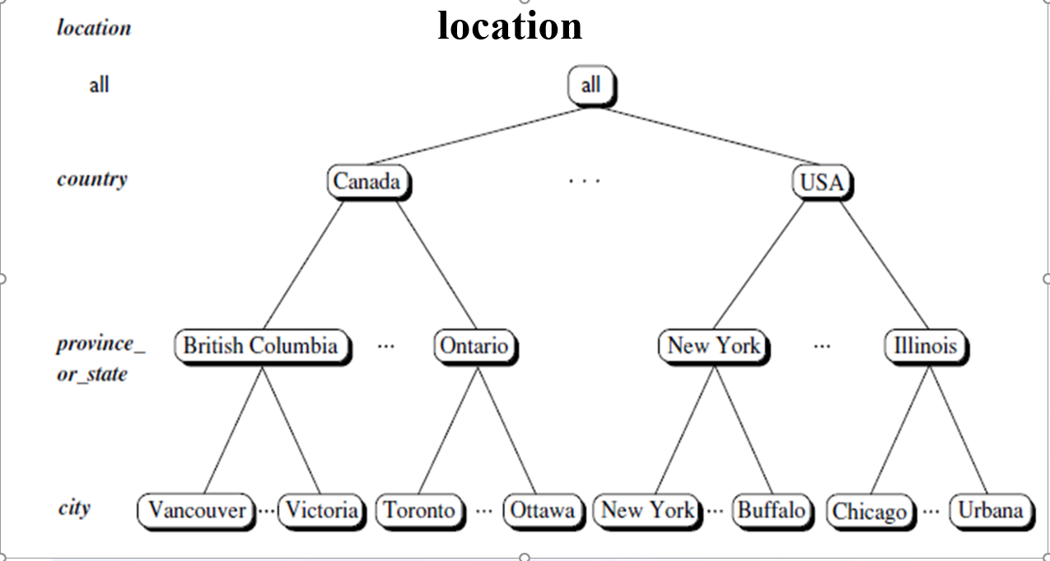
  - For example, suppose that the dimension location is described by the attributes number, street, city, state, zip code and country.
  - These attributes are related by a total order, forming a concept hierarchy such as
“street < city < province or state < country”
  - the attributes of a dimension may be organized in a partial order, forming a lattice.
  - An example of a partial order for the time dimension based on the attributes day, week, month, quarter, and year is
“day <month < quarter; week < year.”
  - the attributes of a dimension may be organized in a partial order, forming a lattice.
  - An example of a partial order for the time dimension based on the attributes day, week, month, quarter, and year is
“day <month < quarter; week < year.”
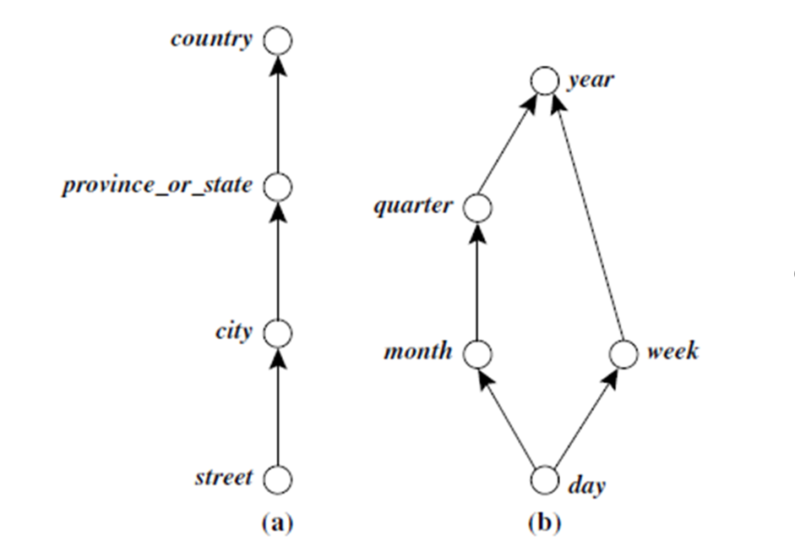
(a) a hierarchy for location and (b) a lattice for time.
  - Concept hierarchies may also be defined by discretizing or grouping values for a given dimension or attribute, resulting in a set-grouping hierarchy.
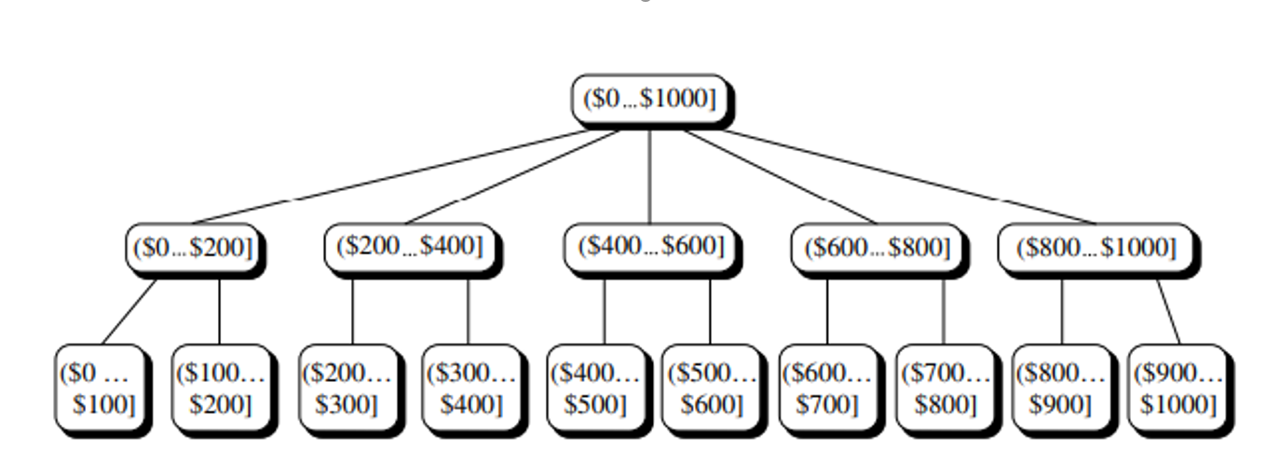
Figure : A concept hierarchy for price.
  - The full range ($0…$1000] is recursively divided into smaller intervals.
  - First, it is split into equal-width bins, such as ($0…$200], ($200…$400], etc.
  - Each of these bins is further divided, for example, ($0…$200] is split into:
  - ($0…$100], ($100…$200], and so on.
  - This forms a multi-level hierarchy used in data cube construction, OLAP roll-up/drill-down, or quantization for mining and analysis.
  - OLAP provides a user-friendly environment for interactive data analysis
  - OLAP operations on multidimensional data are
1)Roll-up
2)Drill-down
3)Slice and dice
4)Pivot(rotate)

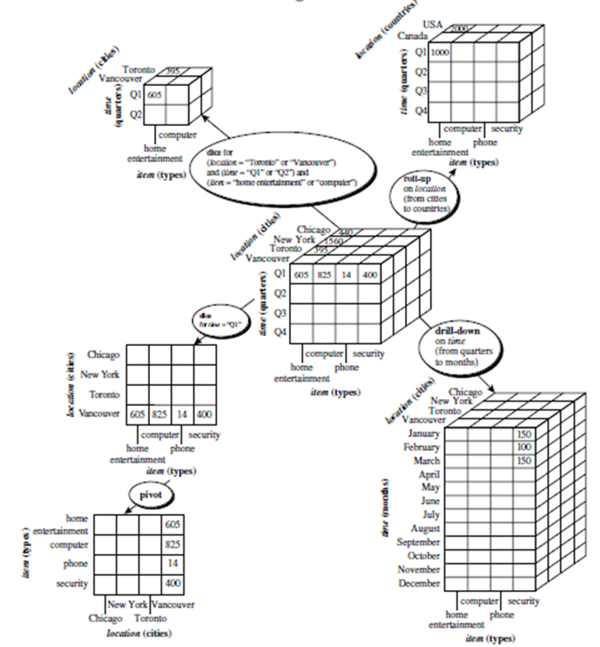
OLAP Operations on Multidimensional Data
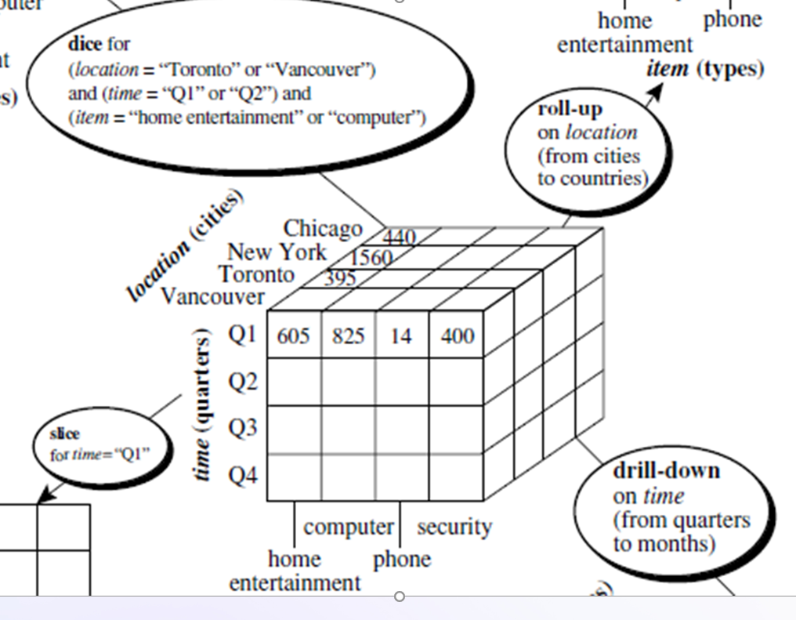
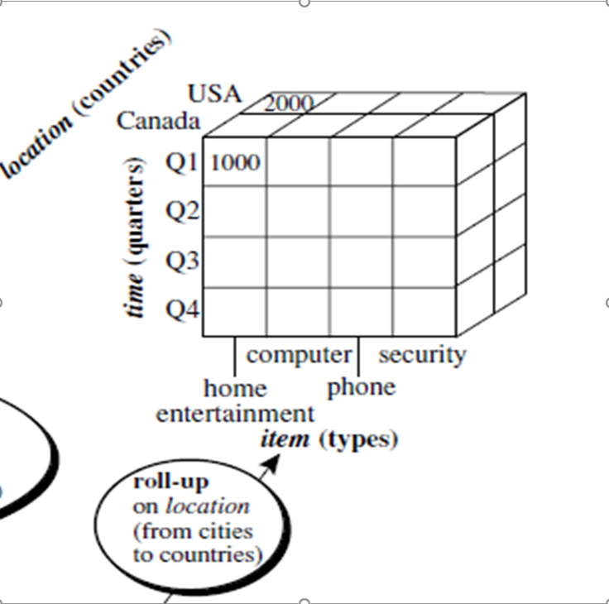
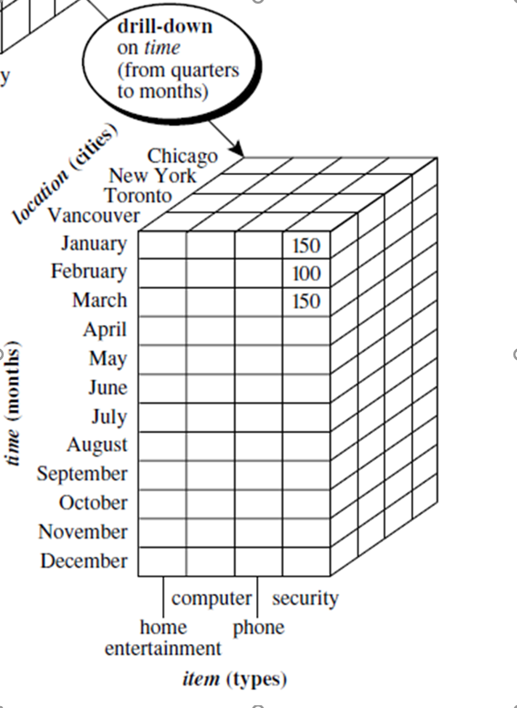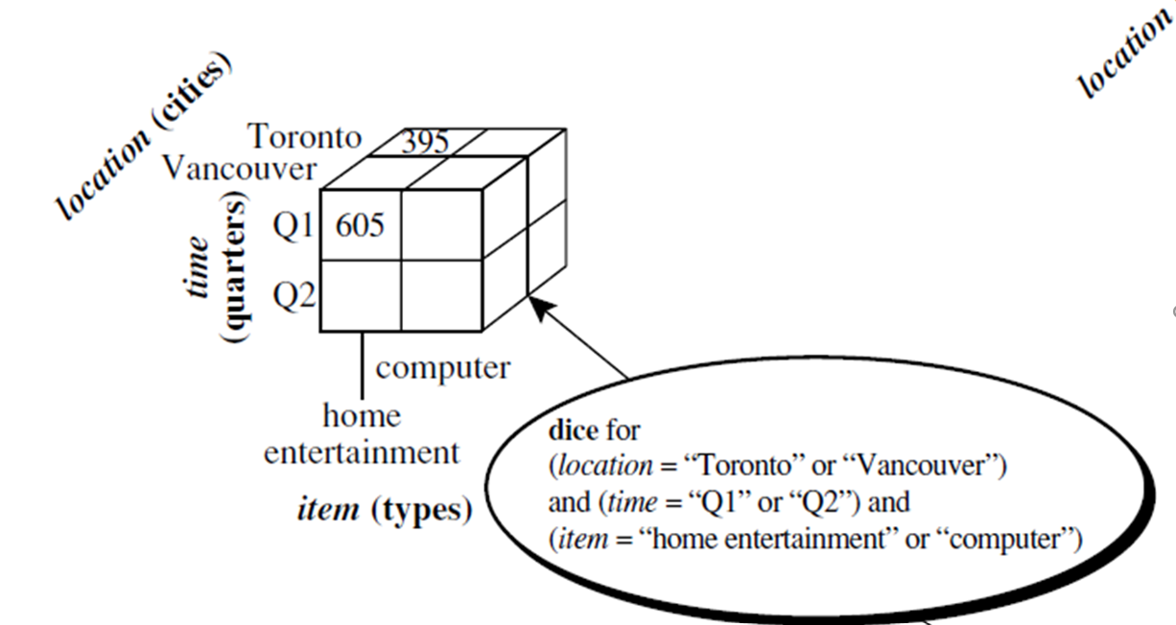
Operations
1)Roll-up :
  - The roll-up operation (also called as drill-up) performs aggregation on a data cube, either by climbing up a concept hierarchy for a dimension.
Ex: roll-up from cities to country
2)Drill-down:
  - Drill-down is the reverse of roll-up.
  - Drill-down can be realized by either stepping down a concept hierarchy for a dimension.
Ex: drill-down from quarter to months
3) Slice and dice(project and select):
  - The slice operation performs a selection on one dimension of the given cube, resulting in a subcube.
Ex: Slice of time=Q1”
Dice of (location = “Toronto” or “Vancouver”) and
(time = “Q1” or “Q2”) and
(item =“home entertainment” or “computer”).
4) Pivot (rotate):
  - Pivot (also called rotate) is a visualization operation that rotates the data axes to provide an alternative presentation of the data.
Ex: 2-D slice are rotated.
1.3 DATA WAREHOUSE DESIGN AND USAGE
Designing a data warehouse means planning how the data will be collected, organized, and stored so it’s useful for decision-making.
  - A Business Analysis Framework for Data Warehouse Design
  - Before designing a data warehouse, we must understand why it's needed:
  - It helps in measuring business performance and making better decisions.
  - It increases productivity by gathering accurate information quickly.
  - It improves customer relationship management by giving a complete view of customers.
  - It reduces costs by analyzing trends and patterns over time.
Think of it like building a building:
  - The owner sees the overall purpose (business needs),
  - The architect plans the structure (data model),
  - The builder builds it (technical implementation).
1. Top-Down View
  - This view helps in choosing the right data for the data warehouse.
  - It focuses on current and future business needs, so that only the most useful information is included.
2. Data Source View
  - This view shows where the data comes from, such as sales or inventory systems.
  - It explains how the data is stored and managed, often using models like ER diagrams or CASE tools.
3. Data Warehouse View
This view shows how data is stored inside the warehouse.
It includes:
  - Fact tables (numbers like sales, totals),
  - Dimension tables (like time, product, region),
  - And also adds details like where the data came from and when it was added.
4. Business Query View
  - This is the view from the user’s perspective.
  - It focuses on how users will search, query, and generate reports from the data warehouse.
  - It must be simple and useful for managers, analysts, or business users.
Data Warehouse Design Process
1. APPROACHES TO DESIGN
There are three main approaches:
[A] Top-Down Approach:
  - Starts with full planning and a complete data model.
  - Best when business needs and technology are well understood.
[B] Bottom-Up Approach:
  - Starts with small data marts (department-level systems).
  - Useful when you want quick results and low cost.
[C] Hybrid Approach:
  - Combines both: plan overall model but build parts step by step.
  - Gives flexibility with clear structure.
2. Software Development Methods
Two popular methods are:
[A] Waterfall Method
  - Step-by-step process. Finish one stage completely before moving to the next.
[B] Spiral Method
  - Fast, iterative approach. Build small versions quickly, test them, and improve.

3. Key Steps in the Design Process
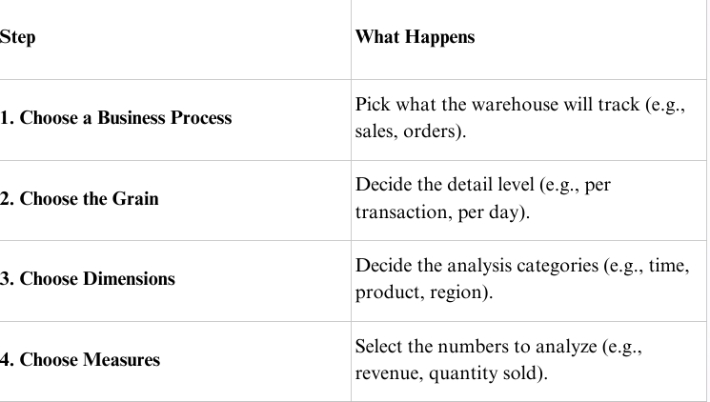
4. Implementation Planning
Before starting, define:
  - Scope (how much will be covered),
  - Budget,
  - Timeline,
  - Which departments and data sources to include.
5. Deployment and Maintenance
After building:
  - Install and train users
  - Keep data updated (refresh regularly)
  - Manage performance, security, and growth
  - Plan for recovery in case of system failure
6. Tools
  - Development Tools: Design schemas, manage metadata
  - Planning Tools: Test refresh speeds, simulate changes
DATA WAREHOUSE USAGE
1. Information Processing
  - Information processing in data warehouses refers to the ability to perform basic querying, statistical analysis, and reporting on stored data. It helps users retrieve specific information using tools like tables, charts, graphs, and crosstabs.
2.Analytical Processing (OLAP)
  - OLAP (Online Analytical Processing) enables users to interactively analyze multidimensional data at different levels of granularity using operations like slice, dice, drill-down, roll-up, and pivoting.
3. Data Mining
  - Data mining is the process of automatically discovering hidden patterns, correlations, trends, and useful knowledge from large volumes of data. It supports predictive and descriptive analytics using machine learning and statistical models.
1.4 DATA WAREHOUSE IMPLEMENTATION
Data warehouse implementation is the process of building and optimizing a data warehouse system to store, manage, and query huge volumes of data efficiently, especially for OLAP (Online Analytical Processing). It includes:
  - Data cube computation
  - Indexing
  - OLAP query processing
  - Server architecture (ROLAP, MOLAP, HOLAP)
1.4.1 Efficient Data Cube Computation
What is a Data Cube?
  - A data cube allows data to be modeled and viewed in multiple dimensions.
  - Each dimension (like time, item, location) is used for analysis.
  - Cuboids represent group-by aggregations across dimensions.
- Example:A data cube is a lattice of cuboids
- Suppose we have 3 dimensions: City, Item, and Year.
- Total Cuboids = 2³ = 8
- (Every combination of group-bys)
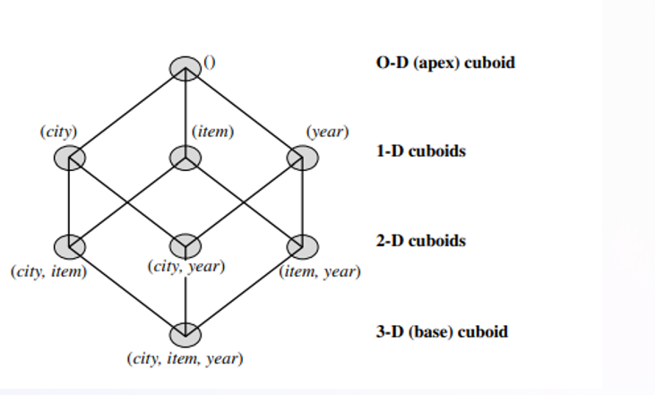
1.4.2. Indexing OLAP Data: Bitmap Index and Join Index
Bitmap Index:
  - A Bitmap Index is a type of indexing technique where each distinct value of an attribute is represented by a bit vector (array of bits). Each bit in the vector corresponds to a record and indicates whether that record contains the value.
  - It is most efficient for low-cardinality attributes (attributes with few unique values).
EXAMPLE:
In the AllElectronics data warehouse, suppose the dimension item at the top level has four values (representing item types): “home entertainment,” “computer,” “phone,” and “security.” Each value (e.g., “computer”) is represented by a bit vector in the item bitmap index table. Suppose that the cube is stored as a relation table with 100,000 rows. Because the domain of item consists of four values, the bitmap index table requires four bit vectors (or lists), each with 100,000 bits. The Figure shows a base (data) table containing the dimensions item and city, and its mapping to bitmap index tables for each of the dimensions.
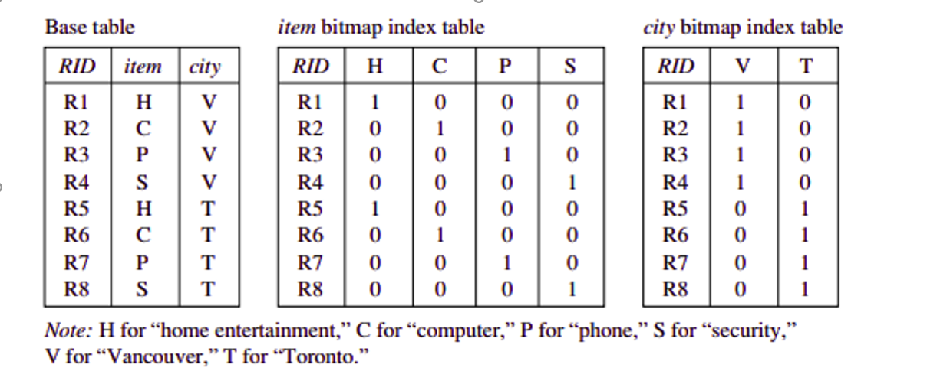Figure : Indexing OLAP data using bitmap indices.
Join Indexing:
  - Join Indexing is a method used to speed up join operations by precomputing and storing joinable row pairs between two tables—typically a fact table and a dimension table in a data warehouse.
Example:
we defined a star schema for AllElectronics of the form “sales star [time, item, branch, location]: dollars sold = sum (sales in dollars).” An example of a join index relationship between the sales fact table and the location and item dimension tables is shown in Figure 4.16. For example, the “Main Street” value in the location dimension table joins with tuples T57, T238, and T884 of the sales fact table. Similarly, the “Sony-TV” value in the item dimension table joins with tuples T57 and T459 of the sales fact table. The corresponding join index tables are shown in Figure 4.17.
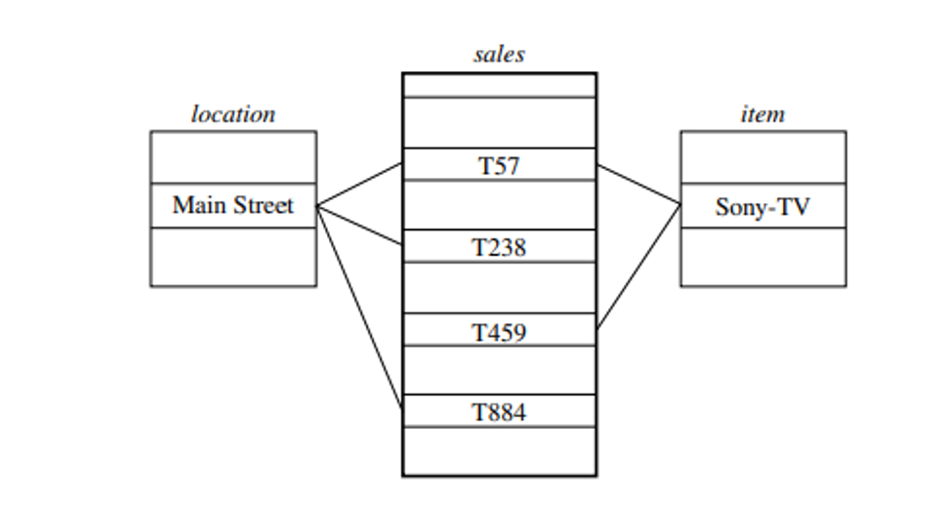
Figure 4.16 Linkages between a sales fact table and location and item dimension tables.
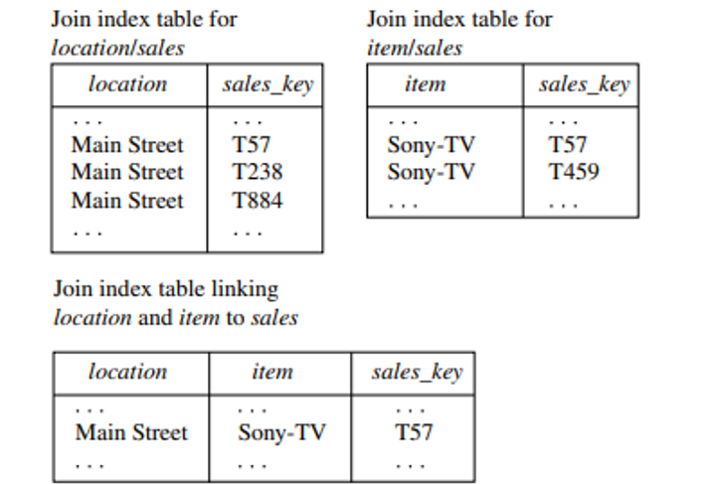
Figure 4.17 Join index tables based on the linkages between the sales fact table and the location and item dimension tables shown in Figure 4.16.
1.4.3. Efficient Processing of OLAP Queries
  - The purpose of materializing cuboids and constructing OLAP index structures is to speed up query processing in data cubes. Given materialized views, query processing should proceed as follows:
A. Determine which operations should be performed on the available cuboids:
- This involves transforming any selection, projection, roll-up (group-by), and drill-down operations specified in the query into corresponding SQL and/or OLAP operations. For example, slicing and dicing a data cube may correspond to selection and/or projection operations on a materialized cuboid.

B. Determine to which materialized cuboid(s) the relevant operations should be applied:
This involves identifying all of the materialized cuboids that may potentially be used to answer the query, pruning the set using knowledge of “dominance” relationships among the cuboids, estimating the costs of using the remaining materialized cuboids, and selecting the cuboid with the least cost.
Example: OLAP query processing. Suppose that we define a data cube for AllElectronics of the form “sales cube [time, item, location]: sum(sales in dollars).” The dimension hierarchies used are “day < month < quarter < year” for time; “item name < brand < type” for item; and “street < city < province or state < country” for location.
  - Suppose that the query to be processed is on {brand, province or state}, with the selection constant “year = 2010.” Also, suppose that there are four materialized cuboids available, as follows:
cuboid 1: {year, item name, city}
cuboid 2: {year, brand, country}
cuboid 3: {year, brand, province or state}
cuboid 4: {item name, province or state}, where year = 2010
1.4.4. OLAP Server Architectures: ROLAP vs MOLAP vs HOLAP
OLAP (Online Analytical Processing) servers allow users to perform multidimensional analysis on data stored in a data warehouse.
Although OLAP presents a multidimensional view logically, the physical implementation (i.e., how and where data is stored and queried) can differ, resulting in:
  - ROLAP (Relational OLAP)
  - MOLAP (Multidimensional OLAP)
  - HOLAP (Hybrid OLAP)
ROLAP – Relational OLAP
  - ROLAP uses relational databases to store data and performs OLAP operations using SQL queries on fact and dimension tables.
MOLAP (Multidimensional OLAP)
  - MOLAP stores data in multidimensional cube structures and provides precomputed aggregations for fast OLAP query performance.
HOLAP (Hybrid OLAP)
  - HOLAP combines the strengths of both ROLAP and MOLAP by storing detailed data in relational databases and aggregated data in multidimensional cubes.
Example:
This example shows how ROLAP stores both detailed (base fact) and aggregated data in a summary fact table.
  - Records like RID 1001/1002 store individual sales on specific dates.
  - Record RID 5001 stores monthly total, using ALL in the day field to show aggregation.
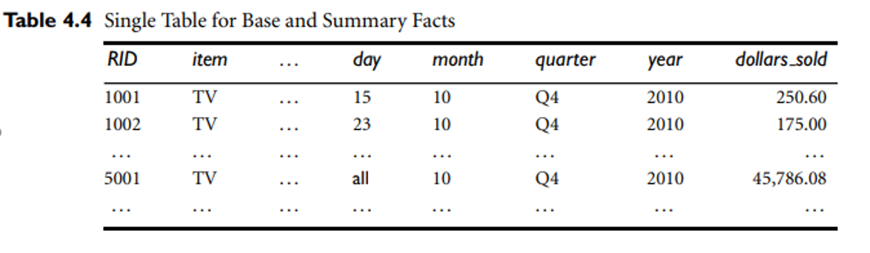
1.5 CLOUD DATA WAREHOUSE
A Cloud Data Warehouse is a modern architecture of data warehousing that supports scalable, real-time, and remote data analysis by integrating various sources (on-premises and cloud-based) into a centralized cloud repository, offering high availability and accessibility through web-based tools.
Components Explained from the Diagram
[A] Cloud Data Warehouse (Central Repository)
  - Acts as the core analytical engine.
  - Stores data that is subject-oriented, integrated, time-variant, and non-volatile — characteristics of a standard data warehouse as per Inmon and Kimball models.
[B] On-premises Data and Applications
  - Internal data systems (ERP, CRM, legacy systems) provide structured data that is extracted, transformed, and loaded (ETL) into the warehouse.
[C] Existing Cloud Applications
  - Data from external services such as Google Analytics, Salesforce, or online transaction systems are streamed into the warehouse using APIs or cloud connectors.
[D] Client Devices (Access Layer)
  - Users (analysts, managers, data scientists) access the warehouse remotely via web interfaces, dashboards, or BI tools for reporting, querying, and visualization.
[E] Universal Accessibility
  - Cloud data warehouses support real-time data access from any device (laptop, desktop, tablet) using the internet, fulfilling the goal of ubiquitous access and collaboration.
MICROSOFT FABRIC
  - Microsoft Fabric is an end-to-end, unified data platform offered by Microsoft that integrates data engineering, data warehousing, data science, real-time analytics, and business intelligence (BI) — all within a single Software-as-a-Service (SaaS) environment on the Microsoft Azure cloud.
AZURE CLOUD DATA WAREHOUSE
  - Azure Cloud Data Warehouse refers to Microsoft Azure’s suite of cloud-based services that allow organizations to store, process, and analyze large volumes of data using scalable infrastructure, mainly centered around Azure Synapse Analytics.
1.6 DATA MINING AND PATTERN MINING
1.6.1 WHAT IS DATA MINING?

Definition: Data mining refers to extracting or “mining” knowledge from large amounts of data.
  - Data mining should have been more appropriately named as “knowledge mining from data,” in short it is “Knowledge mining”
  - Many people treat data mining as a synonym for another popularly used term, Knowledge Discovery in Databases, or KDD.
Different views of Data mining:
  - Data mining as simply an essential step in the process of knowledge discovery.
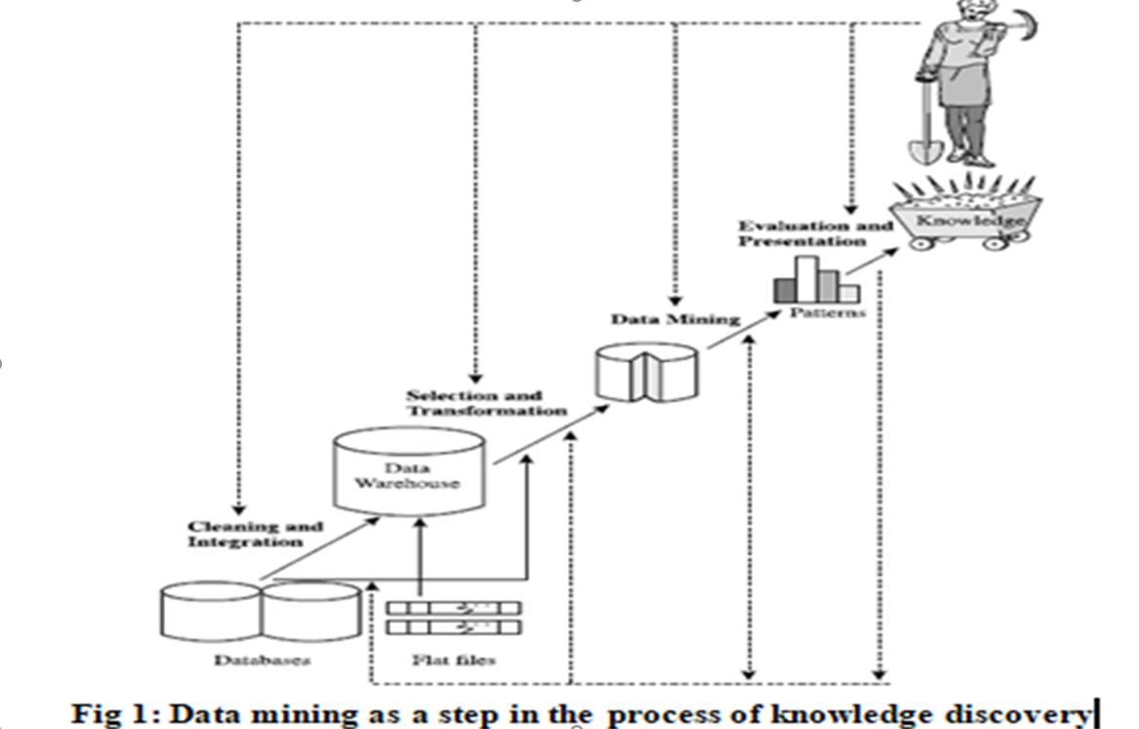
Fig.1 consists of an iterative sequence of the following steps:
  - Data cleaning (to remove noise and inconsistent data)
  - Data integration (where multiple data sources may be combined)
  - Data selection (where data relevant to the analysis task are retrieved from the database)
  - Data transformation (where data are transformed or consolidated into forms appropriate for mining by aggregation operations)
  - Data mining (an essential process where intelligent methods are applied in order to extract data patterns)
  - Pattern evaluation (to identify the interesting patterns representing knowledge based on some measures)
  - Knowledge presentation (where visualization and knowledge representation techniques are used to present the mined knowledge to the user)
  - Steps 1 to 4 are different forms of data preprocessing, where the data are prepared for mining.
  - The data mining step may interact with the user or a knowledge base.
  - Knowledge base: This is the domain knowledge that is used to guide the search or evaluate the resulting patterns.
  - The interesting patterns are presented to the user.
1.6.2 WHAT KINDS OF DATA CAN BE MINED?
  - Data mining can be applied to any kind of data as long as the data are meaningful for a target application.
  - Three kinds of data can be mined
1.Database Data
2.Data Warehouses
3.Transactional Data

1) Database Data:
  - A database system, also called a database management system (DBMS), consists of a collection of interrelated data, known as a database.
  - A Relational database is defined as the collection of data organized in tables with rows and columns.
  - Each table is assigned a unique name. Each table contains a set of attributes (columns) and a set of records(rows).
  - Each record in the table represents an object identified by a unique key and described by the set of attribute values.
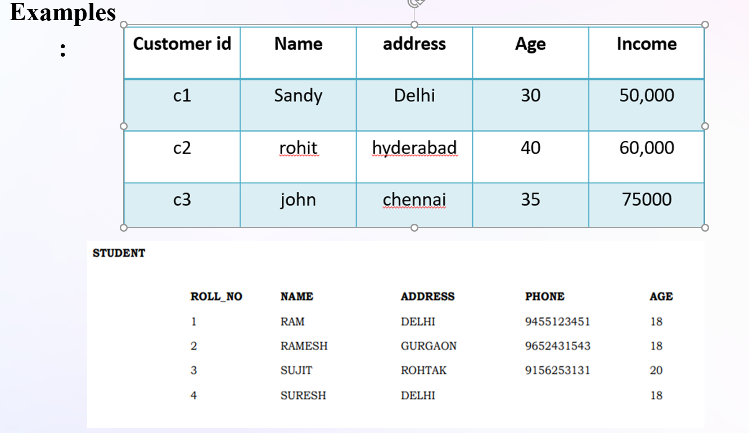

2) Data Warehouses:
  - A data warehouse is a repository of information collected from multiple sources, stored under a unified schema, and usually residing at a single site.
  - Data warehouses are constructed via a process of data cleaning, data integration, data transformation, data loading, and periodic data refreshing.
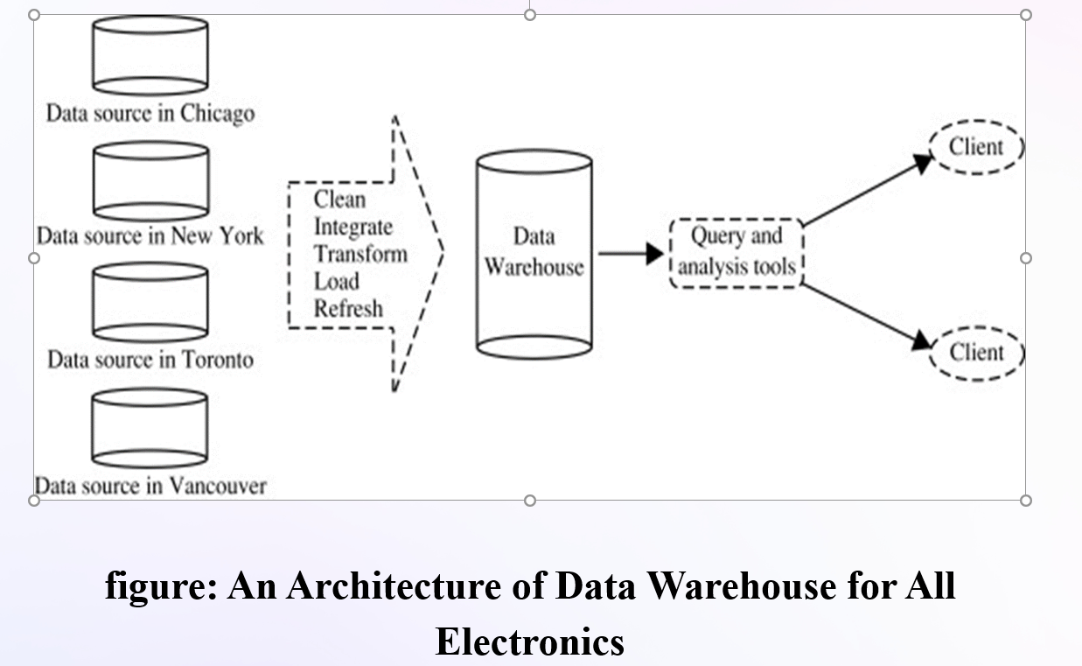
  - To facilitate decision making, the data in a data warehouse are organized around major subjects (e.g., customer)
  - The data are stored to provide information from a historical perspective, such as in the past 6 to 12 months.
  - A data warehouse is usually modeled by a multidimensional data model called a data cube, in which each dimension corresponds to an attribute and each cell stores the value of some aggregate measure such as count.
  - A data cube for All Electronics: A data cube for summarized sales data of All Electronics is.
  - The cube has three dimensions: address (with city values Chicago, New York, Toronto, Vancouver), time (with quarter values Q1, Q2, Q3, Q4), and item(with item type values home entertainment, computer, phone, security)
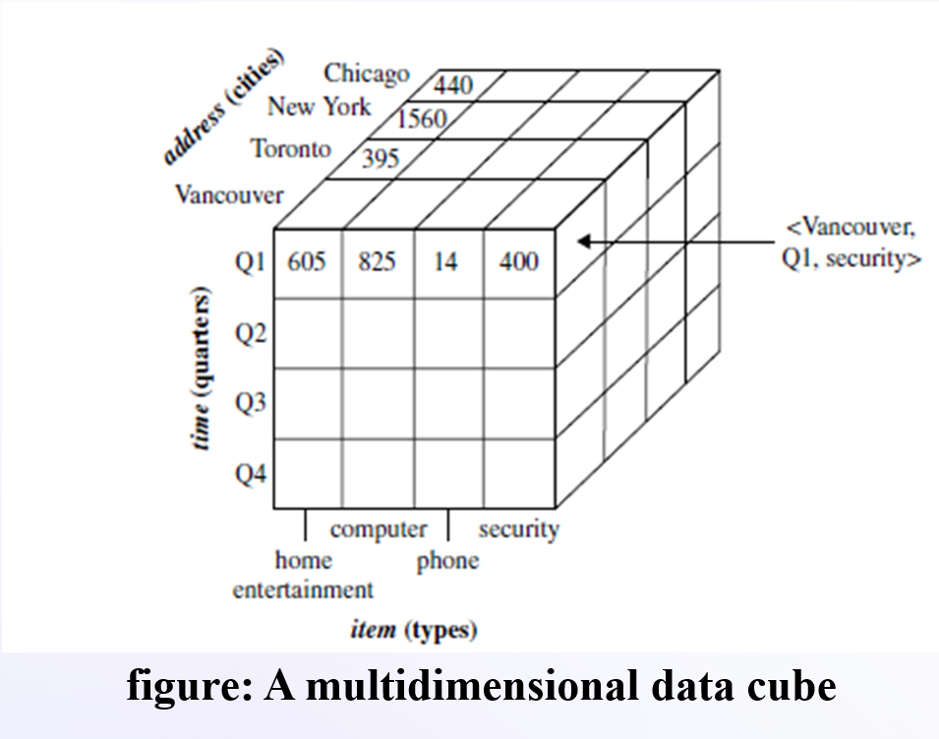
3) Transactional Data
  - In general, each record in a transactional database captures a transaction, such as a customer’s purchase.
  - A transaction includes a unique transaction identity number (trans ID) and a list of the items.
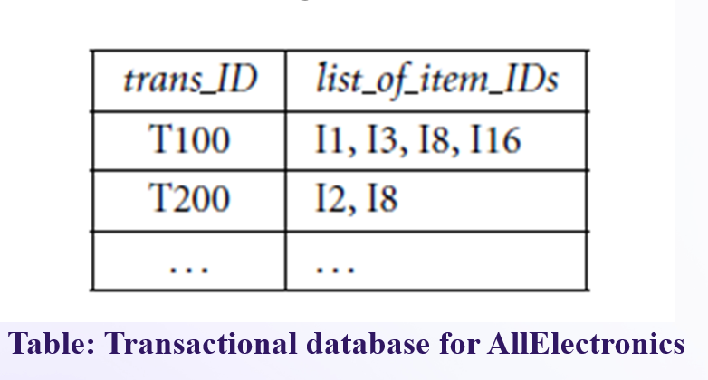
4) OTHER KINDS 0F DATA:
There are so many other kinds of data like time-related or sequence data (e.g., historical records,stock exchange data, and time-series and biological sequence data)
  - data streams (e.g., videosurveillance and sensor data, which are continuously transmitted)
  - spatial data (e.g., maps)
  - hypertext and multimedia data (including text, image, video, and audio data),
  - graph and networked data (e.g., social and information networks)
  - Web data(a huge, widely distributed information repository made available by the Internet).
  - Various kinds of knowledge can be mined from these kinds of data. Ex : Stock exchange data
  - can be mined to uncover trends that could help to plan investment strategies.
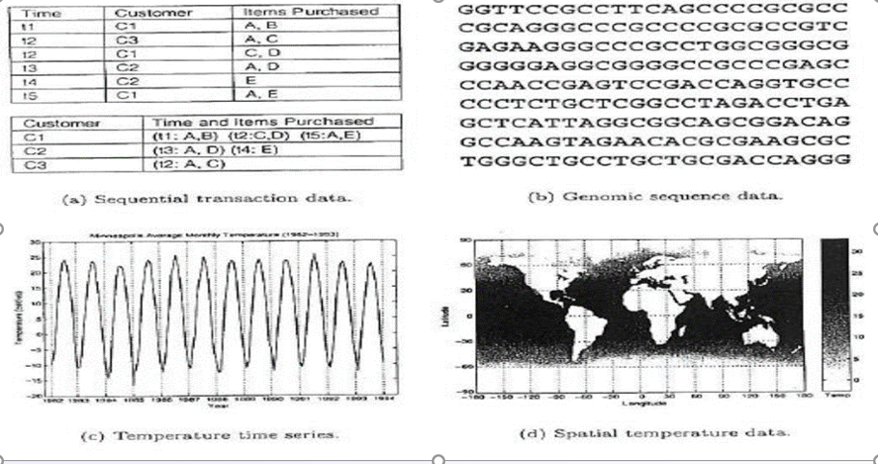
1.6.3 WHAT KINDS OF PATTERNS CAN BE MINED?
  - There are a number of data mining functionalities.
  - Data mining functionalities are used to specify the kinds of patterns to be found in data mining tasks.
  - Data mining tasks can be classified into two categories:
–Descriptive
–Predictive
1.Predictive Data Mining: This type focuses on predicting future outcomes based on historical data. Common techniques include:]
  - Classification: Categorizes data into predefined classes or categories based on specific features. For example, classifying customers as high, medium, or low risk for loan applications.
  - Regression: Predicts continuous numerical values based on the relationship between input variables and a target variable. Used in forecasting sales, predicting housing prices, or estimating customer ages based on purchases.
  - Prediction: Combines various data mining techniques (like trends, clustering, and classification) to forecast future events or outcomes. Examples include forecasting fuel prices or predicting disease outbreaks.
  - Time Series Analysis: Analyzes and predicts data points collected over time, useful for forecasting, trend analysis, and detecting seasonality.
2.Descriptive Data Mining: This type aims to identify patterns, relationships, and trends within existing data. Techniques include:
  - Clustering: Groups similar data points together based on inherent patterns and characteristics. For example, customer segmentation based on buying behavior.
  - Association Rule Learning: Discovers interesting relationships or patterns among a set of items in transactional data, often represented as "if/then" statements. Market basket analysis is a common application, where it identifies products frequently purchased together.
Data mining functionalities are
  - Class/Concept Description: Characterization and discrimination
  - Mining frequent patterns, associations and correlations
  - classification and regression for predictive analysis
  - cluster analysis
  - outlier analysis
Class/Concept Description: Characterization and Discrimination
  - Data can be associated with classes or concepts.
  - Ex: In the AllElectronics store,
  - classes of items for sale include computers and printers
  - concepts of customers include bigSpenders and budgetSpenders.
  - It can be useful to describe individual classes and concepts in summarized and precise terms.
  - Such descriptions of a class or a concept are called class/concept descriptions.
- These descriptions can be derived via
- (1) data characterization
- (2) data discrimination
- (3) both data characterization and discrimination
  - Data characterization is a summarization of the general characteristics or features of data.
  - Ex: study the characteristics of software products whose sales increased by 10% in the last year.
  - The output of data characterization can be presented in various forms.
  - Ex:pie charts, bar charts, curves, multidimensional data cubes.
  - Data discrimination is comparison of the target class with one or a set of comparative classes.
  - Ex: the user like to compare the general features of software products whose sales increased by 10% in the last year with those whose sales decreased by at least 30% during the same period.
Mining Frequent Patterns, Associations, and Correlations
  - Association analysis is the discovery of association rules showing attribute-value conditions that occur frequently together in a given set of data.
  - This analysis is widely used in transaction data analysis.
  - Association rules are of the form
X => Y,
  - is interpreted as “database tuples that satisfy the conditions in X are also likely to satisfy the conditions in Y”.
  - Ex: manager like to determine which items are frequently purchased together within the same transactions.
An example:
buys(X, “computer”) => buys(X, “software”) [support = 1%; confidence = 50%]
Classification and Regression for Predictive Analysis
  - Classification is the process of finding a model that describes and distinguishes data classes.
  - The derived model is based on the analysis of a set of training data.
  - The derived model may be represented in various forms, such as classification (IF-THEN) rules, decision trees or neural networks.
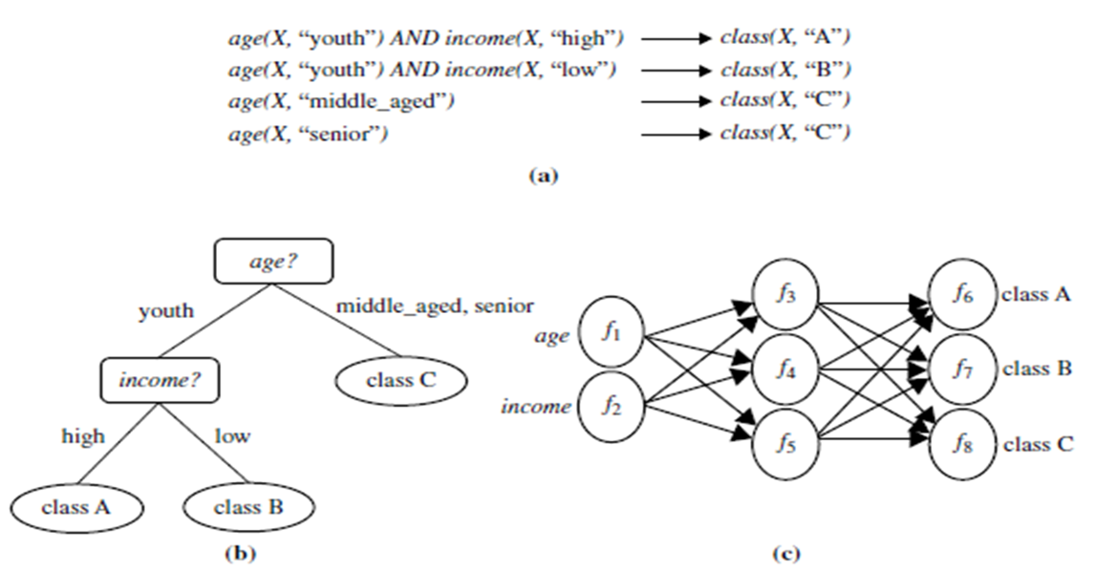

A classification model :(a) IF-THEN rules, (b) a decision tree
(c) a neural network.

  - Classification predicts categorical (discrete, unordered) labels, regression models continuous-valued functions.
  - regression analysis is used to predict missing or unavailable numerical data values rather than (discrete) class labels.
  - Example: Price of an item
Cluster Analysis
  - Cluster is a group of similar data points or objects for analysis.
  - The objects within a cluster have high similarities in comparison to one another but are very dissimilar to objects in other clusters.
  - Ex: Cluster AllElectronics customer data with respect to customer locations in a city.
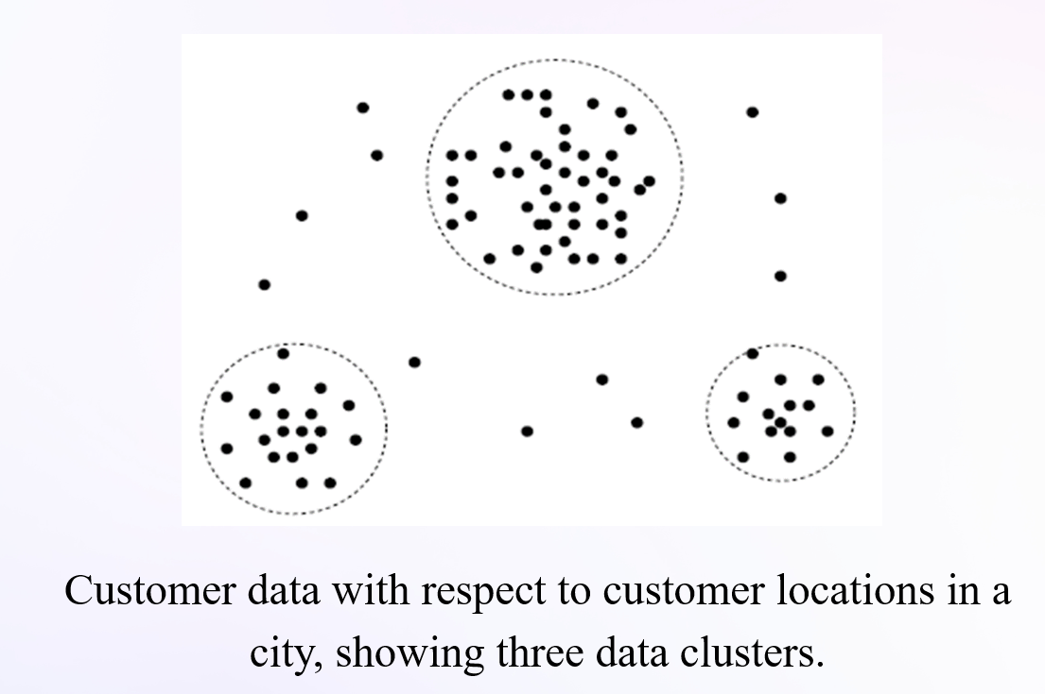
Outlier Analysis
  - A database may contain data objects that do not comply with the general behavior or model of the data.
  - These data objects are outliers(noise in the data) .
  - Ex : Outlier analysis may uncover fraudulent usage of credit cards by detecting purchases of extremely large amounts.
1.7 DATA MINING TECHNOLOGIES
1.7.1 STATISTICS
  - Statistics deals with collecting, analyzing, interpreting, and presenting data.
  - Data mining is closely related to statistics and often uses statistical models to understand data patterns.
  - Statistical models describe data behavior using random variables and probability distributions.
  - Used for tasks like:
1.Data characterization
2.Classification
3.Handling missing or noisy data
4.Prediction and forecasting
  - Inferential statistics helps make decisions or predictions under uncertainty.
  - Statistical hypothesis testing is used to verify model results (e.g., testing if a pattern is real or due to chance).
  - Challenge: Scaling statistical methods for large or real-time datasets is difficult and needs optimized algorithms.
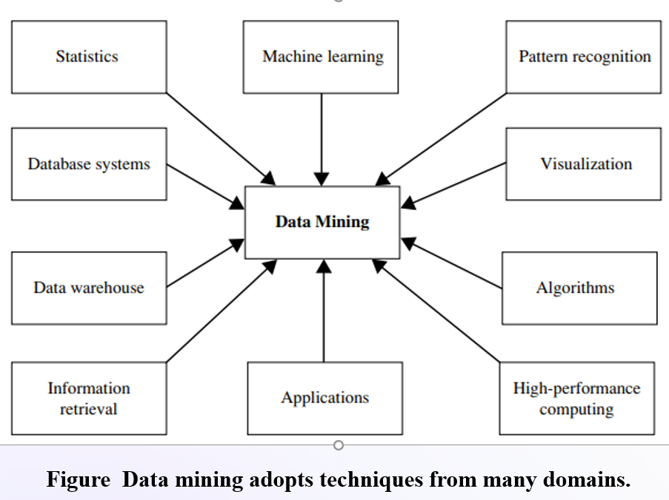
Data mining technologies: techniques and tools
Data mining is a process that involves analyzing large datasets to uncover patterns, trends, correlations, and anomalies, thereby extracting meaningful information that aids in decision-making. This field leverages various technologies, algorithms, and tools to achieve its objectives.
1.7.2 MACHINE LEARNING
  - Machine Learning is about enabling computers to learn from data and make intelligent decisions.
  - It is used to recognize patterns, predict outcomes, and improve performance over time.
  - Types of Learning:
1.Supervised Learning
Uses labeled data
Example: Classification (e.g., digit recognition)
2.Unsupervised Learning
Uses unlabeled data
Example: Clustering (e.g., grouping similar images)
3.Semi-Supervised Learning
  - Uses both labeled and unlabeled data
  - Helps refine model accuracy and detect outliers
4. Active Learning
  - The system asks users (experts) for help in labeling certain examples
  - Helps improve model with minimal user input
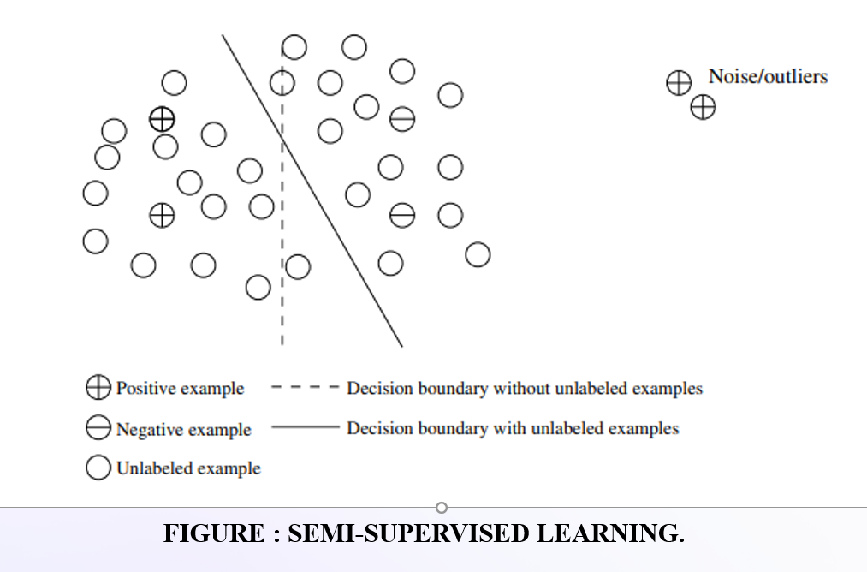

1.7.3 DATABASE SYSTEMS AND DATA WAREHOUSES
Database Systems:
  - Help store, manage, and search data (like customer or sales data).
  - Use tools like SQL, indexes, and query processing.
  - Can handle very large structured data.
  - Useful for data mining because they are fast and scalable.
Data Warehouses:
  - A special system that collects data from many sources.
  - Stores data in a clean, organized way — usually in cubes.
  - Supports OLAP (used to analyze data easily).
  - Helps in decision making and data mining.
1.7.4 INFORMATION RETRIEVAL (IR)
  - Information Retrieval (IR) is the process of finding useful information from a large collection of unstructured data like text documents, web pages, or multimedia files, based on keywords or search queries.
Example:
  - When you search on Google, it finds the most relevant web pages based on your keywords , this is information retrieval in action.
1.8 DATA MINING APPLICATIONS
1.8.1 Business Intelligence:
  - Business Intelligence (BI) refers to the technologies and tools that help companies understand their customers, competitors, and market trends.
  - It provides past, present, and future views of business operations.
Examples of BI Tools:
  - Reporting
  - Online Analytical Processing (OLAP)
  - Performance management
  - Predictive analytics
  - Benchmarking
  - Competitive intelligence
- Role of Data Mining in BI:
- Classification & Prediction → For forecasting and sales analysis
- Clustering → For customer grouping (CRM)
- Characterization → For understanding each customer group
- OLAP + Data Warehouse → For powerful data analysis
1.8.2 Web search Engines
  - A Web search engine is a special system that helps people find information online, like Google, Bing, etc.
  - It returns results (hits) based on your search keywords.
Search Engines use Data Mining in:
  - Crawling – Deciding which web pages to collect
  - Indexing – Organizing the pages and their content
  - Searching – Ranking results, showing ads, personalizing content
Challenges in Search Engines:
1.Huge Data Volumes
  - Search engines need to process billions of web pages
  - Use cloud computing and thousands of machines
2.Real-time Results
  - Must answer your query in milliseconds
  - Needs fast, smart algorithms
3.Data Changes Fast
  - Queries and topics change daily
  - Models must be updated continuously
4.Rare Queries
  - Most search queries are unique or asked only once
  - Hard to train models with so little data
1.9 MAJOR ISSUES IN DATA MINING
  - Data mining is a dynamic and fast-expanding field with great strengths.
  - we briefly outline the major issues in data mining research, partitioning them into two groups: mining methodology, user interaction.
1.9.1 Mining Methodology
  - Mining Methodology Researchers have been vigorously developing new data mining methodologies.
Mining various and new kinds of knowledge:
Data mining covers a wide spectrum of data analysis and knowledge discovery tasks, from data characterization and discrimination to association analysis, classification, regression, clustering, and outlier analysis.
Mining knowledge in multidimensional space:
  - When searching for knowledge in large data sets, we can explore the data in multidimensional space.
  - That is, we can search for interesting patterns among combinations of dimensions (attributes) at varying levels of abstraction
Data mining—an interdisciplinary effort:
  - Boosting the power of discovery in a networked environment: Most data objects reside in a interconnected environment, whether it be the Web, database relations, files, or documents.
  - Handling uncertainty, noise, or incompleteness of data: Data often contain noise, errors, exceptions, or incomplete.
  - Pattern evaluation and pattern: Not all the patterns generated by data mining processes are interesting. And may vary from user to user.
1.9.2 User Interaction
  - The user plays an important role in the data mining process.
Interactive mining:
  - The data mining process should be highly interactive.
  - Thus, it is important to build flexible user interfaces.
  - Incorporation of background knowledge: Background knowledge, constraints, rules, and other information regarding the domain should be included.
  - data mining query languages: Query languages (e.g., SQL) have played an important role in flexible searching because they allow users to pose ad hoc queries.
  - Presentation of data mining results: How can a data mining system present data mining results flexibly.
1.10 DATA OBJECTS & ATTRIBUTE TYPES
1.10.1 What is data object?
Data objects are the individual units of data that we analyze in data mining. These are the entities or instances that contain the information we seek to explore, classify, or cluster.
Examples of Data Objects:
A customer record in a retail database.
A patient's medical history in a healthcare database.
A transaction entry in a financial system.
1.10.2 WHAT IS AN ATTRIBUTE?
Attributes are the properties or characteristics of the data objects. Each attribute represents one aspect of the data object.
Attribute Types:
1. Categorical (Nominal) Attributes
Definition: Represents categories or groups with no inherent order.
Examples: Gender (Male, Female), Product Category (Electronics, Apparel).
2. Ordinal Attributes
Definition: Represents categories with a specific order or ranking, but the distances between categories are not defined.
Examples: Education Level (High School, Bachelor’s, Master’s), Customer Satisfaction (Low, Medium, High).
3. Numerical (Quantitative) Attributes
Definition: Represents measurable quantities with numeric values, where arithmetic operations make sense.
Subtypes:
  - Discrete: Integer values, often countable.
Examples: Number of Children, Number of Products.
2.Continuous: Real-valued numbers with infinite possibilities.
Examples: Temperature, Salary.
4. Binary Attributes
Definition: A special case of categorical attributes with only two possible values (0 or 1).
Examples: Yes/No, True/False, 0/1.
1.11 BASIC STATISTICAL DESCRIPTIONS OF DATA
Basic statistical descriptions are used to summarize and understand the general properties of data. They help us describe the central tendency, spread, and distribution of data values, which is important before applying data mining techniques.
1.11.1 Measures of Central Tendency
These describe where most data values fall.
[A] Mean (Average):
  - It is the sum of all values divided by the number of values.
  - Commonly used, but affected by outliers (very high or low values).
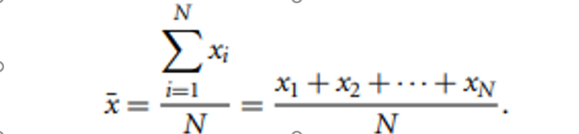
  - This is called the weighted arithmetic mean or the weighted average.
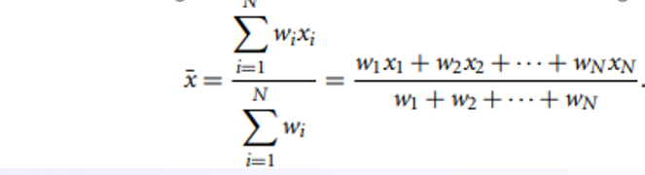
[B] Median
  - It is the middle value when data is arranged in order.
  - Not affected by outliers – better than mean for skewed data.
  - If odd number of values → middle one
  - If even number of values → average of two middle values
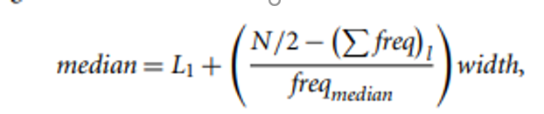
[C] Mode
  - The most frequently occurring value in the data.
  - A dataset can have one mode (unimodal), two (bimodal), or more (multimodal).
  - If all values are different → No mode
[D] Midrange
  - It is the average of the smallest and largest values.
  - Quick to calculate, but easily influenced by outliers.
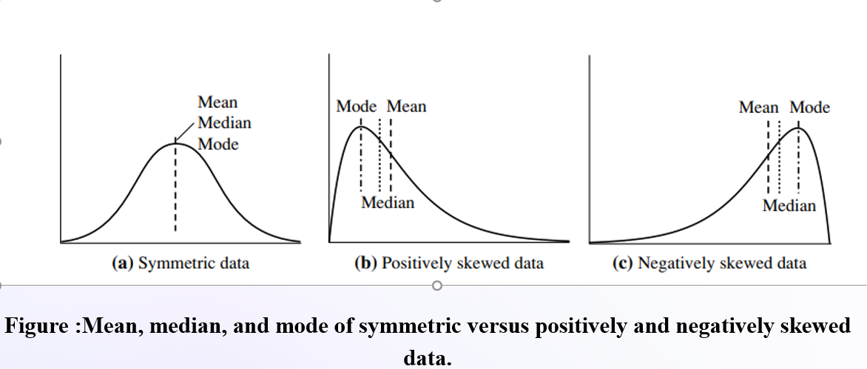
1.11.2 Measures of Dispersion Data
Dispersion tells us how spread out or scattered the data is. It helps us understand if the values are closely packed or widely spread.
  - Range:
Difference between maximum and minimum values.
Range=Max-Min
  - Quartiles & Interquartile Range (IQR):
Quartiles divide the data into 4 equal parts:
Q1: 25th percentile (lower quartile)
Q2: 50th percentile (median)
Q3: 75th percentile (upper quartile)
Interquartile Range (IQR) = Range of middle 50% of data
Boxplots are a popular way of visualizing a distribution. A boxplot incorporates the five-number summary as follows:
  - Typically, the ends of the box are at the quartiles so that the box length is the interquartile range.
  - The median is marked by a line within the box.
  - Two lines (called whiskers) outside the box extend to the smallest (Minimum) and largest (Maximum) observations.
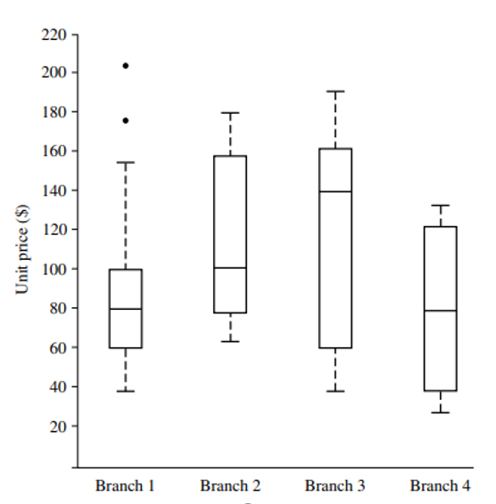
figure: Boxplot for the unit price data for items sold at four branches of AllElectronics during a given time period.
  - Variance and Standard Deviation
These tell us how much data varies from the mean.
Variance (σ²)
Shows the average of the squared differences from the mean
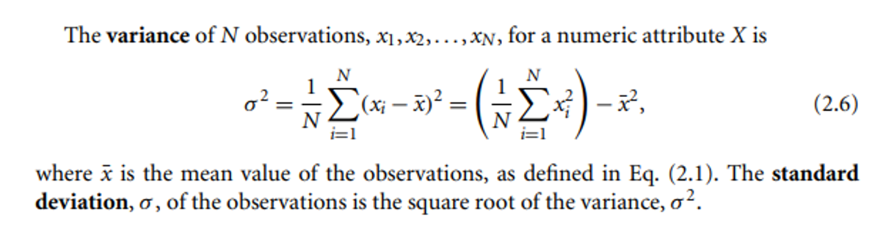

1.11.3 Graphic Displays of Basic statistical Descriptions of data
1. Quantile Plot
A quantile plot is a simple and effective way to have a first look at a univariate data distribution
  - Sort the data values in increasing order: x1,x2,...,xNx_1, x_2, ..., x_Nx1​,x2​,...,xN​
  - For each data point xi​, compute its quantile as:
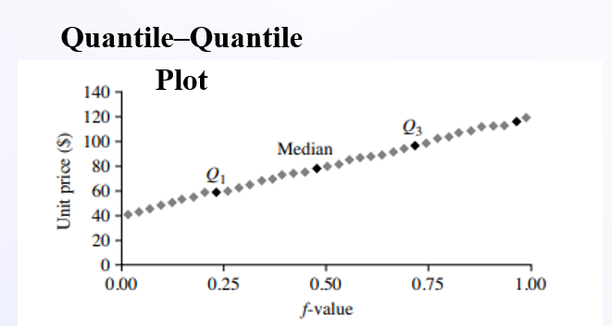
Figure:
A quantile plot for the unit price data of Table

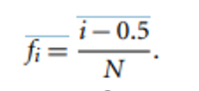
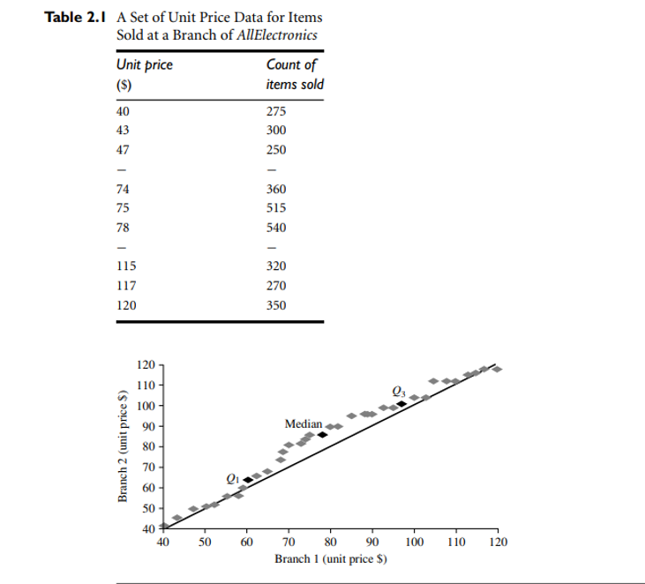
Figure A q-q plot for unit price data from two AllElectronics branches.
1.11.4 HISTOGRAM
  - A histogram is a graphical display used to summarize the distribution of a numeric (or sometimes categorical) attribute by grouping data into equal-width bins and showing the frequency (count) of observations in each bin.
  - The word “Histogram” comes from Greek:
Histos = "pole" or "mast"
Gram = "chart"
So, a histogram literally means a "chart of poles".
Example:
If prices range from $1 to $200, and the bins are defined as $20 wide:
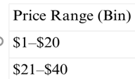
1.11.5 Scatter Plots and Data Correlation
  - A scatter plot is a type of graph used to visualize the relationship between two numeric variables. Each point in the plot represents an observation, where:
  - The X-coordinate is the value of the first attribute (e.g., Age),
  - The Y-coordinate is the value of the second attribute (e.g., Income).
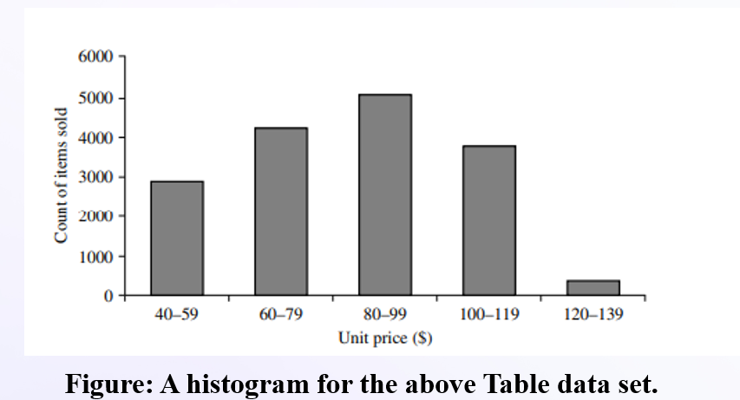
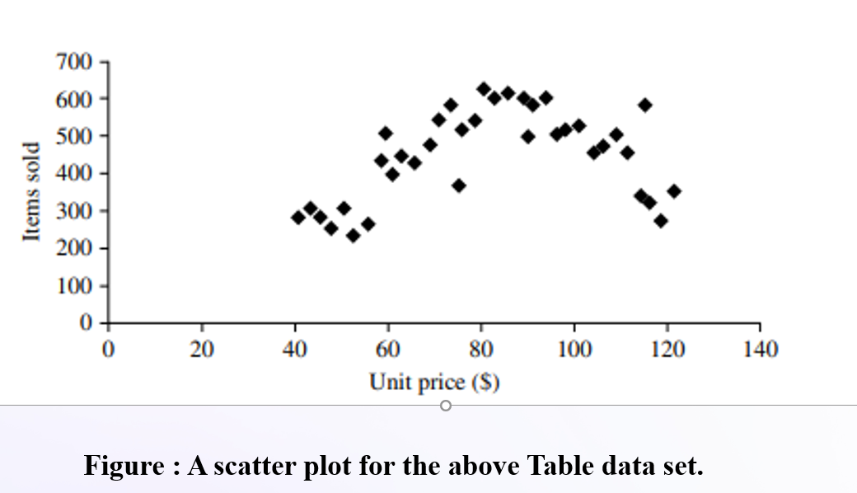
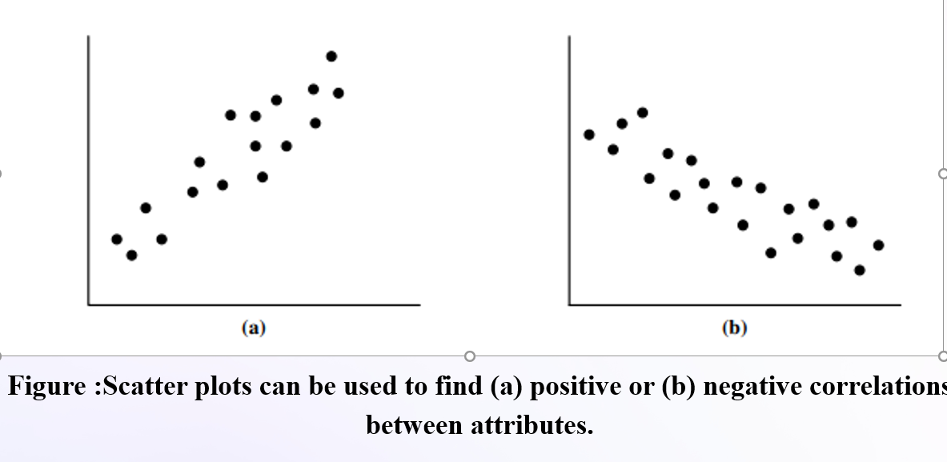
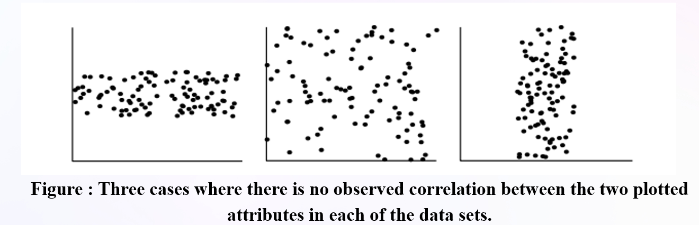
  - Scatter plots visually reveal relationships, patterns, or trends between two numeric variables.
  - They help detect clusters, outliers, and whether the relationship is linear or non-linear.
1.12 DATA VISUALIZATION
1.12.1 Geometric Projection Visualization Techniques
  - These techniques aim to project high-dimensional data onto 2D or 3D visual spaces to help users understand patterns in multidimensional datasets.
  - Scatter Plot (2D & 3D)
  - Displays two (or three) numeric attributes using Cartesian coordinates.
  - A third or fourth dimension can be shown using color or shape.
  - Useful for identifying clusters, correlations, and outliers.
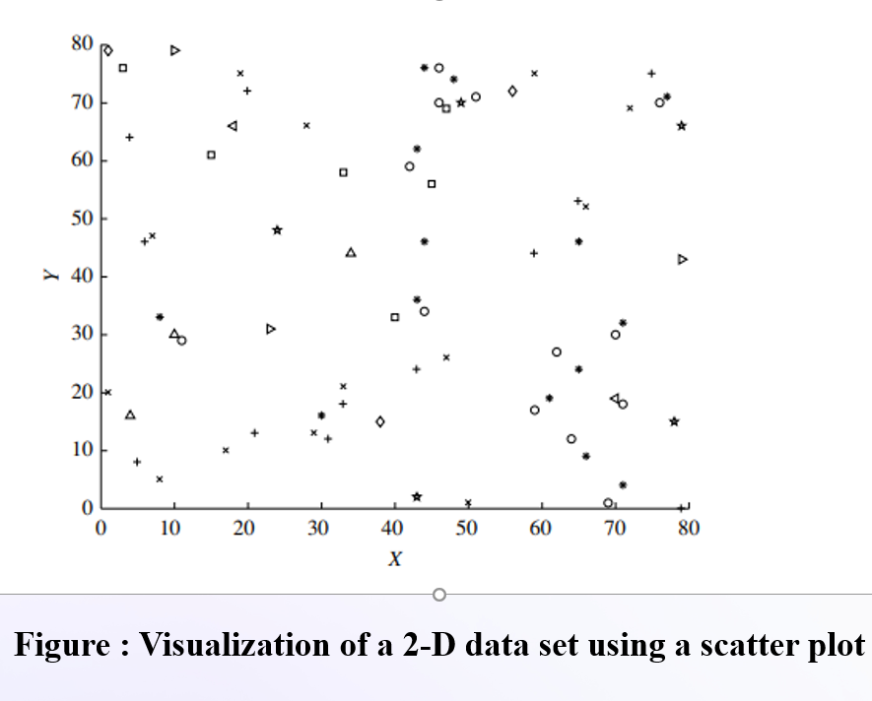
2. Scatter Plot Matrix
Displays an n × n grid of 2D scatter plots for all pairwise combinations of dimensions.
Example: Used in visualizing the Iris dataset (e.g., sepal & petal length/width).
3. Parallel Coordinates
Each dimension is shown as a parallel vertical axis.
A data point is a line that cuts across all axes at its values.
Capable of visualizing very high-dimensional data.
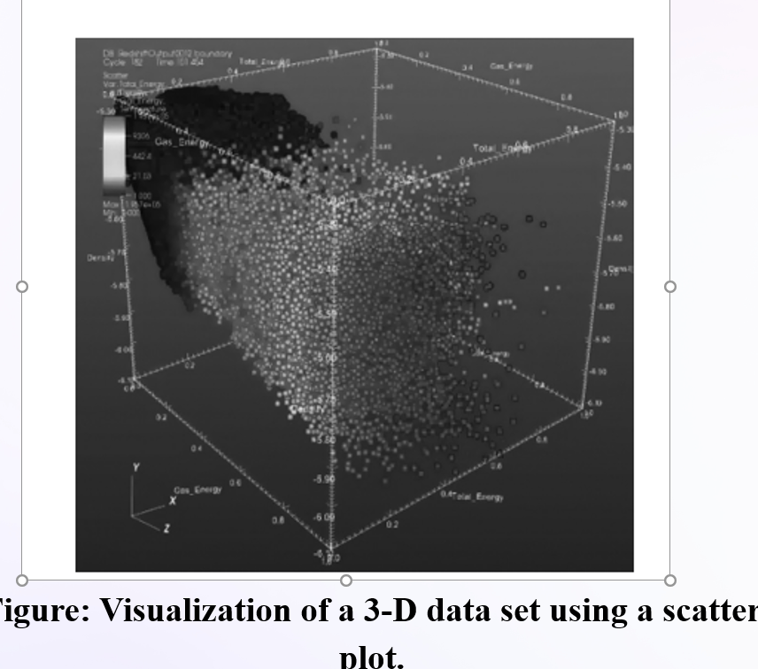
1.12.2 Icon-Based Visualization Techniques
[A] Chernoff Faces:
  - Maps data dimensions to human facial features (e.g., eye size, mouth curve).
  - Leverages human ability to recognize subtle differences in faces.
  - Useful for spotting trends, patterns, and irregularities.
Limitations:
  - Does not show exact values.
  - Perception of features varies.
  - Mapping order affects interpretation.
[B] Stick Figures:
  - Data items are shown as stick figures with limbs representing different dimensions.
  - Two attributes map to X and Y axes; others map to angle or length of limbs.
  - Creates texture-like visual patterns for dense data regions.
Limitation:
  - Works best when data is spatially dense in 2D layout.
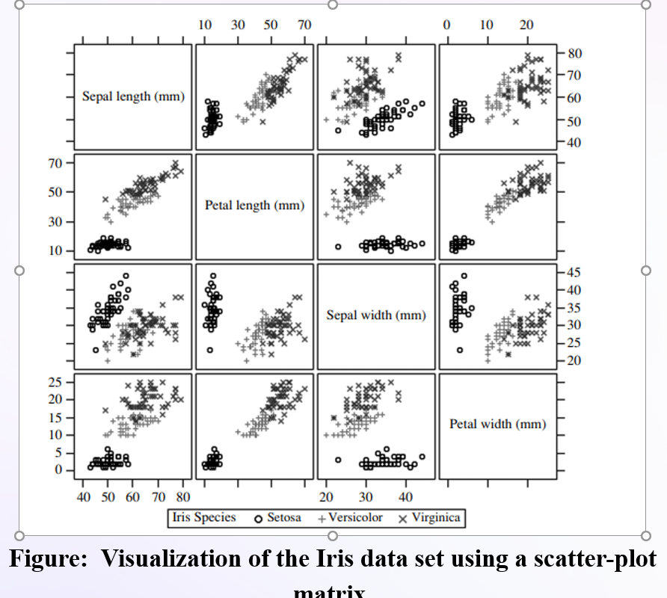

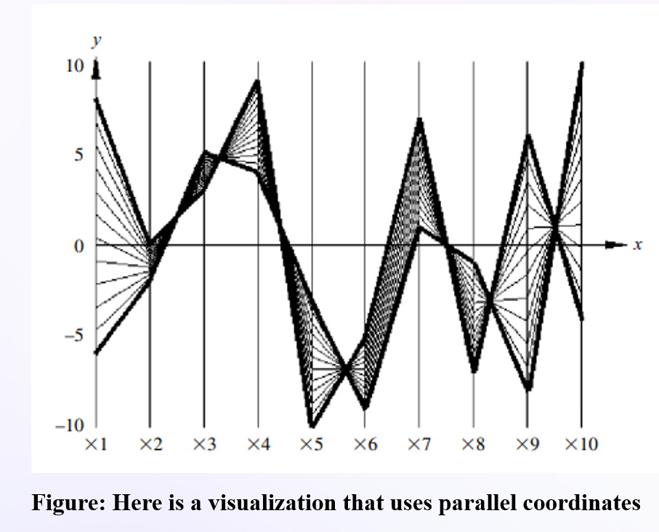
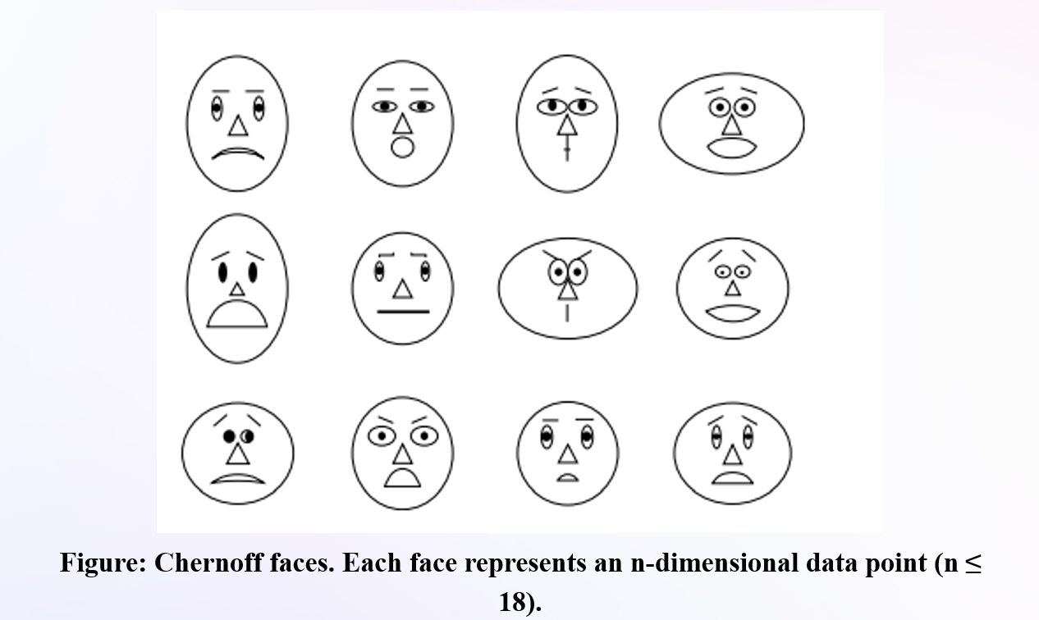
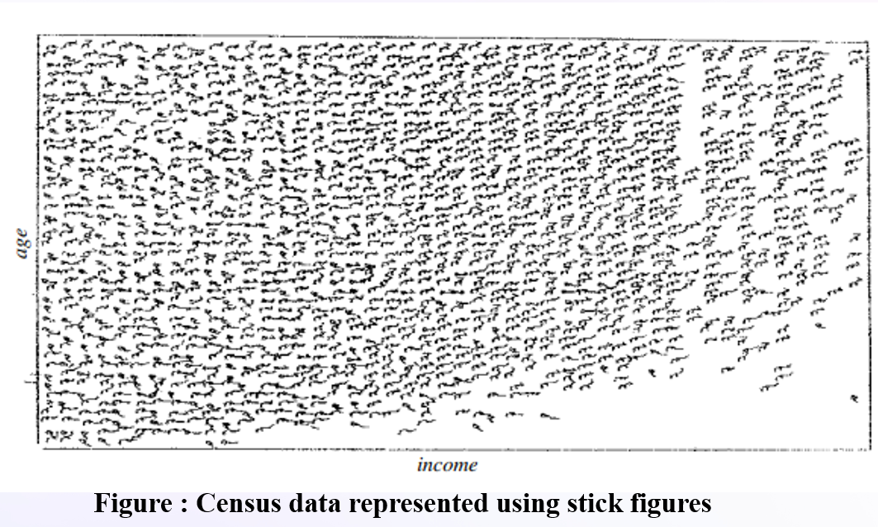
1.13 MEASURING DATA SIMILARITY AND DISSIMILARITY
1.13.1 Data matrix for Dissimilarity Matrix
In data mining, measuring similarity and dissimilarity between data objects is essential for tasks like clustering, classification, and anomaly detection.
  - Similarity measures how alike two data objects are.
  - Dissimilarity measures how different they are.
(High similarity = low dissimilarity, and vice versa)
Data Types Similarity and Dissimilarity Measures
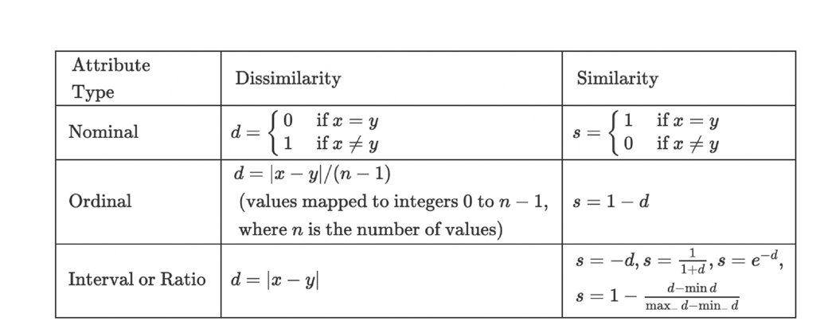Similarity Measures
Similarity measures are mathematical functions used to determine the degree of similarity between two data points or objects. These measures produce a score that indicates how similar or alike the two data points are.
Cosine Similarity:
The cosine similarity between two vectors is calculated as the dot product of the vectors divided by the product of their magnitudes. This calculation can be represented mathematically as follows -
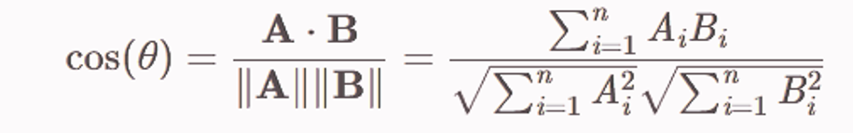
where A and B are the feature vectors of two data points, "." denotes the dot product, and "||" denotes the magnitude of the vector.
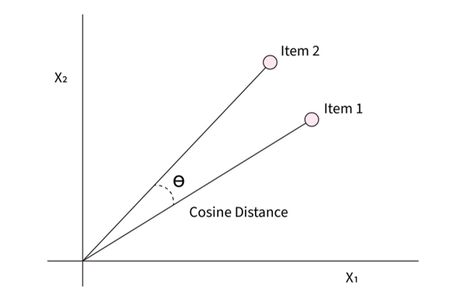
Jaccard Similarity:
Measures similarity between two sets as the ratio of intersection over union.
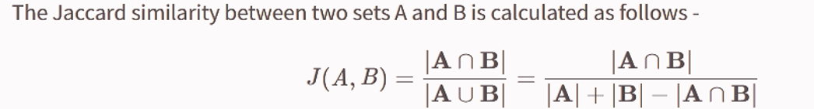
Pearson Correlation Coefficient:
  - Measures the linear relationship between two continuous variables (e.g., X and Y).
  - Range:
−1= perfect negative correlation
0= no correlation
+1 = perfect positive correlation
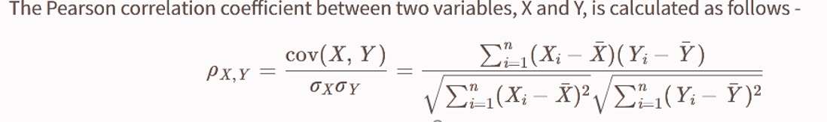where cov⁡(X,Y)cov(X,Y) is the covariance between variables XX and YY, and σXσX​ and σYσY​ are the standard deviations of variables XX and YY, respectively.
Sørensen–Dice Coefficient
The Sørensen–Dice coefficient is a similarity measure used to compare the similarity between two sets.
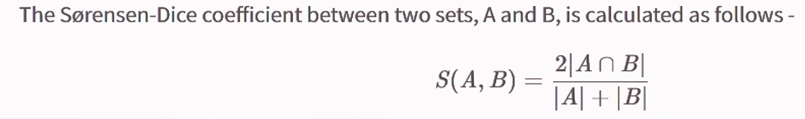where ∣A∩B∣∣A∩B∣ is the size of the intersection of sets AA and BB, and ∣A∣∣A∣ and ∣B∣∣B∣ are the sizes of sets AA and BB, respectively.
1.13.2 Dissimilarity Measures
  - Dissimilarity measures are used to quantify the degree of difference or distance between two objects or data points.
- Euclidean Distance:
  - Euclidean distance measures the straight-line distance between two points in n-dimensional space.
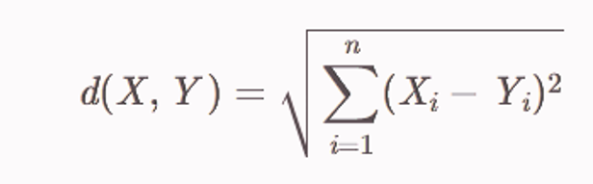
Manhattan Distance
  - sum of absolute differences between coordinates.
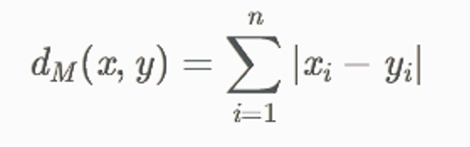
Minkowski Distance (Generalized Distance)
  - A flexible distance metric that includes Manhattan and Euclidean as special cases.
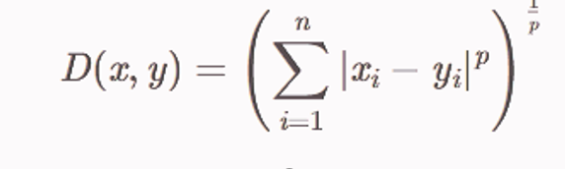
Hamming Distance
  - Number of positions with differing characters in two strings of equal length.
- For example, consider the strings "101010" and "111000". The Hamming distance between these two strings is three since there are three positions at which the corresponding symbols are different: the second, fourth, and sixth positions.

MULTIPLE CHOICE ANSWERS (MCQ’S)
Q1. What is the primary purpose of a data warehouse?
A) Transaction processing
B) Decision support and data analysis
C) Data duplication
D) System backup
Answer: B) Decision support and data analysis
Q2. Which of the following is not a characteristic of a data warehouse?
A) Subject-oriented
B) Time-variant
C) Non-volatile
D) Real-time update
Answer: D) Real-time update
Q3. In a data cube, each cell holds:
A) A database connection
B) A fact or aggregate value
C) A schema diagram
D) A transaction ID
Answer: B) A fact or aggregate value
Q4. Which OLAP operation increases the level of detail?
A) Roll-up
B) Pivot
C) Drill-down
D) Slice
Answer: C) Drill-down
Q5. What does a star schema consist of?
A) Fact table and normalized dimension tables
B) Only fact tables
C) Fact table and denormalized dimension tables
D) Only dimension tables
Answer: C) Fact table and denormalized dimension tables
Q6. Which design approach starts by creating individual data marts?
A) Top-down
B) Waterfall
C) Bottom-up
D) Spiral
Answer: C) Bottom-up
Q7. What is the role of a bitmap index in OLAP?
A) Compress fact tables
B) Join multiple databases
C) Index low-cardinality attributes
D) Encrypt data
Answer: C) Index low-cardinality attributes
Q8. Whih OLAP architecture stores data in multidimensional cubes?
A) MOLAP
B) ROLAP
C) HOLAP
D) SQL-OLAP
Answer: A) MOLAP
Q9. Which is a key benefit of cloud data warehouses?
A) Manual data refresh
B) Limited data access
C) Real-time accessibility
D) On-premise control
Answer: C) Real-time accessibility
Q10. Which of the following is an example of a cloud data warehouse platform?
A) MySQL
B) Oracle 11g
C) Azure Synapse Analytics
D) MS Paint
Answer: C) Azure Synapse Analytics
Q11. What is the goal of data mining?
A) Formatting data
B) Storing transactions
C) Extracting patterns and knowledge
D) Backing up data
Answer: C) Extracting patterns and knowledge
Q12. Which technique is used for classification tasks in data mining?
A) Histogram
B) Decision tree
C) OLAP cube
D) Pivot table
Answer: B) Decision tree
Q13. Which technology allows computers to learn from data?
A) Indexing
B) ETL
C) Machine Learning
D) Networking
Answer: C) Machine Learning
Q14. Which technique in statistics is used to validate a discovered pattern?
A) SQL
B) Hypothesis testing
C) OLAP
D) Data slicing
Answer: B) Hypothesis testing
Q15. Which application uses clustering for customer segmentation?
A) Web scraping
B) CRM
C) Firewall
D) Backup software
Answer: B) CRM
Q16. In search engines, data mining helps with:
A) Query formatting
B) Ad personalization
C) Password recovery
D) Page layout design
Answer: B) Ad personalization
Q17. What is a major issue in mining methodology?
A) Schema renaming
B) Pattern evaluation
C) Cloud syncing
D) HTML formatting
Answer: B) Pattern evaluation
Q18. User interaction in data mining involves:
A) Ignoring feedback
B) Replacing OLAP
C) Providing background knowledge
D) Deleting metadata
Answer: C) Providing background knowledge
Q19. Which attribute type represents measurable numeric values?
A) Ordinal
B) Nominal
C) Numerical
D) Binary
Answer: C) Numerical
Q20. Which attribute type contains only two values like 0/1 or True/False?
A) Categorical
B) Binary
C) Discrete
D) Continuous
Answer: B) Binary
Q21. What measure gives the middle value in a dataset?
A) Mean
B) Mode
C) Median
D) Range
Answer: C) Median
Q22. Which visualization tool shows data spread using quartiles and outliers?
A) Histogram
B) Line chart
C) Boxplot
D) Pie chart
Answer: C) Boxplot
Q23. What chart best shows the relationship between two numerical attributes?
A) Boxplot
B) Scatter plot
C) Histogram
D) Bar chart
Answer: B) Scatter plot
Q24. Which technique uses faces to represent multivariate data?
A) Parallel coordinates
B) Chernoff faces
C) Stick figures
D) Pie charts
Answer: B) Chernoff faces
Q25. Which distance measure calculates straight-line distance in n-dimensional space?
A) Manhattan
B) Euclidean
C) Hamming
D) Cosine
Answer: B) Euclidean
Q26. Which similarity measure is suitable for comparing two text sets?
A) Jaccard
B) Median
C) Regression
D) Mean
Answer: A) Jaccard

