

2024 – Lake Superior College – Advanced GenCyber Camp

**Welcome** to the 2024 Lake Superior College Advanced Gencyber Summer camp! In this module, we will be working with Arduino’s!

Lesson 4 (Making LED blink/getting started with Arduino):

**Components Required:**

**(1) x Elegoo Uno R3**

**(1) x 830 Tie Points Breadboard**

**(4) x M-M wires (Male to Male jumper wires)**

**(1) x RGB LED**

**(3) x 220 ohm resistors**

1. The first thing you are going to need to do is plug your USB A cable into a USB port into your computer and then plug in the male USB B cable into your Arduino usbs port.
2. After this type click start and check device manager

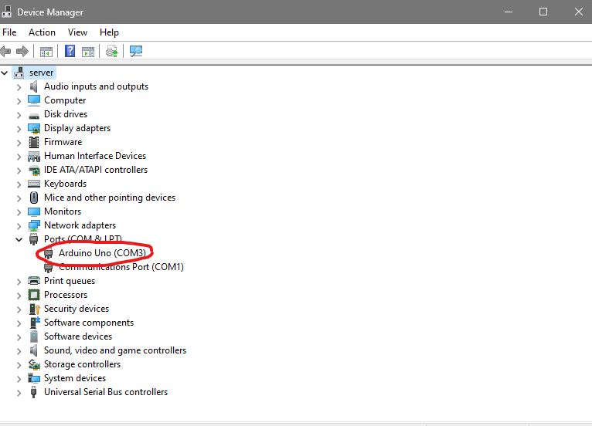

At this point your screen should look like this above. Note your com port and move on

3. Moving on you should start connecting your

4. Next you need to start creating the circuit. I like to start by plugging in the rgb led into the breadboard

5. After plugging in the rgb led the next step is to plug in your three 220 resistors into the board you line them up to pins 1, 3, and 4 of the RGB led

6. You are almost done. The last step is to connect your four jumper wires to the arduino. You want to connect the black male to male jumper wire in between the first and second resistor and plug the other side into the ground port on the digital side of your arduino (This is labeled)

7.After this plug your male-to-male red jumper wire into the digital 6 port of your arduino and the other end directly in front of the first resistor

7b. Plug your green male to male jumper wire into digital port 7 of your arduino and the other end in front of the second resistor

7c. Finally plug in the blue male to male jumper wire into digital port 3 of your arduino uno and the other end directly infront of the third 220 resistor

8. After this is all done your board should look like this.

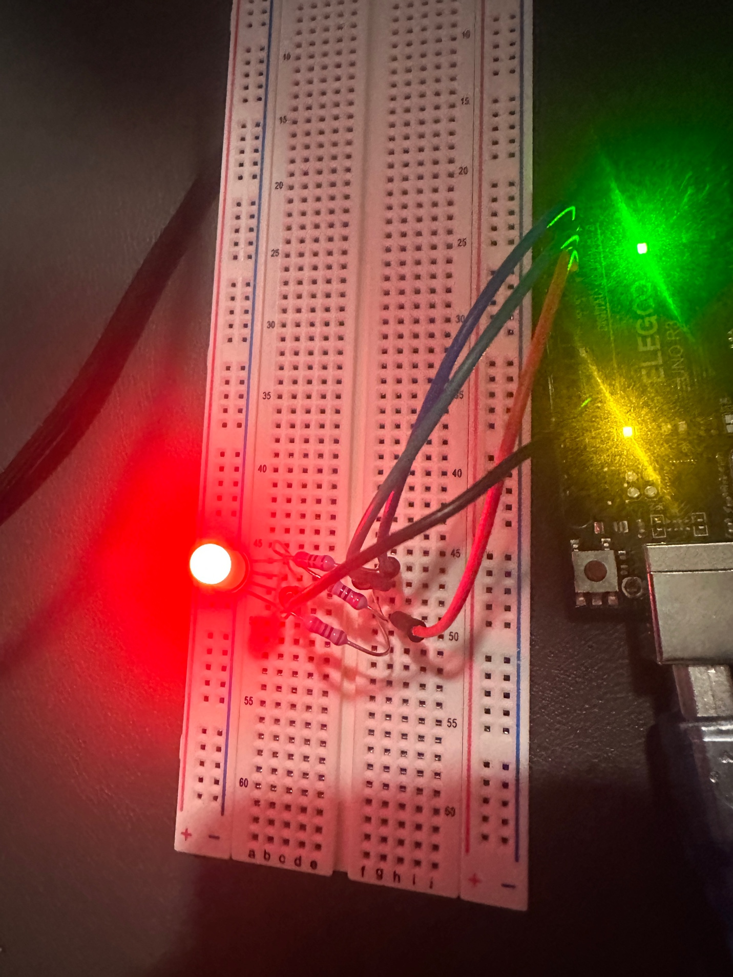

Wiring diagram:

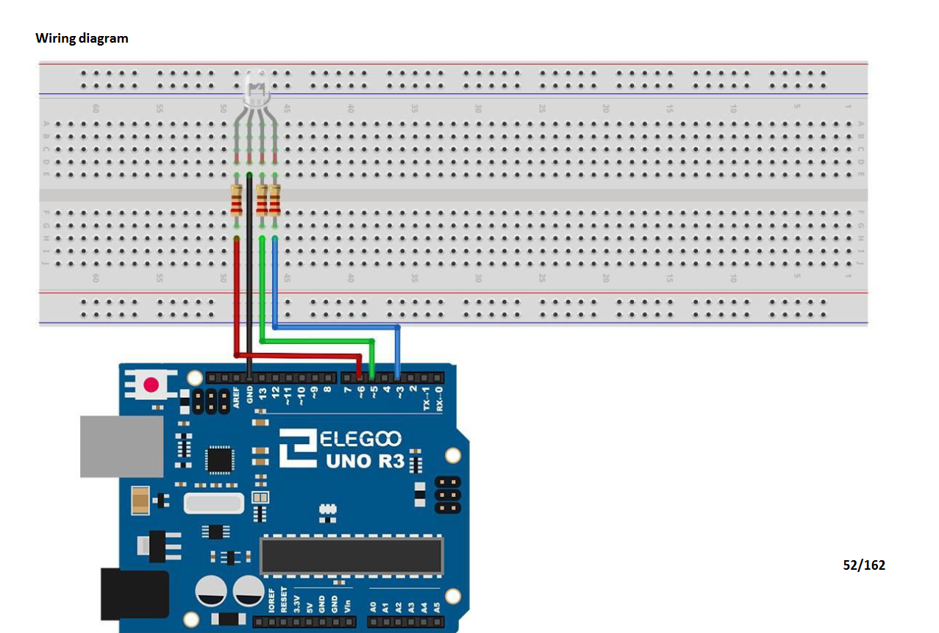9.

Go to back to your desktop and click on the Arduino folder>English>Code>lesson 4 RGB

From here you should explore the code and test different possibilities to familiarize yourself with the Arduino ide.

10.

Bonus challenge: If you finish quickly and you want to challenge yourself you can attempt to write a working program to change the color and speed of the lights.

11. When you are done unplug everything from your breadboard and arduino

Lesson 11(Working with the DHT11 temperature sensor):

**Components Required:**

**(1) x Elegoo Uno R3**

**(1) x DHT11 Temperature and Humidity module**

**(3) x F-M wires (Female to Male DuPont wires(Black, Red, Green)**

1. The first step is to grab your female to male DuPont wires and peel off the red, green, and black wire.
2. Plug the red male end of the male to female DuPont wire into the 5v port of the Arduino uno board and the female part into the middle pin of the dht11 sensor
3. After this plug the black male end of the male to female dupont wire into the gnd port and the female end to the right side of the red wire
4. After this you are going to plug in the male end of the green male to femal dupont wire into number 2 and plug the female end into the left side of the red wire on the dht11 sensor
5. Here is an example of a wire diagram:
6. 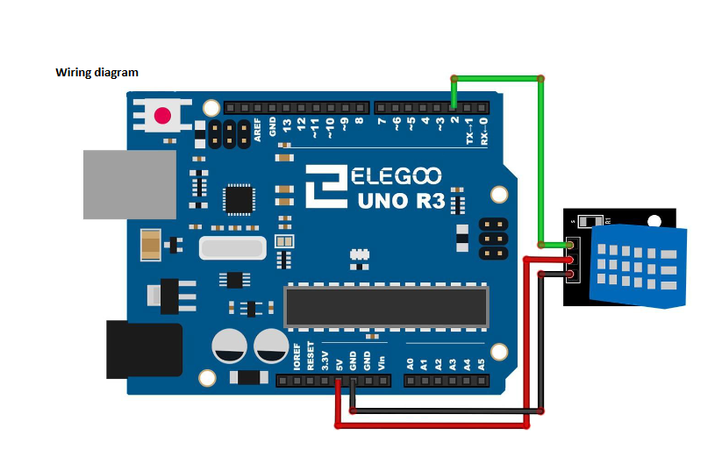
7. After this go to your Arduino ide software > go to manage libraries and type in DHT sensor library and make sure it says by Adafruit. Also ensure that the version is 1.4.6
8. After this it is going to ask you if you want to install all dependencies. Click install all as you will need the dht library as well as the Adafruit unified sensor library for this code to properly run
9. After that press file > new sketch
10. Type out this code:

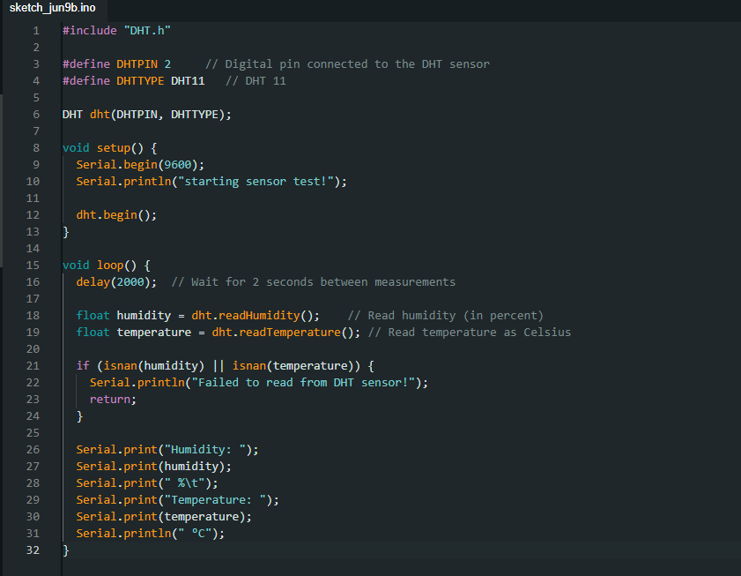

1. After you have ensured that all the wires are wired correctly and installed the needed libraries you can compile the code.
2. After compiling the code, if it does not run don’t be afraid to ask for help.

Bonus/Challenge

If you happen to get done with all challenges you can do your own challenge.

1. The first thing you will need to do is find an interesting tutorial not covered in the previous module.
2. It can be anything simple from making leds change colors to making a fan spin