Cross-broader E-Commerce Research

Table of Contents

US: 3

Amazon 3

eBay 4

Shopify 5

Etsy 6

Wish 7

Jet.com 7

China: 8

Alibaba Taobao 8

Alibaba Tmall 9

Pinduoduo 9

JD.COM 10

Suning 11

Yihaodian 11

Vip.com 12

Canada: 13

Amazon.ca 13

eBay 13

Walmart.ca 13

Bestbuy.ca 13

Canadian Tire 13

Costco 13

Etsy 13

Hudson’s Bay 14

|  |  |  |  |  |  |
| --- | --- | --- | --- | --- | --- |
| E-Commerce | | | | | |
| Country | Company | 2018 Revenue | Model | Strength | Weakness |
| US | [Amazon](https://mgmresearch.com/amazon-revenues-and-profits-analysis-2019-update/) | $232.88B | B2C | 1: Large customer base.  2: Mature logistic, delivery | 1: Less flexible.  2: Low margin. |
| eBay | $10.746B | C2C | 1: No limitations for product.  2: Seller friendly recommendation algorithm. | 1: Tedious customer experience.  2: Public impression as an auction site. |
| Shopify | 1.073B | B2C | 1: Flexible design.  2: Unique brand identity.  3: Easy to use. | 1: Extra money for sellers to do marketing. |
| Wish | 1.9B | B2C | 1: 95% user came from phone app.  2: Strong user stickiness.  3: Low price. | 1: Shortcomings in logistics, payment and even platform rules. |
| Etsy | $0.604B | C2C | 1: Large group of artists to support.  2: Specialized area in handmade. | 1: Limited customers.  2: Not diversified enough. |
| Jet.com | Unfound | B2C | 1: Fast growing customer base. | 1: Spending too much money acquiring customers.  2: Customer not loyal. |
| China | Alibaba | 357B | C2C / B2C | 1: Biggest Chinses E-Commerce.  2: Covered both B2C and C2C.  3: Have the best management team and operation belief.  4: Get fund very early.  5: Huge resources. | 1: No seemingly shortcoming in Chinese market. |
| JD.com | 67 B | B2C | 1: Self built delivery system.  2: Brand is well-known.  3: Good customer experience. | 1: High cost on logistics. |
| Pinduoduo | 68.6 B | C2C | 1: Gain huge amount customer who want to take price advantage.  2: Focused 2ed and 3rd tier cities.  3: Incredible investor team.  4: Greatly utilized wechat.  5: Understand customer psychology. | 1: May encounter lots of law suits.  2: Customers are price driven and not loyal enough. |
| Suning | 36.479 B | B2C | 1: Long history of appliance retailing.  2: Huge physical shop to support delivery. | 1: Difficult to transform from appliance dealer to a comprehensive platform.  2: Poor customer after-sale service experience. |
| Vip.COM | 783.1 M | B2C | 1: ‘Special Sale’ strategy.  2: Buyer team provide special and good price items. | 1: Goods not diverse enough. |
| Yihaodian | Unfound | B2C | 1: Business differentiation.  2: Name recognition is ok. | 1: Low margin.  2: Small Scale  3: Small variety of goods. |
|  |  | Monthly Web Traffic |  |  |  |
| Canada | Amazon.ca | 124M | B2C |  |  |
| eBay | 34.5M | C2C |  |  |
| Walmart | 21.6M | B2C |  |  |
| Bestbuy | 16.7M | B2C |  |  |
| Canadian Tire | 15.2M | B2C |  |  |
| Costco | 14.2M | B2C |  |  |
| Etsy | 7.9M | C2C |  |  |
| Hudson’Bay | 6.6M | B2C |  |  |

*However, everything about strength and weakness here, it is not necessary to be a strength or weakness.

# US:

Amazon: 909.84B Cap / 2018 Annual Revenue: $232.88B

* B2C
* Platform, supply chain, storage.
* More private service. Customer less sensitive to price. High quality products.
* Higher end customers.
* Low cost on supply chain and storage. 60% revenue came from retail stores.
* Pro:
  + Sellers not need to worry marketing but need to be original brand and high quality.
  + Diverse business. Heading more diverse in the future.
  + Massive Subscribers.
* Con:
  + High quality bar for sellers.
  + Low margin.

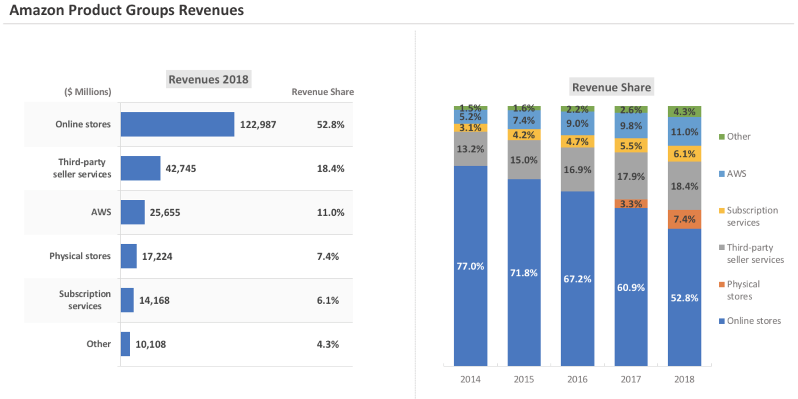

eBay: 33.86B Cap / 2018 Annual Revenue: $10.746B

* C2C
* Pro:
  + Friendly recommendation algorithm and benefit sellers.
  + Anyone can sell and buy, there is no limitations of quality.
  + Massive subscribers.
* Con:
  + Customer impression as an auction platform.
  + Tedious registration and customer experience.

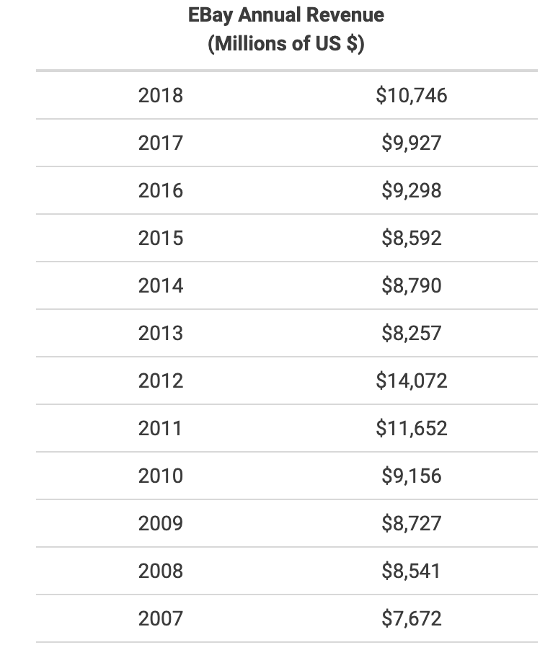

Shopify: 38.09B Cap / 2018 Annual Revenue: 1.073B

* B2C
* Pro:
  + Powerful E-Commerce tools.
  + Unique brand identity, flexible to design, easy to use.
* Con:
  + Extra costs. And need seller to do marketing.

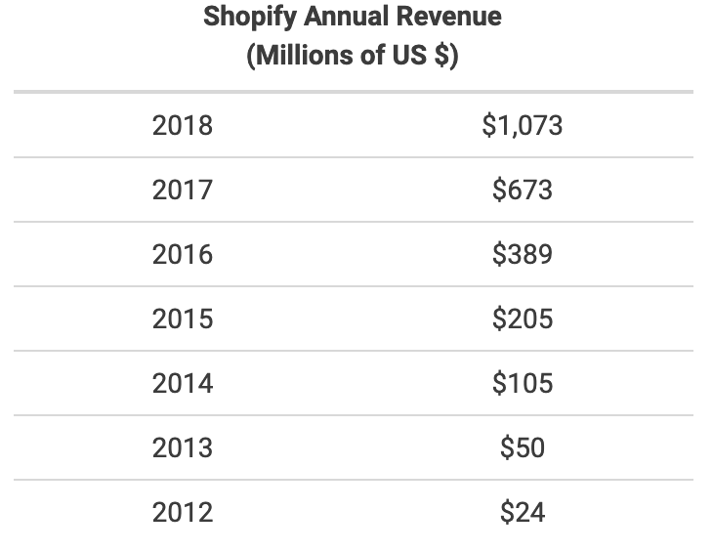

Etsy: 7.1B Cap / 2018 Annual Revenue: $0.604B

* C2C
* Specialized to sell handmade.
* Young customers and sellers. Most of them are female.
* Large artists group.
* Pro:
  + Specialized in handmade.
  + Large artists group to support.
* Con:
  + Not diversified.

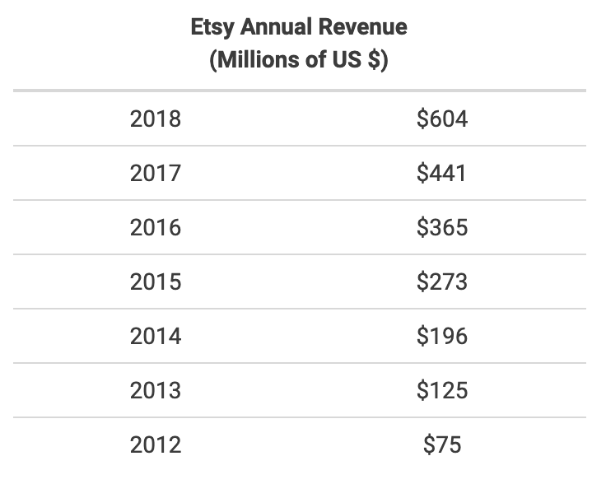

Wish: Estimated value: 8.7B Cap / 2018 Annual Revenue: 1.9B

* B2C
* 95% customers from phone app.
* Pro:
  + Different from cross-border e-commerce platforms such as amazon, eBay and Aliexpress, Wish has more sense of entertainment and stronger user stickiness.
  + Low price, interesting and random products.
* Con:
  + As a newly transformed cross-border e-commerce trading for more than a year, Wish obviously has many shortcomings in logistics, payment and even platform rules.

Jet.com: Estimated value over 3B Cap / 2018 Annual Revenue:

* B2C
* Jet.com started with an online membership model, similar to Costco's online model, that offered discounts to consumers willing to pay a $50 annual fee.
* Pro:
  + The main way Jet.com competes with amazon is through price, which Jet.com claims is 10% to 15% lower than other online stores.
  + Jet.com doesn't run itself, so it's mostly about attracting traditional retailers to join them.
* Con:
  + Jet.com is spending huge money to buy users right now. And Jet's dynamic pricing strategy combined with warehousing is also considered unable to compete with Amazon's mature logistics system.
* Jet's revenue plummeted.

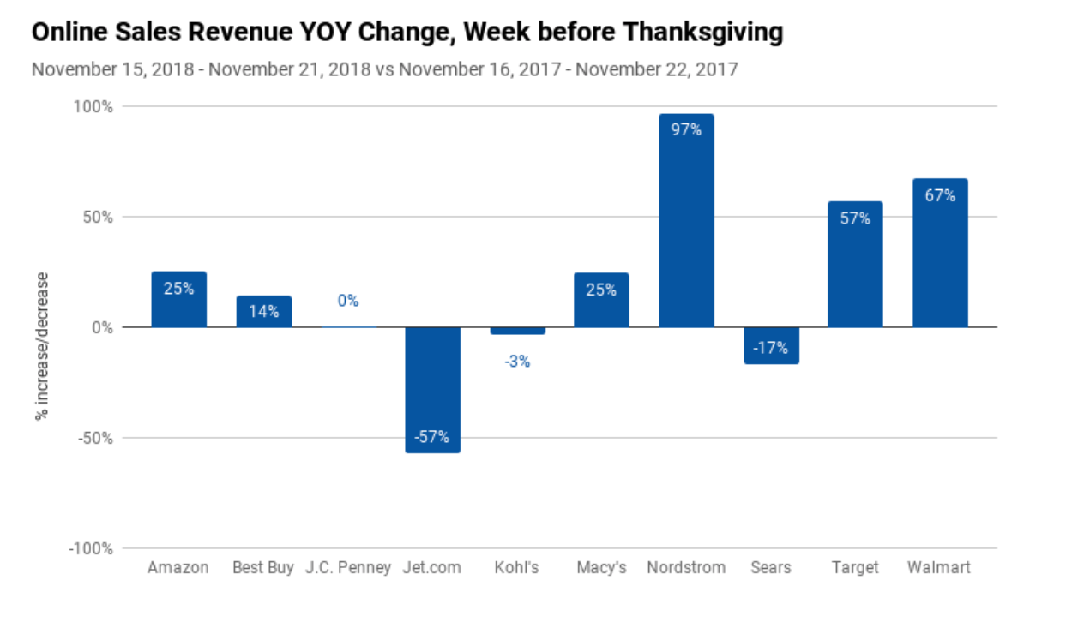

# China:

Alibaba Taobao: 461B Cap / 2018 Annual Revenue: 357B

* C2C
* Largest customer base in China. Owned by Alibaba.
* Brutal-force growing. In the early period, Taobao is heavily advertised. And full of low-price products.
* Taobao's success is largely attributed to Taobao's in-depth understanding of Chinese culture and consumption habits of Chinese netizens, as well as its expectations of the development of online shopping.
* Alibaba's disadvantage is that the product level is not uniformed, and the user experience is a little poor, but Tmall platform effectively makes up for this gap. In terms of logistics, cainiao network was established to effectively integrate logistics resources. However, due to the large number of logistics platforms, user experience is still a little poor.

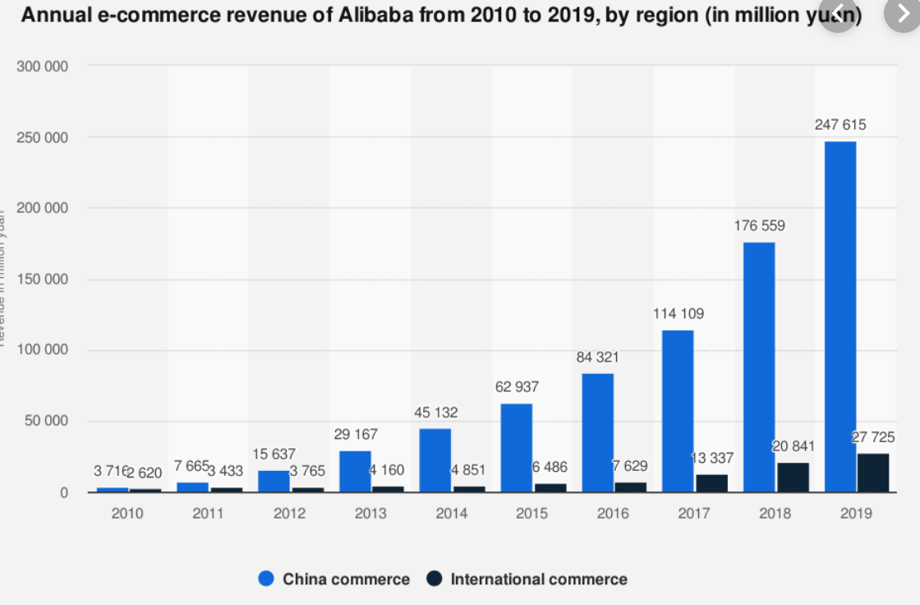

Alibaba Tmall:

* B2C
* Biggest Chinses B2C E-Commerce. Owned by Alibaba.
* High quality products.
* Hold by Alibaba, huge investment, support by Taobao. Also, an alternative of Taobao and target higher end customers.

Pinduoduo: 40B Cap / 2018 Annual Revenue: 1.9B

* C2C
* Used only 3 years to IPO. Huge increase in revenue. Extremely low price.
* Used 3 years to get 300M customers.
* Incredible investor team.
* Focus on lower end customers.
* Fake products are all over the platform.
* Spend too much money on acquiring customers which leads to heavily debt.
* Encounter several huge competitors such as JD, Suning, and Alibaba.
* Weak customer stickiness.
* Pinduoduo’s business model was highly doubted for constant growth.
* We ca see the super high growth rate.

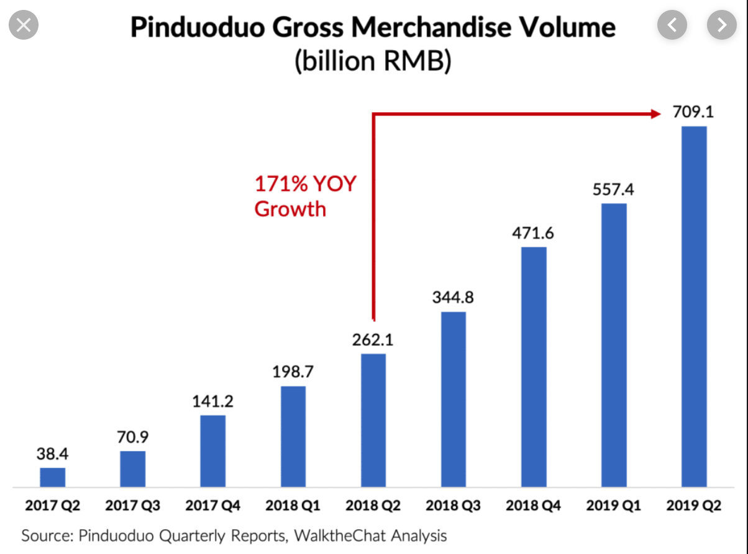

JD.COM: 44B Cap / 2018 Annual Revenue 67B

* B2C
* Jd.com has its own logistics, and its products can be delivered and received quickly. Goods in the same city can be delivered on the same day or the next day, and goods in other places can be delivered on two or three days, with good logistics experience. The purchase of goods is also directly purchased through the manufacturer, and the source of goods is guaranteed.
* The disadvantage may be high operating costs and logistics costs, but good user experience and high user loyalty.

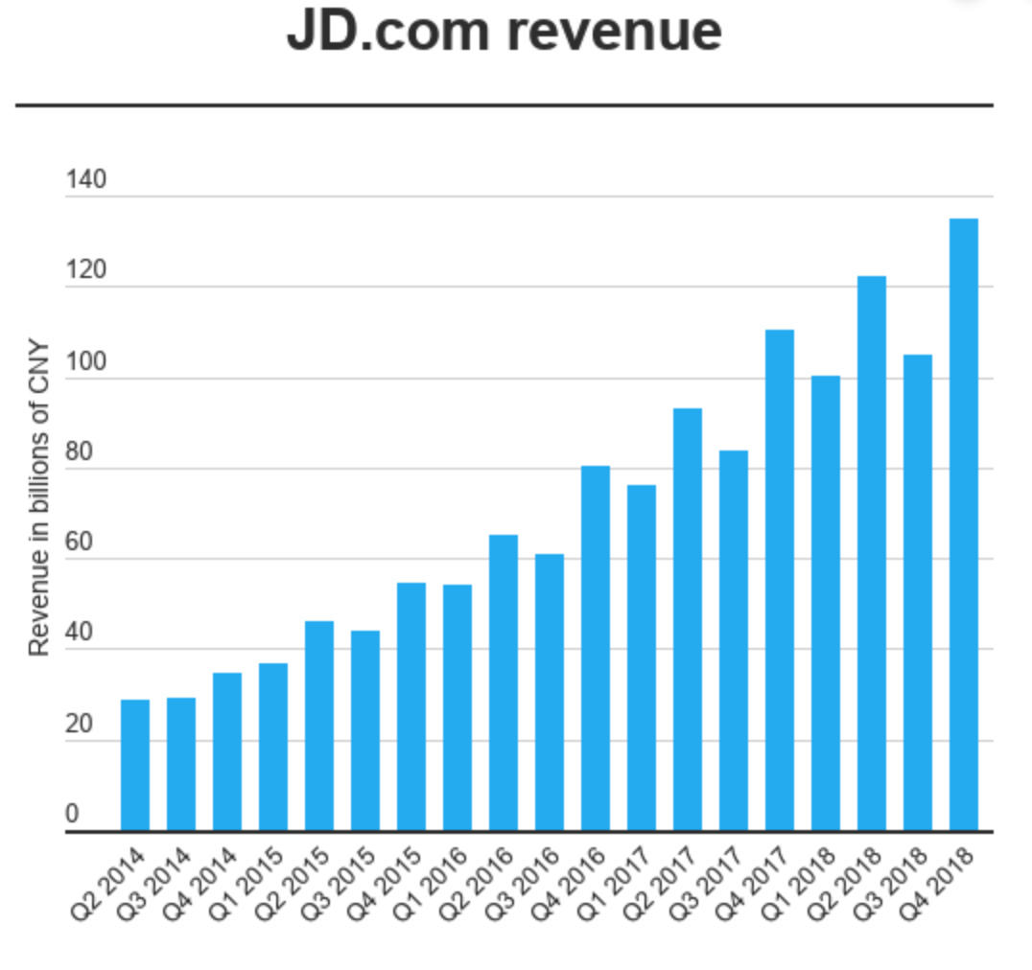

Suning: 99B Cap / 2018 Annual Revenue: 36.479B

* B2C
* Suning's strengths and main focus are household appliances. But, it is hard to form short-term and continuous cash flow. Daily consumer goods are Suning’s weakness, it is difficult to compete with JD and Yihaodian.
* Advantage:
  + Used to have huge retail stores and has been operated for a really long time.
  + Have good delivery system because of the retail stores are everywhere.
* Weakness:
  + Poor management team.
  + Poor after-sale service.
  + Long-term cash flow.
  + Not a main focus. Suning is doing both off line retailing and online platform.

Yihaodian: No Estimated Cap / Estimated 2018 Annual Revenue: 1.8B

* 1： Business category differentiation
  + It started with the concept of "online supermarket", but gradually introduced some other store products through the open platform. Avoided the strengths of other e-commerce sites, with a certain amount of traffic base, and then gradually moves towards the integrated platform. Along the way, it has always performed pretty steady.
* 2： High gross margin and profit.
  + Compared with JD.com, dangdang and other e-commerce giants, Yihaodian has a comparatively higher margin.
* 3： Provided convinience.
  + Although we have supermarket in the community, people are still too lazy to buy stuff especially daily using stuff. And Yihaodian solved this problem. This also won customers’ support.

Vip.com: 6.37B / 2018 Annual Revenue 783.1M

* Vipshop, founded in 2008, is a discount retailer of branded goods, helping brand owners digest their inventory, including clothing, cosmetics, household goods and so on.
* Positioning: Met the consumer’s demand from second and third-tier cities, and digest inventory for second and third-tier brands. And this is how Vipshop become the 3rd place in Chinese E-commerce industry. But now the advantage of Vipshop is not clear any more.
* Although Vipshop's financial figures are good, its share price is still struggling to return to its peak because of the potential for growth.
* Pro:
  + ‘Special Sale’ has fulfilled people’s demand to buy good stuff and also cheap.
    - The "special sale" model is to sell goods at a favorable price within a certain period of time. Different from taobao, jingdong mall and other comprehensive e-commerce, Vipshop, as a vertical e-commerce, mainly focuses on clothing, shoes and hats, and takes female users as the main target group.
  + **Core advantage**: Vipshop has set up a buyer team in 10 countries and regions, with nearly 2,000 buyers. For Vipshop, the professional buyer team has become an important intangible asset. When users are lost in the sea of commodities, Vipshop can select for them. The buyers can buy stuff cannot buy in normal E-commerce platform and with cheap price. So, for example, a Hermes bag is only sold in Europe, and then the sales team will buy those bags in Europe and then put on Vipshop’s website.
* Con:
  + Goods not diverse enough, and this may set business ceiling.
  + More and more platforms are doing ‘special sale’. More competition on the way.

# Canada:

As a medium-sized and mature e-commerce market, the Canadian market is somewhat dominated by the American e-commerce giants, but some local enterprises have also boosted the "sky". Although Canada has only 33 million Internet users, the wealth and online shopping habits of canadians have fed the mature market. Canadians use computers and mobile devices to buy goods and services online.

Mature market also exists fierce competition naturally. Amazon can be said to be a "dominant". However, some traditional brick-and-mortar department stores such as Canadian Tire and Hudson's Bay are still able to occupy a small portion of the market. Some new players, such as Etsy, are also able to carve out new niches for themselves in Canada and globally.

Amazon.ca:

* Estimated monthly web traffic: 124 million

eBay:

* Estimated monthly web traffic: 34.5 million

Walmart.ca:

* Estimated monthly web traffic: 21.6 million

Bestbuy.ca:

* Estimated monthly web traffic: 16.7 million

Canadian Tire:

* Estimated monthly web traffic: 15.2 million

Costco:

* Estimated monthly web traffic: 14.2 million

Etsy:

* Estimated monthly web traffic: 7.9 million

Hudson’s Bay:

* Estimated monthly web traffic: 6.6 million