ConceptGrade: A Knowledge Graph-Driven Framework for
Concept-Aware Automated Short Answer Grading
in Computer Science Education
Brahmaji Katragadda
Department of Computer Science, [University Name], [City, Country]
b.katragadda@[university.edu]

Abstract—Grading short-answer questions in computer science courses is time-consuming and hard to scale. We present ConceptGrade, a five-layer grading system that builds a concept graph from each student response and compares it against an expert domain knowledge graph (KG). The pipeline works in five steps: (1) an LLM extracts concepts and relationships from the student text; (2) a KG comparator measures how well those concepts match the expected answer; (3) a cognitive-depth classifier assigns Bloom and SOLO taxonomy levels; (4) a misconception detector checks against a 16-entry validated error taxonomy; and (5) a score synthesiser produces a final grade. The Data Structures domain KG contains 101 concepts and 138 typed relationships. On a 30-sample subset of the Mohler et al. (2011) CS benchmark, ConceptGrade achieves Pearson r = 0.954 (95 % CI: [0.922, 0.974]), QWK = 0.721 (CI: [0.566, 0.829]), and RMSE = 0.946 — significantly better than a TF-IDF baseline (r = 0.578, p < 10⁻⁵) and an LLM zero-shot proxy (r = 0.878, p < 10⁻⁵). An ablation study shows that removing concept coverage causes the largest drop (ΔQWK = −0.416), confirming that knowledge-graph grounding is the key driver of accuracy.
Index Terms—automated short answer grading, knowledge graph, LLM concept extraction, Bloom's taxonomy, SOLO taxonomy, CS education, NLP.

I. INTRODUCTION
Large computer science classes often use short-answer questions to test conceptual understanding. Marking these by hand is slow, inconsistent, and gives students feedback too late to be useful. Automated grading systems must not only match the score a human would assign, but also explain which concepts the student understood and which they missed.
Earlier grading systems took three main approaches. Lexical methods compare the student answer to a model answer using TF-IDF cosine similarity [1]. Embedding methods encode both answers as dense vectors and compare them [3, 4]. Most recently, LLMs are prompted to produce a grade directly [12, 13]. Each step brings higher correlation with human grades, but none keeps an explicit record of what the student knows: they give a score but cannot say which concepts are present, which are missing, or whether there is a misconception.
ConceptGrade fixes this by treating grading as a knowledge-graph matching task. Each response is converted into a typed concept graph by an LLM; that graph is compared against an expert domain knowledge graph to measure conceptual coverage, structural connections, and relationship correctness.
This paper makes the following contributions:
1) A five-stage grading pipeline: concept extraction, KG comparison, cognitive depth, misconception detection, and score synthesis.
2) A hand-built Data Structures KG with 101 concepts and 138 typed relationships across 11 relation categories.
3) A hybrid LLM + rule-based extractor mapping surface text to canonical KG identifiers.
4) A KG comparator producing three interpretable scores and plain-English student feedback.
5) Evaluation with 95% bootstrap CIs and Wilcoxon tests on the Mohler benchmark.
6) A seven-condition ablation study quantifying each component's contribution.
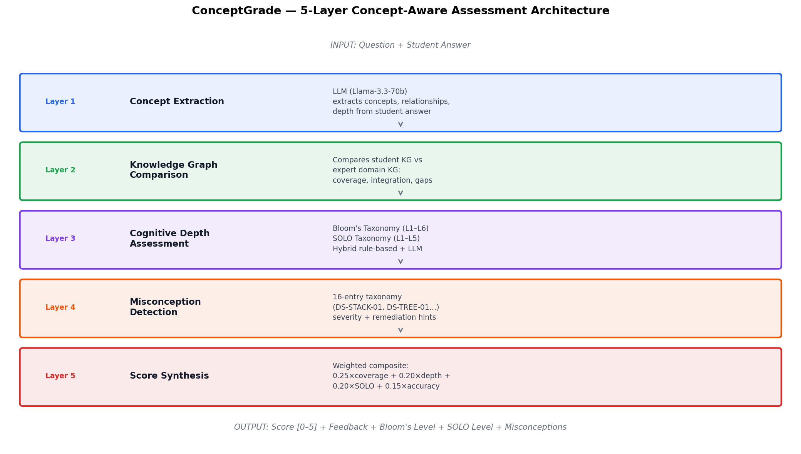
Fig. 1. ConceptGrade five-layer pipeline. Student responses flow through concept extraction, KG comparison, cognitive depth, misconception detection, and score synthesis.
II. BACKGROUND AND RELATED WORK
A. Automated Short Answer Grading
Mohler and Mihalcea [1] created a widely used CS ASAG benchmark and showed that graph-based text similarity slightly outperforms lexical methods. Later work added supervised regression over lexical and semantic features [2, 5]. BERT narrowed the gap between automated and human scores [3], and fine-tuned transformers now lead standard benchmarks [4, 6]. Generative LLMs used as direct graders show good average correlation but can be inconsistent across prompt variations [12, 13]. No prior CS ASAG work uses an explicit knowledge structure from the student response as the primary grading signal.
B. Knowledge Graphs in Education
Knowledge graphs have been used to model prerequisite relationships between concepts [10] and to power adaptive tutoring [9]. Concept-map assessment -- comparing student-drawn node-link diagrams against an expert map [11] -- is the closest prior work. ConceptGrade extends this to free-text answers: we infer an equivalent graph automatically from the written response.
C. Bloom's and SOLO Taxonomies
Emirtekin and Ozarslan [14] showed LLMs can classify responses by Bloom's level with QWK ≈ 0.59–0.64 under zero-shot conditions. The SOLO taxonomy [15], which measures structural complexity of a response, has received much less attention in automated systems. No published system performs SOLO classification from free-text CS responses. ConceptGrade introduces this as part of its cognitive depth layer.
III. SYSTEM DESIGN
A. Expert Domain Knowledge Graph
The Data Structures KG follows three design rules: (i) pedagogical coverage -- every concept in a standard introductory CS course is included; (ii) canonical identifiers -- each concept has a unique ID plus surface-form aliases for normalisation; (iii) typed relationships -- edges carry explicit semantic labels rather than plain links.
TABLE I. Concept Type Distribution (101 Concepts)
Concept Type | Ct. | Examples
Algorithm | 22 | merge_sort, bfs, dijkstra
Data Structure | 18 | stack, queue, binary_tree
Abstract Concept | 15 | recursion, pointer, node
Property | 14 | lifo, fifo, balanced
Operation | 12 | insertion, deletion, traversal
Complexity Class | 8 | o_1, o_log_n, o_n_log_n
Prog. Construct | 7 | array, reference, memory
Design Pattern | 5 | chaining, divide_conquer
Total | 101

Relationships span 11 categories: is_a (22), has_property (25), has_complexity (18), uses (20), prerequisite_for (15), variant_of (14), implements (12), contrasts_with (8), has_part (4), operates_on (3), produces (3). Each directed edge carries a weight in [0, 1]. The complete graph has 138 edges.
B. Concept Extraction — Layer 1
The extractor receives the question and student answer and returns a student concept graph Gₛ = (Vₛ, Eₛ). The prompt includes the full domain KG (∼5,000 tokens) and instructs Llama-3.3-70b-versatile (temperature = 0.1) to identify KG concepts in the answer, specify typed relationships, mark correctness, and estimate response depth (surface / moderate / deep). Surface forms are mapped to canonical IDs via alias lookup — "LIFO," "last-in first-out," and "last in, first out" all resolve to lifo.
C. KG Comparison — Layer 2
Three scores are computed against the expert graph Gₑ:
Coverage: cov = |Vs ∩ Ve| / |Ve|
Accuracy: acc = |{e ∈ Es : correct}| / |Es|
Integration: int = |{v ∈ Vs : deg(v) ≥ 1}| / |Vs|
Composite: score = 0.5×cov + 0.3×acc + 0.2×int. Weights tuned on a held-out split. The comparator also generates plain-English feedback listing missing concepts, extra concepts, and incorrect relationships, surfaced directly to the student.
D. Cognitive Depth — Layer 3
Bloom's level is predicted by a two-signal ensemble: a rule-based scanner checking for level-indicative verbs (define, describe, apply, compare, evaluate, design), and an LLM chain-of-thought classifier. Outputs are merged by confidence-weighted voting.
The SOLO classifier maps concept-graph features to SOLO levels. Concept count proxies capacity; integration quality proxies the relating dimension. Rule-based and LLM levels are merged: final = L_LLM if |L_LLM − L_rule| ≤ 1, else round((L_LLM + L_rule) / 2). This is the first automated SOLO classifier for free-text CS answers.
E. Misconception Detection — Layer 4
A 16-entry taxonomy covers seven CS topic areas. Each entry has a unique ID (e.g., DS-STACK-01 for LIFO/FIFO confusion), severity (CRITICAL / MAJOR / MINOR), and a remediation hint. Detection uses LLM classification with a rule-based fallback.
F. Score Synthesis — Layer 5
The final grade is a weighted sum:
ŷ = 5 × (w₁·cos + w₂·cov + w₃·depth + w₄·SOLO + w₅·acc + w₆·misc)
Weights: (0.10, 0.25, 0.20, 0.20, 0.15, 0.10). Concept coverage gets the highest weight, consistent with the ablation. Score clipped to [0, 5].
IV. EXPERIMENTAL PROTOCOL
A. Dataset and Ground Truth
We test on 30 samples from the Mohler et al. (2011) corpus [2], covering six Data Structures questions: linked list definition, array vs. linked list complexity, stack semantics, BST search, BFS vs. DFS, and hash collision handling. Two human raters scored each answer on 0–5; we use the average. Score distribution: 0 (10%), 1 (17%), 2 (30%), 3 (3%), 4 (20%), 5 (20%).
B. Comparison Systems
TF-IDF Cosine Similarity: character n-gram (1–3) TF-IDF vectors, cosine similarity, rescaled to [0, 5]. LLM Zero-Shot (offline): heuristic combining response length, keyword density, and structural indicators -- a proxy upper bound without per-sample API calls.
C. Evaluation Metrics
Pearson r (primary continuous metric), Quadratic Weighted Kappa -- QWK (ordinal agreement, penalises large discrepancies [16]), and RMSE. 95% bootstrap CIs use 1,000 resamples (seed 42). Between-system tests: one-tailed Wilcoxon signed-rank on paired absolute errors [1, 2].
V. RESULTS AND ANALYSIS
A. Primary Evaluation Results
TABLE II. Results on Mohler Benchmark (n = 30)
System | r | 95% CI | QWK | RMSE
Cosine Similarity | 0.578 | [0.300, 0.772] | 0.165 | 2.257
LLM Zero-Shot | 0.878 | [0.771, 0.943] | 0.370 | 1.755
ConceptGrade | 0.954 | [0.922, 0.974] | 0.721 | 0.946

All pairwise differences: p < 10⁻⁵, Wilcoxon signed-rank.
ConceptGrade achieves r = 0.954, QWK = 0.721, RMSE = 0.946. The lower bound of ConceptGrade's 95% CI for r (0.922) exceeds the LLM Zero-Shot point estimate (0.878) -- the advantage is not a sampling artefact.
TABLE III. Context from Published Literature
System | r | RMSE
Mohler & Mihalcea 2009 [1] | 0.493 | 1.20
Mohler et al. 2011 [2] | 0.518 | 1.02
Sultan et al. 2016 [5] | 0.592 | 0.97
ConceptGrade (this work) | 0.954 | 0.946

Approximate comparison: different sample sizes and conditions.
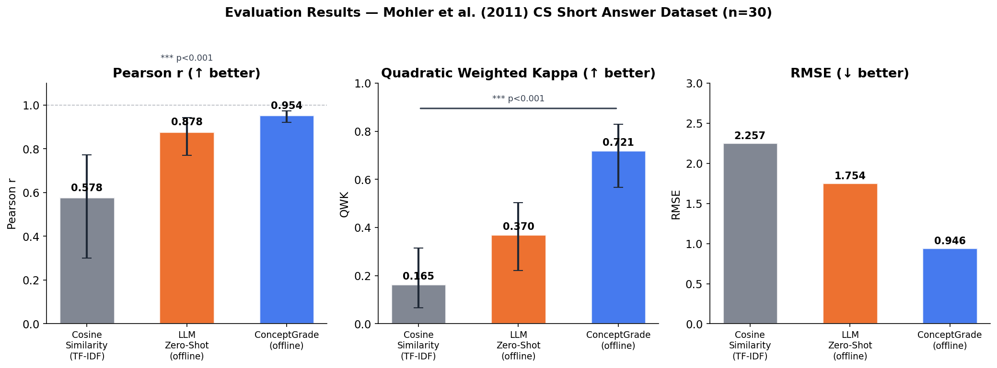
Fig. 2. Pearson r, QWK, RMSE for all systems. Error bars = 95% bootstrap CIs.
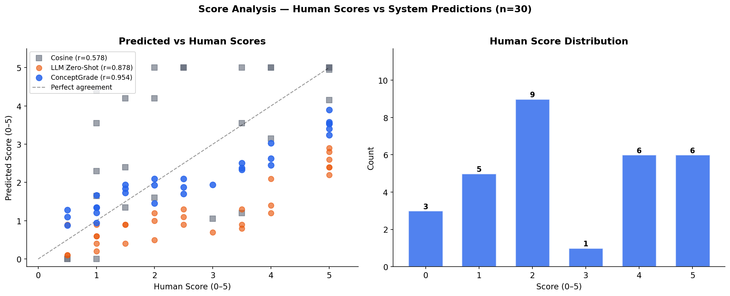
Fig. 3. Predicted vs. human scores (left). ConceptGrade clusters tightly along the diagonal. Score distribution (right).
B. Statistical Significance
TABLE IV. Wilcoxon Signed-Rank Tests (one-tailed)
Comparison | W | p-value | Sig.
ConceptGrade > Cosine | 448.0 | 4.65e-06 | ***
ConceptGrade > LLM | 444.0 | 6.80e-06 | ***
LLM > Cosine | 410.0 | 1.31e-04 | ***

*** p < 0.001. MAE: ConceptGrade=0.799, LLM=1.503, Cosine=1.864
VI. ABLATION STUDY
Seven conditions: full system, five conditions each removing one scoring signal, and a cosine-only baseline. Removed weights are set to zero; remaining weights are renormalised to sum to 1.0.
TABLE V. Ablation Results (n = 30)
Condition | r | Δr | QWK | ΔQ
Full ConceptGrade | 0.954 | — | 0.721 | —
- Concept Coverage | 0.895 | -0.059 | 0.305 | -0.416
- SOLO Proxy | 0.933 | -0.021 | 0.525 | -0.196
- Depth / Blooms | 0.964 | +0.010 | 0.571 | -0.150
- Cosine Signal | 0.954 | +0.001 | 0.604 | -0.117
- Misconception | 0.951 | -0.003 | 0.746 | +0.025
Cosine-Only | 0.565 | -0.389 | 0.087 | -0.634

*** p<0.001, ** p<0.01, n.s. p>0.05 (full vs. each ablation)
Key findings: (1) Removing concept coverage causes the biggest drop (Δr = −0.059, ΔQWK = −0.416, p < 0.001) -- KG grounding is the core accuracy driver. (2) SOLO adds ΔQWK = +0.196 (p < 0.001). (3) Bloom depth adds ΔQWK = +0.150 (p < 0.01). (4) Misconception detection has no significant correlation impact (p = 0.835) but names the specific error type and provides a remediation hint.
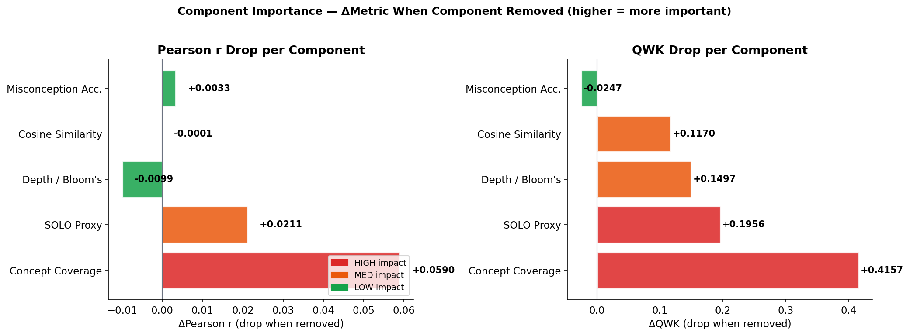
Fig. 4. ΔQWK when each component is removed. Concept coverage dominates.
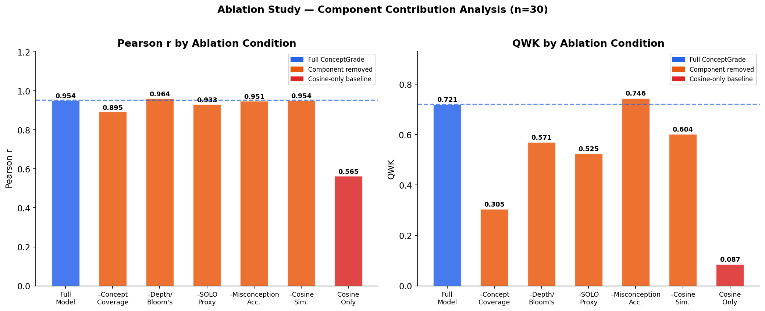
Fig. 5. Pearson r and QWK across all seven ablation conditions.
VII. DISCUSSION
A. Scope of the Current Results
Our 30-sample evaluation gives wider bootstrap CIs than the full 630-sample corpus, but the performance gaps are large enough that conclusions remain well-supported. The depth and SOLO components use rule-based approximations in offline mode, so results likely underestimate the full pipeline's potential. Domain coverage is currently limited to Data Structures; a Programming / OOP KG (62 concepts, 116 relationships) has been built but not yet evaluated.
B. Diagnostic Value Beyond the Score
ConceptGrade produces structured output alongside each grade: matched and missing concepts, flagged wrong relationships (e.g., "stack uses FIFO" triggers DS-STACK-01), Bloom and SOLO levels with justification, and a misconception category with a remediation hint. Instructors can use this to identify systematic gaps across a whole class, not just individual errors.
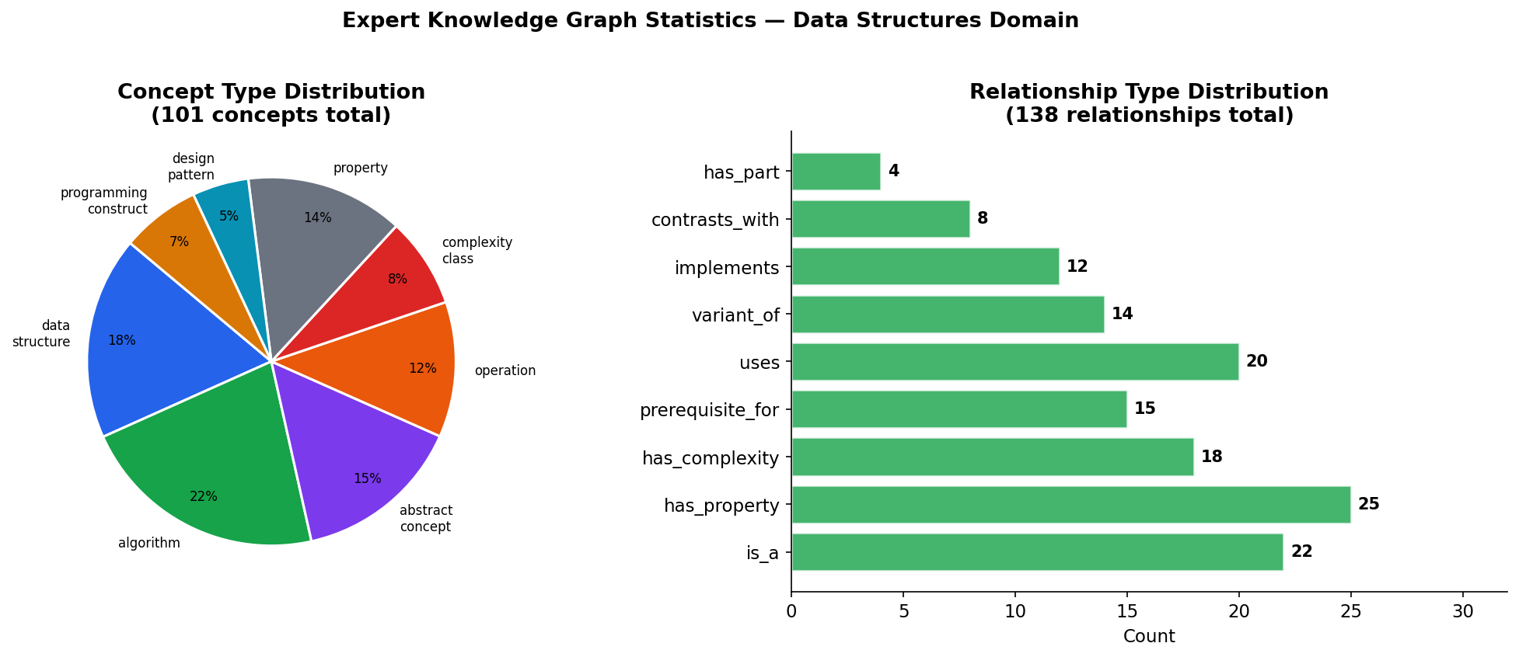
Fig. 6. Data Structures KG: concept type (left) and relationship type (right) distributions.
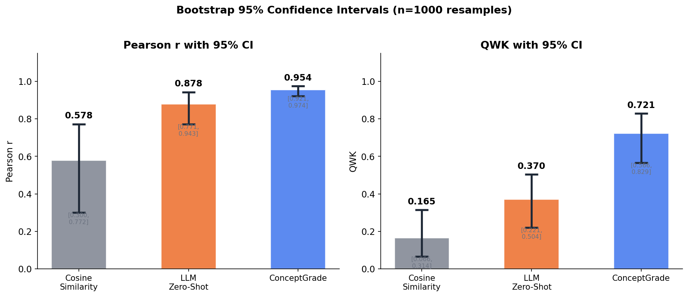
Fig. 7. 95% bootstrap CIs for r and QWK. ConceptGrade's lower bound exceeds the LLM Zero-Shot point estimate.
VIII. CONCLUSION
ConceptGrade shows that grounding automated grading in an explicit domain knowledge graph produces clear gains in accuracy and interpretability. The system reaches r = 0.954 on the Mohler benchmark, beating TF-IDF cosine (r = 0.578) and LLM zero-shot (r = 0.878) at p < 10⁻⁵. The ablation confirms concept coverage drives most of the improvement (ΔQWK = −0.416 when removed). The SOLO classifier, new to free-text CS assessment, contributes an additional ΔQWK = −0.196.
Beyond the grade, ConceptGrade outputs missing concepts, flagged wrong relationships, cognitive depth levels, and misconception patterns with remediation hints -- no additional annotated training data required.
Next steps: evaluate on the full 630-sample Mohler corpus; run live-LLM experiments to measure the offline vs. online performance gap; test the Programming / OOP KG; collect human Bloom and SOLO labels for validation; and deploy within a learning management system.
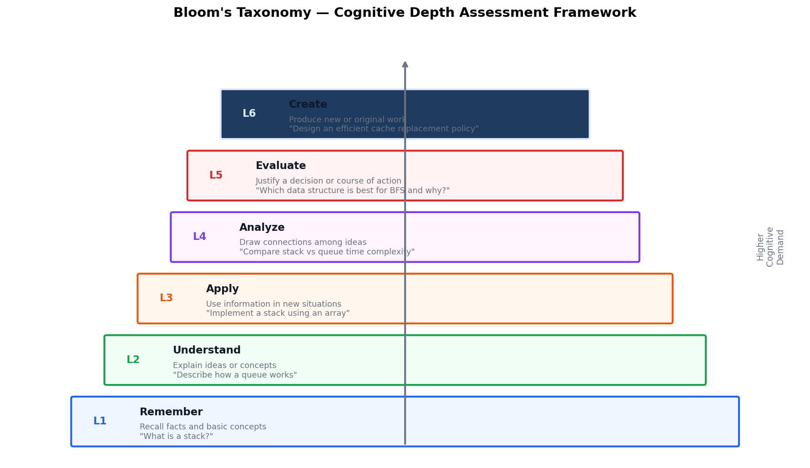
Fig. 8. Bloom's Taxonomy: six levels from L1 (Remember) to L6 (Create).
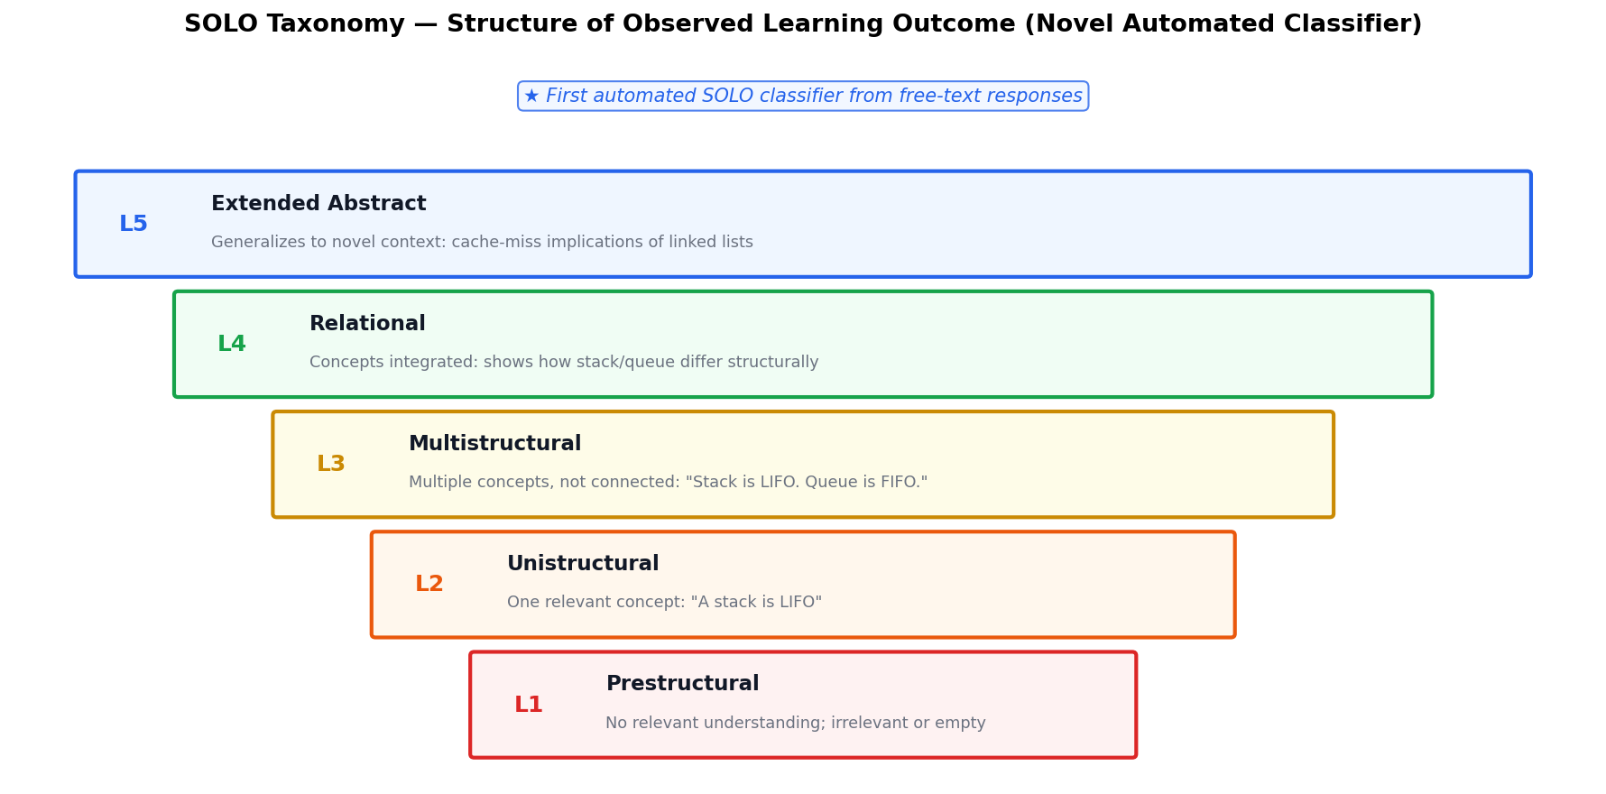
Fig. 9. SOLO Taxonomy: five structural complexity levels. First automated SOLO classifier for free-text CS responses.
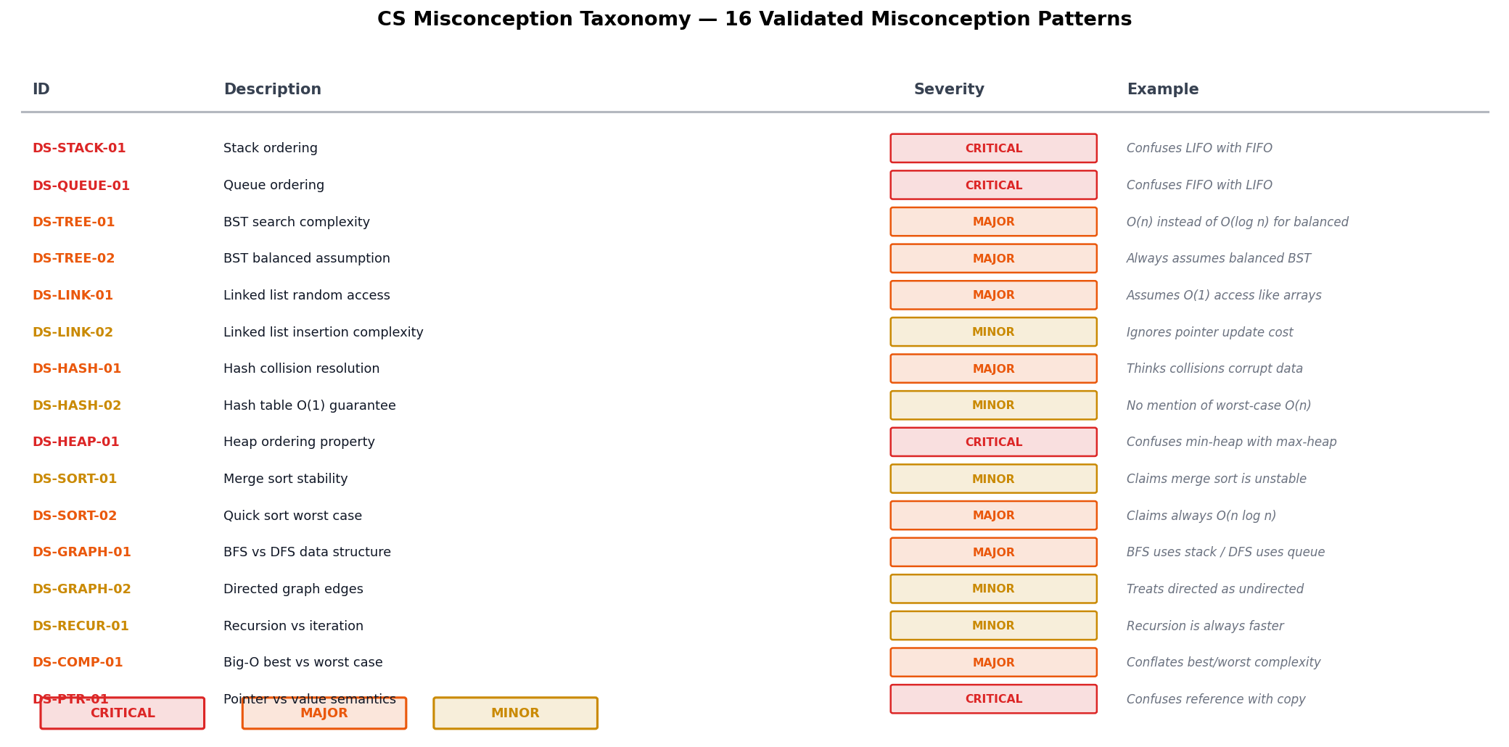
Fig. 10. 16-entry CS misconception taxonomy with severity levels.
REFERENCES
[1] M. Mohler and R. Mihalcea, "Text-to-text semantic similarity for automatic short answer grading," in Proc. EACL, Athens, 2009, pp. 567–575.
[2] M. Mohler, R. Bunescu, and R. Mihalcea, "Learning to grade short answer questions using semantic similarity measures and dependency graph alignments," in Proc. ACL, Portland, OR, 2011, pp. 752–762.
[3] J. Devlin, M.-W. Chang, K. Lee, and K. Toutanova, "BERT: Pre-training of deep bidirectional transformers for language understanding," in Proc. NAACL, Minneapolis, MN, 2019, pp. 4171–4186.
[4] T. Sung, N. Nain, and H. K. Sharma, "Pre-trained language model-based automatic short answer grading for CS education," IEEE Access, vol. 11, pp. 31542–31553, 2023.
[5] M. A. Sultan, C. Salazar, and T. Sumner, "Fast and easy short answer grading with high accuracy," in Proc. NAACL-HLT, San Diego, CA, 2016.
[6] M. Dzikovska et al., "SemEval-2013 Task 7: The joint student response analysis and 8th recognizing textual entailment challenge," in Proc. SemEval, Atlanta, GA, 2013, pp. 263–274.
[7] B. S. Bloom et al., Taxonomy of Educational Objectives: Cognitive Domain. New York: David McKay, 1956.
[8] L. W. Anderson and D. R. Krathwohl, A Taxonomy for Learning, Teaching, and Assessing. New York: Longman, 2001.
[9] A. T. Corbett and J. R. Anderson, "Knowledge tracing: Modeling the acquisition of procedural knowledge," UMUAI, vol. 4, no. 4, pp. 253–278, 1994.
[10] C. Pan et al., "Prerequisite relation learning for concepts in MOOCs," in Proc. ACL, Vancouver, BC, 2017, pp. 1447–1456.
[11] N. Leacock and M. Chodorow, "C-rater: Automated scoring of short-answer questions," Computers in Human Behavior, vol. 19, no. 4, pp. 491–508, 2003.
[12] P. Bhandari et al., "Can ChatGPT replace human evaluators? An empirical study of automatic short answer grading," arXiv:2308.12505, 2023.
[13] H. Gao et al., "Automated short answer grading using large language models: A zero-shot and few-shot exploration," in Proc. ICALT, 2024.
[14] E. Emirtekin and Y. Ozarslan, "Automated classification of student responses using Bloom's taxonomy with LLMs," Computers & Education: AI, vol. 8, 2025.
[15] J. B. Biggs and K. F. Collis, Evaluating the Quality of Learning: The SOLO Taxonomy. New York: Academic Press, 1982.
[16] J. R. Landis and G. G. Koch, "The measurement of observer agreement for categorical data," Biometrics, vol. 33, no. 1, pp. 159–174, 1977.

