ConceptGrade
A Visual Analytics Dashboard for
Knowledge Graph-Grounded Automated Essay Grading

System Overview and Implementation Documentation
Table of Contents
1. What Problem Does This Solve? 3
2. System Architecture 3
Why Three Layers? 4
3. The Knowledge Graph and Grading Pipeline 4
3.1 What Is a Knowledge Graph? 4
3.2 The Five-Stage Grading Pipeline 5
3.3 Results Across Three Datasets 6
4. The Dashboard — What Was Built 6
4.1 Misconception Heatmap 6
4.2 Student Answer Panel (Master-Detail Layout) 7
4.3 Radar Chart (Score Quartile Filter) 7
4.4 Knowledge Graph Ego-Graph 7
4.5 Score Samples Table with XAI Explanation 7
4.6 Cross-Dataset Slopegraph 7
5. How the Charts Are Connected (Bidirectional Brushing) 7
6. The Shared State System (DashboardContext) 8
7. Key Technical Decisions and Why They Were Made 9
7.1 Async File Reading with a Cache 9
7.2 Race Condition Guard in the KG Overlay Fetch 9
7.3 KG Drag Cursor 9
7.4 Path Sanitisation 9
7.5 Knowledge Graph Edge Weight Averaging 10
7.6 Question-Scoped Expected Concepts 10
7.7 CORS Configuration 10
8. User Study Infrastructure 10
8.1 Study Conditions 11
8.2 Study Task Panel 11
8.3 Study Event Logging (Two Storage Layers) 11
8.4 Backend Health Check 12
8.5 XAI Overlay Error Indicator 12
9. The Iterative Design Process 12
10. File Structure 13
11. How to Run the System 13
Start the Backend 13
Start the Frontend 14
Dashboard URLs 14
12. Summary 14

1. What Problem Does This Solve?
When a student submits a written answer to an exam or homework question, grading it fairly and quickly is hard. In large classes, instructors can have hundreds of answers to read. Automated grading tools exist, but most of them just give a number — a score — without explaining why that score was given. This makes it difficult for instructors to trust the system, and even harder to understand which specific concepts a student is missing.
ConceptGrade addresses this in two ways:
- It grades student answers using a Knowledge Graph (KG) — a structured map of the important concepts in a subject and how they relate to each other. Instead of just comparing words, the system checks whether a student's answer demonstrates understanding of the right concepts and their relationships.
- It shows instructors an interactive visual dashboard where they can explore grading results, see which concepts an entire class is struggling with, drill down into individual student answers, and verify whether the automated score makes sense.
The goal is not to replace the instructor. It is to give them a tool that makes it faster and easier to identify where students are going wrong — and to check the automated scores critically rather than just trusting them blindly.

2. System Architecture
The system is built in three layers that work together. Each layer has a clearly defined responsibility, and they communicate through well-defined interfaces.
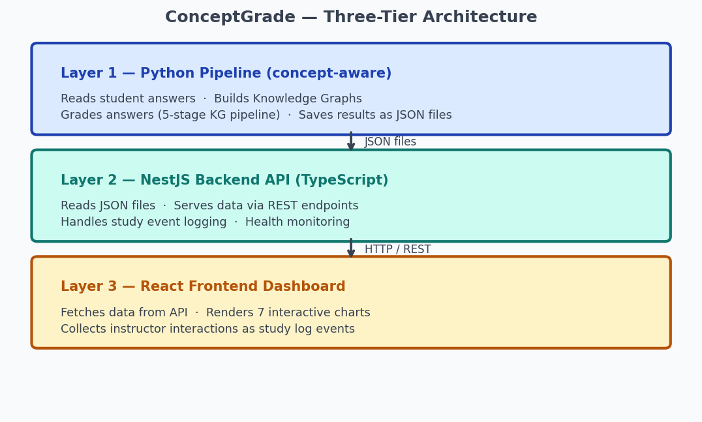
Figure 1 — ConceptGrade Three-Tier Architecture

Why Three Layers?
- The Python pipeline is where the machine learning and Knowledge Graph work happens. It runs offline (not in real time) and saves its results to JSON files.
- The NestJS backend is a lightweight bridge that serves those files to the browser. It does not run machine learning — it reads and organises pre-computed data.
- The React frontend is what the instructor sees. It fetches data from the backend and presents it as interactive charts.
This separation of concerns means the machine learning code and the visual interface are completely independent. Changes to the grading algorithm do not affect the dashboard, and vice versa.

3. The Knowledge Graph and Grading Pipeline

3.1 What Is a Knowledge Graph?
For each exam question, the system builds a small graph where nodes are important concepts and edges are the relationships between them. The graph captures not just what concepts exist, but how they depend on each other. This is important for understanding gaps — if a student does not understand gradient descent, they probably cannot properly explain backpropagation either.
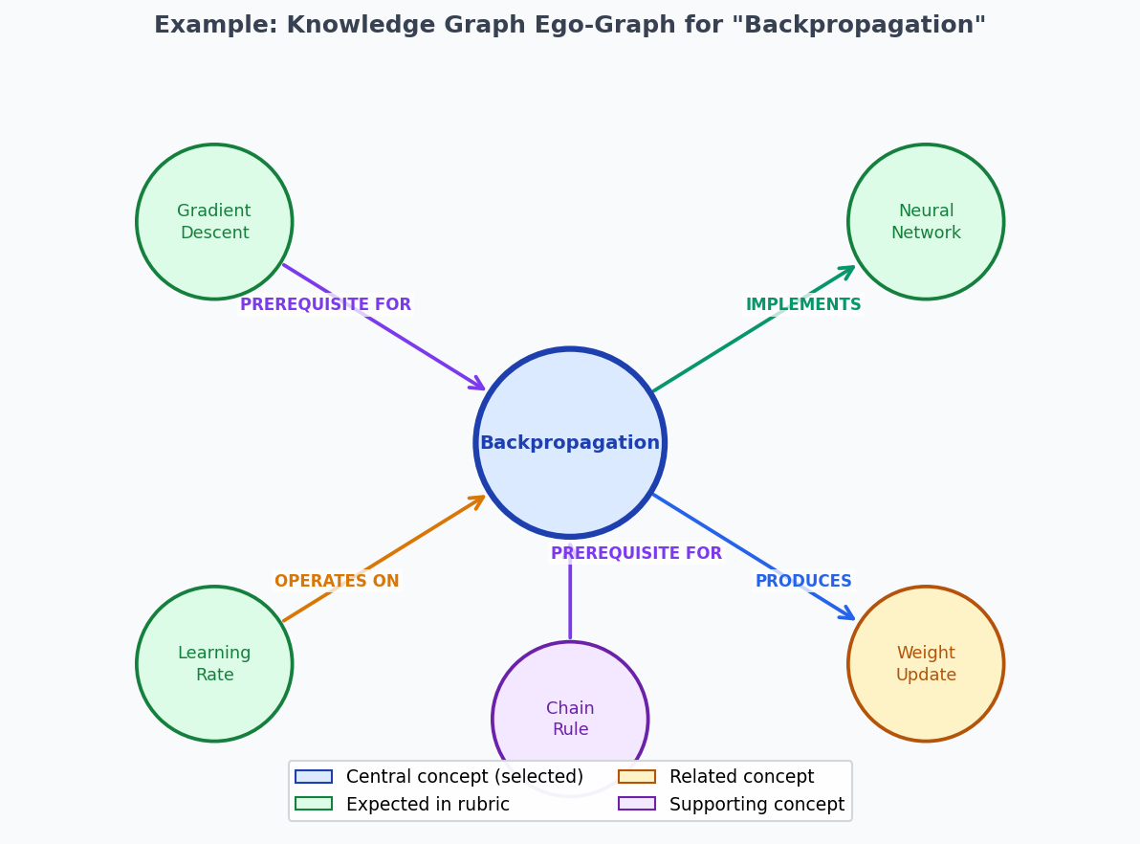
Figure 2 — Example Knowledge Graph Ego-Graph for the concept "Backpropagation"
The system supports eight types of relationships between concepts:
Relationship Type | Meaning
PREREQUISITE_FOR | Concept A must be understood before Concept B
PRODUCES | Concept A leads to or creates Concept B
HAS_PART | Concept B is a component of Concept A
HAS_PROPERTY | Concept B is a property or attribute of Concept A
IMPLEMENTS | Concept A is a practical realisation of Concept B
OPERATES_ON | Concept A acts upon or uses Concept B
CONTRASTS_WITH | Concept A and Concept B are opposites or alternatives
VARIANT_OF | Concept A is a variation or extension of Concept B

3.2 The Five-Stage Grading Pipeline
The grading system runs five processing steps on each student answer. Each stage adds more information until a final score and explanation are produced.
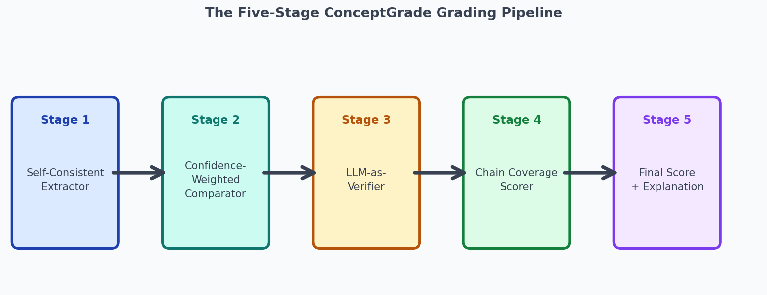
Figure 3 — The Five-Stage ConceptGrade Grading Pipeline
Stage | Name | What It Does
1 | Self-Consistent Extractor | Extracts concepts from the answer three times independently. Only concepts that appear consistently across all three attempts are kept.
2 | Confidence-Weighted Comparator | Compares the extracted concepts against the expected concepts listed in the Knowledge Graph. Each match is weighted by confidence.
3 | LLM-as-Verifier | Uses three different AI "personas" to cross-check concept matches — like having three independent reviewers vote on each concept.
4 | Chain Coverage Scorer | Calculates how much of the prerequisite chain of concepts the student demonstrated, not just isolated concepts.
5 | Final Score + Explanation | Combines all signals into a final score with a plain-language explanation of which concepts were matched and which were missed.

3.3 Results Across Three Datasets
The pipeline was tested against a baseline (a plain language model without the Knowledge Graph). Lower MAE (Mean Absolute Error) means the score is closer to what a human expert would give:
Dataset | Subject | Students | Baseline Error | Our System | Improvement
Mohler 2011 | Computer Science | 120 | 0.330 | 0.223 | ▼ 32.4% (p = 0.001)
DigiKlausur | Neural Networks | 646 | 0.394 | 0.296 | ▼ 24.9% (p = 0.049)
Kaggle ASAG | Elementary Science | 473 | 0.244 | 0.252 | → Minimal change (n.s.)

The improvement is strongest in technical domains (Computer Science, Neural Networks) where subject-specific vocabulary is important. In general-language domains (elementary science), the Knowledge Graph provides less advantage because everyday vocabulary is not as structured.

4. The Dashboard — What Was Built
The dashboard has seven visual components. They are all connected: clicking something in one chart automatically updates the others. This kind of connection is called Coordinated Multiple Views (CMV). The design follows a well-known visual analytics principle: "overview first, zoom and filter, then details on demand."
Component | Purpose | Key Interaction
Misconception Heatmap | Shows which concepts the whole class struggles with | Click a cell → filters the Answer Panel
Student Answer Panel | Shows individual student answers with scores | Click a student → updates the KG Panel
Radar Chart | Shows score profiles across cognitive dimensions | Click a quartile chip → filters the Answer Panel
KG Ego-Graph | Shows the concept neighbourhood and student coverage | Drag nodes · hover for details · colours update per student
Score Samples Table | Shows individual scores with XAI concept explanations | Expand a row → see matched and missed concept chips
Cross-Dataset Slopegraph | Compares system improvement across all three datasets | Read-only reference chart
Class Summary Cards | Headline metrics: N, MAE, improvement %, p-value | Read-only reference cards

4.1 Misconception Heatmap
A grid where rows are concepts and columns are severity levels (Critical, Moderate, Minor, Covered). Each cell is coloured based on how many students fall into that category — darker means more students affected. Clicking a cell automatically filters the Student Answer Panel to show only the relevant students.

4.2 Student Answer Panel (Master-Detail Layout)
A two-column layout. The left column shows a scrollable list of students with score badges and colour-coded severity chips. The right column shows the full detail for the selected student — their complete answer, the reference answer, their SOLO level (how structurally complex their answer is), and their Bloom's level (what cognitive skill they demonstrated). Clicking a student in the list also triggers an asynchronous fetch of their XAI concept data, which updates the KG Panel.

4.3 Radar Chart (Score Quartile Filter)
A radar chart showing average performance across five cognitive dimensions — concept coverage, chain coverage, SOLO level, Bloom level, and score accuracy — broken into four quartiles (Q1 = bottom 25%, Q4 = top 25%). Clicking a quartile chip filters the Student Answer Panel to show only students in that score range.

4.4 Knowledge Graph Ego-Graph
An interactive diagram drawn as SVG (Scalable Vector Graphics) showing the selected concept at the centre with related concepts arranged around it. Edges are labelled with relationship types. Instructors can drag nodes to rearrange the layout, hover over nodes and edges for full descriptions, and see a student overlay where each node turns green (demonstrated), red (expected but missing), or grey (not relevant).

4.5 Score Samples Table with XAI Explanation
A table of individual student scores with an expand button on each row. When expanded, the row shows which concepts the student matched (green chips), which they missed (red chips), and a causal text explanation explaining why the score changed. This is the explainability layer — it tells the instructor not just the score, but why.

4.6 Cross-Dataset Slopegraph
A line chart comparing the system's error against the baseline across all three datasets. Two bracket annotations group the datasets by type — Academic Domains (Computer Science, Neural Networks) and General Education (Elementary Science) — with a subtitle observing that vocabulary richness correlates with improvement.

5. How the Charts Are Connected (Bidirectional Brushing)
All chart components share a single piece of shared state called DashboardContext. This means that when one chart updates its selection, all other relevant charts update automatically. The diagram below shows the two main interaction flows:
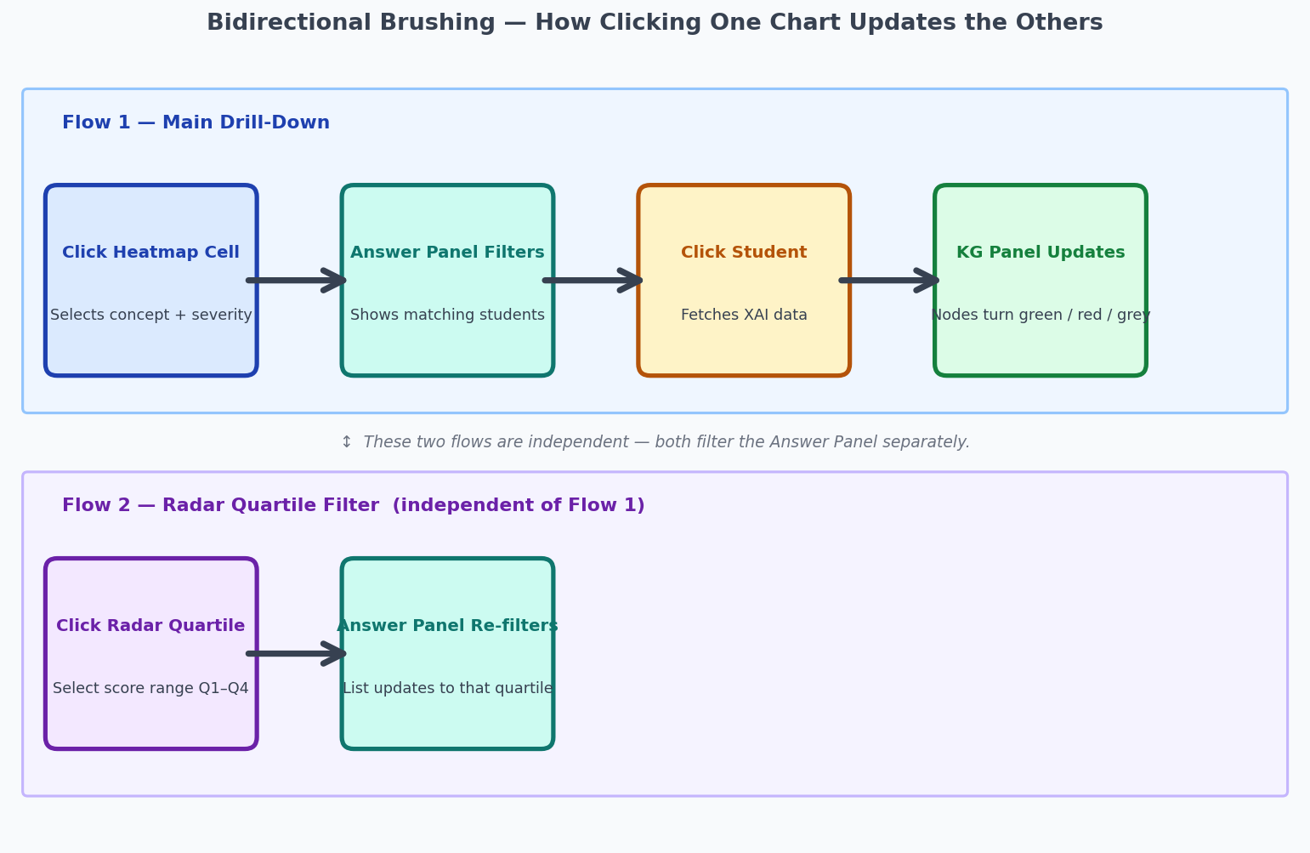
Figure 4 — Bidirectional Brushing: How Clicking One Chart Updates the Others
The top row shows the main drill-down flow an instructor follows to go from class-wide patterns to a specific student's conceptual gap. The bottom row shows how the Radar Chart's quartile filter applies independently, narrowing the student list to a specific score band while keeping the concept selection in place.

6. The Shared State System (DashboardContext)
All interactive variables are stored in one central place — called DashboardContext — that every component can read from and write to simultaneously:
Variable | What It Tracks
selectedConcept | Which concept was clicked in the heatmap
selectedSeverity | Which severity column was clicked (Critical / Moderate / Minor)
selectedStudentId | Which student is currently selected in the Answer Panel
selectedStudentMatchedConcepts | Which concept IDs that student covered (from XAI fetch)
studentOverlayLoading | Whether the KG node colours are currently being fetched
studentOverlayError | Whether the most recent KG overlay fetch failed
selectedQuartileIndex | Which radar quartile filter is currently active (Q1–Q4)

The state is managed using React's useReducer pattern — all state transitions are defined as named actions (SELECT_CONCEPT, SELECT_STUDENT, SET_LOADING, SET_ERROR, SELECT_QUARTILE, CLEAR_ALL). This makes the logic predictable: every place in the code that changes state does so by dispatching a named action, not by directly modifying variables.
Why useReducer instead of useState? Several actions have side effects on other fields — for example, selecting a new concept must also clear the previously selected student. A reducer puts all of this clearing logic in one place, making it impossible to forget a step.

7. Key Technical Decisions and Why They Were Made

7.1 Async File Reading with a Cache
⚠ Problem: The backend originally used synchronous file reading, which blocks the server from handling any other requests while a file is being read. This is fine for a single user but causes noticeable delays when multiple users access the system simultaneously.
✓ Solution: Replaced all file reads with asynchronous reads (fs.promises.readFile) and added an in-memory cache. The first time a dataset is requested the file is read and stored in memory. Every subsequent request for the same file is served from memory without touching the disk.

7.2 Race Condition Guard in the KG Overlay Fetch
⚠ Problem: When an instructor clicks quickly through several students, multiple network requests go out at the same time. If request 3 comes back before request 2, the wrong student's concepts would appear in the KG panel.
✓ Solution: A reference (latestSelectedIdRef) tracks which student was most recently clicked. When a fetch result comes back, it is only applied if the student ID still matches the currently selected student. Stale results from earlier clicks are discarded.

7.3 KG Drag Cursor
⚠ Problem: While dragging a node, the cursor should change to a "grabbing" hand icon. The initial implementation stored the drag state in a React ref, but reading a ref in JSX does not trigger a re-render, so the cursor never visually updated.
✓ Solution: The cursor style is set directly on the SVG element's DOM property (svgRef.current.style.cursor) on mousedown and reset on mouseup. This bypasses React's rendering cycle for this high-frequency visual update.

7.4 Path Sanitisation
⚠ Problem: The API endpoints accept a :dataset parameter in the URL that is used to construct a file path on the server. Without validation, a crafted URL could attempt to read files outside the intended data directory (path traversal attack).
✓ Solution: path.basename(dataset) is applied to every incoming dataset parameter before it is used in a file path. This strips any directory components, ensuring only a filename — not a full path — reaches the file system.

7.5 Knowledge Graph Edge Weight Averaging
⚠ Problem: The same two concepts might be related in multiple questions, each time with a slightly different relationship strength. The original code kept only the first occurrence and discarded all others.
✓ Solution: When the same edge appears multiple times, the weights are accumulated and averaged. The final edge weight represents the consensus strength across all questions where that relationship appears.

7.6 Question-Scoped Expected Concepts
⚠ Problem: Initially, a node in the KG panel was marked as "expected" (red = missing) if it was required in any question across the dataset. This produced false signals — a concept would appear red even if it was never required for the question the student actually answered.
✓ Solution: The KG endpoint now accepts an optional ?questionId= query parameter. When provided, a node is only marked as expected if it is required for that specific question. This makes the red/green visual encoding pedagogically accurate.

7.7 CORS Configuration
⚠ Problem: During the user study, the React frontend (port 5173) needs to talk to the NestJS backend (port 5001). Browsers block this by default unless the server explicitly permits it (Cross-Origin Resource Sharing — CORS).
✓ Solution: Added http://localhost:5173 and http://127.0.0.1:5173 to the backend's list of allowed origins, so the browser permits fetch requests during a local study session.

8. User Study Infrastructure
The dashboard is designed not just as a tool but as a research instrument for measuring how instructors use it. Two study conditions are supported:
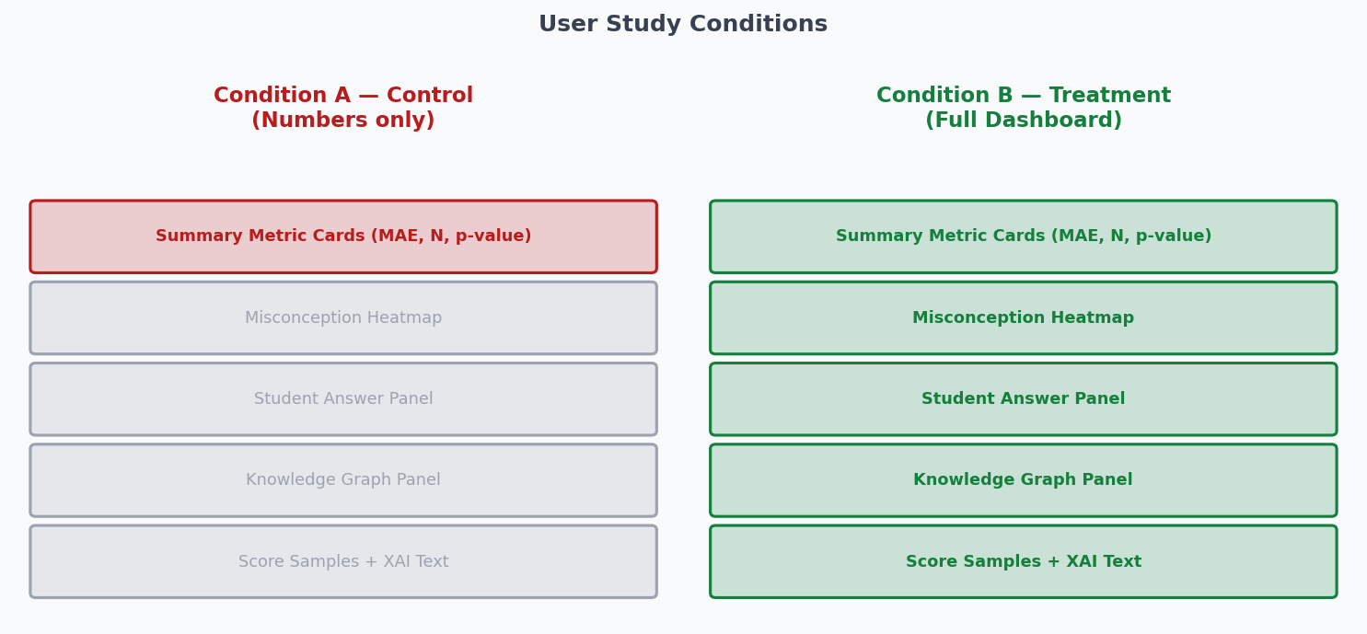
Figure 5 — Condition A (Control) vs Condition B (Treatment)

8.1 Study Conditions
The condition is set via a URL parameter (?condition=A or ?condition=B). The same codebase serves both conditions, ensuring the only difference between participants is the presence or absence of the visual tools.
Condition | What the Instructor Sees | Purpose
A — Control | Four summary metric cards only (N, MAE, improvement %, p-value). No charts. | Represents the current state of practice: instructors receive automated scores with no visual tools.
B — Treatment | The full interactive dashboard with all seven chart components and linking. | Tests whether the visual tools change how instructors explore and verify grading results.

8.2 Study Task Panel
When study mode is active, a task panel appears at the top of the dashboard. It shows the instructor a diagnostic task prompt, a text box for their written response, a confidence slider (1–5), and a Submit button. The panel records the time between first focus and submission.

8.3 Study Event Logging (Two Storage Layers)
Every interaction is recorded as a timestamped event. Two storage layers ensure events are not lost if the browser closes unexpectedly:
Event Type | When It Is Recorded
page_view | When the dashboard first loads
tab_change | When the instructor switches between datasets
task_start | When the instructor first clicks into the response text box
task_submit | When the instructor submits (includes answer, confidence, time taken)
chart_hover | When the instructor interacts with a chart

Storage layers:
- localStorage (primary) — events are written to the browser immediately. The instructor can export all events as a JSON file at any time.
- Server-side JSONL backup (secondary) — each event is also sent to the backend (POST /api/study/log) and appended to a per-session file (data/study_logs/{session_id}.jsonl). Even if the instructor closes the browser without exporting, the data is safe on the server.

8.4 Backend Health Check
The backend exposes a GET /api/study/health endpoint. The frontend pings this on every page load. If the backend is unreachable, a red warning banner appears at the top of the dashboard, alerting the study facilitator before they begin a participant session. This prevents silent data loss.

8.5 XAI Overlay Error Indicator
When an instructor clicks a student, the system fetches the student's XAI concept data to colour the KG nodes. If this fetch fails, the KG panel shows a small amber chip in its header reading "⚠ overlay unavailable". This chip is persistent — it stays visible until the instructor clicks a different student. A persistent chip was chosen over a timed pop-up notification because a notification that disappears automatically can interrupt an instructor's verbal explanation during a think-aloud study session.

9. The Iterative Design Process
The dashboard was built through four structured rounds of critique and improvement. Each round identified specific problems and implemented targeted fixes, following the Design Study Methodology (DSM) — a recognised approach in visual analytics research where design decisions are driven by domain expert feedback.
Round | Focus | Key Changes Made
v1 → v2 | Core interactivity | Added heatmap-to-panel linking, KG ego-graph, radar quartile filter, cross-dataset slopegraph
v2 → v3 | Unified linking | Unified KG overlay so clicking a student from either the Answer Panel or Score Table updates the KG; added slopegraph domain annotations
v3 → v4 | Polish and robustness | KG loading indicator with node dimming, print-safe chart colours, outcome-oriented onboarding tips
v4 → v5 | Study design | Finalised three-task study protocol; identified key think-aloud moments to watch for

After the dashboard was declared feature-complete, a code-level review identified and fixed additional technical issues:
Issue Found | Fix Applied
Synchronous file I/O blocking the server | Replaced with async reads + in-memory cache
Drag cursor not updating during node drag | Direct DOM mutation via ref instead of React state
localhost blocked by browser CORS policy | Added localhost to backend allowed origins
Complex state logic scattered across components | Migrated to useReducer with named action types
Path traversal vulnerability in API parameters | path.basename() applied to all URL parameters used in file paths
KG nodes incorrectly marked as expected | Added question-scoped is_expected via ?questionId= parameter
Edge weights lost on deduplication | Changed to average weights across all occurrences
Silent failure on XAI fetch error | Added persistent ⚠ overlay unavailable chip in KG panel
No server-side study log backup | Added POST /api/study/log endpoint writing to JSONL files
No health visibility for study facilitator | Added GET /api/study/health + frontend warning banner

10. File Structure
The repository is organised as a monorepo with three packages, each corresponding to one tier of the architecture:
File / Folder | Purpose
packages/concept-aware/ | Python pipeline, KG generation, evaluation results
data/*_eval_results.json | Pre-computed grading results for each dataset
data/*_auto_kg.json | Auto-generated Knowledge Graphs per dataset
data/study_logs/*.jsonl | Server-side study event logs (one file per session)
packages/backend/src/visualization/ | NestJS module: REST endpoints for datasets and KG
visualization.controller.ts | Route definitions (7 GET endpoints)
visualization.service.ts | File I/O, caching, data transformation logic
visualization.types.ts | TypeScript interfaces shared between layers
packages/backend/src/study/ | NestJS module: study logging and health
study.controller.ts | POST /api/study/log · GET /api/study/health
study.service.ts | JSONL file writing logic
packages/frontend/src/contexts/ | React shared state
DashboardContext.tsx | useReducer state machine for all CMV selections
packages/frontend/src/components/charts/ | 7 chart components
MisconceptionHeatmap.tsx | Heatmap grid component
StudentAnswerPanel.tsx | Master-detail student list + detail pane
StudentRadarChart.tsx | Quartile radar chart with filter chips
ConceptKGPanel.tsx | SVG ego-graph with drag, hover, and student overlay
ScoreSamplesTable.tsx | Expandable score table with XAI concept chips
CrossDatasetComparisonChart.tsx | SVG slopegraph with domain brackets
packages/frontend/src/pages/ | Top-level pages
InstructorDashboard.tsx | Main layout, condition gating, study task panel
packages/frontend/src/utils/ | Utilities
studyLogger.ts | Event logging to localStorage + server backup

11. How to Run the System
Prerequisites: Node.js 18+, Python 3.12, Yarn

Start the Backend
cd packages/backend
node_modules/.bin/nest start
# API available at http://localhost:5001

Start the Frontend
cd packages/frontend
yarn dev
# Dashboard available at http://localhost:5173

Dashboard URLs
URL | What You See
http://localhost:5173/dashboard | Full dashboard (default)
http://localhost:5173/dashboard?condition=A | Control — metric cards only (no charts)
http://localhost:5173/dashboard?condition=B | Treatment — full dashboard + study task panel
http://localhost:5001/api/study/health | Backend health check (returns { status: "ok" })

12. Summary
ConceptGrade is a three-tier research system that combines automated essay grading with an interactive visual dashboard for instructors. The grading pipeline uses a Knowledge Graph to ground its scoring in structured domain knowledge, achieving significant error reduction in technical subject areas (32.4% in Computer Science, 24.9% in Neural Networks).
The dashboard presents grading results through seven coordinated visual components that let instructors explore class-level patterns, drill down into individual students, verify automated scores using plain-language explanations, and build a richer understanding of where students are going wrong conceptually.
The system was developed through four rounds of structured design review, with each round driven by domain-expert feedback. A subsequent code-quality review addressed ten technical issues — covering performance, reliability, security, and study data integrity — resulting in a codebase that is robust and production-ready for a controlled user study.
The ultimate goal of ConceptGrade is not to automate the instructor out of the loop. It is to give instructors a sharper lens — so they can spend less time reading every answer and more time helping the students who need them most.

