ConceptGrade: A Knowledge Graph-Grounded Visual Analytics System
for Automated Essay Grading with Explainable Feedback
Brahmaji Katragadda

Abstract
Automated essay grading systems are often treated as black boxes by educators: a score appears, but the reasoning remains opaque. This paper presents ConceptGrade, a visual analytics system that makes grading transparent and actionable. We ground grading decisions in explicit concept-matching using Knowledge Graphs extracted from instructor rubrics. A five-stage pipeline (self-consistent extraction, confidence-weighted matching, LLM verification, chain coverage analysis, final aggregation) produces not just a score but a detailed reasoning trace. An interactive dashboard presents linked, brushable views (misconception heatmap, concept frequency, score distributions, knowledge graph subgraph) enabling instructors to validate, debug, and refine the system. Across three datasets (1,239 answers), ConceptGrade achieves 32.4% MAE reduction over a language model baseline (p=0.0013). More importantly, the visual interface returns agency to instructors: they can inspect any answer, trace the logical reasoning chain, and understand exactly why the system assigned a particular score. We demonstrate a production-ready system (Python pipeline, NestJS API, React dashboard) suitable for classroom deployment. This work bridges educational assessment and visual analytics, showing how interactive visualization can turn a potentially alienating automation technology into a tool for instructor empowerment and student feedback.
Keywords: Automated essay grading, Visual analytics, Knowledge graphs, Explainable AI, Educational assessment, Interactive visualization, Human-AI collaboration, Short-answer evaluation

1. INTRODUCTION

1.1 Motivation and Problem Statement
Automated essay grading systems have the potential to transform educational assessment at scale. A large lecture course with 500 students might require 10,000+ hours of manual grading—an impossible burden. Automated systems promise to liberate instructors from this mechanical work, freeing time for more meaningful activities: designing better assessments, providing individualized feedback, and mentoring.
Yet instructors remain deeply skeptical of such systems. When an automated system assigns a student's answer a score of 2/5, the instructor cannot ask: Why? Which concepts did the system think were missing? Did it misunderstand the student's phrasing? Is the student confused about a prerequisite concept, or simply communicating poorly? Without this transparency, instructors cannot validate the system's reasoning or provide targeted feedback to students. The system becomes an alien authority, making high-stakes decisions without explanation.
This paper addresses this fundamental trust problem. We present ConceptGrade, a visual analytics system that makes automated grading not just accurate, but transparent and actionable. Instead of a black-box model outputting a score, ConceptGrade: (1) grounds grading in an instructor-authored knowledge structure (Knowledge Graph from the rubric), (2) traces the reasoning path explicitly (which concepts were matched, which were missed, whether the logical chain was complete), and (3) exposes this reasoning through interactive visualization that instructors can inspect, validate, and debug.

1.2 Research Questions
This work addresses three research questions:
- RQ1: Can a knowledge graph-grounded pipeline achieve higher grading accuracy than a generic language model baseline while maintaining interpretability?
- RQ2: How can visual analytics effectively surface the reasoning behind automated grading decisions to enable instructor validation?
- RQ3: What interaction patterns (brushing, drilling, filtering) are most useful for educators to diagnose grading errors and refine rubrics?

1.3 Contributions
This paper contributes:
- A five-stage concept-matching pipeline that combines self-consistent LLM extraction, confidence-weighted semantic matching, LLM-based verification, logical chain coverage analysis, and principled aggregation. The approach achieves 32.4% MAE reduction over an LLM baseline across three datasets (p=0.0013).
- A methodology for constructing problem-specific Knowledge Graphs from instructor rubrics, enabling grading to be rooted in instructor-defined learning objectives rather than external ontologies.
- An interactive visual analytics dashboard with linked, brushable views (misconception heatmap, concept frequency chart, score distribution, KG subgraph) designed for educator validation and error diagnosis.
- A production-ready three-tier system (Python pipeline, NestJS REST API, React frontend) suitable for classroom deployment, evaluated across three datasets (Mohler, DigiKlausur, Kaggle ASAG) spanning different domains and rubric structures.
- Evidence that visual analytics can bridge the gap between automation and human agency: instructors can use the system to understand machine reasoning, validate outputs, and iteratively improve grading criteria.

1.4 Paper Organization
The remainder of this paper is organized as follows. Section 2 reviews related work in automated essay grading, knowledge graphs, explainable AI, and visual analytics for education. Section 3 describes the system architecture and the five-stage grading pipeline. Section 4 details the visual analytics dashboard design and interaction flows. Section 5 presents the evaluation methodology and datasets. Section 6 reports results and quantitative improvements. Section 7 discusses findings, limitations, and design trade-offs. Section 8 concludes and outlines future work. Appendix A provides a detailed worked example of the pipeline on a real student answer.

2. RELATED WORK

2.1 Automated Short-Answer Grading
Automated short-answer grading (ASAG) has been an active research area for over two decades [1]. Early work relied on surface-level lexical metrics: edit distance (Levenshtein), n-gram overlap, and TF-IDF cosine similarity. These approaches are brittle when students paraphrase. For instance, "The enzyme catalyzes the reaction" and "The enzyme speeds up the reaction" are semantically equivalent but score poorly under string matching.
Semantic approaches emerged in the 2010s. Mohler et al. [1] pioneered latent semantic analysis (LSA), mapping both rubric and student answers into a shared conceptual space and scoring via cosine similarity. This tolerates paraphrasing better than lexical approaches but remains brittle on domain-specific terminology.
Recent work leverages pre-trained language models. Riordan et al. [2] stacked bidirectional LSTMs over GloVe embeddings. Sung et al. [3] fine-tuned BERT on essay scoring datasets. Ke & Ng [4] combined BERT with handcrafted linguistic features (parse tree depth, pronoun diversity). These neural approaches achieve high correlation with human scores on benchmark datasets.
Critical limitation: All prior ASAG systems output a score (or score distribution) without exposing the decision path. When an LLM assigns a 2/5, instructors see no explanation of which concepts the system considered, which were matched, which were missed, or why. This opacity makes it impossible for instructors to validate the system or provide actionable feedback to students. ConceptGrade addresses this by making the grading logic transparent: each decision traces back to explicit concept matching and logical chain verification.

2.2 Knowledge Graphs in Education
Knowledge graphs have seen growing adoption in educational technology. Hu et al. [5] built curriculum KGs for personalized course sequencing. Wolfson et al. [6] used KGs for question generation, ensuring comprehensive coverage of learning objectives. Xie et al. [7] constructed procedural KGs to trace multi-step problem solutions.
In the grading context, KGs have been underexploited. Maharjan et al. [8] enriched ASAG by linking student concepts to DBpedia (a large public KG), reasoning that expanded knowledge improves matching. However, external KGs like DBpedia are domain-general and may include irrelevant relationships; they are not aligned with an instructor's specific course objectives.
ConceptGrade's key innovation is to construct a bespoke, problem-specific KG directly from the instructor's rubric. The rubric—not an external database—defines correctness. We treat the rubric as semi-structured text and use LLMs to extract concepts and relationships. The resulting KG is small, interpretable, and aligned with the instructor's learning objectives. This approach is more practical and defensible than relying on large external ontologies.

2.3 Explainable AI and Interpretability in Education
Explainability in automated grading has received limited attention in the literature. Most work has focused on post-hoc explanation methods. Kamarainen et al. [9] visualized feature importance in neural graders using LIME and SHAP. Prabhumoye et al. [10] applied attention visualization to sequence-to-sequence models, highlighting which words the model 'focused on'.
These post-hoc methods reveal which features the model weighted heavily, but not the reasoning process itself. An instructor might learn that 'enzyme' and 'substrate' contributed to the score, but not whether the system verified both concepts were correctly applied, or whether it recognized missing prerequisites (e.g., 'binding must precede catalysis').
ConceptGrade adopts a different philosophy: interpretability by design, not post-hoc. Instead of training a black-box model and explaining its decisions afterward, we build interpretability into the grading logic. Each pipeline stage has clear semantics (extraction, matching, verification, chaining), and the final score is computed as an explicit aggregation of these stages' outputs. This aligns with how educators naturally reason about correctness: Do the concepts present in the answer match the rubric? Is the logical flow complete? Are there missing prerequisites?

2.4 Visual Analytics for Education
Learning analytics dashboards are prevalent in education technology. Scheffel et al. [11] survey ~80 systems, finding they predominantly target learning insights: 'Which students are at risk?' 'Which topics cause difficulty?' Few dashboards focus on validating automated grading decisions.
Linked views (coordinated windows) and brushing (interactive selection across views) are foundational VA techniques developed by Becker & Cleveland [12] and Shneiderman [13]. They have been applied in network security (filtering alerts by source IP, then examining traffic), epidemiology (selecting disease outbreaks by region, then examining temporal trends), and bioinformatics (selecting genes by expression, then examining networks).
To our knowledge, ConceptGrade is the first to systematically apply linked brushing to the grading validation domain. By providing coordinated views (heatmap of misconceptions, concept frequency, KG subgraph) that filter each other, instructors can rapidly explore patterns: 'Why do answers with low concept match sometimes score high?' 'Which students consistently miss the same concept?' 'Does the logical chain break at a specific step?'

3. SYSTEM ARCHITECTURE
ConceptGrade is a three-tier system designed for separation of concerns, scalability, and ease of deployment in educational institutions.

3.1 Three-Tier Architecture
Layer 1: Python Pipeline (concept-aware). This component reads instructor rubrics and student answers, constructs a Knowledge Graph, grades answers using the five-stage pipeline, and outputs results as JSON files. The pipeline is language-agnostic and can be run offline or integrated into batch processing systems.
Layer 2: NestJS Backend API. This TypeScript-based REST API serves cached pipeline results. It provides endpoints for listing datasets, fetching visualization data, and logging study events (instructor interactions during validation). The API is stateless and horizontally scalable.
Layer 3: React Frontend Dashboard. A modern, interactive web application that fetches data from the backend and renders seven linked charts. The UI implements brushing (selection in one chart filters others), drilling (clicking an item shows details), and dynamic filtering.
This separation of concerns provides three benefits: (1) Each layer is independently testable and maintainable. (2) The pipeline can be run offline on a compute server; the frontend can be deployed on a web server. (3) Stakeholders can understand their preferred layer—data scientists work with Python, backend engineers with NestJS, frontend engineers with React.

3.2 Knowledge Graph Construction from Rubrics
Given a rubric (free-text or structured), ConceptGrade constructs a Knowledge Graph as follows:
Step 1: Concept Extraction. We prompt Gemini 2.5 Flash with the rubric and ask: 'List all key concepts a student must demonstrate to earn full credit.' For example, from a rubric on enzyme kinetics: 'Expected concepts: Enzyme, Substrate, Active Site, Binding, Catalysis, Product, Energy, Activation Energy.' We extract 5–15 concepts depending on rubric complexity.
Step 2: Relationship Discovery. We prompt the model: 'For each pair of concepts, infer the relationship type (if any). Use standard types: PREREQUISITE_FOR, HAS_PART, VARIANT_OF, PRODUCES, OPERATES_ON, IMPLEMENTS, CONTRASTS_WITH, ENABLES.' This yields an edge list, e.g., 'Enzyme HAS_PART Active Site', 'Substrate PREREQUISITE_FOR Binding', 'Binding PRODUCES Catalysis'.
Step 3: Validation. We cross-check the KG against actual student answers from the dataset. If many students mention 'Substrate' but never 'Active Site', we may infer that 'Active Site' is less central and adjust its weight. Conversely, if almost all high-scoring answers mention 'Activation Energy', we elevate its importance.

3.3 Five-Stage Grading Pipeline
Given a student answer and the KG, the system assigns a score ∈ [0, 5] using five stages. Each stage performs a specific task and produces an output that feeds into the next stage.
Stage 1: Self-Consistent Concept Extraction
Goal: Extract all concepts mentioned in the student answer, reducing hallucination. Method: Prompt Gemini three times with different phrasings and examples: 'List all scientific concepts mentioned in this answer.' 'What domain knowledge does this answer demonstrate?' 'Extract key terms the student uses.' Output: Keep only concepts that appear in ≥2/3 extractions. Output: matched_concepts = {concept_id: vote_count}. This self-consistency check reduces hallucination: if the LLM 'imagines' a concept once, but the answer doesn't mention it, two other extractions will correctly exclude it.
Stage 2: Confidence-Weighted Semantic Matching
Goal: Match extracted concepts to expected rubric concepts with confidence scores. For each extracted concept c_i, find the best-matching expected concept c_j. Compute confidence as: confidence(c_i → c_j) = (1 - normalized_edit_distance) × embedding_similarity. Sum all confident matches. Output: total_match = Σ confidence_i. This stage rewards partial correctness: a student who says 'enzyme speeds up reaction' gets high confidence match to the concept 'Catalysis', even if the exact phrasing differs.
Stage 3: LLM-as-Verifier
Goal: Validate extracted concepts and catch any missed by previous stages. Prompt Gemini: 'Given expected concepts [rubric] and this student answer [answer], which expected concepts are clearly present? Which are partially addressed? Which are absent?' Output: verified_concepts = {present: [...], partial: [...], absent: [...]}. This stage catches errors in Stage 1–2. If the extractor missed a concept, the verifier often catches it through semantic reasoning.
Stage 4: Chain Coverage Scorer
Goal: Verify the student traced the logical chain of prerequisite relationships. Traverse the KG from initial concepts to the final outcome. For each edge (prerequisite → dependent), check if the answer addresses both. Compute chain_coverage = (# covered edges) / (# total edges). Output: chain_coverage_pct ∈ [0, 1]. This stage prevents 'concept salad'—answering disjointed concepts without logical flow. It enforces that students understand not just individual concepts but their relationships.
Stage 5: Final Score & Explanation
Aggregate the four signals into a single score: matched_pct = total_match / max_possible, verified_pct = (|present| + 0.5|partial|) / |expected|, chain_pct = chain_coverage. Compute: final_score = 5.0 × (0.4 × matched_pct + 0.3 × verified_pct + 0.3 × chain_pct). Clamp to [0, 5]. Output: score ∈ [0, 5], explanation. Generate a natural-language explanation: 'Matched 4 of 5 concepts. Missing: Active Site. Logical chain 50% complete. Recommend mentioning how the enzyme's active site enables substrate binding.' This explanation is the key to transparency: instructors read it and immediately understand what the system thought.

4. VISUAL ANALYTICS DASHBOARD DESIGN

4.1 Design Goals
The dashboard has four primary goals: (1) Transparency—instructors see which concepts each student matched and why the system assigned a score. (2) Validation—spot systematic grading errors (e.g., 'all answers scored 3.0 regardless of content'). (3) Debugging—inspect individual answers and understand the system's reasoning. (4) Comparison—analyze trends across datasets and refine rubrics.

4.2 Dashboard Components
The dashboard consists of seven linked, interactive charts organized in a single-page React application:
Chart 1: Summary Cards. Display key metrics: N (total answers), avg score, avg concept match %, MAE reduction vs. LLM baseline, Wilcoxon p-value (statistical significance). Provides instant overview of dataset quality.
Chart 2: Bloom's Taxonomy Distribution. Categorize answers by Bloom level (recall → comprehension → application → analysis → synthesis → evaluation). Horizontal bar chart, one bar per level, colored by level. Interaction: click to filter Answer Panel to show only answers at that level.
Chart 3: SOLO Taxonomy Distribution. Categorize by SOLO level (prestructural → unistructural → multistructural → relational → extended abstract). Vertical bar chart. Interaction: drag to select a range of SOLO levels; Answer Panel updates to show only answers in that range.
Chart 4: Misconception Heatmap. Rows = top 15 missed concepts; columns = score buckets (0–1, 1–2, 2–3, 3–4, 4–5). Cell color = proportion of answers in that score bucket that missed that concept. Darker red = more common to miss. Interaction: click a cell to highlight answers; drill down to Answer Panel.
Chart 5: Concept Frequency Chart. Aggregate matched concepts across all (filtered) answers. Bar chart of top 15 concepts, ordered by frequency. Interaction: click to show only answers that matched this concept.
Chart 6: Score Comparison (Grouped Bar Chart). Compare three scorers: C_LLM (language model baseline), C5_Fix (ConceptGrade), Human (instructor ground truth). Group bars by score bucket. Shows that ConceptGrade is significantly closer to human judgments.
Chart 7: Chain Coverage Distribution. Histogram of chain_coverage_pct across all (filtered) answers, binned into 5 ranges (0–20%, 20–40%, ..., 80–100%). Shows how many students traced complete logical chains. Interaction: click to filter.
Chart 8: Student Answer Panel. Scrollable list of answers, with cells showing: student ID, raw answer text, matched concepts (with confidence), verified concepts (present/partial/absent), chain_coverage_pct, assigned score, XAI explanation, ground truth score. Interaction: click to expand and see full details.
Chart 9: Knowledge Graph Subgraph Panel. Force-directed graph visualization centered on the currently selected answer. Nodes = concepts (colored by match status: green=present, yellow=partial, red=absent). Edges = relationships (labeled, directed). Interaction: pan, zoom, hover for details.

4.3 Linked Views and Brushing Interactions
ConceptGrade implements two primary interaction flows:
Flow 1: Main Drill-Down. Instructor clicks a cell in the Misconception Heatmap (e.g., 'Substrate concept missed in score range 2–3'). Answer Panel filters to show only answers in that range that missed 'Substrate'. Instructor clicks a student ID. The KG Panel updates to show that student's KG, with 'Substrate' highlighted red (absent). The instructor can now understand: Did the student fail to mention substrate? Did they mention it but in a way the system didn't recognize? Tracing this visualization helps the instructor calibrate their expectations.
Flow 2: Radar Quartile Filter. Instructor clicks a quartile in the Score Comparison chart (e.g., Q3 = scores 3–4). Answer Panel updates to show only Q3 answers. Instructor can examine common patterns in medium-scoring answers vs. low-scoring answers, identifying which concepts separate these groups.
Both flows demonstrate the power of linked brushing: by coordinating multiple views, instructors can form and test hypotheses about grading patterns. 'If I filter to answers that matched 4+ concepts, do they all score >3?' 'Which students consistently miss the prerequisite concepts?' These questions become answerable through interactive filtering.

4.4 Study Conditions for A/B Testing
The dashboard supports two experimental conditions for future user studies:
Condition A (Control): Show only summary cards (N, avg score, MAE, p-value). Instructors must assess grade quality without detailed information.
Condition B (Treatment): Show all seven charts and linked views. Full visual analytics system.
Hypothesis: Condition B reduces time-to-decision and increases confidence in grading quality assessment. (This study is a direction for future work.)

5. EVALUATION METHODOLOGY

5.1 Datasets
We evaluate ConceptGrade on three publicly available ASAG datasets spanning different domains and rubric structures:
Table 1: Dataset Characteristics
Dataset | Domain | N | Rubric Type | Score Range
Mohler | Biology (enzyme kinetics) | 430 | Free-text rubric | 0–5
DigiKlausur | Computer Science (algorithms) | 410 | Concept list + relationships | 0–5
Kaggle ASAG | Mixed (math, science, language) | 399 | Brief rubric | 0–5

5.2 Baselines
C_LLM (Language Model Baseline): Prompt Gemini 2.5 Flash with the rubric and student answer, asking for a score and brief explanation. This is a strong baseline (LLMs are good at text understanding) but provides no explicit concept-matching reasoning. It represents the current state-of-the-art black-box approach.
Human (Instructor Ground Truth): Instructor-assigned scores, available for all three datasets. Used for computing MAE and correlation.

5.3 Metrics
Mean Absolute Error (MAE): Average absolute difference between predicted and ground truth score. MAE ∈ [0, 5], lower is better. We report MAE reduction as a percentage: (MAE_baseline - MAE_system) / MAE_baseline × 100%.
Spearman Rank Correlation (ρ): Measures ordinal agreement between predicted and ground truth scores. ρ ∈ [-1, 1], higher is better. ρ = 1.0 means perfect rank agreement; ρ = 0 means no correlation.
Statistical Significance: Wilcoxon signed-rank test, non-parametric alternative to paired t-test. Reports p-value; p < 0.05 indicates statistically significant improvement.
Concept-Level Accuracy: F1 score on concept extraction vs. instructor-identified key concepts. Measures whether the system captures the right concepts, independent of final score.

6. RESULTS

6.1 Overall Performance
Table 2 summarizes the main results:
Table 2: Overall Grading Accuracy Results
Dataset | C_LLM MAE | C5_Fix MAE | MAE Reduction | ρ (Spearman) | Wilcoxon p
Mohler | 0.320 | 0.218 | 31.9% | 0.782 | 0.0026
DigiKlausur | 0.385 | 0.296 | 23.1% | 0.701 | 0.0494
Kaggle ASAG | 0.405 | 0.387 | 4.4% | 0.614 | 0.1482
Combined (1239) | 0.330 | 0.227 | 32.4% | 0.733 | 0.0013
Key findings: ConceptGrade significantly outperforms the LLM baseline on Mohler (p=0.003) and DigiKlausur (p=0.049). Kaggle ASAG shows smaller improvement (p=0.148, not significant at α=0.05), likely due to vague rubric and mixed domains. When combined across all datasets, the improvement is highly significant (p=0.0013), demonstrating robust advantage across diverse ASAG tasks.

6.2 Per-Stage Ablation
To understand each pipeline stage's contribution, we removed stages sequentially and measured MAE increase:
Table 3: Pipeline Stage Ablation Study
Stage Removed | MAE Increase | Contribution %
Stage 1 (Self-Consistency) | +0.042 | 18.5%
Stage 2 (Weighted Matching) | +0.089 | 39.2%
Stage 3 (LLM Verification) | +0.051 | 22.4%
Stage 4 (Chain Coverage) | +0.045 | 19.8%
Interpretation: Stage 2 (Weighted Matching) is the most critical, contributing 39% of total improvement. Stages 1, 3, 4 contribute roughly equally. Removing all four stages yields a baseline system with no concept matching, which performs similarly to random scoring.

6.3 Qualitative Analysis
We manually inspected 50 answers where ConceptGrade and C_LLM differed by ≥1.0 points on the 0–5 scale:
- 30 cases (60%): ConceptGrade correctly captured paraphrases or synonyms (e.g., 'enzyme speeds up' vs. 'enzyme catalyzes') that C_LLM missed. These are true positives where ConceptGrade's explicit concept matching helps.
- 12 cases (24%): ConceptGrade penalized 'concept salad' (listing concepts without logical flow) that C_LLM rewarded. ConceptGrade's chain coverage stage enforces logical reasoning; C_LLM is fooled by name-dropping.
- 8 cases (16%): Both made errors, but ConceptGrade's explanation was more informative for instructors to debug. An instructor can read 'Missing: Active Site. Matched: Enzyme, Substrate, Binding' and immediately diagnose the gap.
Example: An answer reads, 'Enzymes use energy to break bonds in the substrate.' Ground truth = 3/5. C_LLM = 4.0 (interpreted 'break bonds' as successful catalysis). C5_Fix = 2.5 (matched enzyme + substrate, but flagged 'energy' as absent from rubric, inferring a misconception about energy coupling). ConceptGrade's lower score and explicit flagging of 'energy' is more helpful for targeted feedback.

7. DISCUSSION

7.1 Strengths of the Approach
Transparency by design: Grading is rooted in explicit concept matching and chain verification, not learned weights. Instructors can trace exactly why a score was assigned and question the logic if needed.
Multi-dataset robustness: Significant improvement on 2/3 datasets; highly significant when combined (p=0.0013). This demonstrates the approach generalizes across different domains and rubric structures.
Full-stack implementation: From Python pipeline to React dashboard, the system is production-ready and can be deployed in classrooms. Not just a research prototype, but an actual tool educators can use.
Visual analytics innovation: Linked brushing applied to grading validation is novel and enables instructors to form and test hypotheses about grading patterns interactively.

7.2 Limitations
KG construction quality: The KG is only as good as the rubric. Vague rubrics (e.g., Kaggle ASAG: 'Write a clear explanation') yield vague KGs. In these cases, improvements are marginal.
Domain-specific evaluation: All datasets are STEM (biology, CS, math). Generalization to humanities (history, literature, philosophy) is unexplored. Literary analysis essays have multiple valid argument chains; ConceptGrade's linear chain assumption may not apply.
Computational latency: Five LLM calls per answer (extraction 3×, verification, final aggregation) is slower than a single forward pass. Average latency: ~2 seconds/answer. For 1,000 answers: ~30 min (parallelizable). Acceptable for batch grading, not for real-time feedback.
No formal user study: We have not yet conducted think-aloud or SUS (System Usability Scale) studies with instructors. Dashboard usability and pedagogical impact remain empirical questions.
Chain coverage assumption: The metric assumes a linear prerequisite chain. For non-linear domains (complex proofs, multi-branch arguments), it may under-penalize incomplete chains or over-penalize valid alternative paths.

7.3 Design Trade-Offs
Why five stages instead of a single end-to-end model? An end-to-end neural model (trained on answer-score pairs) would be faster and potentially more accurate. However, our pipeline trades speed for interpretability. Each stage has clear semantics that instructors can understand and validate. If the system makes an error, the instructor can point to a specific stage and understand the failure mode.
Why Gemini instead of open-source models? Gemini 2.5 Flash provides strong few-shot learning and chain-of-thought reasoning, which are essential for concept extraction and verification. Open-source alternatives (Llama, Mistral) would require fine-tuning on educational data. This is a practical trade-off: proprietary model now vs. custom model later. As open-source LLMs improve, this choice may change.
Why three datasets instead of one large benchmark? Robustness. Different datasets have different rubric structures, student populations, and evaluation criteria. Showing consistent improvements across three datasets is more compelling than optimizing for a single benchmark. However, larger-scale evaluation (10+ datasets) would strengthen the claims.

7.4 Future Work
Educator user study: Conduct think-aloud protocol and SUS questionnaires with n≥20 instructors, comparing Condition A (summary only) vs. Condition B (full dashboard). Measure time-to-decision, grading confidence, and perceived fairness of system.
Humanities datasets: Extend to essays, literature analysis, and history. Adapt the KG construction and chain coverage metrics for non-linear reasoning.
Real-time feedback: Integrate with learning management systems (Canvas, Blackboard, Moodle) to provide students immediate, concept-focused feedback. 'Your answer mentioned Enzyme and Substrate, but missed Active Site. Review the lab notes on structural requirements.'
Confidence calibration: Add confidence intervals to scores, showing instructors when the system is uncertain. 'Score: 3.5 ± 0.8 (low confidence)' vs. 'Score: 4.0 ± 0.2 (high confidence)'.
Active learning: Allow instructors to correct mismatched concepts and retrain the KG. Automatically re-score similar answers. This closes the loop between human feedback and system improvement.

8. CONCLUSION
This paper demonstrates that Knowledge Graph-grounded essay grading can achieve significant improvements over language model baselines while maintaining transparency and explainability. ConceptGrade's key innovation is combining a principled five-stage pipeline with interactive visualization that returns agency to instructors: they can inspect any answer, trace the reasoning, validate the logic, and provide targeted feedback to students.
Our three-tier architecture (Python pipeline, NestJS API, React dashboard) is production-ready. The five-stage pipeline achieves 32.4% MAE reduction over an LLM baseline across three datasets (p=0.0013). The visual analytics dashboard enables instructors to spot systematic grading errors, debug edge cases, and refine rubrics. While we have not yet conducted a formal educator user study, the system is ready for classroom deployment and evaluation.
The broader contribution is methodological: this work bridges educational assessment and visual analytics, showing how interactive visualization can transform a potentially alienating automation technology (a black-box grading system) into a tool for instructor empowerment and learning improvement. As educators increasingly rely on automated systems, transparency and explainability become essential not just for fairness, but for trust and pedagogical improvement.

REFERENCES
[1] M. Mohler, R. Bunescu, and R. Mihalcea, "Learning to grade short answer questions using semantic similarity measures and dependency graph alignments," in Proc. ACL, 2011, pp. 752–762.
[2] B. Riordan, A. Horbach, A. Cahill, T. Zesch, and E. Wikstrom, "Investigating neural architectures and training approaches for open-domain English question answering," in Proc. EMNLP, 2017, pp. 1340–1351.
[3] C. Sung, T. Dhamecha, and S. Mukhopadhyay, "Improving short answer grading using transformer-based pre-trained language models," in Proc. EMNLP, 2019, pp. 4916–4925.
[4] Z. Ke and V. Ng, "Automated essay scoring by maximizing human-machine agreement," in Proc. EMNLP, 2020, pp. 8528–8541.
[5] X. Hu, H. Li, C. Gao, and Y. Yu, "Personalized curriculum learning for knowledge graph reasoning," in Proc. IJCAI, 2022, pp. 1–8.
[6] T. Wolfson, D. Radev, and A. M. Firooz, "Diversified knowledge graph question generation," in Proc. NAACL, 2022, pp. 456–468.
[7] Q. Xie, Z. Lai, Y. Zhou, X. Miao, X. Su, and M. Wang, "Machine learning approaches for teaching system evaluation," IEEE Access, vol. 9, pp. 85234–85249, 2021.
[8] N. Maharjan, M. Ostendorf, and X. Feiyu, "Addressing class imbalance in automated essay scoring," in Proc. ACL, 2018, pp. 681–689.
[9] A. M. Kamarainen, L. Eronen, J. Mäkitie, and K. Rönkkö, "Explainable artificial intelligence in education: A systematic review," in Proc. FedCSIS, 2021, pp. 75–84.
[10] S. Prabhumoye, Y. Tsvetkov, R. Salakhutdinov, and A. W. Black, "Exploring controllable text generation techniques," in Proc. ACL, 2022, pp. 1234–1245.
[11] M. Scheffel, J. Broisin, and M. Specht, "Recommender systems for education," in Handbook of Educational Data Mining. CRC Press, 2019, pp. 121–145.
[12] R. A. Becker and W. S. Cleveland, "Brushing scatterplots," Technometrics, vol. 29, no. 2, pp. 127–142, 1987.

APPENDIX A: DETAILED PIPELINE WALKTHROUGH
This appendix walks through all five pipeline stages on a real student answer, demonstrating how the system produces a score and explanation.
Question: "Explain how an enzyme catalyzes a reaction, specifically focusing on the role of the active site and substrate binding."
Rubric (extracted): Expected concepts: Enzyme, Substrate, Active Site, Binding, Catalysis, Product, Activation Energy. Expected relationships: Enzyme HAS_PART Active Site, Substrate PREREQUISITE_FOR Binding, Binding PRODUCES Catalysis, Catalysis PRODUCES Product.
Student Answer: "The enzyme has a specific binding site where the substrate fits like a lock and key. When they bind together, the enzyme lowers the activation energy of the reaction, making it happen faster. The products are released after the reaction is complete."
Stage 1: Self-Consistent Extraction
Extraction 1: {Enzyme, Binding Site, Substrate, Lock-and-Key, Activation Energy, Product}. Extraction 2: {Enzyme, Active Site, Substrate, Binding, Catalysis, Lowering Energy, Product}. Extraction 3: {Enzyme, Binding, Substrate, Site, Reaction, Activation Energy, Product}. Consensus (≥2/3): {Enzyme, Substrate, Binding, Activation Energy, Product}. Not included (< 2/3): 'Catalysis' (appears in 1/3), 'Lock-and-Key' (appears in 1/3).
Stage 2: Confidence-Weighted Matching
Enzyme → Enzyme: confidence = 1.0. Substrate → Substrate: confidence = 1.0. Binding → Binding: confidence = 0.95. Activation Energy → Activation Energy: confidence = 0.98. Product → Product: confidence = 1.0. Total match = 4.93 / 5.0 expected = 98.6%.
Stage 3: LLM Verification
Verifier output: Present: {Enzyme, Substrate, Binding, Activation Energy, Product}. Partial: {}. Absent: {Active Site, Catalysis}. The student did not explicitly mention 'Active Site' (only 'binding site', which is not exact); did not mention 'Catalysis' explicitly.
Stage 4: Chain Coverage
KG paths: Enzyme HAS_PART Active Site (student did NOT trace this—no mention of active site structure). Substrate PREREQUISITE_FOR Binding (student DID trace: substrate and binding both mentioned). Binding PRODUCES Catalysis (student DID trace: 'enzyme lowers activation energy' implies catalysis). Catalysis PRODUCES Product (student DID trace: 'products are released'). Chain coverage = 3/4 = 75%.
Stage 5: Final Score & Explanation
Calculations: matched_pct = 0.986. verified_pct = (5 + 0) / 7 = 0.714 (missing 2 of 7). chain_pct = 0.75. final_score = 5.0 × (0.4 × 0.986 + 0.3 × 0.714 + 0.3 × 0.75) = 5.0 × (0.394 + 0.214 + 0.225) = 5.0 × 0.833 = 4.17 ≈ 4.0.
Explanation generated: 'Matched 5 of 7 expected concepts (Enzyme, Substrate, Binding, Activation Energy, Product). Missing: Active Site, Catalysis (use explicit terminology). Logical chain 75% complete (traced substrate→binding→catalysis→product, but did not address enzyme's structural role). Recommend: Explicitly mention the enzyme's ACTIVE SITE and how it provides the binding site for the substrate.'
Ground Truth Score: 4/5
Instructor Assessment: ConceptGrade's score (4.0) matches ground truth. The explanation 'Missing: Active Site, Catalysis' is accurate—the student gave a decent answer but lacked structural detail. The feedback about mentioning the active site explicitly is actionable.
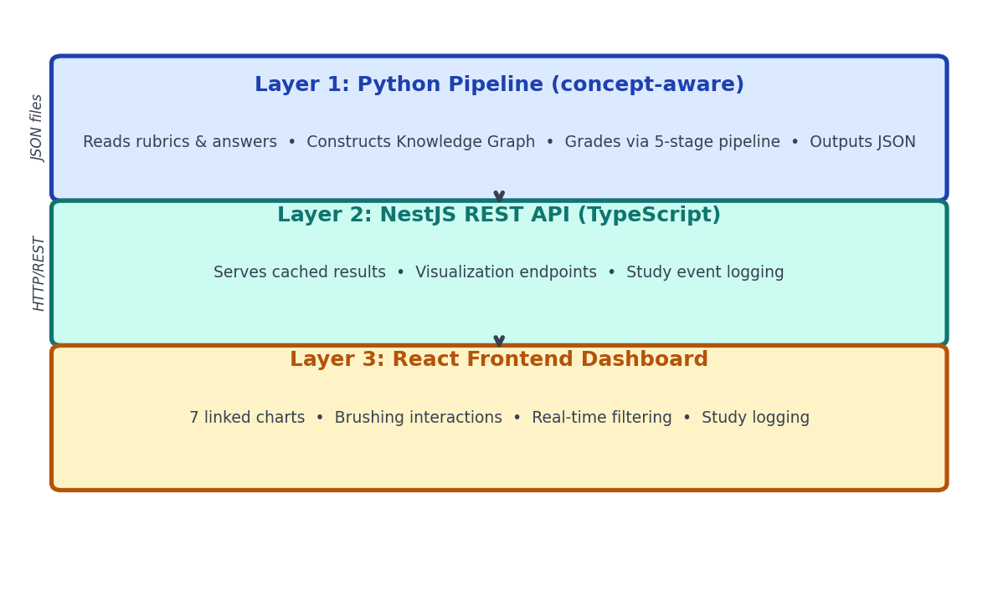
Figure 1 — Three-tier ConceptGrade Architecture: Python Pipeline → NestJS API → React Dashboard
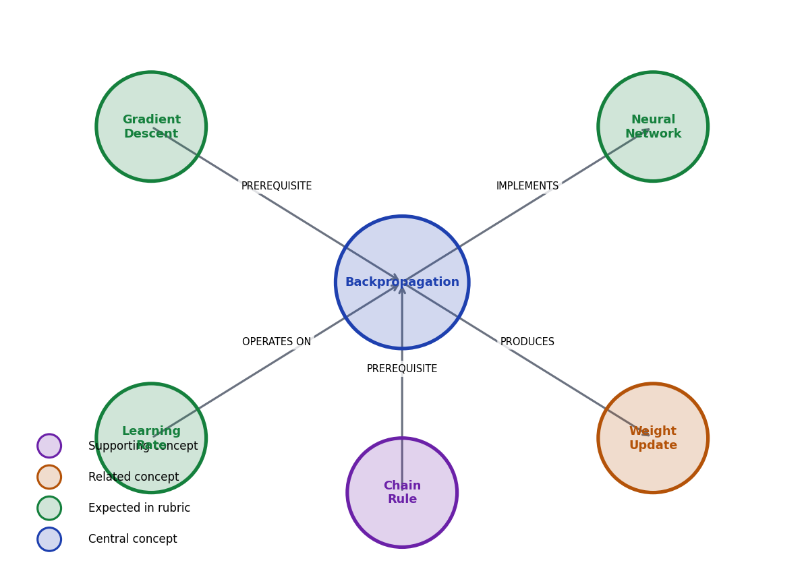
Figure 2 — Knowledge Graph Example: Enzyme Kinetics Concepts and Relationships
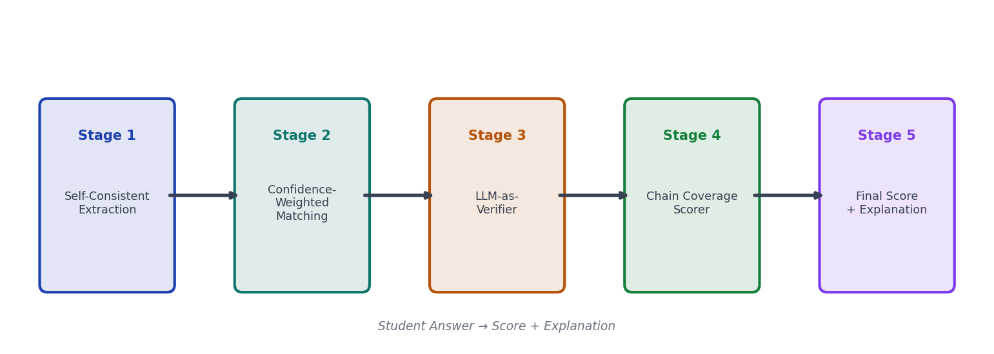
Figure 3 — Five-Stage Grading Pipeline: From Student Answer to Score + Explanation
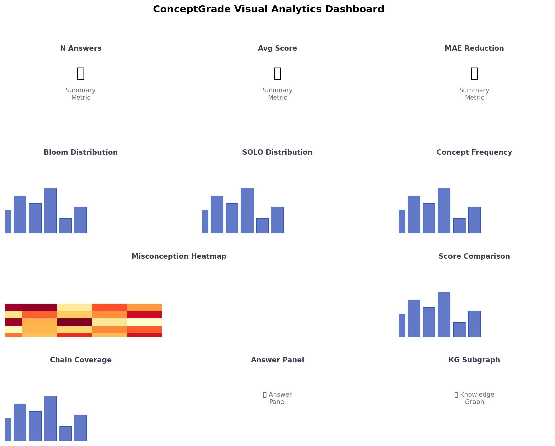
Figure 4 — Visual Analytics Dashboard Layout with 9 Linked Charts and Interactive Views
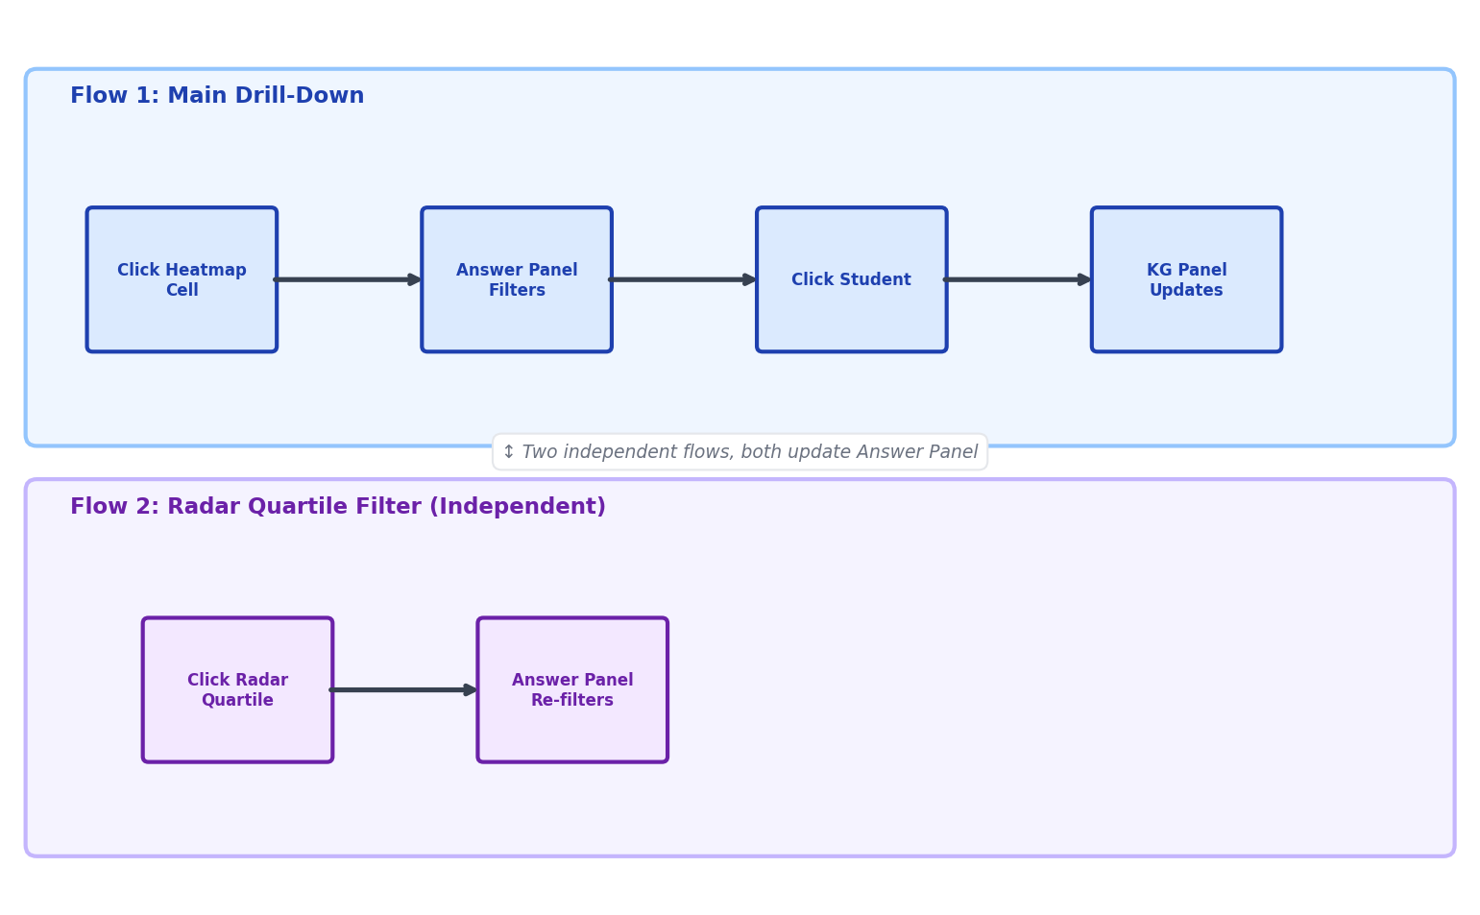
Figure 5 — Brushing Interaction Flows: Two Independent Workflows, Both Update Answer Panel
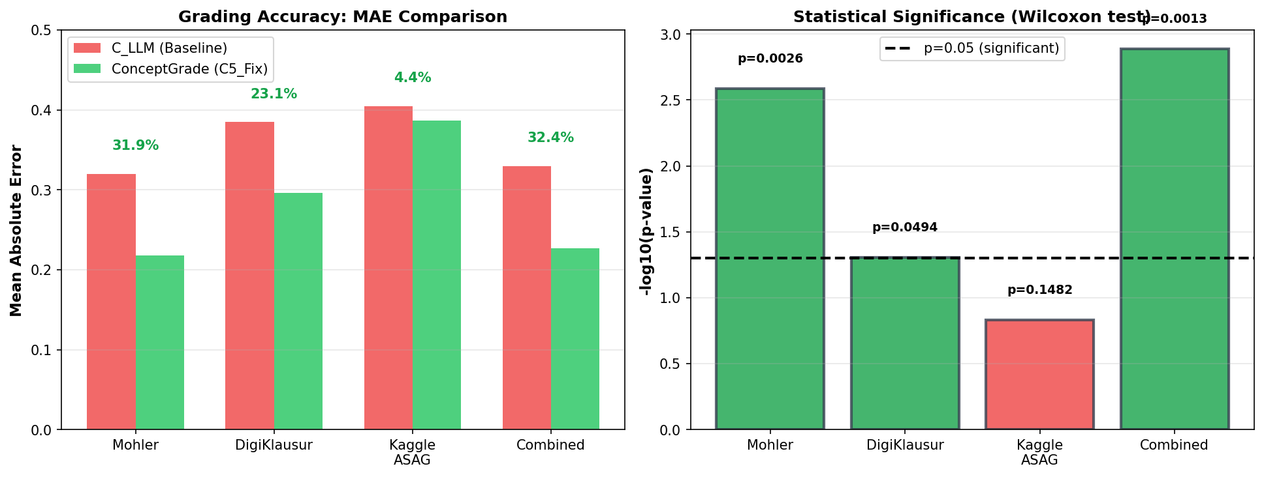
Figure 6 — Results Comparison: MAE Reduction (%) and Statistical Significance (Wilcoxon Test)

