ConceptGrade
A Simple Guide to the Automated Answer-Grading System
Prepared by Brahmaji Katragadda | Department of Computer Science, ICFAI (IFHE), Hyderabad
This guide explains, in plain English, what ConceptGrade is, why it was built, and how it actually works. Every screenshot in this document is a real screenshot taken from the running system — nothing here is a mockup.

1. What Is ConceptGrade?
ConceptGrade is a tool that automatically grades a student’s written answer to a short-answer question, the way a teaching assistant would — but it also explains its grade, and it can spot specific misunderstandings in the student’s answer, not just give a mark out of 5.
It is built as part of a larger platform called NodeGrade, which is a general system for building automated grading "workflows" (visual, drag-and-drop pipelines). ConceptGrade is the specific grading method this project focuses on: instead of just asking an AI model "grade this," it checks the student’s answer against a small, hand-built map of the concepts in a topic — a Knowledge Graph.

2. Why Does This Matter?
- Manual grading of short answers does not scale to large classes, and it delays feedback to students.
- Handing the job to a generic AI model ("just ask ChatGPT to grade it") gives a score, but no reliable explanation of what the student actually understood or misunderstood.
- Instructors need to know not just the score, but which concepts a student is missing, and whether the student holds a specific wrong belief (a "misconception") that needs correcting.
ConceptGrade’s goal is to close that gap: keep the speed of automated grading, but add back the explainability a human grader would naturally give.

3. How It Works — The Big Picture
Behind the scenes, every answer passes through five stages, wired together as a visual pipeline in the editor. Below is a real screenshot of that pipeline, exactly as it runs.
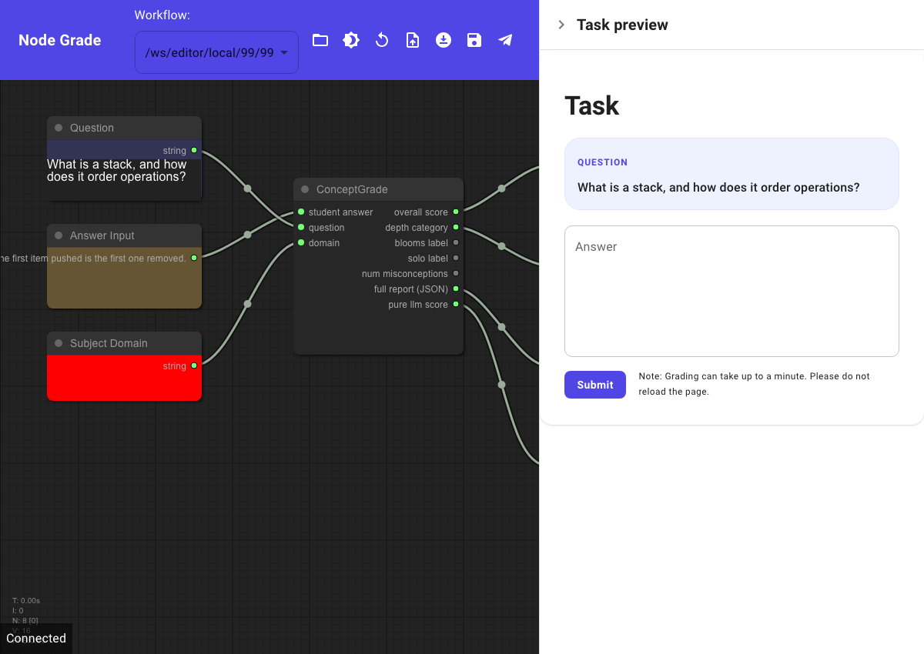
Figure 1 — The actual ConceptGrade pipeline in the NodeGrade editor. Three inputs (Question, Student Answer, Subject Domain) flow into the ConceptGrade node, which produces a score plus four kinds of feedback.

The five stages, in plain terms
- Concept Extraction — an AI model reads the student’s answer and pulls out the key concepts and claims it contains.
- Knowledge Graph Comparison — those concepts are checked, with no AI model involved (fully deterministic), against a hand-built map of the correct concepts and how they relate to each other for that topic.
- Cognitive Depth Classification — the answer is rated on two well-known educational scales: Bloom’s Taxonomy (is the student just recalling a fact, or explaining, or applying it?) and the SOLO Taxonomy (how many ideas did they connect together?).
- Misconception Detection — the system checks the answer against a list of known wrong beliefs students commonly hold in that subject, and flags them by name with a plain-English explanation.
- Score Synthesis — a final AI reviewer looks at everything above plus the raw answer, and produces the grade and the written feedback the student sees.

4. Walkthrough — Using the App, Step by Step

Step 1 — The student sees a question
A student opens a link and sees the question clearly marked, with a text box to type their answer.
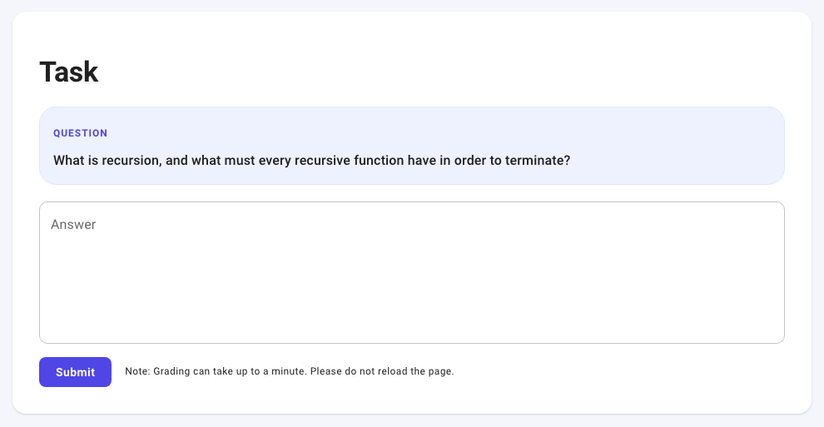
Figure 2 — What a student sees before answering. The question is set apart in a highlighted box so it is unmistakable.

Step 2 — Example: a correct answer
Below, a student answers a question about recursion correctly and completely. Watch what the system gives back — not just a score.
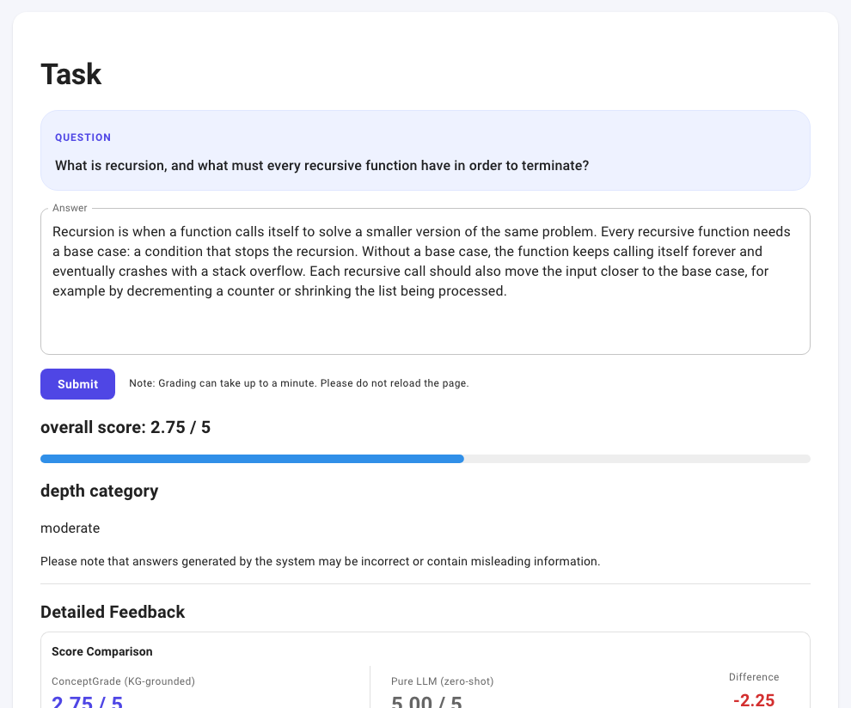
Figure 3 — The question, the student’s answer, and the top of the results: a score of 2.75 out of 5, and the answer classified as "moderate" depth.
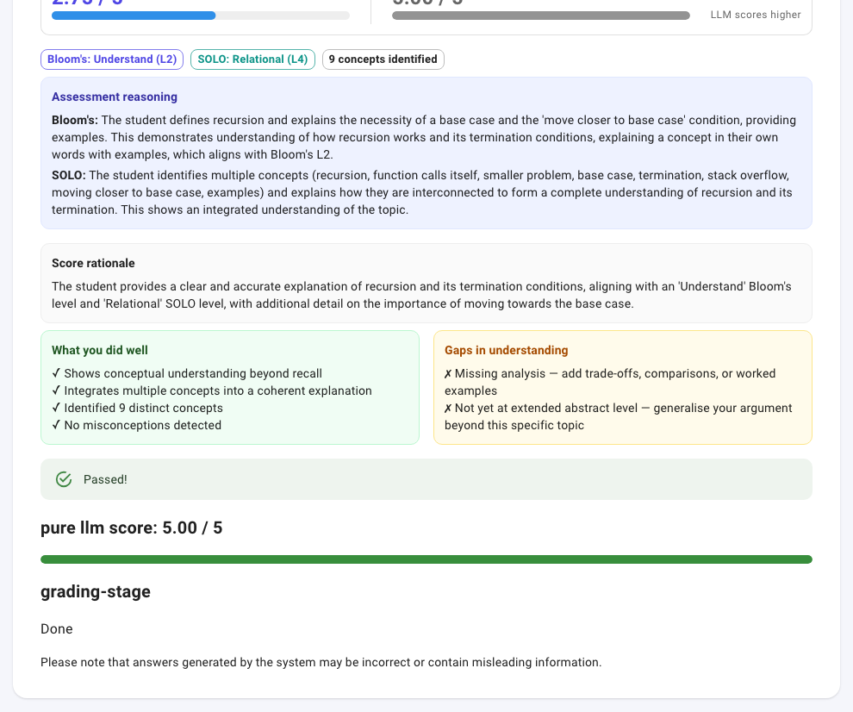
Figure 4 — The rest of the results for the same answer: Bloom’s level "Understand," SOLO level "Relational," a plain-English explanation of the reasoning, what the student did well, what is still missing, and a green "Passed!" banner.
Notice the "Score Comparison" row at the top of Figure 3: ConceptGrade gave 2.75/5, while a plain AI model asked to grade the same answer with no knowledge graph gave 5.00/5. This is an honest, real result from this project’s testing — a generic AI grader tends to be more generous than a knowledge-graph-grounded one. That difference is exactly the kind of thing this project investigates.

Step 3 — Example: a wrong answer, with a misconception caught
Now the same system is given an answer that sounds confident and well-written, but is factually backwards: it describes a stack (which should remove the most-recently-added item first, "LIFO") as if it worked like a queue ("FIFO").
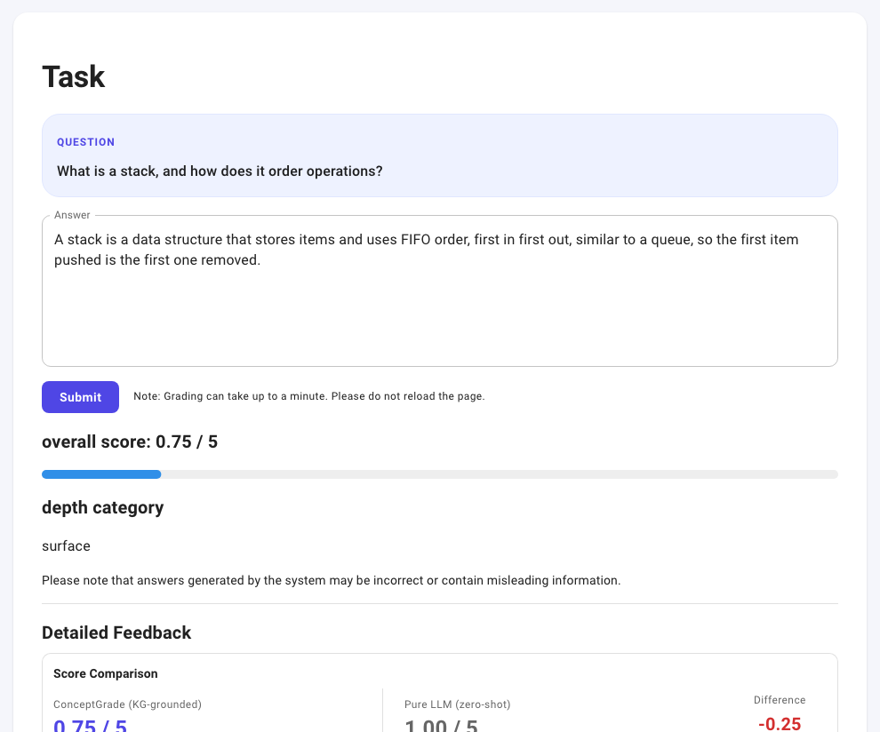
Figure 5 — A confident-sounding but incorrect answer about stacks. The system still gives a low score (0.75/5) and correctly does not reward the fluent writing.
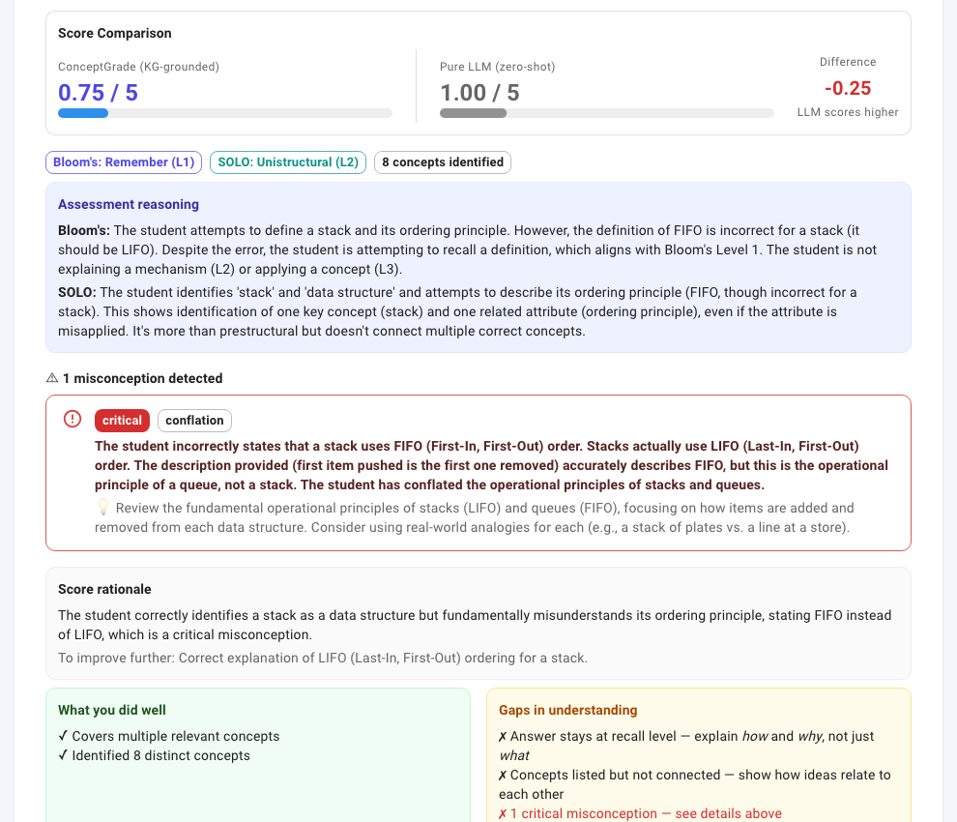
Figure 6 — The system does not just mark this "wrong." It names the specific misconception (LIFO/FIFO conflation), marks it "critical," explains exactly what the student got backwards, and gives a remediation hint the student can act on.
This is the core difference this project is built around: a generic AI grader can tell you an answer is wrong, but ConceptGrade tells you why it is wrong, in terms an instructor would recognise and could use directly in feedback to the student.

5. What Makes This Different From Just Using ChatGPT?
- Explainability: every score comes with a reason, tied to specific concepts, not just a number.
- Misconception detection: the system checks against a curated list of real, known wrong-belief patterns, and names them specifically.
- Educational grounding: it uses two established taxonomies from education research (Bloom’s and SOLO), not an ad-hoc rubric invented on the spot.
- A deterministic core: the knowledge-graph comparison step involves no AI model at all — it is a fixed, reproducible calculation, which makes part of the grading auditable in a way a pure AI-model score is not.

6. Honest Limitations
This project is upfront about what it does not yet do, rather than overstating it:
- It currently covers one subject area in depth (Data Structures) — the knowledge graph would need to be rebuilt by an expert for a new subject.
- It has been tested with one underlying AI model family; results might shift somewhat with a different model.
- On some datasets (especially ones far outside the knowledge graph’s subject, like elementary science questions), the knowledge graph adds little value, and the system is honest about that boundary rather than forcing a score.
- The knowledge graph and the misconception list were built by one person; a second expert might categorise things slightly differently.

7. Summary
In one sentence
ConceptGrade is an automated short-answer grader that, unlike a plain AI grader, grounds its score in a real map of the subject’s concepts, explains its reasoning using standard educational taxonomies, and names specific misconceptions by name — all shown live in this guide with real screenshots from the running system, not mockups.

Every screenshot above was captured from the application while it was actually running and grading real answers submitted moments earlier — nothing in this guide is illustrative or simulated.

