**2017-2018 CAMS TASKS DOCUMENTATION**

**BY SENGHOR Etienne, ERP Analyst**

1. **CAMS Overview**

CAMS ERP System is the main College information System used in the college to track student activities.

CAMS ERP is mainly used in the following areas:

* Admissions
* Registration
* Billing
* Financial Aid
* Health
* Faculty and Staff
* Meetings and Room Reservations
* Reporting

The role of the CAMS Administrator is to facilitate department to use the software more efficiently, administers the CAMS platform and to develop features that will help them get the information they need.

1. **Important College Acronyms**

The following Acronyms are mostly used for term designation:

**SP-XX**: SP Stands for Spring and XX the last 2 digits of the year. For example, SP-18 (Spring 18)

**SU-XX**: SU Stands for Summer and XX the last 2 digits of the year. For example, SU-18 (Summer 18)

**FA-XX**: FA Stands for Fall and XX the last 2 digits of the year. . For example, SP-18 (Fall 18)

1. **Different CAMS Servers, CAMS DB, CAMS Portal Servers, Files and Locations**

The following are the different Servers used to manage and store CAMS information. Those servers located in the Cloud A2k and are only accessible via RDP :

**A. CAMS Servers**

* **Trocaire-sql01**:

is the main CAMS Server. It Hosts the database and also a Client Sample of the CAMS Application.

* **Troc-camsdev**:

is a test server environment for Trocaire-sql01. It is generally used to test CAMS functionalities and the database servers.

This server also hosts the eCard System Server.

**B. Portals Servers**

There are 5 portal apps: Student, Faculty, Application, Evaluation, Adminpanel and they all located on the following servers:

* **Trocaire-ecams01**:

is the main portal server for CAMS. It hosts the webs apps which the prospects, students and faculty use on a daily basis.

* **Troc-portaldev**:

Is a test server environment for the portal and is mainly used for development purpose and test portal environment.

**B. CAMS Databases**

The 2 CAMS Databases are :

* **CAMS_Enterprise**: is the main CAMS enterprise databases where all the information is stored.
* **Trocaire_Extra**: hosts information about extra reporting functionalities, access, and student accounts

**C. Files and Location**

CAMS Files Location:

* On Trocaire-sql01 , Drive D, (D:\CAMS Enterprises)

Portal File Location:

* On the portal Server (Trocaire-ecams01), Drive C:

C:\inetpub\wwwroot\estudent for the student portal.

C:\inetpub\wwwroot\efaculty for the faculty portal.

C:\inetpub\wwwroot\applications for the application portal.

C:\inetpub\wwwroot\adminpanel for the adminpanel portal.

1. **CREATE Staff Accounts / Give Access**

To Create Staff Accounts, follow the following steps:

1. Open CAMS and logon with a CAMS Mgr account and go to CAMS Manager \ Users

And select User Administration.

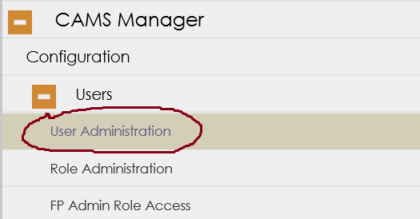

1. In the User Administration window, click and then right click on the window to start creating a new Staff Account.

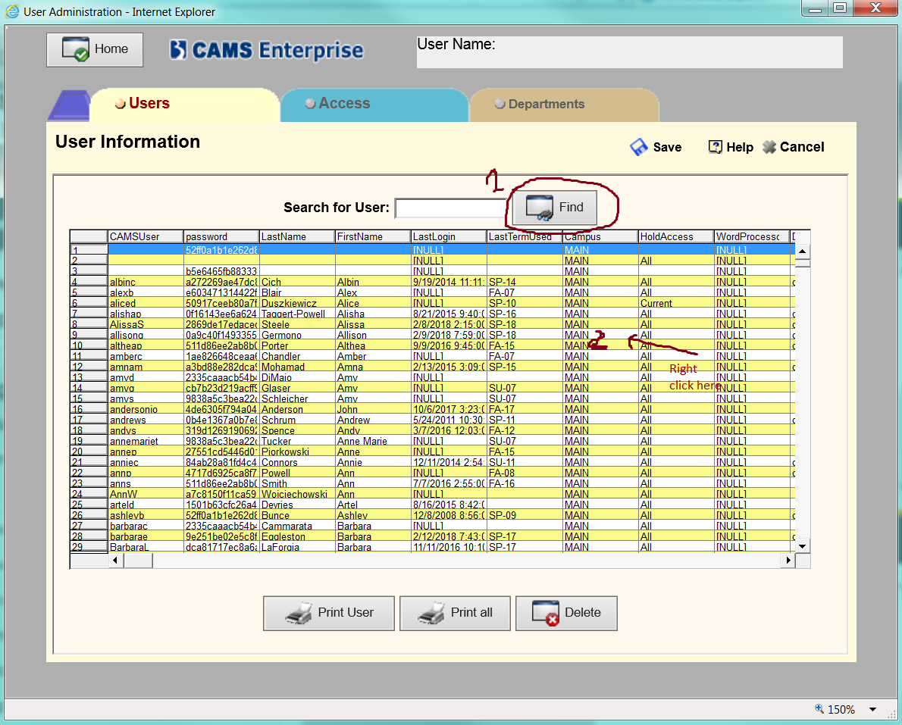

1. Enter the Username, Password , FirstName, LastName in the Box.

Usertype should be Normal

SSN Visibility should set to Masked

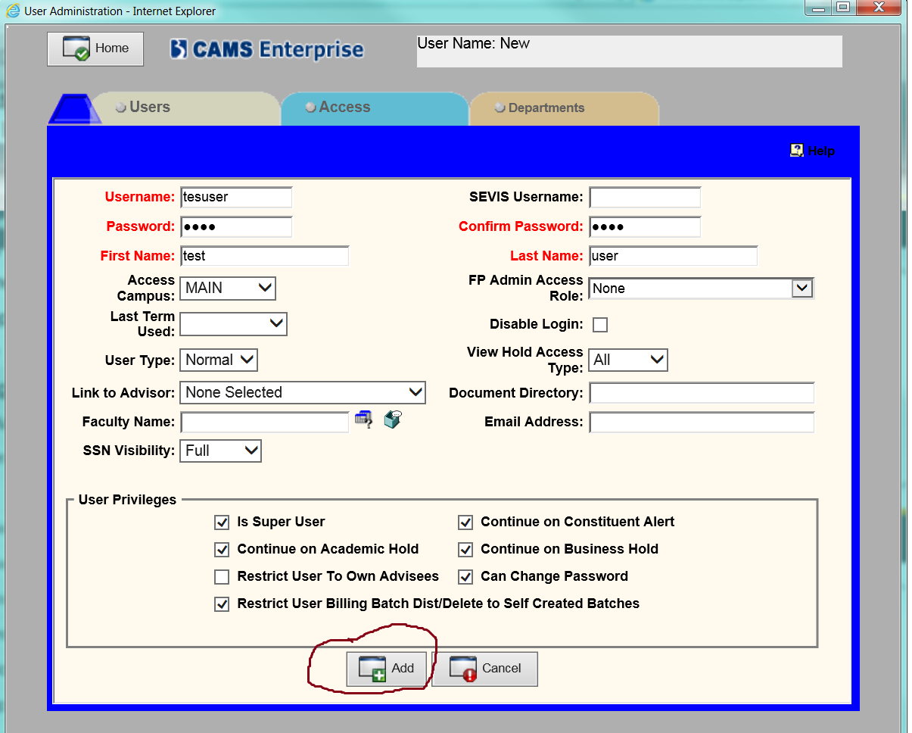

1. To assign rights to the user, go to access tab and you can either copy a previous user settings or set them one by one (to be able to do that, you have to set role to blank) and then click **Save**.

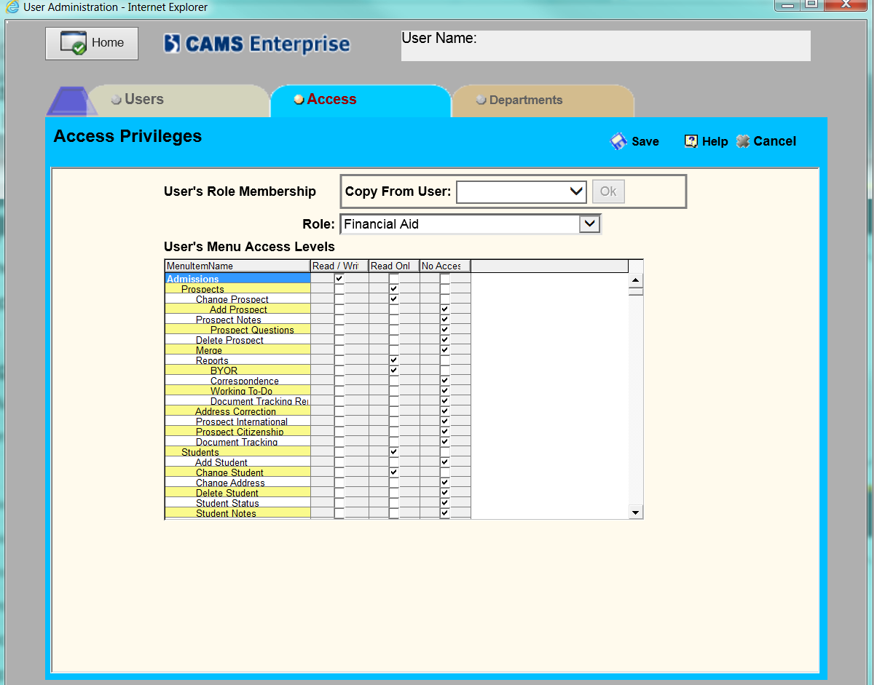

1. **CREATE Student Accounts**

Please, see System Jobs section

1. **Create Faculty / Reset Account**

The faculty module is used for both faculty and staff information.

To create or modify faculty information , follow the steps below:

1. Open CAMS with an administrator account and go to Faculty\Maintain and select **Modify**.

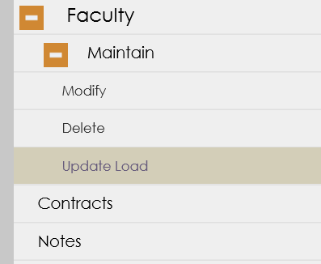

1. From the screen below, you can start entering faculty information.

It is important to set the person with correct Type whether, he is a staff, faculty or contractor.

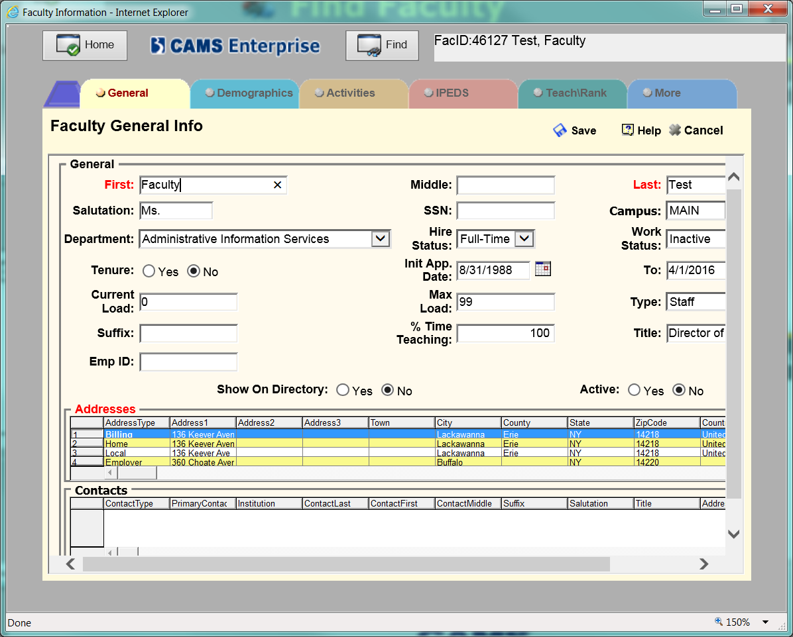

1. **Faculty Password Reset**

To set or reset a faculty password , after selecting the faculty in the Faculty / Maintain menu, Go to the Tab **More** and click on **Portal** and from you can set a username and Password for the faculty and then Click **Save.**

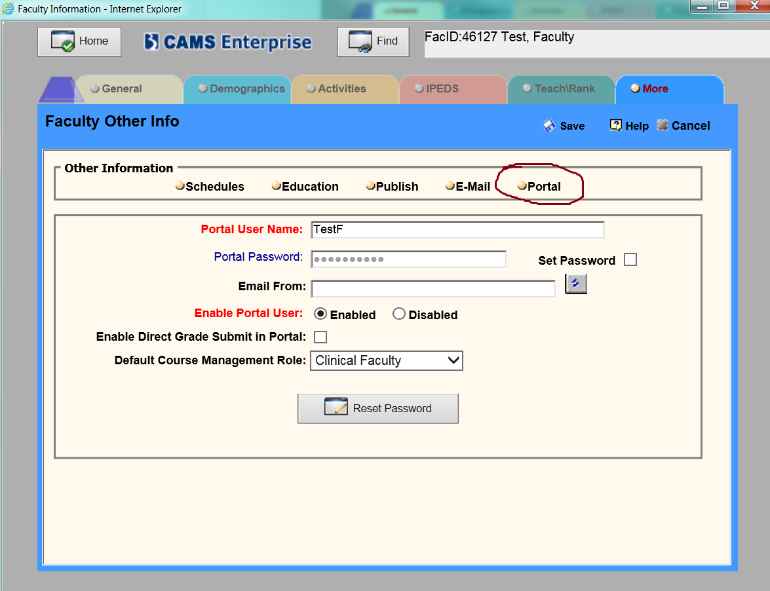

1. **Student Password Reset**

Password is usually done on a regular basis by the CAMS administrator or Help Desk.

The steps below describe how to reset a student password:

1. Open CAMS with an administrator Account and go to Admissions \ Students and Select the **Student Access Menu**

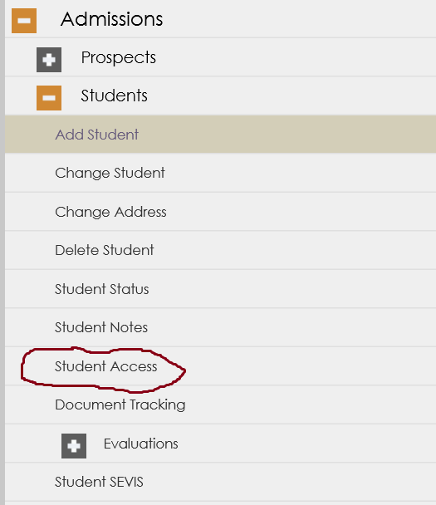

1. Open the Student Access menu and search for a student.

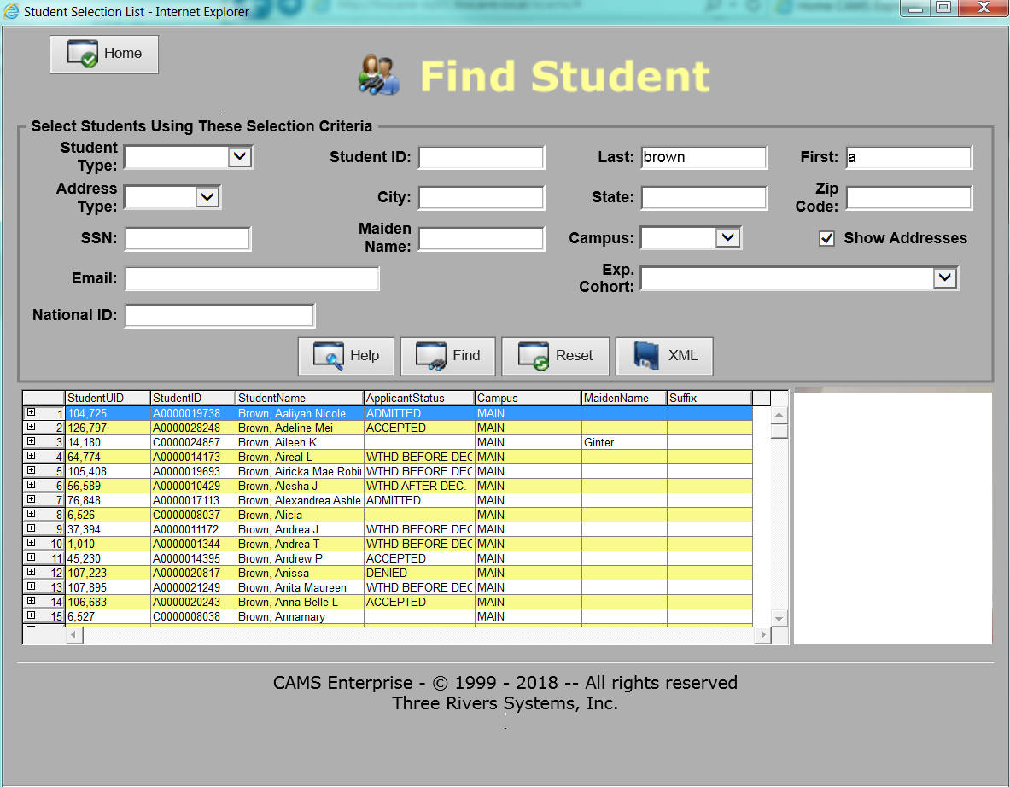

.

1. In the **Portal Password** text box set a new password by clicking on the Set Password checkbox and then click **Save**.

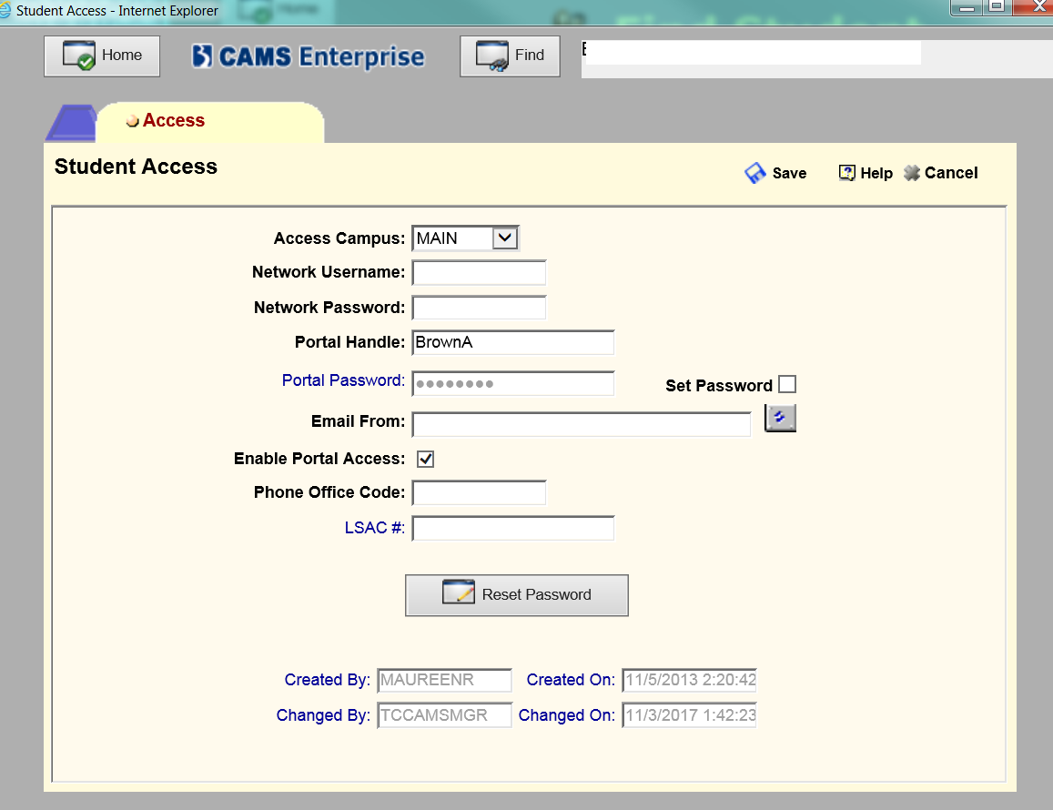

1. **OneCard System Server Overview and Update**

Please, see System Jobs section

1. **Great Plain Server , DB and Credentials**

Great Plain Software is the main system the college for its accounting Systems. It’s is supported by Software Solutions and they usually provide most of the support for this program.

1. **Some key contacts over there:**

. **Coleen McNally**

[coleen@softsolgrp.com](mailto:coleen@softsolgrp.com)

Microsoft Dynamics, GP Consultant

Buffalo: 716.568.2040 x115

. **Audrey Charbonneau, ERP Consultant**

aubrey.Charbonneau@softsolgrp.com

Buffalo: 716.568.2040 x131

1. **Great Plain Servers and DB and Credentials**

The Great Software is located on the server troc-gp-sql

Credentials for the great plain software are:

**Username**: sa

**Password**: Advance2k$@

The Main database for Great Plain on the troc-gp-sql server is called: **TC**

1. **Admin Panel Portal and Sections**

The Admin Panel portal is a recently created application which purpose is to create administration or report interface for departments or users. You can access the adminpanel by going to the following link: [**https://ecams.trocaire.edu/adminpanel**](https://ecams.trocaire.edu/adminpanel)**.**

Among the useful section of admin panel are the following:

* **Accomodation**: is the principal interface to manage accessibility request sent from the Student Portal by the students. It is usually managed by accessibility service.

The credentials are accoadmin/ Password@1

* **Accuplacer**: is the principal interface for the Placement test. It is Claudia by the pronctor to release and upload High School Scores.
* **Evaluation:** is the principal for the nursing department to check for evaluation of all faculty.

Credentials are evaladmin/ Password@1

* **Project Tracking**: is the main interface for IT to check status of projects.

Credentials are projectadmin/Password@1

* **Tools** : is the main interface for help desk, admissions, ed tech to perform certain backend tasks by themselves.

Credentials are:

helpdesk/Password@1

admissions/Password@1

moodleadmin@Password@1

* **Conduct:** is the main interface to visualize student conduct information.

Credentials are: studentaffairs/Password@1

1. **CAMS Admin Email Account**

The [camsadmin@trocaire.edu](mailto:camsadmin@trocaire.edu) email should be added as a second mailbox to anyone managing CAMS . It is the main email account that receives notifications about status of jobs and some other important information.

1. **Scheduled Tasks**

The following Scheduled Tasks are located on trocaire-sql01 server and are very important for the smooth running of the certain system jobs and automation process. They absolutely must run in their scheduled time.

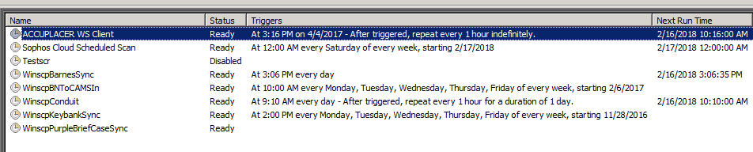

1. **Accuplacer WS Client:**

is responsible to downloading the high score scores from Accuplacer website on a daily basis.

1. **WinscpBarnesSync:**

Is Responsible for uploading the file from our sFTP folder via winscp to Barnes and Nobles SFtp server.

1. **WinscpBNToCAMSIn**

Is Responsible for Downloading Transaction files from Barnes Nobles to upload to CAMS.

1. **WinscpConduit:**

Is responsible for uploading CAMS enrollment data to Moodle Conduit process.

1. **WinScpKeybankSync:**

Is responsible for uploading ACH Files from Finance to Keybank sftp server.

1. **WinscpPurpleBriefcaseSync:**

Is responsible for uploading CAMS data to the Purple Briefcase Server program.

1. **System Jobs**
2. **Preparing the Upcoming Term**

Before the beginning of every term , it is essential to set the jobs to the correct term and make the essential term preparation to ensure the jobs will be running smoothly.

1. **System Jobs Listing**

* **Student Accomodation Reminder Email (AccoReminJob)**

Note: This is job is termless job which triggers a reminder email based on the request that was submitted by the student for the Accessibility services.

* **CAMS to Barnes and Nobles Export (Barnes_Noble_Job_SP-18) – (Critical)**

Note: This job exports data regularly from CAMS to the Barnes Servers via SFTP.

This job is a term based job. Before the start of every term, edit the job and set the job to the appropriate term. It is important to ask the Student Accounts director as for when to change the term.

* **Barnes and Nobles to CAMS Import (BN_TO_CAMS_JOB_SP-18) – (Critical)**

Note: This job import data regularly from Barnes and Nobles Servers to CAMS via SFTP.

This job is a term based job. Before the start of every term, edit the job and set the job to the appropriate term.

* **Barnes and Nobles Transactions Hit/Miss Verification Report (BNToCAMSWeeklyVerifJob_SP18) – (Critical)**

Note: This job is a report job that sends an email weekly to Student Accounts about the status of the transactions imported in CAMS during the week.

This job is a term based job. Before the start of every term, edit the job and set the job to the appropriate term.

* **BookStore Enrollment File(BKSTORE_EnrollFILE_SP-18) – (Critical)**

Note: This job is a report job that sends an email weekly to the bookstore to inform them about the enrollment status of students so they can buy the appropriate amount of books.

This job is a term based job. Before the start of every term, edit the job and set the job to the appropriate term.

* **CAMS to EMP Prospect Bridge (CAMS_PROSPECT_EMP_JOB) – (Critical)**

Note: This job uploads Propect information from CAMS and sends to the EMP CRM for admissions via sftp.

* **CAMS to EMP Student Bridge (CAMS_Student_EMP_Job) – (Critical)**

Note: This job uploads Propect information from CAMS and sends to the EMP CRM for admissions via sftp.

* **Check Daily Dropped Faculty in Moodle (CheckDroppedFacultyJob_SP18) – (Critical)**

Note: This job monitors faculty drops on a daily basis and transmit the information to moodle for deassociation of a faculty with a particular course.

This job is a term based job. Before the start of every term, edit the job and set the job to the appropriate term.

* **CAMS to Moodle Export (Conduit_Job) – (Critical)**

Note: This job exports enrollment information from CAMS and uploads them to Moodle on a daily basis.

This job is a term based job. Before the start of every term, edit the job and set the job to the appropriate term. It is important to ask permission to the Moodle administrator as for when to change the term.

* **Wrong ID Card Detection (DetectWrongBNID) – (Critical)**

Note: This job scans the transaction files from Barnes and Noble everyday to determine if there is a wrong student ID in the Student and reports it to the administrator , student accounts and the bookstore. Once the Wrong Student ID locate the file in

**D:\SFTP\barnes_noble\Imports\Archives\[TermXX]\Raw** and change to the appropriate ID.

* **Emergency Notification System Student Upload (ENSSTUDENTS_SP18) – (Critical)**

Note: This job exports enrollment information from CAMS and uploads them to Moodle on a daily basis.

This job is a term based job. Before the start of every term, edit the job and set the job to the appropriate term. It is important to ask permission to the Moodle administrator as for when to change the term.

* **Generate Student Accounts (GENERATE_ADIMPORT_GLOBAL) – (Critical)**

Note: This job is responsible for generating the Students Accounts everyday and sends it as list to help desk for email creation.

* **Generate Financial Aid Acceptance Report (Generate_FA_Accept_Job) – (Critical)**

Note: This job produces a daily report of the student Financial Aid Status and sends a daily email to the Financial Aid department.

* **Generate Moodle Faculty History (GenerateMoodleEnrollHistory) – (Critical)**

Note: This job Takes a snapshot of faculty enrollment everyday so faculty drops can be detected.

This Job is a term based job and the correct term information must be changed in the Stored procedure dbo.Conduit_getEnrollList.

* **Upload New Pictures from OneCard into CAMS (GetNewPicsFromOneCard)**

Note: This job Uploads New Pictures from OneCard and Uploads them into CAMS.

This Job can be run every month or every week.

* **EMP to CAMS Import (LIAISON_TO_CAMS_JOB)**

Note: This job Uploads data from EMP CRM and uploads them into CAMS.

* **Program Directors Health Report Generation (NotifyHealthProgDirOfAlerts)**

Note: This Job produces a monthly report of Shots alerts and sends them to the Program Directors.

* **Students Health Record Reminder Emails (NotifyShotExpiration_Job) – (Critical)**

Note: This Job produces a daily reminder email to Students about shots that’s going to be expired in the Student Records.

* **Accepted Students Letter Upload (PickUpAcceptedStudentsJob_Global) – (Critical)**

Note: This Job Uploads accepted Students on a daily basis , after the help desk finished creating an email account for the students so letters can be generated with their login information at acceptance.

* **High School Scores Pickup (PickUpHSScoreJob) – (Critical)**

Note: This Job allows Accuplacer Scores to be uploaded in CAMS on a daily basis from the accuplacer.org website.

* **Purple Briefcase Students Upload (Purple_Briefcase_SP-18_JOB) – (Critical)**

Note: This job exports data from CAMS and uploads to the Purple Briefcase System via Sftp.

This Job is a term based job and the correct term information must be changed in the Stored procedure.

* **Backup Rotation (RotateBackup) – (Critical)**

Note: This allows the rotation of the backup jobs in the SQLBackup Folder on the D: drive of Trocaire-sql01 to be rotated every 2 weeks.

* **Report Processor (RptProcessorJob)**

Note: This job helps process the Phi theta kappa reports which takes long time to generate.

* **Semester Snapshots Processing (Sem_SnapShot_Job_SP-18) – (Critical)**

Note: This job performs a mandatory State Required Snapshot operation in CAMS to be taken at period interval.

This Job is a term based job and the correct term information must be changed in the job.

Also, this job is setup to run on a particular date throughout the course of the semester. (summer is excluded)

The dates of when those Snapshots to be taken needs to be confirmed with Nikki Rodriguez, Director of Assessment before the beginning of every semester.

Here is the schedule settings for the snapshot. The snapshot needs to be taken 3 times during the semester.

You need to edit each of this schedule and set the appropriate date. Also, make the schedule is enabled after changing it.

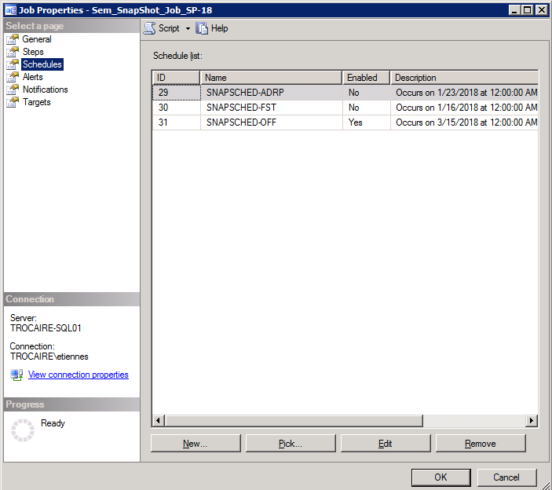

* **Generate Prior Day acceptance Report to HelpDesk (SendPriorDayAccStudentsJob) – (Critical)**

Note: This job sends of a daily report of the all the accepted students the day before to help desk prepare the email accounts for the students and verify any discrepancy.

* **Update OneCard System with Newly accepted Students (SendUpdatesToOneCard_SP18) – (Critical)**

Note: This job performs a daily update of the OneCard System and notify help desk of the update.

* **Semester Academic Status Update (SetAcademicStatusForTerm_Job) – (Critical)**

Note: This job set the academic Standing of Students at the end of every term automatically based on their GPA.

* **Student Status Update (UPDATESTDSTAT) – (Critical)**

Note: This job updates the student enrollment status every week each term.

1. **Some other CAMS Resources at Trocaire**

* Dr Nikki Tomasello
* Dr Dick Linn
* Jim Poulos
* CAMS Community Forum
* Managing CAMS Enterprise Book
* CAMS Support

1. **CAMS Support**

For all CAMS issues that isn’t listed, CAMS support is a great resource, they are open Monday through Friday 8:30a to 8pm Central Time

**Phone Number**: **636-386-8616 Option 3**