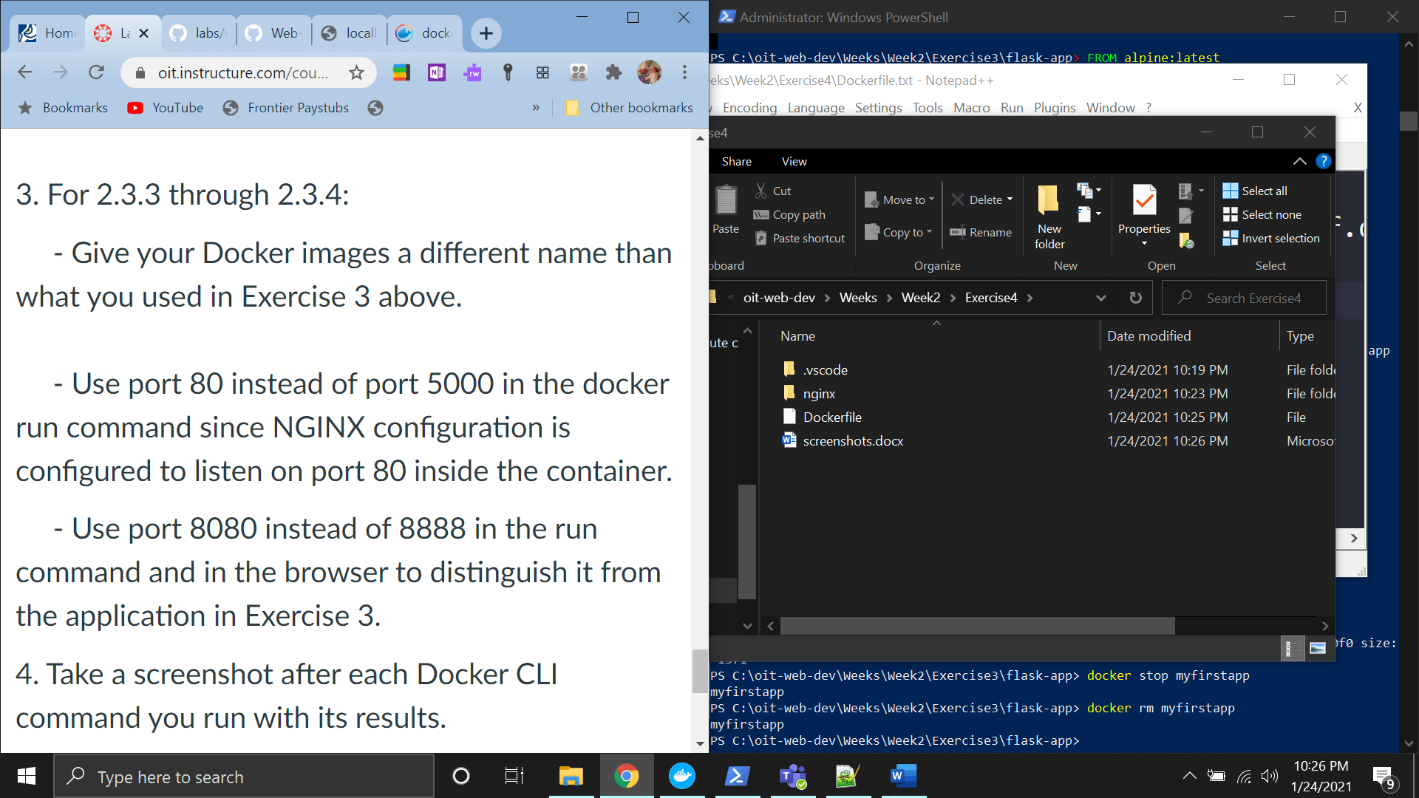

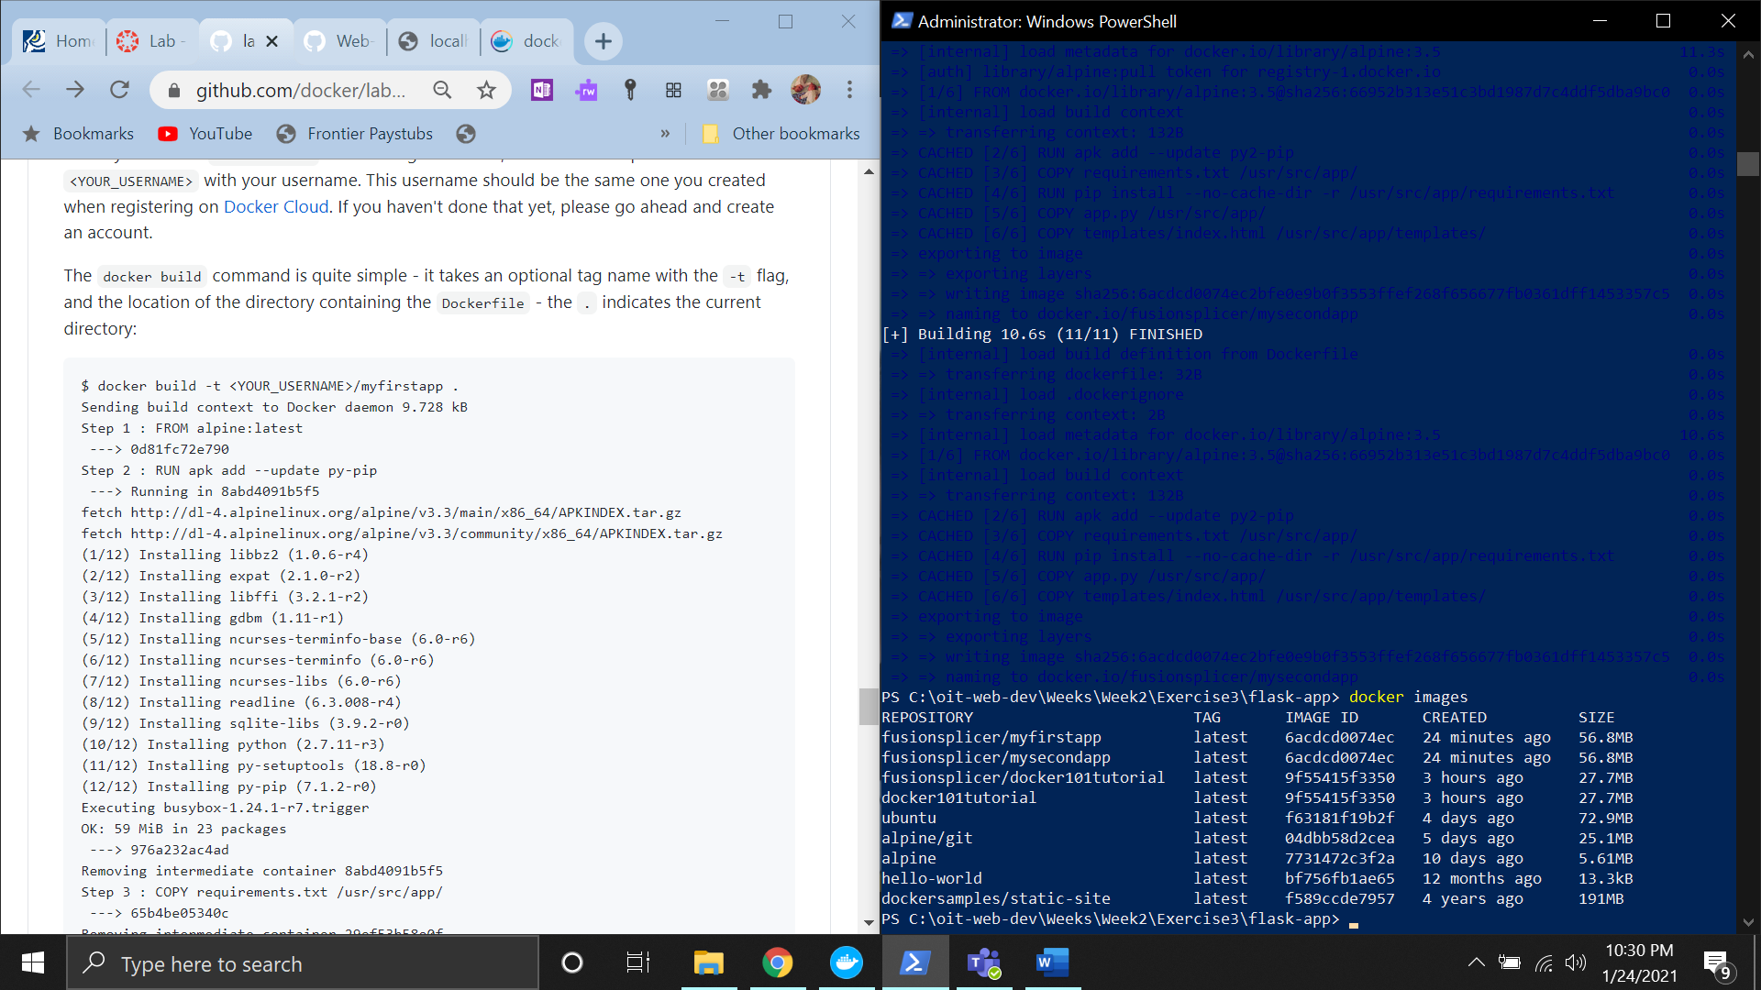

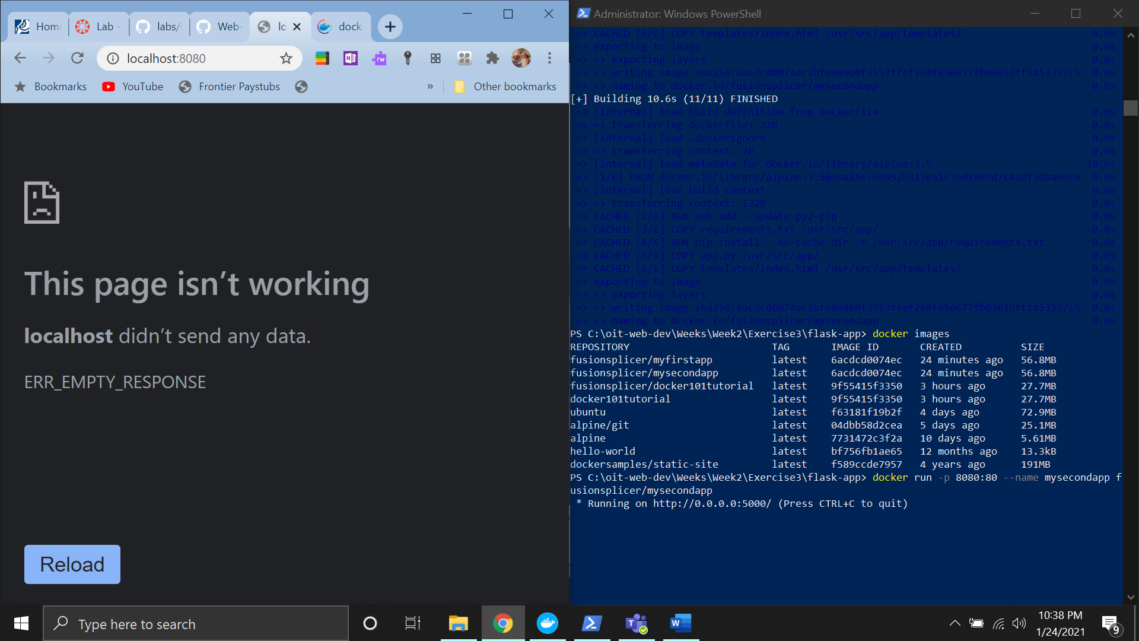

Not sure why I can not get the page to display but I don’t want to lose more points for being late.

https://hub.docker.com/repository/docker/fusionsplicer/myfirstapp