### ****Preparation****

### 

### 

### ****Exercise 1 - Create the database with****

### 6. Start the Postgres container by opening a cmd/terminal window into the database folder and running the command:

### 

### 

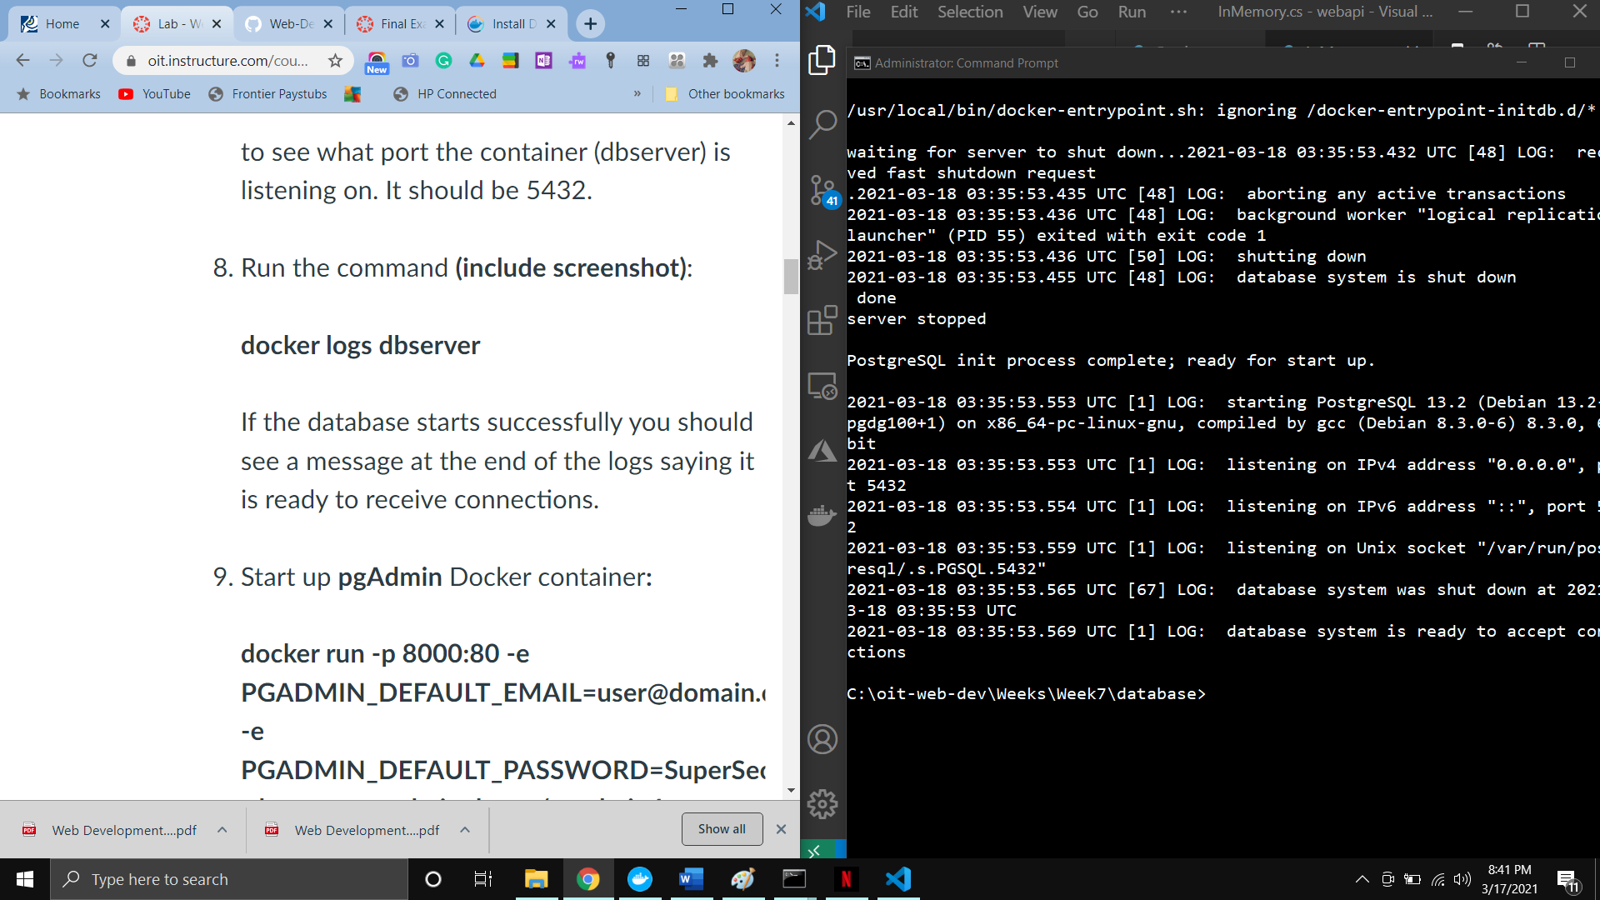

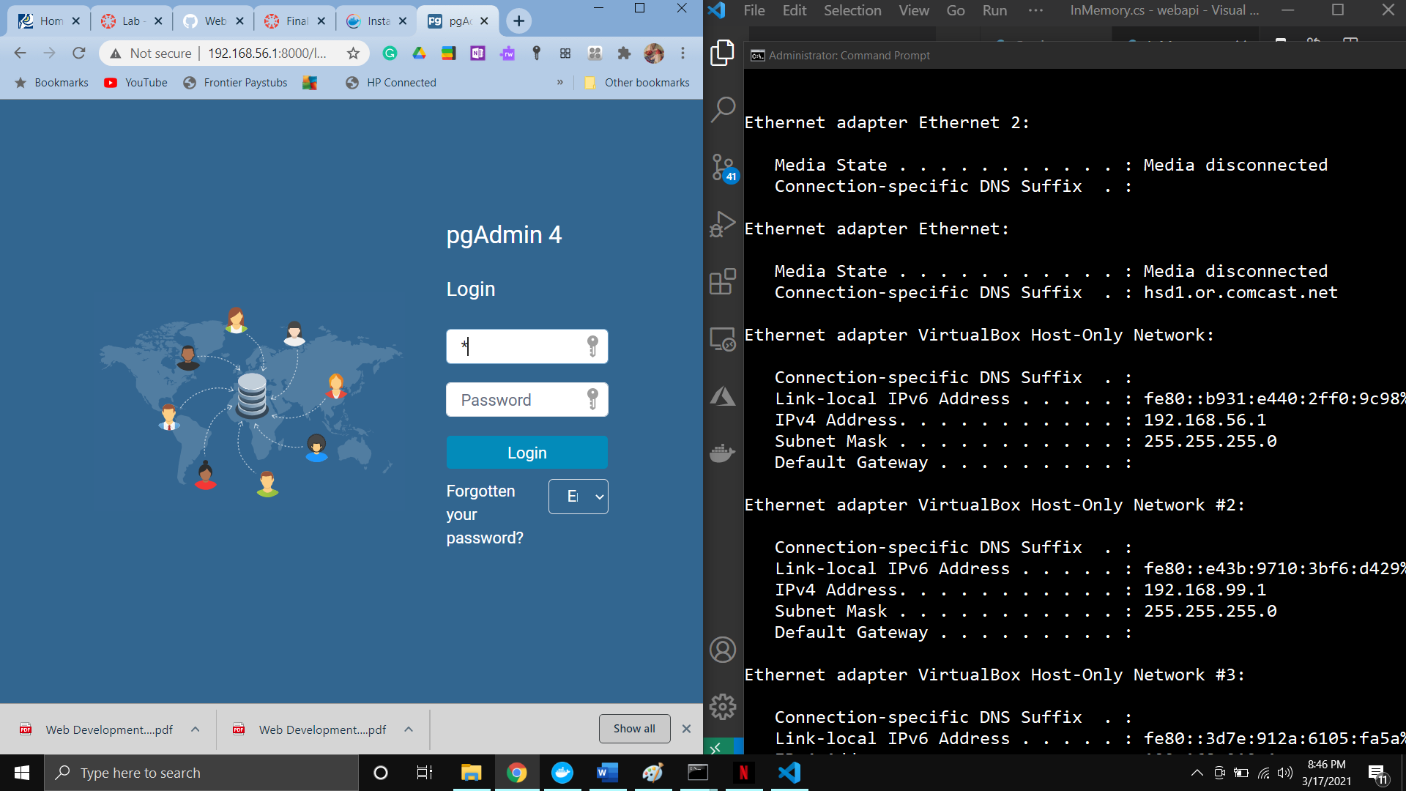

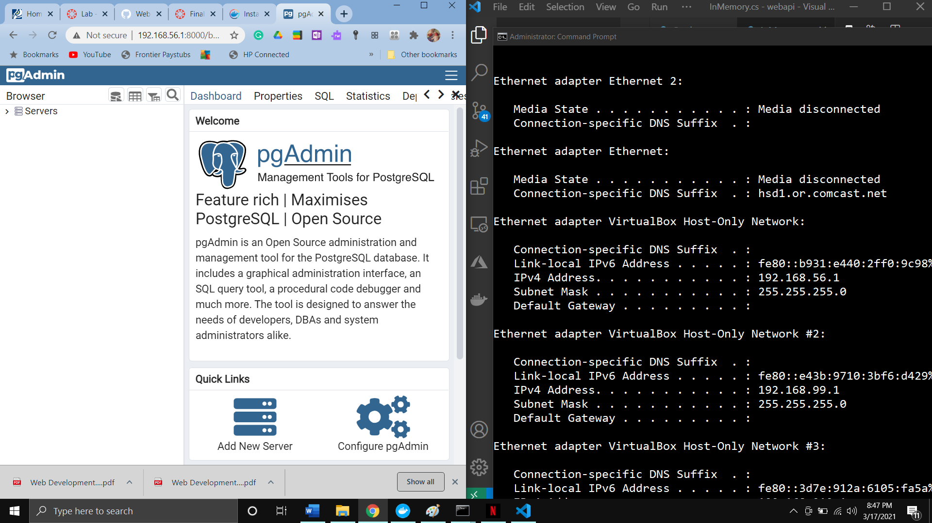

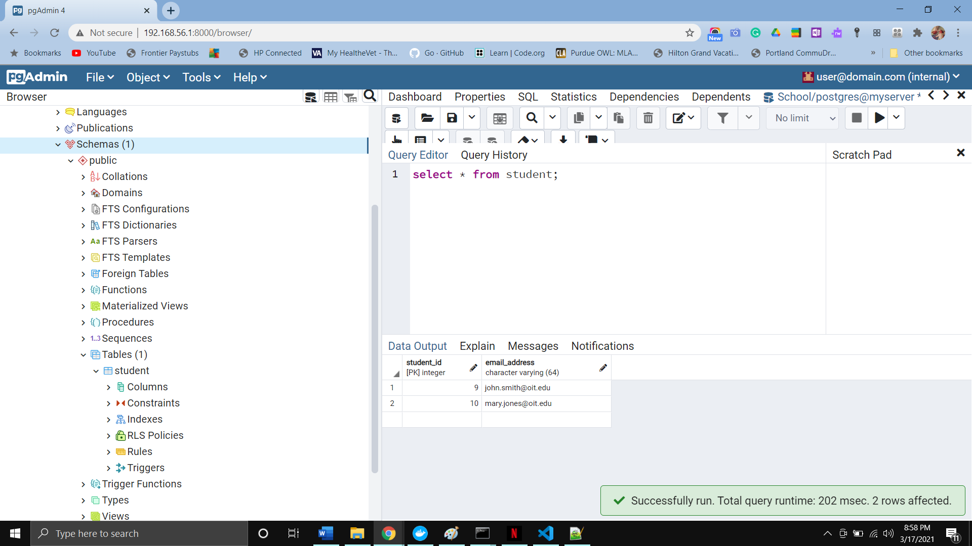

### ****Exercise 2 - Modify your REST service to now access the database****