COMP2005 Report
GitHub Repo: github.com/Plymouth-University/comp2005-assessment2-bobbymannino
YouTube Video: youtu.be/fkzyoxktT6E (Note: I did the video before making the UAT changes)

Test Plan
I have been tasked with creating an API that interacts with a predefined API, and an application that interacts with my API. Along with this I need to test (and document the tests) that everything works using multiple testing methods including user acceptance testing.

The test plan has been created to communicate the approach I have taken to test the software, as well as what is and is not in scope.

Objectives
The object is this project is to deliver two well tested products along with a report of the analysis of my findings/learnings.

Scope
The scope is ignore any problems on the hosted API, if the API returns malformed data it is not my job to parse through it and fix it, I expect the data to be as presented.

What is in scope though is user testing, I must get user feedback on the app and make changes accordingly.

Test Approach
For both the API and app, I have created unit tests, integration tests and system tests. For the app I have also tested the user acceptance. I will do this via a JISC survey (more info later on).

API Testing
The approach I took for implementing the API was test driven development. I chose this because it is nice to know how well your code is working before you get to the end (like washing up as you go).

I have added unit tests for classes such as `AdmissionClass` like so:
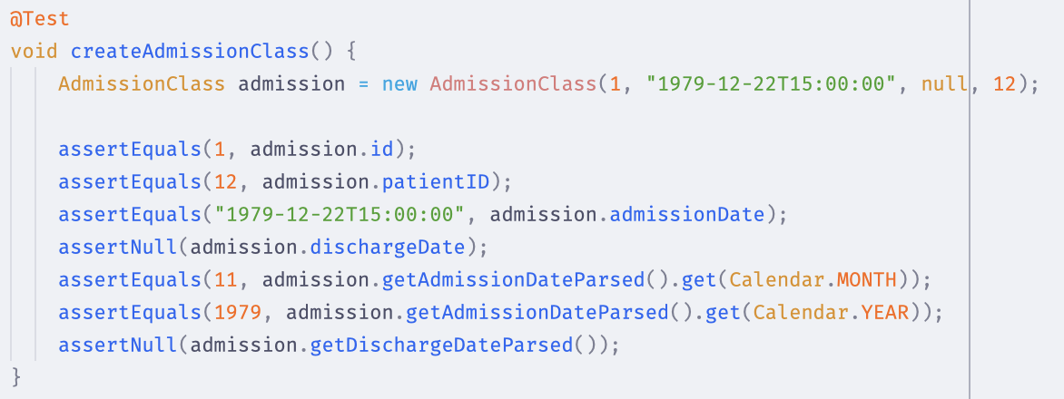

These tests ensure that given the correct data in, you should get the expected output. Throughout this document I will give examples, I have more tests then the examples.

In this API I found early on that I needed to work with dates a lot, so I abstracted that out into its own class. Without a unit I cannot unit test. Doing this enabled 2 things, one is I can unit test it like so:

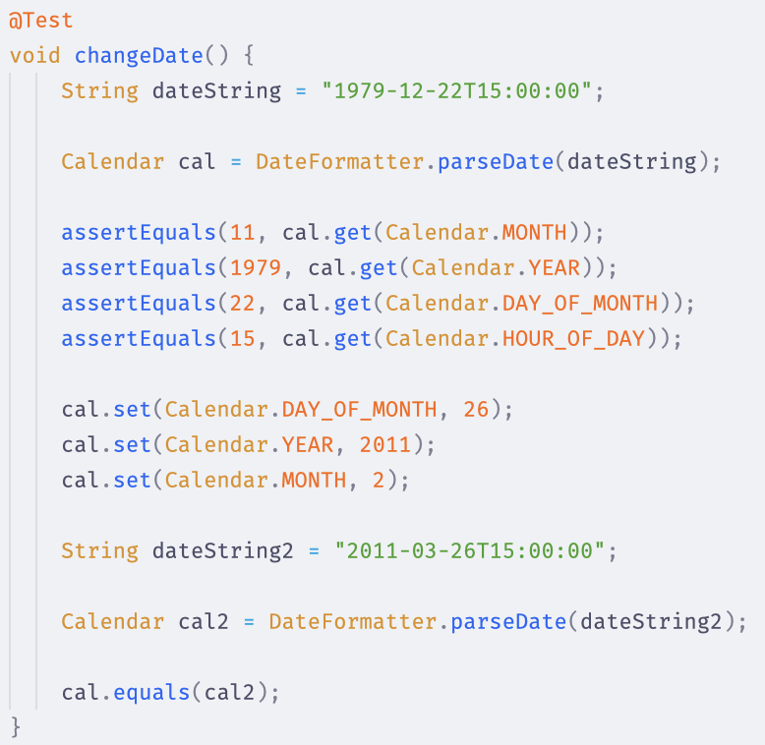

This ensures that `DateFormatter` on its own works, but to test `AdmissionClass` and `DateFormatter` together, I need integration tests. Through my unit tests I have levered the AAA (arrange, act, assert) testing convention. An example of integration testing between `AdmissionClass` and `DateFormatter`:
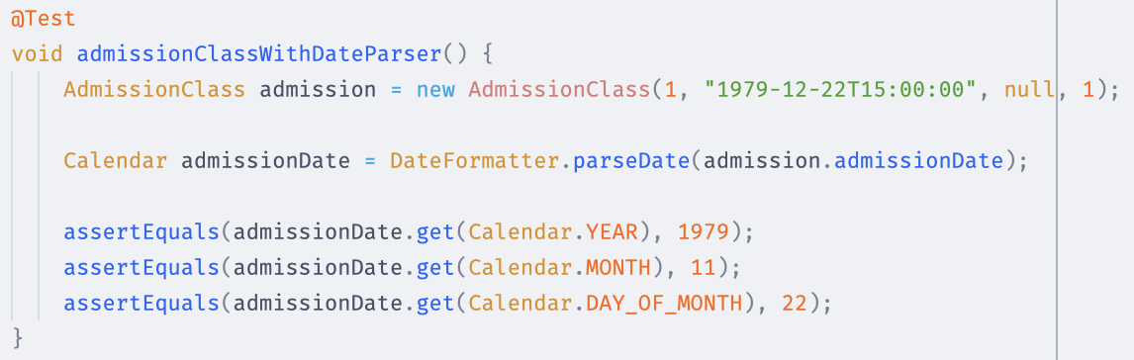

Consistency
Dr. Dixon and I spoke about wether to return patient details or just patient IDs for `/patients/never-admitted`, we agreed that as long as i'm consistent across the entire project it doesn't matter. From there that gave me the idea to be consistent across all endpoints for the type of data I return. I ended up deciding that no matter what is returned, error or success, it must conform to `ResponseEntity<ObjectNode>`. This made working with the API in the app 10x easier.

Any errors that occur that will return the status and a message to help the user understand the error:
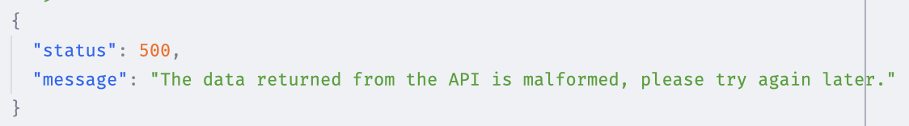

I looked to HCI's best practices and found Jakob Nielsen's 10 Usability Heuristics, #9 talks about not error prevention but recognition and more importantly diagnosis. In order to help the user diagnose and resolve an error if something does go wrong, to comply with this all errors returned useful information.

Manual Endpoint Testing
There was some manual endpoint testing which I used Insomnia for, this was helpful for repeatedly getting a status from an endpoint (e.g. 200, 500), but also seeing the response formatted. If you would like to see the YAML file of the endpoints it is location in the repo.

Using `MockMvc` allows me to test each endpoint without having to start up the HTTP server, this saves me time and processing power. They all conform to AAA. The regex testing allows me to be super precise with what the response body can be which will decrease the chances of malformed data being returned. An example:
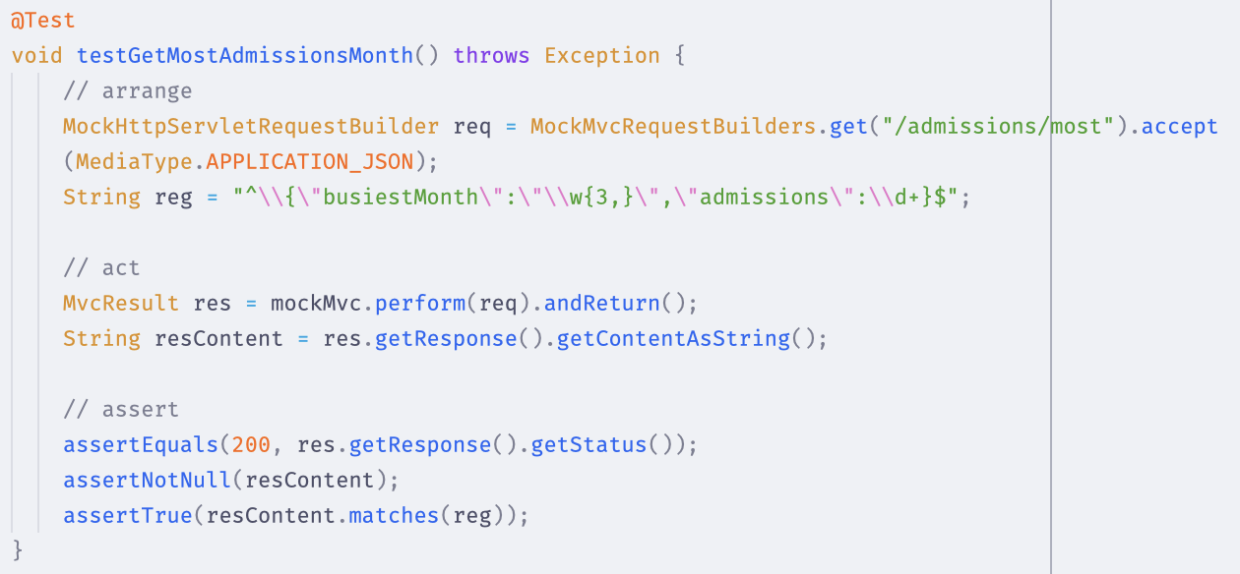

Edge/Corner Cases
Throughout testing I remembered to think about edge and corner cases, so after I had made some progress I extract the logic for determining wether a patient has been readmitted within 7 days into its own function so I could test it. This allowed me to created edge cases where the exact second was 7 days on the nose, 1 second before, 1 second after, etc. I could then make sure it behaved the way it should.
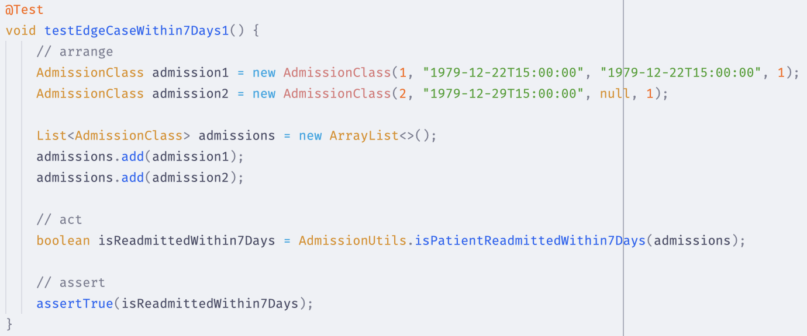

Refactoring the logic for this actually ended up saving a lot of lines and processing. If I hadn’t refactored the edge case would have failed due to a rounding error.

Incase somebody new wanted to understand the API i‘ve added an OpenAPI plugin that generates documentation based off the endpoints. This makes it much quicker for people to understand the API. Here is a screenshot of one of the endpoints:
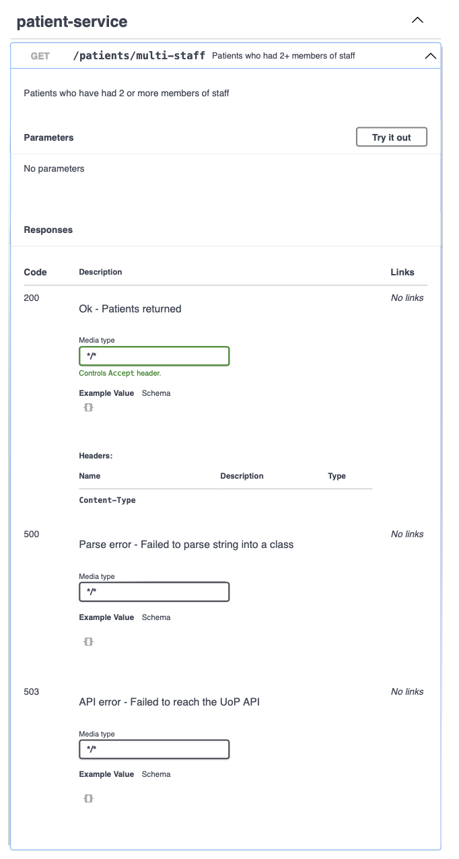

Code Coverage
Code coverage is the percent of your code that has been put through 1+ tests, this could be measured by line, unit, classes, files, etc. I started by using the built in tool but found it troublesome so switched over to the JaCoCo plugin. This enabled the same features but worked quicker and gave more details on the coverage. Coverage is important for finding blindspots and reducing untested code. At first the results were quite low across the board, I was actually unaware of this until I looked at the results. Once I had I went through all the test files and added more tests, re ran the coverage, and repeated until I was satisfied.
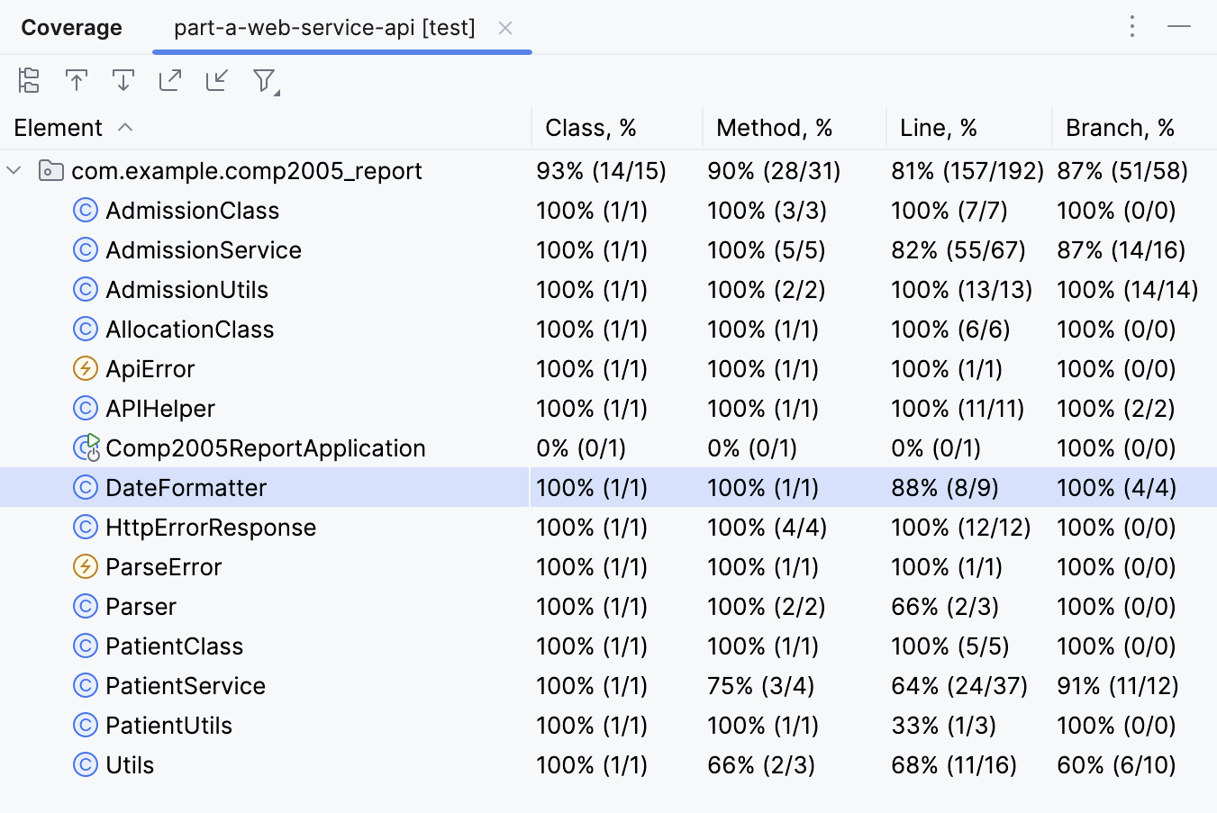

App Testing
I followed a similar process with the app as to the API. The apps requirements was for it to interact with one of my created endpoints and I chose the never admitted patients route. The app contains 3 screens: menu, never admitted patients, and patient details.

The HCI principles is something that I have make sure to incorporate and make decisions based off, for instance when creating a `Patient` if there is no `firstName` or `lastName` passed in (or blank strings) I will assign `UNKNOWN` as that name, this way the user will see that they don't have a name. I would put this under #10 which is help and documentation as it helps the user understand this user does not have a name set.

I started by using the template I was instructed to but after much fighting with machines I ended up rewriting the project after I had finished from scratch, I coped some files but anything build/dependency related I explicitly set myself. After this I found everything to work across machines as expected.

I have a utility class `StringParser` which helps me take in a string and parse it into a class. I tested this on its own but also with a `Patient` string, this way I can test the name fallback and parser at once. I did a few tests so here's an example:
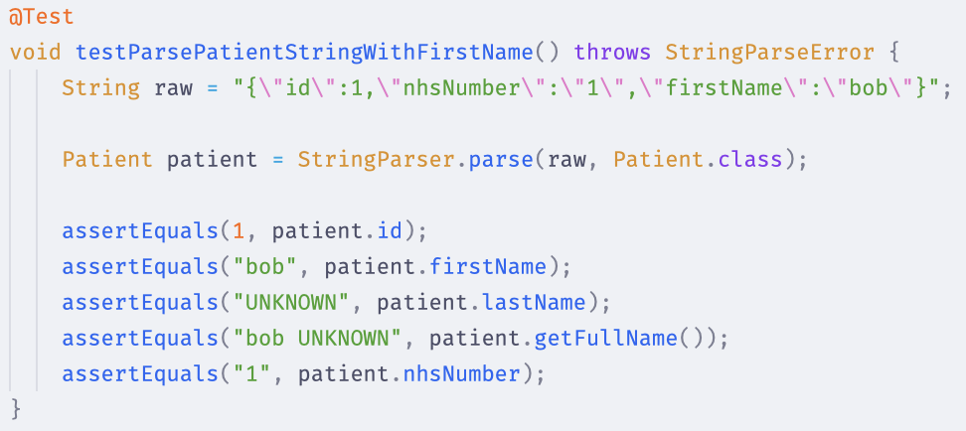

What happens when something goes wrong? Well because it is a GUI we can show the user visual elements to help them which complies with the 10 usability heuristics' (10UH) 9th principle: help users recognize and recover from errors.
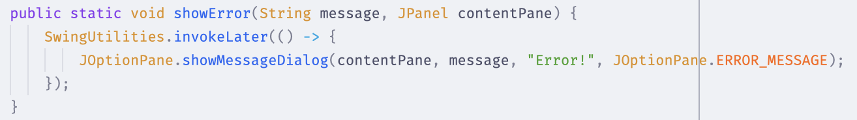

I created 3 severities of there: warning, error, and info, each with a message that would tell the user what has gone wrong and then something they could do to help fix the error or how to contact support. Example:
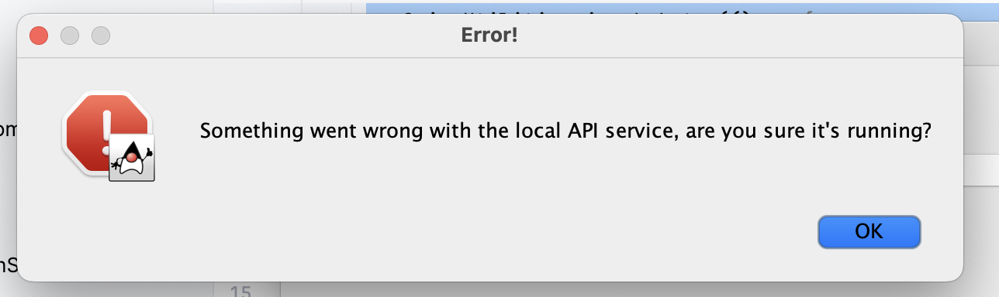

A small thing I added across all screens was a close button at the bottom of the page. This follows the 10UHs 4th rule: consistency and standards. By having a close button on every page and in the same spot (which happens to be where most close/cancel buttons are in software) really helps with keeping the user comfortable and familiar with the UI.

Following Jakobs 1st principle we have show the user system status, keep them aware of whats going on. So after the user clicks the button to open the window there will be a loading state appear. This is useful because it shows the user that something is happening which makes them more comfortable with waiting. It's not a fabulous or pretty UI but it is functional enough that the user is aware they are waiting while something is happening.

User Acceptance Testing
I have performed UAT testing on 4 different people. The questions were aimed at 3 things: efficacy of the app, UI/UX & error handling. There are some questions about the UAT process but those are more for me then the app. The UAT gave me a lot of valuable feedback on how to improve the app for the users. Some of the changes I have made based on the feedback is as follows:
- Close button test “Close App” on main menu
- Close buttons text color now red
- Larger font size
- Alternating list row background color
- List row padding

I had the API running in the background already so the user doesn't have to worry about it. I did also have somebody feedback that even to test the app should be an exe instead of a jar file. For each person I had the command `java -jar blah.jar` ready in the terminal so they just have to hit enter but as this person pointed out that is not user friendly.

A good thing about being a jar vs exe is compatibility, jar can run anywhere with java where as exe is only windows. The feedback was still taken in and I would have made the change except he was the last tester. It is still valuable advice that I will remember for any time I ask someone to test something.

List UI Before/After:
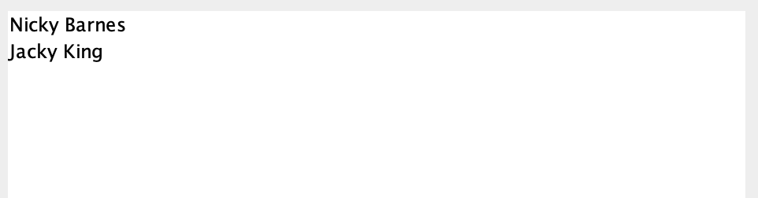 | 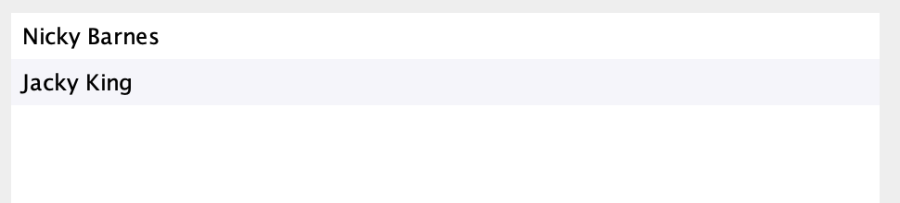

UAT Questions & Answers:
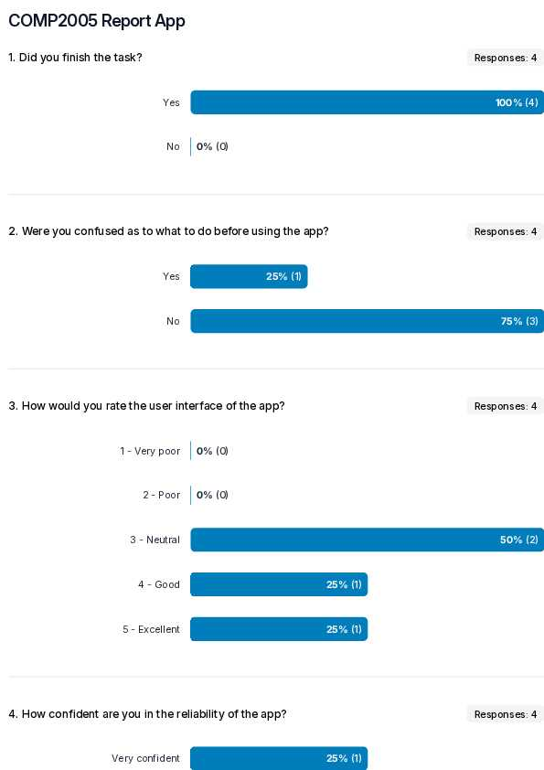
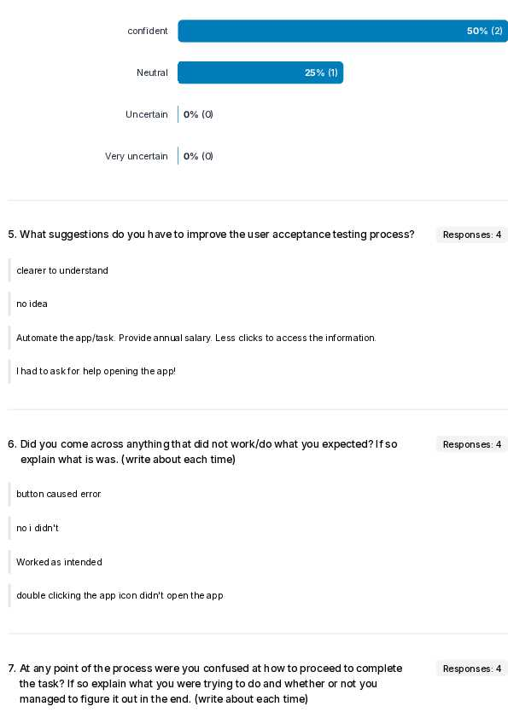
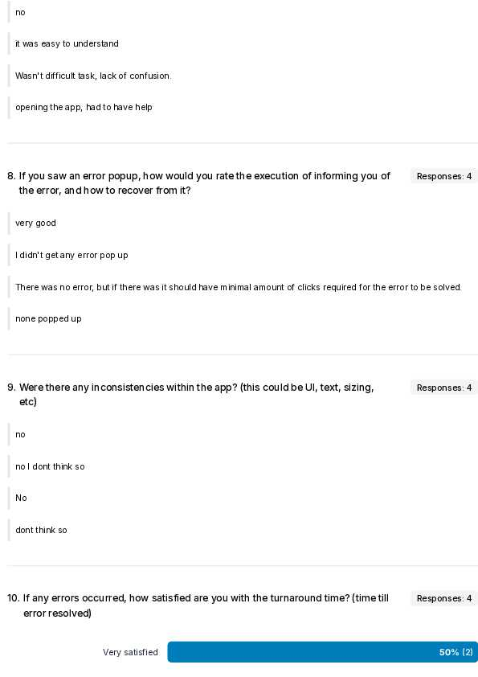
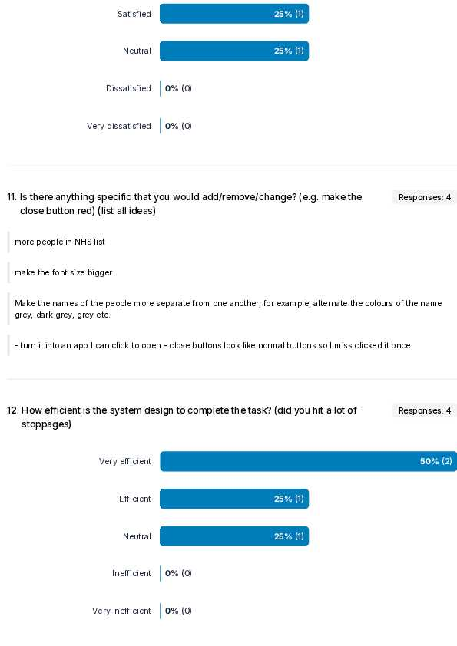
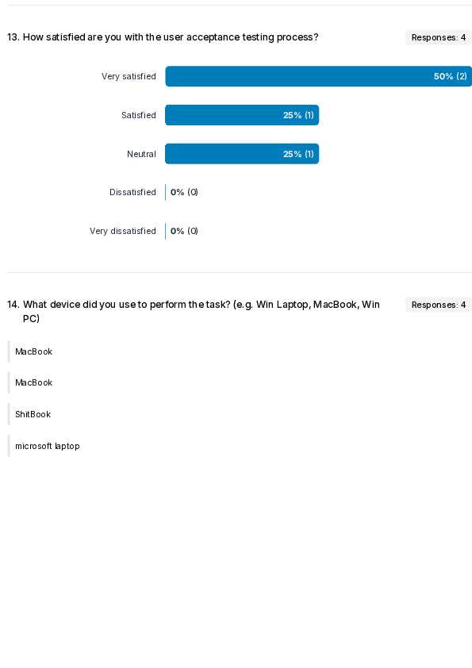

The UAT is a perfect addition to the test suite as it allows a developer to have the insight of a non-technical person. To me at least this is not possible otherwise, I see things in such a different light that without this form of testing I would not be making the app as well as I could for the users who will actually use it.

Automated Testing
I have enabled automatic testing via GitHub actions. This saves me a lot of time manually running the tests. Here is the API YAML along with the pipeline responses:
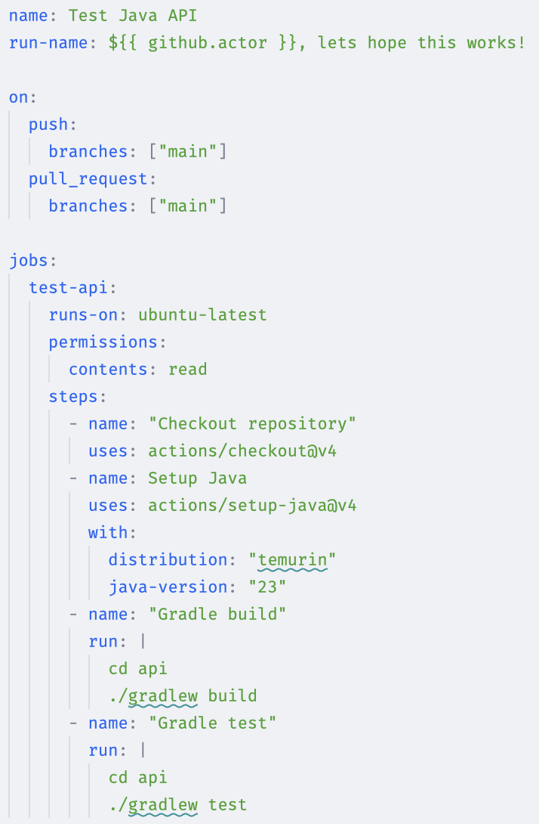 | 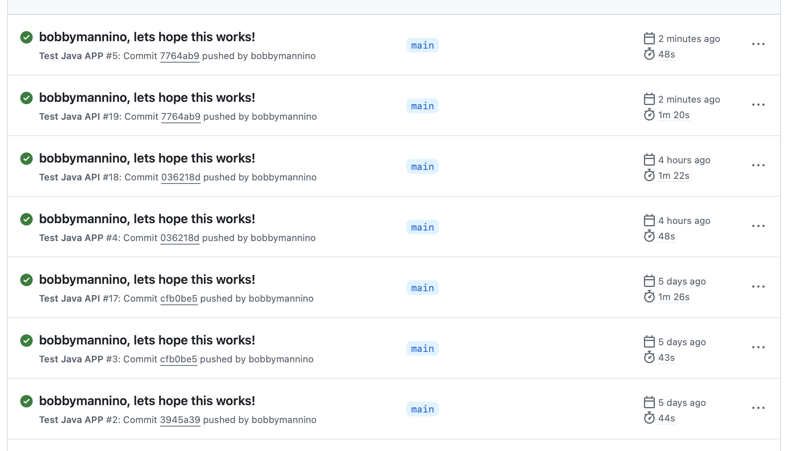

Evaluation
The test strategy I have implemented in this project hopefully shows my understanding of testing as a whole as well as on an individual level.

I chose to follow a test driven approach to my testing because I found that it works best for me, I find the functional coding easier than the testing. The API is testable without human interaction so that can be fully automated (which it is) but something with a GUI should be tested using human interaction too.

I chose to use unit, system, and integration tests for both app & API.˚I chose all these because the more testing the better especially different types. For the app it is important to have these as well as user acceptance tests. UAT is there to ensure that the actual use of the app works as expected as well as being optimized for the users using it. All of these combined provide a suitable test suite for production ready software.

I also used regression testing to ensure that any changes I made would not break the existing system. I used this through development from adding the first bit of code.

Strengths
- Code coverage for the API is in the 90s
- Code is verbose and commented where needed, this helps new people understand the codebase quicker
- Automated testing

Weaknesses
- There is little mention of mocking external dependencies, particularly for the university API. Tests that rely on external systems should be mocked for improved testability
- I did not test performance in any way
- Did not componentize anything in the app making it harder to change in the future

