noise detection
New
January 28, 2020
OSCE <- read.csv("C:/Users/LUFEMOS/Desktop/Untitled spreadsheet - OSCE Results.csv")
upload package psych to examine the descriptive statistics of the station score by group
library(psych)
This command computes the descriptive statistics of the station score across the 5 groups
describeBy(OSCE$station_score,OSCE$location_index)
##
## Descriptive statistics by group
## group: 1
## vars n mean sd median trimmed mad min max range skew kurtosis
## X1 1 43 81.57 12.24 83.75 82.25 9.27 48.75 100 51.25 -0.46 -0.22
## se
## X1 1.87
## --------------------------------------------------------
## group: 2
## vars n mean sd median trimmed mad min max range skew kurtosis
## X1 1 141 73.5 15.43 75 74.26 14.83 28.75 100 71.25 -0.42 -0.05
## se
## X1 1.3
## --------------------------------------------------------
## group: 3
## vars n mean sd median trimmed mad min max range skew kurtosis
## X1 1 60 77.98 16.5 81.88 79.77 15.75 37.5 100 62.5 -0.75 -0.34
## se
## X1 2.13
## --------------------------------------------------------
## group: 4
## vars n mean sd median trimmed mad min max range skew kurtosis
## X1 1 152 72.12 16.47 73.75 72.32 14.83 8.75 100 91.25 -0.28 0.37
## se
## X1 1.34
## --------------------------------------------------------
## group: 5
## vars n mean sd median trimmed mad min max range skew kurtosis
## X1 1 25 79.75 10.25 80 80.54 9.27 46.25 93.75 47.5 -1.1 2.2
## se
## X1 2.05
This code computes the variance of the station score by group to examine the group with the highest dispersion (NOISE)
ag <- aggregate(station_score~ location_index, data = OSCE, var)
dispersion=xtabs(station_score ~ ., data = ag)
This code plots the level of dispersion across the groups
barplot(dispersion, col=c("blue", "green","brown","red","purple"))
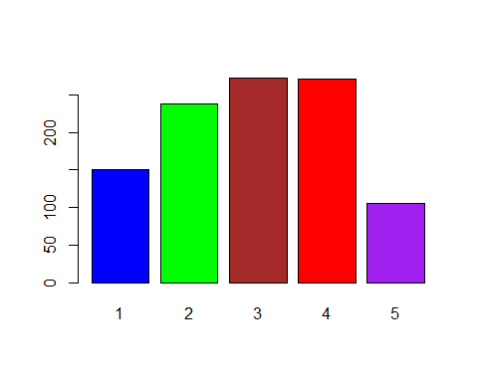 ##Separating the dataset into the 5 groups of students
group1=OSCE[OSCE$location_index=="1", ]
group2=OSCE[OSCE$location_index=="2", ]
group3=OSCE[OSCE$location_index=="3", ]
group4=OSCE[OSCE$location_index=="4", ]
group5=OSCE[OSCE$location_index=="5", ]

Plotting the station score of each of the 5 groups to examine the spread of station score by group
hist(group1$station_score, col="blue")
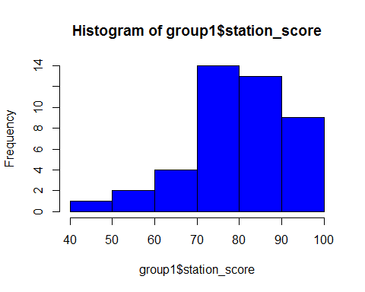
hist(group2$station_score, col="green")
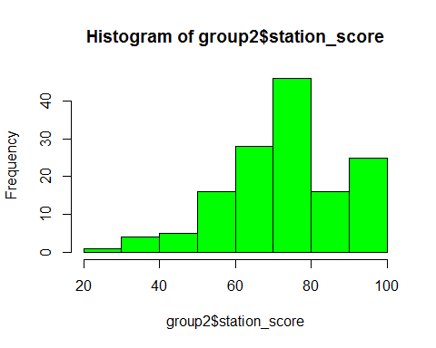
hist(group3$station_score, col="brown")
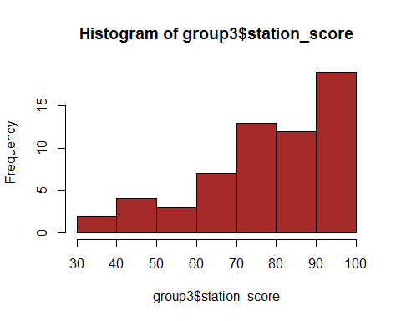
hist(group4$station_score,col="red")
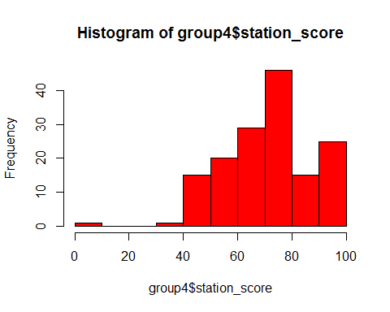
hist(group5$station_score, col="purple")
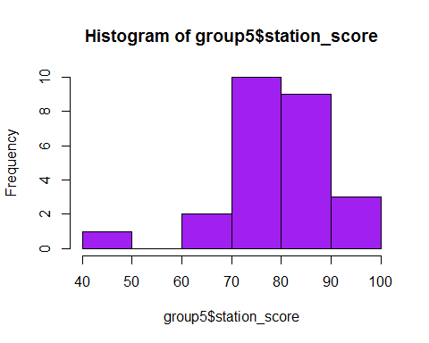

Box plot of the station score by group
boxplot(OSCE$station_score~OSCE$location_index)
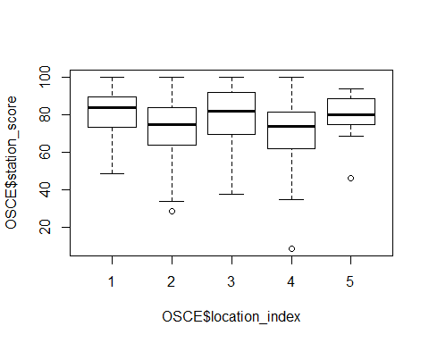

Outlier detection using the nearesk neighbor method
library(OutlierDetection)
## Warning: package 'OutlierDetection' was built under R version 3.6.2
nn(OSCE, k = 0.05 * nrow(OSCE), cutoff = 0.95, Method = "euclidean", rnames = FALSE, boottimes = 100)
## Warning in dist(data, diag = T, upper = T, method = Method): NAs introduced
## by coercion
## $`Outlier Observations`
## date_of_hand_exam location location_index station_score
## 8 7/9/2019 Non-UK 1 48.75
## 64 7/10/2019 UK 2 43.75
## 97 7/10/2019 UK 2 28.75
## 110 7/10/2019 UK 2 41.25
## 133 7/10/2019 UK 2 41.25
## 154 7/10/2019 UK 2 33.75
## 160 7/10/2019 UK 2 35.00
## 178 7/10/2019 UK 2 38.75
## 181 7/10/2019 UK 2 40.00
## 197 7/10/2019 Non-UK 3 42.50
## 221 7/10/2019 Non-UK 3 38.75
## 244 7/10/2019 Non-UK 3 37.50
## 285 7/11/2019 UK 4 42.50
## 327 7/11/2019 UK 4 35.00
## 340 7/11/2019 UK 4 8.75
##
## $`Location of Outlier`
## [1] 8 64 97 110 133 154 160 178 181 197 221 244 285 327 340
##
## $`Outlier Probability`
## [1] 0.95 0.96 1.00 1.00 1.00 1.00 1.00 1.00 1.00 0.96 1.00 1.00 0.98 1.00
## [15] 1.00
##
## $`3Dplot`
## Warning: `line.width` does not currently support multiple values.
## Warning: `line.width` does not currently support multiple values.

Outlier Detection using the Connectiveity Based Outlier Factor algorithm
COF computes the connectivity-based outlier factor for observations, being the comparison of chaining-distances between observation subject to outlier scoring and neighboring observations.The COF function is useful for outlier detection in clustering and other multidimensional domains.
library(DDoutlier)
## Warning: package 'DDoutlier' was built under R version 3.6.2
outlier_score=COF(OSCE, k = 5)
## Warning in dist(dataset): NAs introduced by coercion
names(outlier_score) <- 1:nrow(OSCE)
sort(outlier_score, decreasing = TRUE)
## 13 15 29 66 187 210
## Inf Inf Inf Inf Inf Inf
## 401 404 398 374 208 236
## Inf Inf 13.4515621 6.6666667 5.0000000 5.0000000
## 320 340 205 352 367 44
## 5.0000000 4.3430635 3.7500000 2.8409091 2.6785714 2.6041667
## 397 1 7 12 36 38
## 2.6041667 2.5000000 2.5000000 2.5000000 2.5000000 2.5000000
## 189 190 200 229 239 263
## 2.5000000 2.5000000 2.5000000 2.5000000 2.5000000 2.5000000
## 266 267 272 292 372 145
## 2.5000000 2.5000000 2.5000000 2.5000000 2.5000000 2.4752475
## 41 256 211 5 193 216
## 2.4553571 2.3584906 2.3076923 2.0114943 1.9767442 1.9607843
## 252 222 232 355 360 97
## 1.9503546 1.8666667 1.7647059 1.7613636 1.7613636 1.7042586
## 188 230 9 14 22 25
## 1.6847826 1.6847826 1.6666667 1.6666667 1.6666667 1.6666667
## 33 34 117 138 158 198
## 1.6666667 1.6666667 1.6666667 1.6666667 1.6666667 1.6666667
## 201 215 220 223 237 242
## 1.6666667 1.6666667 1.6666667 1.6666667 1.6666667 1.6666667
## 400 403 405 406 195 226
## 1.6666667 1.6666667 1.6666667 1.6666667 1.6666667 1.6666667
## 228 64 132 399 409 206
## 1.6225166 1.5763006 1.5734266 1.5687150 1.5687150 1.5555556
## 408 20 59 71 183 85
## 1.5432099 1.5408805 1.5277778 1.5277778 1.5277778 1.5217391
## 92 199 224 250 389 102
## 1.5217391 1.5217391 1.5217391 1.5217391 1.5217391 1.4917127
## 349 392 207 60 165 31
## 1.4876033 1.4876033 1.4855072 1.4527027 1.4527027 1.4388489
## 39 407 412 415 362 3
## 1.4367816 1.4077670 1.4077670 1.4077670 1.3976589 1.3945578
## 28 255 4 40 416 16
## 1.3945578 1.3841808 1.3358779 1.3358779 1.3297136 1.3125000
## 17 240 61 197 257 330
## 1.3125000 1.3085938 1.2926829 1.2831955 1.2790698 1.2790698
## 336 154 21 35 37 67
## 1.2790698 1.2550248 1.2500000 1.2500000 1.2500000 1.2500000
## 81 177 410 418 122 8
## 1.2500000 1.2500000 1.2500000 1.2500000 1.2416107 1.2027491
## 99 143 166 72 76 27
## 1.2011173 1.2011173 1.1842105 1.1813187 1.1813187 1.1744966
## 414 244 327 160 417 130
## 1.1589404 1.1505012 1.1477140 1.1451432 1.1432110 1.1418685
## 219 285 279 385 196 231
## 1.1407767 1.1211243 1.1111111 1.1111111 1.0989011 1.0989011
## 150 184 234 254 383 50
## 1.0459184 1.0459184 1.0459184 1.0342217 1.0342217 1.0317460
## 106 129 170 191 178 221
## 1.0317460 1.0317460 1.0317460 1.0256410 1.0222083 1.0222083
## 283 334 354 381 11 18
## 1.0156250 1.0156250 1.0156250 1.0156250 1.0000000 1.0000000
## 30 32 42 73 98 111
## 1.0000000 1.0000000 1.0000000 1.0000000 1.0000000 1.0000000
## 114 116 137 148 162 164
## 1.0000000 1.0000000 1.0000000 1.0000000 1.0000000 1.0000000
## 186 209 213 217 264 268
## 1.0000000 1.0000000 1.0000000 1.0000000 1.0000000 1.0000000
## 273 302 308 96 134 152
## 1.0000000 1.0000000 1.0000000 0.9920635 0.9920635 0.9920635
## 48 58 153 281 307 368
## 0.9659091 0.9659091 0.9659091 0.9565217 0.9565217 0.9565217
## 275 276 375 260 300 357
## 0.9523810 0.9523810 0.9523810 0.9293836 0.9293836 0.9293836
## 278 395 181 65 174 110
## 0.8974359 0.8974359 0.8859091 0.8823529 0.8823529 0.8712521
## 133 411 420 421 2 10
## 0.8712521 0.8659231 0.8659231 0.8659231 0.8333333 0.8333333
## 26 43 83 103 126 147
## 0.8333333 0.8333333 0.8333333 0.8333333 0.8333333 0.8333333
## 280 309 348 373 185 203
## 0.8333333 0.8333333 0.8333333 0.8333333 0.8130081 0.8130081
## 227 344 371 394 212 235
## 0.8130081 0.7911392 0.7911392 0.7911392 0.7692308 0.7692308
## 243 62 182 306 311 313
## 0.7692308 0.7575758 0.7575758 0.7500000 0.7500000 0.7500000
## 318 261 329 376 277 325
## 0.7500000 0.7396450 0.7396450 0.7396450 0.7352941 0.7352941
## 351 364 80 84 146 172
## 0.7352941 0.7352941 0.7303371 0.7303371 0.7303371 0.7303371
## 6 19 23 24 69 82
## 0.7142857 0.7142857 0.7142857 0.7142857 0.7142857 0.7142857
## 119 175 321 328 332 346
## 0.7142857 0.7142857 0.7142857 0.7142857 0.7142857 0.7142857
## 402 413 419 194 204 233
## 0.7142857 0.7142857 0.7142857 0.6976744 0.6976744 0.6976744
## 238 57 77 86 87 88
## 0.6976744 0.6250000 0.6250000 0.6250000 0.6250000 0.6250000
## 89 90 109 113 155 246
## 0.6250000 0.6250000 0.6250000 0.6250000 0.6250000 0.5555556
## 253 269 270 293 316 317
## 0.5555556 0.5555556 0.5555556 0.5555556 0.5555556 0.5555556
## 339 343 356 378 382 384
## 0.5555556 0.5555556 0.5555556 0.5555556 0.5555556 0.5555556
## 388 118 131 139 140 157
## 0.5555556 0.5555556 0.5555556 0.5555556 0.5555556 0.5555556
## 294 299 319 359 361 288
## 0.5555556 0.5555556 0.5555556 0.5555556 0.5555556 0.5357143
## 310 377 393
## 0.5357143 0.5357143 0.5357143
Inspect the distribution of outlier scores
hist(outlier_score)
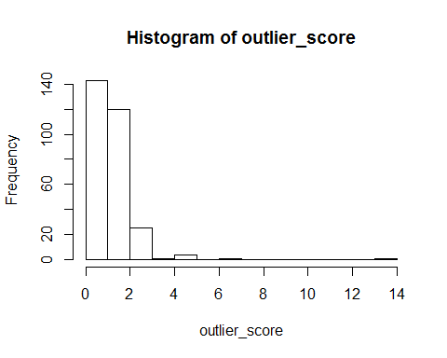
OSCE=cbind(OSCE,outlier_score)
This code computes the average outlier score across the group and identify the group with highest dispersion (noise) level
agg <- aggregate(outlier_score~ location_index, data = OSCE, FUN= "mean")
agg
## location_index outlier_score
## 1 1 Inf
## 2 2 Inf
## 3 3 Inf
## 4 4 1.18266
## 5 5 Inf
Notes: All methods which include visualization and classification indicates that the data does not account for noise in group 3. The analysis only points at noise in group 4 and 5. Though group 3 has the highest variance. but this cannot be established beyond that.

