noise detection

New

January 28, 2020

OSCE <- read.csv("C:/Users/LUFEMOS/Desktop/Untitled spreadsheet - OSCE Results.csv")

upload package psych to examine the descriptive statistics of the station score by group

library(psych)

This command computes the descriptive statistics of the station score across the 5 groups

describeBy(OSCE$station_score,OSCE$location_index)

##   
## Descriptive statistics by group   
## group: 1  
## vars n mean sd median trimmed mad min max range skew kurtosis  
## X1 1 43 81.57 12.24 83.75 82.25 9.27 48.75 100 51.25 -0.46 -0.22  
## se  
## X1 1.87  
## --------------------------------------------------------   
## group: 2  
## vars n mean sd median trimmed mad min max range skew kurtosis  
## X1 1 141 73.5 15.43 75 74.26 14.83 28.75 100 71.25 -0.42 -0.05  
## se  
## X1 1.3  
## --------------------------------------------------------   
## group: 3  
## vars n mean sd median trimmed mad min max range skew kurtosis  
## X1 1 60 77.98 16.5 81.88 79.77 15.75 37.5 100 62.5 -0.75 -0.34  
## se  
## X1 2.13  
## --------------------------------------------------------   
## group: 4  
## vars n mean sd median trimmed mad min max range skew kurtosis  
## X1 1 152 72.12 16.47 73.75 72.32 14.83 8.75 100 91.25 -0.28 0.37  
## se  
## X1 1.34  
## --------------------------------------------------------   
## group: 5  
## vars n mean sd median trimmed mad min max range skew kurtosis  
## X1 1 25 79.75 10.25 80 80.54 9.27 46.25 93.75 47.5 -1.1 2.2  
## se  
## X1 2.05

This code computes the variance of the station score by group to examine the group with the highest dispersion (NOISE)

ag <- aggregate(station_score~ location_index, data = OSCE, var)  
dispersion=xtabs(station_score ~ ., data = ag)

This code plots the level of dispersion across the groups

barplot(dispersion, col=c("blue", "green","brown","red","purple"))

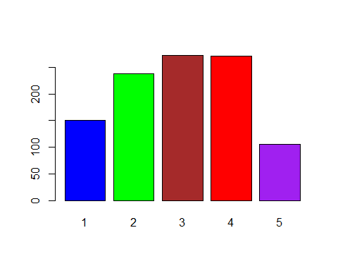 ##Separating the dataset into the 5 groups of students

group1=OSCE[OSCE$location_index=="1", ]  
group2=OSCE[OSCE$location_index=="2", ]  
group3=OSCE[OSCE$location_index=="3", ]  
group4=OSCE[OSCE$location_index=="4", ]  
group5=OSCE[OSCE$location_index=="5", ]

## Plotting the station score of each of the 5 groups to examine the spread of station score by group

hist(group1$station_score, col="blue")

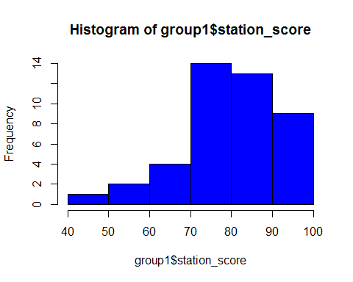

hist(group2$station_score, col="green")

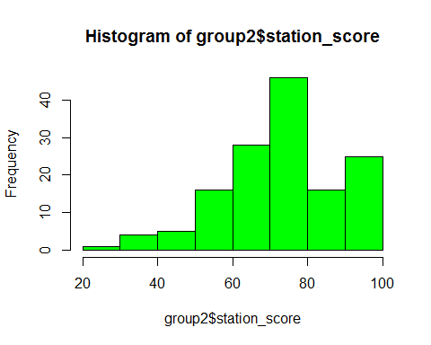

hist(group3$station_score, col="brown")

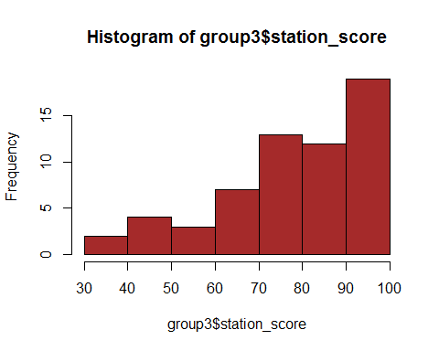

hist(group4$station_score,col="red")

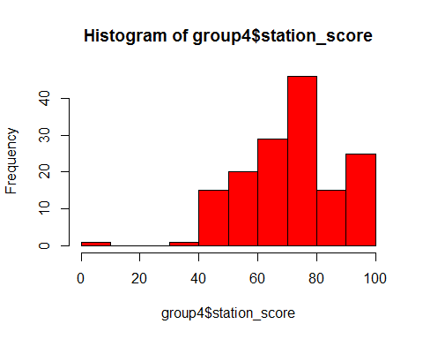

hist(group5$station_score, col="purple")

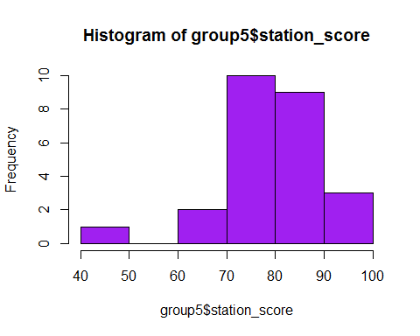

# Box plot of the station score by group

boxplot(OSCE$station_score~OSCE$location_index)

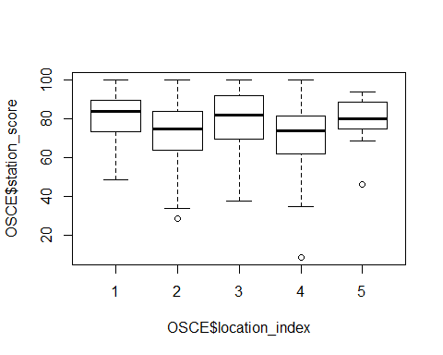

## Outlier detection using the nearesk neighbor method

library(OutlierDetection)

## Warning: package 'OutlierDetection' was built under R version 3.6.2

nn(OSCE, k = 0.05 * nrow(OSCE), cutoff = 0.95, Method = "euclidean", rnames = FALSE, boottimes = 100)

## Warning in dist(data, diag = T, upper = T, method = Method): NAs introduced  
## by coercion

## $`Outlier Observations`  
## date_of_hand_exam location location_index station_score  
## 8 7/9/2019 Non-UK 1 48.75  
## 64 7/10/2019 UK 2 43.75  
## 97 7/10/2019 UK 2 28.75  
## 110 7/10/2019 UK 2 41.25  
## 133 7/10/2019 UK 2 41.25  
## 154 7/10/2019 UK 2 33.75  
## 160 7/10/2019 UK 2 35.00  
## 178 7/10/2019 UK 2 38.75  
## 181 7/10/2019 UK 2 40.00  
## 197 7/10/2019 Non-UK 3 42.50  
## 221 7/10/2019 Non-UK 3 38.75  
## 244 7/10/2019 Non-UK 3 37.50  
## 285 7/11/2019 UK 4 42.50  
## 327 7/11/2019 UK 4 35.00  
## 340 7/11/2019 UK 4 8.75  
##   
## $`Location of Outlier`  
## [1] 8 64 97 110 133 154 160 178 181 197 221 244 285 327 340  
##   
## $`Outlier Probability`  
## [1] 0.95 0.96 1.00 1.00 1.00 1.00 1.00 1.00 1.00 0.96 1.00 1.00 0.98 1.00  
## [15] 1.00  
##   
## $`3Dplot`

## Warning: `line.width` does not currently support multiple values.

## Warning: `line.width` does not currently support multiple values.

# Outlier Detection using the Connectiveity Based Outlier Factor algorithm

COF computes the connectivity-based outlier factor for observations, being the comparison of chaining-distances between observation subject to outlier scoring and neighboring observations.The COF function is useful for outlier detection in clustering and other multidimensional domains.

library(DDoutlier)

## Warning: package 'DDoutlier' was built under R version 3.6.2

outlier_score=COF(OSCE, k = 5)

## Warning in dist(dataset): NAs introduced by coercion

names(outlier_score) <- 1:nrow(OSCE)  
sort(outlier_score, decreasing = TRUE)

## 13 15 29 66 187 210   
## Inf Inf Inf Inf Inf Inf   
## 401 404 398 374 208 236   
## Inf Inf 13.4515621 6.6666667 5.0000000 5.0000000   
## 320 340 205 352 367 44   
## 5.0000000 4.3430635 3.7500000 2.8409091 2.6785714 2.6041667   
## 397 1 7 12 36 38   
## 2.6041667 2.5000000 2.5000000 2.5000000 2.5000000 2.5000000   
## 189 190 200 229 239 263   
## 2.5000000 2.5000000 2.5000000 2.5000000 2.5000000 2.5000000   
## 266 267 272 292 372 145   
## 2.5000000 2.5000000 2.5000000 2.5000000 2.5000000 2.4752475   
## 41 256 211 5 193 216   
## 2.4553571 2.3584906 2.3076923 2.0114943 1.9767442 1.9607843   
## 252 222 232 355 360 97   
## 1.9503546 1.8666667 1.7647059 1.7613636 1.7613636 1.7042586   
## 188 230 9 14 22 25   
## 1.6847826 1.6847826 1.6666667 1.6666667 1.6666667 1.6666667   
## 33 34 117 138 158 198   
## 1.6666667 1.6666667 1.6666667 1.6666667 1.6666667 1.6666667   
## 201 215 220 223 237 242   
## 1.6666667 1.6666667 1.6666667 1.6666667 1.6666667 1.6666667   
## 400 403 405 406 195 226   
## 1.6666667 1.6666667 1.6666667 1.6666667 1.6666667 1.6666667   
## 228 64 132 399 409 206   
## 1.6225166 1.5763006 1.5734266 1.5687150 1.5687150 1.5555556   
## 408 20 59 71 183 85   
## 1.5432099 1.5408805 1.5277778 1.5277778 1.5277778 1.5217391   
## 92 199 224 250 389 102   
## 1.5217391 1.5217391 1.5217391 1.5217391 1.5217391 1.4917127   
## 349 392 207 60 165 31   
## 1.4876033 1.4876033 1.4855072 1.4527027 1.4527027 1.4388489   
## 39 407 412 415 362 3   
## 1.4367816 1.4077670 1.4077670 1.4077670 1.3976589 1.3945578   
## 28 255 4 40 416 16   
## 1.3945578 1.3841808 1.3358779 1.3358779 1.3297136 1.3125000   
## 17 240 61 197 257 330   
## 1.3125000 1.3085938 1.2926829 1.2831955 1.2790698 1.2790698   
## 336 154 21 35 37 67   
## 1.2790698 1.2550248 1.2500000 1.2500000 1.2500000 1.2500000   
## 81 177 410 418 122 8   
## 1.2500000 1.2500000 1.2500000 1.2500000 1.2416107 1.2027491   
## 99 143 166 72 76 27   
## 1.2011173 1.2011173 1.1842105 1.1813187 1.1813187 1.1744966   
## 414 244 327 160 417 130   
## 1.1589404 1.1505012 1.1477140 1.1451432 1.1432110 1.1418685   
## 219 285 279 385 196 231   
## 1.1407767 1.1211243 1.1111111 1.1111111 1.0989011 1.0989011   
## 150 184 234 254 383 50   
## 1.0459184 1.0459184 1.0459184 1.0342217 1.0342217 1.0317460   
## 106 129 170 191 178 221   
## 1.0317460 1.0317460 1.0317460 1.0256410 1.0222083 1.0222083   
## 283 334 354 381 11 18   
## 1.0156250 1.0156250 1.0156250 1.0156250 1.0000000 1.0000000   
## 30 32 42 73 98 111   
## 1.0000000 1.0000000 1.0000000 1.0000000 1.0000000 1.0000000   
## 114 116 137 148 162 164   
## 1.0000000 1.0000000 1.0000000 1.0000000 1.0000000 1.0000000   
## 186 209 213 217 264 268   
## 1.0000000 1.0000000 1.0000000 1.0000000 1.0000000 1.0000000   
## 273 302 308 96 134 152   
## 1.0000000 1.0000000 1.0000000 0.9920635 0.9920635 0.9920635   
## 48 58 153 281 307 368   
## 0.9659091 0.9659091 0.9659091 0.9565217 0.9565217 0.9565217   
## 275 276 375 260 300 357   
## 0.9523810 0.9523810 0.9523810 0.9293836 0.9293836 0.9293836   
## 278 395 181 65 174 110   
## 0.8974359 0.8974359 0.8859091 0.8823529 0.8823529 0.8712521   
## 133 411 420 421 2 10   
## 0.8712521 0.8659231 0.8659231 0.8659231 0.8333333 0.8333333   
## 26 43 83 103 126 147   
## 0.8333333 0.8333333 0.8333333 0.8333333 0.8333333 0.8333333   
## 280 309 348 373 185 203   
## 0.8333333 0.8333333 0.8333333 0.8333333 0.8130081 0.8130081   
## 227 344 371 394 212 235   
## 0.8130081 0.7911392 0.7911392 0.7911392 0.7692308 0.7692308   
## 243 62 182 306 311 313   
## 0.7692308 0.7575758 0.7575758 0.7500000 0.7500000 0.7500000   
## 318 261 329 376 277 325   
## 0.7500000 0.7396450 0.7396450 0.7396450 0.7352941 0.7352941   
## 351 364 80 84 146 172   
## 0.7352941 0.7352941 0.7303371 0.7303371 0.7303371 0.7303371   
## 6 19 23 24 69 82   
## 0.7142857 0.7142857 0.7142857 0.7142857 0.7142857 0.7142857   
## 119 175 321 328 332 346   
## 0.7142857 0.7142857 0.7142857 0.7142857 0.7142857 0.7142857   
## 402 413 419 194 204 233   
## 0.7142857 0.7142857 0.7142857 0.6976744 0.6976744 0.6976744   
## 238 57 77 86 87 88   
## 0.6976744 0.6250000 0.6250000 0.6250000 0.6250000 0.6250000   
## 89 90 109 113 155 246   
## 0.6250000 0.6250000 0.6250000 0.6250000 0.6250000 0.5555556   
## 253 269 270 293 316 317   
## 0.5555556 0.5555556 0.5555556 0.5555556 0.5555556 0.5555556   
## 339 343 356 378 382 384   
## 0.5555556 0.5555556 0.5555556 0.5555556 0.5555556 0.5555556   
## 388 118 131 139 140 157   
## 0.5555556 0.5555556 0.5555556 0.5555556 0.5555556 0.5555556   
## 294 299 319 359 361 288   
## 0.5555556 0.5555556 0.5555556 0.5555556 0.5555556 0.5357143   
## 310 377 393   
## 0.5357143 0.5357143 0.5357143

Inspect the distribution of outlier scores

hist(outlier_score)

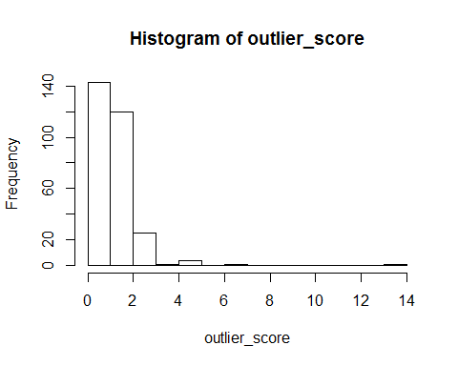

OSCE=cbind(OSCE,outlier_score)

This code computes the average outlier score across the group and identify the group with highest dispersion (noise) level

agg <- aggregate(outlier_score~ location_index, data = OSCE, FUN= "mean")  
agg

## location_index outlier_score  
## 1 1 Inf  
## 2 2 Inf  
## 3 3 Inf  
## 4 4 1.18266  
## 5 5 Inf

Notes: All methods which include visualization and classification indicates that the data does not account for noise in group 3. The analysis only points at noise in group 4 and 5. Though group 3 has the highest variance. but this cannot be established beyond that.