**CO202 Design of Digital Systems**

**Mini Project**

**Logisim**

**Video of the demo:** https://drive.google.com/open?id=0By3iWd18PJFKQjhwUWw3Y2xhdlE

**Steps of execution:**

**1)** **Initialise maximum number of people that can be accomodated in a room**:

This is done by initialising the 10 bit binary input which represents the maximum limit to the desired value.

Note: Make sure the maximum limit is a value greater than 0 otherwise the counter will not count up at the start.

In the figure shown the maximum limit is set to 20.

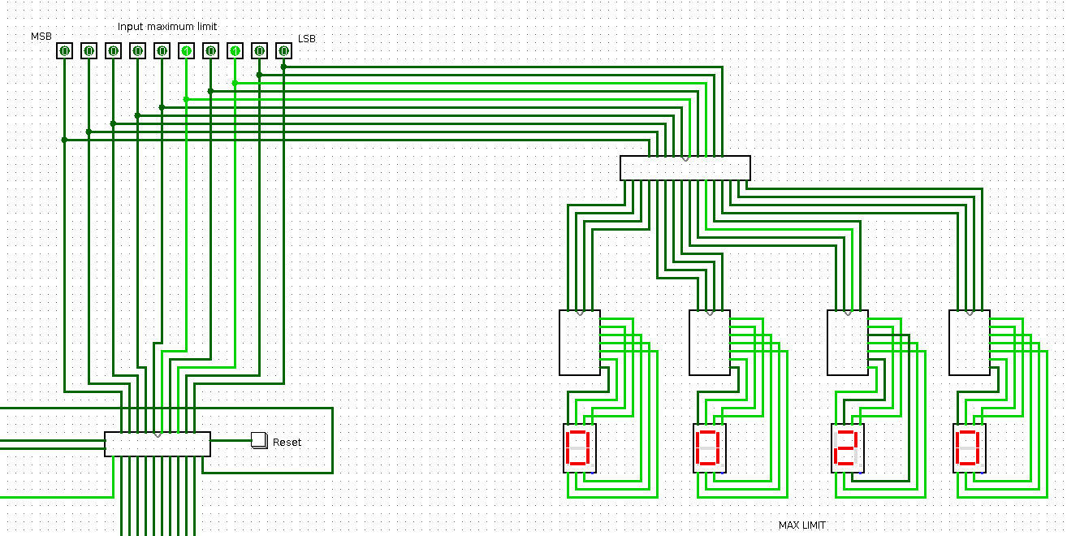

**Initially when no person is there in the room, entry door is open to allow people, exit door is closed and the power in the room is switched off.** Also the count is zero. In the figure shown below, the entry door is switch on (i.e it is open), the exit door is switched off (i.e it is closed) and the power is switched off.

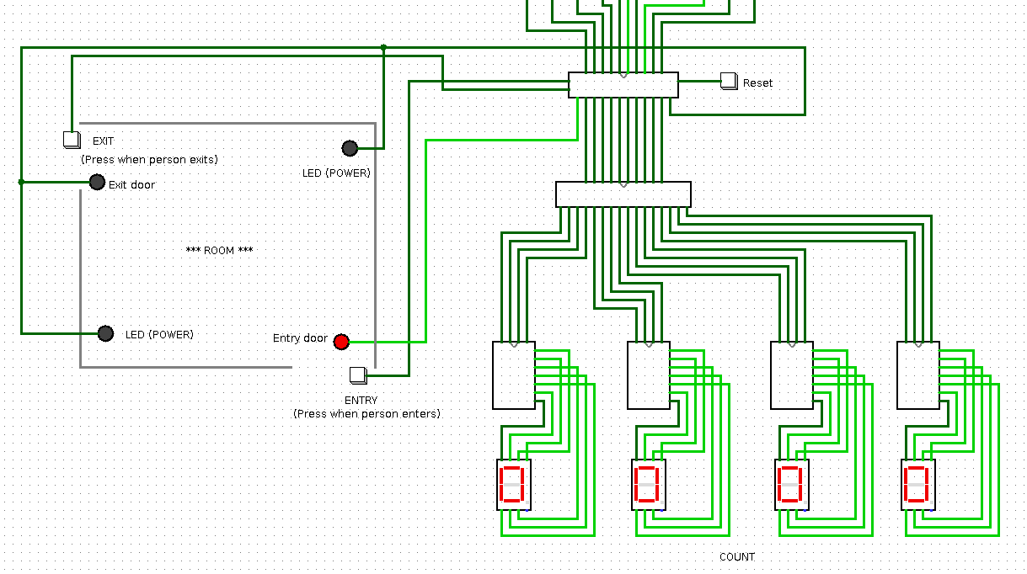

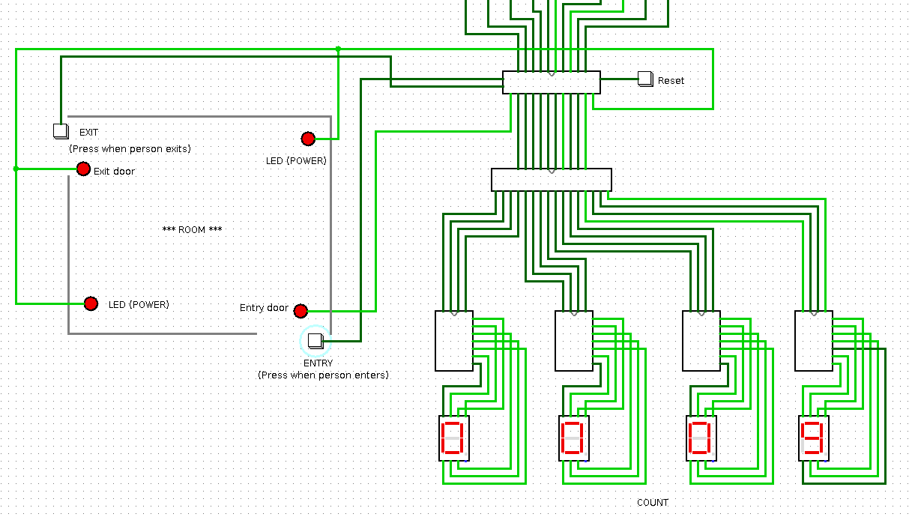**2)** **Press the entry button**:

When a person enters the room the entry button is pressed. Now the **power is switched on and the exit door is open**. Entry button is pressed for each person entering the room. Observe that the **count increases by one each the entry button is pressed**. In the figure shown below, 9 people are present in the room. The entry door is open, exit door is open and the power is switched.

**When the count reaches the maximum limit, the entry door closes to prevent entry of people.** **The counter is modified to take care of overflow,** i.e the count never increases more than the maximum limit. In the figure shown below, the count has reached the maximum limit of 20 and hence the entry door is closed(switched off).

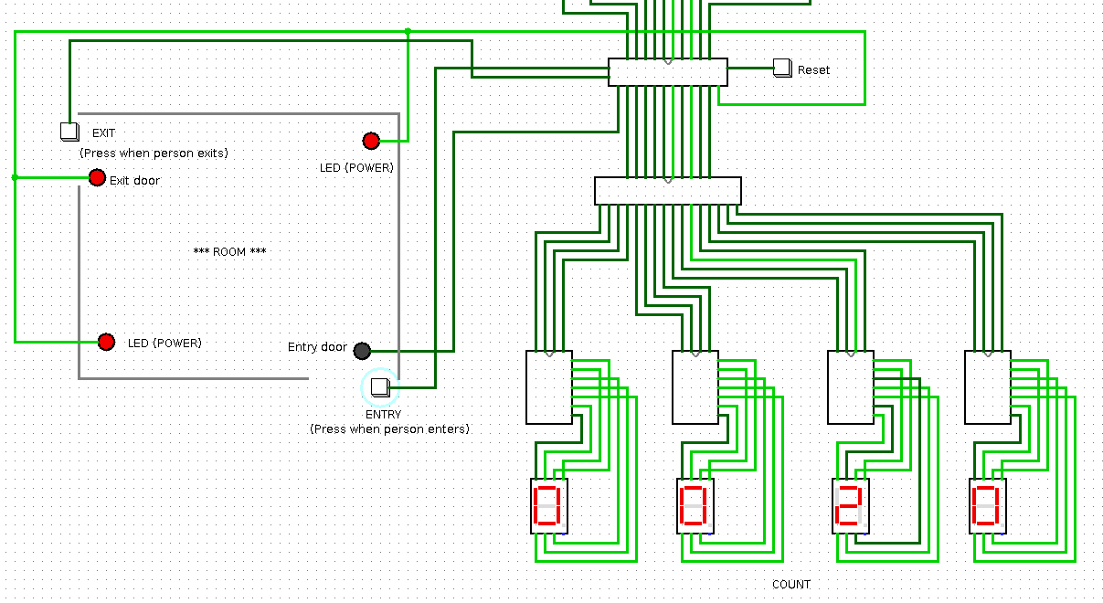**3) Press the exit button**:

When a person exits the room, the exit button is pressed. Observe that the **count decreases by one each time the exit button is pressed**.

**The counter is modified to take care of underflow**. When the count is zero and exit is pressed the count remains zero and does not underflow.

**4) Reset button**: The counter can be reset to the initial state by pressing the reset button.

Note: If there are red/blue wires, please refer video.

**Main features of the project** :-

1) **Maximum Limit** :- User can input maximum limit on the number of people in the room ranging from 1 to 1023 people.

2) **Automatic Power controller** :- By controlling power based on the number of people, energy is saved.

3 ) **Door opening and locking** :- It includes the feature of locking the entry and exit door. When there is no person in the room exit door is locked and when number of people in the room has reached the maximum limit, entry door is locked .

4) **Modified counter** :- A 10 bit synchronous/asynchronous up – down counter with additional features used to keep count of number of people in the room. It prevents underflow, i.e if room is empty and exit button is pressed count remains 0. It checks overflow, i.e if room is full and entry button is pressed count is not incremented. It controls the power in the room accordingly. It can also be reset to zero.

5) **Binary to BCD converter**:- Converts the 10 bit output from counter to binary coded decimal which is used in 7 segment display.

6) **7 Segment Display**:- Displays the number of people in room as 4 digit decimal number.