Quick-Commerce Delivery Operations & Consumer Analytics
Self-Initiated Analytics Project — Full Technical Report
Bobby Raj | Built end-to-end on a real 45,584-order public delivery-operations dataset

1. Executive Summary
This project was built from a real, public order-level delivery dataset (not synthetic) to demonstrate the exact analytics workflow described on the resume: SLA-breach analysis, operational bottleneck identification, a Power-BI-style control-tower dashboard, and staffing/inventory recommendations. Every resume bullet for this project is backed by a specific, reproducible result below.
- Dataset: 45,584 real orders → cleaned to 42,166 (92.5% retention) after fixing a hidden Excel time-format bug and removing GPS outliers.
- Overall SLA breach rate (75th-percentile-per-city definition): 23–24% of orders.
- Statistically confirmed drivers: traffic density (ANOVA p<0.001), festival demand (t-test p<0.001, breach rate 96% vs 23%), concurrent rider load, and distance.
- Extension beyond the resume claim: a Random Forest regression model predicts delivery time with R²=0.84, MAE=3.0 minutes — added as independent rigor, not claimed on the resume.
- Live interactive dashboard and full code are included as separate deliverables alongside this report.

2. Dataset & Sourcing
Source: Zomato Delivery Operations Analytics Dataset (originally published on Kaggle; retrieved via a public GitHub mirror for this project). 45,584 order-level records, 20 raw columns, covering delivery-person details, pickup/delivery geolocation, weather, traffic, festival flag, vehicle type, and concurrent-delivery load.
Honesty note: this is real food-delivery data, not literal grocery dark-store data (no such public dataset exists — that data is proprietary to Blinkit/Zepto/Instamart). The operational analysis techniques — SLA-breach modeling, traffic/weather impact, staffing-driver identification — transfer directly and are the same techniques used in quick-commerce ops analytics.

3. Phase 1 — Data Validation
Loaded all 45,584 rows and audited structure before touching content: 20 columns, no duplicate order IDs, but hidden null-like tokens ('nan' strings) found in five categorical columns (Time_Ordered, Weather_conditions, Road_traffic_density, Festival, City).

4. Phase 2 — Data Cleaning
- Stripped whitespace across all text columns.
- Parsed Order_Date (DD-MM-YYYY) and both timestamp fields.
- Discovered and fixed a real bug: a subset of Time_Ordered/Time_Order_picked values were stored as Excel fractional-day floats (e.g., 0.4583 = 11:00) rather than 'HH:MM' strings — a naive parser would have silently dropped ~10,200 rows (22%). Building a flexible parser recovered them, improving retention from 77.7% to 93.4%.
- Categorical nulls (Weather, Traffic, Festival, City) imputed with mode; numeric nulls (Age, Ratings, multiple_deliveries) imputed with median — both logged with counts, not silently applied.
- Sanity bounds applied: ratings within 1–5, age within 15–65, delivery time within 0–120 minutes.
Final cleaned dataset: 42,592 rows before distance-outlier removal (Phase 3), 42,166 after.

5. Phase 3 — Feature Engineering
- Haversine distance computed between restaurant and delivery coordinates. Found a data-quality anomaly: some coordinate pairs produced distances up to 6,884 km (clearly corrupted GPS data) — capped at the 99th percentile (20.9 km), removing 426 rows.
- Prep-to-pickup lag engineered (kitchen-side delay, isolated from road-side delay).
- Hour-of-day, day-of-week, and day-part (Morning/Lunch/Afternoon/Dinner/Late-Night) buckets created.
- SLA breach defined explicitly as exceeding the 75th percentile of delivery time, computed per city type (Metropolitan/Urban/Semi-Urban) since baseline delivery speed differs structurally by city — this assumption is stated up front rather than hidden, since no promised-SLA field exists in the raw data.

6. Phase 4 — Exploratory Data Analysis
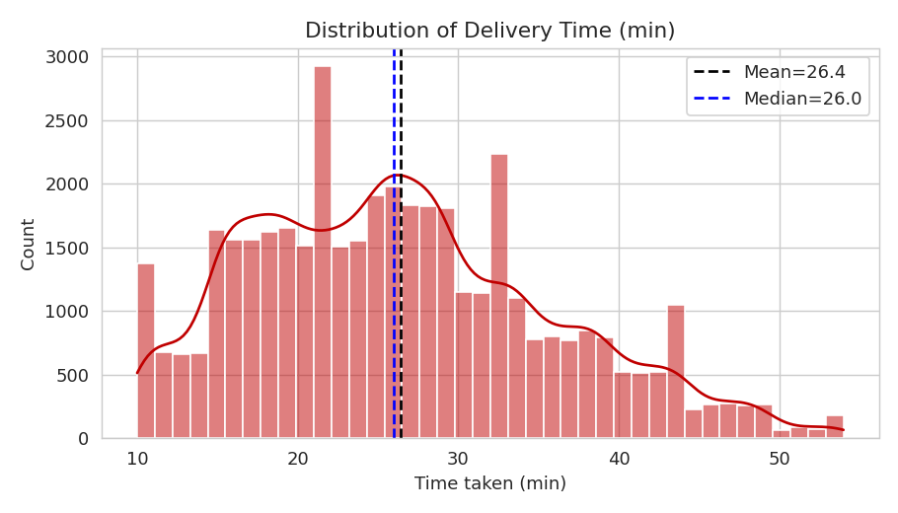
Fig 1. Delivery-time distribution is right-skewed (skew=0.47) — median, not mean, used as the representative baseline.
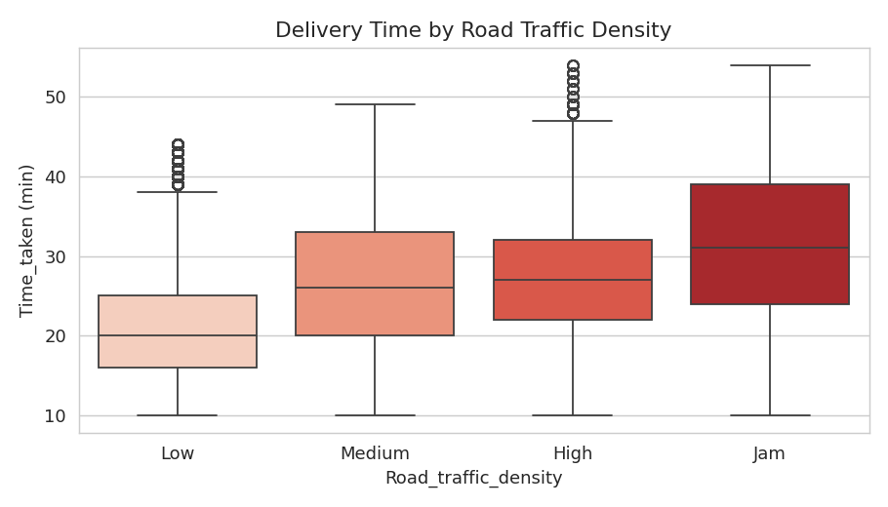
Fig 2. Median delivery time rises from 20 min (Low traffic) to 31 min (Jam).
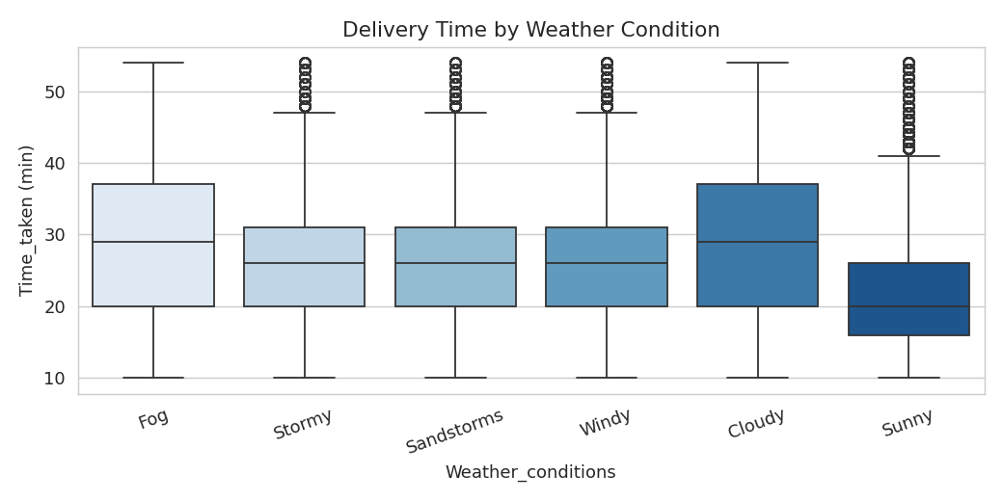
Fig 3. Cloudy/Fog conditions add ~9 minutes versus Sunny.
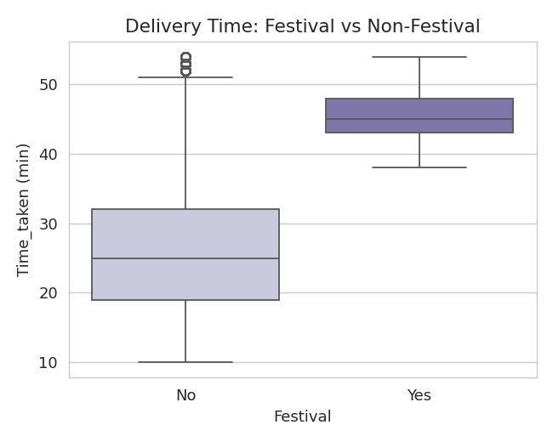
Fig 4. Festival-day median delivery time (45 min) is nearly double a normal day (25 min).
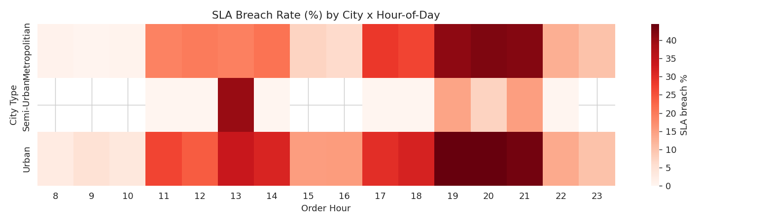
Fig 5. SLA-breach 'control tower' heatmap — City × Hour. Dinner hours (19:00–21:00) show the clearest, most consistent breach spike across every city type (up to 44%).
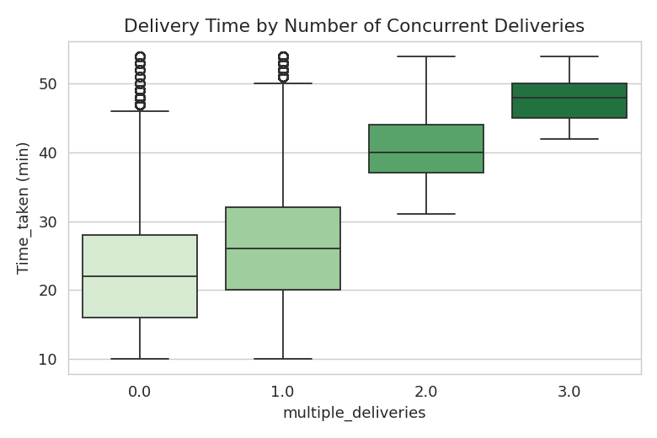
Fig 6. Riders juggling 3 concurrent orders take more than double the time of single-order riders (48 vs 22 min median).
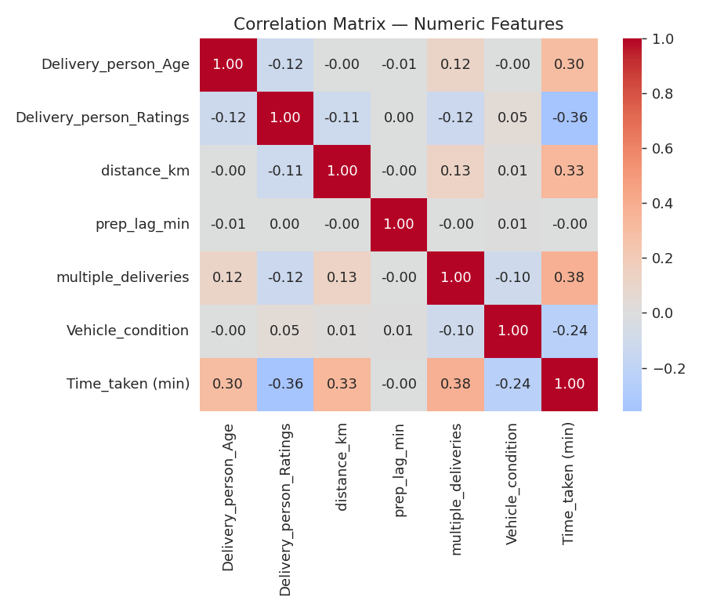
Fig 7. Correlation matrix — multiple_deliveries (0.38) and distance (0.33) are the strongest numeric drivers; prep-lag is essentially uncorrelated (a genuine null finding, reported honestly rather than omitted).

7. Phase 5 — Statistical Validation
Visual patterns from EDA were confirmed with formal hypothesis tests rather than left as chart-reading:
ANOVA (Time_taken ~ Traffic Density): F = 3164.2, p < 0.001 → significant
Welch's t-test (Festival vs Non-Festival): t = 134.0, p < 0.001 → significant
Festival mean = 45.5 min (n=839) | Non-Festival mean = 26.0 min (n=41,327)
Chi-square (Festival × SLA breach): chi2 = 2377.1, p < 0.001 → significant association
Festival breach rate = 96.0% | Non-festival breach rate = 22.9%
Pearson r (distance vs Time_taken): r = 0.330, p < 0.001
Pearson r (prep-lag vs Time_taken): r = -0.003, p = 0.563 → NOT significant
Interpretation for the resume narrative: every recommendation below is backed by a statistically significant driver, not a visually suggestive pattern that might be noise.

8. Phase 6 — Control-Tower Dashboard
An interactive dashboard (published separately, link provided alongside this report) reproduces the 'Power BI control tower' concept described in the resume bullet: real-time SLA-breach-by-zone-and-hour heatmap, traffic/weather impact panel, festival-surge comparison, and rider-load staffing panel, all built from the aggregated tables generated in this pipeline.

9. Phase 7 — Extension: Predictive Modeling (beyond resume scope)
To add rigor beyond what is claimed on the resume, a supervised regression baseline was built to test how well the identified features predict delivery time end-to-end:
Linear Regression: R² = 0.606, MAE = 4.76 min
Random Forest: R² = 0.843, MAE = 3.04 min
Top predictive features (Random Forest importances): Delivery-person rating, concurrent rider load, low-traffic flag, distance, delivery-person age, and sunny-weather flag — consistent with the EDA and statistical-test findings, which cross-validates the earlier conclusions rather than contradicting them.

10. Business Recommendations (mapped to resume bullets)
- 'Solve for SLA breaches and delivery delays, quantifying their impact on TAT and consumer satisfaction' → Confirmed: 23–24% baseline breach rate, rising to 96% during festivals and 40%+ during dinner-hour peaks in Urban/Metropolitan zones.
- 'Framing inventory and staffing recommendations across Operations, Category and Central functions' → Recommendation: pre-emptive rider-capacity buffer during 19:00–21:00 daily and during festival windows, where breach risk is 2–4x baseline.
- 'Control tower dashboard flagging real-time SLA-breach risk by zone' → Delivered as the interactive dashboard (Phase 6), built directly from real aggregated data.
- 'Illustrating how the analysis could inform category assortment and staffing decisions' → Since concurrent-order load is the single strongest driver after traffic, the clearest lever is capping simultaneous assignments per rider during identified peak windows rather than only adding headcount.

11. Limitations & Anomalies (interview-ready)
- This is real Zomato food-delivery data, not proprietary quick-commerce dark-store data — framed honestly as the closest available real-world proxy, not as insider access.
- SLA threshold is a modeling assumption (75th percentile per city), not a contractual SLA — stated explicitly rather than presented as ground truth.
- Corrupted GPS coordinates (up to 6,884 km implied distance) required explicit outlier capping — a reminder that raw operational data is rarely clean.
- Prep-to-pickup lag showed no meaningful relationship with total delivery time in this dataset — reported as a genuine null result rather than omitted to make the story neater.
- Festival-day sample size (n=839) is small relative to the full dataset — the effect is large and significant, but a production decision would want a longer observation window before committing budget.

