J O H N
PROFESSIONAL SUMMARY
M I L L I E
First things first. You need to decide which company you want to
work for and research it. Analyze the job description for the position
and write down the job requirements, industry-specific keywords and
phrases, and key skills required for the job. A professional summary,
also known as a resume summary statement, is a brief statement at
the top of your resume.
P R O F E S S I O N A L T I T L E
CONTACT
+123-456-7890
EXPERIENCE
123 Garrison St., Freetown
youremail@gmail.com
www.yoursite.com
2019 - 2022
Job Title here
Company Name | Location
One of the most difficult parts in writing a resume is composing
the descriptions of your jobs, volunteer work, projects, and other
relevant experiences.
Each description of your work history and volunteer experience
should be clear and concise, yet descriptive.
Write what your responsibilities were, what skills you have
developed, where your strengths lie, and what you have achieved.
EDUCATION
Diploma/Degree
College/University
2011 - 2014
2019 - 2022
Job Title here
Company Name | Location
Begin each item by stating the name of the place, location, dates,
and job title (e.g. manager, volunteer) List experiences in reverse
chronological order (most current experience first).
Describe your responsibilities in concise statements led by strong
verbs.
Diploma/Degree
College/University
2011 - 2014
Focus on those skills and strengths that you possess and that you
have identified as being important to your field.
Diploma/Degree
College/University
2011 - 2014
2019 - 2022
Job Title here
Company Name | Location
Be sure to vary your action words. You do not want all your
descriptions to sound the same.
Use present tense for those activities which are ongoing and past
tense for those with which you are no longer involved.
Avoid summarizing or describing what a company or organization
you worked with did or does.
TECH SKILLS
Graphic Design
UX/UI Design
Image Manipulation
Illustration
PROFESSIONAL DEVELOPMENT
Workshop/Class/Course
School/University/Organization
Location
2011 - 2014
2011 - 2014
Web Design
Workshop/Class/Course
School/University/Organization
Location
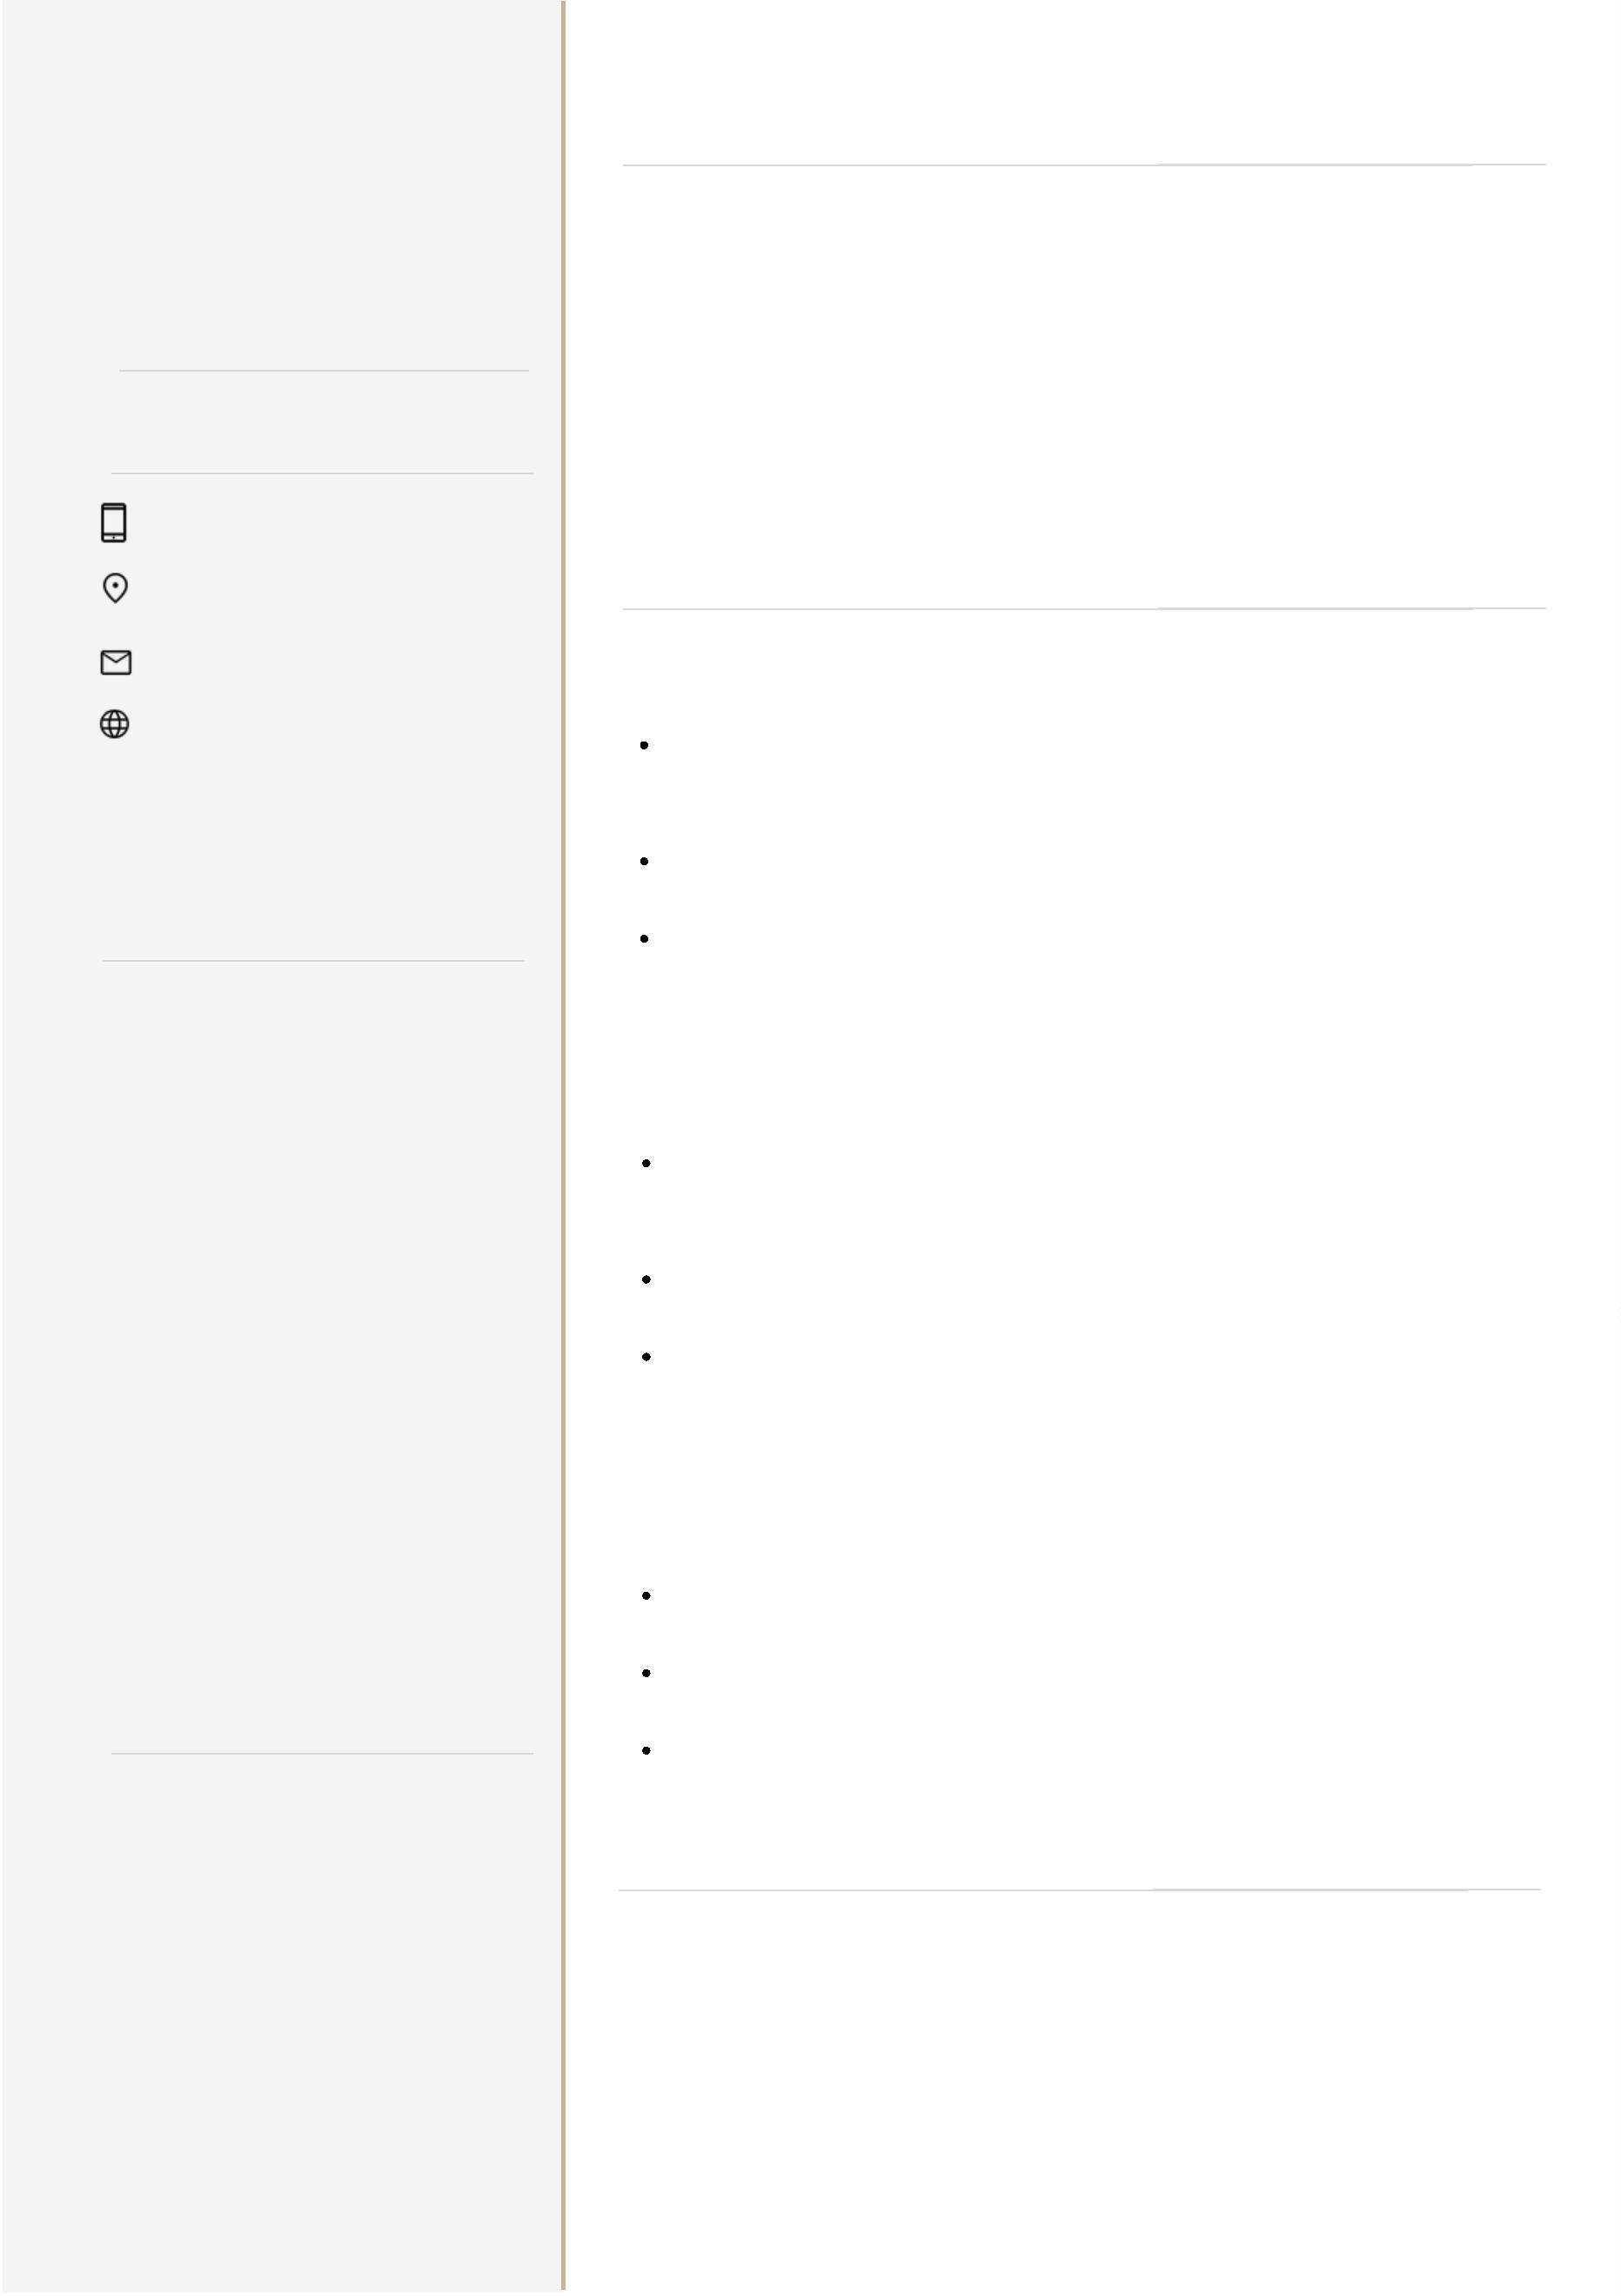

WORK EXPERIENCE CONTINUED
CERTIFICATIONS &
LICENSUR
2019 - 2022
Job Title here
Company Name | Location
2011 - 2014
Name of Certificate
Name of Institute
Location
One of the most difficult parts in writing a resume is composing
the descriptions of your jobs, volunteer work, projects, and other
relevant experiences.
Each description of your work history and volunteer experience
should be clear and concise, yet descriptive. Write what your
responsibilities were, what skills you have developed, where your
strengths lie, and what you have achieved.
2011 - 2014
Name of Certificate
Name of University
Location
2019 - 2022
Job Title here
2011 - 2014
Company Name | Location
Name of Certificate
Name of University
Location
Begin each item by stating the name of the place, location, dates,
and job title (e.g. manager, volunteer) List experiences in reverse
chronological order (most current experience first).
Describe your responsibilities in concise statements led by strong
verbs. Focus on those skills and strengths that you possess and
that you have identified as being important to your field.
2011 - 2014
Name of Certificate
Name of University
Location
2019 - 2022
Job Title here
Company Name | Location
AWARDS
Be sure to vary your action words. You do not want all your
descriptions to sound the same. Use present tense for those
activities which are ongoing and past tense for those with which
you are no longer involved.
Avoid summarizing or describing what a company or organization
you worked with did or does.
2011 - 2014
Award Title
Awarding organization
Location
2011 - 2014
Award Title
Awarding organization
Location
2019 - 2022
Job Title here
Company Name | Location
Be sure to vary your action words. You do not want all your
descriptions to sound the same. Use present tense for those
activities which are ongoing and past tense for those with which
you are no longer involved.
Avoid summarizing or describing what a company or organization
you worked with did or does.
2011 - 2014
Award Title
Awarding organization
Location
PROFESSIONAL DEVELOPMENT
LANGUAGE
Workshop/Class/Course
School/University/Organization
Location
2011 - 2014
2011 - 2014
English
Spanish
French
Workshop/Class/Course
School/University/Organization
Location
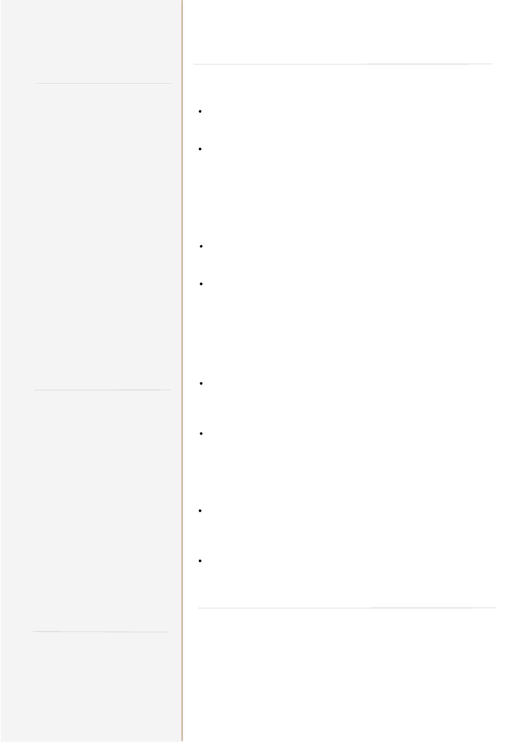

J O H N
M I L L I E
COVER LETTER
January 2, 2025
Noah Schumacher
Recruitment Specialist
Name of Company
Location
P R O F E S S I O N A L T I T L E
City
CONTACT
Dear Mr. Schumacher,
+123-456-7890
A cover letter allows you to professionally introduce yourself to a
prospective employer. Your goal in writing your cover letter
should be to encourage the employer to read your resume and
consider you for a specific position.
123 Garrison St., Freetown
youremail@gmail.com
www.yoursite.com
Highlight your achievements, skills, experiences, and training that
are relevant to the position you want to get. However, avoid
simply repeating the information you included in your resume.
Tailor your cover letter to each employer and job. Since you are
applying for specific roles, give specific examples and events that
demonstrate your ability to perform well if given the position.
Yes, you should maintain a professional air throughout the copy,
however, an exceedingly formal tone may turn off those who read
it. Remember to also show genuine enthusiasm for the job. You
can think of it this way: it’s not a suit-and-tie event, but a smart
casual gathering. Steer away from highly personal information
and questions about the position. This includes talking about
salary expectations and company benefits. Instead, reserve such
inquiries for the actual interview.
Make sure you proofread your cover letter before sending it. There
are various online tools that can help you catch minor
grammatical or typographical errors. Additionally, make sure
your cover letter is easy to read. Use a simple font like the one
used here. Avoid walls of text, too. Dividing your letter into
paragraphs makes it easy on the eyes and organizes the
information you provide.
Best regards,
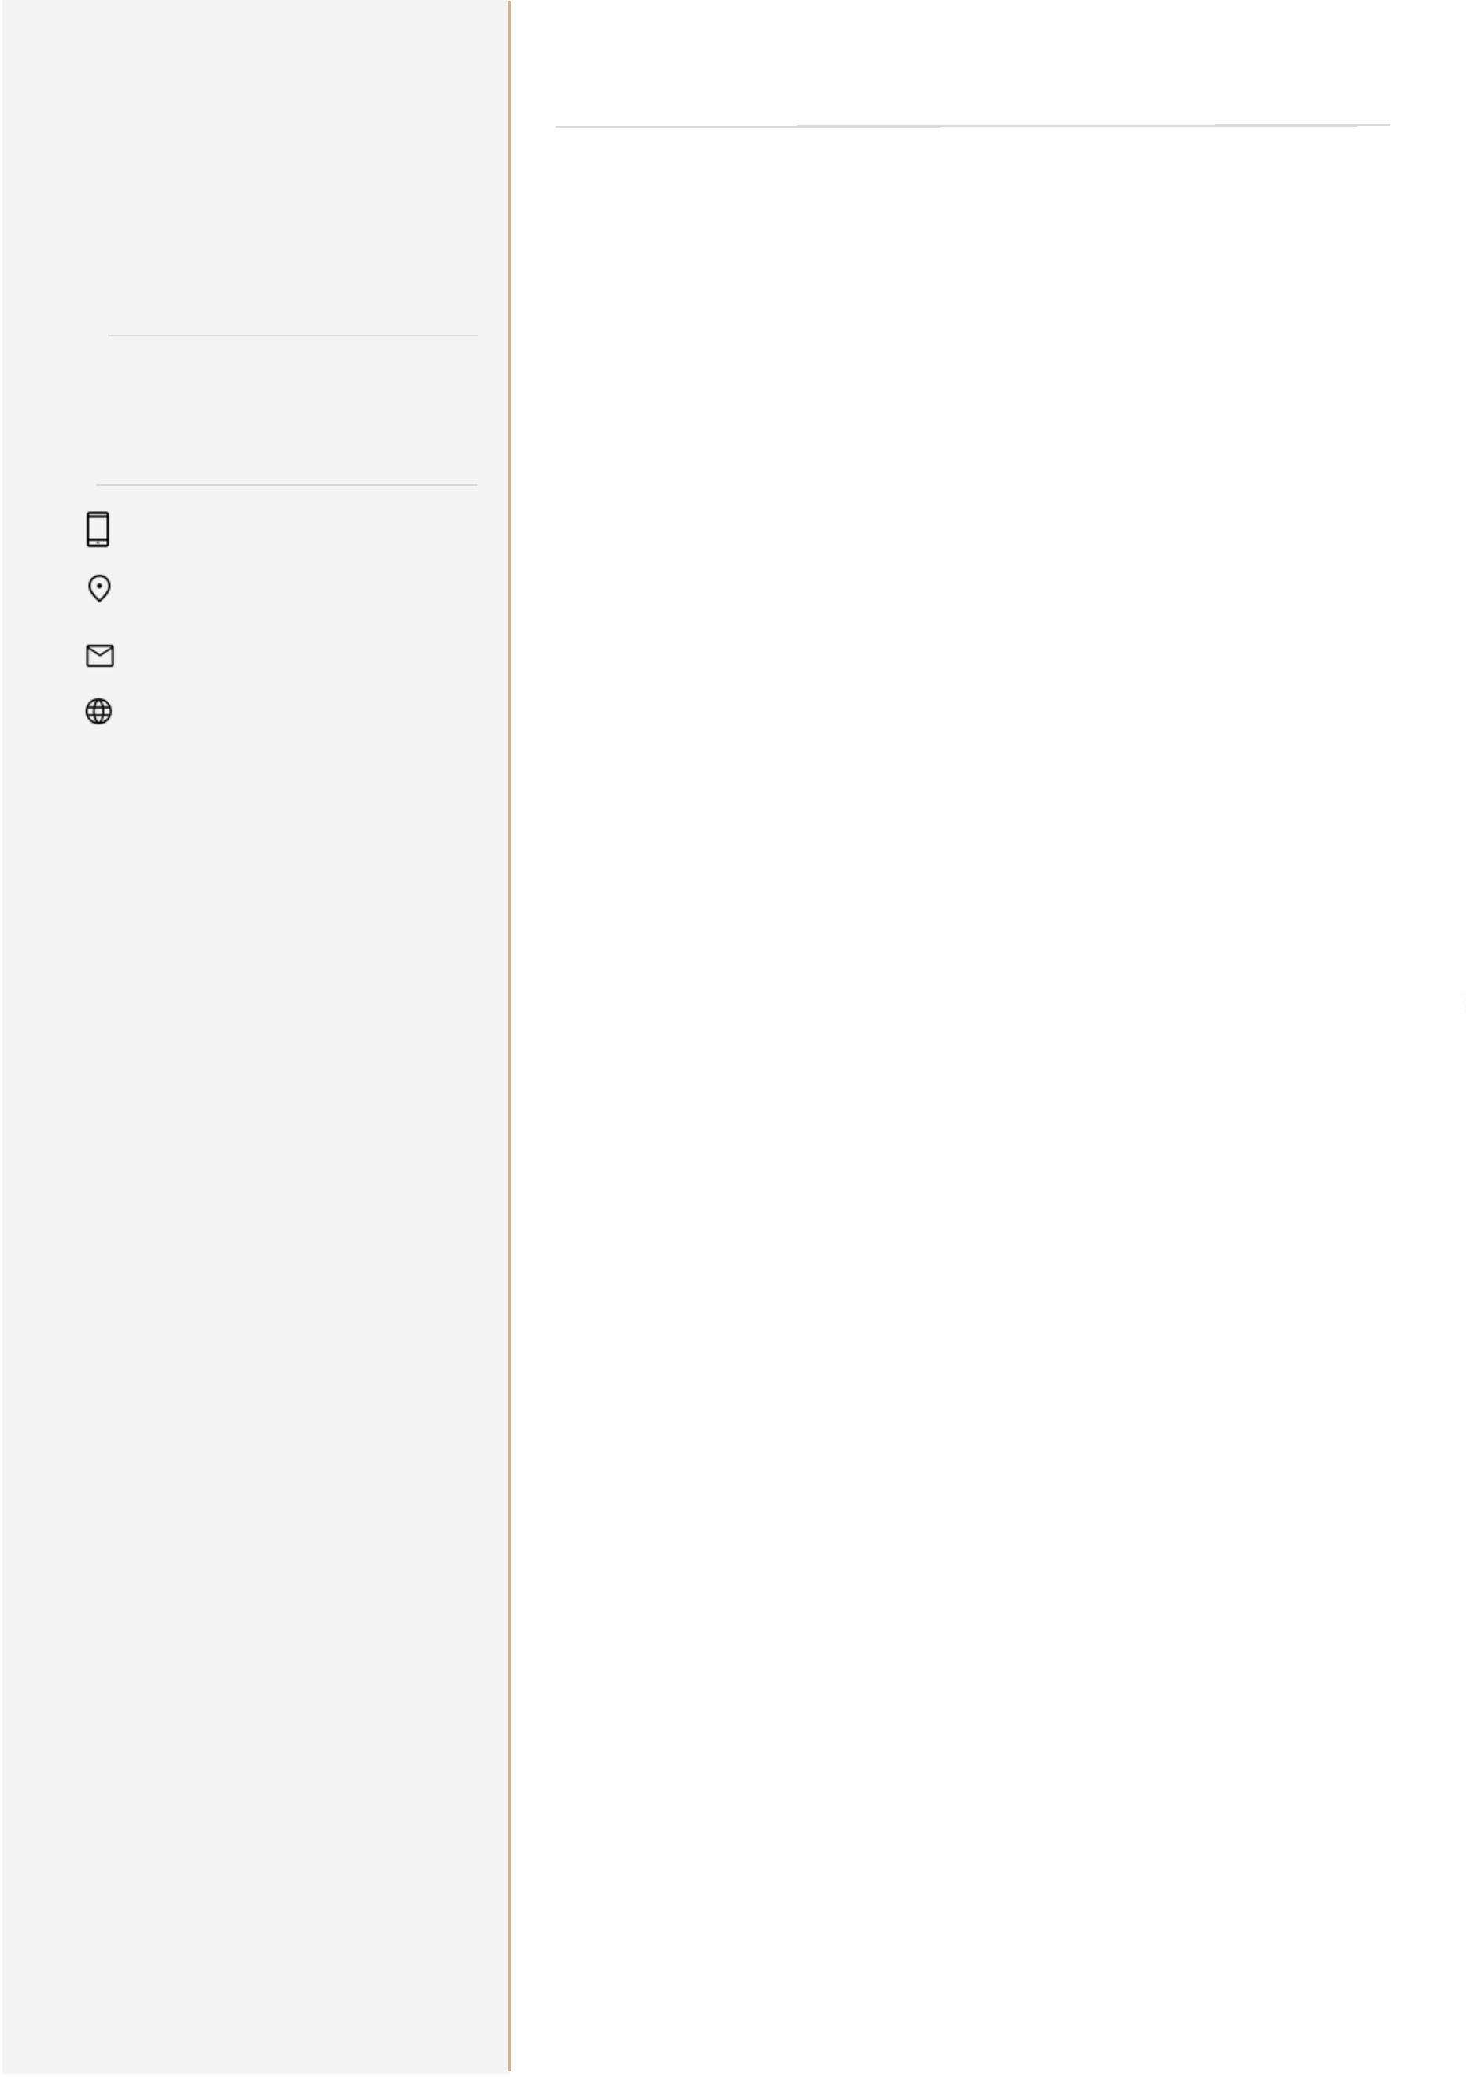

J O H N
M I L L I E
THANK YOU
P R O F E S S I O N A L T I T L E
August 8, 2023
Company Name
123 Address of the company
CONTACT
Dear [Mr./Ms. Name]:
+123-456-7890
It was a pleasure to meet you this afternoon. I appreciate you
taking time out of your busy schedule to discuss the available
position of [Position title] at [Company name], I enjoyed learning
about the position as an industry leader, its mission statement
and its plan to [company plans].
123 Garrison St., Freetown
youremail@gmail.com
www.yoursite.com
As we talked about in the interview, I have extensive experience in
[industry-related job duties] including [relevant experience]. My
proficiency in [hard skill] coupled with my robust [soft skill] has
allowed me to make the following noteworthy accomplishments
in my professional career [achievement] and [accomplishment].
Given my proven record of success, commitment to quality, and
leadership capabilities. I. am confident that I can assist
[Company Name] reach the company goal to [company goal].
[Optional Section] If you weren't able to discuss certifications.
skills, or experience that makes you an ideal candidate during
the interview, use this section to offer information about these
qualifications. You can also use this section to clear up any
misconceptions or discuss any point in the interview that you feel
you didn't cover strongly enough.
Thank you again, [Mr./Ms. Name] for your time and attention.
I look forward to hearing from you regarding the next steps in the
interview process. Please contact me if you require any
additional information regarding my application.
Sincerely,
Your Signature
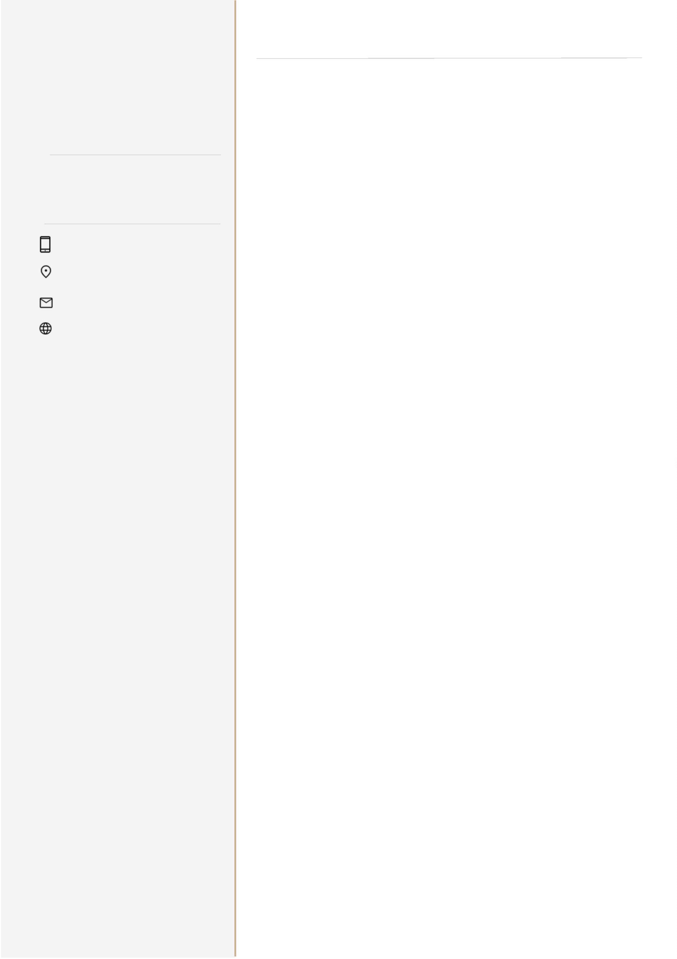

J O H N
REFERENCES
M I L L I E
NAME OF REFERENCE
Name of company, Date worked together
P R O F E S S I O N A L T I T L E
Address of the company
www.website.com
+1 273 8192 182
CONTACT
+123-456-7890
NAME OF REFERENCE
123 Garrison St., Freetown
youremail@gmail.com
www.yoursite.com
Name of company, Date worked together
Address of the company
www.website.com
+1 273 8192 182
NAME OF REFERENCE
Name of company, Date worked together
Address of the company
www.website.com
+1 273 8192 182
NAME OF REFERENCE
Name of company, Date worked together
Address of the company
www.website.com
+1 273 8192 182
